PROFESSIONAL PROJECT REPORT
Fraud Alert Control Tower
Explainable fraud alert prioritization, investigator queue control, threshold economics, and governance evidence.
Prepared by | Mirza Saif Baig
Date | June 21, 2026
Project | JPMorgan-inspired explainable fraud alert prioritization
Status | Submission-ready prototype using synthetic data

1. Executive Summary
This project was built to solve an explainable fraud alert prioritization problem. I interpreted the brief as an operational analytics challenge: a fraud team cannot review every transaction, so the system must rank the riskiest cases, explain why each case is risky, and show how the threshold affects investigator workload.
The final deliverable is an end-to-end fraud analytics workflow covering data cleaning, feature engineering, model comparison, threshold selection, explainability, governance, and a deployed Vercel-style analyst app.
Final conclusion
The project is not only a fraud classifier. It is a decision-support control tower that connects fraud scoring to review queues, investigator explanations, false positives, and governance controls.

2. Project Brief And My Interpretation
The assigned problem was to build an explainable fraud alert prioritization system. My first decision was to avoid treating it as a simple fraud vs legitimate prediction task. In a bank, the bigger question is which alerts should be reviewed first when investigator capacity is limited.
- Score transaction-level fraud risk.
- Prioritize a review queue instead of only producing a model score.
- Explain the main drivers behind each high-risk case.
- Tune thresholds around investigator capacity and false-positive load.
- Document limitations and responsible-use controls before production use.
3. Project Journey
Phase | What I did | Why it mattered
1. Understand the brief | Reframed the task as fraud operations and review-capacity prioritization. | This made the work more realistic for a banking fraud team.
2. Prepare the data | Joined transaction, customer, and merchant information; fixed known data issues; prevented leakage. | A model is only useful if the data pipeline is trustworthy.
3. Build features | Selected the top 10 explainable features using training-only mutual information. | Kept the model defensible and easy to connect to the app.
4. Compare models | Tested weighted models and evaluated them using fraud-focused metrics. | Accuracy is misleading when fraud is rare.
5. Deploy workflow | Built a Vercel-style control tower with scoring, queue, metrics, governance, and export. | Turned the analysis into something a reviewer can operate and assess.

4. Data Cleaning And Preparation
The modelling table was created at transaction grain, meaning one row represented one transaction. Customer and merchant fields were joined in as supporting context. The cleaning stage focused on keeping records, flagging data quality issues, and removing fields that could leak the answer.
- Parsed transaction timestamps into hour, day-of-week, month, and weekend features.
- Normalized country values, including mapping GB to UK for consistency.
- Left joined customer and merchant profiles so transaction records were preserved.
- Created missing-profile flags rather than dropping unmatched customer records.
- Flagged broken tenure values instead of treating them as valid numeric tenure.
- Excluded IDs, target fields, and the existing alert flag from model inputs.
5. Feature Engineering And Selection
Feature selection was performed using training-only mutual information. This avoided selecting features based on validation or test data and kept the final app aligned with the same input fields used by the modelling workflow.
Rank | Feature | Reason it is useful
1 | geo_distance_km | Captures unusual transaction location distance.
2 | txn_country | Captures country-level transaction context.
3 | synthetic_identity_score | Flags possible identity-profile risk.
4 | merchant_risk_score | Adds merchant-level risk signal.
5 | channel | Separates P2P, wire, card, and online behavior.
6 | txn_hour | Captures time-of-day transaction pattern.
7 | device_risk_score | Adds device-level fraud risk context.
8 | merchant_profile_risk_score | Adds broader merchant profile signal.
9 | transaction_amount_usd | Captures transaction value risk.
10 | amount_log1p | Reduces skew from transaction amount.

6. Modelling And Threshold Strategy
The modelling stage compared several weighted models because the fraud class was rare. I did not treat accuracy as the main evidence. Instead, I focused on ranking quality, precision, recall, false positives, and review count.
Metric | Selected operating result | Interpretation
Recommended threshold | 0.798 | Prototype threshold selected around 5% review capacity.
Review count | 74 of 1,000 test transactions | Actual test queue rate was 7.4%.
Queue hit rate | 13.5% | Share of reviewed cases that were confirmed fraud.
Fraud capture | 25.0% | Share of all frauds captured in the review queue.
True positives | 10 | Fraud cases caught at the selected operating point.
False positives | 64 | Legitimate cases requiring review before action.

The key conclusion is that the threshold is a business-control decision. Lower thresholds increase fraud capture but create more false positives. Higher thresholds reduce workload but risk missing fraud.
Tier | Probability band | Analyst meaning
Critical | p >= max(0.820, review threshold) | Emergency review before any customer-impacting decision.
High | review threshold <= p < Critical band | Manual investigator review.
Medium | 0.350 <= p < review threshold | Monitor closely and escalate if behavior repeats or another signal appears.
Low | p < 0.350 | Likely legitimate; keep score and reasons in the audit trail.

7. Deployed Analyst App
The final app was built as a Vercel-style static application so reviewers can open it in a browser without running a Python server. The app has four main sections: Score, Queue, Metrics, and Governance.
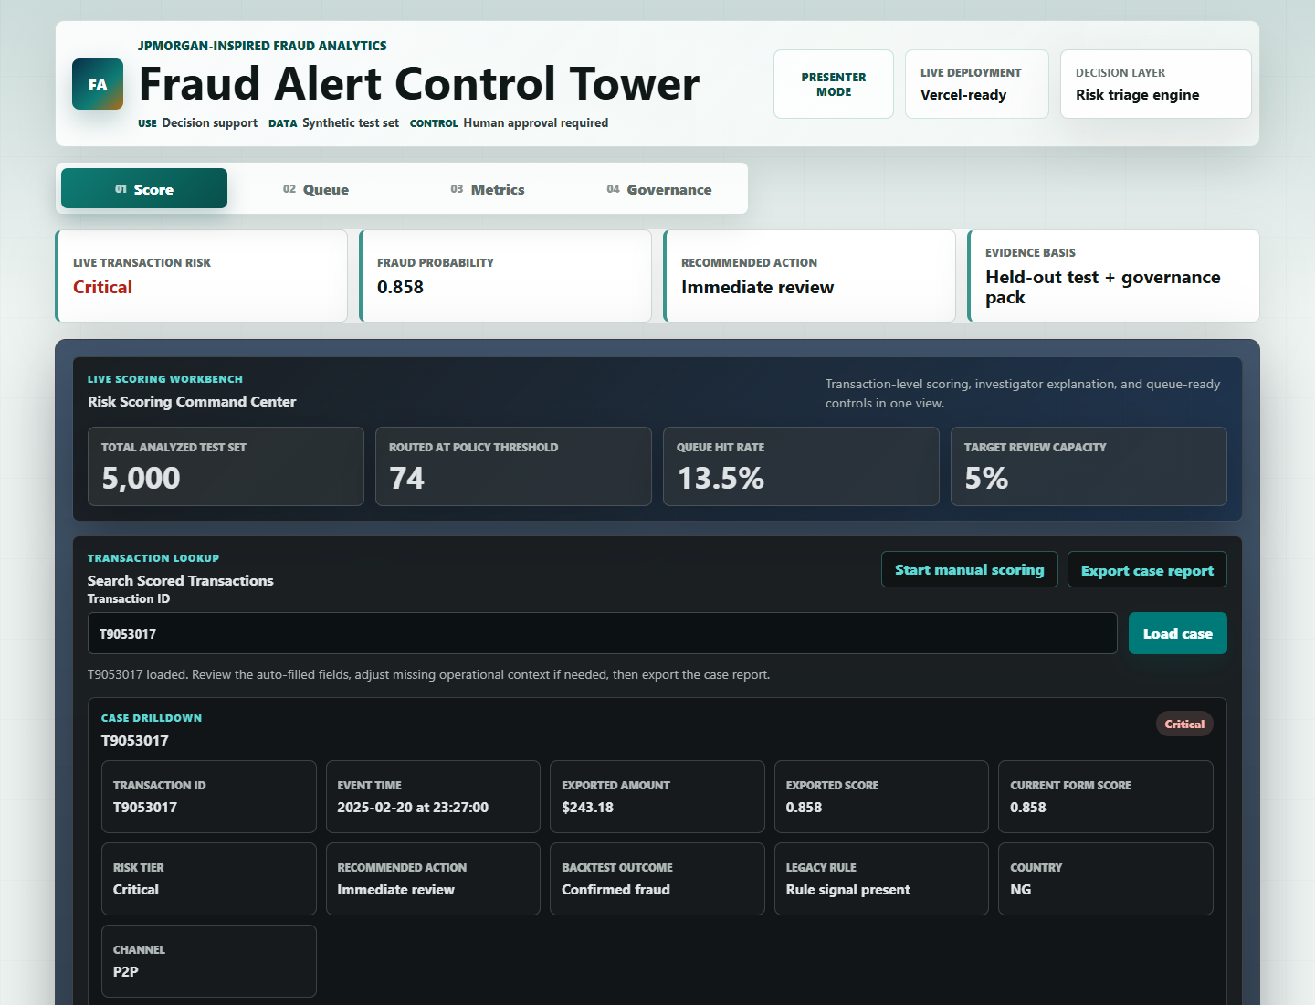
Score view: transaction lookup, manual scoring, risk decision, explanation, and case export.
App section | Purpose
Score | Search or manually enter a transaction and receive risk probability, alert tier, action, explanation, and CSV export.
Queue | Show the investigator review queue, top cases, rule-gap cases, triage lanes, and control checks.
Metrics | Translate model performance into fraud capture, false positives, review cost, and threshold trade-offs.
Governance | Summarize model card, limitations, approval gates, monitoring controls, and responsible-use policy.

8. Explainability And Investigator Use
The app explains the score by comparing each transaction with typical reference values. If a transaction has unusually high geographic distance or amount, the app shows how that signal increased model risk. If a feature lowers risk, the app presents it as a protective signal.
Important wording control: the explanation describes model behavior, not guaranteed causality. It means the model treated a feature value as risk-increasing or risk-reducing; it does not prove that the feature caused fraud.
- High-risk cases receive investigator actions such as validation, step-up verification, or manual review.
- Low-risk cases can be monitored with audit trail only unless behavior changes.
- The exportable CSV case report gives transaction facts, risk score, explanation, next steps, and governance notes.
9. Governance And Responsible Use
Because this is a banking-style fraud project, governance was treated as part of the deliverable rather than an afterthought. The model is positioned as decision support only. It should not automatically freeze accounts or create customer-impacting decisions without human review.
Control | How it was handled
Leakage prevention | Removed IDs, target fields, and the old alert flag from model inputs.
Human review | App recommends review actions but does not automate blocking.
Threshold governance | Threshold selected with investigator capacity and false-positive load in mind.
Monitoring | Defined queue size, hit rate, fraud capture, false positives, drift, and segment review.
Limitations | Synthetic data means production use would require real-data validation and approval.

10. Changes Made After Feedback
After receiving feedback, I improved the project to make it easier for a tutor or JPMorgan-style reviewer to understand and evaluate. The main changes focused on clarity, professional presentation, and reviewer usability.
Feedback theme | Change made
PPT needed a stronger story | Created a new journey-based deck explaining how the project started, evolved, and reached its conclusion.
App needed clearer analyst flow | Improved opening state, labels, sections, and risk analyst wording.
Export report needed to be more useful | Changed the case report export to CSV with transaction facts, decision evidence, and governance notes.
Tutor may ask how it was built | Added optional Presenter Mode so build notes appear only when needed.
Submission folder needed focus | Kept final submission materials project-focused and separated from learning notes.

11. Project Report Card
Review area | Evidence in this project
Fraud relevance and feature engineering | Top-10 fraud features, transaction/customer/merchant joins, leakage prevention, and explainable inputs.
Model evaluation and threshold discipline | Weighted model comparison, held-out test metrics, threshold capacity ladder, false-positive analysis.
Explainability and governance | Local explanations, model card, threshold memo, responsible-use summary, monitoring controls.
Operational dashboard usefulness | Score, Queue, Metrics, Governance, transaction lookup, case drilldown, and CSV export.
Business communication | Alert economics, review cost framing, fraud capture trade-off, final PPT, and professional report.

12. Final Recommendation
For the final review, I would present the project as an end-to-end fraud analytics control tower. The strongest message is that the work starts with data cleaning and modelling discipline, but the final value is operational: helping investigators decide what to review first, why it is risky, and how the review threshold affects cost and workload.
Two-minute closing pitch
I built an explainable fraud alert prioritization system that cleans and joins transaction, customer, and merchant data; selects top risk features; compares fraud models; tunes the threshold around investigator capacity; and deploys a Vercel-style control tower with scoring, queue, metrics, governance, and case export.

