[Ramakrishna's blog : My Musings on Sharepoint 2010, MOSS 2007,PerformancePoint, InfoPath](http://ramakrishnaraja.blogspot.com/)

**Visit my new Blog :**[**http://www.sharepointdeveloper.in/**](http://www.sharepointdeveloper.in/)

**THURSDAY, JULY 01, 2010**

SharePoint 2010: How to enable anonymous access - Part 1

For some reason if you want to enable anonymous access, after creating your W

eb Applications, then here are the steps to enable it to your site.  
Step 1 : Goto Central Administration ->Application Management ->Manage Web Applications  
  
[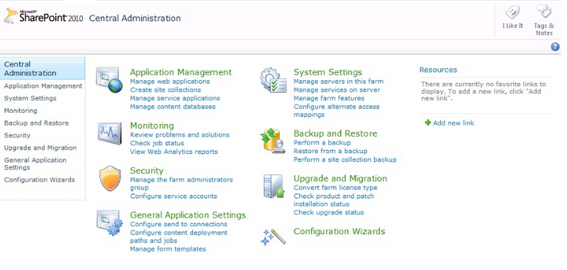](http://2.bp.blogspot.com/_P1_cuc7Lr_Y/TL3tSHtmHiI/AAAAAAAAAGQ/FrCcNWo7Az8/s1600/Step1.png)  
Step 2 : Select the web application for which you need to enable anonymous access  
  
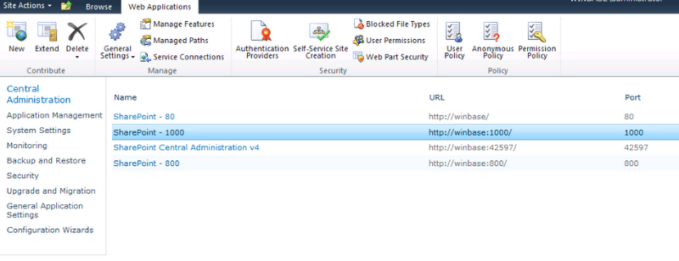Step 3 : Select Default (Authentication Providers)  
(Note:I created my web application with Claims authentication)  
  
[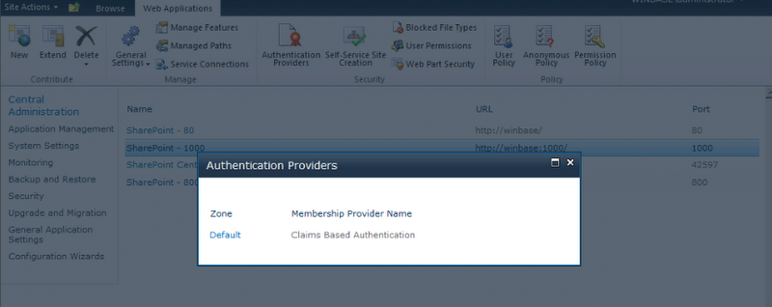](http://4.bp.blogspot.com/_P1_cuc7Lr_Y/TL3nvCjsrsI/AAAAAAAAAFo/JzCE5a95-is/s1600/step3.PNG)Step 4 : Select Enable anonymous access

[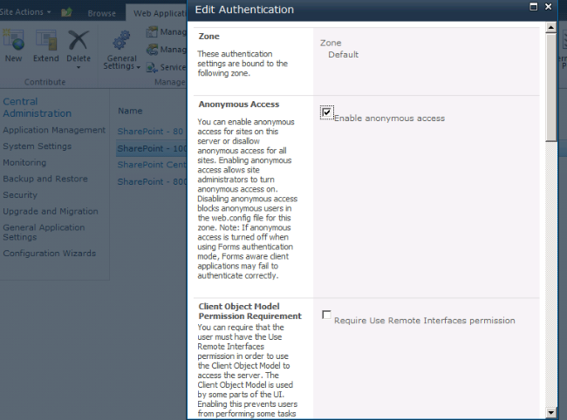](http://4.bp.blogspot.com/_P1_cuc7Lr_Y/TL3ouMpkttI/AAAAAAAAAFw/OX-cJYij2qs/s1600/step4.PNG)Step 5 : Save

[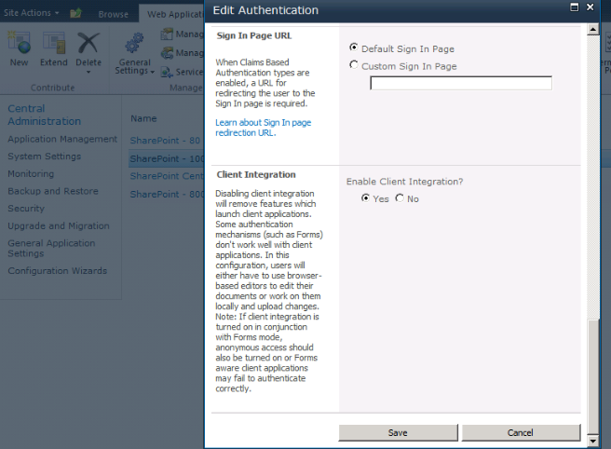](http://3.bp.blogspot.com/_P1_cuc7Lr_Y/TL3ph6GgugI/AAAAAAAAAF4/jjijYKSoBfg/s1600/step5.PNG)Step 6 : GoTo the site for which you need to enable anonymous access

[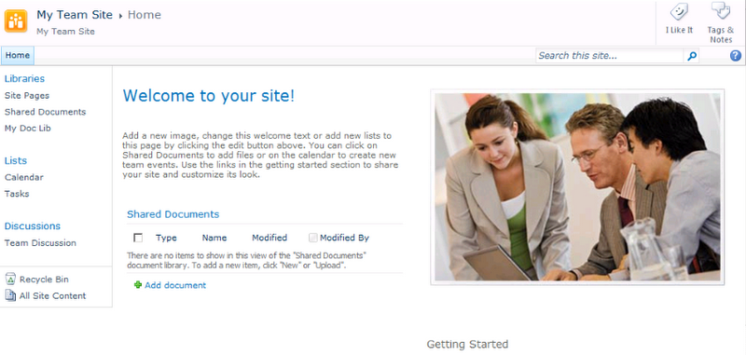](http://2.bp.blogspot.com/_P1_cuc7Lr_Y/TL3rF4wfasI/AAAAAAAAAGA/7iR84QggHGE/s1600/step6.PNG)

Step 7 : Click on Site actions -> Site Permissions

[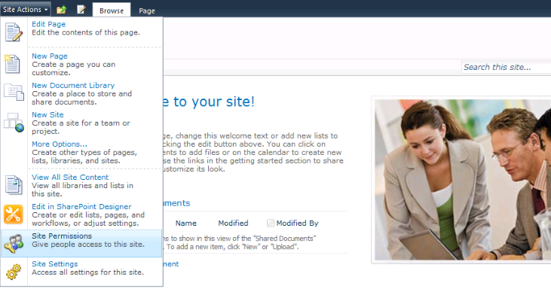](http://1.bp.blogspot.com/_P1_cuc7Lr_Y/TL3rfjh3slI/AAAAAAAAAGI/2AEjuFqh7Fs/s1600/step7.PNG)Step 8: Click on Anonymous Access

[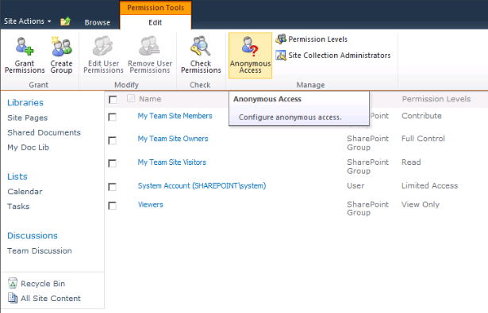](http://2.bp.blogspot.com/_P1_cuc7Lr_Y/TL3uD08fhLI/AAAAAAAAAGY/mUXEWQqmccw/s1600/step8.PNG)And for Step 9, we have three options to select

1. Entire Web Site - Select this option to enable Anonymous access to the entire web site
2. Lists and Libraries - Select this option to enable Anonymous access only to your lists and libraries, This way you can provide access only to a particular list or a library for your anonymous users.
3. Nothing

Step 9: Select List and Libraries ( I am not enabling anonymous access to the entire site)

[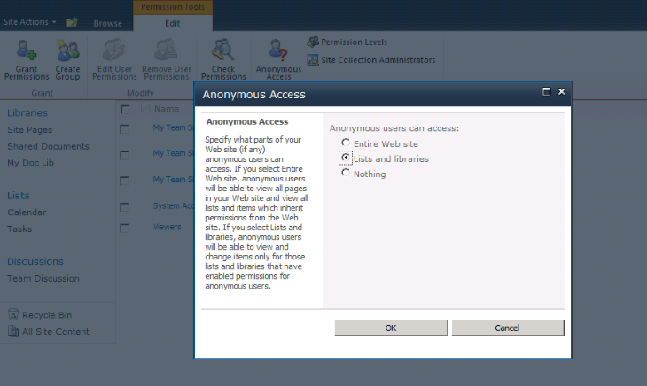](http://2.bp.blogspot.com/_P1_cuc7Lr_Y/TL3wmVRhpYI/AAAAAAAAAGg/BNdImWWVGl8/s1600/step9.PNG)Step 10: Done, anonymous access is enabled for your site's Lists and Libraries.

[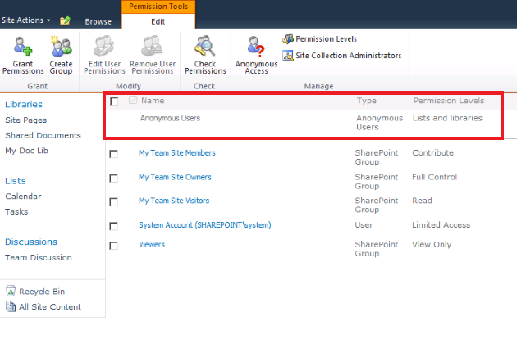](http://1.bp.blogspot.com/_P1_cuc7Lr_Y/TL3xUnkbVTI/AAAAAAAAAGo/GJ8nFsSJQJM/s1600/step10.PNG)Ok, Mission accomplished, and we have enabled anonymous access to our site lists and libraries, but the big question is for which list and library of our site.

Let see how to enable anonymous access to our document library in [Part 2 - How to Enable anonymous access to List and Libraries.](http://ramakrishnaraja.blogspot.com/2010/07/sharepoint-2010-how-to-enable-anonymous_02.html)

Posted by [Ramakrishna](http://www.blogger.com/profile/10492705635247236912)at [9:50 AM](http://ramakrishnaraja.blogspot.com/2010/07/sharepoint-2010-how-to-enable-anonymous.html) [[http://img1.blogblog.com/img/icon18_email.gif](http://www.blogger.com/email-post.g?blogID=26942855&postID=8300960381754865501)](http://www.blogger.com/email-post.g?blogID=26942855&postID=8300960381754865501)

Labels: [Anonymous Access](http://ramakrishnaraja.blogspot.com/search/label/Anonymous%20Access), [Sharepoint 2010](http://ramakrishnaraja.blogspot.com/search/label/Sharepoint%202010)

No comments:

[Post a Comment](http://www.blogger.com/comment.g?blogID=26942855&postID=8300960381754865501)

Merge test , Merge test