* [HOME](http://www.topsharepoint.com/" \o "Home)
* [ABOUT](http://www.topsharepoint.com/about)
* [SUBMIT SITE](http://www.topsharepoint.com/submit)
* [ADVERTISE](http://www.topsharepoint.com/Advertise)
* [BLOG](http://www.topsharepoint.com/category/blog)
* [THEMES](http://www.topsharepoint.com/themes)
* [GIFT SHOP](http://www.topsharepoint.com/gift-shop)
* [JOB BOARD](http://jobs.topsharepoint.com/)
* [DIRECTORY](http://www.topsharepoint.com/sharepoint-consulting-companies)

[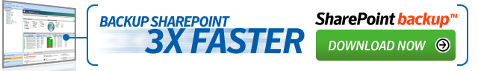](http://sharepointads.com/members/scripts/click.php?a_aid=topsharepoint&a_bid=62e75df3&desturl=http://www.idera.com/SharePoint/SharePoint-backup/?s=BN_SPADS_spbu)

[](http://www.topsharepoint.com/)

[](http://www.sieena.com/Pages/Eight-Tips-For-Rebranding-SharePoint.aspx)[](http://sharepointads.com/members/scripts/click.php?a_aid=topsharepoint&a_bid=065f951e)http://sharepointads.com/members/scripts/imp.php?a_aid=topsharepoint&a_bid=065f951e[](http://sharepointads.com/members/scripts/click.php?a_aid=topsharepoint&a_bid=eb089f59)http://sharepointads.com/members/scripts/imp.php?a_aid=topsharepoint&a_bid=eb089f59[](http://plexhosted.com/services/hosted-sharepoint/overview.html)[](http://sharepointads.com/members/scripts/click.php?a_aid=topsharepoint&a_bid=8bf2ea75)http://sharepointads.com/members/scripts/imp.php?a_aid=topsharepoint&a_bid=8bf2ea75[](http://sharepointads.com/members/scripts/click.php?a_aid=topsharepoint&a_bid=75099361)http://sharepointads.com/members/scripts/imp.php?a_aid=topsharepoint&a_bid=75099361[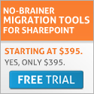](http://sharepointads.com/members/scripts/click.php?a_aid=topsharepoint&a_bid=e8f32524)http://sharepointads.com/members/scripts/imp.php?a_aid=topsharepoint&a_bid=e8f32524[](http://sharepointads.com/members/scripts/click.php?a_aid=topsharepoint&a_bid=9b45d8e2)http://sharepointads.com/members/scripts/imp.php?a_aid=topsharepoint&a_bid=9b45d8e2

[Highest Rated](http://www.topsharepoint.com/?r_sortby=highest_rated&r_orderby=desc&cat=1) | [Lowest Rated](http://www.topsharepoint.com/?r_sortby=highest_rated&r_orderby=asc&cat=1) | [Most Rated](http://www.topsharepoint.com/?r_sortby=most_rated&r_orderby=desc&cat=1) | [Least Rated](http://www.topsharepoint.com/?r_sortby=most_rated&r_orderby=asc&cat=1) | [Random](http://www.topsharepoint.com/?orderby=rand&cat=1) | [Latest](http://www.topsharepoint.com/?orderby=date&cat=1)

**Enable Anonymous Access in SharePoint 2010**

Author: [Luis Kerr](http://www.topsharepoint.com/author?id=1)

Here are 8 simple steps on how to set up anonymous access in [MS SharePoint 2010](http://www.sherweb.com/sharepoint-hosting). It is not much different then SharePoint 2007 set up, the only difference is the GUI or the Ribbon.

1. Starting in Central Administration, under Application Management, click on the Manage web applications.

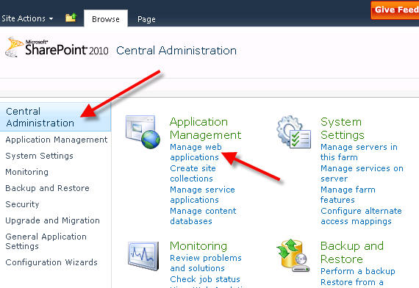

2. Make sure you select the site you want to enable anonymous access and click on the Authentication Providers icon.  
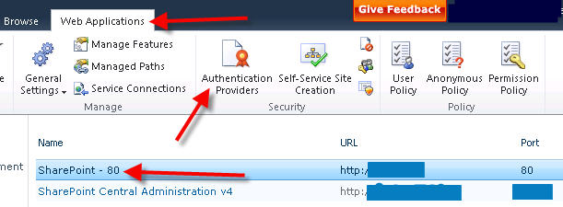

3. On the Authentication Providers pop-up window click on the Default zone.  
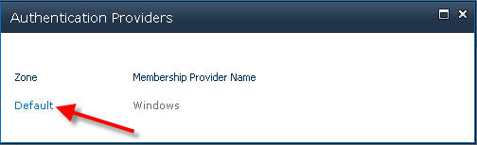

4. Under Edit Authentication, check Enable anonymous access and click Save.  
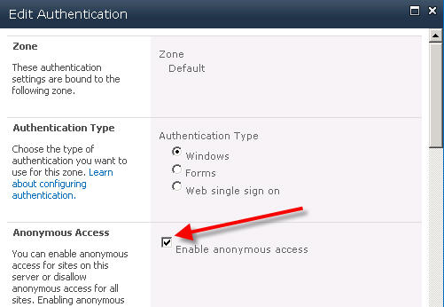

5. Going back to Web Application Management click on the Anonymous Policy icon.  
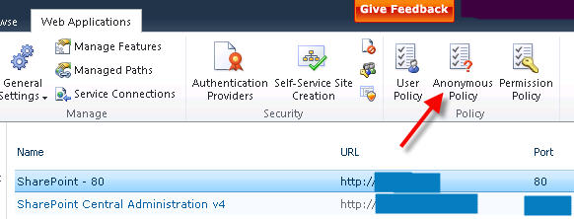

6. Under Anonymous Access Restrictions select your Zone and set the Permissions to None – No policy and click Save.  
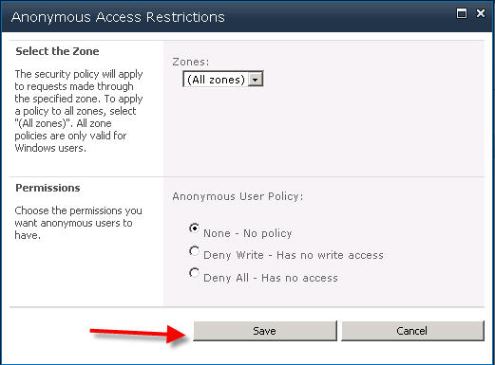

7. Now, web application will allow anonymous access to be set. So, navigate to your top level site collection for the web application. Click the Site Actions > Site Settings. Under Users and Permissions click Site permissions.  
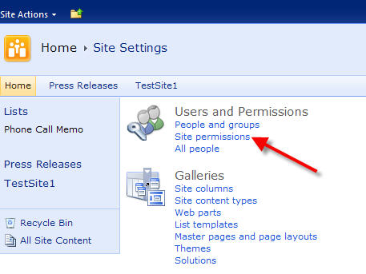

8. Under Permission Tools, click Anonymous Access icon and set the permissions to Entire Web site and click OK.  
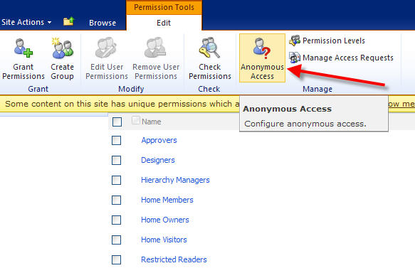  
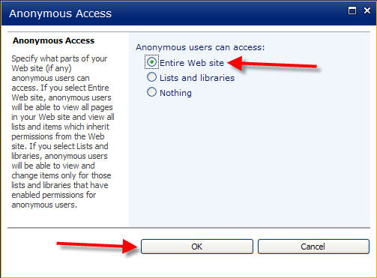

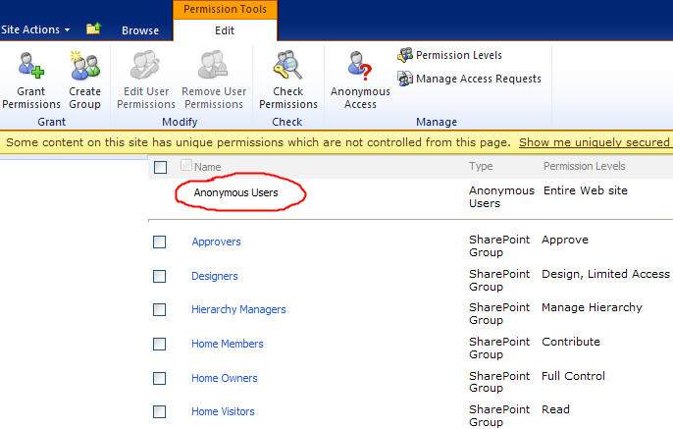

That’s all, folks! If you followed these steps properly you should have now Anonymous Access enabled.

**Related Link**  
- [30 Awesome SharePoint-powered Sites](http://www.topsharepoint.com/30-awesome-sharepoint-powered-sites)  
- [Inspiring Colorful SharePoint Websites](http://www.topsharepoint.com/inspiring-colorful-sharepoint-websites)  
- [Top Rated SharePoint Sites for 2011](http://www.topsharepoint.com/top-rated-sharepoint-sites-for-2011)  
- [50 Beautiful Dark Websites Built on SharePoint](http://www.topsharepoint.com/50-beautiful-dark-websites-built-on-sharepoint)  
- [Beautiful Blue SharePoint Websites](http://www.topsharepoint.com/beautiful-blue-sharepoint-websites)

**Popular SharePoint Books**  
[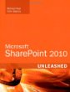](http://www.amazon.com/gp/product/0672333252/ref=as_li_tf_il?ie=UTF8&tag=myclcom-20&linkCode=as2&camp=1789&creative=9325&creativeASIN=0672333252)[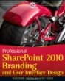](http://www.amazon.com/gp/product/0470584645/ref=as_li_tf_il?ie=UTF8&tag=myclcom-20&linkCode=as2&camp=1789&creative=9325&creativeASIN=0470584645)[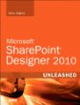](http://www.amazon.com/gp/product/0672331055/ref=as_li_tf_il?ie=UTF8&tag=myclcom-20&linkCode=as2&camp=1789&creative=9325&creativeASIN=0672331055)[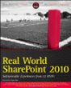](http://www.amazon.com/gp/product/0470597135/ref=as_li_tf_il?ie=UTF8&tag=myclcom-20&linkCode=as2&camp=1789&creative=9325&creativeASIN=0470597135)

**Popular SharePoint Books**

[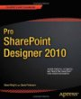](http://www.amazon.com/gp/product/1430236175/ref=as_li_tf_il?ie=UTF8&tag=myclcom-20&linkCode=as2&camp=1789&creative=9325&creativeASIN=1430236175)http://www.assoc-amazon.com/e/ir?t=myclcom-20&l=as2&o=1&a=1430236175 [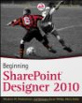](http://www.amazon.com/gp/product/0470643161/ref=as_li_tf_il?ie=UTF8&tag=myclcom-20&linkCode=as2&camp=1789&creative=9325&creativeASIN=0470643161)http://www.assoc-amazon.com/e/ir?t=myclcom-20&l=as2&o=1&a=0470643161 [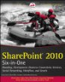](http://www.amazon.com/gp/product/0470877278/ref=as_li_tf_il?ie=UTF8&tag=myclcom-20&linkCode=as2&camp=1789&creative=9325&creativeASIN=0470877278)http://www.assoc-amazon.com/e/ir?t=myclcom-20&l=as2&o=1&a=0470877278 [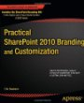](http://www.amazon.com/gp/product/1430240261/ref=as_li_tf_il?ie=UTF8&tag=myclcom-20&linkCode=as2&camp=1789&creative=9325&creativeASIN=1430240261)http://www.assoc-amazon.com/e/ir?t=myclcom-20&l=as2&o=1&a=1430240261 [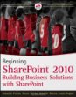](http://www.amazon.com/gp/product/0470617896/ref=as_li_tf_il?ie=UTF8&tag=myclcom-20&linkCode=as2&camp=1789&creative=9325&creativeASIN=0470617896)http://www.assoc-amazon.com/e/ir?t=myclcom-20&l=as2&o=1&a=0470617896

[**Document SharePoint Farm**](http://sharepointads.com/members/scripts/click.php?a_aid=topsharepoint&a_bid=da4bff09)  
Automatically generate SharePoint documentation. Free 30 days trial!http://sharepointads.com/members/scripts/imp.php?a_aid=topsharepoint&a_bid=da4bff09

[**Packaged Enterprise Search**](http://sharepointads.com/members/scripts/click.php?a_aid=topsharepoint&a_bid=581db658)  
for SharePoint.View a quick online demo here! Surfray.com/Ontolicahttp://sharepointads.com/members/scripts/imp.php?a_aid=topsharepoint&a_bid=581db658

**31 Responses So Far, Want To Say Something?**

1. **Soichiro Oka says:**

Hello,

I am wondering how anonymous users can view Excel web part.

Thanks

1. **chris says:**

Hi

I have a (publishing portal) site with anonymous acces enabled (thanks for your procedure) ,When i go to this site in anonymous i don’t get the same design that i got when i’m logged.  
is there another master page for anonymous user ?

thanks for your help

1. **Anonymous says:**

When I get to step 8, there is no icon for anonymous access next to check permissions. However, I am certain that I have properly followed all of the preceding steps. Can you think of an explanation for this? Thanks so much.

1. **Paul says:**

For chris, don’t forget to check-in your Master page in order for the changes to take effect. For “Anonymous”, make sure you selected the right site and do an iisreset.

1. **Luke Watt says:**

hi there,

I have tried Sharepoint 2010 with asphostcentral.com and so far, everything looks good. To be honest, the interface is completely different and I am amazed with the improvement that has been done on this Sharepoint version.

Anonymous Access is one of the issue that requires special attention. It is not easy to have it setup as you always need to check the application pool identity settings as well. Make sure it operates under NETWORK SERVICE

Hope this helps

1. [**Peter**](http://twitter.com/Peter_D503)**says:**

The “Anonymous Access” button in Step #8 doesn’t appear for our extended web application with anonymous configured in Central Admin. Not sure why.

1. [**James**](http://www.laomu.com/)**says:**

Very helpful thanks!

1. **Muhammed says:**

In our company we have internal Portal (by using SP server 2010) for internal user now we have a requirement to create a Team Site for our external users who will have upload different documents and perform other task. For this we have two type of user:  
1. User with Active Directly ID  
2. External user with email  
Can any one guide us on how to plan to create and deploy SharePoint website where we have Single Form with separate DB server and around 100 users.

1. **Johan says:**

Same here. The “Anonymous Access” button in Step #8 doesn’t appear for our extended web application with anonymous configured in Central Admin.

Is it because we are using the default SQL Server Express?

1. **Pepe says:**

In our company we have a public website with anonymous access. We need to add 3 forms (contact us, …). We found a SharePoint tool called “Kaldeera Advanced Forms”. info about this tool?

thanks in advance.

1. **RV says:**

When I get to step 8, there is no icon for anonymous access next to check permissions. However, I am sure that i have followed all the steps .can you explain me why this happening

1. **Mike says:**

I’m also having the problem at step #8 where I don’t get the anonymous access button to appear. I’ve done an IISRESET and I have verified that I am accessing the same site that I was using in the earlier steps. Can someone please tell me what I am doing wrong?

1. **Ibrahim says:**

For those who are experiencing trouble on step 8, make sure you are accessing the site from the correct url where the anonymous policy is defined.

1. **Raj says:**

Hi Julian

Thank you for giving very good explinatory post.

I am having issue with MySite Anonymous access.

Could you please clear my problem. In my sharepoint environment, i have mysite enabled. I gave my sharepoint site (main site) anonymous access. and users are able to login successfully without login prompt. However, when user clicks on MySite link on the page, he is getting login prompt. Dont know the reason.

I went to central admin and opend webapp that is created for mysite and givin anonymous access. but still didnt work.

please help me out.

thanks beforehand

raj

1. [**sreekanth**](http://sp77.blogspot.com/)**says:**

anonymous access working or not when we install different language packs( means multi lingual web site )

1. **Rutuma says:**

Awesome article.. Very helpful.  
Thanks for sharing.

1. **Henry says:**

We had this silmilar problem with MySites not able to use Anonymous access. We called Microsoft support and they couldn’t figured it out. We setup everything correctly in SharePoint Administration and IIS. We turned on Anonymous access for mysite but didn’t work. We figured it out the problem. The root of the site <http://mysites.woodbury.edu/personal/lauh>doesn’t work with Anonymous access. you will have to create a new sub-site and turn on Anonymous access. For example we created a site called Portfolio and turned on Anonymous access. The site url is<http://mysites.woodbury.edu/personal/lauh/portfolio> and it worked.

1. **nan says:**

I followed all the steps mentioned but it did not work. I had the option before but it disappeared. We have other forms that were configured to have anonymous access and they are still working fine but since yesterday the option disappeared . Is there a reset we need to do?

1. [**solvetech**](http://www.solvetech.com/)**says:**

For those who have the problem seeing the anonymous button on the permissions of the site make sure you have selected the web application in central administration and followed the steps described to add the anonymous access.

I usually restart the server(s) (just to be sure)

1. **aru says:**

hi in my application authentication provider is disable how can i enable  
Thanks

1. **kavya says:**

Hi,

I have done the anonymous and checked it,works fine. But when I created the variation for english & french anonymous is not working. Asking the user name and password.. Even I give the anonymous to site collection asses and images. What did I miss? Pl guide me. very urgent.

Thanks.

1. [**W@rfi**](http://www.warfiblog.com/)**says:**

Thanks … the steps really saved my time … especially enabling Anonymous at Site Permissions level ….

1. **Ramon N Diaz says:**

works great! thanks you!

1. [**pandeybpo**](http://www.pandeybpo.com/)**says:**

nice posting.thank you

1. **torontom says:**

Great! it works on every steps! on step 6, it seems that it is the default setting, I did not make any change on step 6

1. **Asher says:**

hi

for users who cannot see the Anonymous Access button when extending a web application – you will need to navigate to the extended site collection to apply the final steps.  
Cheers

Ash

1. [**sunit**](http://www.sawinfotech.com/)**says:**

good post. thanx.

1. [**Doris**](http://www.topsharepoint.com/enable-anonymous-access-in-sharepoint-2010)**says:**

Good, thx a lot.

1. **Arnel Tolentino says:**

Hi Everyone,  
We are having a problem with SharePoint. We cannot publish an access database to SharePoint server 2010 as we get this error “An error occurred while initializing access services database.” whenever we try to publish the default contact database. By the way, we are using the single server environment (standalone). If you need more details just let me know. Any help would be appreciated guys, thanks.

1. **Hemalatha says:**

Good post. Thank you!

1. **Matthew Lamb says:**

I also found at stage 8 that I did not have the ‘Anonymous Access’ option in the Site Permissions page.

This was because I had extended a web application for anonymous access in the Internet zone, but SharePoint for some reason had extended a DIFFERENT web application to the one I had selected. So when I accessed my new URL (for the anonymous site) I was actually seeing the wrong site collection. Everything looked correct in Central Admin, though.

I ended up unextending the web application (using the drop-down on the ‘Delete’ option in the Web Applications management page of Central Admin, and selecting ‘Remove SharePoint from IIS Web Site), and then re-extending it again into the internet zone. The second time it worked properly.

**Leave A Reply**

Top of Form

 Name (required)

 Mail (will not be published) (required)

 Website



Submit

Bottom of Form

**Best Site Of The Month**

[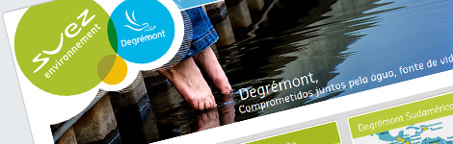](http://www.topsharepoint.com/degremont)

[see other months...](http://www.topsharepoint.com/best-sharepoint-site-of-the-month)

* **Poll**

Top of Form

**How many master pages do you use in your SharePoint public-facing website?**

* +  One
  +  Two
  +  Three
  +  Four
  +  More than four

[View Results](http://www.topsharepoint.com/#ViewPollResults)

Bottom of Form

* + [Polls Archive](http://www.topsharepoint.com/pollsarchive)

**Recent Comments**

Riley on [Responsive – Free SharePoint 2010 Theme](http://www.topsharepoint.com/responsive-free-sharepoint-2010-theme#comment-9339)

Riley on [Responsive – Free SharePoint 2010 Theme](http://www.topsharepoint.com/responsive-free-sharepoint-2010-theme#comment-9337)

Matthew Lamb on [Enable Anonymous Access in SharePoint 2010](http://www.topsharepoint.com/enable-anonymous-access-in-sharepoint-2010#comment-9118)

Luis Kerr on [Responsive – Free SharePoint 2010 Theme](http://www.topsharepoint.com/responsive-free-sharepoint-2010-theme#comment-8971)

Daniel on [Responsive – Free SharePoint 2010 Theme](http://www.topsharepoint.com/responsive-free-sharepoint-2010-theme#comment-8958)

Brett on [Responsive – Free SharePoint 2010 Theme](http://www.topsharepoint.com/responsive-free-sharepoint-2010-theme#comment-8863)

Sinuhe on [Rename SharePoint 2010 Server](http://www.topsharepoint.com/rename-sharepoint-2010-server#comment-8566)

Evoke Sharepoint on [Reliance](http://www.topsharepoint.com/reliance#comment-8481)

Marco on [Enabling or Disabling Claims Based Authentication](http://www.topsharepoint.com/enabling-or-disabling-claims-based-authentication#comment-7656)

Evoke Sharepoint on [Computershare](http://www.topsharepoint.com/computershare#comment-7572)

[](http://sharepointads.com/members/scripts/click.php?a_aid=topsharepoint&a_bid=509d63b8)http://sharepointads.com/members/scripts/imp.php?a_aid=topsharepoint&a_bid=509d63b8 [](http://sharepointads.com/members/scripts/click.php?a_aid=topsharepoint&a_bid=b90a77b0)http://sharepointads.com/members/scripts/imp.php?a_aid=topsharepoint&a_bid=b90a77b0

**Popular Tags**

[Finance](http://www.topsharepoint.com/tag/finance) [software](http://www.topsharepoint.com/tag/software) [dark](http://www.topsharepoint.com/tag/dark) [development](http://www.topsharepoint.com/tag/development)[children](http://www.topsharepoint.com/tag/children) [innovation](http://www.topsharepoint.com/tag/innovation) [training](http://www.topsharepoint.com/tag/training) [hospital](http://www.topsharepoint.com/tag/hospital)[consultants](http://www.topsharepoint.com/tag/consultants) [food](http://www.topsharepoint.com/tag/food) [transportation](http://www.topsharepoint.com/tag/transportation)[Netherlands](http://www.topsharepoint.com/tag/netherlands) [resources](http://www.topsharepoint.com/tag/resources) [healthcare](http://www.topsharepoint.com/tag/healthcare) [USA](http://www.topsharepoint.com/tag/usa)[grey](http://www.topsharepoint.com/tag/grey) [Europe](http://www.topsharepoint.com/tag/europe) [non profit](http://www.topsharepoint.com/tag/non-profit) [Illinois](http://www.topsharepoint.com/tag/illinois)[consulting](http://www.topsharepoint.com/tag/consulting) [engineering](http://www.topsharepoint.com/tag/engineering) [travel](http://www.topsharepoint.com/tag/travel)[management](http://www.topsharepoint.com/tag/management) [College](http://www.topsharepoint.com/tag/college) [Health](http://www.topsharepoint.com/tag/health) [agency](http://www.topsharepoint.com/tag/agency)[California](http://www.topsharepoint.com/tag/california) [Australia](http://www.topsharepoint.com/tag/australia) [education](http://www.topsharepoint.com/tag/education) [blue](http://www.topsharepoint.com/tag/blue)[environment](http://www.topsharepoint.com/tag/environment) [London](http://www.topsharepoint.com/tag/london) [Association](http://www.topsharepoint.com/tag/association) [School](http://www.topsharepoint.com/tag/school)[students](http://www.topsharepoint.com/tag/students) [University](http://www.topsharepoint.com/tag/university) [Community](http://www.topsharepoint.com/tag/community)[Technology](http://www.topsharepoint.com/tag/technology) [services](http://www.topsharepoint.com/tag/services) [light](http://www.topsharepoint.com/tag/light) [green](http://www.topsharepoint.com/tag/green)[research](http://www.topsharepoint.com/tag/research) [destination](http://www.topsharepoint.com/tag/destination) [Foundation](http://www.topsharepoint.com/tag/foundation)[solutions](http://www.topsharepoint.com/tag/solutions) [canada](http://www.topsharepoint.com/tag/canada) [red](http://www.topsharepoint.com/tag/red) [investment](http://www.topsharepoint.com/tag/investment) [white](http://www.topsharepoint.com/tag/white)[Government](http://www.topsharepoint.com/tag/government) [innovative](http://www.topsharepoint.com/tag/innovative) [energy](http://www.topsharepoint.com/tag/energy)[awesome](http://www.topsharepoint.com/tag/awesome) [manufacturer](http://www.topsharepoint.com/tag/manufacturer) [knowledge](http://www.topsharepoint.com/tag/knowledge)[Insurance](http://www.topsharepoint.com/tag/insurance) [UK](http://www.topsharepoint.com/tag/uk) [SharePoint 2010](http://www.topsharepoint.com/tag/sharepoint-2010)[Washington](http://www.topsharepoint.com/tag/washington) [colorful](http://www.topsharepoint.com/tag/colorful)

**[Follow Us on Twitter](http://twitter.com/topsharepoint) [Join Us on Facebook](http://www.facebook.com/pages/TopSharePoint/487128550012) [Join Us on G+](https://plus.google.com/u/0/b/117266364467416809353/117266364467416809353/posts) [Follow Us on FriendFeed](http://friendfeed.com/topsharepoint) [RSS Feed](http://feeds.feedburner.com/TopSharepoint)**

**2 071**

**Featured  
SharePoint  
Sites**

Top of Form

 

Bottom of Form

**Recent Blog Posts**

[](http://www.topsharepoint.com/best-sharepoint-designs-in-south-africa)

[Best SharePoint Designs in Sout...](http://www.topsharepoint.com/best-sharepoint-designs-in-south-africa)

[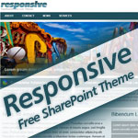](http://www.topsharepoint.com/responsive-free-sharepoint-2010-theme)

[Responsive – Free SharePoint ...](http://www.topsharepoint.com/responsive-free-sharepoint-2010-theme)

[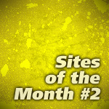](http://www.topsharepoint.com/sharepoint-sites-of-the-month-2)

[SharePoint Sites of the Month #...](http://www.topsharepoint.com/sharepoint-sites-of-the-month-2)

[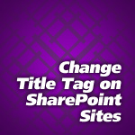](http://www.topsharepoint.com/change-title-tag-on-sharepoint-sites)

[Change Title Tag on SharePoint ...](http://www.topsharepoint.com/change-title-tag-on-sharepoint-sites)

[](http://www.topsharepoint.com/best-sharepoint-designs-in-germany)

[Best SharePoint Designs in Germ...](http://www.topsharepoint.com/best-sharepoint-designs-in-germany)

[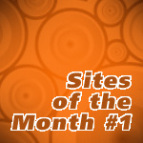](http://www.topsharepoint.com/sharepoint-sites-of-the-month-1)

[SharePoint Sites of the Month #...](http://www.topsharepoint.com/sharepoint-sites-of-the-month-1)

[](http://www.topsharepoint.com/beautiful-green-sharepoint-websites)

[Beautiful Green SharePoint Webs...](http://www.topsharepoint.com/beautiful-green-sharepoint-websites)

[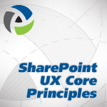](http://www.topsharepoint.com/sharepoint-custom-user-experience-some-core-principles)

[SharePoint Custom User Experien...](http://www.topsharepoint.com/sharepoint-custom-user-experience-some-core-principles)

[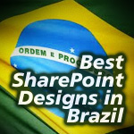](http://www.topsharepoint.com/best-sharepoint-designs-in-brazil)

[Best SharePoint Designs in Braz...](http://www.topsharepoint.com/best-sharepoint-designs-in-brazil)

[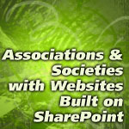](http://www.topsharepoint.com/associations-with-websites-built-on-sharepoint)

[Associations with Websites Buil...](http://www.topsharepoint.com/associations-with-websites-built-on-sharepoint)

* **Upcoming Conferences**
  + [Microsoft SharePoint Conference 2012](http://www.mssharepointconference.com/)November 12-15, 2012 | Las Vegas, NV
  + [SharePoint Connections](http://www.devconnections.com/shows/fall2012/default.aspx?s=192) October 29 – November 1, 2012 | Las Vegas, NV
  + [SharePoint Fest – Chicago 2012](http://www.sharepointfest.com/Chicago/)September 25-27, 2012 | Chicago, IL
  + [SharePoint Live!](http://splive360.com/Events/2012/Home.aspx) December 10-14, 2012 | Orlando, FL
* [**See More Upcoming Conferences**](http://www.topsharepoint.com/upcoming-sharepoint-conferences)

**Recent SharePoint Jobs**

* [SharePoint Consultant](http://jobs.topsharepoint.com/jobs/sharepoint-consultant-2)
* [Sharepoint Developer](http://jobs.topsharepoint.com/jobs/sharepoint-developer-20)
* [Sr. SharePoint Designer](http://jobs.topsharepoint.com/jobs/sr-sharepoint-designer)
* [SharePoint Developer](http://jobs.topsharepoint.com/jobs/sharepoint-developer-19)
* [SharePoint Engineer II](http://jobs.topsharepoint.com/jobs/sharepoint-engineer-ii)
* [Submit a Job](http://jobs.topsharepoint.com/submit)

**Best SharePoint Sites In:**

[USA](http://www.topsharepoint.com/tag/usa?r_sortby=highest_rated&r_orderby=desc) [Europe](http://www.topsharepoint.com/tag/europe?r_sortby=highest_rated&r_orderby=desc) [UK](http://www.topsharepoint.com/tag/uk?r_sortby=highest_rated&r_orderby=desc) [Australia](http://www.topsharepoint.com/tag/australia?r_sortby=highest_rated&r_orderby=desc)[Canada](http://www.topsharepoint.com/tag/canada?r_sortby=highest_rated&r_orderby=desc) [Netherlands](http://www.topsharepoint.com/tag/netherlands?r_sortby=highest_rated&r_orderby=desc) [New Zealand](http://www.topsharepoint.com/tag/new-zealand?r_sortby=highest_rated&r_orderby=desc)[France](http://www.topsharepoint.com/tag/france?r_sortby=highest_rated&r_orderby=desc) [Finland](http://www.topsharepoint.com/tag/finland?r_sortby=highest_rated&r_orderby=desc) [Denmark](http://www.topsharepoint.com/tag/denmark?r_sortby=highest_rated&r_orderby=desc)[Germany](http://www.topsharepoint.com/tag/germany?r_sortby=highest_rated&r_orderby=desc) [Switzerland](http://www.topsharepoint.com/tag/switzerland?r_sortby=highest_rated&r_orderby=desc) [Spain](http://www.topsharepoint.com/tag/spain?r_sortby=highest_rated&r_orderby=desc)[Italy](http://www.topsharepoint.com/tag/italy?r_sortby=highest_rated&r_orderby=desc) [South Africa](http://www.topsharepoint.com/tag/south-africa?r_sortby=highest_rated&r_orderby=desc) [More Stats...](http://www.topsharepoint.com/topics)

[](http://sharepointads.com/members/scripts/click.php?a_aid=topsharepoint&a_bid=5a8349f1)http://sharepointads.com/members/scripts/imp.php?a_aid=topsharepoint&a_bid=5a8349f1

[](http://sharepointads.com/members/scripts/click.php?a_aid=topsharepoint&a_bid=245c4abf)http://sharepointads.com/members/scripts/imp.php?a_aid=topsharepoint&a_bid=245c4abf

[](http://sharepointads.com/members/scripts/click.php?a_aid=topsharepoint&a_bid=2b88b1eb)http://sharepointads.com/members/scripts/imp.php?a_aid=topsharepoint&a_bid=2b88b1eb

***twitter feed***

**390 SharePoint 2010 websites in the showcase so far. See the Crème de la Crop**[**http://t.co/HU5agDr8**](http://t.co/HU5agDr8)[**#SharePoint**](http://search.twitter.com/search?q=%23SharePoint)**Saturday**

**Best SharePoint Designs in South Africa: The following showcase presents the Top 20 Best Rated Sha...**[**http://t.co/SlNIPnPD**](http://t.co/SlNIPnPD)**-**[**#SharePoint**](http://search.twitter.com/search?q=%23SharePoint)

**Showcase presents Top 20 Best Rated SharePoint websites in South Africa. Get inspired!**[**http://t.co/3D6YApeJ**](http://t.co/3D6YApeJ)[**#webdesign**](http://search.twitter.com/search?q=%23webdesign)[**#SharePoint**](http://search.twitter.com/search?q=%23SharePoint)**Saturday**

**New job in Naperville, IL posted on our Job Board: SharePoint Developer**[**http://t.co/UMHLxTPw**](http://t.co/UMHLxTPw)[**#SharePoint**](http://search.twitter.com/search?q=%23SharePoint)

**New**[**#SharePoint**](http://search.twitter.com/search?q=%23SharePoint)**Site Bool: Bool started with distinct goals right from the beginning. We wo...**[**http://t.co/M1Ffn7vJ**](http://t.co/M1Ffn7vJ)**-Vote 4 Best**[**#Design**](http://search.twitter.com/search?q=%23Design)

***popular blog posts***

[**1. GreenShade – Free Share...**](http://www.topsharepoint.com/greenshade-free-sharepoint-2010-theme)

[**2. Enable Anonymous Access in Sh...**](http://www.topsharepoint.com/enable-anonymous-access-in-sharepoint-2010)

[**3. Synesthesia – Free SharePoi...**](http://www.topsharepoint.com/synesthesia-%e2%80%93-free-sharepoint-2010-theme)

[**4. Fortune 500 Companies Using S...**](http://www.topsharepoint.com/fortune-500-companies-using-sharepoint)

**[5. Hide the Ribbon from Anonymou...](http://www.topsharepoint.com/hide-the-ribbon-from-anonymous-users" \o "Hide the Ribbon from Anonymous Users - )**

**[6. Upcoming SharePoint Conferenc...](http://www.topsharepoint.com/upcoming-sharepoint-conferences" \o "Upcoming SharePoint Conferences - )**

[**7. Content Migration Tools for S...**](http://www.topsharepoint.com/content-migration-tools-for-sharepoint)

[**8. Tendance – Free SharePo...**](http://www.topsharepoint.com/tendance-free-sharepoint-2010-theme)

[**9. Best Rated Websites Built wit...**](http://www.topsharepoint.com/best-rated-websites-built-with-sharepoint-2010)

[**10. Most Expensive Website in The...**](http://www.topsharepoint.com/most-expensive-website-in-the-world)

***social networks***

[**Follow Us on Twitter**](http://twitter.com/topsharepoint)

[**Follow Us on G+**](https://plus.google.com/u/0/117266364467416809353/posts#117266364467416809353/posts)

[**Follow Us on FriendFeed**](http://friendfeed.com/topsharepoint)

[**Combined RSS Feed**](http://feeds.feedburner.com/TopSharepoint)

[**Blog RSS Feed**](http://www.topsharepoint.com/category/blog/feed)

[**Add to Delicious**](http://del.icio.us/post?url=http://www.topsharepoint.com)

[**Stumble Us**](http://www.stumbleupon.com/submit?url=http://www.topsharepoint.com)

[**Digg Us**](http://www.digg.com/submit?phase=2&url=http://www.topsharepoint.com)

[**Add to Reddit**](http://www.reddit.com/submit?url=http://www.topsharepoint.com)

[**Site Submission**](http://www.topsharepoint.com/submit)

[](http://sharepointads.com/members/scripts/click.php?a_aid=topsharepoint&a_bid=aa88f188)http://sharepointads.com/members/scripts/imp.php?a_aid=topsharepoint&a_bid=aa88f188

© 2012 [Top SharePoint Sites](http://www.topsharepoint.com/) - All Rights Reserved[About Us](http://www.topsharepoint.com/about) | [Authors](http://www.topsharepoint.com/authors) | [Writers Guidelines](http://www.topsharepoint.com/writers-guidelines) | [Contact Us](http://www.topsharepoint.com/contact-us) | [Advertise](http://www.topsharepoint.com/advertise) | [Sign Up for Our Newsletter](http://eepurl.com/fUxQT)