Information system for helping students find the place to live

(Project for Systems III)

Mirza Redzic

Definition of the problem

In Slovenia, there are more and more international students every year. These students face more or less the same problems upon their first arrival to completely new surroundings. Undoubtedly, one of the first and most important such issues is finding a suitable place to live.

Going through tons of advertisements online, on the social media, as well as in the newspapers is a slow and unreliable process, especially since you can’t tell almost anything about the actual apartment from the provided images, let alone about the owner of the property. The circumstance that makes this process even harder is that owners usually ask for the deposit even before the students’ arrival, which was especially the case in the year 2020, when students had to provide the proof of having a place to live in order to cross the border, due to the pandemic.

This in particular is the main reason many students often come to conflicts with the owners of the property and have to move to different places several times during the first year of studying.

So far, there are many websites that offer the assistance for the international students in seeking the suitable apartment, however, no website allows students to get the feedback from the tenants who previously lived in the apartment that would help the students make their choice. On the other hand, since the owners of the apartment aren’t getting rated, they do not feel the obligation to make the students’ stay in Slovenia as comfortable as possible.

As a project in the course Systems III, I want to develop an information system that will help students as successfully and in the most satisfiable manner find the desired apartment.

Functional requirements

The system should enable the following functionalities:

- The system should allow user to create an account and login. After the login the user should gain access to some of the features previously unavailable. The account on the system should be connected to the users’ Google account which enables the user easier and smoother login to the system. Upon the first login, user can choose if he/she will use the system as a student (search for the apartment), or as a landlord (rent his/her apartment) and based on that, different features are available for the user.

- User logged in as the landlord can create and edit an instance of accommodation that will be displayed to the users logged in as students, as well as the users who aren’t logged in to the system. The instance has many parameters that the user creating it can insert manually and allows the user to upload up to 10 images of the accommodation.

- Each created instance should get an initial rating based on different weighted parameters (distance to the closest faculty building, rating of the user who created the instance, size, distance to the city center, pets allowed, price), so that the instances are sorted in some manner even if the user doesn’t apply any filters whatsoever. This rating is not fixed and the system should track different changes and update the rating accordingly (actual rating of a user (student) who rented the place, popularity of the ad, changes in the rating of the user who created the ad, availability)

- User logged in as student is allowed to rate and leave the comments on the profile of the landlord of the place he/she stayed at (reservation must have been made using the system) as well as the rating and the comments on the place itself.

- User logged in as student can contact the user who posted the instance of the desired accommodation and make the reservation via the system. The reservation is to be confirmed by the owner of the accommodation before it is officially valid.

- The system provides all users with the search engine that allows sorting by variety of parameters as well as filtering the results.

Non-functional requirements

- The system should be capable to handle at least 20.000 users without affecting the performance

- The system should be developed and deployed within 2 months of system designs being finalized.

- The system must ensure 24/7 operation with an uptime of at least 98%.

- The system should support two different types of users: landlords and students.

- The system should be packaged as a web application.

- The communication between the users might contain private information and must be encrypted to allow the safe environment for data exchange

- The system shall maintain data integrity by keeping backups of all updates to the database.

- The website’s interface has to be user-friendly and easy to use.

Feasibility study

From a technical point of view, the system is not too demanding to build. The process of building of the system will require standard web development tools (html, css, js, jsf, php). For the database, SQL will be used. We will also require some web server, which is not considered a problem, since nowadays we can find many free servers online, which also guarantees the economical
feasibility of the system, since given the low traffic amount [almost guaranteed in this particular case], both server and database are free, the project requires no additional software nor hardware costs, and we only need to invest time in order to realize this project.

Legally, the project is feasible for usage inside Slovenia. However, all the personal information must be encrypted to assure privacy of the users. Also EU's 1998 Data Protection Directive prohibits transfer of data to the third countries. Third countries is the term used in legislation to designate countries outside the European union. Personal data may only be transferred to third countries if that country provides an adequate level of protection^{[1]}. Since the system will be used by international students, it is likely that we will need to tackle this problem.

The project is organizationally and socially acceptable for students, as it only simplifies the process of tackling this issue and gives them insurance for safety of the choice. It also gives people owning an apartment a network of users who are interested in their property. The only issue that might arise among them is the worry that the system might be countereffective for them, as it is possible that they get negative ratings.

Matrix User role

Functions | Student | Landlord | Administrator | Guest
Using the search engine on the System | Yes | Yes | Yes | Yes
Rating the user logged in as Landlord and leaving comments on his/hers profile | Yes | No | No | No
Contacting the creator of the instance of property | Yes | No | Yes | No
Creating and editing an instance of a propery | No | Yes | Yes | No
Managing and/or banning the user from the System | No | No | Yes | No

Table 1: Matrix user role

[1]Reference: McAdams, Neslund N., and Neslund K. Law, Business and Society

Data dictionary

Entity | Description | Attribute | Type | Description of the attribute
User | User of the system | Id(PK) | Int | Identifier of the user
 |  | Username | Varchar(40) | Username displayed publicaly
 |  | Name | Varchar(255) | Full name of the user
Role | Type of the user (Student/Landlord/Admin) | Id(PK) | Int | Identifier of the Role
 |  | Value | Varchar(10) | Role of the user in the system
Rating | Table storing all the ratings of the user/Accommodation | Id(PK) | Int | Identifier of the Rating
 |  | Value | Decimal | Value in range 0.0 to 5.0
Accommodation | Instance of accommodation | Id(PK) | Int | Identifier of the accommodation
 |  | Name | Varchar(100) | Name of the ad instance to be displayed on the search engine of the system
 |  | Description | Varchar(2048) | Detailed description of the property
 |  | Date added | Date | Display the date when the instance was created
 |  | Available beds | Int | Number of available beds
 |  | Pets allowed | Int | 0 or 1 (True/False)
 |  | Price | Int | Price in €/month
 |  | Size | Int | Size in m²
City | Cities(Municipalities) in Slovenia | Id(PK) | Int | Id of the city
 |  | Name | Varchar(30) | Name of the city
Address | Table containing all the different street names in Slovenia | Id(PK) | Int | Identifier of the adress
 |  | Name | Varchar(100) | Name of the adress
Images | Table containing all the images uploaded by users and mapped to instances of accomodation | Id(PK) | Int | Identifier of image
 |  | Image | Image | Image of the property
Comment | Table containing all the comments on the properties | Id (PK) | Int | Identifier of the comment
 |  | Content | Varchar(1024) | Content of the comment

Table 2: Data dictionary

ER Diagram
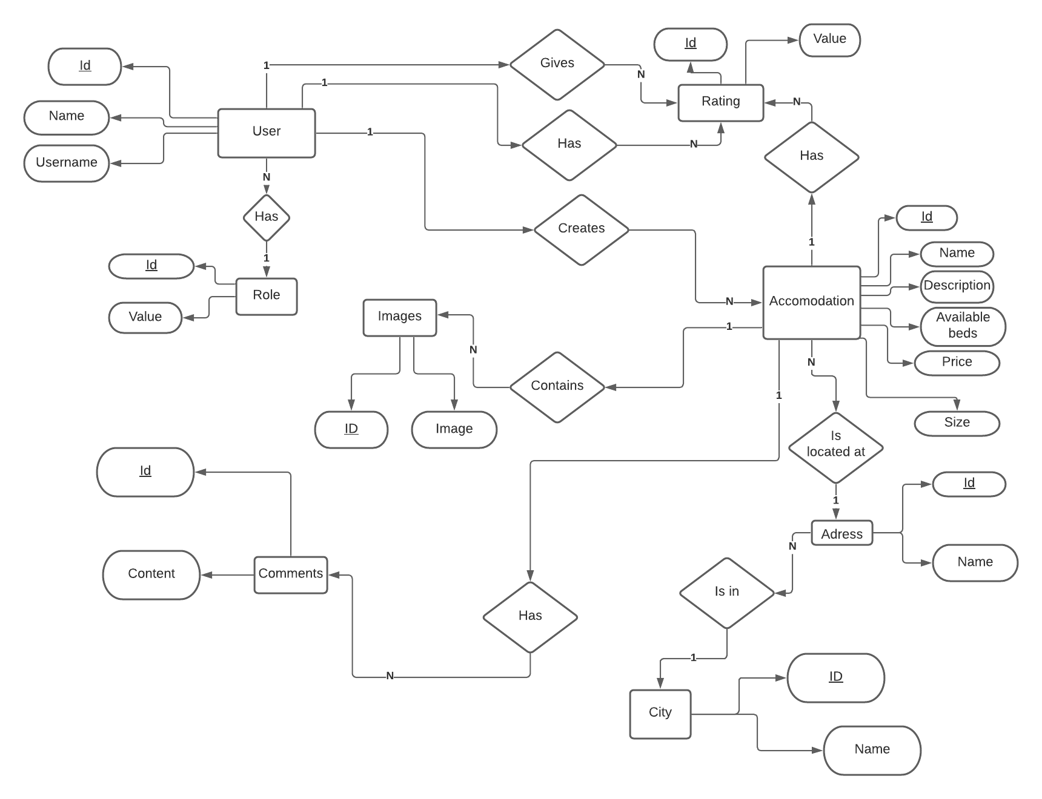
Figure 1: ER diagram

Relational Model

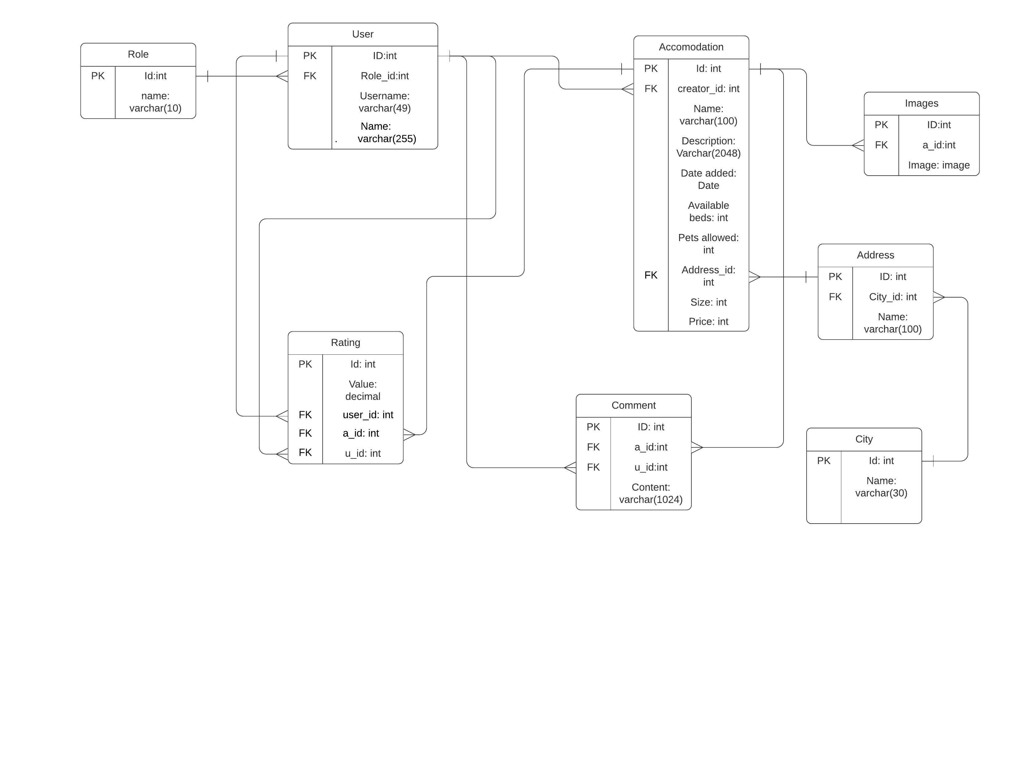
Figure 2: Relational model

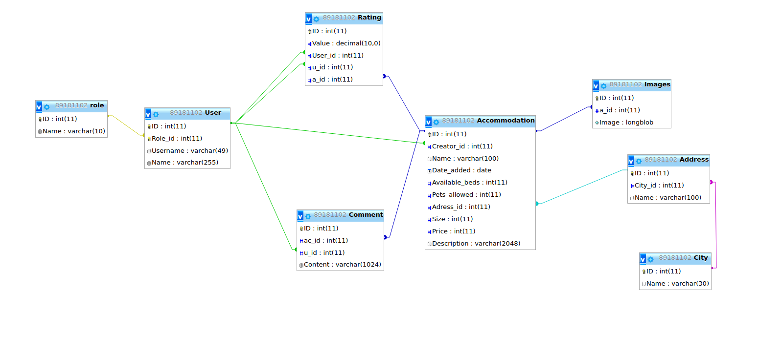
Physical Data base and UML Class diagram

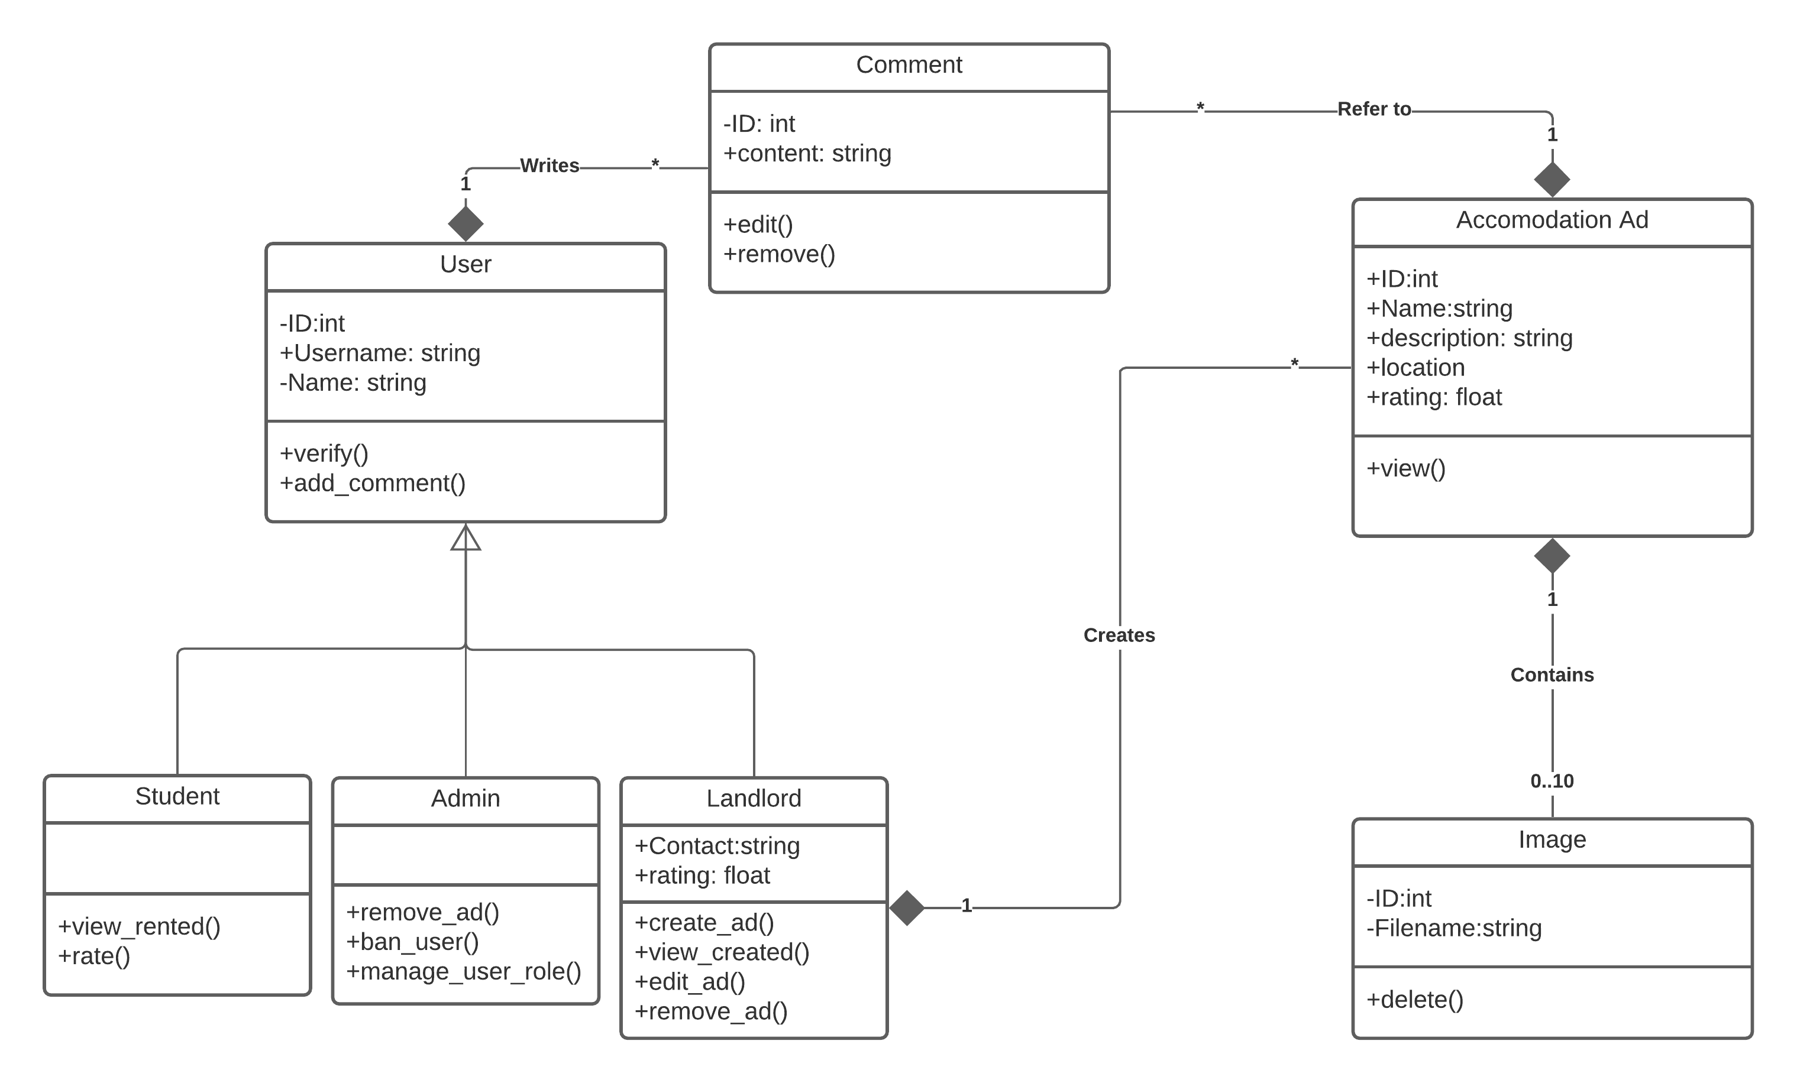
Figure 3: DB model

Figure 4: UML Class diagram

