Profesorovi prijedlozi za izmjene na report
Title page
- We don’t have to use proposed title, we can chose the title that better reflects our work (Good example- add “Exploring” into title)
- Change professor’s title to “Associate professor”
Abstract
- Remove the title from the abstract
- Abstract should be shorter
- Research what are the things that need to be mentioned in the abstract (Probably hook, methodology and results). Something like this:
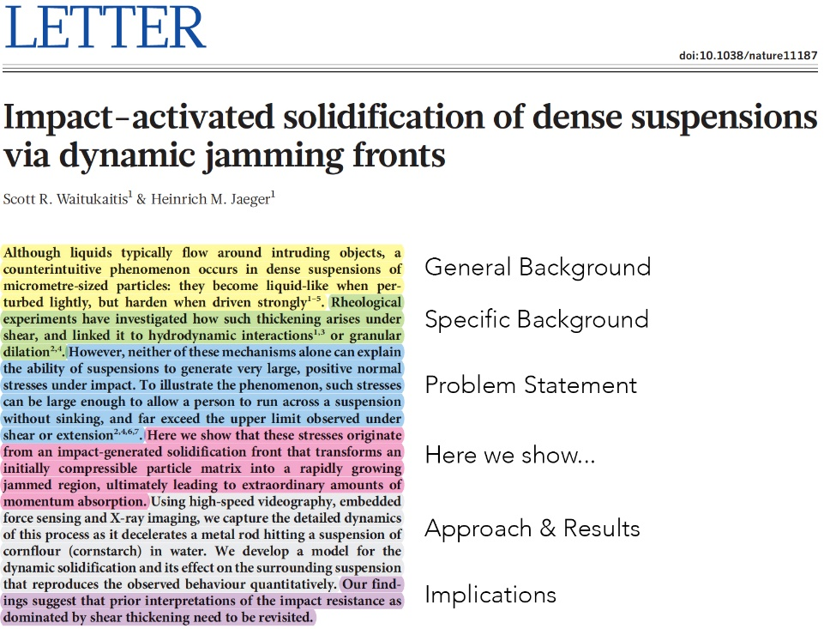
- In table of contents, list of tables, list of figures, the text (links) should be black. Right now they are blue. Just CTRL+A and select black.
Introduction
- Start with Overview, end with Summary. Organize like this:
- Introduction
  - Overview
  - Background study
  - Rest of intro (keep the same sub-titles)
1.x. Summary
- Google the structure, similar like abstract.
Objectives
- Must start with “To…”- To implement, To build, To provide, To write.
- Add more explanation about objectives. Add more correlation with problem statement and Research questions.
- After objectives, add Thesis summary (google how it is written- it has 3 parts). Basically it introduces next parts. Example:
“Chapter 2 introduces….. Chapter 3 talks about…..”
Literature review
- Also needs to have 2.1. Overview, then other subtitles. At the end, it should have 2.x. Summary
- Must have a lot of citations in LR
- Method to finding more citations:
- Find articles on google scholar.
- Find 10 and download them
- Use https://www.mendeley.com (it will automatically add them to report? Im not sure)
- Another method:
- Copy section from report
- Paste to AI and ask to find suitable articles
- Check each of those articles to make sure they actually exist
- Current mistake- we write about our own work in LR. Instead, it should be in methodology. LR should be about previous work. Use methods above to find those work. You can also find other thesis and copy their citations. Preferably citations from 2020+
(My opinion: we do not need to move it to methodology, since methodology is well done already. Just remove it and replace with previous work)
Methodology
- Include diagrams in text where they are mentioned, not only at the end. After that, change the numbers in List of figures
- For methodology diagram:
- Call it “Methodology pipeline diagram”
- Explain each step in that diagram in detail.
- Organize the explanation like 3.1. dataset, 3.2. Embeddings….
- Explain math behind embeddings (this can be done by taking the code and reversing it, since programming is application of math. I assume AI can do this)
- Explain dataset, is it images, text or both. Add figures, diagrams or screenshots of dataset. Add sample of images.
- There are some equations that are written in line, when it should be in new line, captioned and numbered. Most of the equations are alright tho.
- In 3.5.1 Engines, engines are not ordered. Add uppercase letters before their names.
Example: A) Brute-Force Cosine, B) FAISS Flat (Exact). Do the same for quantum engines
- Move “Use of AI” after conclusion, right before references
- Images on pages 14 15 and 16- move them up, to their right place in text
Results and analysis
- Add 4.1. Overview and continue with other sections (4.2 Accuracy Across Engines…)
- Do we have a formula of how we calculated accuracies in table 3? If not, add it in methodology.
- Page 20 has this awkward “figure” at the beginning of the line. Fix it
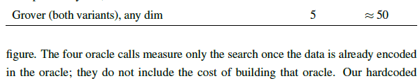
- Elhan sent some diagrams about IBM test to professor. Put them in IBM section. (I assume they are on teams group)
Conclusion
- No 5.1. Overview and 5.x. Summary in conclusion
- Google how to structure conclusion
- Move limitations (4.6) to conclusion
- Structure the conclusion like this:
6.1. Summary
6.2. Limitations
6.3. Future work
References
Remove unnecessary spaces between resources
Must have 40 references
Use copilot to find those references. Copilot that we got from IUS is protected and has access to many databases. Prompt “This is my topic, find articles/ references”. It will tell you where to put them (?). Use Mendeley, it will add them to document immediately in milliseconds (?)

