**Find Local Volunteer Projects.**

**Group Number: 4**

**Group Members:**

|  |  |
| --- | --- |
| **Student ID** | **Student Name** |
| 18101496 | Mirza Ahmad Shayer |
| 18141009 | Saraf Noor Khaled |
| 18101563 | Mahima Rabbi |

# Introduction

In this era, there are two things that always come about - social issues and the internet. Now, if only there was an application that could use the internet to solve the social issues plaguing society, then we could focus on moving towards a better future. This project aims to achieve just that, in a very unique and efficient way. This website-based application will allow project sponsors to recruit volunteers or clients to solve particular social problems through the internet. On the other hand, it will encourage youth and interested ones to use their time and energy in a better way.

# Motivation

Social issues are everywhere all across the globe. This application will help in connecting the people and make them more aware. When the people come together anything can be achieved. The application makes this a reality in a short span of time. By using this app anyone can ask for help to solve problems in an efficient and quick manner. We wanted to see what we could do for our community and we have come up with this amazing solution. Through the power of the internet we can bring a crowd in a matter of minutes. We can then, work together as a team and find the solutions to any particular problem.

# System Description

**System Request -- Find Local Volunteer Projects**

**Project Sponsor:**

Dave Spencer, Vice President of Social Services Marketing

**Business Need:**

This project has been initiated to find local volunteers to solve social issues in an area and to increase awareness of the public. This will also help in finding new volunteers or make the experience of older volunteers better.

**Business Requirements:**

It is a web-based application, and it can create new social projects or search for existing ones. Volunteers and sponsors should also be able to know the location of the project, a description of the project, and the job description along with what amount is to be paid to the volunteers. The functionalities of the project are:

* Scroll through feed of the app
* See ongoing, old, new, started and finished projects
* See the location and number of people working on projects
* Connect with other known volunteers of a project like friends or family, if they are also working on this project
* Volunteers can join and quit projects anytime
* Rich people can donate to volunteers by hiding their identities

**Business Value:**

This application will not only assist the public in elevating them from social issues, this will also create employment opportunities. This will increase the application sales numbers. Advertisers can post ads as well and shareholders, NGOs can also assist us. This will increase our revenues as more customers, advertisers and volunteers can join in. Furthermore, it will spread very quickly as the customers and volunteers will be satisfied with the features we provide. Our brand value will increase and more people will be aware of the good we do along with the revenue we bring.

Estimates of tangible value to the company include:

* $200,000 (50% of $400,000) increase in revenue due to new customers and volunteers using the application
* $300,000 (40% of $750,000) in donations from advertisers and NGOs sponsoring various charities, social issues and helpful products
* $100,000 (50% of $200,000) in sales from volunteers and customers who are satisfied with our features in using the application
* $50,000 (33% of 150,000) increase in payments from Government that use the application to solve social problems or ask for social services

**Special Constraints or Issues**

* Our HR teams told us we need the Government’s approval for such an application
* The safety of customers and volunteers accounts is our most important priority
* The payment systems need to be very secure and easy to use at the same time

# Requirement analysis

**1. System Features:**

1.1. Project Finder

Functional Requirement:

FR-1.1.1. Find projects near client’s location

FR-1.1.2. Connect clients to their friends or families who are in the current project

Non Functional Requirement:

NFR-1.1.1. Maximum distance of 20 km from client

NFR-1.1.2. Projects arranged in alphabetical order

1.2. Quick Money Transfer

Functional Requirements:

FR-1.2.1. Pay by cash to sponsor of event or by card through digital transactions

FR-1.2.2. Pay by using ATM or Bank as well

Non Functional Requirements:

NFR-1.2.1. Safe and secure payments and donations

NFR-1.2.2. No delays in money transfer

1.3. Project Create

Functional Requirements:

FR-1.3.1. Announce or create new projects and update old ones at any time

FR-1.3.2. Hire clients, volunteers, special social workers

Non Functional Requirements:

NFR-1.3.1. Help spread the message of any project through advertisements or news

NFR-1.3.2. Uses digital advertising or pop up ads on many websites

1.4. Project Assist

Functional Requirements:

FR-1.4.1. Clients enter their strengths and weaknesses, which gives them better results

FR-1.4.2. Enter any known projects name to narrow down the search

FR-1.4.3. Enter details of projects to find it, if the name of the project is not known

Non Functional Requirements:

NFR-1.4.1. Helps clients find their ideal projects

NFR-1.4.2. Reduces time required to find ideal projects for clients

NFR-1.4.3. Clients are prevented from getting confused

1.5. Government Aid

Functional Requirements:

FR-1.5.1. Call for government help or call for government funding for projects

FR-1.5.2. Call government officials on particular social issues

Non Functional Requirements:

NFR-1.5.1. Allows clients to get government assistance

NFR-1.5.2. Maximum amount of funding to be discussed with government officials

1.6. NGO Help

Functional Requirements:

FR-1.6.1. Call for aid or funding from various NGOs

FR-1.6.2. Call for assistance from NGO experts on social challenges

FR-1.6.3. Contact NGOs to solve any social problems given by them

Non Functional Requirements:

NFR-1.6.1. Helps clients to get opportunities to work for NGOs

NFR-1.6.2. Allows clients to get assistance from NGOs

NFR-1.6.3. Funding amount to be discussed with officials of chosen NGO

**2. Other Non-Functional:**

2.1. Operational

2.1.1. Optimized for all devices- Smartphones, Laptops, Tablets, PCs

2.1.2. Load high quality photos quickly with no delay or pixel problems

2.1.3. Website should support large amount of traffic

2.2. Performance

2.2.1. Auto update smoothly and quickly with no lagging or crashes

2.2.2. Uploading content or photos takes about 1-2 seconds

2.2.3. No lag or load times for loading content or photos in feed or main pages

2.3. Security

2.3.1. Accounts are only accessible by client and service managers

2.3.2. Two factor authentication for money transfer or donation

2.3.3. Software security and anti-virus protection

2.4. Cultural and Political

2.4.1. Accounts of clients protected as per Data Protection Act

2.4.2. As per company policy, we must follow all rules set by Government, NGOs

2.4.3. There should be no political content or campaigns in the website

# Design diagram

1) Use Case Diagram

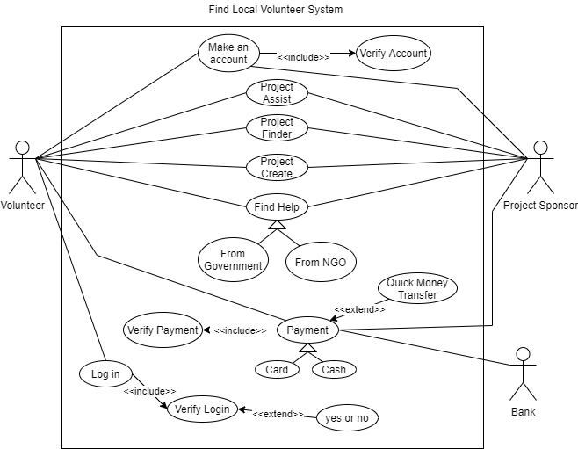

Figure-1: Use Case Diagram

The Use case Description is given below.

|  |  |
| --- | --- |
| Use case Name: | Make an account |
| ID: | BRACU_03_BD |
| Priority: | High |
| Actors: | Volunteers(primary), Project sponsors(secondary) |
| Description: | User can make an official account in the website |
| Included Use Case: | Verify Account |
| Trigger: | Pressing the sign up button |
| Pre-condition: | None |
| Normal flow of steps: | 1)User go to website  2)User clicks on sign up  3)Homepage goes to account page and asks for email and other details  4)After filling all data users can press next and homepage updates  5)Users are asked to verify accounts, a text code is sent to users phone number  6)If verification is successful system displays policies and rules homepage  7)A new account of user is made and project homepage is displayed  8)Use case ends |
| Post-conditions: | Home page changes as per steps of user and system commands |
| Exceptions: | 1)If account not verified, will ask for a verified account  2)If all necessary information is not given by user cannot go to next page  3)If account not found popup message appears |

|  |  |
| --- | --- |
| Use case Name: | Project Assist |
| ID: | BRACU_02_BD |
| Priority: | High |
| Actors: | Volunteers(primary), Project sponsors(secondary) |
| Description: | User can find their ideal projects fit for their capabilities |
| Trigger: | Pressing the Project Assist button on top left corner of webpage |
| Pre-condition: | Must be logged in website |
| Normal flow of steps: | 1)User go to website  2)User clicks on project assist  3)Homepage goes to project catalogue page  4)Users can use search bar and write name of projects they want to find  5)Users can also use advanced search and give more details of project  6)If project name matches of those that exist in catalogue then page updated  7)If not found then popup message shown  8)Use case ends |
| Post-conditions: | Home page changes when project found else popup message |
| Exceptions: | 1)Project names cannot have symbols  2)Project names must not be too long or short |

|  |  |
| --- | --- |
| Use case Name: | Project Finder |
| ID: | BRACU_01_BD |
| Priority: | High |
| Actors: | Volunteers(primary), Project sponsors(secondary) |
| Description: | Users can find projects that are near their location and also connect with friends and family |
| Trigger: | Pressing the Project Finder button on top right corner of webpage |
| Pre-condition: | Must be logged in website |
| Normal flow of steps: | 1)User go to website  2)User clicks on project finder  3)Homepage goes to project catalogue page and on right side shows friends and families in the project searched  4)Users can use search bar to find projects or type names of friends or families members to find them  5)If project or persons name matches of those that exist in catalogue then page and right side bar updated  6)If not found then popup message shown and right side bar empty  7)Use case ends |
| Post-conditions: | Home page changes when project or person found else popup message |
| Exceptions: | 1)Project and person names cannot have symbols  2)Project names must not be too long or short  3)Only one person’s name can be inputted at a time |

|  |  |
| --- | --- |
| Use case Name: | Project Create |
| ID: | BRACU_02_BD |
| Priority: | High |
| Actors: | Volunteers(primary), Project sponsors(secondary) |
| Description: | Volunteers or Sponsors can make their projects |
| Trigger: | Pressing the Project Create button in middle and top of webpage |
| Pre-condition: | Must be logged in website |
| Normal flow of steps: | 1)User go to website  2)User clicks on project create  3)Homepage goes to project create page  4)User then fills up all necessary details of project like description, location etc.  5)Project names and descriptions need to be clear  6)If clear then user proceeds to payment page else popup messages tell user to change details or project name  7)In payment page, user writes necessary details of how payment is to be made and gives bank account number  8)Webpage asks for verification from user then bank  9)If all okay then user can pin new project page in any catalogue, else popup message tells user what’s wrong  10)Use case ends |
| Post-conditions: | Home page changes when project or person found else popup message |
| Exceptions: | 1)Project name and details must be clear and symbols cannot be used  2)Project names and description must not be too long or short  3)User must use verified bank account  4)User can pin project to only one catalogue |

|  |  |
| --- | --- |
| Use case Name: | Find Help |
| ID: | BRACU_01_BD |
| Priority: | High |
| Actors: | Volunteers(primary), Project Sponsors(Secondary) |
| Description: | Users can ask for help from either the government or any NGO |
| Trigger: | Pressing the Find help box in the webpage |
| Pre-condition: | Must be logged in to account |
| Normal flow of steps: | 1)User must login the website  2)User must select the find help feature  3)System updates homepage  4)User can choose between Government or NGO  5)System updates homepage with selected option  6)User must enter all necessary details in homepage  7) User can choose NGOs, and type of help – donation, experts etc.  8)User submits and waits for verification  9)System asks for bank information  10)User submits bank information  11)User waits for verification , once verified help is sent  12)use case ends |
| Post-conditions: | Homepage gets updated as per users selections and pop up messages appear |
| Exceptions: | 1)Verification must be successful for receiving anything, if any wrong information then, help or aid cancelled  2)Must be legal bank account, in public or private bank else nothing is given |

|  |  |
| --- | --- |
| Use case Name: | Payment |
| ID: | BRACU_03_BD |
| Priority: | High |
| Actors: | Volunteers(primary), Project Sponsors(secondary), Bank(secondary) |
| Description: | To give or receive payments or donations |
| Included use case: | Verify Payment |
| Trigger: | Pressing the payment button in homepage |
| Pre-condition: | Must be logged in website |
| Normal flow of steps: | 1)User logs in website  2)User goes to payment  3)System updates homepage  4)User fills in details  5)User selects bank to pay from  6)User sends bank account number  7)User waits for verification  8)User receives verification  9)use case ends  10)(Extension:)Users can use Quick payment feature to make transaction faster; using double authentication simultaneously from and by both bank and sponsor in a split page manner |
| Post-conditions: | Home page gets updated with payment page and verification popup messages  Before and after payment is complete |
| Exceptions: | 1) Verified bank account must be used  2)If any problems transaction is stopped  3) Can use cash or credit, both must be verified by bank |

|  |  |
| --- | --- |
| Use case Name: | Log in |
| ID: | BRACU_01_BD |
| Priority: | High |
| Actors: | Volunteers(primary) |
| Description: | Log into the system using verified email and password |
| Included use case: | Verify Password |
| Trigger: | Pressing the login button |
| Pre-condition: | None |
| Normal flow of steps: | 1)Go to website  2)Press log in  3)Enter email and password  4) (Extension: ) Password may match and be successful or fail  5)Homepage loaded  6)Use case ends |
| Post-conditions: | User can see homepage |
| Exceptions: | 1)Verified Email must be used  2) Password must be correct and 3 attempts given  3)After 3 attempts for 5 minutes user can’t log in |

2) Sequence Diagrams

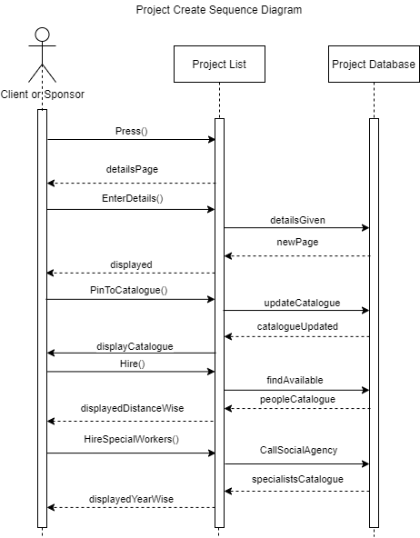

Figure-2.1: Project Create Sequence Diagram

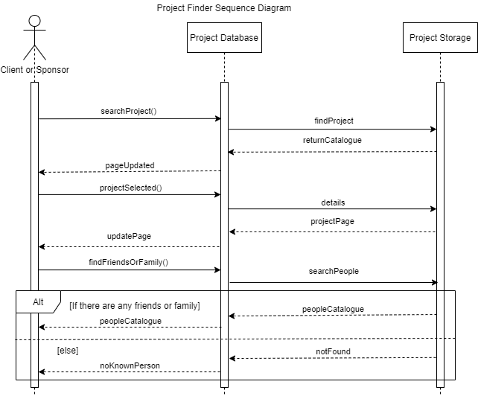

Figure-2.2: Project Finder Sequence Diagram

3) Activity Diagram

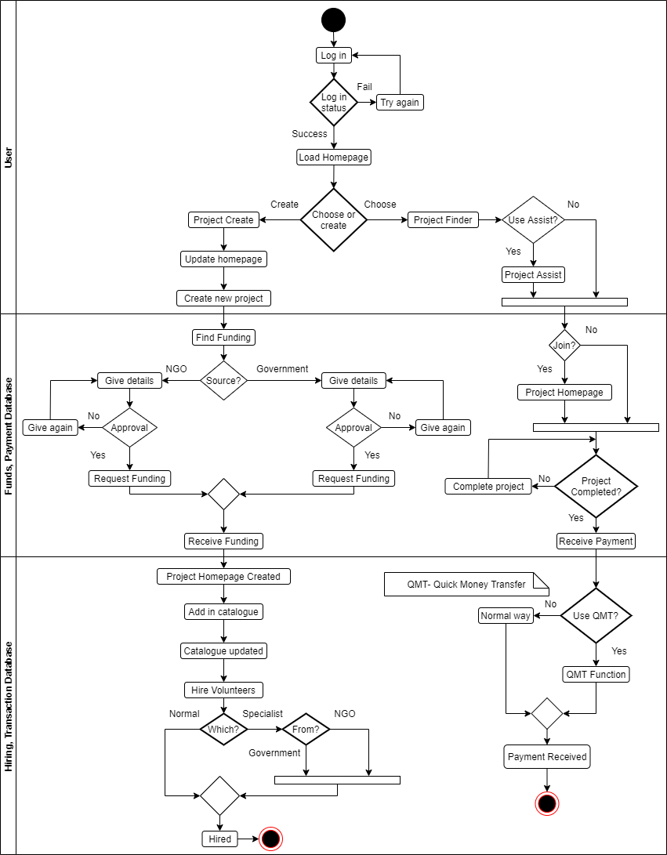

Figure-3: Activity Diagram

4) State Machine Diagrams

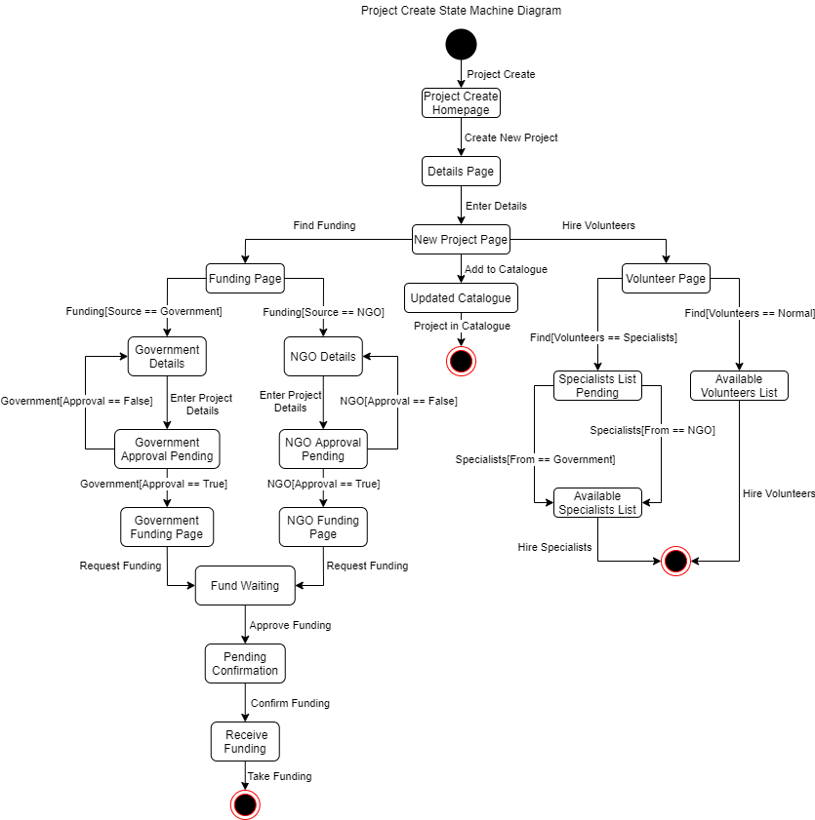

Figure-4.1: Project Create State Machine Diagram

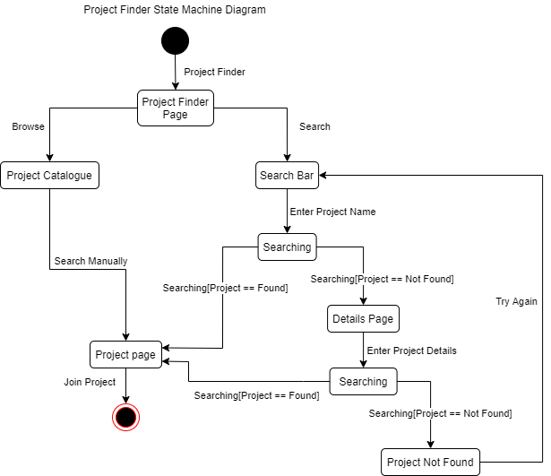

Figure-4.2: Project Finder State Machine Diagram

5) Data Flow Diagrams

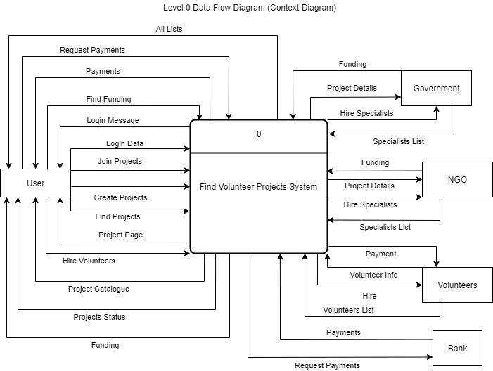

Figure-5.1: Level 0 Data Flow Diagram (Context Diagram)

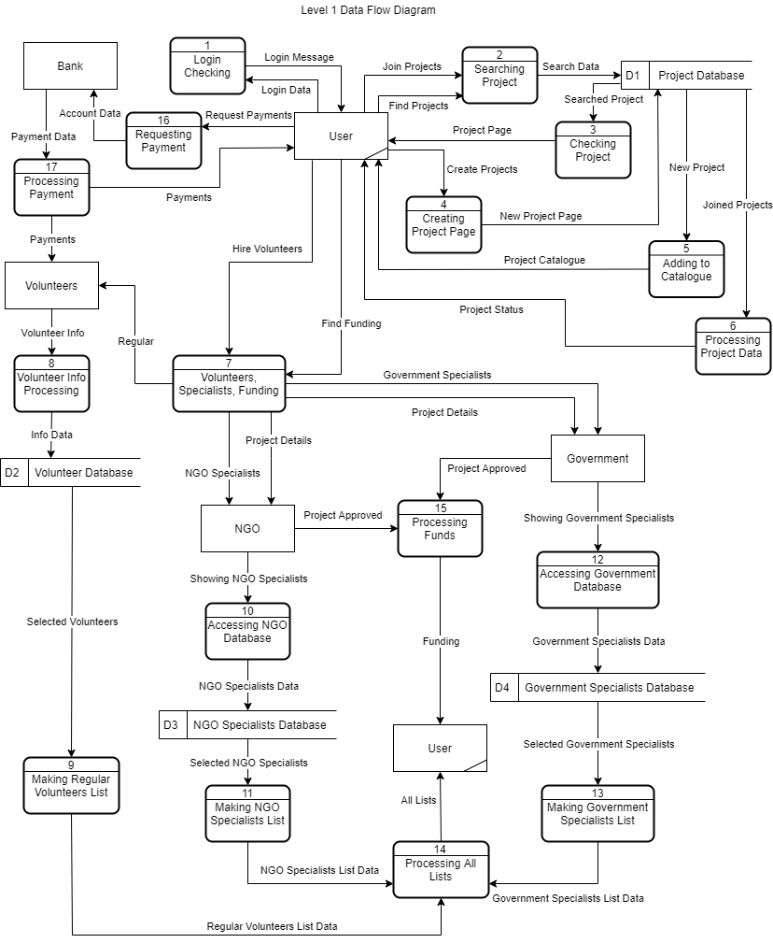Figure-5.2: Level 1 Data Flow Diagram

# Conclusion

With this application we can make the community better and reduce social tensions. This will strengthen the community as they tackle hardships together. We can also positively use the power of youth. This application will allow the customers, volunteers and all the other people involved to develop a better understanding of each other as they solve various problems together. Sometimes it's better to do it in a group for the best result. We believe that a social community is a healthy community. Indeed, a future with less social issues is truly worth striving for.