Global high-resolution suitability maps for projecting future agricultural expansion

Mirza Čengić¹, Zoran J.N. Steinmann¹, Pierre Defourny², Jonathan C. Doelman³, Céline Lamarche², Elke Stehfest³, Mark A.J. Huijbregts¹, Aafke M. Schipper^{1,3}

¹ Department of Environmental Science, Institute for Water and Wetland Research, Radboud University, PO Box 9010, 6500 GL Nijmegen, The Netherlands
² Earth and Life Institute, Environmental Sciences, Université catholique de Louvain, Louvain-la-Neuve, Belgium
³ PBL Netherlands Environmental Assessment Agency, PO Box 30314, 2500 GH The Hague, The Netherlands

Correspondence to: Mirza Čengić (m.cengic@science.ru.nl; Mobile: +31657020823; Office: +31-(0)24-3652060)
Abstract. Conversion of natural land cover for agricultural purposes is a major driver of environmental change worldwide and a leading cause of biodiversity loss. Land change models are critical to better understand the process of land change, and to project future conversions of land. Yet, the relatively coarse spatial resolution of current global land change models (>10km) does not capture fine-grained patterns of conversion relevant for quantifying location-specific impacts on ecosystems. To fill this gap, we present global maps of the suitability for conversion into three categories of agricultural land at a resolution of 10 arc-seconds (~300 meters at the equator). To compile the maps, we developed binomial regression models relating recent conversions to agricultural land (2003-2013) to a suite of predictor variables reflecting topography, climate, soil and accessibility. We then tested the models against conversions to agriculture observed from 1992 to 2002, which revealed good performance with a True Skill Statistic (TSS) of 0.56 (± 0.17) and Area under the Curve (AUC) of 0.84 (± 0.08) on average (± SD) over different world regions and cropland categories (including homogeneous croplands and mosaics with natural vegetation). We found that the local suitability for conversion to agriculture was mainly related to soil characteristics and climate variables. The resulting suitability maps can be used to create high-resolution discrete maps of future expansion of agricultural land worldwide, which is an asset for global environmental assessments. Suitability maps for three categories of agriculture and accompanying data can be downloaded from DANS EASY archive (https://doi.org/10.17026/dans-xj3-ce8p).

1. Introduction
Conversion of natural land for agricultural purposes is one of the leading causes of ecosystem degradation and biodiversity loss globally (Ellis et al., 2010; Lambin and Meyfroidt, 2011; Newbold et al., 2015; Turner et al., 2007)⁠. Expansion of agricultural land directly causes terrestrial biodiversity loss (Newbold et al., 2015)⁠, impacts freshwater ecosystems through altered surface runoff, increased usage of water for irrigation, and pesticide use (Laurance et al., 2014)⁠, causes loss of soil organic carbon (Post and Kwon, 2000)⁠, and leads to increases in anthropogenic carbon emissions (Houghton et al., 2012)⁠.
Between 1992 and 2015, the gross gain in cropland areas globally was around 1.2 million km2 (Li et al., 2017)⁠, which roughly equates to the size of South Africa. Recent projection of Shared Socio-economic Pathways (SSP) have estimated that future demands in the 2010 - 2050 period may result in additional 4.24 km² – 8.26 km² of cropland (with grazing land included) for SSP2 and SSP3 scenarios, respectively (Doelman et al., 2018)⁠.
Identifying and understanding where future agricultural expansion is likely to occur is crucial for developing appropriate strategies to minimize adverse environmental consequences. Land change models are critical in this context, as they help to understand the proximate and ultimate causes of agricultural expansion, and they can be used to simulate future patterns of conversion (Brown et al., 2013; Meiyappan et al., 2014)⁠. Land change models developed for future projections typically require two inputs: information on the future land demand, usually estimated for aggregated spatial units (e.g., countries or world regions), and spatially explicit information on the local suitability for land change (Meiyappan et al., 2014; Seto et al., 2012; Verburg et al., 2002, 2008)⁠. Location suitability is commonly estimated using regression models based on the spatial distribution of a land use type related to a set of local biophysical and socio-economic conditions that are expected to influence land conversion (Van Asselen and Verburg, 2012; Seto et al., 2012)⁠.
Land change models often exhibit a trade-off between the spatial extent and spatial resolution. While models with a high level of spatial detail (high resolution) are available for local and regional scales, global models tend to have a relatively coarse level of spatial detail (low resolution). The resolution of global land change models typically ranges between 5 arc-minutes (~10 kilometers) and 30 arc-minutes (~50 kilometers) (Van Asselen and Verburg, 2012; Hasegawa et al., 2017; Klein Goldewijk et al., 2011; Letourneau et al., 2012; Meiyappan et al., 2014)⁠. However, a coarse resolution hampers assessment of land change impacts that are highly dependent on the local context, and the spatial configuration of the landscape, such as impacts on biodiversity and carbon stock (Hoskins et al., 2016; Pereira et al., 2010; Verburg et al., 2008)⁠. For example, biodiversity responses to habitat loss and habitat fragmentation ultimately depend on the spatial distribution of suitable habitat patches in relation to the dispersal ability of the species (Didham, 2001)⁠. Hence, global assessments of the impacts of future agricultural expansion on biodiversity and ecosystems would greatly benefit from more spatially detailed maps of conversion suitability.
In this study, we aimed to develop high-resolution location suitability maps for projecting future agricultural expansion. We made use of the recently released ESA CCI land cover dataset (ESA, 2017)⁠, which contains a consistent time series of annual land-cover maps (1992-2015) at a spatial resolution of 10 arc-seconds (~ 300 meters). This dataset enabled us to identify locations of recent conversion to agricultural land, which we related to a suite of relevant local landscape characteristics using binomial regression. We did this for each of the 26 regions used by the integrated assessment model IMAGE (Stehfest et al., 2014)⁠, as the relationship between agricultural conversion and explanatory variables may change with the regional socio-economic context (Van Asselen and Verburg, 2012)⁠. We trained the models on conversions observed from 2003 to 2013 and then tested them against conversions observed from 1992 to 2002. Finally, we used the models to create maps of suitability for conversion into each of the three categories of agricultural land, at a spatial resolution unprecedented in global land change modeling. The maps can be used to create high-resolution discrete maps of future cropland expansion worldwide, which in turn provide an asset to environmental assessments that require information on landscape configuration. The maps are publicly available for download from https://doi.org/10.17026/dans-xj3-ce8p (Čengić et al., 2019)⁠.

2. Methodology

2.1 Conversion to agriculture
The European Space Agency Climate Change Initiative (ESA CCI) recently released a yearly land cover product based on remotely sensed data for the 1992 - 2015 timespan (ESA, 2017)⁠. This dataset comes at a spatial resolution of 10 arc-seconds and includes 21 main land cover categories (Table S1). Agricultural land encompasses rainfed crops, irrigated crops, and two types of mosaic agriculture (> 50% cropland or < 50% cropland). As irrigated and rainfed crops are not distinguished as separate categories in some world regions, we combined rainfed and irrigated crops into a single category (“cropland only”). We then divided the dataset in two parts, selecting the years 2003 – 2013 for model fitting and the 1992 – 2002 period for model evaluation via hindcasting. We excluded the years 2014 – 2015 because we preferred to have periods of equal duration for cross-validation and hindcasting, and because changes detected in 2014 – 2015 are limited to forest changes (ESA, 2017)⁠. We derived the response variables for the agricultural conversion suitability models by first selecting all the grid cells where the land cover changed from a non-agricultural category into one of our three agricultural land cover categories over the 2003-2013 period. Next, we performed spatial subsampling of agricultural conversion locations in order to reduce the risk of model overfitting and the effect of spatial autocorrelation (Dale and Fortin, 2002; Overmars et al., 2003)⁠. To that end, we randomly selected a single observation of agricultural land cover conversion per 30 arc-seconds grid cell. This minimal separation between adjacent observations corresponds with the spatial resolution of the coarsest explanatory variable (Table 1). Because model fitting also requires absence data, we subsequently selected all grid cells which were not converted into agriculture within the given period. From there, we first subsampled again one observation per 30 arc-seconds grid cell and then we sampled for each of the 26 world regions in IMAGE (Figure S1) a number of absences equal to the number of conversions. The procedure was done for each of the three categories of agricultural land cover separately.

2.2 Explanatory variables
We selected a set of explanatory variables that are expected to influence the suitability for conversion into agricultural land, including variables related to climate, topographic characteristics of the landscape, soil properties, and accessibility (Van Asselen and Verburg, 2012; Hoskins et al., 2016; Meiyappan et al., 2014)⁠. An overview of all explanatory variables is given in Table 1. For climate, we included annual mean values of temperature and precipitation as well as their seasonality (standard deviation and coefficient of variation, respectively), as both aspects are expected to influence local suitability for crop production (Van Asselen and Verburg, 2012; Wheeler et al., 2000)⁠. We used long-term climate averages of temperature and precipitation based on the period 1979 – 2013, provided by the CHELSA climate database (Karger et al., 2017)⁠. Topographic landscape properties included elevation, terrain slope, northness (a measure of terrain aspect), and wetness index. We retrieved elevation from the MERIT Digital Elevation Model (DEM) (Yamazaki et al., 2017)⁠ and derived terrain slope and northness from this DEM using the gdaldem function from Geospatial Data Abstraction Library (GDAL) 2.1.0 software (GDAL/OGR contributors, 2018)⁠. The topographic wetness index was retrieved from ISRIC's worldgrids database (ISRIC, 2017)⁠. Physical and chemical soil properties relevant for agricultural development, such as organic carbon content and pH, were selected from the SoilGrids database (Hengl et al., 2017)⁠, from which we took geometric mean values across 0 – 30 cm depth, as recommended by Hengl et al. (2017). To cover accessibility variables, we included distance to roads, distance to urban areas, population density (year 2000), and the presence or absence of protected areas, which might restrict conversion to agriculture. Distances to roads or urban areas were calculated as the minimum Euclidean distance to any of the road types I-IV in the GRIP dataset (Meijer et al., 2018)⁠ or cells classified as urban in ESA CCI land cover map for 2003, respectively.
We resampled all explanatory variables to a spatial resolution of 10 arc-seconds. Explanatory variables with a spatial resolution finer than 10 arc-seconds were resampled by calculating the average value of cells within the coarser 10 arc-second cell. Similarly, variables with a spatial resolution coarser than 10 arc-seconds were resampled to match this resolution using cubic spline resampling. This approach produces smoother and more accurate surfaces compared to simpler resampling techniques (Li and Heap, 2014)⁠. To harmonize the spatial resolution and extent of gridded explanatory variables, we used GDAL 2.1.0 (GDAL/OGR contributors, 2018)⁠.
Table 1: List of explanatory variables with original units and spatial resolution, prior to standardization and resampling.
Type | Variable | Unit | Original spatial resolution | Reference
Climate | Annual mean temperature | ºC | 1 km | Karger et al., 2017
 | Temperature seasonality | dimensionless | 1 km | Karger et al., 2017
 | Annual precipitation | mm / year | 1 km | Karger et al., 2017
 | Precipitation seasonality | dimensionless | 1 km | Karger et al., 2017
Soil | Available water capacity | % | 250 m | Hengl et al., 2017
 | Cation exchange capacity | cmol / kg | 250 m | Hengl et al., 2017
 | Clay content | % | 250 m | Hengl et al., 2017
 | Organic carbon content | g / kg | 250 m | Hengl et al., 2017
 | pH | dimensionless | 250 m | Hengl et al., 2017
 | Silt content | % | 250 m | Hengl et al., 2017
 | Sand content | % | 250 m | Hengl et al., 2017
Topography | Elevation | m | 90 m | Yamazaki et al., 2017
 | Slope | Degrees | 300 m | This study
 | Northness index | dimensionless | 300 m | This study
 | Topographic Wetness Index | dimensionless | 250 m | ISRIC, 2017
Accessibility | Distance to urban areas | Planar unit (m) | 300 m | This study
 | Distance to roads | Planar unit (m) | 300 m | This study
 | Protected areas | Yes/No | 300m | UNEP-WCMC and IUCN, 2017
 | Population density | Person/km² | 1 km | CIESIN, 2016

2.3 Model fitting
We used binary logistic regression to link the presences and absences of agricultural conversion in the 2003-2013 time frame with the set of explanatory variables. Logistic regression is a commonly used technique in land change analyses (Van Asselen and Verburg, 2012; Letourneau et al., 2012; Prishchepov et al., 2013)⁠. For each response variable and each region, we performed stepwise regression based on Akaike’s Information Criterion (AIC) (Akaike, 1974)⁠. Prior to fitting the regression models, explanatory variables with clear positive skew (human population density, distance to roads, and distance to urban areas) were log-transformed in order to limit the effect of extreme values. Furthermore, the variables were standardized and centered to remove the effect of units on the regression coefficients. For each of 26 world regions, we subsequently removed predictor variables with a Variance Inflation Factor (VIF) larger than 5 (O’brien, 2007; Table S2)⁠. We did not include quadratic terms because exploratory analyses of the relationships between the response and explanatory variables showed no evidence of other than monotonic responses (Figure S2). For simplicity, we neglected possible interactions between explanatory variables.

2.4 Model evaluation
We evaluated the performance of the regressions models in two ways. First, we performed cross-validation within the training dataset (2003-2013), using two-thirds of data for model fitting and the remaining part for model evaluation. Second, we applied a hindcasting approach using the data of the time period 1992 - 2002 to evaluate the models that were fitted on the full training dataset. Thus, the second approach enabled us to evaluate the performance of the models based on temporally independent data. Model performance was summarized with the True Skill Statistics (TSS) and the Area Under the Curve of the Receiver Operator Characteristic (in short AUC) (Allouche et al., 2006; Liu et al., 2011)⁠. TSS values range between -1 and 1, where 0 indicates that the model discriminates presences and absences no better than by change, while values above 0 represent models that perform better (Allouche et al., 2006)⁠. The AUC metric ranges between 0 and 1, where values above 0.5 represent models that discriminate presences and absences better than by chance (Swets, 1988)⁠.

2.5 Contribution of explanatory variables
We estimated the relative importance of explanatory variables for each region and each category of modeled agriculture. First, we used the full model to project the suitability for conversion across all cells within the region (reference projection). We then made a second projection with the values reshuffled for one of the predictor variables, such that each variable was reshuffled once. We subsequently derived the pairwise Pearson’s correlation coefficients (r) between the reference prediction and predictions with one variable randomized and quantified the importance of the randomized variable as 1 – r, similar to the Random Forest variable importance algorithm (Breiman, 2001)⁠. If a variable was eliminated via the VIF procedure or the AIC stepwise model selection, the importance of this variable was set to 0. All analyses were performed with R 3.4.2 software (R Core Team, 2017)⁠.

3. Results

3.1 Model performance
Both the cross-validation and hindcasting showed that the suitability models for agricultural conversion perform well (Figure 1). Mean values ± SD over all modeling regions and agricultural land categories were 0.57 ± 0.16 for TSS and 0.84 ± 0.08 for AUC of cross-validated models, and 0.54 ± 0.18 for TSS and 0.83 ± 0.09 for AUC of hind-casted models. The models for the cropland only category showed the highest performance, with TSS value of 0.59 ± 0.16 based on hindcasting, while mosaics with > 50% cropland and < 50% cropland had TSS values of 0.55 ± 0.18 and 0.50 ± 0.19, respectively. Performance metrics were highest for the models of North Africa, Canada, and Middle East regions, with TSS values for hindcasted cropland only models of 0.92 ± 0.02, 0.89 ± 0.01, and 0.81 ± 0.02, respectively. The lowest TSS values were found for India with 0.36 ± 0.11, Turkey with 0.25 ± 0.05, and Ukraine region with 0.22 ± 0.03, for the cropland only models assessed on hindcasted dataset.
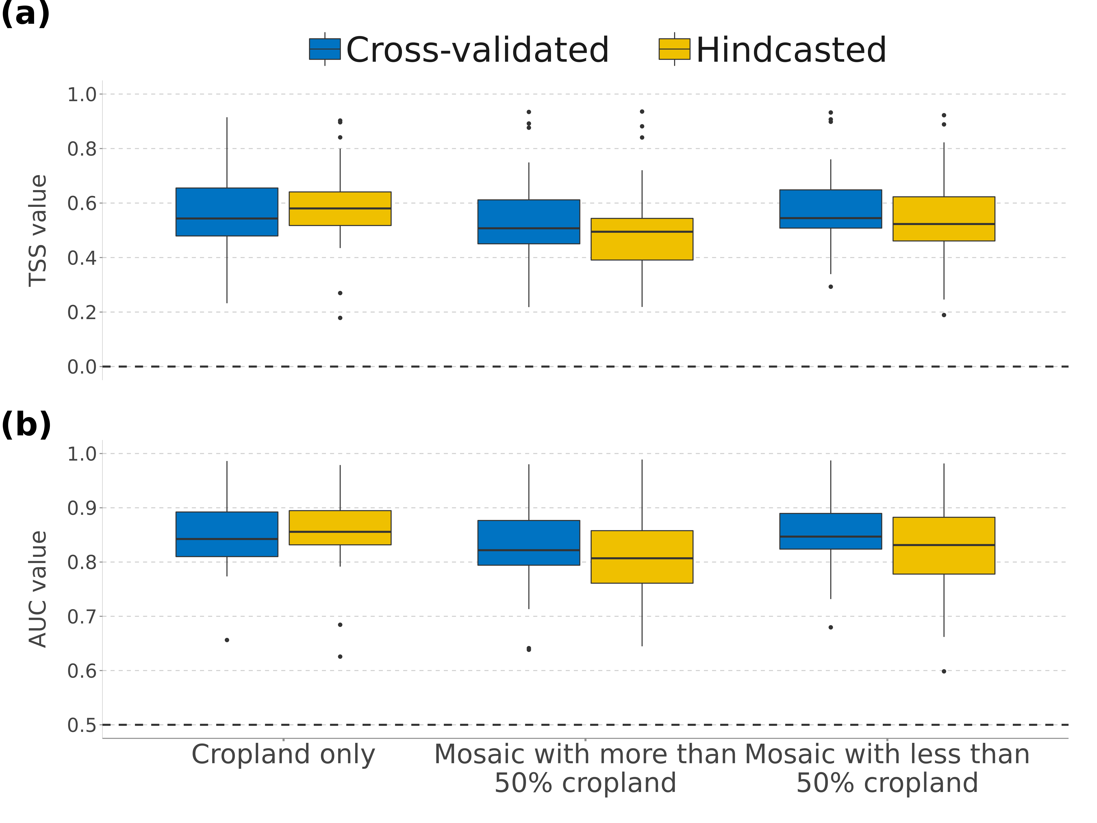
Figure 1: Model performance as measured by a) the True Skill Statistic (TSS) and b) the Area Under the Curve (AUC), summarized over 26 regions for three agricultural categories. Whiskers extend to 1.5 times the inter-quartile range.

3.2 Explanatory variables importance
In general, soil and climate variables were found to be important groups of explanatory variables for all three categories of agricultural land (Figure 2, Figure S4 to S5). When summarized over the regions, the most important explanatory variables for conversion to 'cropland only' were soil pH, distance to from roads, and topographic wetness index (Figure 2A). Variables with a relatively low importance were the northness index, presence of protected areas, and terrain slope (Figure 2A). Although mean annual temperature had a relatively high importance value as well, it was often eliminated prior to the model fitting by VIF due to high multicollinearity issues (Figure 2B), which should be considered when importance of single variable is looked upon. Variables with a relatively low importance were the northness index, presence of protected areas, and terrain slope (Figure 2A).
Conversion suitability was mostly positively related to topographic wetness index, population density, soil pH, and soil silt content and negatively Accessibility variables that were representing to distance to from roads or distance from urban areas had predominantly negative sign of standardized regression coefficient per region (Figure 2B, Figures S4B-S5B). Negative sign of standardized regression coefficient was also dominantly appearing for terrain slope, and northness index.

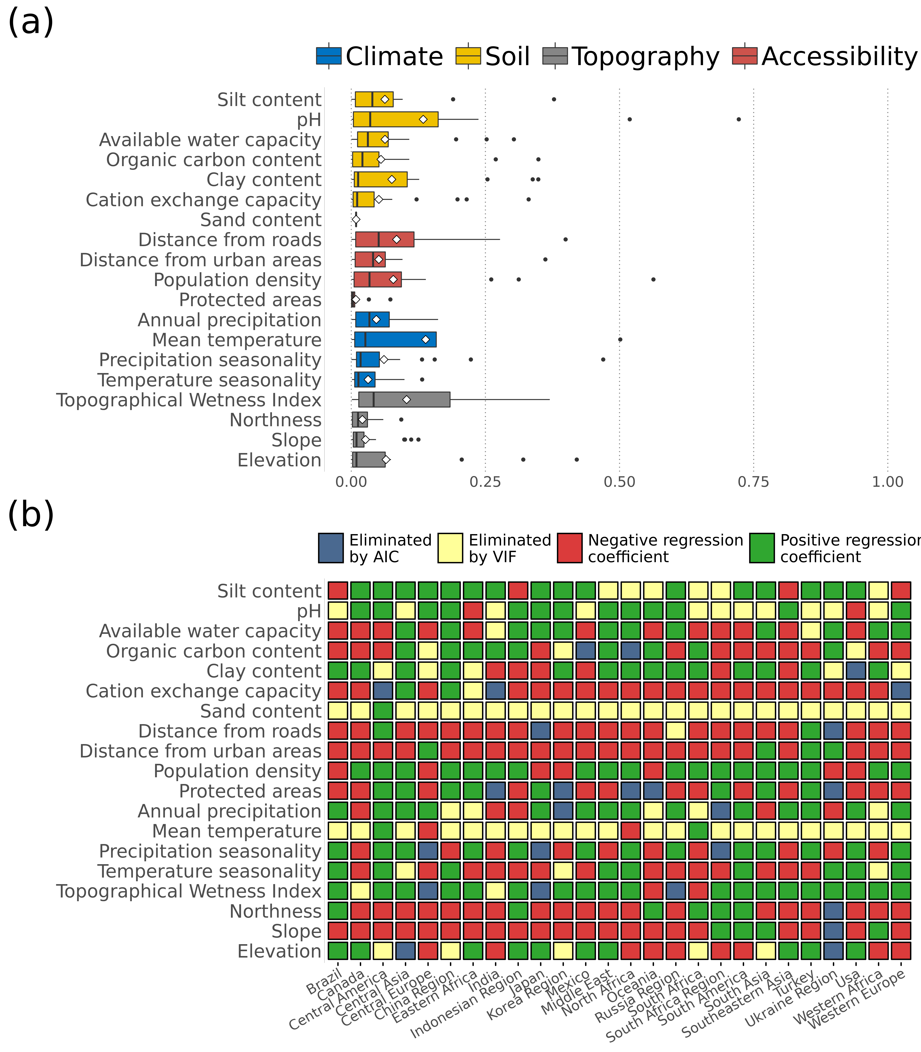
Figure 2: Importance of explanatory variables for agricultural suitability (cropland only category). Panel a) shows the relative contribution of explanatory variables to the suitability models, summarized over the regions. Whiskers extend to 1.5 times the inter-quartile range. Black vertical lines and white dots represent median and mean values, respectively. Panel b) shows the sign of the regression coefficients (negative or positive) for each variable and region, unless the variable was eliminated based on AIC or VIF (shown in blue or grey). Plots for the mosaic cropland categories are given in figures S4 and S5.

3.3 Suitability for agricultural conversion
High suitability values for agricultural conversion were found in major agricultural areas across the world (Figure 3). For the cropland only category, these include the North American plains in the Canada and USA regions, the South American Chaco region in Brazil and South America regions, floodplains in eastern China and Hoang-Ho and Yangtze valleys in China region, western Sub-Saharan Africa, and the northern parts of the Indian sub-continent (Figure 3). In addition, high suitabilities for the mosaic cropland categories were found in the Amazon region (Figure SI6).
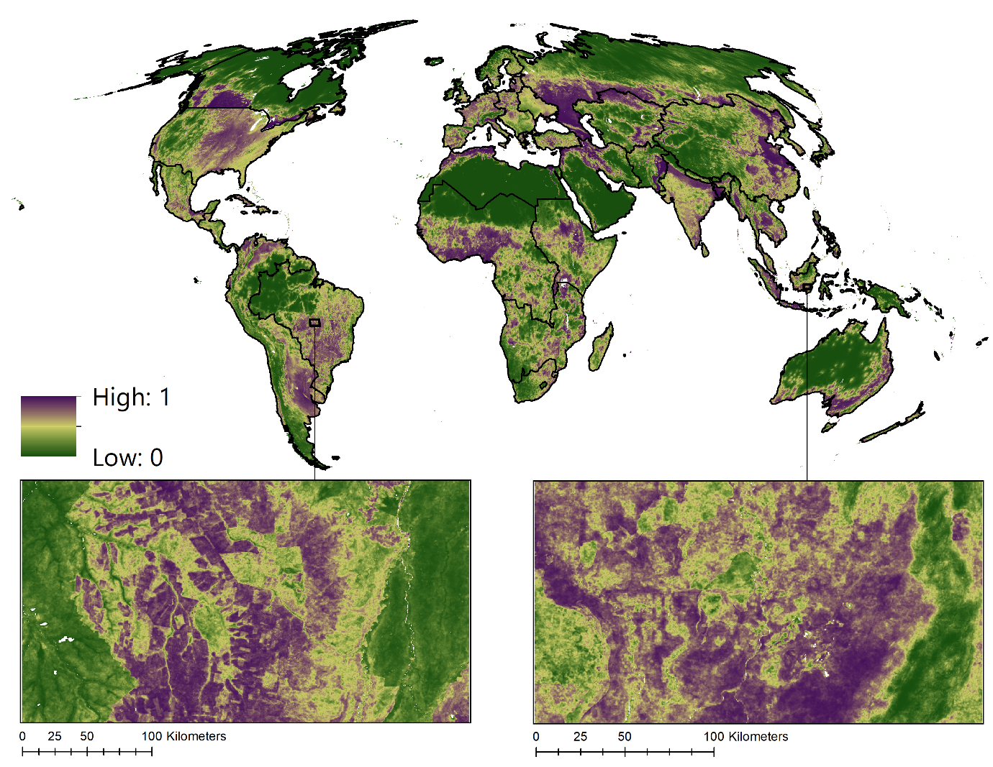
Figure 3: Global suitability map for conversion to cropland (“cropland only” category). Suitability predictions were made independently for each of the 26 IMAGE regions (black outline) and then merged. For visualization purposes, the global map has been resampled to a spatial resolution of 5 arc-minutes (~10 km) and projected in Mollweide equal area projection. Inset maps are displayed at the original 10 arc-second resolution.

Predicted suitability values for agricultural conversion vary across land cover types. In general, higher suitability values were projected in agricultural land cover and in urban areas. Low suitability values were projected in snow and ice, bare areas, and land cover where lichens and mosses prevail (Figure 4).
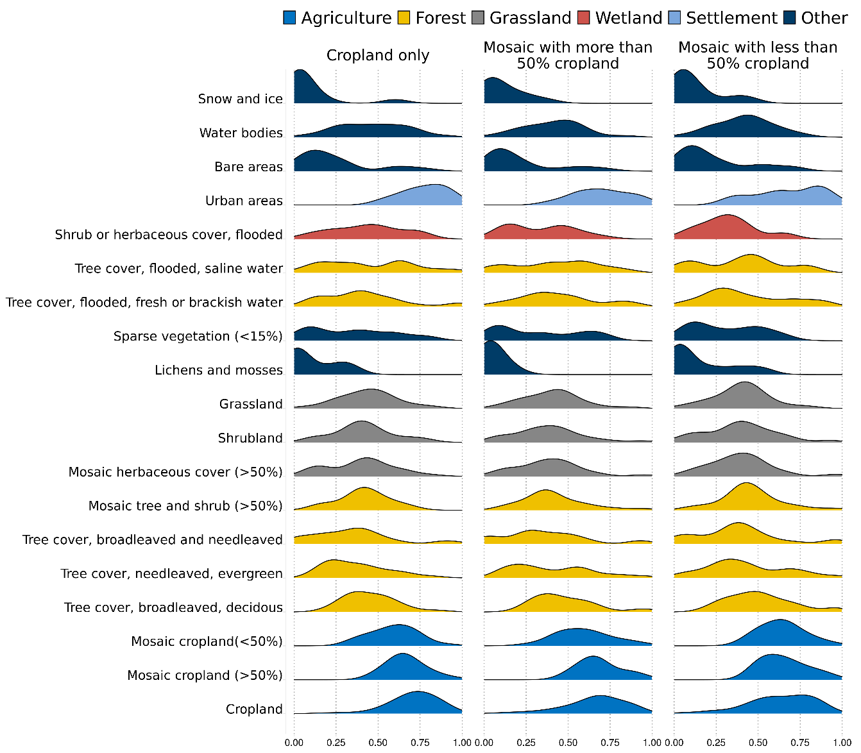
Figure 4: Density plots of predicted suitability region averages, extracted for each land cover class from ESA CCI LC map from 2002. ESA land cover categories shown are as given in the ESA CCI LC dataset (Table S1).

4. Discussion

4.1 Interpretation
To our knowledge, our study is the first to derive global maps of agricultural conversion suitability at a spatial resolution of 10 arc-seconds (~300 meters at the equator), which is considerably higher than the spatial resolution of current global land change models. This improvement in spatial resolution was enabled by the development of ESA CCI land cover dataset, which offers consistent time-series data on global land cover and land changes. The regression models used to project the location suitability maps showed high performance in both cross-validation and hindcasting, indicating that the developed models are robust. The high model performance in North Africa, Canada, and Middle East reflects that within these regions areas suitable for agriculture are restricted, due to the large extent of unsuitable areas such as deserts and permafrost regions. As a result, agricultural conversion locations tend to be clustered along the gradients of the explanatory variables, which leads to a better discriminatory power of the models and thus higher performance metric values (Lobo et al., 2008)⁠. The lowest model performance was found for the Ukraine region, as measured by both TSS and AUC (TSS = 0.238 ± 0.04, and AUC = 0.65 ± 0.02). Ukraine in particular has been characterized by high rates of agricultural abandonment after the fall of Soviet Union (Prishchepov et al., 2013)⁠, which cannot be captured by our agricultural conversion models. Other regions with relatively low model performance (Turkey, Central Europe, Western Europe) are characterized by major agricultural developments that occurred already before the time span of our input data, and it is likely that current agricultural expansion is predominantly determined not by local conditions, but by other factors such as property regime and land tenure (Bonilla-Moheno et al., 2013)⁠.
Amongst the explanatory variables used in the regression models, soil properties and climatic parameters were identified as the most important (Figure 2B). Soil properties such as silt/clay content, soil pH and cation exchange capacity were shown to be important spatial determinants for the occurrence of croplands in other studies (Van Asselen and Verburg, 2012; Etter et al., 2006)⁠. Van Asselen & Verburg (2012) also found terrain to be an important factor underlying the distribution of croplands, whereas our models captured terrain elevation and topographic wetness index as more important than terrain slope and terrain’s northness index. Nevertheless, variable importance differed largely across regions (Figure 2A), indicating that local determinants of suitability might change over the regions (Van Asselen and Verburg, 2012; Veldkamp and Lambin, 2001)⁠. This was particularly evident for variables such as soil pH, distance from roads, or topographic wetness index.
In the ESA CCI time series, conversion from urban area to cropland is not captured (ESA, 2017)⁠. As a consequence, we could not include previous land cover as explanatory variable in our regression models: the absence of conversion from urban to cropland would lead to a perfect separation of cases hence unstable regression coefficients (Zorn, 2005)⁠. By ignoring existing land cover or use, the regression models project the potential rather than actual suitability for conversion to agricultural land. For example, predicted suitability values for conversion are particularly high for urban areas (Figure 4), reflecting that the occurrence of croplands and urban areas are spatially correlated or related to the same explanatory variables (Van Asselen and Verburg, 2012; Bren d’Amour et al., 2017)⁠. Furthermore, even though the amount of data used for model fitting was substantial in terms of spatial and temporal coverage, the signal that our models capture is contingent on characteristics of the time-frame that data used for model fitting span. As an example, relatively poor model performance resulted from the dominance of agricultural abandonment in the Ukraine region (Prishchepov et al., 2013)⁠. Future developments of land cover time series data with longer time frames would help to expand the models' applicability domain to broader temporal contexts.

4.2 Applicability
Our suitability models and maps are useful for researchers and practitioners interested in assessing the locations and effects of future agricultural expansion, for example in integrated assessment modeling (Doelman et al., 2018)⁠. In order to project future agricultural expansion, the suitability maps can be combined with models that quantify the future demand for agricultural area (Pontius et al., 2008)⁠. In such a coupled approach, the suitability maps can be used to spatially allocate future demands for agricultural land (“claims”). Since our models and maps were developed based on IMAGE model regions, suitability values are comparable within but not necessarily also between regions. For example, a cell with a suitability value of 0.9 in the Russian plains is not necessarily equally suitable for conversion as a cell with a value of 0.9 in the Brazilian chaco region. This implies that claims are preferably allocated at the level of IMAGE regions or smaller.
It should further be stressed that our maps represent potential suitabilities based on local environmental conditions, i.e., suitability values are also projected for cells that are unlikely to be converted, for example based on current land cover or use (e.g., urban areas) or based on specific environmental policies (e.g., no conversion in protected areas). We opted for potential suitabilities in order to provide the users of our maps with maximum flexibility regarding the implementation of additional location-specific decision rules (Verburg et al., 2002)⁠.
In addition, the suitability modeling approach can be extended to other land use/land cover types, provided that time series data on conversions are available. Ultimately, this would lead to a set of suitability maps for multiple land categories, which subsequently can be combined with corresponding “claims” to result in high-resolution discrete land use/land cover maps. This would be useful in particular for assessment of ecological processes that operate on small scales (Hoskins et al., 2016)⁠.

5. Data availability and usage notes
Our suitability maps are freely available for download at DANS EASY repository (https://doi.org/10.17026/dans-xj3-ce8p). This repository contains suitability maps for three categories of agricultural land, available in GeoTIFF format. Pixel values range from 0 – 1, reflecting the potential suitability for conversion into agriculture for each IMAGE region. To arrive at actual conversions, the maps can be combined with location-specific decision rules, for example based on current land cover (e.g., no conversion of water and urban areas). To this end, users may make use of the ESA CCI land cover dataset, which can be freely obtained from https://maps.elie.ucl.ac.be/CCI. Since the models were developed for individual IMAGE regions, the suitability maps are preferably combined with land demand data at the level of IMAGE regions or smaller. i.e. cell with the suitability value of 0.9 in Russian plains should not be directly compared with cell with value of 0.9 in Brazilian chaco. To aid the users, we included vector layer of IMAGE regions, available in geopackage and shapefile formats in the repository.

6. Conclusions
We produced global maps of suitability for conversion into agriculture at a resolution of 300 m, based on location-specific information of sites where land has recently been converted into agriculture. The models used for compiling these maps were thoroughly tested based on temporally independent data in a hindcasting approach. The testing revealed that the models are robust, indicating that the resulting maps can be reliably used to project future agricultural expansion. The developed maps give insight in areas that are under high risk of being converted to agricultural land at unprecedented spatial detail. Integrating this information into future scenario modeling can help to better quantify impacts of future agricultural expansion on ecosystems, and ultimately lead to a more informed policy decisions. Further, the regression modeling approach that we have described here can be extended to other land-use types, and with the development and improvement of long-term time series data, enable more accurate assessment of drivers and patterns of land change and its effects.

Author contributions
MČ, ZJNS, MAJH, and AMS designed the study. MČ carried out the data processing and analysis. All authors contributed to the interpretation of the results and writing of the manuscript.

Competing interests
The authors declare that they have no conflict of interest.

References

Akaike, H.: A new look at the statistical model identification, IEEE Trans. Automat. Contr., 19(6), 716–723, doi:10.1109/TAC.1974.1100705, 1974.
Allouche, O., Tsoar, A. and Kadmon, R.: Assessing the accuracy of species distribution models: prevalence, kappa and the true skill statistic (TSS), J. Appl. Ecol., 43(6), 1223–1232, doi:10.1111/j.1365-2664.2006.01214.x, 2006.
Van Asselen, S. and Verburg, P. H.: A Land System representation for global assessments and land-use modeling, Glob. Chang. Biol., 18(10), 3125–3148, doi:10.1111/j.1365-2486.2012.02759.x, 2012.
Bonilla-Moheno, M., Redo, D. J., Aide, T. M., Clark, M. L. and Grau, H. R.: Vegetation change and land tenure in Mexico: A country-wide analysis, Land use policy, 30(1), 355–364, doi:10.1016/j.landusepol.2012.04.002, 2013.
Breiman, L.: Random Forests, Popul. Health Metr., (45), 5–32, doi:10.1023/A:1010933404324, 2001.
Bren d’Amour, C., Reitsma, F., Baiocchi, G., Barthel, S., Güneralp, B., Erb, K.-H., Haberl, H., Creutzig, F. and Seto, K. C.: Future urban land expansion and implications for global croplands, Proc. Natl. Acad. Sci., 114(34), 8939–8944, doi:10.1073/pnas.1606036114, 2017.
Brown, D., Band, L. E., Green, K. O., Irwin, E. G., Jain, A., Lambin, E. F., Pontius, R. G., Seto, K. C., Turner II, B. L. and Verburg, P. H.: Advancing Land Change Modeling: Opportunities and Research Requirements, The National Research Council Press., 2013.
Čengić, M., Steinmann, Z. J. N., Defourny, P., Doelman, J. C., Stehfest, E., Huijbregts, M. A. J. and Schipper, A. M.: Global high-resolution suitability maps for projecting future agricultural expansion, , doi:doi:10.17026/dans-xj3-ce8p, 2019.
Dale, M. R. T. and Fortin, M.-J.: Spatial autocorrelation and statistical tests in ecology, Écoscience, 9(2), 162–167, doi:10.1080/11956860.2002.11682702, 2002.
Didham, R. K.: Ecological Consequences of Habitat Fragmentation, Encycl. Life Sci., doi:10.1002/9780470015902.a0021904, 2001.
Doelman, J. C., Stehfest, E., Tabeau, A., van Meijl, H., Lassaletta, L., Gernaat, D. E. H. J., Hermans, K., Harmsen, M., Daioglou, V., Biemans, H., van der Sluis, S. and van Vuuren, D. P.: Exploring SSP land-use dynamics using the IMAGE model: Regional and gridded scenarios of land-use change and land-based climate change mitigation, Glob. Environ. Chang., 48(December 2016), 119–135, doi:10.1016/j.gloenvcha.2017.11.014, 2018.
Ellis, E. C., Klein Goldewijk, K., Siebert, S., Lightman, D. and Ramankutty, N.: Anthropogenic transformation of the biomes, 1700 to 2000, Glob. Ecol. Biogeogr., 19(5), no-no, doi:10.1111/j.1466-8238.2010.00540.x, 2010.
ESA: Land Cover CCI Product User Guide Version 2.0, , (April), 1–52 [online] Available from: http://maps.elie.ucl.ac.be/CCI/viewer/download/ESACCI-LC-Ph2-PUGv2_2.0.pdf, 2017.
Etter, A., McAlpine, C., Wilson, K., Phinn, S. and Possingham, H.: Regional patterns of agricultural land use and deforestation in Colombia, Agric. Ecosyst. Environ., 114(2–4), 369–386, doi:10.1016/j.agee.2005.11.013, 2006.
GDAL/OGR contributors: {GDAL/OGR} Geospatial Data Abstraction software Library, [online] Available from: http://gdal.org, 2018.
Hasegawa, T., Fujimori, S., Ito, A., Takahashi, K. and Masui, T.: Global land-use allocation model linked to an integrated assessment model, Sci. Total Environ., 580, 787–796, doi:10.1016/j.scitotenv.2016.12.025, 2017.
Hengl, T., Mendes de Jesus, J., Heuvelink, G. B. M., Ruiperez Gonzalez, M., Kilibarda, M., Blagotić, A., Shangguan, W., Wright, M. N., Geng, X., Bauer-Marschallinger, B., Guevara, M. A., Vargas, R., MacMillan, R. A., Batjes, N. H., Leenaars, J. G. B., Ribeiro, E., Wheeler, I., Mantel, S. and Kempen, B.: SoilGrids250m: Global gridded soil information based on machine learning, edited by B. Bond-Lamberty, PLoS One, 12(2), e0169748, doi:10.1371/journal.pone.0169748, 2017.
Hoskins, A. J., Bush, A., Gilmore, J., Harwood, T., Hudson, L. N., Ware, C., Williams, K. J. and Ferrier, S.: Downscaling land-use data to provide global 30″ estimates of five land-use classes, Ecol. Evol., 6(9), 3040–3055, doi:10.1002/ece3.2104, 2016.
Houghton, R. A., House, J. I., Pongratz, J., van der Werf, G. R., DeFries, R. S., Hansen, M. C., Le Quéré, C. and Ramankutty, N.: Carbon emissions from land use and land-cover change, Biogeosciences, 9(12), 5125–5142, doi:10.5194/bg-9-5125-2012, 2012.
ISRIC: worldgrids, [online] Available from: http://worldgrids.org, 2017.
Karger, D. N., Conrad, O., Böhner, J., Kawohl, T., Kreft, H., Soria-Auza, R. W., Zimmermann, N. E., Linder, H. P. and Kessler, M.: Climatologies at high resolution for the earth’s land surface areas, Sci. Data, 4, 170122, doi:10.1038/sdata.2017.122, 2017.
Klein Goldewijk, K., Beusen, A., Van Drecht, G. and De Vos, M.: The HYDE 3.1 spatially explicit database of human-induced global land-use change over the past 12,000 years, Glob. Ecol. Biogeogr., 20(1), 73–86, doi:10.1111/j.1466-8238.2010.00587.x, 2011.
Lambin, E. F. and Meyfroidt, P.: Global land use change, economic globalization, and the looming land scarcity, Proc. Natl. Acad. Sci., 108(9), 3465–3472, doi:10.1073/pnas.1100480108, 2011.
Laurance, W. F., Sayer, J. and Cassman, K. G.: Agricultural expansion and its impacts on tropical nature, Trends Ecol. Evol., 29(2), 107–116, doi:10.1016/j.tree.2013.12.001, 2014.
Letourneau, A., Verburg, P. H. and Stehfest, E.: A land-use systems approach to represent land-use dynamics at continental and global scales, Environ. Model. Softw., 33, 61–79, doi:10.1016/j.envsoft.2012.01.007, 2012.
Li, J. and Heap, A. D.: Spatial interpolation methods applied in the environmental sciences: A review, Environ. Model. Softw., 53, 173–189, doi:10.1016/j.envsoft.2013.12.008, 2014.
Li, W., MacBean, N., Ciais, P., Defourny, P., Lamarche, C., Bontemps, S., Houghton, R. A. and Peng, S.: Gross and net land cover changes based on plant functional types derived from the annual ESA CCI land cover maps, Earth Syst. Sci. Data Discuss., (August), 1–23, doi:10.5194/essd-2017-74, 2017.
Liu, C., White, M. and Newell, G.: Measuring and comparing the accuracy of species distribution models with presence-absence data, Ecography (Cop.)., 34(2), 232–243, doi:10.1111/j.1600-0587.2010.06354.x, 2011.
Lobo, J. M., Jiménez-Valverde, A. and Real, R.: AUC: a misleading measure of the performance of predictive distribution models, Glob. Ecol. Biogeogr., 17(2), 145–151, doi:10.1111/j.1466-8238.2007.00358.x, 2008.
Meijer, J. R., Huijbregts, M. A. J., Schotten, K. C. G. J. and Schipper, A. M.: Global patterns of current and future road infrastructure, Environ. Res. Lett., 13(6), doi:10.1088/1748-9326/aabd42, 2018.
Meiyappan, P., Dalton, M., O’Neill, B. C. and Jain, A. K.: Spatial modeling of agricultural land use change at global scale, Ecol. Modell., 291, 152–174, doi:10.1016/j.ecolmodel.2014.07.027, 2014.
Newbold, T., Hudson, L. N., Hill, S. L. L., Contu, S., Lysenko, I., Senior, R. a, Börger, L., Bennett, D. J., Choimes, A., Collen, B., Day, J., De Palma, A., Díaz, S., Echeverria-Londoño, S., Edgar, M. J., Feldman, A., Garon, M., Harrison, M. L. K., Alhusseini, T., Ingram, D. J., Itescu, Y., Kattge, J., Kemp, V., Kirkpatrick, L., Kleyer, M., Correia, D. L. P., Martin, C. D., Meiri, S., Novosolov, M., Pan, Y., Phillips, H. R. P., Purves, D. W., Robinson, A., Simpson, J., Tuck, S. L., Weiher, E., White, H. J., Ewers, R. M., Mace, G. M., Scharlemann, J. P. W. and Purvis, A.: Global effects of land use on local terrestrial biodiversity, Nature, 520(7545), 45–50, doi:10.1038/nature14324, 2015.
O’brien, R. M.: A Caution Regarding Rules of Thumb for Variance Inflation Factors, Qual. Quant., 41(5), 673–690, doi:10.1007/s11135-006-9018-6, 2007.
Overmars, K. P., de Koning, G. H. J. and Veldkamp, A.: Spatial autocorrelation in multi-scale land use models, Ecol. Modell., 164(2–3), 257–270, doi:10.1016/S0304-3800(03)00070-X, 2003.
Pereira, H. M., Leadley, P. W., Proença, V., Alkemade, R., Scharlemann, J. P. W., Fernandez-Manjarrés, J. F., Araújo, M. B., Balvanera, P., Biggs, R., Cheung, W. W. L., Chini, L., Cooper, H. D., Gilman, E. L., Guénette, S., Hurtt, G. C., Huntington, H. P., Mace, G. M., Oberdorff, T., Revenga, C., Rodrigues, P., Scholes, R. J., Sumaila, U. R. and Walpole, M.: Scenarios for Global Biodiversity in the 21st Century, Science (80-. )., 330(6010), 1496–1501, doi:10.1126/science.1196624, 2010.
Pontius, R. G., Boersma, W., Castella, J.-C., Clarke, K., de Nijs, T., Dietzel, C., Duan, Z., Fotsing, E., Goldstein, N., Kok, K., Koomen, E., Lippitt, C. D., McConnell, W., Mohd Sood, A., Pijanowski, B., Pithadia, S., Sweeney, S., Trung, T. N., Veldkamp, A. T. and Verburg, P. H.: Comparing the input, output, and validation maps for several models of land change, Ann. Reg. Sci., 42(1), 11–37, doi:10.1007/s00168-007-0138-2, 2008.
Post, W. M. and Kwon, K. C.: Soil carbon sequestration and land-use change: processes and potential, Glob. Chang. Biol., 6(3), 317–327, doi:10.1046/j.1365-2486.2000.00308.x, 2000.
Prishchepov, A. V., Müller, D., Dubinin, M., Baumann, M. and Radeloff, V. C.: Determinants of agricultural land abandonment in post-Soviet European Russia, Land use policy, 30(1), 873–884, doi:10.1016/j.landusepol.2012.06.011, 2013.
R Core Team: R: A Language and Environment for Statistical Computing, [online] Available from: https://www.r-project.org/, 2017.
Seto, K. C., Guneralp, B. and Hutyra, L. R.: Global forecasts of urban expansion to 2030 and direct impacts on biodiversity and carbon pools, Proc. Natl. Acad. Sci., 109(40), 16083–16088, doi:10.1073/pnas.1211658109, 2012.
Stehfest, E., Van Vuuren, D. P., Kram, T. and Bouwman, L.: Integrated Assessment of Global Environmental Change with IMAGE 3.0, PBL, The Hague., 2014.
Swets, J.: Measuring the accuracy of diagnostic systems, Science (80-. )., 240(4857), 1285–1293, doi:10.1126/science.3287615, 1988.
Turner, B. L., Lambin, E. F. and Reenberg, A.: The emergence of land change science for global environmental change and sustainability, Proc. Natl. Acad. Sci., 104(52), 20666–20671, doi:10.1073/pnas.0704119104, 2007.
Veldkamp, A. and Lambin, E. .: Predicting land-use change, Agric. Ecosyst. Environ., 85(1–3), 1–6, doi:10.1016/S0167-8809(01)00199-2, 2001.
Verburg, P. H., Soepboer, W., Veldkamp, A., Limpiada, R., Espaldon, V. and Mastura, S. S. A.: Modeling the Spatial Dynamics of Regional Land Use: The CLUE-S Model, Environ. Manage., 30(3), 391–405, doi:10.1007/s00267-002-2630-x, 2002.
Verburg, P. H., Eickhout, B. and van Meijl, H.: A multi-scale, multi-model approach for analyzing the future dynamics of European land use, Ann. Reg. Sci., 42(1), 57–77, doi:10.1007/s00168-007-0136-4, 2008.
Wheeler, T. R., Craufurd, P. Q., Ellis, R. H., Porter, J. R. and Vara Prasad, P. .: Temperature variability and the yield of annual crops, Agric. Ecosyst. Environ., 82(1–3), 159–167, doi:10.1016/S0167-8809(00)00224-3, 2000.
Yamazaki, D., Ikeshima, D., Tawatari, R., Yamaguchi, T., O’Loughlin, F., Neal, J. C., Sampson, C. C., Kanae, S. and Bates, P. D.: A high-accuracy map of global terrain elevations, Geophys. Res. Lett., 44(11), 5844–5853, doi:10.1002/2017GL072874, 2017.
Zorn, C.: A Solution to Separation in Binary Response Models, Polit. Anal., 13(02), 157–170, doi:10.1093/pan/mpi009, 2005.

