Installation of Python

1. Go to <https://www.python.org/downloads/>
2. Select Python 3.4.3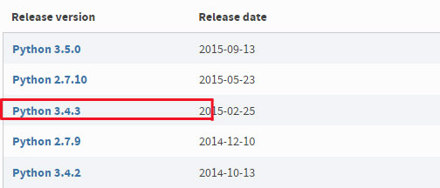
3. Scroll down to the section called files and select Windows x86 MSI installer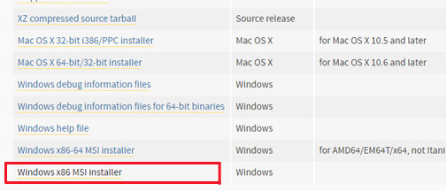
4. Wait for the file to finish downloading.
5. Locate your file and open it by double clicking it, and allow to run if windows requests permissions and then you should see this screen: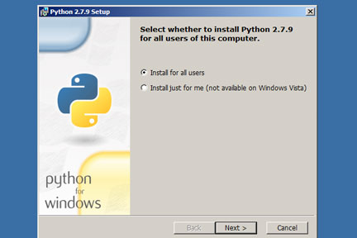
6. Select install for all users and click the next button.
7. Make sure the install path is C:\Python34\ then click the next button:

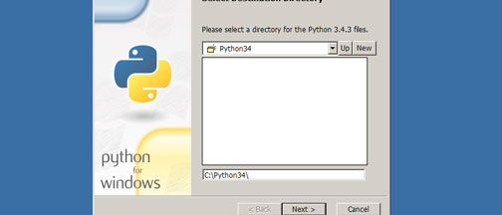

1. At the next screen left click on the icon next to python on the list and select “Entire feature will be installed on local herd drive”.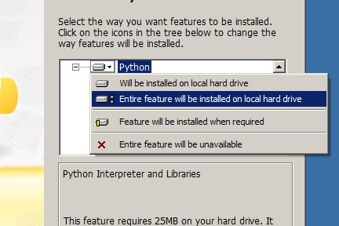
2. Check to make sure that the feature “Add python.exe to Path” does not have the red X next to it like so:

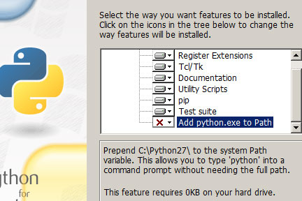

Make sure it looks like this: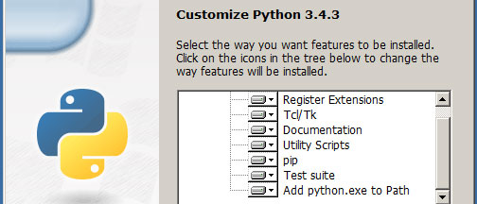

1. Then click the next button.
2. Wait for the installation to complete then click the finished button.
3. Confirm that python installed correctly on your computer open the command prompt.
4. Type in the command, python (space) –(double dash)(no space)version:

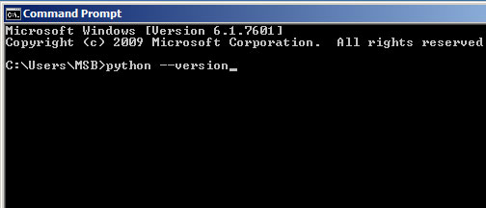

1. If your installation has been successful then you should see the python version Python 3.4.3:

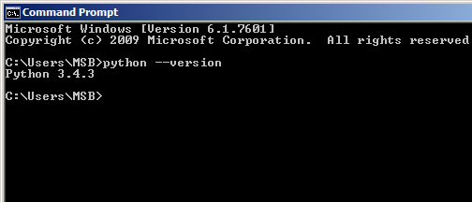

Installation of win32com

1. Go to the web site <http://sourceforge.net/projects/pywin32>
2. Left click on files.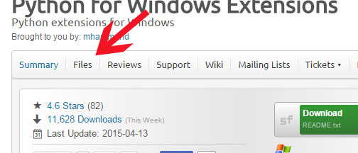
3. Left click on the pywin32.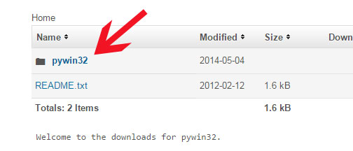
4. Left click on Build 219.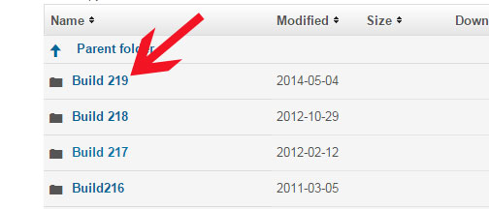
5. Left click on pywin32-219.win32-py3.4.exe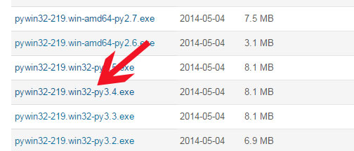
6. Let the file finish downloading.
7. Locate and run the file, if windows require permission to run, allow it.
8. You should see the following screen, left click on the next button.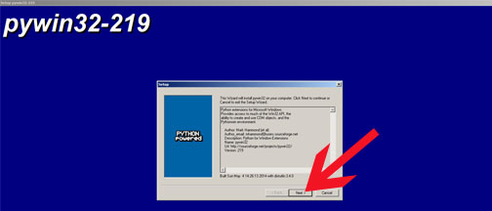
9. If your python does not have any issues then you should see the following screen with the proper paths filled in. 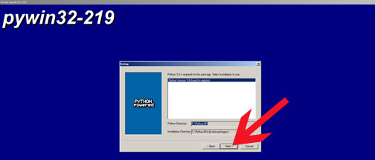
10. Left click on the next button to continue and you should see this screen.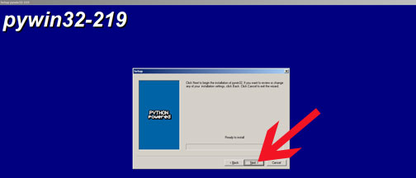
11. Left click on the next button to start the installation of win32com
12. When the installation finishes just left click on the finished button.

Installation of LiClipse 2.4.0

1. Go to <http://www.liclipse.com/download.html>
2. If you have a 64 bit system then left click on LiClipse 2.4.0 for Windows(64bits), 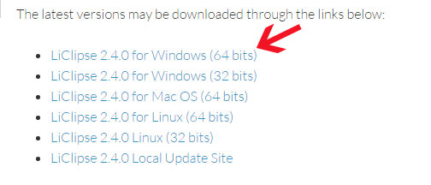
3. If you have a 32 bit system then left click on LiClipse 2.4.0 for Windows(32bits).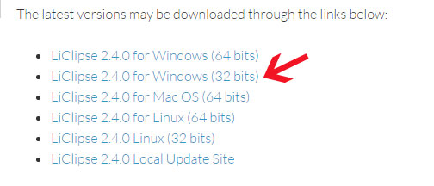
4. Let the download finish.
5. Locate and run the file, if windows require permission, allow it.
6. You should see this screen after running the file: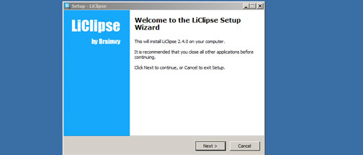
7. Left click on next button.
8. Select the “I accept the agreement” choice.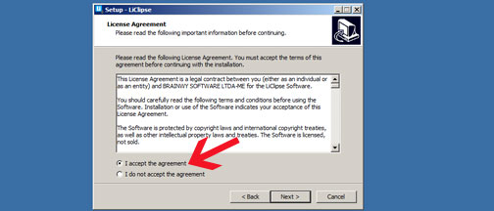
9. Then left click on the next button.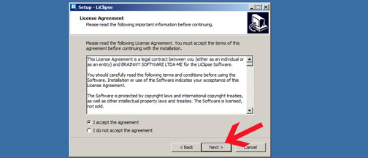
10. Confirm the installation path directory and left click on the next button.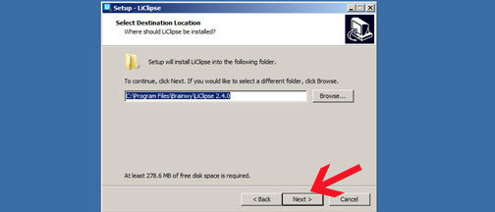
11. Left click next for the installation of a start menu.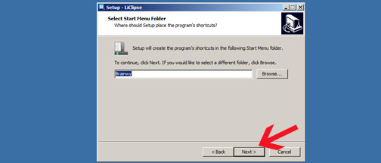
12. Make sure the create a desktop icon is checked: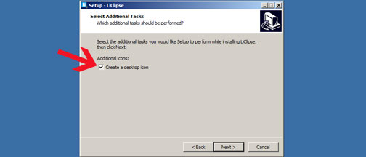
13. Left click the next button.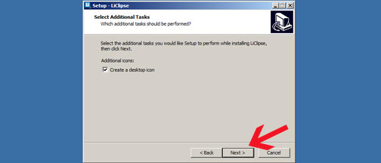
14. Left click the intall button.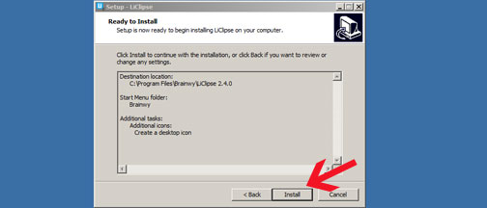
15. Allow the installation to complete.
16. Left click on the finished button.

Setting up PyDev in LiClipse 2.4.0

1. Open LiClipse 2.4.0.
2. Left click on Window.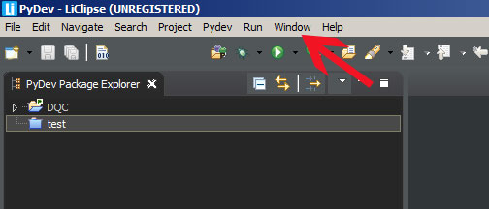
3. Left click on preferences.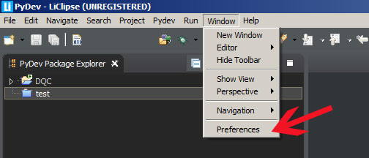
4. Left click on the drop menu for PyDev.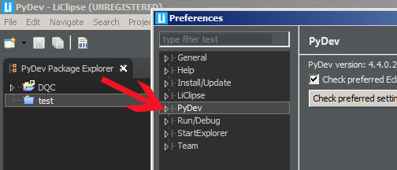
5. Left click on the drop menu for interpreters.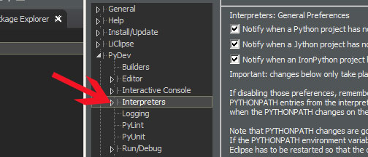
6. Left click on python interpreter. 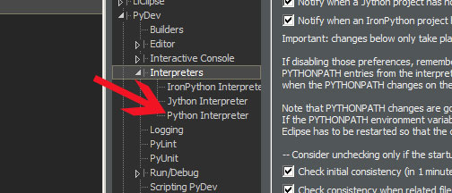
7. Left click on the “Quick Auto-Config” button.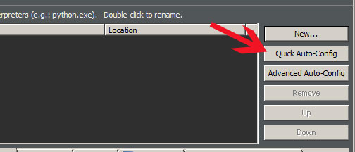
8. LiClipse will auto detect your python installation and libraries as show here: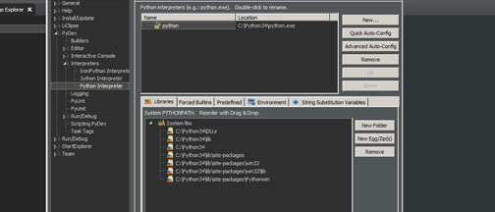
9. Left click on the “Apply” button.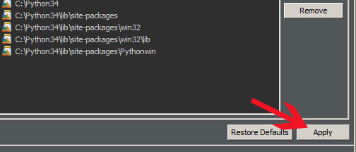
10. Allow LiClipse to finish applying your python version and the libraries as shown: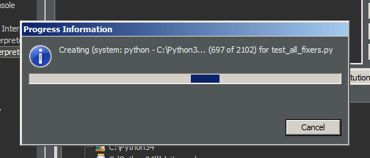
11. Left click the okay button.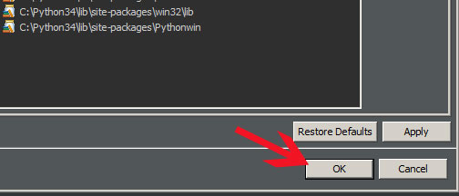

DQC PyDev Project Setup

1. Navigate to the appropriate path, and create a new directory called “DQC”. 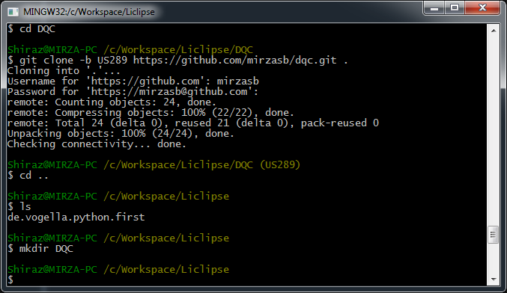
2. Execute the command, “cd DQC”. 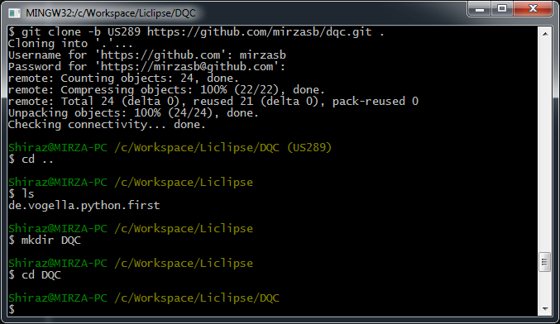
3. Execute the command, “git clone –b <branch name> <https://github.com/mirzasb/dqc.git> .”. Then, login using the Git username and password. 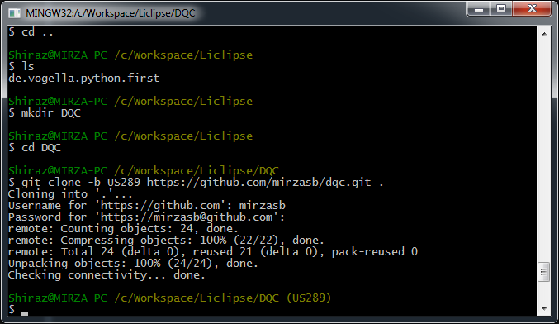
4. Invoke LiClipse.
5. Click on “File” 🡪 “New” 🡪 “PyDev Project”.
6. Populate the “Project name:” field with the value, “DQC”.
7. Uncheck the “use default” checkbox. 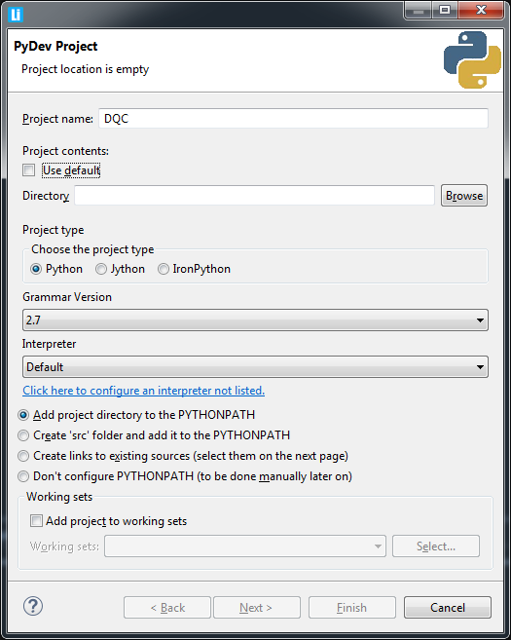
8. Click on the “Browse” button, and navigate to the path where the repository was cloned in step 3. 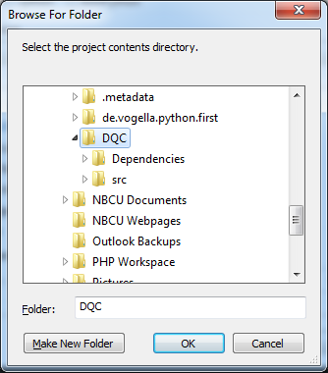
9. Click on the “OK” button.
10. Once the user returns to the “PyDev Project” dialog box, change the “Interpreter” field value to the one that uses Python 3.4. 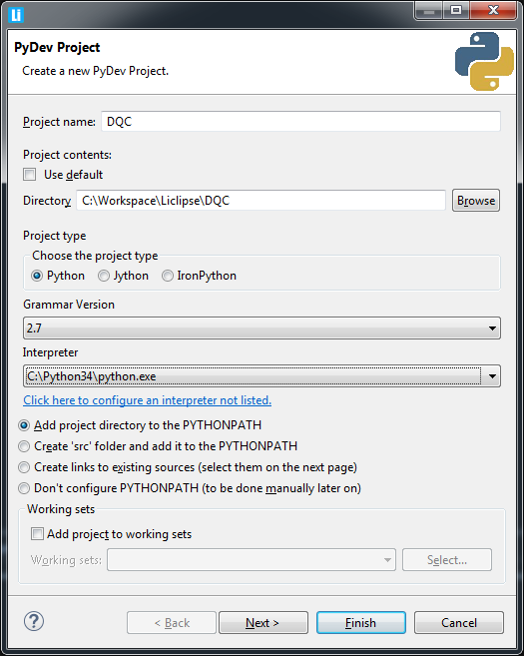
11. Ensure the radio button is checked for the option, “Add project directory to the PYTHONPATH”.
12. Click “Finish”. 