CAI601400 - Artificial Intelligence

Lab 5 Report: Adversarial Search (Minimax & Alpha-Beta Pruning)
Field | Detail
Student | Sajid Hussain (ID BSAIM-046)
Lab / Week | Lab 5, Week 5 (Lectures L11-L12)
CLO / Level | CLO2 (C3: Apply), 3C focus: Competence
GitHub repository | [INSERT REPOSITORY URL]
Commit ID (code) | [INSERT COMMIT HASH]

1. Problem and Objective
A game-playing agent must choose a move while assuming that the opponent also acts optimally. Searching every leaf of the game tree is expensive, so the agent needs a way to avoid branches that cannot change the final decision. The case study is a small two-player zero-sum game tree whose terminal scores are known.
In this lab I (1) traced the supplied trees bottom-up with Minimax, (2) added a leaf-evaluation counter to Minimax and alpha-beta pruning and logged every pruning decision, and (3) reordered the branches to see how pruning changes while the Minimax value stays the same.

2. Assumptions and Scope
- Tree representation. A complete binary tree stored as a list of leaf utilities. Node (depth, index) has children (depth + 1, 2*index) and (depth + 1, 2*index + 1). Depth 0 is a MAX node and the layers alternate MAX, MIN, MAX. Children are searched left to right.
- Two supplied trees. Section 5.1 uses the six scores [3, 5, 2, 9, 0, 7], which the supplied code pads with zeros to the 8 leaves [3, 5, 2, 9, 0, 7, 0, 0]. Section 5.2 uses [3, 5, 2, 9, 3, 5, 2, 9]. Both have 8 leaves and depth 3. I call them tree 5.1 (padded) and tree 5.2.
- Counting convention. A leaf is "evaluated" each time the recursion reaches depth = target and returns its utility. Plain Minimax therefore always evaluates every leaf.
- Root action and ties. The root action is the child with the strictly largest value; the first (Left) child wins ties. Left and Right are positions, not fixed moves.
- Synthetic data. All utilities are the manual's examples or synthetic numbers; the random trees use a fixed seed. Python 3.12.3; the scripts use the standard library only (the figure script also needs matplotlib).

3. Concepts Used
Term | Meaning
Game tree | Nodes are game positions; edges are moves; leaves carry a terminal utility from the point of view of MAX.
MAX / MIN layers | MAX picks the child with the highest value; MIN, the opponent, picks the lowest. MAX assumes MIN plays optimally, so it plans for the worst case.
Minimax value | Leaf utility at the leaves; max of the children at MAX nodes; min of the children at MIN nodes. Computed bottom-up.
alpha | The best value MAX can already guarantee along the current path (a lower bound).
beta | The best value MIN can already guarantee along the current path (an upper bound).
Pruning condition | When alpha >= beta, the remaining children of the node cannot change the decision above it, so they are skipped.
Table 1: Definitions (Russell & Norvig, 2021).

4. Task 1: Minimax Hand Trace (Bottom-Up)
Values are computed from the leaves up. The figure shows both trees with every node's Minimax value; the grey dashed part of tree 5.2 is explained in Section 5.
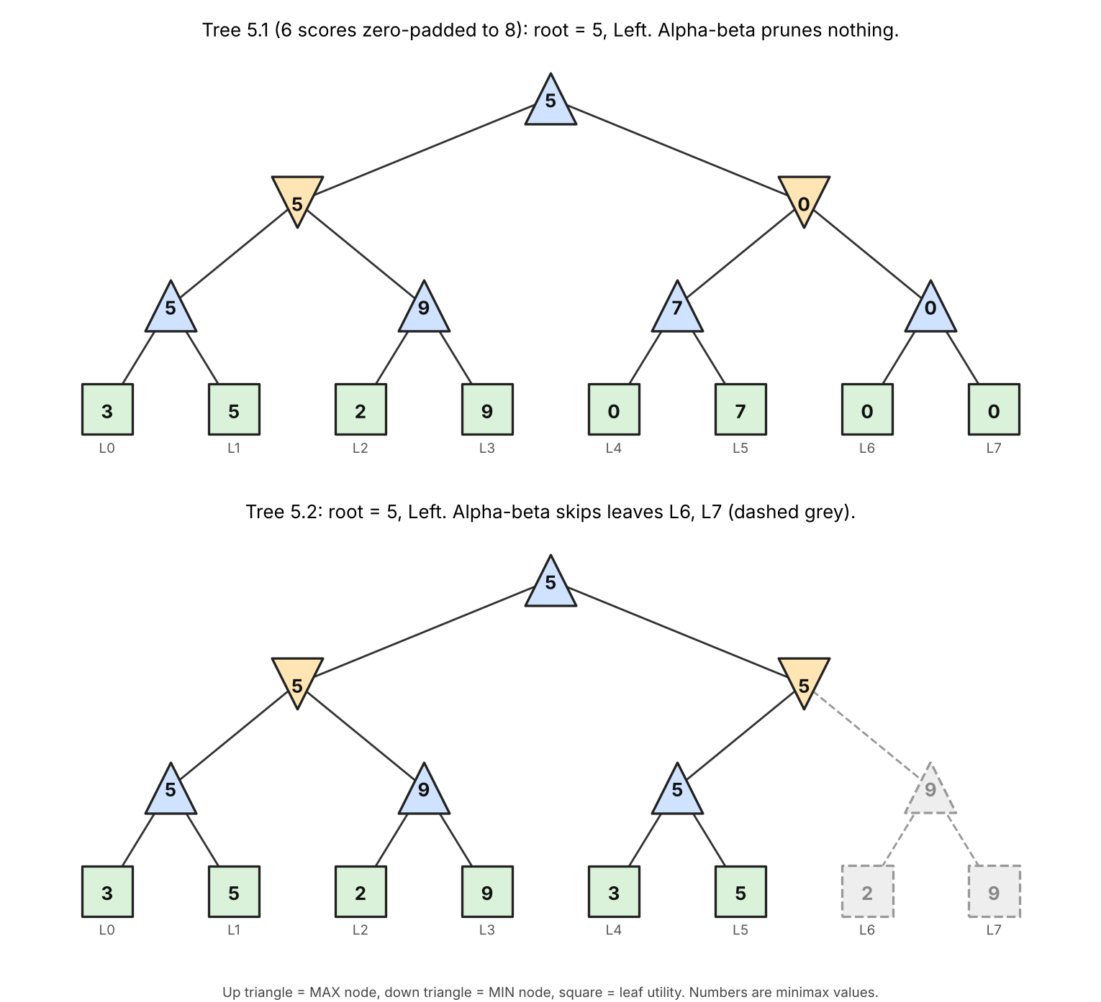
Figure 1: Tree 5.1 (padded) and tree 5.2 with Minimax values. Up triangle = MAX, down triangle = MIN, square = leaf.

4.1 Tree 5.1 (zero-padded leaves [3, 5, 2, 9, 0, 7, 0, 0])
Depth | Layer | Calculation | Node values
3 | Leaves | L0 = 3, L1 = 5, L2 = 2, L3 = 9, L4 = 0, L5 = 7, L6 = 0, L7 = 0 | 3, 5, 2, 9, 0, 7, 0, 0
2 | MAX | max(3, 5) = 5; max(2, 9) = 9; max(0, 7) = 7; max(0, 0) = 0 | 5, 9, 7, 0
1 | MIN | min(5, 9) = 5; min(7, 0) = 0 | 5, 0
0 | MAX (root) | max(5, 0) = 5 | 5
Table 2: Minimax trace of tree 5.1. Root value 5; the best action is Left (value 5 against 0 on the right).

4.2 Tree 5.2 (leaves [3, 5, 2, 9, 3, 5, 2, 9])
Depth | Layer | Calculation | Node values
3 | Leaves | L0 = 3, L1 = 5, L2 = 2, L3 = 9, L4 = 3, L5 = 5, L6 = 2, L7 = 9 | 3, 5, 2, 9, 3, 5, 2, 9
2 | MAX | max(3, 5) = 5; max(2, 9) = 9; max(3, 5) = 5; max(2, 9) = 9 | 5, 9, 5, 9
1 | MIN | min(5, 9) = 5; min(5, 9) = 5 | 5, 5
0 | MAX (root) | max(5, 5) = 5 | 5
Table 3: Minimax trace of tree 5.2. Root value 5. Both children have value 5, so the tie goes to Left.
Why does MAX assume MIN picks the worst outcome for MAX? In a zero-sum game MIN's gain is MAX's loss, so an optimal opponent picks the child that is worst for MAX. At MIN node (1,0) of tree 5.1, MAX could hope for 9 but MIN will steer to 5, so only 5 can be guaranteed.

5. Task 2: Leaf-Evaluation Counters and Pruning Decisions
minimax_counted() and alphabeta_counted() use exactly the supplied recursion and in addition record every leaf evaluation, every pruning decision and the value of each root child. The supplied functions give 5 on both trees, and the counted versions agree.
Tree | Algorithm | Root value | Root action | Leaves evaluated | Evaluation order (leaf index)
5.1 (padded) | Minimax | 5 | Left | 8 of 8 | 0, 1, 2, 3, 4, 5, 6, 7
5.1 (padded) | Alpha-beta | 5 | Left | 8 of 8 | 0, 1, 2, 3, 4, 5, 6, 7
5.2 | Minimax | 5 | Left | 8 of 8 | 0, 1, 2, 3, 4, 5, 6, 7
5.2 | Alpha-beta | 5 | Left | 6 of 8 | 0, 1, 2, 3, 4, 5
Table 4: Root value, action and leaf counts. Alpha-beta never evaluates more leaves than Minimax and returns the same value.

5.1 Alpha-beta trace of tree 5.2
Step | Node | alpha, beta on entry | What happens
1 | MAX (2,0) | -inf, +inf | L0 = 3 gives value 3, alpha = 3. L1 = 5 gives value 5, alpha = 5. Returns 5.
2 | MIN (1,0) | -inf, +inf | Value 5, so beta = 5. Continue with the second child.
3 | MAX (2,1) | -inf, 5 | L2 = 2 gives alpha = 2. L3 = 9 gives value 9, alpha = 9. alpha >= beta (9 >= 5), but no child remains. Returns 9.
4 | MIN (1,0) | -inf, 5 | min(5, 9) = 5. Returns 5.
5 | MAX root (0,0) | -inf, +inf | Value 5, so alpha = 5. Continue with the right child.
6 | MAX (2,2) | 5, +inf | L4 = 3 gives value 3, alpha stays 5. L5 = 5 gives value 5. Returns 5.
7 | MIN (1,1) | 5, +inf | Value 5, so beta = 5. alpha >= beta (5 >= 5): PRUNE the unvisited child MAX (2,3), i.e. leaves L6 and L7. Returns 5.
8 | MAX root (0,0) | 5, +inf | max(5, 5) = 5. Root value 5, action Left.
Table 5: Alpha-beta trace of tree 5.2 (hand-derived and identical to the program's pruning log).
Why the cut is safe. At MIN node (1,1) the value can only fall to 5 or below, but MAX already has a guaranteed 5 from the left branch. Nothing MIN finds in L6 or L7 can make the right branch better than 5 for MAX, so skipping them cannot change the decision. In tree 5.1 the original ordering allows no cut (all 8 leaves are evaluated): on the right branch MIN's first child gives 7, which is above alpha = 5, so the second child must still be checked and it gives 0.
Supplied code, as given in the manual
5.1 minimax on [3, 5, 2, 9, 0, 7, 0, 0] -> 5
5.2 alphabeta on [3, 5, 2, 9, 3, 5, 2, 9] -> 5

Task 1: Minimax bottom-up trace, tree 5.1 (6 scores zero-padded to [3, 5, 2, 9, 0, 7, 0, 0])
depth | type | calculations
3 | leaf | L0 = 3; L1 = 5; L2 = 2; L3 = 9; L4 = 0; L5 = 7; L6 = 0; L7 = 0
2 | MAX | max(3, 5) = 5; max(2, 9) = 9; max(0, 7) = 7; max(0, 0) = 0
1 | MIN | min(5, 9) = 5; min(7, 0) = 0
0 | MAX | max(5, 0) = 5
Root value = 5; root action = Left (first child wins ties)

Task 1: Minimax bottom-up trace, tree 5.2 [3, 5, 2, 9, 3, 5, 2, 9]
depth | type | calculations
3 | leaf | L0 = 3; L1 = 5; L2 = 2; L3 = 9; L4 = 3; L5 = 5; L6 = 2; L7 = 9
2 | MAX | max(3, 5) = 5; max(2, 9) = 9; max(3, 5) = 5; max(2, 9) = 9
1 | MIN | min(5, 9) = 5; min(5, 9) = 5
0 | MAX | max(5, 5) = 5
Root value = 5; root action = Left (first child wins ties)

Task 2: leaf-evaluation counters
tree | algorithm | root value | root action | leaves evaluated | evaluation order (leaf indices)
5.1 (padded) | Minimax | 5 | Left | 8 of 8 | 0, 1, 2, 3, 4, 5, 6, 7
5.1 (padded) | Alpha-beta | 5 | Left | 8 of 8 | 0, 1, 2, 3, 4, 5, 6, 7
5.2 | Minimax | 5 | Left | 8 of 8 | 0, 1, 2, 3, 4, 5, 6, 7
5.2 | Alpha-beta | 5 | Left | 6 of 8 | 0, 1, 2, 3, 4, 5

Alpha-beta pruning decisions
tree 5.1 (padded): no pruning occurred (all 8 leaves evaluated)
tree 5.2: pruned at MIN node (depth 1, index 1) after its first child: alpha = 5, beta = 5 (alpha >= beta); skipped leaf indices 6, 7

Verification
tree 5.1 (padded): same root value = True; same root action = True; alpha-beta leaves 8 <= minimax leaves 8: True
tree 5.2: same root value = True; same root action = True; alpha-beta leaves 6 <= minimax leaves 8: True

Listing 1: Raw output of python lab5_minimax_ab.py.

6. Task 3: Reordering Branches
Reordering swaps the left and right subtrees of nodes; the utilities are never changed. Four named orderings were tried on each tree: the original, the mirrored tree (every node swapped), best-first (MAX nodes try their largest child first, MIN nodes their smallest, using the exact Minimax values) and worst-first (the opposite).
Tree | Order | Leaf order | Root value | Root action | Alpha-beta leaves | Leaves skipped
5.1 | original | [3, 5, 2, 9, 0, 7, 0, 0] | 5 | Left | 8 | 0
5.1 | mirrored | [0, 0, 7, 0, 9, 2, 5, 3] | 5 | Right | 7 | 1
5.1 | best-first | [5, 3, 9, 2, 0, 0, 7, 0] | 5 | Left | 5 | 3
5.1 | worst-first | [0, 7, 0, 0, 2, 9, 3, 5] | 5 | Right | 8 | 0
5.2 | original | [3, 5, 2, 9, 3, 5, 2, 9] | 5 | Left | 6 | 2
5.2 | mirrored | [9, 2, 5, 3, 9, 2, 5, 3] | 5 | Left | 8 | 0
5.2 | best-first | [5, 3, 9, 2, 5, 3, 9, 2] | 5 | Left | 5 | 3
5.2 | worst-first | [2, 9, 3, 5, 2, 9, 3, 5] | 5 | Left | 8 | 0
Table 6: Named orderings. Minimax always evaluates 8 leaves. The root value is 5 in every row.
To avoid relying on four hand-picked orderings I also ran all 2^7 = 128 combinations of child swaps for each tree:
Alpha-beta leaves evaluated | Tree 5.1 (padded): orderings | Tree 5.2: orderings
5 | 8 | 16
6 | 32 | 48
7 | 40 | 16
8 | 48 | 48
Fewest / most / mean | 5 / 8 / 7.00 | 5 / 8 / 6.75
Table 7: Distribution over all 128 orderings of each tree. The root value was 5 in all 256 runs.
- The Minimax value does not change. Reordering changes how many leaves are evaluated but never the root value, because pruning only skips branches that cannot affect the decision.
- Pruning depends strongly on order. The same tree needs between 5 and 8 leaves. Best-first ordering reaches 5, which equals the best case b^ceil(d/2) + b^floor(d/2) - 1 = 4 + 2 - 1 = 5 for branching factor b = 2 and depth d = 3 (Knuth & Moore, 1975). Worst-first ordering gives no saving.
- Why ordering matters. A cut needs alpha >= beta. If MAX tries its best child first, alpha becomes large early; if MIN tries its smallest child first, beta becomes small early. Good bounds early mean more cuts.
- The action label can change. In the mirrored tree 5.1 the root action is Right, not Left. The tree was mirrored, so the best move sits at the other position. The value 5 is unchanged and it is the same move.
Tree 5.1 (padded): leaves [3, 5, 2, 9, 0, 7, 0, 0]
ordering | leaf order | root value | root action | minimax leaves | alpha-beta leaves | skipped
original | [3, 5, 2, 9, 0, 7, 0, 0] | 5 | Left | 8 | 8 | 0
mirrored | [0, 0, 7, 0, 9, 2, 5, 3] | 5 | Right | 8 | 7 | 1
best-first | [5, 3, 9, 2, 0, 0, 7, 0] | 5 | Left | 8 | 5 | 3
worst-first | [0, 7, 0, 0, 2, 9, 3, 5] | 5 | Right | 8 | 8 | 0
Root value identical for all four orderings and both algorithms: True

All 128 child-swap orderings of tree 5.1 (padded)
alpha-beta leaves evaluated | number of orderings
5 | 8
6 | 32
7 | 40
8 | 48
fewest = 5, most = 8, mean = 7.00 (minimax always evaluates 8)
Root value unchanged in every ordering: True

Tree 5.2: leaves [3, 5, 2, 9, 3, 5, 2, 9]
ordering | leaf order | root value | root action | minimax leaves | alpha-beta leaves | skipped
original | [3, 5, 2, 9, 3, 5, 2, 9] | 5 | Left | 8 | 6 | 2
mirrored | [9, 2, 5, 3, 9, 2, 5, 3] | 5 | Left | 8 | 8 | 0
best-first | [5, 3, 9, 2, 5, 3, 9, 2] | 5 | Left | 8 | 5 | 3
worst-first | [2, 9, 3, 5, 2, 9, 3, 5] | 5 | Left | 8 | 8 | 0
Root value identical for all four orderings and both algorithms: True

All 128 child-swap orderings of tree 5.2
alpha-beta leaves evaluated | number of orderings
5 | 16
6 | 48
7 | 16
8 | 48
fewest = 5, most = 8, mean = 6.75 (minimax always evaluates 8)
Root value unchanged in every ordering: True

Listing 2: Raw output of python lab5_ordering.py.

7. Testing and Edge Cases
Case | Result (11 of 11 checks passed)
Single leaf [7] | Both algorithms return 7 after evaluating 1 leaf; there is no root action.
Two leaves [4, 9] | MAX picks 9 (Right); both leaves are evaluated because no pruning is possible at the root.
All-equal leaves (eight 5s) | Both return 5 and the tie goes to Left. Alpha-beta evaluates 5 of 8, because pruning uses alpha >= beta, so equal bounds already allow a cut.
Negative utilities | Alpha-beta and Minimax agree.
Zero-padding of the 6-score tree | The padded tree gives root 5 (Left), but without a dummy branch the root would be 7 (Right). See Section 8.
2000 random trees (depth 1 to 5, seed 5) | Same root value and same root action as Minimax on all 2000. Alpha-beta never evaluated more leaves, and used fewer in 1240 trees. Leaves: 17,750 against 24,800 (72%).
100 random trees x 128 orderings | The root value never changed.
Table 8: Edge-case and random-tree results.
Depth | Minimax leaves (400 trees) | Alpha-beta leaves | Alpha-beta / Minimax
1 | 800 | 800 | 1.00
2 | 1600 | 1445 | 0.90
3 | 3200 | 2693 | 0.84
4 | 6400 | 4577 | 0.72
5 | 12800 | 8235 | 0.64
Table 9: Savings grow with depth. Depth 1 has no possible pruning.
== Part 1: edge cases ==
PASS | single leaf [7]: both return 7 after evaluating 1 leaf
PASS | single leaf: no root action exists
PASS | two leaves [4, 9]: MAX picks 9 (Right), both leaves evaluated
info | all-equal leaves: alpha-beta evaluates 5 of 8
PASS | all-equal leaves: same value 5, tie goes to Left, no extra work
PASS | negative utilities: values agree
info | zero-padded tree [3, 5, 2, 9, 0, 7, 0, 0]: root value 5, action Left
info | same 6 scores with NO dummy branch: root value 7, action Right
PASS | padding assumption matters: padded root 5 (Left) vs. unpadded root 7 (Right)

== Part 2: 2000 random trees (seed 5) ==
depth | minimax leaves (400 trees) | alpha-beta leaves | alpha-beta / minimax
1 | 800 | 800 | 1.00
2 | 1600 | 1445 | 0.90
3 | 3200 | 2693 | 0.84
4 | 6400 | 4577 | 0.72
5 | 12800 | 8235 | 0.64
total | 24800 | 17750 | 0.72
trees where alpha-beta evaluated fewer leaves: 1240 of 2000
PASS | alpha-beta root value equals minimax on all 2000 trees
PASS | alpha-beta root action equals minimax action on all 2000 trees
PASS | alpha-beta never evaluates more leaves than minimax
PASS | alpha-beta evaluated fewer leaves in total
PASS | root value is unchanged by every branch ordering (100 random trees x 128 orderings)

11/11 checks passed

Listing 3: Raw output of python lab5_tests.py.

8. Failure and Edge-Case Analysis: Zero-Padding
Item | Detail
Input | The manual's six scores [3, 5, 2, 9, 0, 7], padded with zeros to 8 leaves so the tree is a complete binary tree.
Observed behaviour | Root value 5 and action Left. If the missing branch simply does not exist, so that the right MIN node has one child with value 7, the root value would be 7 and the action Right.
Likely cause | The code requires a complete binary tree and fills the missing leaves with 0. But 0 is a real utility, not a neutral value: the dummy MAX node (value 0) gives MIN a choice that drags the right branch down from 7 to 0, so MAX prefers the left branch.
Impact | The chosen move depends on an assumption about the tree and not on the game. If the real game has no such outcomes, the agent would pick the wrong move.
Proposed improvement | Represent the tree with nodes that may have any number of children (nested lists or node objects), so no dummy leaves are needed. If padding is unavoidable, state it as an assumption and check that the answer does not change under other padding values.
Table 10: Failure analysis (checked in lab5_tests.py).
Other limitations. The tests use binary trees of depth at most 5, so they illustrate the pruning mechanism but do not measure it for real game branching factors. Alpha-beta saves work only in proportion to how good the move ordering is.

9. Limitations
- The trees are small, synthetic and binary; savings on real games depend on branching factor, depth and move ordering.
- Minimax assumes a two-player zero-sum game with an opponent who plays optimally; a weaker opponent could be beaten with a different strategy.
- The terminal utilities are given; in a real game they would come from an evaluation function that can be wrong.
- The padding with zeros is an assumption (Section 8).
- Leaf counts are used as a proxy for work; running time and memory were not measured.

10. Reflection
What did I learn today? Alpha-beta gives the same Minimax value with fewer leaves, and the savings depend on the order in which branches are tried: from 5 to 8 leaves on the same tree. Pruning only skips what cannot change the decision.
How will I apply this in a real AI system? For a turn-based game agent I would use alpha-beta with a move-ordering heuristic (try promising moves first) and check against plain Minimax on small cases to confirm they agree.
What failed or surprised me? I expected the supplied tree 5.1 to show pruning, but with the original order alpha-beta evaluated all 8 leaves; only tree 5.2 lost leaves. It also surprised me that the zero-padding changed the answer from 7 to 5.
What would I do differently next time? I would draw the tree and predict the cuts by hand before running the code, and support unequal branching so no padding is needed.

11. Responsible Practice and Character Integration
- Transparency. The report shows the tree, the utilities, every Minimax value and every pruning decision (with alpha and beta), so another student can reproduce the chosen move.
- Honest reporting. I report that tree 5.1 shows no pruning in its original order and that a padding assumption affects the answer, rather than showing only favourable cases.
- Evidence over claims. "Alpha-beta evaluates no more leaves than Minimax" is supported by counts on 2000 random trees and 128 orderings per tree, not only by one example.
- Real-world care. If such an agent were used in a competitive or safety-related setting, the utilities encode value judgements and the optimal-opponent assumption may not hold, so results should be checked and not trusted blindly. This lab uses synthetic trees only.
- Attribution. minimax() and alphabeta() are the supplied reference code; all other code is my own. Sources are listed below.

12. Viva-Ready Design Explanation
- Why does MAX assume MIN will choose the worst outcome for MAX? In a zero-sum game the opponent's gain is MAX's loss, so MAX plans for the best the opponent can do. That gives the best guaranteed result.
- What do alpha and beta represent? Alpha is the best value MAX can already guarantee on the current path; beta is the best value MIN can already guarantee. When alpha >= beta, the rest of the node cannot matter.
- Does pruning change the optimal Minimax result? No. In every test (2000 random trees and all 128 orderings) the root value and action matched plain Minimax.
- Why does move ordering affect pruning efficiency? Cuts need tight bounds early. Trying the best move first raises alpha (or lowers beta) at once, so later siblings are cut: best-first needed 5 leaves, worst-first 8.
- Why does alpha-beta evaluate 6 leaves on tree 5.2 but 8 on tree 5.1? In tree 5.2 the right MIN node first sees 5, which equals alpha = 5, so its second child is skipped. In tree 5.1 its first child is 7, which is above alpha, so no cut occurs.
- Why is the second child skipped but not the first? Alpha-beta needs at least one child to learn a bound; the cut is made after that child, so only later siblings are skipped.

13. Repository Contents
File | Description
lab5_minimax_ab.py | Supplied Minimax/alpha-beta, counted versions, traces (Tasks 1-2).
lab5_ordering.py | Branch-reordering experiments (Task 3).
lab5_tests.py | Edge cases, padding check, 2000 random trees.
lab5_draw_trees.py | Optional: redraws the tree figure (needs matplotlib).
outputs/minimax_ab_output.txt, ordering_output.txt, tests_output.txt, trees.png | Captured outputs and the tree figure.
README.md | Setup and run commands.
Lab5_Report.docx | This report.

References
Russell, S., & Norvig, P. (2021). Artificial Intelligence: A Modern Approach (4th ed.). Pearson. (Chapter 5: adversarial search and games.)
Knuth, D. E., & Moore, R. W. (1975). An analysis of alpha-beta pruning. Artificial Intelligence, 6(4), 293-326.
Shannon, C. E. (1950). Programming a computer for playing chess. Philosophical Magazine, 41(314), 256-275.
Lab 5 manual: CAI601400 Artificial Intelligence Lab Manual, Lab 5 (Sections 5.1-5.2): supplied minimax() and alphabeta() reference code and example trees.

