Fixa2an – UX/UI Improvements (v3)

Start / Landing
Clear value proposition immediately. Focus on fast user action.
Why: Increases conversion through simplicity and clear CTA.
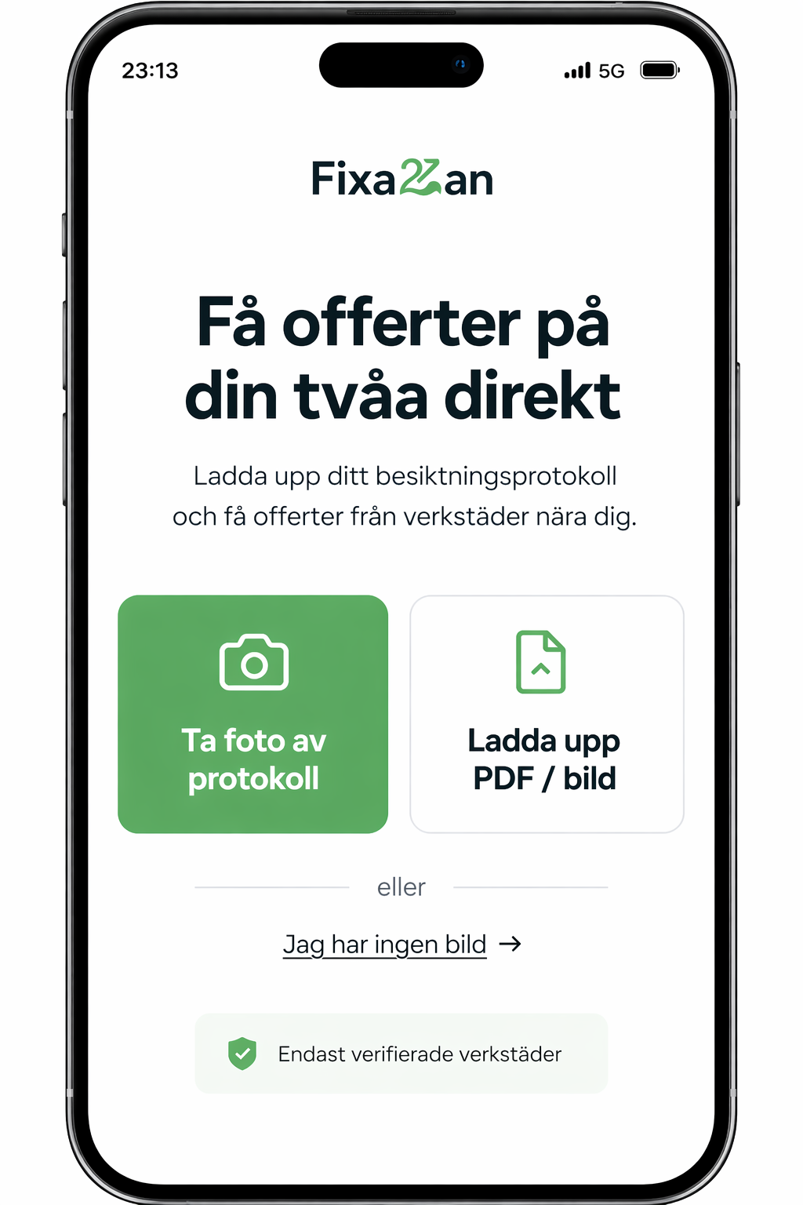

Fill in details
Minimal required input.
Why: Reduces friction and drop-off.
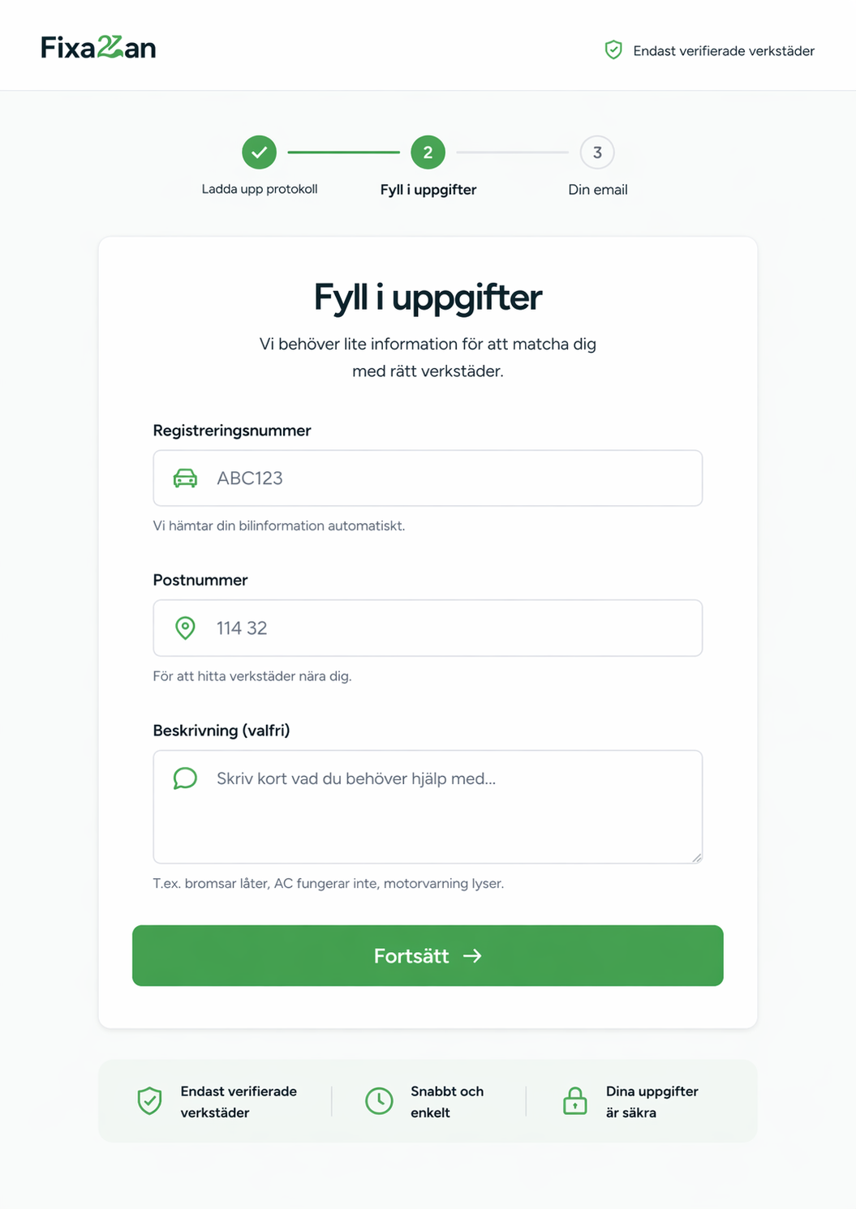

Email / Magic link
No account creation needed.
Why: Frictionless onboarding.
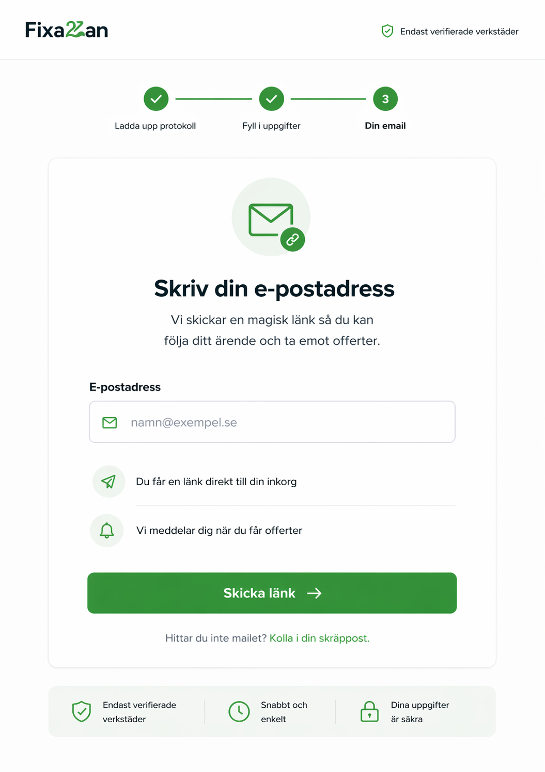

Offers list
Clear ranking and best match highlighted.
Why: Helps users make decisions quickly.
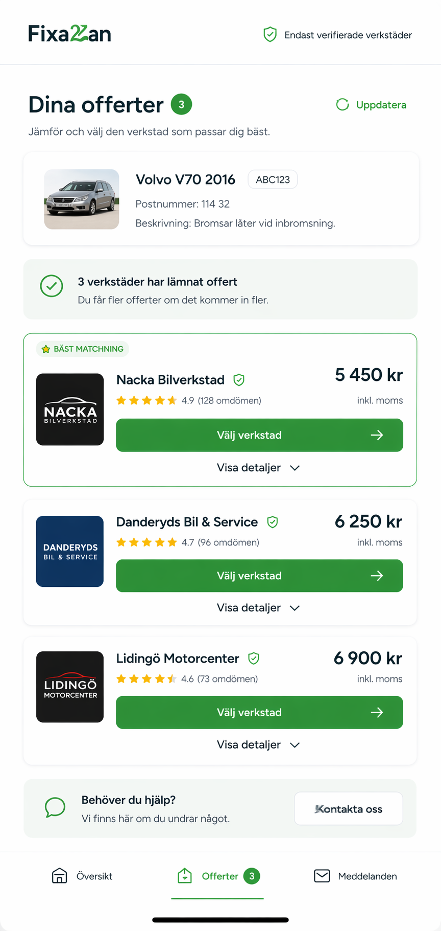

Select workshop
Transparent pricing and scope.
Why: Builds trust.
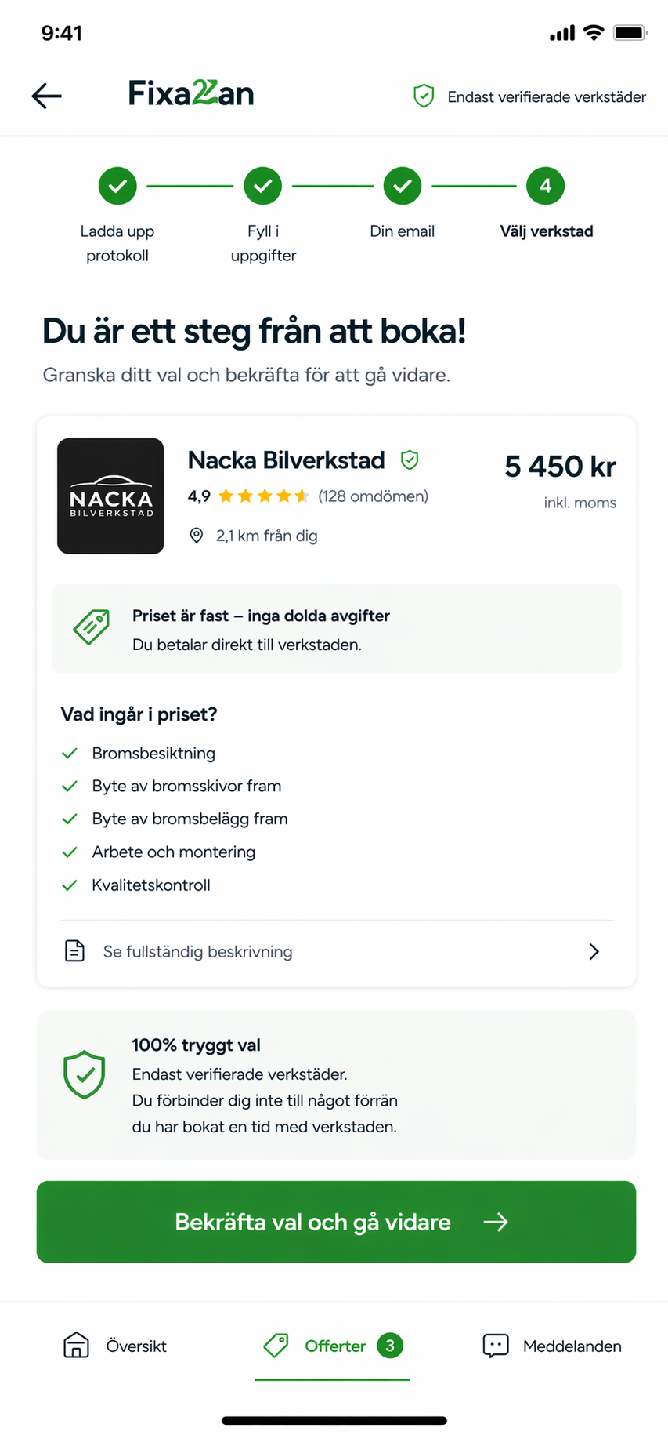

Booking confirmation
Clear next steps.
Why: Reduces uncertainty.
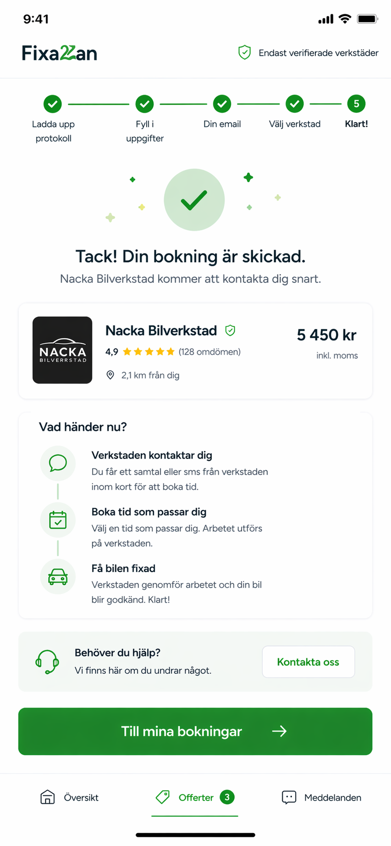

My cases
Overview of all cases.
Why: Gives control and clarity.
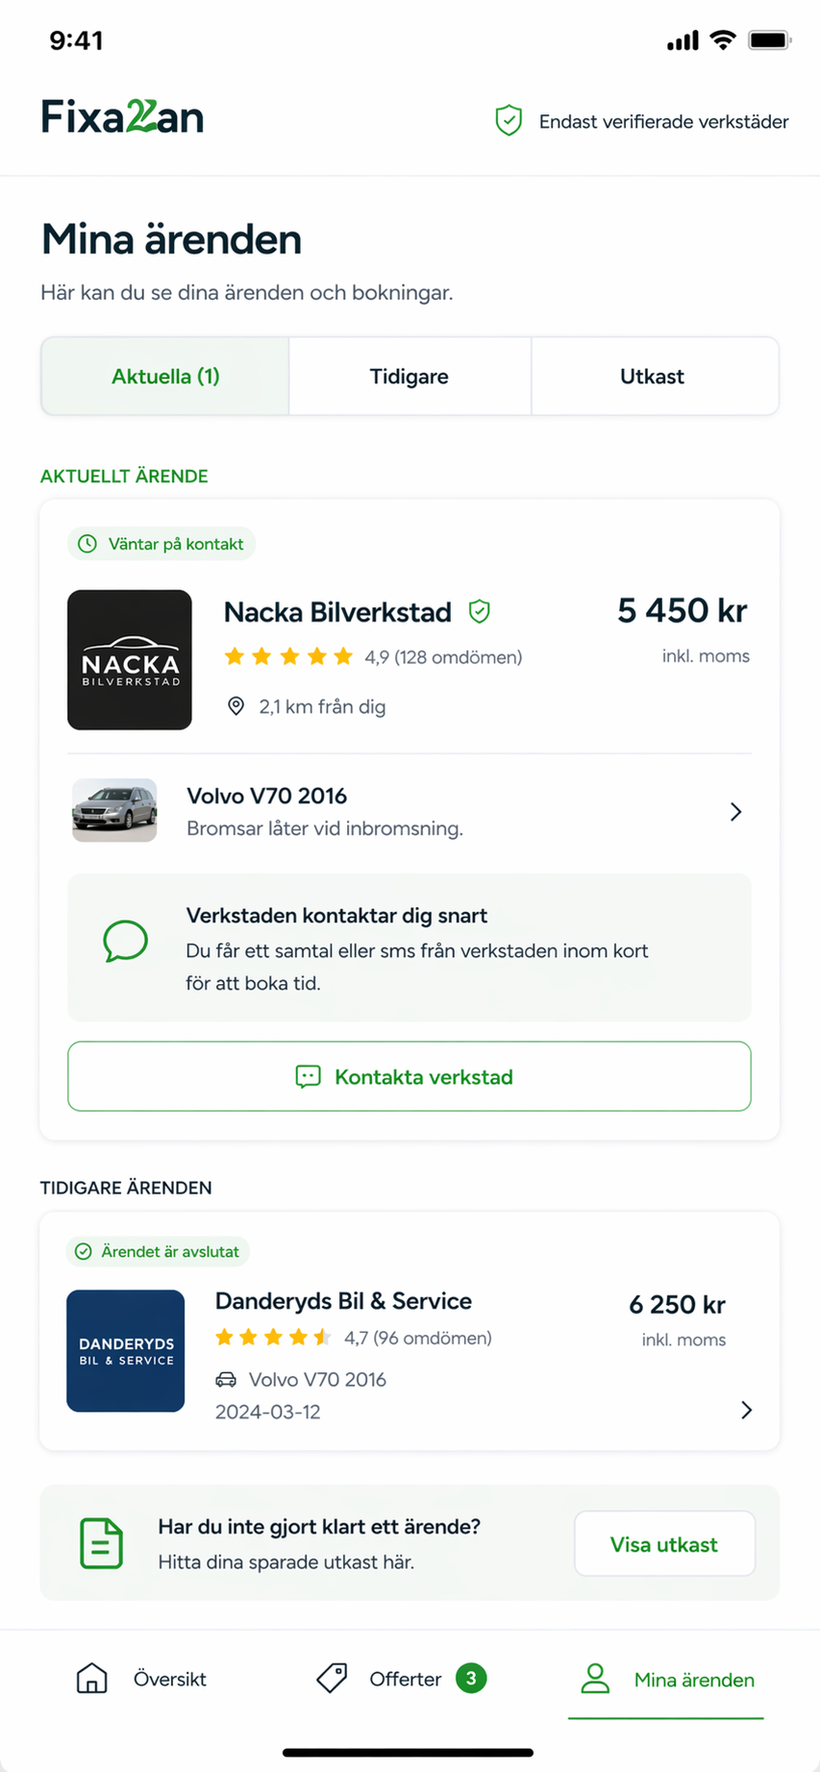

Workshop – Requests
New jobs clearly presented.
Why: Enables faster responses.
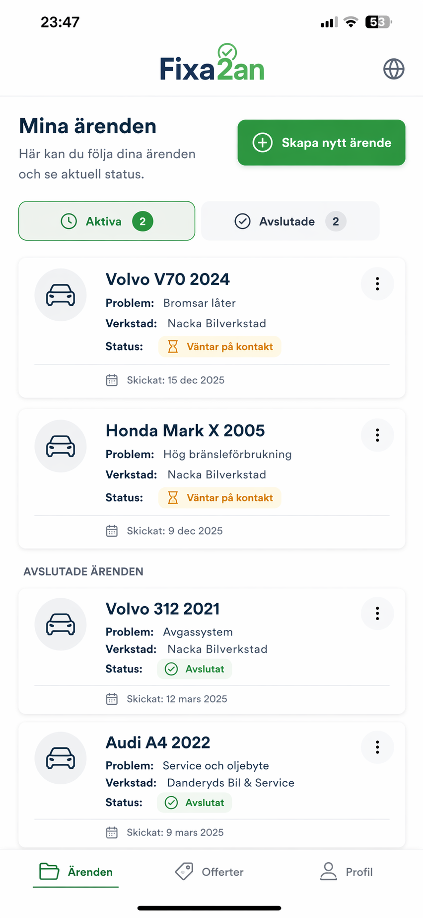

Workshop – Jobs
Status management.
Why: Structured workflow.
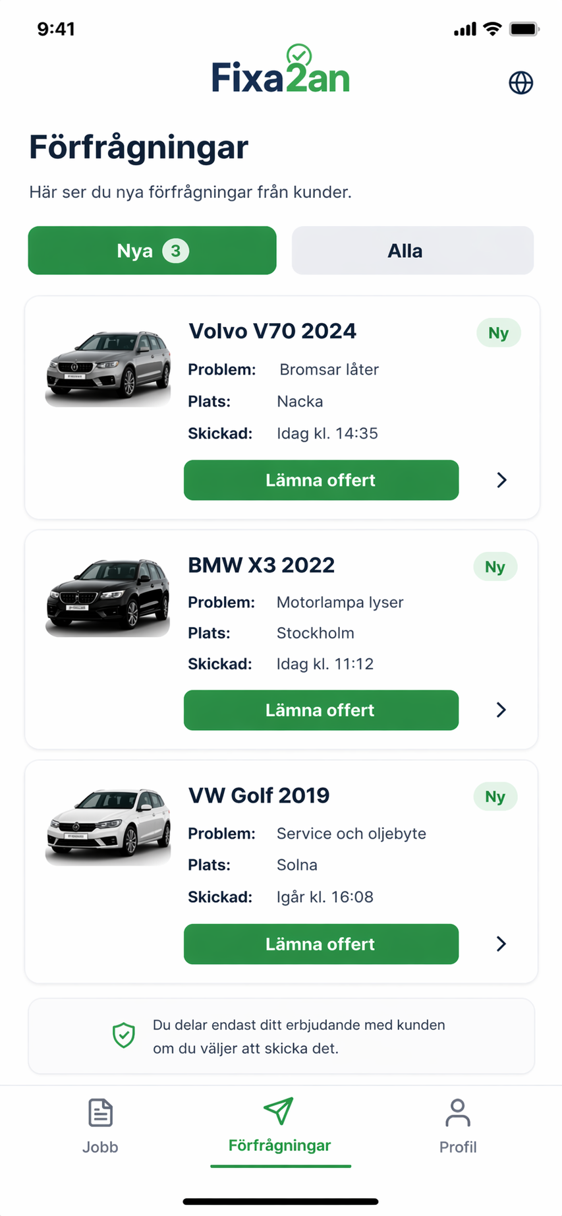

Profile
Settings and information.
Why: Easy administration.
