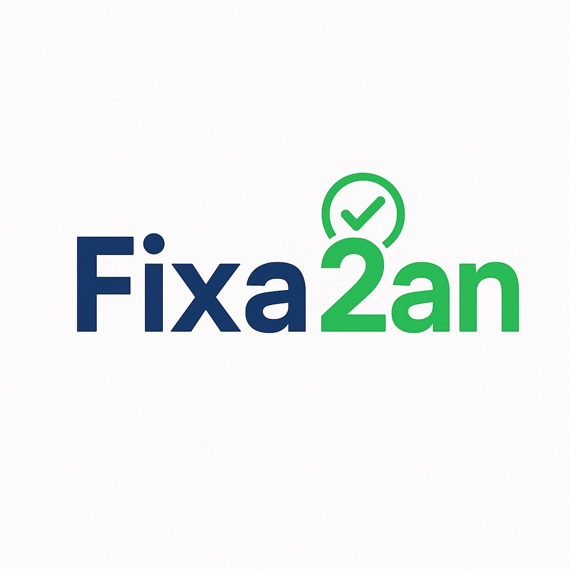
Fix2An Elite UX/UI Specification
Developer-ready document with all annotated screens, final logo, and landing-page separation rules
Purpose | Explain every required UX/UI change clearly with visual references.
Audience | Developer / builder / designer
Critical rule | The main landing page must target customers only. Workshops must have a separate page.
Deliverable | Implement the changes in the order listed below and ask before deviating.

Core rules
• Main landing page = customer only. No workshop-focused messaging on the customer homepage.
• Workshop content must live on a separate page such as '/workshop' or '/for-workshops'.
• Sent offers must be locked after submission.
• Status labels and colours must be consistent across all customer, workshop, and contract views.
• Each key screen should have one clear primary CTA.
• Dropdowns, menus, and overlays must never cover critical content.
Recommended implementation order
• Homepage and onboarding improvements
• Separate workshop landing page
• My Cases empty-state improvements
• Create Offer form improvements
• Offers list rules and trust improvements
• Contracts execution flow
• Cancel booking modal

1. Customer homepage / hero section
Goal: Improve first impression, clarity, and trust for car owners.
• Keep the homepage focused on car owners only.
• Strengthen the value proposition and CTA wording.
• Move trust signals higher on the page.
• Make the reason to choose Fix2An clearer and more specific.
Developer note: Do not place workshop-focused content on this page.
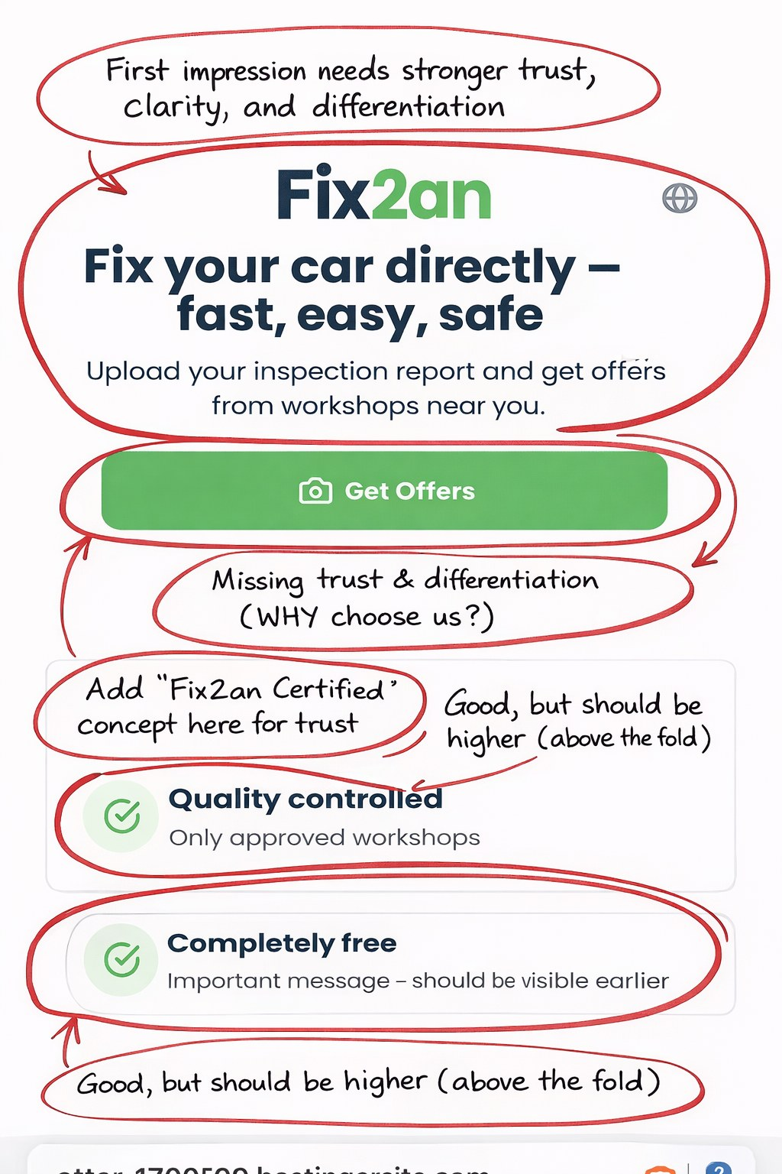

2. Homepage flow / first-step explanation
Goal: Keep the homepage simpler and avoid showing the full process too early.
• Do not overload the homepage with the entire step-by-step flow.
• Keep the message shorter and more direct.
• Move detailed flow guidance into the upload/request journey.
• Keep the primary CTA dominant.
Developer note: This screen should support the homepage, not compete with it.
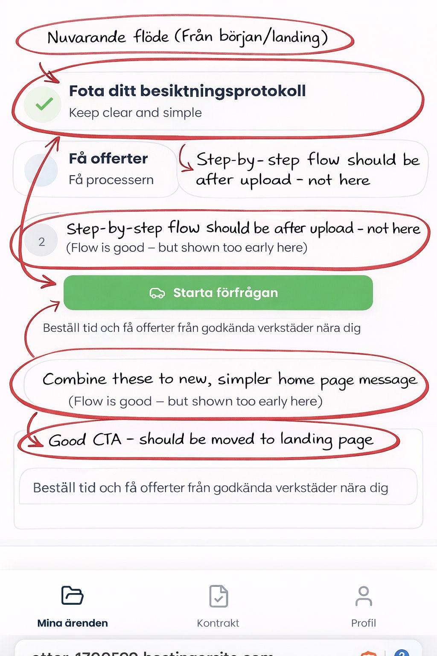

3. Separate workshop landing page (new page)
Goal: Move all workshop-targeted communication away from the customer homepage.
• Create a dedicated workshop page with its own headline, trust section, and CTA.
• Move workshop value proposition and application/contact CTA to that page.
• Add a small secondary header link such as 'For workshops' to reach this page.
• Do not mix customer and workshop messaging on the same landing page.
Developer note: This is a product and conversion rule, not just a copy change.

4. My Cases – empty state
Goal: Turn the empty state into guided onboarding instead of a passive blank state.
• Remove duplicate CTAs that do the same thing.
• Hide filters until the user actually has cases.
• Strengthen the CTA wording.
• Add visual next-step guidance.
• Add a trust message such as 'Only approved workshops will respond.'
Developer note: This screen should help the user move forward immediately.
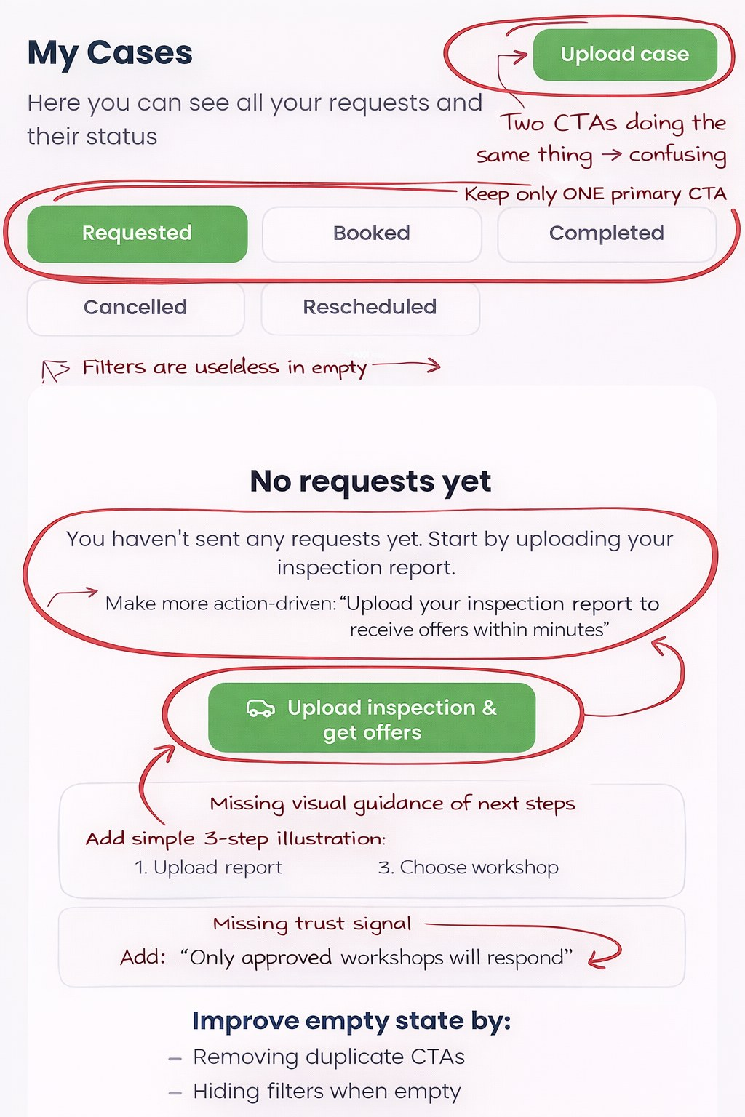

5. Create Offer form
Goal: Improve offer quality, reduce ambiguity, and make every sent offer trustworthy.
• Show total final price including VAT clearly.
• Make offer validity easier to understand and choose.
• Improve the detailed description field so labor, materials, parts, and inclusions are explicit.
• Make available time slots easier to add and understand.
• Strengthen the primary CTA and overall form structure.
Developer note: This is one of the most important screens in the product because it directly affects trust and acceptance rate.
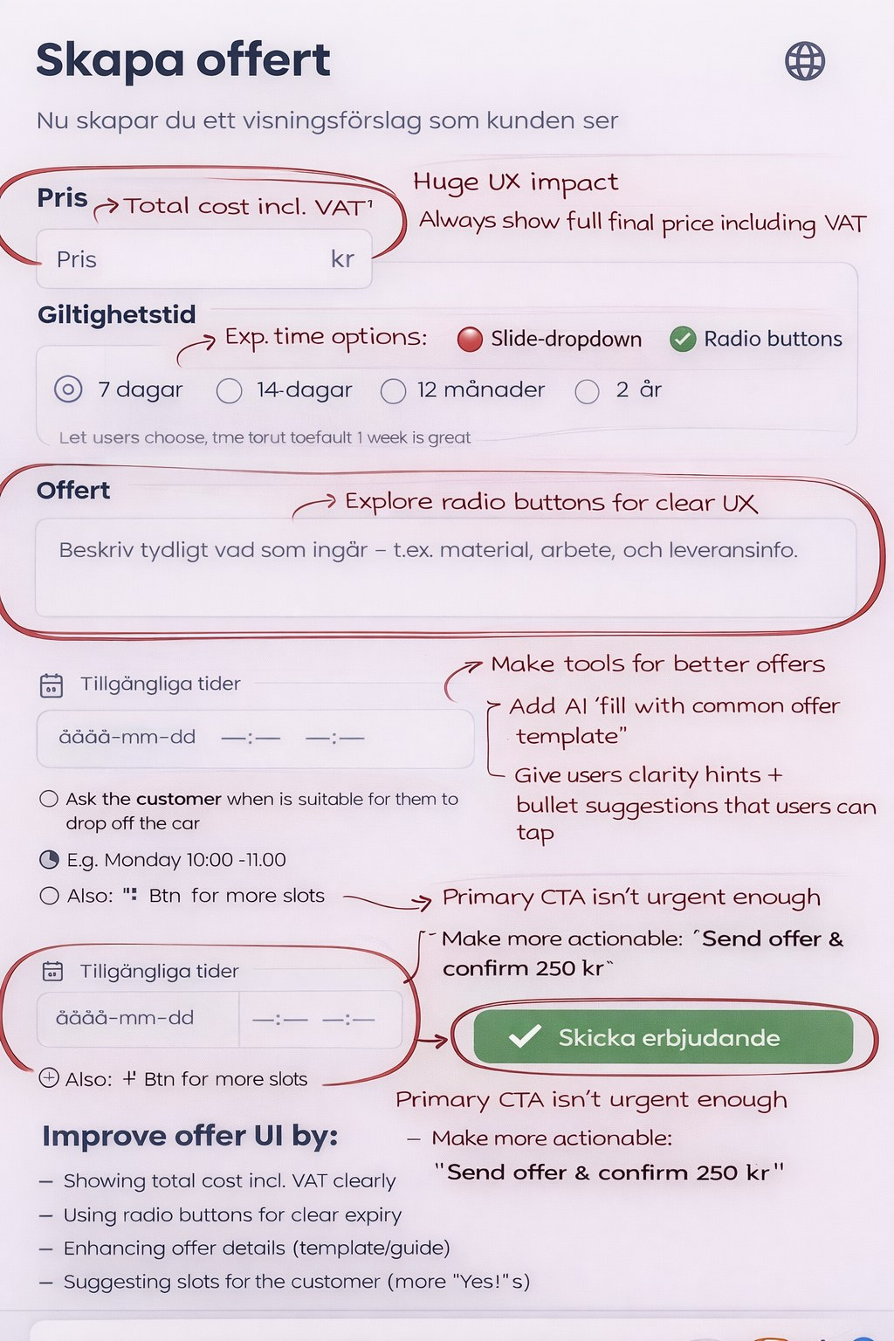

6. Offers list (workshop side)
Goal: Make sent offers final, understandable, and trustworthy.
• Lock offers after submission; do not allow normal editing after send.
• Replace 'Edit' with 'View' or optional 'Duplicate & edit'.
• Use a consistent status system with clear colours and labels.
• Show currency and VAT clearly.
• Add short summary information per offer.
Developer note: This prevents trust issues and makes pricing feel final and professional.
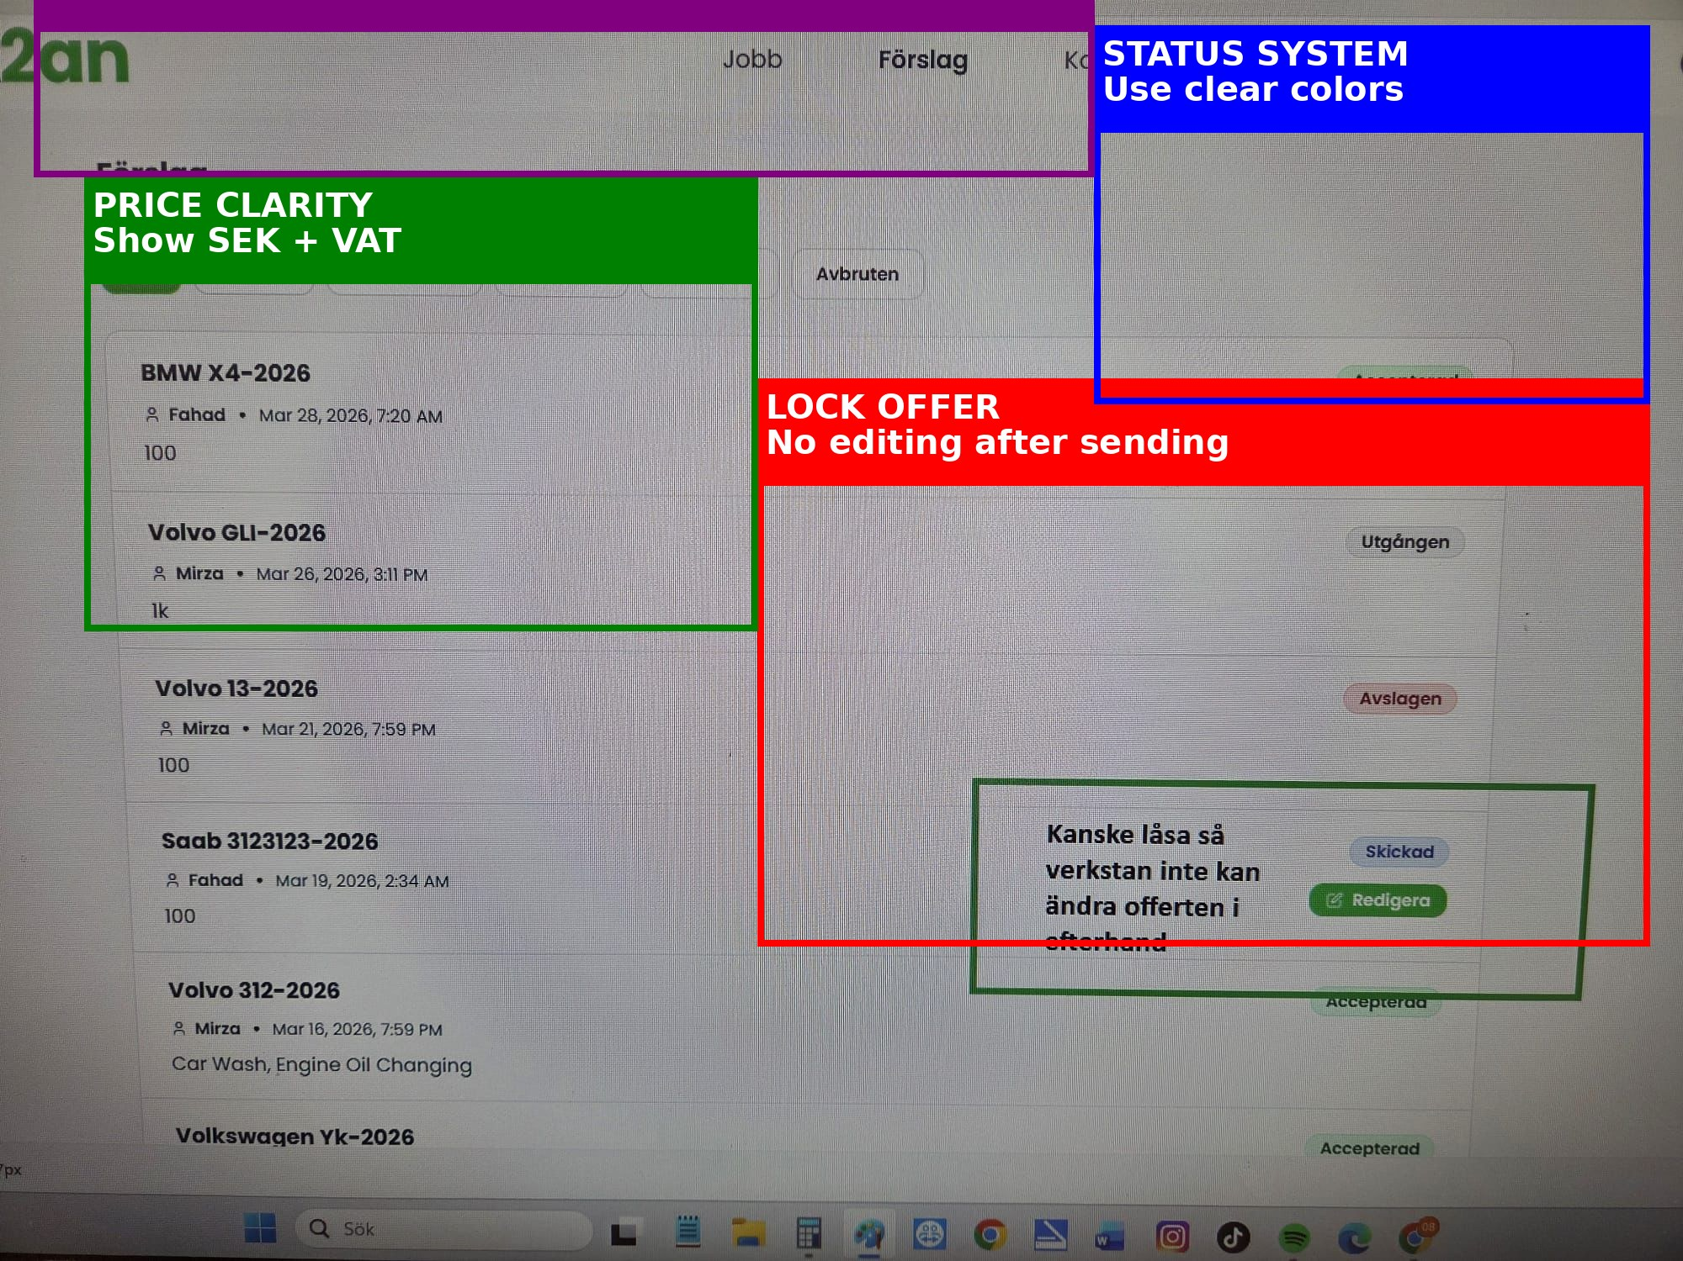

7. Contracts / execution phase
Goal: Make active work clear and completion-focused.
• Rename tabs to clearer active/completed language and add counts.
• Add visible status badges per card.
• Group customer information better and support quick actions like calling.
• Show price and estimated duration more clearly.
• Add a primary 'Mark as completed' action and keep cancel secondary.
• Fix the profile menu overlap bug.
Developer note: This screen represents live execution and therefore needs very high clarity and confidence.
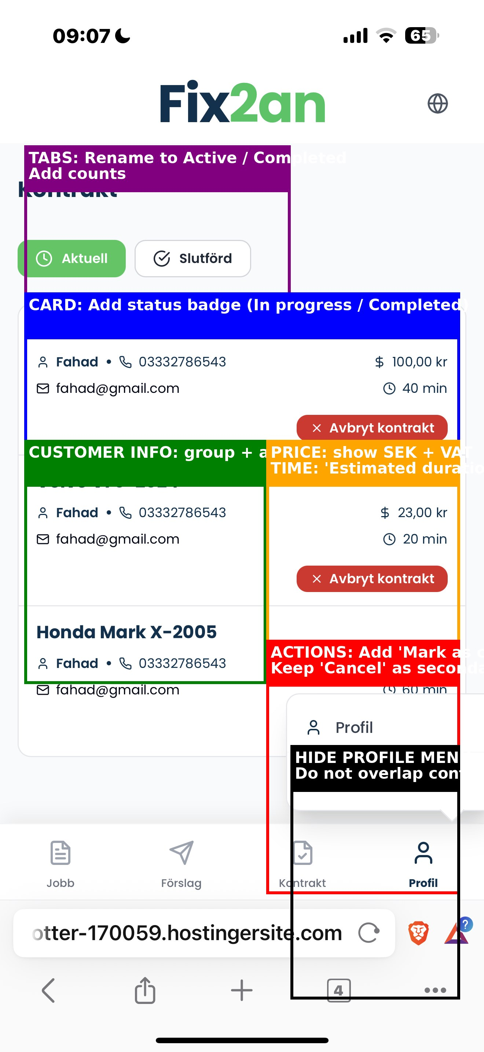

8. Cancel booking modal
Goal: Make cancellation feel clear, serious, and policy-safe.
• Use a clearer title such as 'Cancel booking'.
• Explain that the action cannot be undone.
• Show consequences or link to cancellation policy.
• Improve button hierarchy: Keep booking / Confirm cancellation.
• Optional: require a cancellation reason.
Developer note: This is a sensitive screen and must reduce conflict risk.
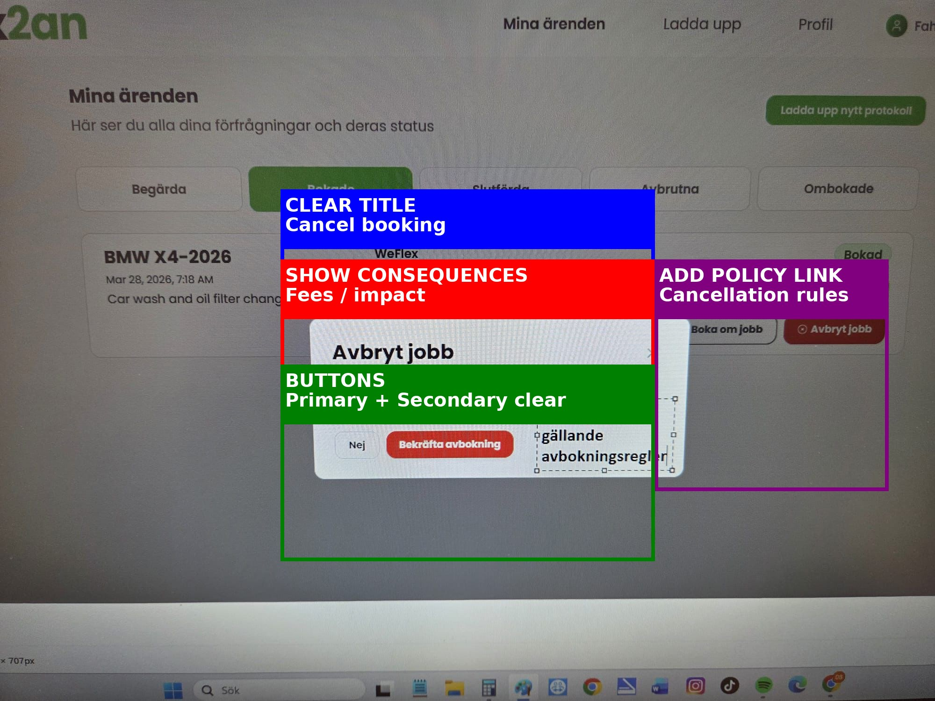

State logic and implementation rules
• Sent offers must be locked after submission.
• Every important screen should support empty, loading, error, and success states.
• Tabs and filters should only appear when they add real value.
• A single strong primary CTA should be visible on each key screen.
• Menus and dropdowns must never overlap or block important content.

