

***Software Requirement and Design Specifications***

*** [E-commerce Website]***

|  |  |
| --- | --- |
| *Course Code* | *CS-324* |
| *Instructor* | *Miss Nida Munawar* |
| *Project Team* | *Masab Bakhtiar - 19k-1259*  *Syed Mahad - 19k-1283*  *Rafay Akram - 19k-1490* |
| *Submission Date* | *20-Dec-2021* |



***[Instructions]***

* *No section of template should be deleted. You can write ‘Not applicable’ if a section is not applicable to your project. But all sections must exist in the final document.*
* *All comments/examples mentioned in square brackets ([]) are in the template for explanation purposes and must be replaced / removed in final document.*
* *This’ Instruction’ section should also be removed in final document.*

*Table of Contents*

1. Introduction 5

1.1. Purpose of Document 5

1.2. Intended Audience 5

2. Overall System Description 6

2.1. Project Background 6

2.2. Project Scope 6

2.3. Not In Scope 6

2.4. Project Objectives 6

2.5. Stakeholders 6

2.6. Operating Environment 6

2.7. System Constraints 6

2.8. Assumptions & Dependencies 6

3. External Interface Requirements 7

3.1. Hardware Interfaces 7

3.2. Software Interfaces 7

3.3. Communications Interfaces 7

4. Functional Requirements 8

4.1. Functional Hierarchy 8

4.2. Use Cases 8

4.2.1. [Title of use case] 8

5. Non-functional Requirements 9

5.1. Performance Requirements 9

5.2. Safety Requirements 9

5.3. Security Requirements 9

5.4. User Documentation 9

SDS 11

6. System Architecture 12

6.1. System Level Architecture 12

6.2. Software Architecture 12

7. Design Strategy 12

8. Detailed System Design 13

8.1. Database Design 13

9. Application Design 14

10. References 15

11. Appendices 16

## 1. Introduction

#### 1.1. Purpose of Document

#### Almost every activity in the world today is controlled by computer driven

#### software programs. His trend was first accommodated by engineering

#### applications in the past. However, as the life style became more and more

#### complex, every area of human interactions was invaded by various

#### Software systems, such as real time, business, simulation, embedded, web based,

#### personal and more recently, artificial intelligence software etc.

#### According to the above facts, managing and maintaining a perfume shop could also

#### be controlled by efficient software. This project focuses attention on designing

#### efficient and reliable software which controls the transactions of a perfume shop.

#### In real world, it tends to associate with automated systems as they provide many

#### benefits than doing the same thing in manually. As above mentioned, here we

#### have introduced a system which can be used to maintain a perfume shop.

#### When we are concerning the manual process of a perfume shop, the major problem is

#### the waste of time. A customer has to waste his/her valuable time when he needs

#### to buy a perfume as all the events such as searching, purchasing are done by

#### members of the staff .In briefly, the manual process is very slow. But automation

#### will reduce the time taken in the whole process.

#### The purpose of this project is to provide easy shopping facility online and easy selling

#### facility to the merchants of all categories.

#### 1.2. Intended Audience

We are making this document by keeping in mind different types of readers. This document will be useful for different audience in various ways.

|  |  |
| --- | --- |
| **Audience** | **Use** |
| Developers | They will use this document for guidance for design and implementation phase. |
| Managers | They will see the constraints all cover properly. Time and cost is within limits or not. |
| Marketing Staff | They can use this document to make advertisements for this perfume store because by reading this document they will know what the system will do? How this system is different from others. |
| User | They can ensure there self by reading the SRS that their needs being met in the perfume store or not. |
| Testers | They will test the implementation of the project according to the SRS base. |
| Documentation  Writer | They will use this document during the documentation of the project. It will be really helpful for them. |

**1.3 Definition of Terms, Acronyms and Abbreviations**

*[This section should provide the definitions of all terms, acronyms, and abbreviations required to interpret the terms used in the document properly. ]*

|  |  |
| --- | --- |
| ***Term*** | ***Description*** |
| *SRS* | *Software Requirements Specification* |
| Customer | It refers to the people who will purchase the things from the web store. |
| PTA | Pakistan telecommunication authority maintains the cyber authority. |
| Customer | It refers to the people who will purchase the things from the web store. |
|  |  |
| *Admin* | *Refers to the administrators of the store* |
| *User* | *Refers to the visitor of the site* |
| *Instructor* | *Refers to the person in charge of evaluation* |
| *Store , Shop , MRM shop , Website.* | *Different names of one thing.* |

***1.4 Document Convention***

|  |  |
| --- | --- |
| ***Font*** | ***Font Size*** |
| *Calbri* | *11,12* |
| *Arial* | *12* |

## 2. Overall System Description

#### 2.1. Project Background

This project is for a client, a shoe store owner, who needs to expand his business online by with the help of e-commerce. Our website is for those who find it more convenient to shop online rather than going to the store and buying the product. The website creation is a new project which will help the existing business of the store we are making this website for.

#### 2.2. Project Scope

**The software provides the following facilities to the customers :**

ϖ Admin panel is the back end of application from where the admin can manage the whole site and its contents as well.

ϖ Facilitates easy shopping online any where with free shipping (conditions apply)

ϖ Provides information about the products.

ϖ Can reserve or order if the particular product is not available.

ϖ Customers are provided with up to date information on the products available.

ϖ Provides email facility for future correspondence (Added soon).

ϖ Provides backup facility.

ϖ We will maintain database for different users

**The software will not provide the following facilities to the customers :**

ϖ Cannot reserve the product for more than two days.

ϖ Cannot reserve more than two products.

ϖ Responsibility of damages.

ϖ Cannot add more than one products to their shopping cart at a time.

ϖ The product cannot be changeable when once confirmed.

#### 2.3. Not In Scope

*[This section will highlight/explicitly mention the functionalities (if any) that are not in the scope of current project.]*

#### 2.4. Project Objectives

The objective of the Perfume Shop is to increase the point of customer choice in perfumes and reduce time used in shopping and efficiency in buying product.

• To develop an easy way to use web based interface where users can search for product view the details of the product and order it without going to market.

• The searching product can be done by product category, manufacturer as well as latest product, view it purchase it become a convenient way for customer(General).

• Customer can add product to cart to purchase, delete the product from cart before selecting the final submission.(General)

• A user can view the complete details of the product with images and also view the customer review the product.

• It minimize the shopping time of customer, increase the point of choice.

• It also facilitate the service provider to know the current stats of perfume market and take decision which product are selling more now a days and have to keep in store.

#### 2.5. Stakeholders

* Developers
* Project Managers
* Marketing Staff
* Users(Admin + Customer)
* Testers
* Database Administrators

#### 2.6. Operating Environment

The website does not require any particular special hardware or software requirements. It just requires a basic computer hardware requirement as: RAM , Hard disk , Stable network connection Where as in software requirement any operating system with a web browser. This website shall be functional in both desktop application and laptops and designed and developed purely web application.

#### 2.7. System Constraints

* ***Software constraints***

There needs to be a browser to browse the website. The website would be readily available on browser once connected by the XAMPP server and DATABASE.

* ***Hardware constraints***

A gadget/device is needed to surf the web. Server has to be fully operational, if it crashes the website has to have a backup. A backup server is necessary for orders.

* ***Cultural constraints***

This website is only in English. It might become a problem for people which cannot read or write in English. Translation in Urdu or any other language will increase the development time period and would be more costly.

* ***Legal constraints***

According to cyber-crimes law and regulation, anyone who tries to corrupt/hack into the website illegally will face strict penalties. If an employee tries to tamper with the customer information, legal actions will be taken against them.

* **Environmental constraints**

No environmental constraint.

* **User constraints**

It has to be user-friendly with easy navigation so that people that are not computer-literate can also easily use it. There should be a user-manual for the admins on how to operate the website and perform important operations.

* ***Off the shelf components***

Website will follow all the copyright and cyber laws of PTA.

#### 2.8. Assumptions & Dependencies

* We assume that customer will have a proper internet connection for this project.
* Wev assumed that the hardware designed will work correctly with the third-party operating system.
* The product assumes that the users don’t opt for the same product number simultaneously.
* The shop’s database should be accessible in real time.
* The shop’s database will be modified to admin accounts.
* **AND**
* All things will be happen according to the plan inshallah.

## 3. External Interface Requirements

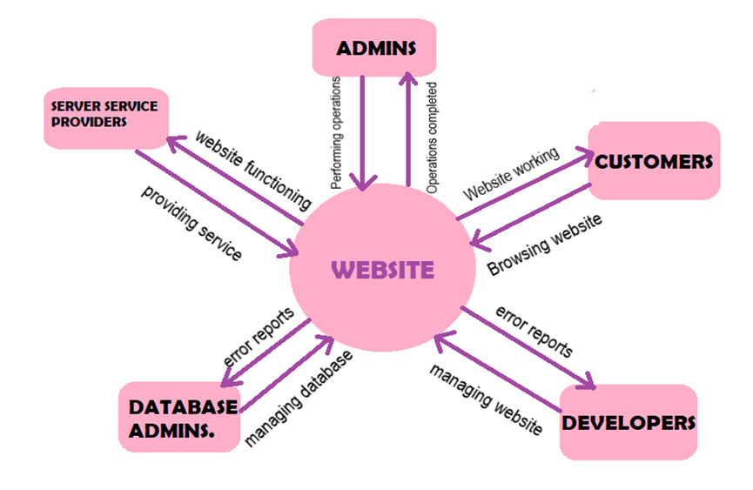

#### 3.1. Hardware Interfaces

Basic input/output devices:

* Mouse
* Keyboard
* Display screen

For internet connection:

* Router
* Mobile data hotspot device (if unavailability of Wi-Fi occurs)

#### 3.2. Software Interfaces

1. Browser: Google chrome, Microsoft edge, Firefox, etc.
2. Server connection is made using expressJS
3. Compatible with: Windows(all versions)
4. Database used: Mysql
5. Libraries: Node JS and mysql libraries used, along other node modules, such as bcrypt, sessions, flash, cloudinary
6. Text editing software for development: Visual Studio Code
7. Database is shared with the admins using the website, access is granted so that they are able to maintain and modify items.

#### 3.3. Communications Interfaces

* Local intranet and internet protocols.
* Three things to make this work: the NODE parser (CGI or server module), a web server and a web browser. You need to run the web server, with a connected node installation. Node program output can be accessed with a web browser, viewing the project page through the server.
* NODE also has support for talking to other services using protocols such as LDAP, IMAP, SNMP, NNTP, POP3, HTTP, COM (on Windows).
* Users can connect with system using browser and internet once user login user can easily buy perfume’s.

## 4. Functional Requirements

### *4.1. Functional Hierarchy*

#### 

#### 4.2. Use Cases

##### 4.2.1. MRM Perfume Shop Online shopping website.

**USE CASE :**

A Use-case diagrams are usually referred to as behavior diagrams used to describe a set of actions (use cases) that some system or systems (subject) should or can perform in collaboration with one or more external users of the system (actors). Each use case should provide some observable and valuable result to the actors or other stakeholders of the system. Use-case diagram contains the actor and the use case symbols, along with connection lines. Actors are similar to external entities; they exist outside the system. The term actor refers to a particular role of a user of the system. The main purpose of a use-case diagram is to show what system functions are performed for which actor. Roles of the actors in the system can be depicted.

The purposes of use case diagrams can be as follows:

* Used to gather requirements of a system.
* Used to get an outside view of a system.
* Identify external and internal factors influencing the system.
* Show the interacting among the requirements are actors

**USE CASE DIAGRAMS :**

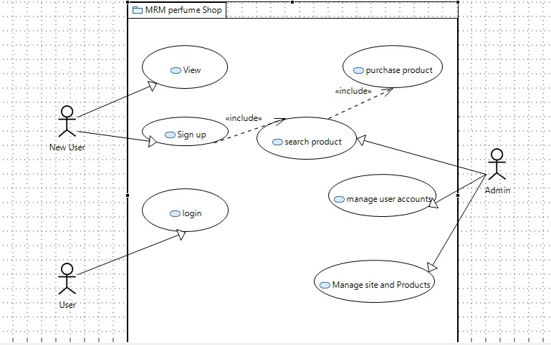

Figure 1 High Level Diagram

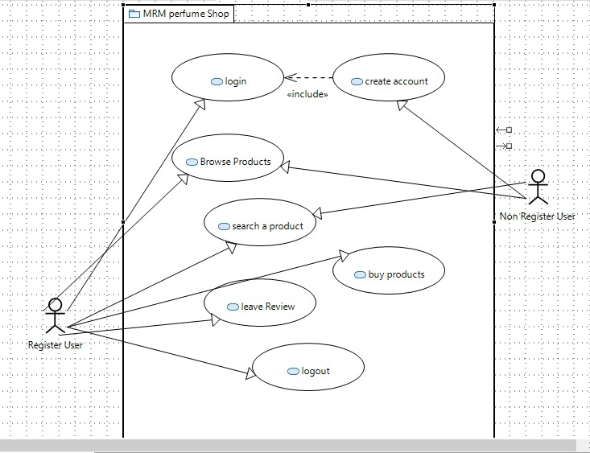

Figure 2 User Management Use Case Diagram

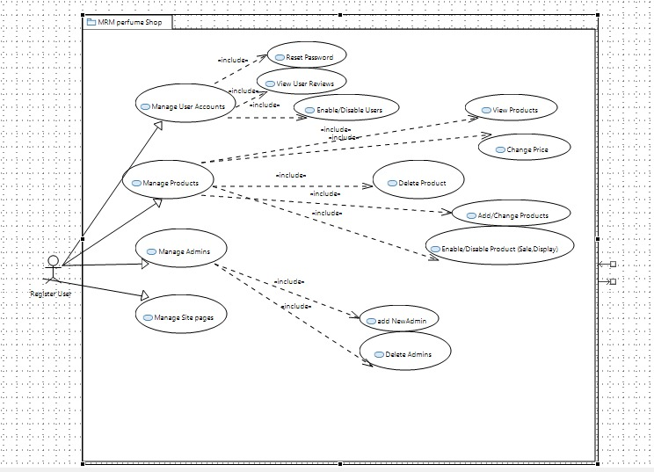

Figure 3 Admin Diagram

|  |
| --- |
| **Use Case Description** |
| **Use Case name:** MRM Perfume Shop |
| **Use Case Description:** This use case is made for the people who are using the website without any technical knowledge. |
| **Primary actor:** Customer, Admin |
| **Stakeholders:** Customer, Admin, Shoe store owner |
| **Relationships**  **Includes:**  Login as user includes enter username and password  Login as admin includes enter username and password  Place order  Register includes create username and password  **Extends:** login as user ->give reviews, place order  Login as admin->modify item inventory, check reviews, view user purchase history, delete user, check order details . |
| **Pre-conditions:** Thewebsite should be function properly, the items in the inventory should also be present at the store physically so the orders can be dispatched if the user places one. And if a new stock is delivered at the perfume shop or if something is out of stock, the admin should check if correct information is present in the website and modify accordingly if not. |
| **Flow of Events:**  Customer:   1. User goes to website 2. Browse the website 3. Select one item 4. logins 5. Places order 6. Makes payment   Admin:   * Logs in as admin * Modifies inventory if required * If the user has queries related to order, checks order details. * If information regarding a user is needed, views user history/ information * If a customer has given a feedback, admin is able to check it |
| **Alternative and exceptional flows:**  Customer:  3.1. If the customer doesn’t want to purchase anything, he/she can leave the website or not place any order.  4.1. if account is not made, the user registers.  4.2. user then logins .  Admin:  The admin will be registered through the Super Admin to make sure that an authentic admin is being registered, if their account already does not exist in the system. |
| **Post-conditions:** If the user has purchased something, the order should be dispatched immediately without any delay. A reliable rider should be available for delivering the orders. Admin should check again if the information has been updated or not. Once the ordered is delivered, the admins should confirm about it from the customer. If the website has something out of stock then the admin should restock it in the store as well as the website. The admins should be responsible for collecting the exact amount from the rider that is of the delivery, as the system is cash-on-delivery. |

## 5. Non-functional Requirements

#### 5.1. Performance Requirements

1. The most important performance requirement has to be that as soon as an order has been place, its dispatched from the warehouse and delivered as soon as possible.
2. The customer feedback is important, if the customer rates below average, the staff/admin of the store should be quick to contact the customer so that they can figure out what dissatisfied the customer.
3. Restocking of perfumes, once they are out of stock, should be done immediately so that orders are not left pending.
4. Customer queries and problems regarding the site should be answered immediately, a quick response from staff/admin is required.
5. The riders should be quick in delivering the orders.

#### 5.2. Safety Requirements

1. The admins using the website should be registered in the presence of the owner/boss.
2. Policies have to me made to ensure no one tries to tamper with site, if one does so, there should be a penalty.
3. Customer data should be kept safe and secure, the system should have a password so that not everyone can login to the computer.

#### 5.3. Security Requirements

#### Web store will validate credit cards against fraud.

#### Web store keep the information of the customers and merchants safe.

#### Web store obeys all the security laws of Pakistan relating to cyber traffic.

#### The customer information should be confidential and data integrity needs to maintained.

1. Admins should be notified if a suspicious activity tries to take place in the system. (General)
2. Unusual orders placed should be confirmed by the admin through other means like contacting the customer via a phone call.
3. The rider should be reliable for the delivery and payments.

#### 5.4. User Documentation

1. The web store well is easy to use.
2. It will be easy to learn how to operate it.
3. The web store will show easy to locate buttons
4. The web store use simple English so that user cannot confuse with terms.
5. The web store should be easy to upgrade

## SDS

# 6. System Architecture

**Class Diagram :**

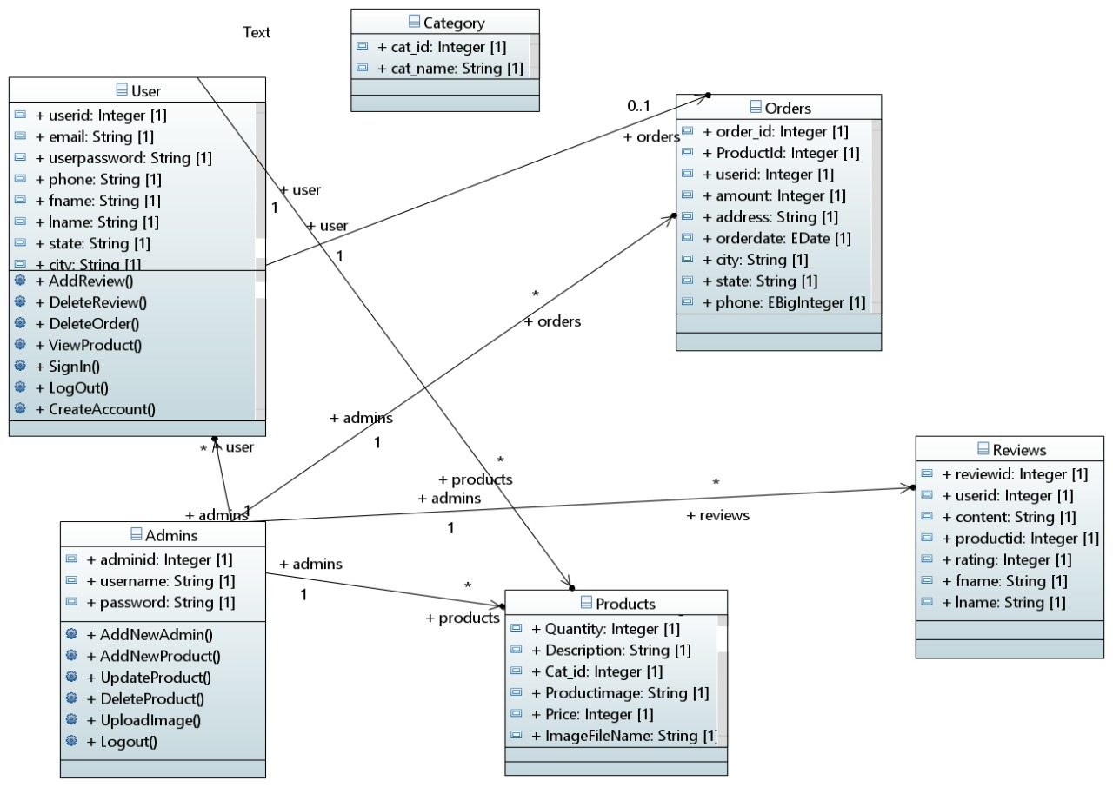

Figure 4 Complete Overview of Website

### 6.1. System Level Architecture

**Component Diagram :**

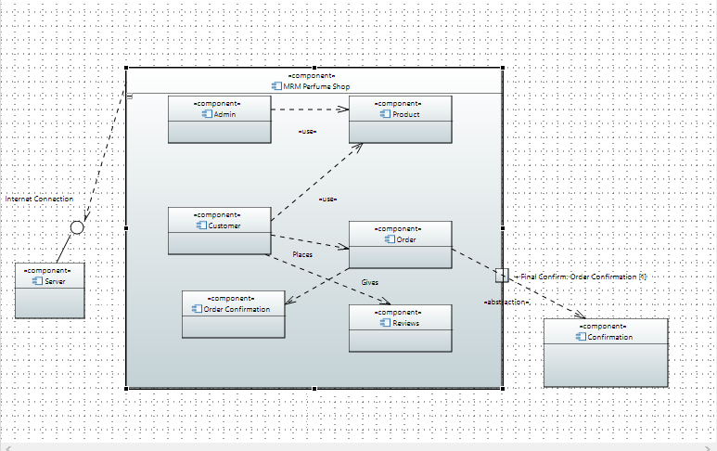

Figure 5 Component Diagram (Component and their Relations )

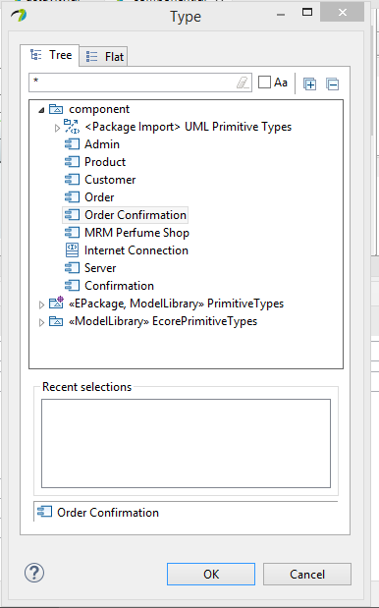

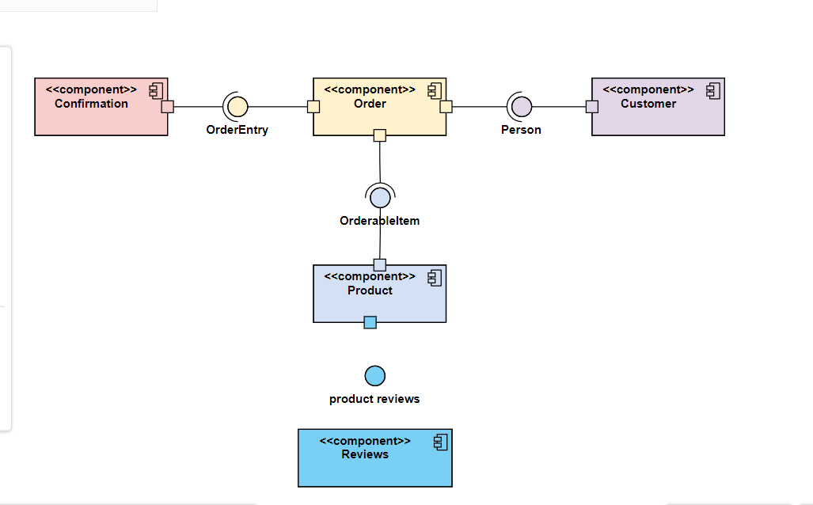

**Deployment Diagram :**

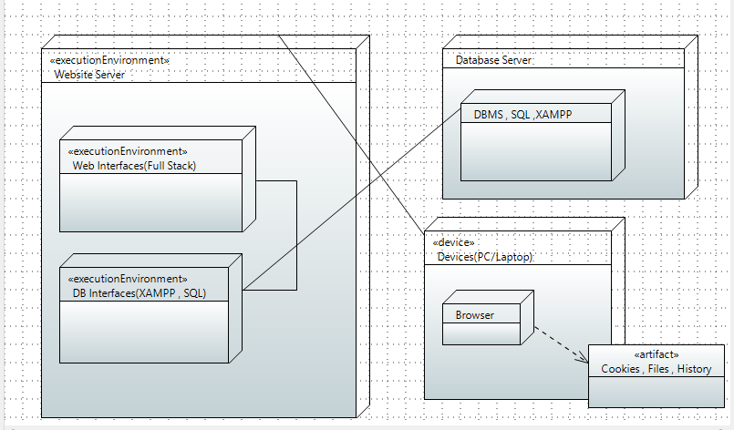

Figure 6 Deploy Environments Servers and Devices

# 7. Design Strategy

**ECB :**

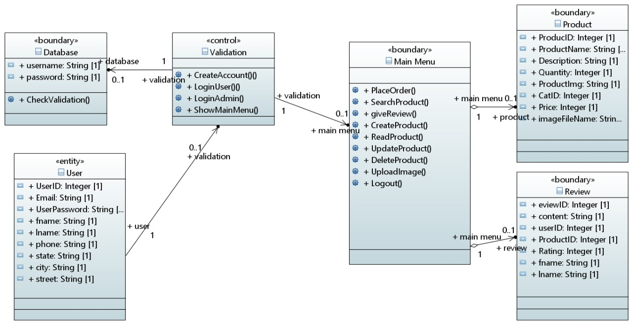

# 8. Detailed System Design

### 

### 8.1. Database Design

***8.1.1. ER Diagram***

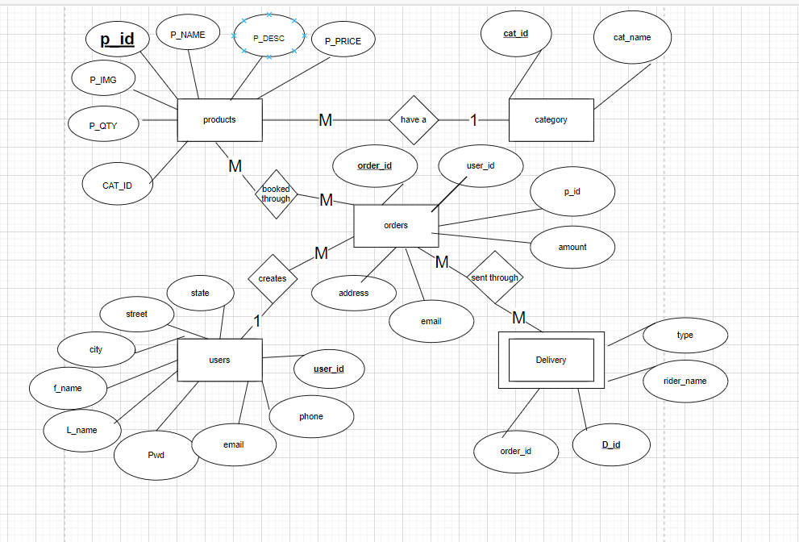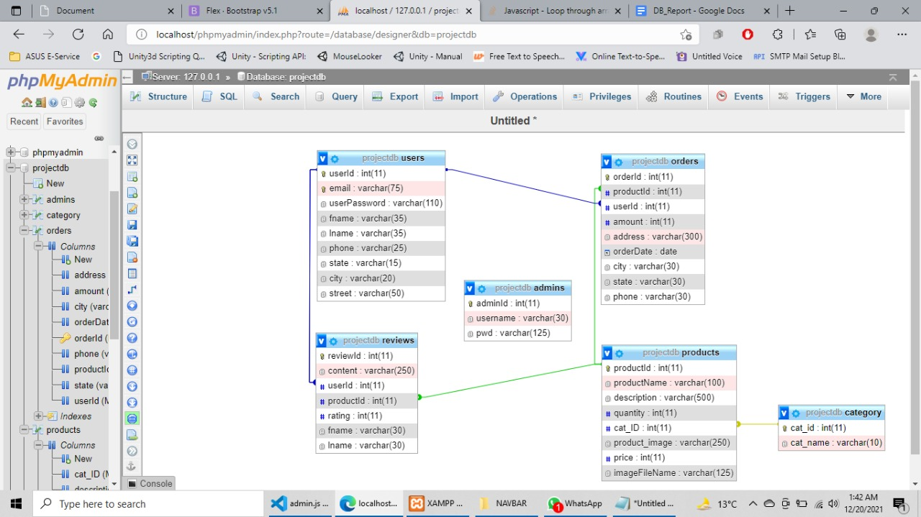

## 9. Application Design

***9.1.1. Collaboration / Communication Diagram***

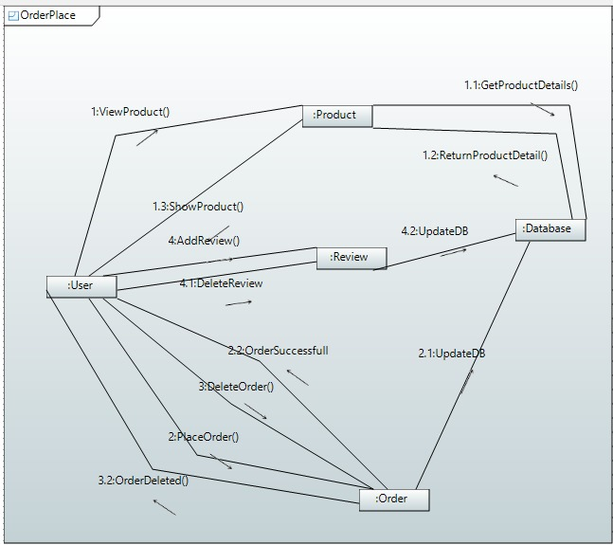

Figure 7 Placing Order

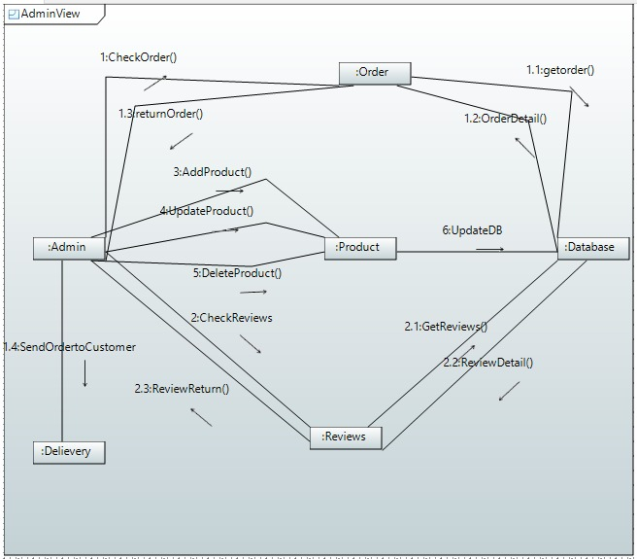

Figure 8 Wide Admin View

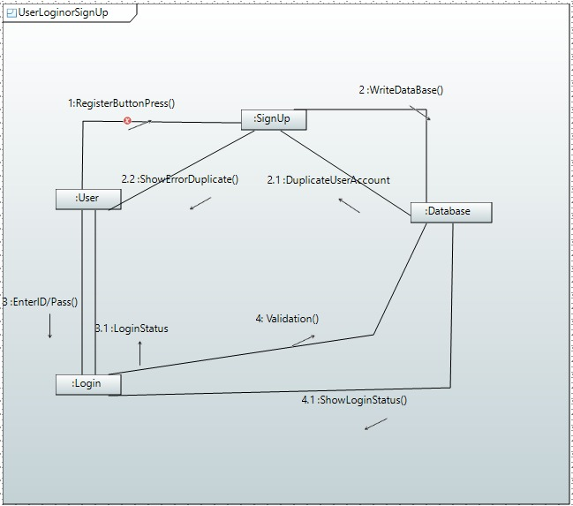

Figure 9 Wide User SignUp and Login View

***9.1.2. Sequence Diagram***

***9.1.2.1 <Sequence Diagram 1>***

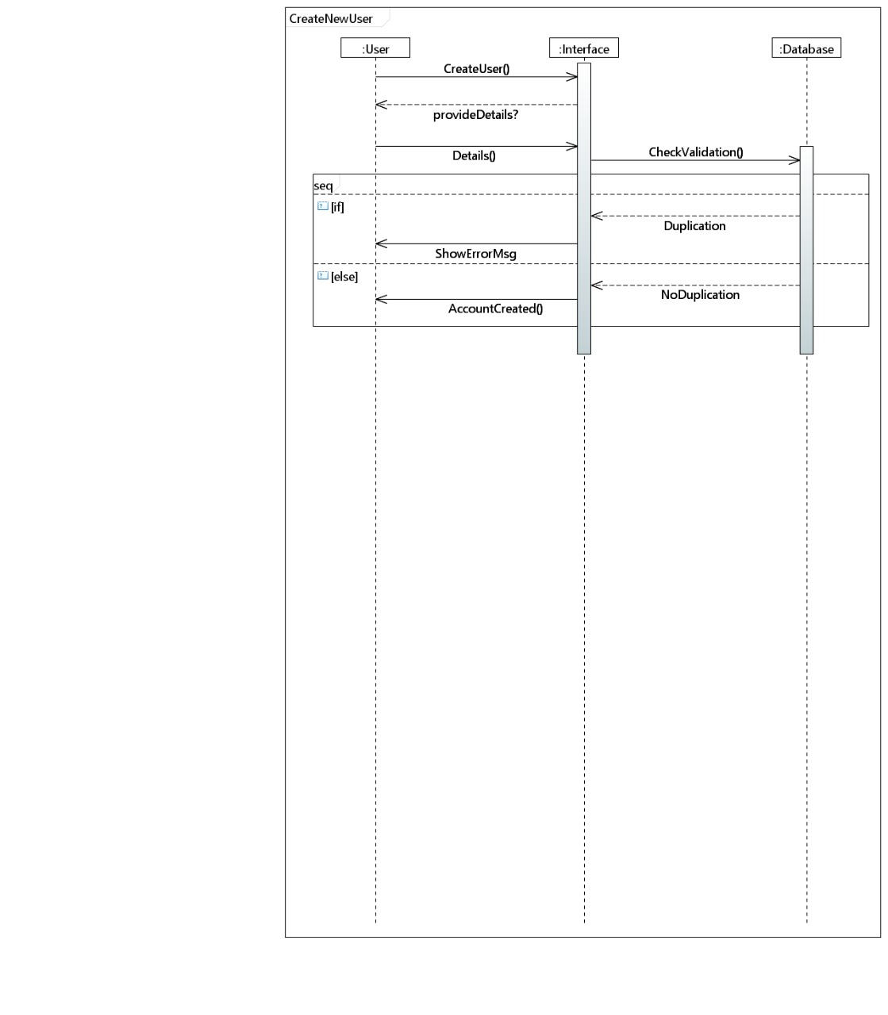

Figure 10 New user Show

***9.1.2.2 <Sequence Diagram 2>***

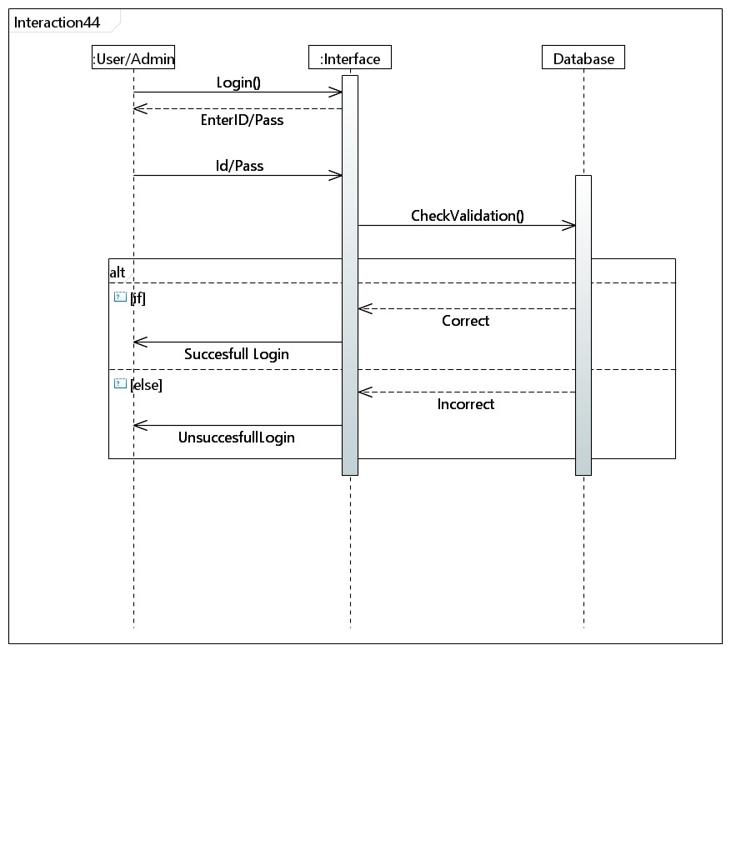

Figure 11 User Interaction

***9.1.2.3 <Sequence Diagram 3>***

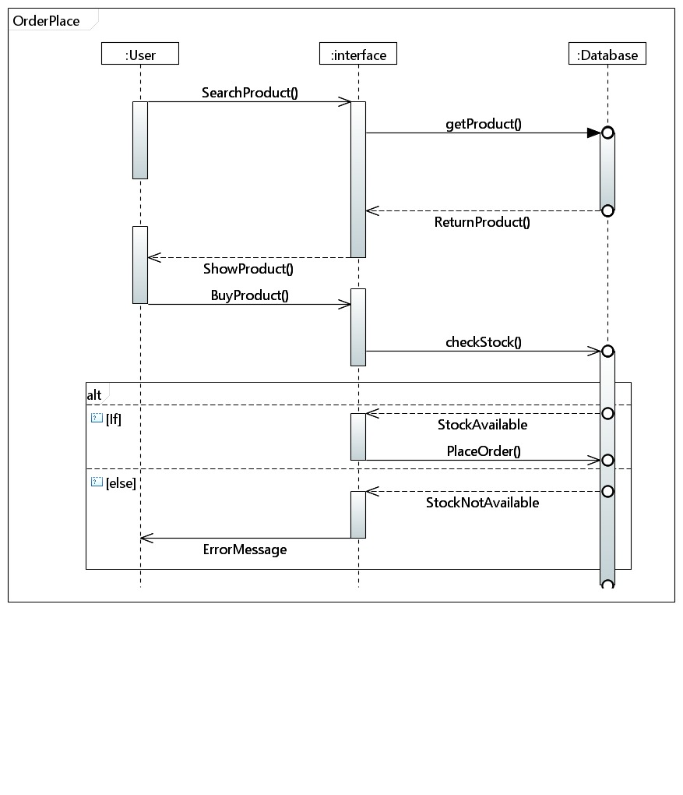

Figure 12 Placing an Order

**9.1.2.4 <Sequence Diagram 4>**

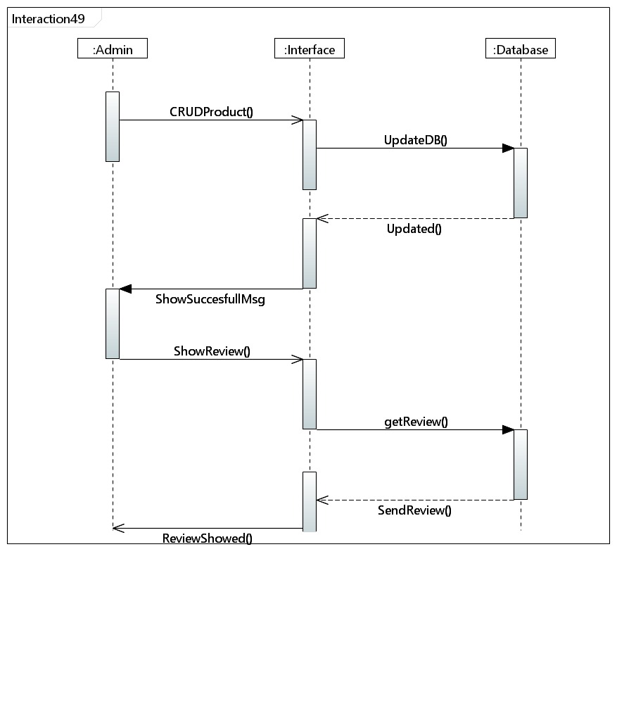

Figure 13 Admin View

***9.1.2.5 <Sequence Diagram 5>***

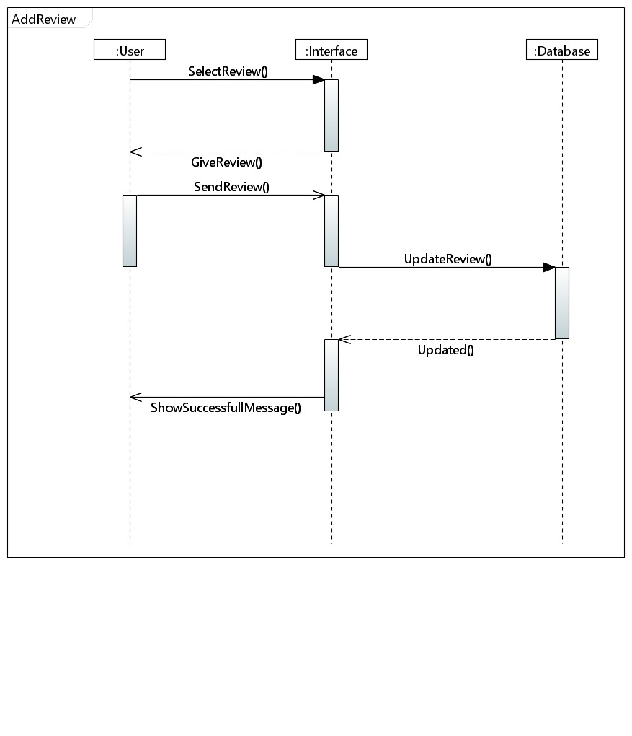

Figure 14 Reviews View

***9.1.3. State Diagram***

***9.1.3.1 <State Diagram 1>***

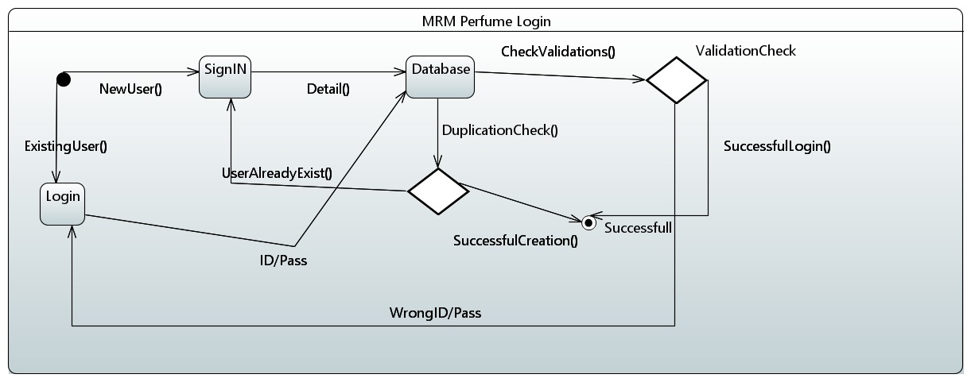

Figure 15 General View

***9.1.3.2 <State Diagram 2>***

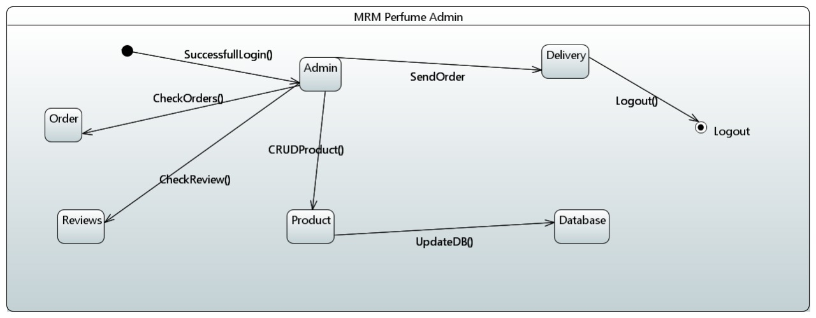

Figure 16 Admin View

***9.1.3.3 <State Diagram 3>*** 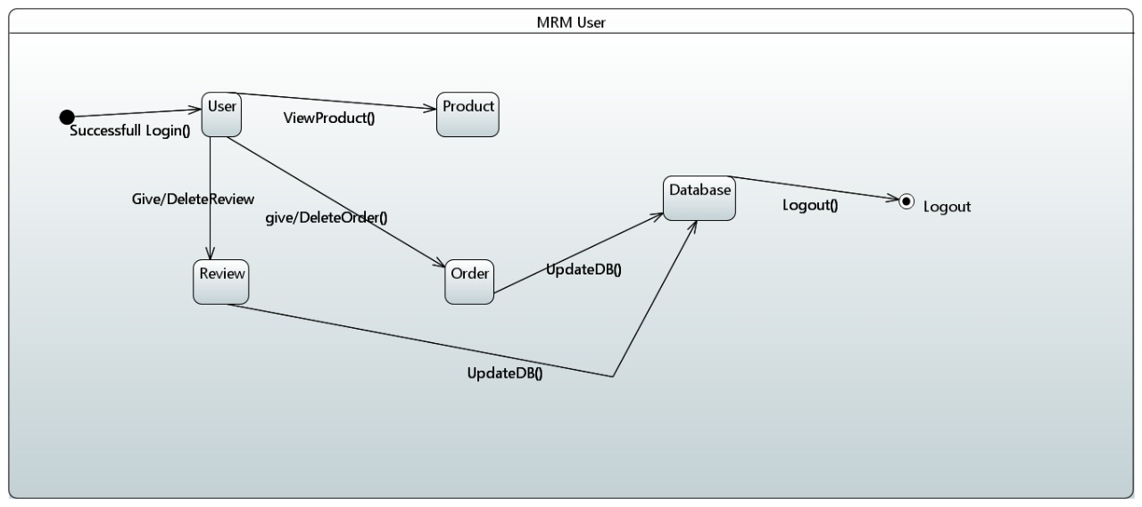

Figure 17User View

***9.1.4. Activity Diagram***

***9.1.4.1 <Activity Diagram 1>***

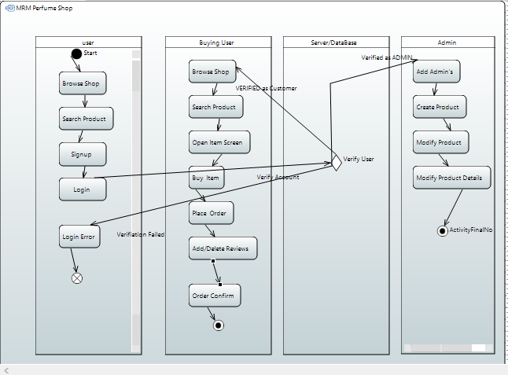

Figure 18 Complete View of the Website

## 10. References

*For SRS and SDS :*

[*https://drive.google.com/file/d/1S6qpaiC5dvK73JuKCdfeEcdbRdNBZ7j7/view?usp=sharing*](https://drive.google.com/file/d/1S6qpaiC5dvK73JuKCdfeEcdbRdNBZ7j7/view?usp=sharing)

*Google :*

<https://www.google.com/search?q=uml+diagrams&rlz=1C1CHBD_enPK979PK979&oq=uml+diagrams&aqs=chrome..69i57j0i433i512l2j0i131i433i512j0i512j69i61l3.3108j0j7&sourceid=chrome&ie=UTF-8>

<https://www.google.com/search?q=timing+diagram+uml&tbm=isch&ved=2ahUKEwix-O327fD0AhVI_zgGHfu8AHAQ2-cCegQIABAA&oq=timing+diagram+uml&gs_lcp=CgNpbWcQA1AAWDhgmgJoAHAAeACAAQCIAQCSAQCYAQCgAQGqAQtnd3Mtd2l6LWltZ8ABAQ&sclient=img&ei=_aq_YfGFIsj-4-EP-_mCgAc&bih=722&biw=1536&hl=en>

<https://www.google.com/search?q=google+uml+diagrams&rlz=1C1CHBD_enPK979PK979&oq=google+uml+diagrams&aqs=chrome..69i57j0i131i433i512l2j69i60l3j69i65j69i60.6776j0j7&sourceid=chrome&ie=UTF-8>

Youtube :

<https://www.youtube.com/watch?v=WnMQ8HlmeXc>

<https://www.youtube.com/watch?v=UI6lqHOVHic&t=1s>

<https://www.youtube.com/watch?v=pCK6prSq8aw>

<https://www.youtube.com/watch?v=hZFwL7n6wus&list=PLr3OnN7KdzeiR4zrkbXLQC2xPMAhPhR86>

Other links :

https://www.edrawmax.com/article/deployment-diagram-explained.html

https://creately.com/diagram/example/ie5c7by43/e-commerce-deployment-%5Bclassic%5D

https://creately.com/blog/diagrams/sequence-diagram-tutorial/

https://www.visual-paradigm.com/guide/uml-unified-modeling-language/uml-aggregation-vs-composition/

## 11. Appendices

*Google.com*

<https://www.visual-paradigm.com/>

<https://www.uml-diagrams.org/>

youtube.com

**Working Project GITHUB Link :**

https://github.com/smahad09/CS2005