



***Software Requirement and Design***

***Specifications***

***[ Student Management System ]***

***Version: [2.0]***

| *Course Code* | Software Design Architecture |
| --- | --- |
| *Instructor* | Miss Rubab Jaffer |
| *Project Team* | 20k1672 - Zain Ul Abdin  20k-0196 - Siddque Akber  20k-1038 - Kazi Zain  19k-1066 - Ali Khaf |
| *Submission Date* | 30/04/2023 |

***[Instructions]***

- *No section of template should be deleted. You can write ‘Not applicable’ if a section is not applicable to your project. But all sections must exist in the final document.*

- *All comments/examples mentioned in square brackets ([]) are in the template for explanation purposes and must be replaced / removed in final document.*

- *This’ Instruction’ section should also be removed in final document.*

***TABLE OF CONTENT OF SRS***

*1. INTRODUCTION .....................................................................................................................................................5*

1.1. Purpose of Document.........................................................................................................................5

1.2. Intended Audience ..............................................................................................................................5

*2. OVERALL SYSTEM DESCRIPTION ............................................................................................................................6*

2.1. Project Background.............................................................................................................................6

2.2. Project Scope ......................................................................................................................................6

2.3. Not in Scope ........................................................................................................................................6

2.4. Project Objectives ...............................................................................................................................6

2.5. Stakeholders ........................................................................................................................................6

2.6. Operating Environment ......................................................................................................................6

2.7. System Constraints.............................................................................................................................6

2.8. Assumptions & Dependencies ..........................................................................................................6

*3. EXTERNAL INTERFACE REQUIREMENTS ..................................................................................................................7*

3.1. Hardware Interfaces ...........................................................................................................................7

3.2. Software Interfaces .............................................................................................................................7

3.3. Communications Interfaces ...............................................................................................................7

*4. FUNCTIONAL REQUIREMENTS................................................................................................................................8*

*4.1. FUNCTIONAL HIERARCHY .............................................................................................................................8*

4.2. Use Cases............................................................................................................................................8

4.2.1. [Title of use case] ...........................................................................................................................8

4.3 ERD Diagram —---------------------------------------------------------------------------------------------*9*

*5. NON-FUNCTIONAL REQUIREMENTS........................................................................................................................9*

5.1. Performance Requirements...............................................................................................................9

5.2. Safety Requirements ..........................................................................................................................9

5.3. Security Requirements .......................................................................................................................9

5.4. User Documentation ...........................................................................................................................

***1. Introduction***

***1.1. Purpose of Document***

*The purpose of this document is to describe how our student portal will work and resolve the problems.*

***1.2. Intended Audience***

* *Student*
* *Teacher*
* *Admin*

**1.3 Definition of Terms, Acronyms and Abbreviations**

*[This section should provide the definitions of all terms, acronyms, and abbreviations required to interpret the terms used in the document properly. ]*

| ***Term*** | ***Description*** |
| --- | --- |
| *ERD* | *Entity Relationship Diagram* |
| *DD* | *Design Specification* |
|  |  |
|  |  |
|  |  |
|  |  |
|  |  |
|  |  |

***1.4 Document Convention***

*Using the size of*

*12 : for subheading*

*16 : for Sub headings*

*and 10 : for normal text or description text*

***2. Overall System Description***

***2.1. Project Background***

*This project will provide all the necessary facilities and functions which are used for managing the organizational goal .This Project will provide not only good user experience but also ease of use interface.*

***2.2. Project Scope***

*This project will be managing all details of academic processes . Furthermore , students can see their attendance , their grade and further queries . On the other hand teachers will add their marks, Attendance. At the Backend of our project ,we will be using SQL server to connect to Frontend . Furthermore , we will try to use the concept of Database . We will execute the some constraints on student class , student can online see the attendance can not mark their own attendance ,student can only see the marks no one allow to upload the marks except the teacher .*

***2.3. Not In Scope***

*Project will only include all the needed functionality of the system .Not include the external feature .*

*Like : Attachment of assignment .*

***2.4. Project Objectives***

1. *Manage the marks and And Attendance of course effectively.*
2. *Teachers manage student records effectively According to the course.*
3. *management of university records will perform efficiently by Administration.*

***2.5. Stakeholders***

1. *Student*
2. *Teacher*
3. *Admin*

***2.6. Operating Environment***

*This system will include*

* *Xampp Server*
* *PhpMyAdmin*
* *Web Browser (E.g : Edge,Chrome)*

***2.7. System Constraints***

* ***Software Constraints:***

1. *Mark Attendance and grades only for those students who are enrolled in the course.*
2. *Teacher marks only that particular course which is assigned to that teacher.*
3. *Only Related stakeholders can Login to the system.*
4. *Every stakeholder can perform system functionalities according to their privileges.*

* ***Legal Constraints:***

1. *The project is developed for University, so it may be required that the project has themes related to the study and require more textual tools rather than graphical tools.*

•

***2.8. Assumptions & Dependencies***

*[This section will identify:*

• *Any assumptions taken regarding the system or environment*

•

***3. External Interface Requirements***



***3.1. Hardware Interfaces***

*This software will be available for all the websites . Like : Google Chrome or Microsoft Edge .*

***3.2. Software Interfaces***

*As early , we discussed that this software is a web based application .So, its does not need any particular operating system . It will only need the Browser .*

***3.3. Communications Interfaces***

*[Describe the requirements associated with any communication functions the system will use, including e- mail, web browser, network communications standards or protocols, electronic forms, and so on. Define any pertinent message formatting. Specify communication security or encryption issues, data transfer rates, and synchronization mechanisms.]*

***4. Functional Requirements***

***4.1. Functional Hierarchy***

*[This section will give a big picture of overall system functionality. The main modules/features of the system and their sub-functions will be described here in the form of a functional hierarchy so that, before getting into the use case, the audience could grab the idea of overall system functions.]*

***4.2. Use Case Diagram***

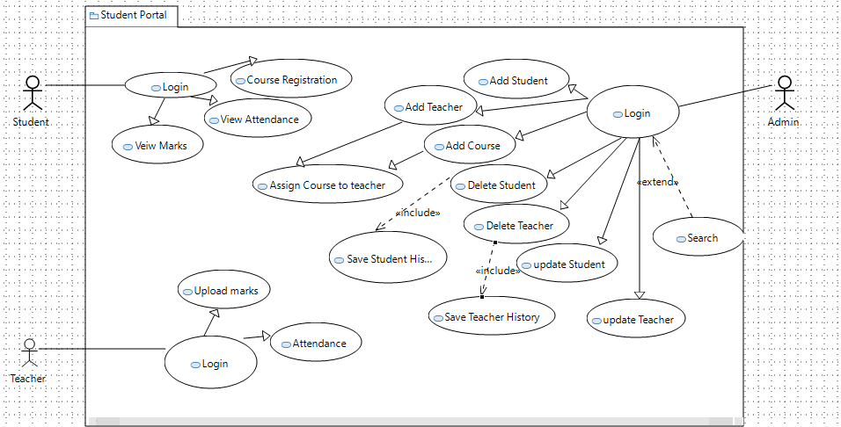

| ***Use Case Description*** | |
| --- | --- |
| ***Use Case name:*** | Student Portal |
| ***Use Case Description:*** | |
| ***Primary actor: 03*** | ***Other actors: 00*** |
| ***Stakeholders:*** | **03** |
| ***Relationships***  ***Includes: 02***  ***Extends: 01*** | |
| ***Pre-conditions: To manipulate any record or detail .Your have to Login first .*** | |
| ***Flow of Events:***  ***1. Login as Admin***  ***2. Select any one option .*** | |
| ***Alternative and exceptional flows:***  ***Invalition input or*** *….* | |
| ***Post-conditions:***  *Successfully login and*  *Successfully updated* | |

***5. Non-functional Requirements***

***5.1. Performance Requirements***

1. *Atomicity (*guarantees that all of the commands that make up a transaction are treated as a single unit and either succeed or fail together*)*
2. *Consistency (*guarantees that changes made within a transaction are consistent with database constraints*)*
3. *Isolation (* enables running transactions concurrently because transactions don’t interfere with each other.*)*
4. *Durability (*This ensures that data within the system will persist even in the case of system failures like crashes or power outages.*)*

***5.2. Safety Requirements***

1. ***Encryption:*** *Use encryption to protect sensitive data Like : password of user .*

***5.3. Security Requirements***

1. No student has access to see other students' marks and attendance.
2. Teacher only marks the attendance of the course which is assigned to him.
3. Students have only the privileges to see their marks and attendance only they have no right to edit them or access the teacher panel.

***5.4. User Documentation***

* *User manual .*
* *A video demonstration of software will be provided .*

SDS

CONTENT TABLE OF SDS

**6. System Architecture 15**

6.1. System Level Architecture 15

6.1.1. Deployment Diagram 15

6.1.2. Component Diagram 16

**7 DataBase Relationship 17**

7.1. ER Diagram 17

**8. Application Design 17**

8.1. Sequence Diagram 18

8.1.2. State Diagram 18

8.1.2.1 <State Diagram of student panel> 18

8.1.2.2 <State Diagram of teacher panel> 19

8.1.2.3 <State Diagram of admin panel> 19

8.1.3. Activity Diagram 19

8.1.3.1 <Student Activity Diagram > 19

8.1.3.2 <TEACHER ACTIVITY DIAGRAM> 20

8.1.3.2 <Admin Activity Diagram> 21

8.1.4 < Class Diagram > 22

8.1.5 <Robust Diagram> 23

8.1.6<Communication Diagram> 24

# 6. System Architecture

*Using Deployment diagram and Component diagram for representing the system.*

## 6.1. System Level Architecture

### 6.1.1. Deployment Diagram

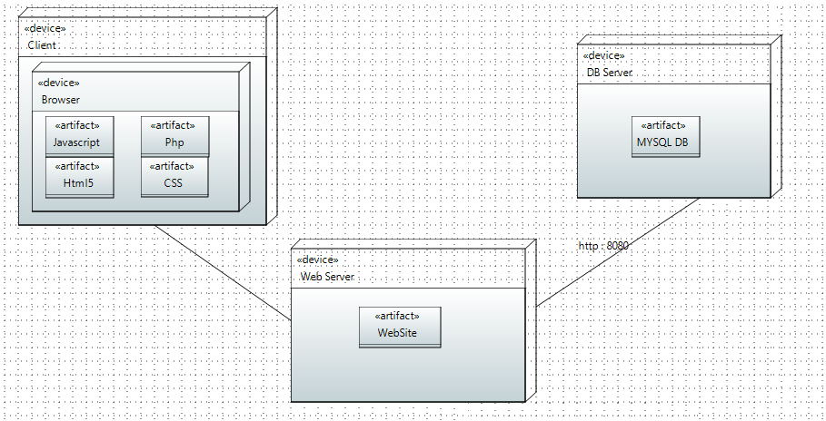

### 6.1.2. Component Diagram

Using Arrows Instead of Connectors . Due to not present in application.

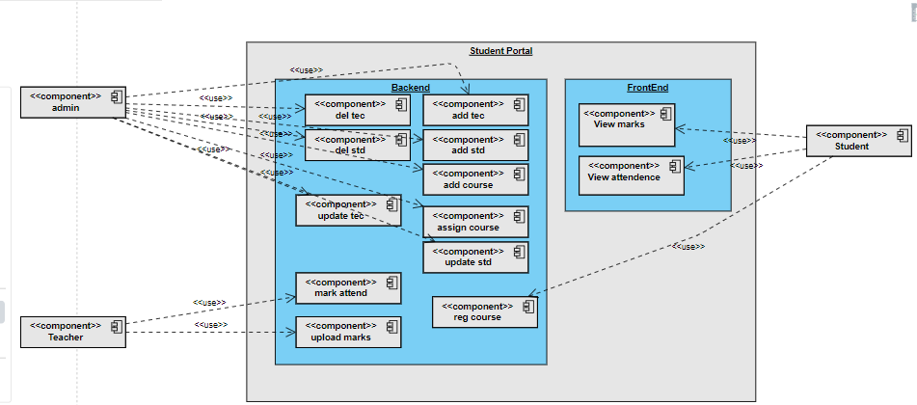

# 7 DataBase Relationship

## 7.1. ER Diagram

*[Entity Relationship Diagram of the system with description]*

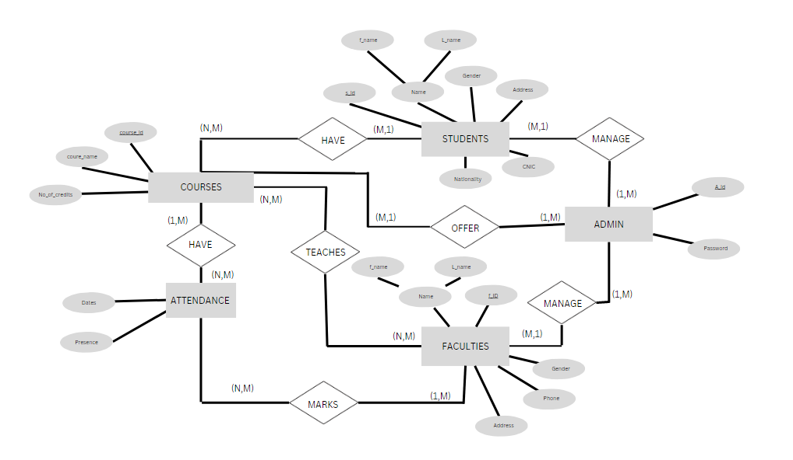

# 8. Application Design

Using Sequence diagram ,State diagram of three stakeholder [Students , Teachers and Admin ] which are interacting with system .

## 8.1. Sequence Diagram

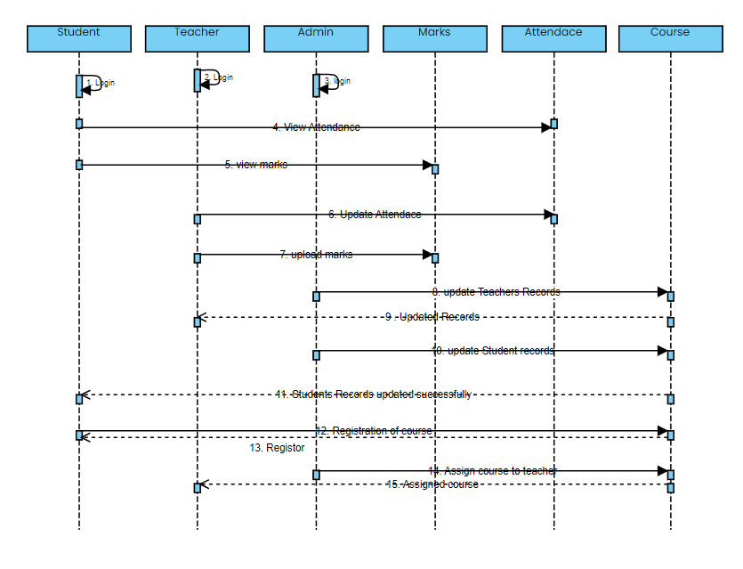

## 8.1.2. State Diagram

### 8.1.2.1 <State Diagram of student panel>

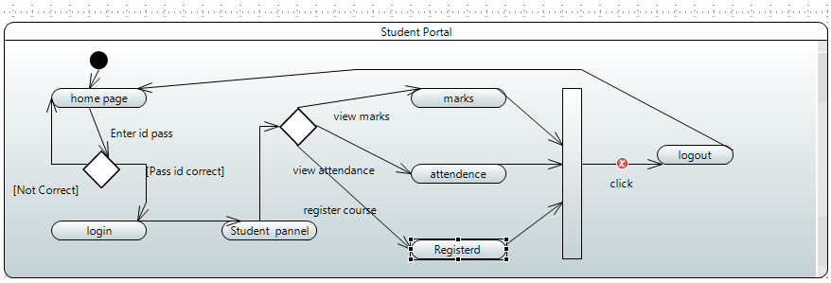

### 8.1.2.2 <State Diagram of teacher panel>

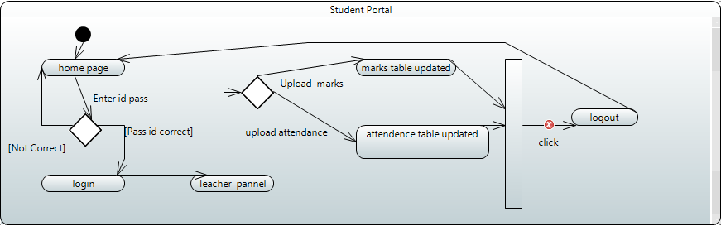

*.*

*.*

*.*

### 8.1.2.3 <State Diagram of admin panel>

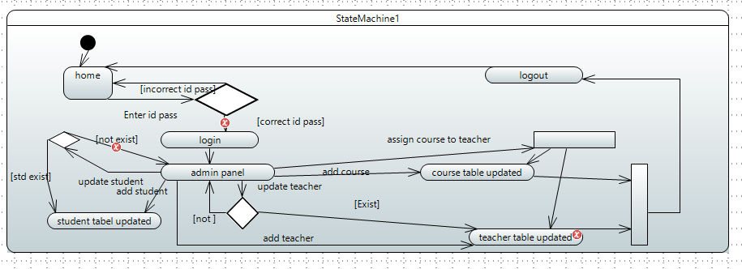

## 8.1.3. Activity Diagram

### 8.1.3.1 <Student Activity Diagram >

*This is*

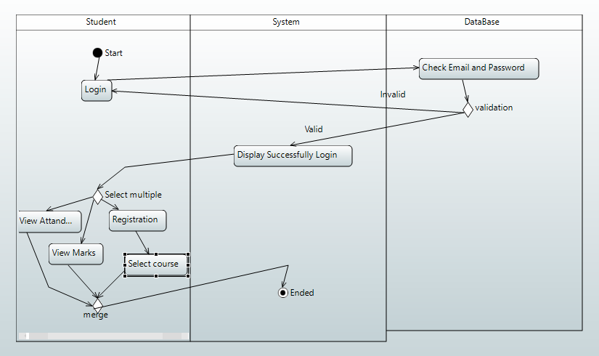

### 8**.1.**3**.2 <**TEACHER ACTIVITY DIAGRAM**>**

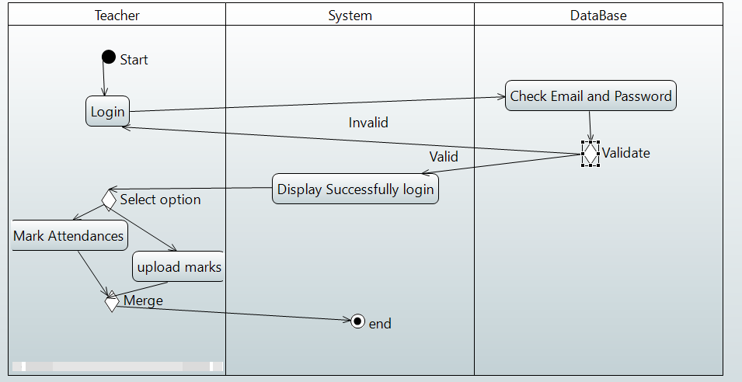

### 

### 8.1.3.2 <Admin Activity Diagram>

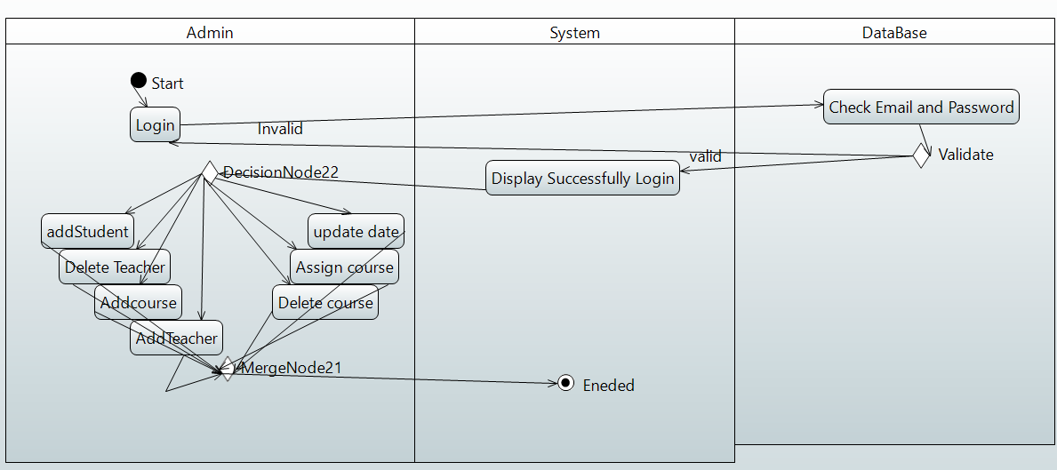

## 8.1.4 < Class Diagram >

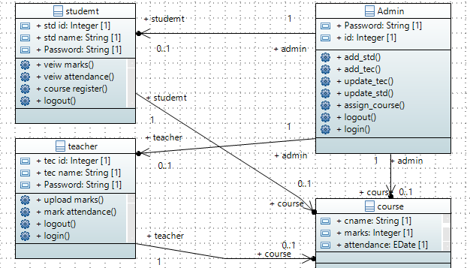

## 8.1.5 <Robust Diagram>

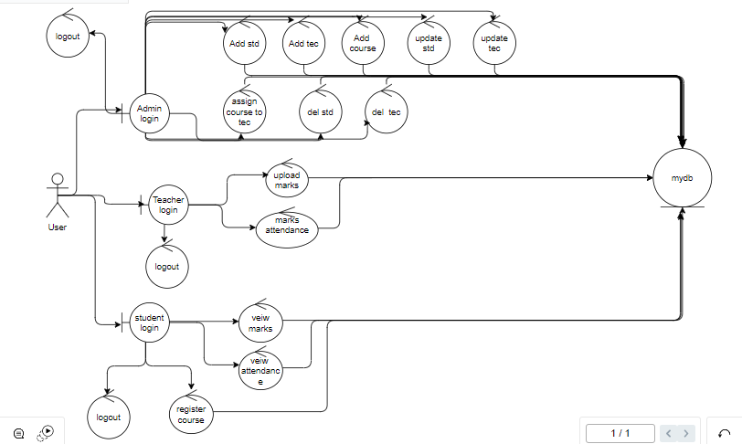

## 8.1.6<Communication Diagram>

