Download the jbn code and import it into eclipse.
Goto: https://punch.cs.sfu.ca/svn/oschulte-srl/elwinjbn/
Download the jbn.rar
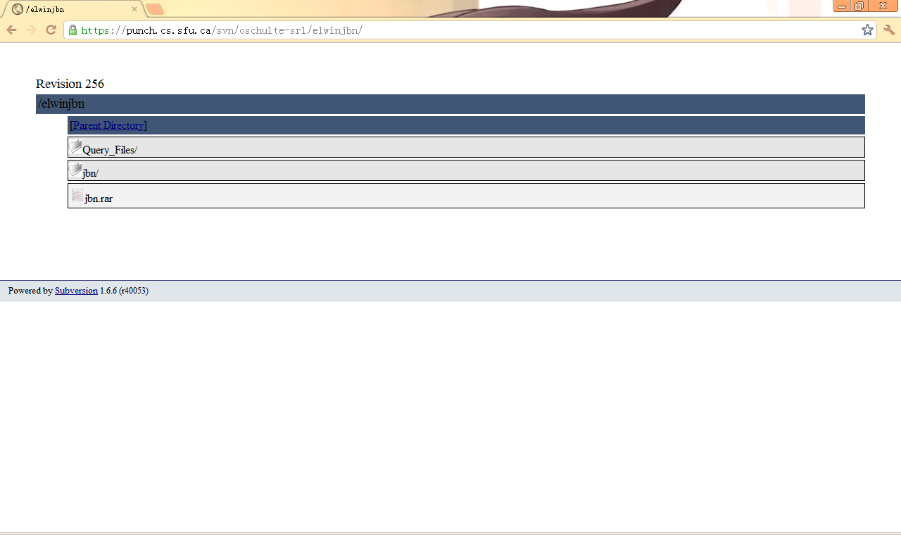

Unzip the jbn.rar

Import the jbn folder into eclipse
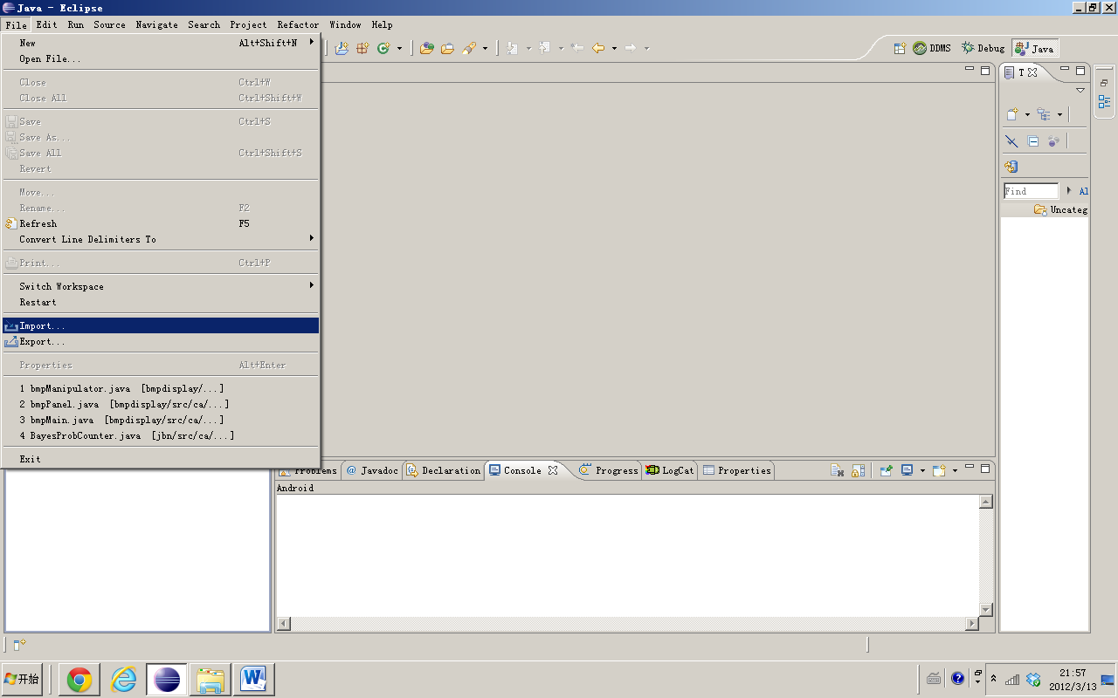

Choose ‘Existing Projects into Workspace’
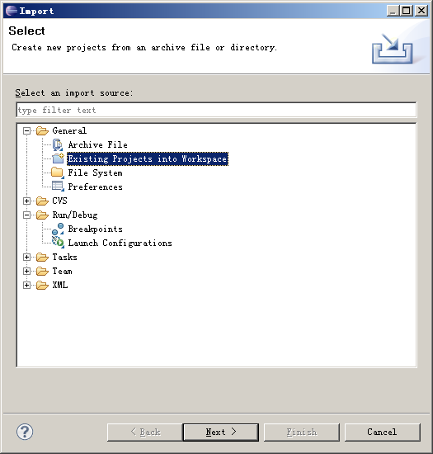

Select root directory, and click ‘Finish’
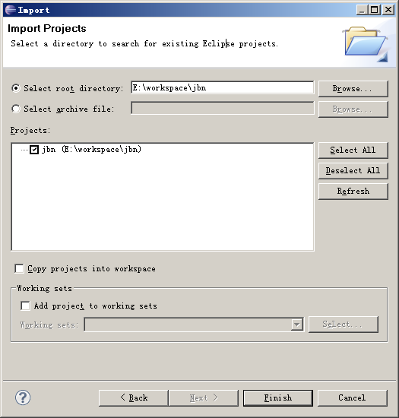

Choose the package “ca.sfu.jbn.frequency”, select the file ‘Compare_main.java’. This is the main function that we need run.
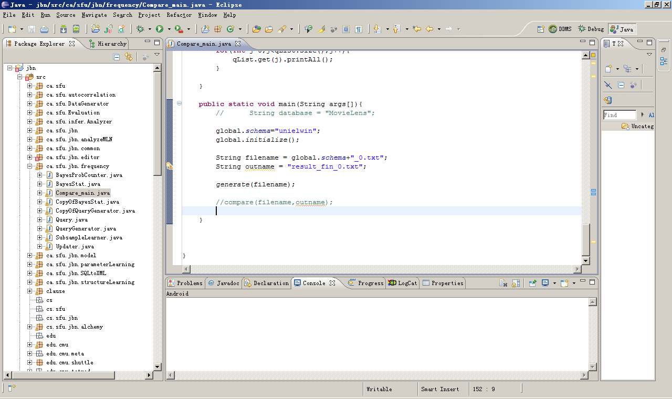

Scroll to the main function:

public static void main(String args[]){
// String database = "MovieLens";

global.schema="unielwin"; // Choose the database that you want to generate the random query
// for example: global.schema="MovieLens";

global.initialize();

String filename = global.schema+"_0.txt"; // the filename of the random query
String outname = "result_unielwin_0.txt";

generate(filename); // generate the random query file

compare(filename,outname);
}

Generating the random query
It will generate a file call ‘unielwin_0.txt’ which is the ‘filename’ in the java program and located in the jbn directory.
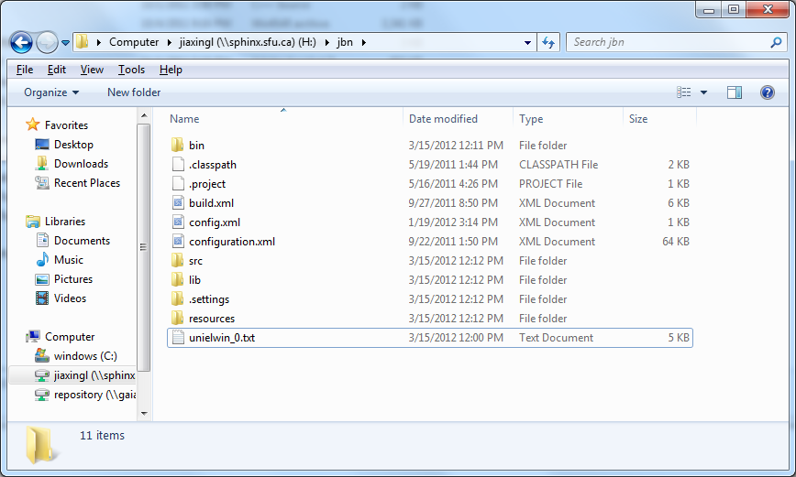
Back to Eclipse
Comment the code ‘generate(filename); // generate the random query file’
Uncomment the code ‘compare(filename,outname);’

public static void main(String args[]){
// String database = "MovieLens";
global.schema="unielwin"; // Choose the database that you want to generate the random query
// for example: global.schema="MovieLens";

global.initialize();

String filename = global.schema+"_0.txt"; // the filename of the random query
String outname = "result_unielwin_0.txt";

//generate(filename); // generate the random query file

compare(filename,outname);

}

We will get txt file call ‘result_unielwin_0.txt’
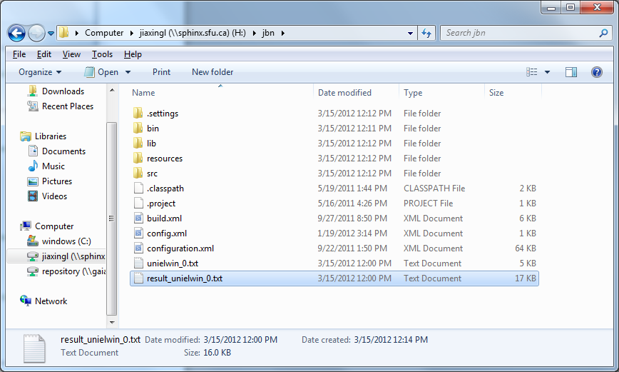

We can import the txt file into Excel
Find the ‘Data’ Button in the menu bar.
Click the Button ‘ From text’.
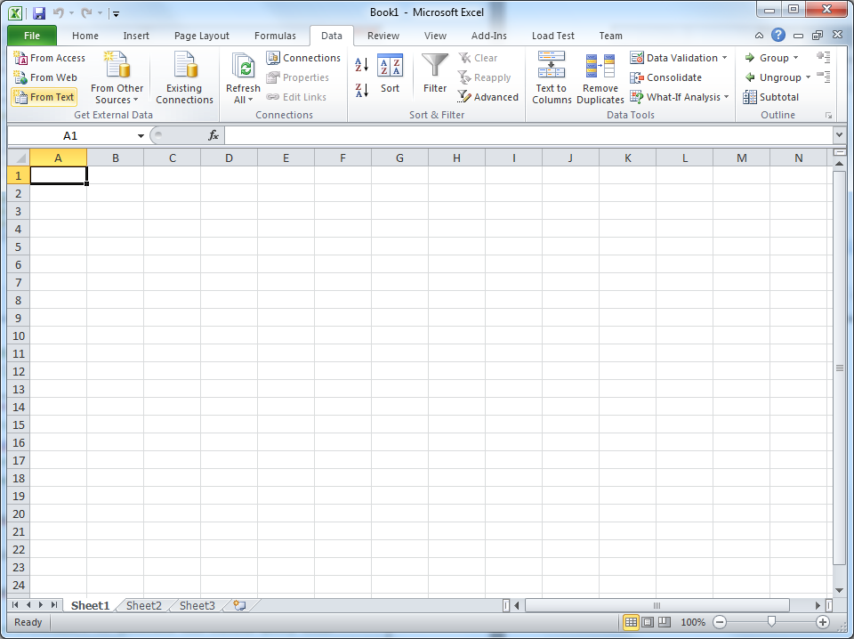

Click ‘Next’
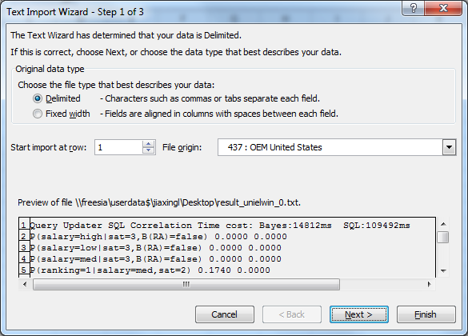
Check the box ‘Space’, and finish.

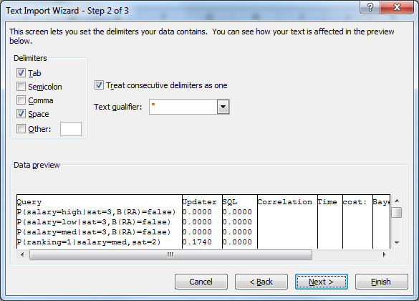

Finally, we get the random data.

