**SSH Password-Based authentication to connect to the node from Master node**

**Step1.** Install and Configure Ansible on Ubuntu 20.04.

sudo apt update

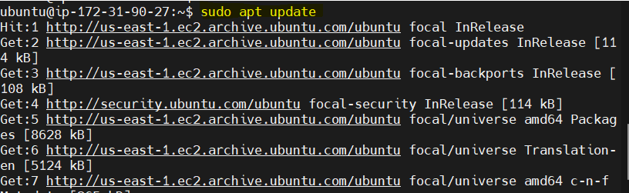

sudo apt install ansible -y

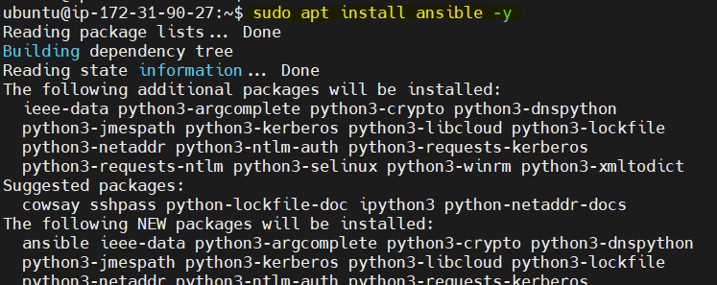

Check Ansible version

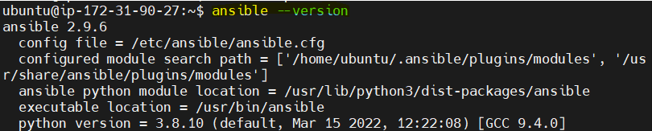

Installing sshpass act as SSH authentication mechanism.

sudo apt install sshpass

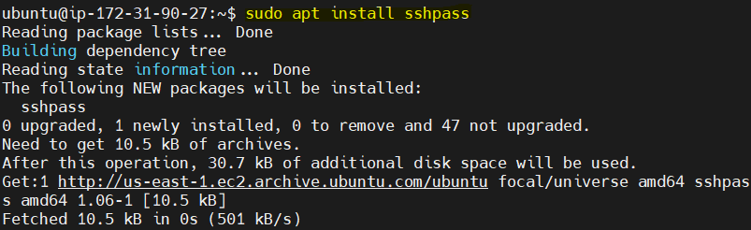

**Step2.** Now, configure the ansible hosts inventory file which is come with default ansible inventory file.

Sudo vim /etc/ansible/hosts



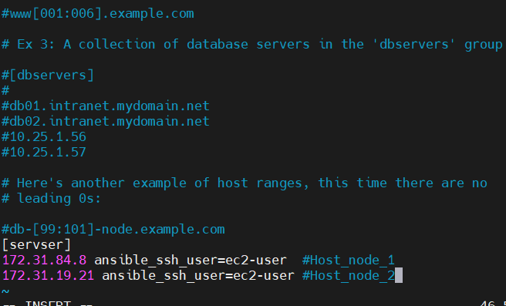

**List of inventories below**

ansible-inventory --list -y

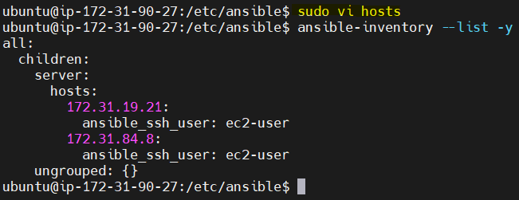

Step3. Now, Connect Password based SSH logging or Connection testing and need to append the option **--ask-pass** that means will make ansible prompt for the password of the host-node user.

* Validity of SSH credentials (node user)

ansible all -m ping --ask-pass

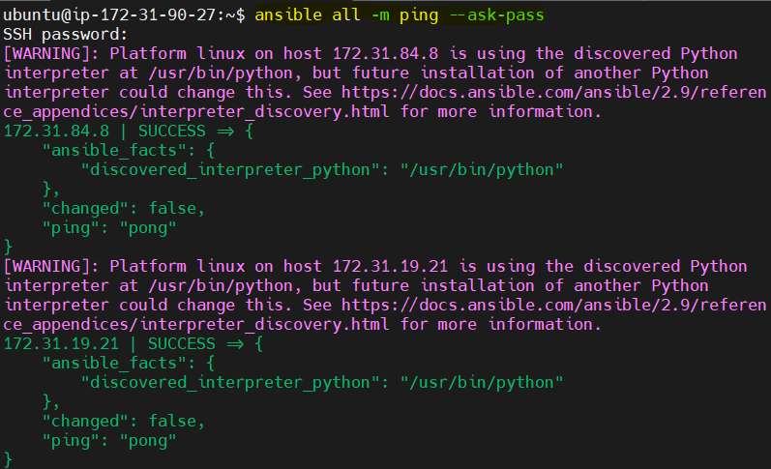

**#############SSH with Passwordless Logging###############**

**Step1.** Create SSH Key-pair like Private and Public Key pair on the Ansible Master node.

ssh-keygen

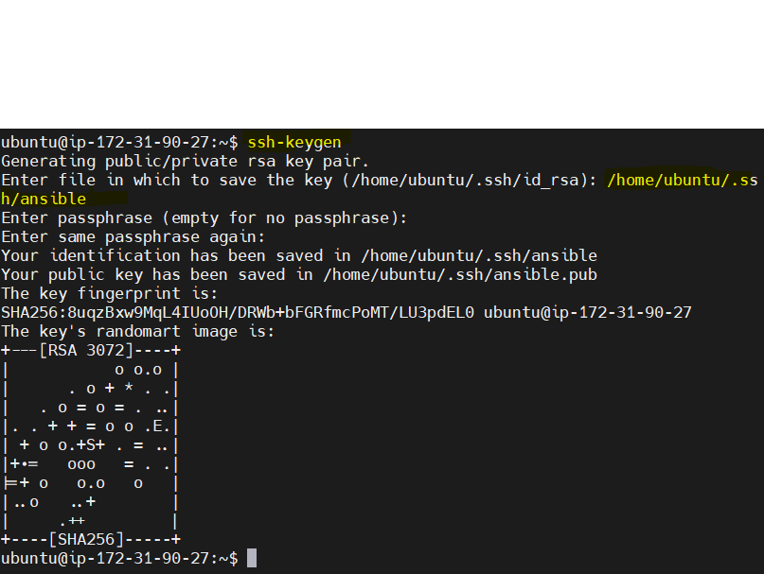

Copy the Public Key to my both Host-node machine (node1 and node2) below an example.

sudo ssh-copy-id -i ~/.ssh/id_rsa.pub ec2-user@172.31.19.21

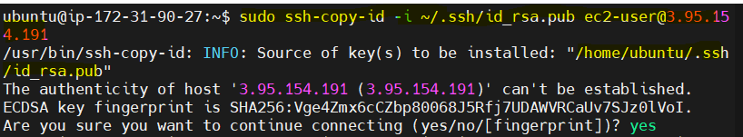

Note: Once triggered this command it will copy the content of **id_rsa.pub** key under the .ssh file for ec2-user of the node server side

**Step2.** Now**,** SSHtesting tohost node from Master node

ssh ec2-user@172.32.84.8

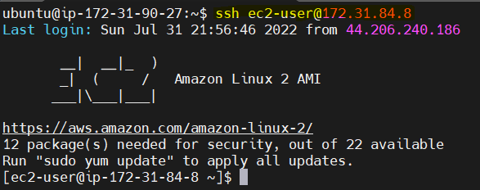

**Step3.** Thisallows to control host-node without a password (Passwordless) from Master-node`

ansible -m ping all

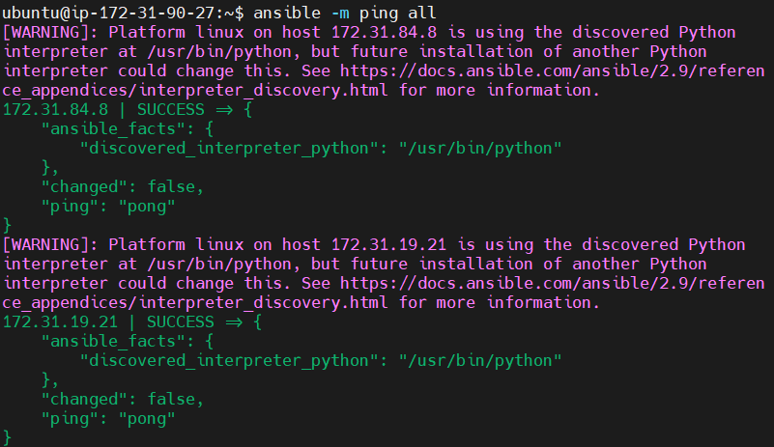

Gufran Shaikh