PHASE 3 CLOSURE REPORT
Heterogeneous Graph Reconstruction and Model-Ready Encoding
ITRS Reproduction using Crunchbase
Final Phase-3 closure manifest:
data/experimental/phase_3/model_ready/phase_3_closure_manifest.json
Report date: 19 August 2026

Executive Summary
Phase 3 reconstructed the heterogeneous structural graph required for the ITRS reproduction while preserving the immutable Phase-1 investment-event layer and the frozen Phase-2 temporal split. The phase first recovered the graph-construction principles disclosed in the ITRS paper, then audited every available Crunchbase source before accepting any structural relationship. The final graph uses only relationships that can be supported by the available data and never forces the paper's reported 103 relationship types when the required Tianyancha fields are absent.
The final scientific graph contains 477,564 role-namespaced nodes and 158,818 directed structural edge records. The graph has two node types (Investor and Startup), three semantic relations (shared_founder, acquired, acquired_by), and 12 typed source-relation-target channels. Historical investment interactions are deliberately excluded from the structural graph and remain in the Phase-2 temporal interaction layer. The final edge table contains zero T60 held-out structural leakage records and all final integrity checks passed.
Core methodological principle: Phase 3 reproduces the ITRS relationship-construction logic rather than fabricating unavailable Tianyancha relations. Crunchbase UUIDs define underlying identity, semantic role defines graph identity, and all structural relations are audited for endpoint validity, directionality, temporal provenance, and T60 leakage before materialization.

Metric | Final value
Canonical Phase-1 interactions | 1,208,051
Total role nodes | 477,564
Directed structural edges | 158,818
T60 structural leakage edge records | 0

Contents
1. Phase Objective and Scope
2. Paper-Grounded ITRS Graph Interpretation
3. Crunchbase Source Universe and Identity Architecture
4. Structural Relationship Source Audit
5. SHARED_FOUNDER Construction and Leakage Control
6. ACQUIRED Construction and Leakage Control
7. Final Graph Schema Selection
8. Node-Table Materialization
9. Edge-Table Materialization and Integrity
10. Model-Ready Encoding
11. Structural Coverage and Sparsity
12. Final Integrity and Frozen Deliverables
13. Known Limitations
14. Phase-4 Handoff Constraints
Appendix A. Typed Relation Vocabulary
Appendix B. Phase-3 Script and Artifact Inventory
References

1. Phase Objective and Scope
The objective of Phase 3 was to reconstruct an ITRS-compatible heterogeneous structural graph from the relationships that are actually observable in the available Crunchbase exports. Phase 3 did not train the ITRS model, perform negative sampling, change the Phase-2 temporal split, or convert historical investment events into R-GCN structural edges.
- Immutable interaction input: data/processed/interactions.parquet.
- Frozen temporal split: Phase-2 T0-T60 reconstruction with T60 = 2026-01-01 through 2026-03-31.
- Final graph node universe: canonical Phase-1 Investors and Startups only.
- Identity principle: graph role and underlying Crunchbase UUID are stored separately.
- Structural-relation principle: accept only empirically auditable Crunchbase relationships.
- Leakage principle: remove any direct structural relationship whose unordered underlying entity pair matches a T60 held-out Investor-Startup pair.
- Primary Phase-3 output: a scientific node/edge graph plus deterministic model-ready integer encodings.

2. Paper-Grounded ITRS Graph Interpretation
The ITRS paper distinguishes Organization, Brand, Company, and Human concepts. Organization and Brand become the final recommendation graph nodes, whereas Company and Human can act as intermediary sources for relationship construction. Investment events E=(investor, startup, time) feed the temporal recommendation process and are conceptually separate from the static structural graph. [1]
The paper reports ten primitive Tianyancha relationship families and a final graph with 103 relationships. However, the full 103-relation vocabulary and all preprocessing rules needed to reproduce it are not published. Phase 3 therefore treats exact reproduction of the final Tianyancha relation vocabulary as impossible from the paper alone and reproduces the disclosed construction principle instead.
ITRS primitive relation | Intermediary / target type | Reported count | Crunchbase disposition
Ten major shareholders | Company or human | 25,137 | Unsupported in available exports
Shareholder | Company or human | 35,984 | Unsupported
Former shareholders | Company or human | 13,238 | Unsupported
Controlling | Company | 10,014 | Unsupported
Supplier | Company | 17,932 | Unsupported
Client | Company | 15,981 | Unsupported
Competitor | Company | 107,767 | Unsupported
Holding shares now | Company | 26,254 | Unsupported
Once held shares | Company | 12,234 | Unsupported
Business | Brand | 45,238 | Identity mapping only; not a standalone edge

Reproduction boundary: The graph does not force 103 relation types. Unsupported Tianyancha relations are excluded rather than approximated with unrelated Crunchbase attributes.

3. Crunchbase Source Universe and Identity Architecture
Phase 3 audited the complete available raw source universe after the auxiliary exports were placed under data/raw. The relationship investigation covered Companies, Investor, Funding, Acquisitions, People, Hubs, Schools, Events, and Contacts. These source tables were not automatically converted into graph node types; their schemas and cross-dataset references were first audited for relationship semantics and identity integrity.
Dataset family | Rows / files | Phase-3 role
Companies | 4,689,624 rows across 24 chunks | Authoritative Startup registry; founder relationship source
Investor | 333,726 rows | Authoritative Investor registry
Funding | 797,177 rows | Temporal interaction source; not structural R-GCN relation
Acquisitions | 204,525 rows | Directed structural relationship source
People | 2,154,681 rows across 11 chunks | Human intermediary registry for founder bridge
Schools | 37,193 rows | Deferred relationship source
Contacts | 724,553 rows | Excluded from strict graph after bridge audit
Hubs | 99,380 rows | Unsupported: aggregate fields, no membership references
Events | 31,261 rows | Unsupported: participant counts without entity references

A critical identity finding was that Crunchbase UUIDs can appear in both the Investor and Company/Startup role universes. Exactly 9,633 canonical UUIDs occur in both roles. These are the same underlying entities but they must remain distinct semantic graph nodes for ITRS-style message passing.
underlying Crunchbase UUID = X
investor::X -> Investor role node
startup::X -> Startup role node
raw_entity_id = X (shared underlying identity)

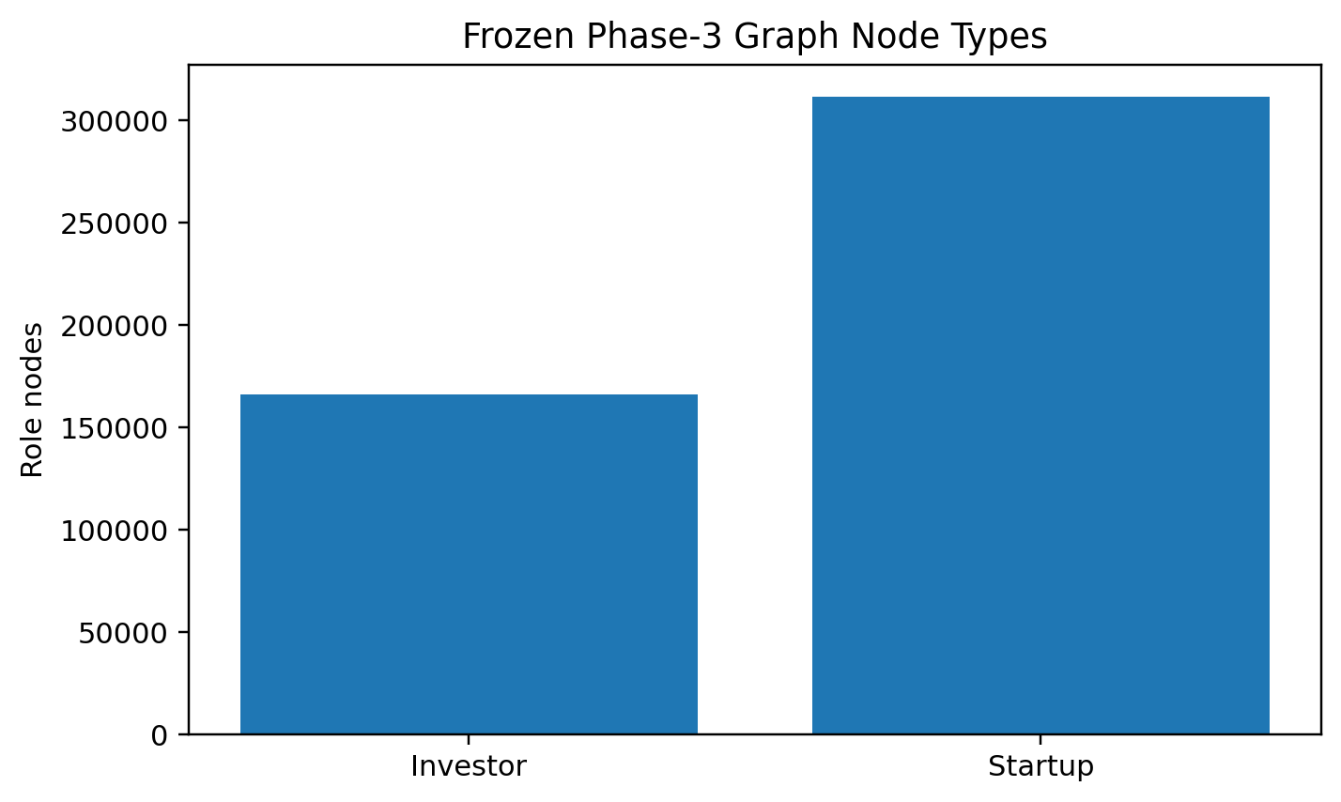
Figure 1. Frozen Phase-3 graph node counts by semantic role.

4. Structural Relationship Source Audit
The relationship-source audit narrowed the available Crunchbase data to two defensible structural sources. A founder-to-person URL bridge provides an ITRS-principle-aligned Human-intermediary relation, while the acquisition table provides a timestamped company-to-company relation. Other candidate sources were explicitly deferred or excluded.
Candidate relation | Status | Evidence / handling
SHARED_FOUNDER | Supported | companies.founder_links -> people.link exact URL bridge; 99.9969% exact resolution
ACQUIRED | Supported Crunchbase adaptation | Conservative endpoint resolution; explicit announced_on; pre-T60 cutoff and holdout masking
INVESTMENT_EVENT | Separate temporal layer | Recommendation target / temporal interaction; not structural R-GCN edge
SHARED_SCHOOL | Deferred | People schools are name lists, not direct UUID references
EMPLOYMENT_OR_CONTACT | Excluded | contacts.id has 0 overlap with people.id; organization UUID/permalink empty
HUB_MEMBERSHIP | Unsupported | No audited entity-level membership references
EVENT_PARTICIPATION | Unsupported | No audited participant entity references
SAME_CATEGORY / SAME_LOCATION | Extension only | Attributes, not observed business relationships; excluded from initial graph

5. SHARED_FOUNDER Construction and Leakage Control
The strongest cross-dataset bridge was companies.founder_links -> people.link. Among 319,284 unique founder URLs extracted from canonical role entities, 319,274 resolved to exactly one People ID, seven were ambiguous, and three were unresolved. Exact resolution was therefore 99.9969%.
Founder audit stage | Count
Founder-induced role-pair occurrences | 66,227
Unique role-node pairs after deduplication | 54,332
Same-underlying-entity pairs removed | 6,901
T60 holdout role-pairs removed | 22
Final leakage-safe SHARED_FOUNDER candidates | 47,409
Potential directed edge records (both directions) | 94,818

The 6,901 same-underlying-entity pairs were removed because investor::X and startup::X represent two semantic roles of the same organization rather than a relationship between two organizations. The 22 held-out pairs were removed under the global underlying-pair leakage policy.
Role combination | Final symmetric pairs | Share
Startup -- Startup | 38,411 | 81.0205%
Investor -- Startup | 7,768 | 16.3851%
Investor -- Investor | 1,230 | 2.5944%

SHARED_FOUNDER is semantically symmetric. Each accepted pair is therefore stored as two directed message-passing records with the same semantic relation label. Founder relationship timestamps are not available, so temporal provenance is retained as current_snapshot_unversioned.

6. ACQUIRED Construction and Leakage Control
Acquisition endpoints are not exported with explicit acquirer/acquiree UUIDs, so Phase 3 resolved endpoints conservatively through exact normalized names and websites. Accepted evidence statuses were name_website_agree, ambiguous_name_resolved_by_website, and unique_name_only. Website-only and conflicting cases were excluded from the strict graph.
Acquisition filtering stage | Rows remaining
Fully resolved input | 158,307
Accepted endpoint evidence | 157,989
Observable before T60 | 152,212
Remove self-acquisitions | 152,211
Both endpoints in canonical roles | 23,329
Remove T60 holdout underlying pairs | 23,306
Unique directed underlying acquisition pairs | 23,301

The timestamp policy requires announced_on < 2026-01-01, so only relationships observable before the T60 evaluation interval enter the graph. The holdout mask removed 22 direct and one reverse T60 underlying pair. Five repeated acquisition events collapsed during pair deduplication.

Role projection | Forward ACQUIRED candidates
Investor -> Investor | 1,565
Investor -> Startup | 11,427
Startup -> Investor | 1,271
Startup -> Startup | 17,737
Total | 32,000

ACQUIRED is treated as a Crunchbase-specific adaptation rather than a literal Tianyancha primitive relation. Every forward ACQUIRED edge receives an explicit ACQUIRED_BY inverse so information can propagate in both directions without discarding acquisition direction semantics.

7. Final Graph Schema Selection
Phase 3.3 froze the graph representation before materialization. The scientific graph contains two role node types, three semantic relation labels, and 12 typed source-relation-target channels. Role type is not embedded inside the base relation name; instead, src_type, relation, and dst_type jointly define the typed channel used by the R-GCN.
Graph component | Frozen specification
Node types | investor, startup
Node ID format | investor::<uuid>, startup::<uuid>
Underlying identity | raw Crunchbase UUID
Semantic relations | shared_founder, acquired, acquired_by
Typed relation key | src_type|relation|dst_type
Typed relation channels | 12
Graph snapshot | Static structural graph
Investment events as structural edges | No
Explicit self-loop relation | No
Node filtering | None

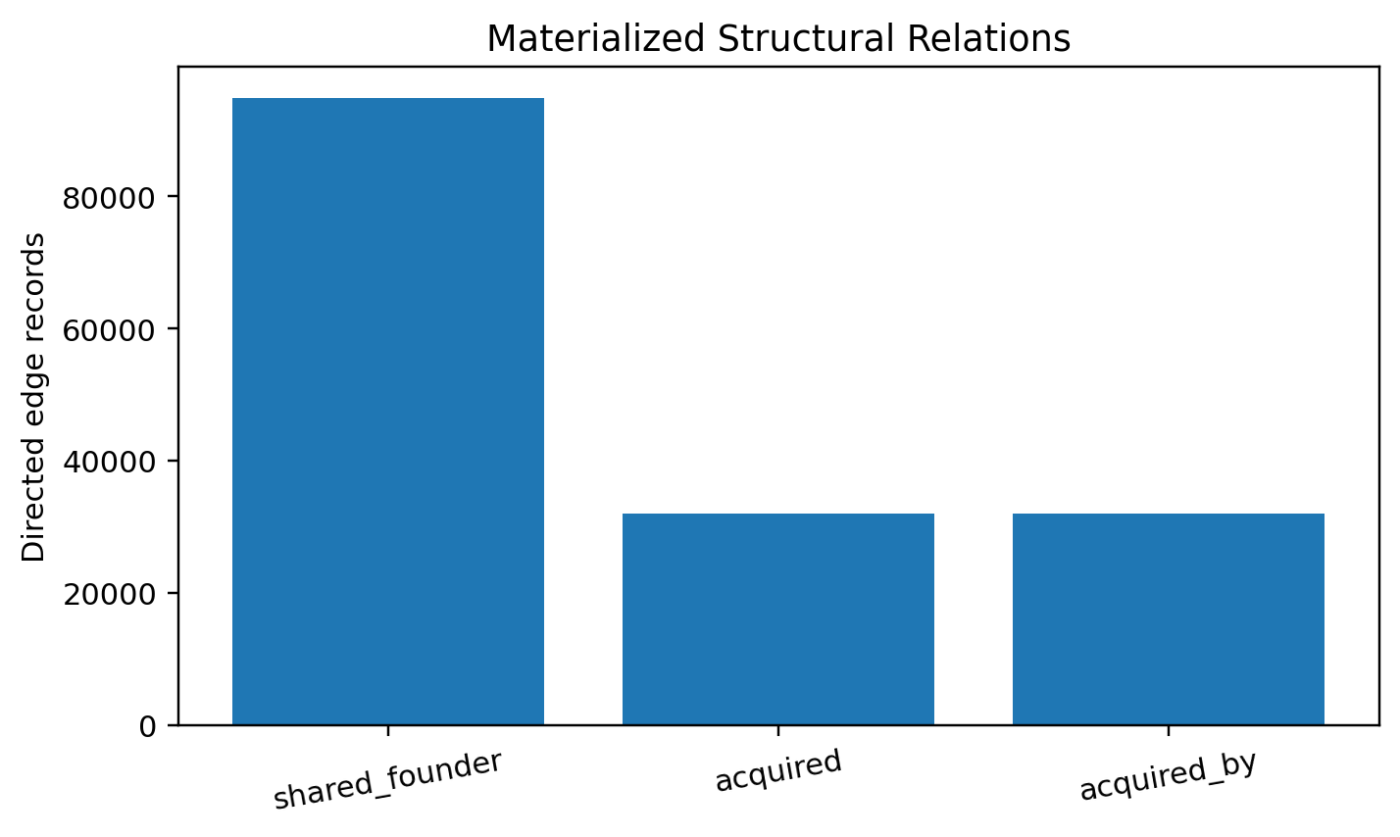
Figure 2. Directed structural edge records by base semantic relation.

8. Node-Table Materialization
The node table materialization preserved the complete canonical Investor and Startup universes. Both authoritative registries achieved 100% coverage. Graph identity is role + Crunchbase UUID; names are display attributes only and never graph keys.
Node identity metric | Final value
Investor role nodes | 165,975
Startup role nodes | 311,589
Total role nodes | 477,564
Unique underlying entity IDs | 467,931
Dual-role underlying IDs | 9,633
Dual-role graph nodes | 19,266
Duplicate node IDs | 0
Missing raw entity IDs | 0
Missing display names | 0
Dual-role display-name disagreements | 0

data/experimental/phase_3/graph/nodes.parquet
rows: 477,564
columns: 6
node_id | node_type | raw_entity_id | display_name | source_registry | underlying_entity_has_dual_role

9. Edge-Table Materialization and Integrity
The structural edge table materializes exactly the frozen Phase-3.3 schema. Every integrity check passed: there are no duplicate edge IDs or source-relation-destination triples, no graph-node self-loops, no same-underlying-entity relations, no missing endpoints, no endpoint identity mismatches, no missing SHARED_FOUNDER reverse records, no missing ACQUIRED_BY inverses, and no T60 holdout leakage records.
Relation | Directed edges | Unique source nodes | Unique destination nodes
shared_founder | 94,818 | 50,314 | 50,314
acquired | 32,000 | 14,107 | 23,267
acquired_by | 32,000 | 23,267 | 14,107
Total | 158,818

Leakage result: The final structural edge table contains 0 edge records whose unordered underlying entity pair matches one of the 22,326 T60 holdout mask pairs.

data/experimental/phase_3/graph/edges.parquet
rows: 158,818
columns: 15
semantic relations: shared_founder | acquired | acquired_by
typed relation channels: 12

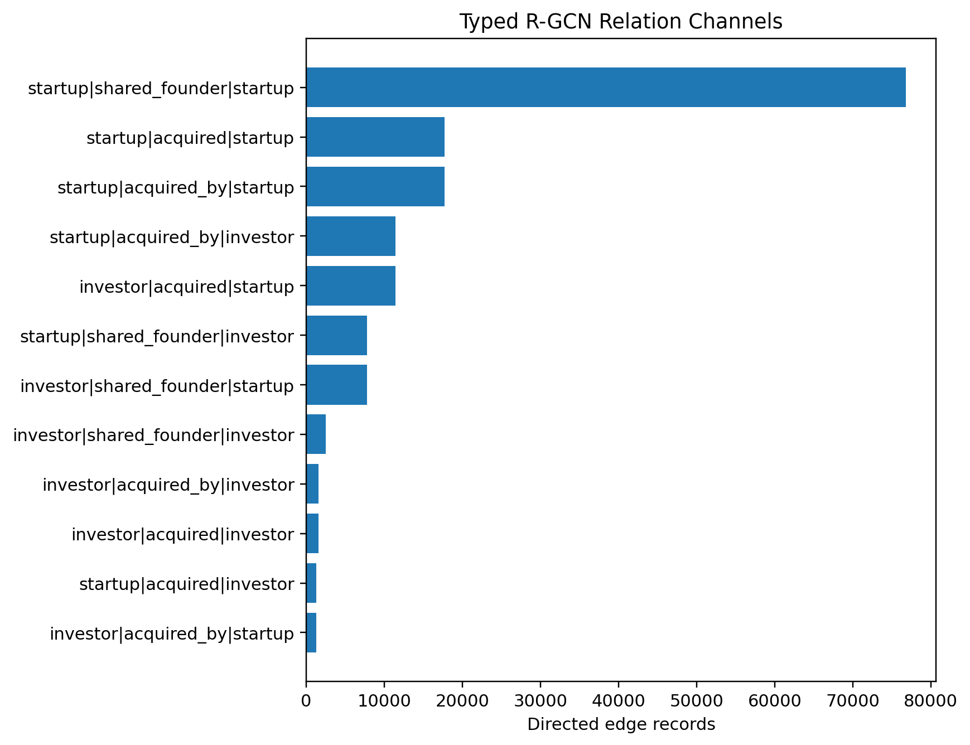
Figure 3. Final typed R-GCN relation-channel edge counts.

10. Model-Ready Encoding
Phase 3.4 converted the scientific string-identified graph into deterministic integer indices without changing graph semantics. Investor nodes occupy indices 0-165,974 and Startup nodes occupy indices 165,975-477,563. Typed relations are sorted lexicographically and assigned deterministic relation IDs 0-11. All node and relation round-trip checks returned zero mismatches.
Model-ready artifact | Specification
node_index.parquet | 477,564 deterministic contiguous node indices
relation_index.csv | 12 deterministic typed relation IDs
edge_index.npy | shape (2, 158,818), int64; row 0 source, row 1 destination
edge_type.npy | shape (158,818,), int64 typed relation IDs
edge_manifest.parquet | Tensor position -> source graph edge audit mapping
graph_variant_masks.npz | core, founder_only_ablation, acquisition_only_ablation
model_ready_graph_metadata.json | Ordering rules and file checksums
node_structural_coverage.parquet | Per-node variant degrees and structural-source class

Graph variant | Relations | Directed edge records
Core | shared_founder | acquired | acquired_by | 158,818
Founder-only ablation | shared_founder | 94,818
Acquisition-only ablation | acquired | acquired_by | 64,000

11. Structural Coverage and Sparsity
The most important empirical limitation of the reconstructed graph is coverage. Only 74,757 of 477,564 role nodes have at least one structural neighbor in the core graph. This sparsity is treated as a property of the available Crunchbase relationship exports, not as a preprocessing error; isolated nodes are retained in the canonical recommendation universe.
Population | Connected nodes | Total nodes | Connected share
Investors | 8,771 | 165,975 | 5.2845%
Startups | 65,986 | 311,589 | 21.1773%
All role nodes | 74,757 | 477,564 | 15.6538%

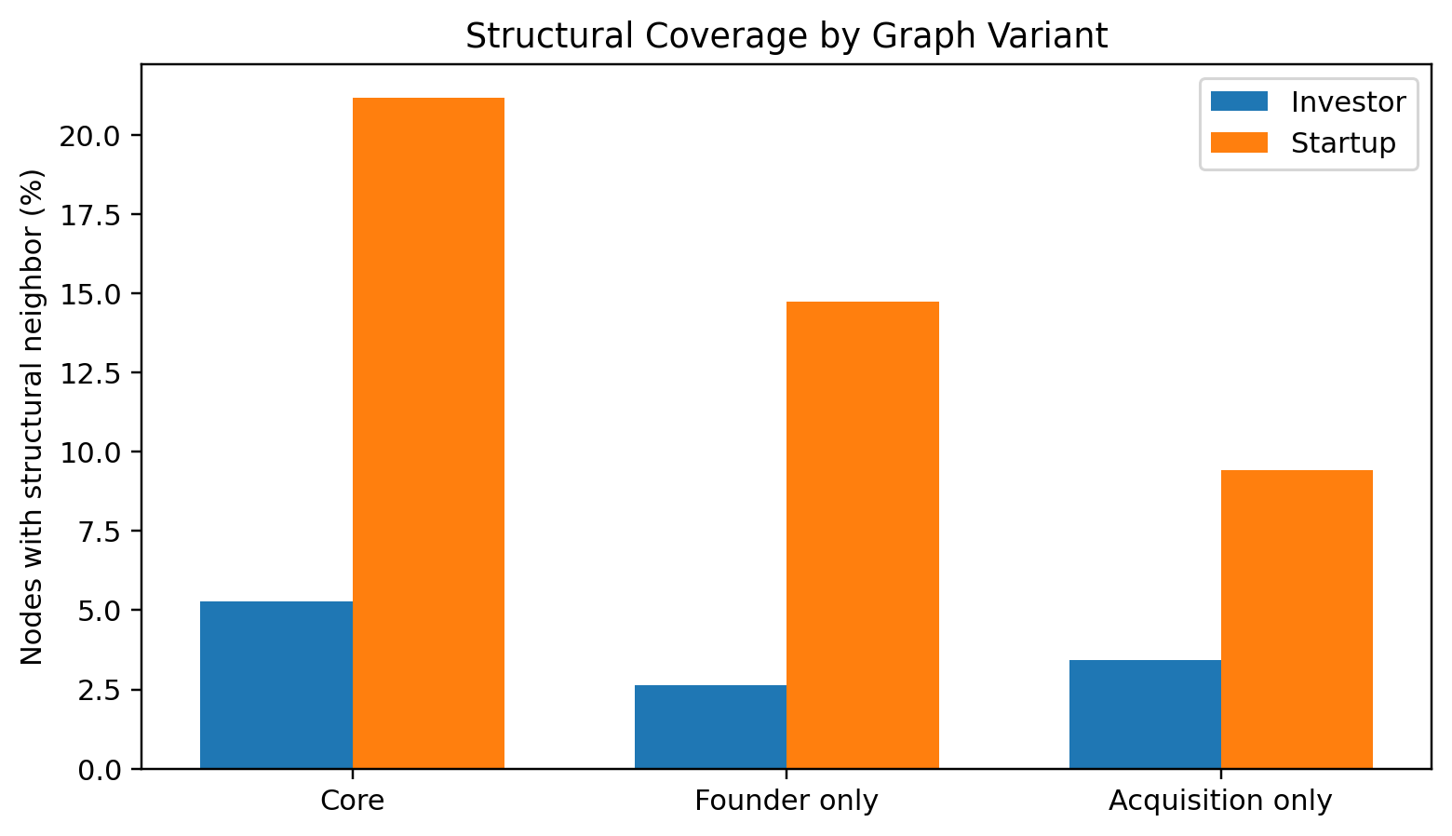
Figure 4. Investor and Startup structural coverage by graph variant.
The two structural sources are complementary rather than redundant. Of all role nodes, 10,543 receive information from both founder and acquisition relations, 39,771 are founder-only, 24,443 are acquisition-only, and 402,807 receive neither structural source.
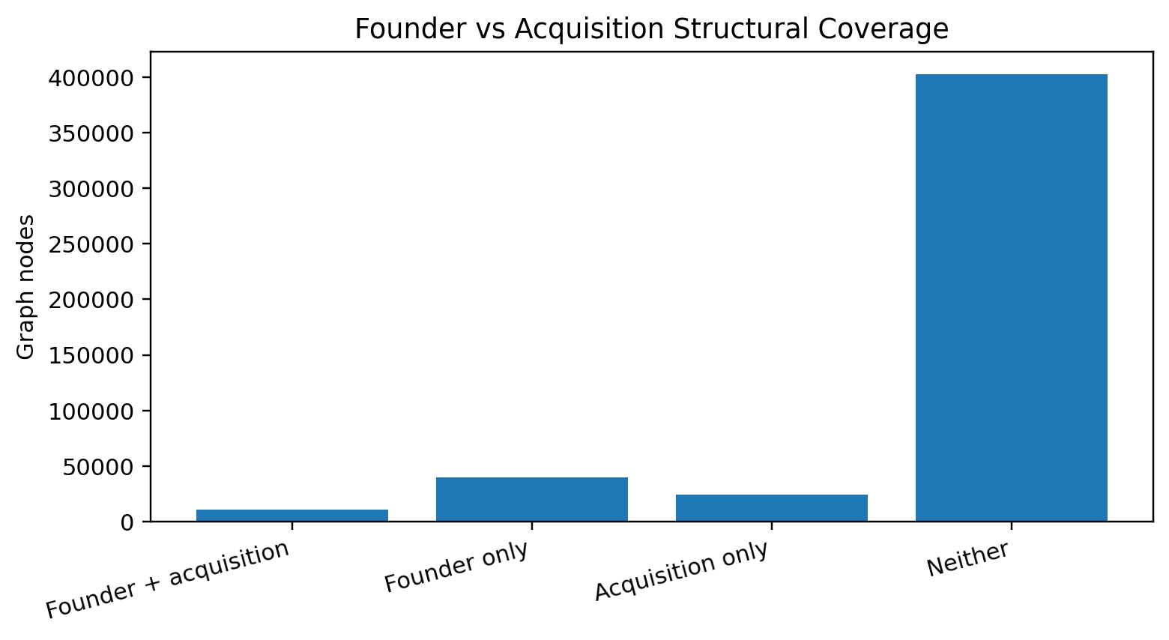
Figure 5. Complementarity of founder and acquisition structural sources.
T60 coverage is also limited. Among 11,884 unique T60 investors, 864 (7.2703%) have a core structural neighbor. Among 8,992 unique T60 startups, 1,349 (15.0022%) have a core structural neighbor. At the pair level, only 653 held-out pairs (2.9247%) have structural information on both endpoints, while 16,113 (72.1682%) have no structural neighbor on either endpoint.
T60 pair structural state | Pairs | Share
Both endpoints connected | 653 | 2.9247%
Investor only connected | 1,798 | 8.0530%
Startup only connected | 3,763 | 16.8540%
Neither endpoint connected | 16,113 | 72.1682%
At least one endpoint connected | 6,214 | 27.8318%

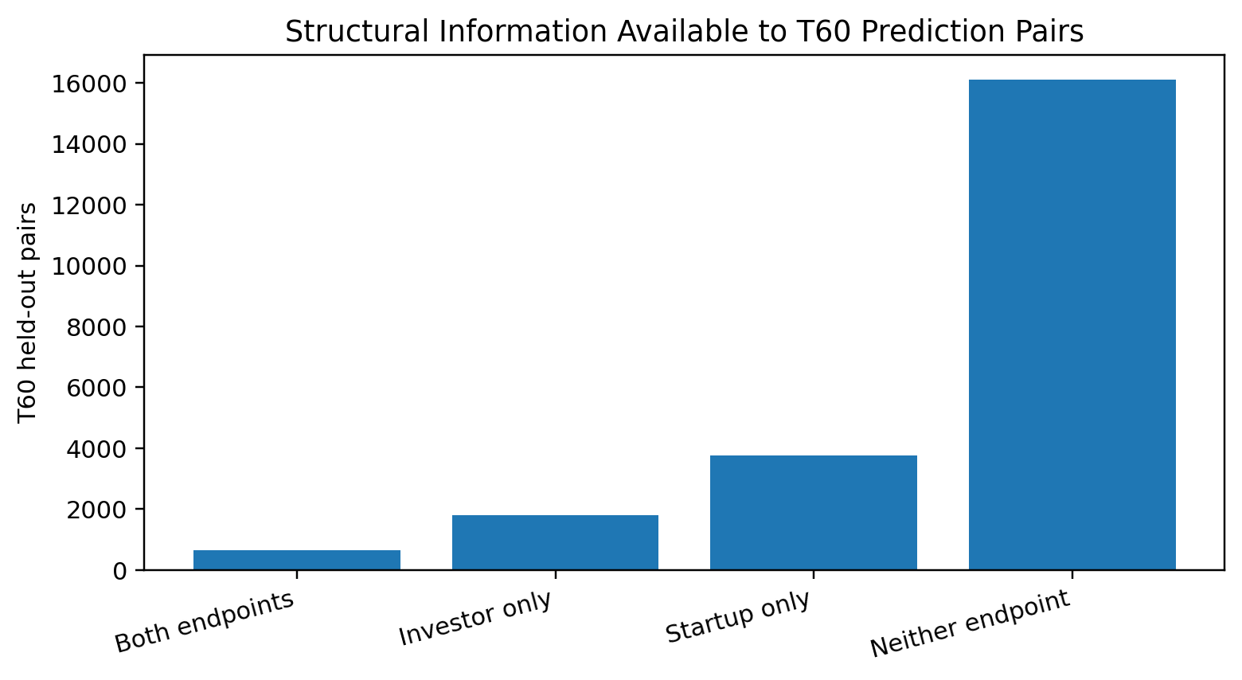
Figure 6. Structural information available to the frozen T60 held-out pairs.
Evaluation implication: The T60 evaluation set must remain unchanged. node_structural_coverage.parquet should be used later only for diagnostic performance slices such as structurally covered versus isolated investors or pairs; it must not be used to filter the primary test population.

12. Final Integrity and Frozen Deliverables
Phase 3.4.3 rechecked the complete chain from canonical interactions through scientific graph materialization and model-ready arrays. Every closure check passed, including canonical counts, node counts, edge counts, typed relation counts, variant-mask reconstruction, T60 pair counts, zero structural leakage, and structural coverage totals.
Closure check group | Result
Canonical Phase-1 universe | PASS
Role identity / underlying identity | PASS
Scientific node table | PASS
Scientific edge table | PASS
Typed relation vocabulary | PASS
Model-ready node indices | PASS
edge_index / edge_type shapes | PASS
Graph variant masks | PASS
T60 structural leakage | PASS (0 records)
Structural coverage totals | PASS

Scientific graph:
data/experimental/phase_3/graph/nodes.parquet
data/experimental/phase_3/graph/edges.parquet
Model-ready graph:
data/experimental/phase_3/model_ready/node_index.parquet
data/experimental/phase_3/model_ready/relation_index.csv
data/experimental/phase_3/model_ready/edge_index.npy
data/experimental/phase_3/model_ready/edge_type.npy
data/experimental/phase_3/model_ready/edge_manifest.parquet
data/experimental/phase_3/model_ready/graph_variant_masks.npz
data/experimental/phase_3/model_ready/model_ready_graph_metadata.json
data/experimental/phase_3/model_ready/node_structural_coverage.parquet
data/experimental/phase_3/model_ready/phase_3_closure_manifest.json

13. Known Limitations
Limitation | Phase-3 handling
Full ITRS 103-relation vocabulary unavailable | Reproduce disclosed construction principle; do not force 103 relation types.
Most Tianyancha primitive relationships unavailable in exports | Exclude unsupported shareholder/control/supplier/client/competitor/shareholding relations rather than approximate them.
Founder relationships temporally unversioned | Preserve provenance as current_snapshot_unversioned and disclose possible historical-information leakage as a dataset limitation.
ACQUIRED is a Crunchbase adaptation | Label explicitly as an adaptation following the ITRS company-relationship principle.
Structural graph sparsity | Retain 402,807 isolates and preserve full canonical recommendation universe.
Limited structural information for T60 pairs | Do not change evaluation set; use structural-coverage slices only as later diagnostics.

14. Phase-4 Handoff Constraints
Phase 4 begins from a frozen graph. Model reconstruction may consume or transform the model-ready arrays, but it must not silently change Phase-3 graph semantics.
- Do not change the canonical Investor/Startup node universe or remove structural isolates.
- Do not merge investor::<uuid> and startup::<uuid> when the same underlying UUID has two semantic roles.
- Do not add historical INVESTMENT_EVENT records as structural R-GCN edges unless a separately documented experimental variant is explicitly introduced.
- Use the deterministic relation_index.csv mapping; never infer relation semantics from integer IDs alone.
- Keep the core graph at 158,818 directed structural edge records unless a named ablation/extension is being evaluated.
- Preserve the global T60 underlying-pair leakage mask and keep structural leakage at zero.
- Retain temporal provenance: acquisitions are timestamped_pre_T60; founder relations are current_snapshot_unversioned.
- Use graph_variant_masks.npz for founder-only and acquisition-only ablations rather than rebuilding the graph differently.
- Use node_structural_coverage.parquet only for diagnostic evaluation slices, not for test-set filtering.
- Treat Phase-2 temporal interactions as the authoritative investment-event sequence for the model trend component.
Phase-3 closure status: COMPLETE. The graph identity, structural relation semantics, node/edge tables, typed relation vocabulary, model-ready indices and arrays, variant masks, leakage policy, temporal provenance, and known limitations are now frozen for Phase 4.

Appendix A. Final Typed Relation Vocabulary
ID | Source | Relation | Target | Typed relation key | Edges
0 | investor | acquired_by | investor | investor|acquired_by|investor | 1,565
1 | investor | acquired_by | startup | investor|acquired_by|startup | 1,271
2 | investor | acquired | investor | investor|acquired|investor | 1,565
3 | investor | acquired | startup | investor|acquired|startup | 11,427
4 | investor | shared_founder | investor | investor|shared_founder|investor | 2,460
5 | investor | shared_founder | startup | investor|shared_founder|startup | 7,768
6 | startup | acquired_by | investor | startup|acquired_by|investor | 11,427
7 | startup | acquired_by | startup | startup|acquired_by|startup | 17,737
8 | startup | acquired | investor | startup|acquired|investor | 1,271
9 | startup | acquired | startup | startup|acquired|startup | 17,737
10 | startup | shared_founder | investor | startup|shared_founder|investor | 7,768
11 | startup | shared_founder | startup | startup|shared_founder|startup | 76,822

Appendix B. Phase-3 Script and Artifact Inventory
Confirmed Phase-3 scripts:
scripts/phase_3_2_1_raw_dataset_schema_inventory.py
scripts/phase_3_2_2_companies_master_entity_audit.py
scripts/phase_3_2_3_cross_role_identity_and_company_duplicate_audit.py
scripts/phase_3_2_4_identity_anomaly_closure_audit.py
scripts/phase_3_2_5_relationship_source_dataset_discovery.py
scripts/phase_3_2_6_relationship_source_schema_semantics_audit.py
scripts/phase_3_2_7_cross_dataset_reference_bridge_audit.py
scripts/phase_3_2_8_acquisition_endpoint_resolution_audit.py
scripts/phase_3_2_9_conservative_acquisition_acceptance_audit.py
scripts/phase_3_2_10_shared_founder_candidate_leakage_audit.py
scripts/phase_3_2_11_relation_support_matrix_closure.py
scripts/phase_3_3_1_graph_schema_specification.py
scripts/phase_3_3_2_graph_node_table_materialization.py
scripts/phase_3_3_3_structural_edge_table_materialization.py
scripts/phase_3_4_1_model_ready_graph_encoding.py
scripts/phase_3_4_2_structural_coverage_relation_degree_audit.py
scripts/phase_3_4_3_final_integrity_and_closure.py

High-value audit/config outputs:
configs/phase_3_itrs_graph_schema.json
data/experimental/phase_3/audits/itrs_crunchbase_relation_support_matrix.csv
data/experimental/phase_3/audits/crunchbase_relation_source_decision_matrix.csv
data/experimental/phase_3/audits/phase_3_2_closure_summary.csv
data/experimental/phase_3/audits/graph_node_identity_summary.csv
data/experimental/phase_3/audits/graph_edge_integrity_summary.csv
data/experimental/phase_3/audits/graph_edge_typed_relation_summary.csv
data/experimental/phase_3/audits/graph_edge_holdout_leakage_audit.csv
data/experimental/phase_3/audits/graph_variant_node_coverage.csv
data/experimental/phase_3/audits/structural_source_node_overlap.csv
data/experimental/phase_3/audits/t60_holdout_endpoint_structural_coverage.csv
data/experimental/phase_3/audits/t60_holdout_pair_structural_coverage.csv
data/experimental/phase_3/audits/phase_3_final_integrity_summary.csv
data/experimental/phase_3/audits/phase_3_final_counts.csv
data/experimental/phase_3/audits/phase_3_final_relation_vocabulary.csv
data/experimental/phase_3/audits/phase_3_final_graph_variants.csv
data/experimental/phase_3/audits/phase_3_known_limitations.csv

References
[1] Chen et al. (2021). A Trend-aware Investment Target Recommendation System with Heterogeneous Graph. International Joint Conference on Neural Networks (IJCNN).
Project source: Crunchbase CSV exports audited during Phase 3. The closure report documents only relationships and counts established by the recorded Phase-3 scripts and terminal audits.

