PHASE 4 CLOSURE REPORT
Model Reconstruction, End-to-End Integration, and Initialization
ITRS Reproduction using Crunchbase
Final Phase-4 closure manifest:
data/experimental/phase_4/closure/phase_4_closure_manifest.json
Report date: 20 August 2026

Executive Summary
Phase 4 reconstructed the complete ITRS neural architecture against the frozen Phase-2 temporal experiment and the frozen Phase-3 heterogeneous graph. The phase did not reopen temporal segmentation, graph semantics, role identity, structural edges, or the T60 holdout policy. Instead, it translated the model components disclosed in the paper into explicit, auditable PyTorch contracts and resolved every architecture-level ambiguity required before training.
The final reconstructed model contains 19,217,929 trainable parameters across 32 trainable tensors. It uses exactly two shared latent tables: an Investor table L_o with shape [165,975, 40] and a Startup table L_b with shape [311,589, 40]. Description, trend, structural, and latent representations are all 40-dimensional. Recommendation scoring concatenates a 160-dimensional Investor representation and a 120-dimensional Startup representation into a 280-dimensional pair vector and applies a four-hidden-layer MLP with architecture 280 -> 128 -> 64 -> 32 -> 16 -> 1.
The complete computation was verified numerically with a real frozen T60 validation positive. Real Doc2Vec/category inputs, historical T0-T59 memberships, the complete 477,564-node / 158,818-edge structural graph, and the shared latent parameters were propagated through description extraction, trend attention and GRU encoding, two-layer basis R-GCN propagation, recommendation scoring, BCEWithLogitsLoss, and a complete backward pass. Every expected trainable parameter family received finite, non-zero gradients. No optimizer, optimizer step, training epoch, negative sample, or learned-model persistence was used during Phase 4.
The final initialization contract freezes Kaiming normal initialization with a = 0, mode = fan_in, nonlinearity = ReLU, zero biases, and global neural seed 42. Canonical initialization is performed on CPU with a dedicated torch.Generator under PyTorch 2.7.0. The canonical initial model state has SHA-256 49e822ea7fad35c458f47e134c94c05eac099b68c5c468e2c71559c8c88998ab. Phase 4 closes with zero model-reconstruction blockers; seven training/evaluation decisions remain deliberately deferred to Phase 5.

Metric | Final value
Role nodes | 477,564
Structural edges | 158,818
Typed relation channels | 12
Trainable tensors | 32
Trainable parameters | 19,217,929
Latent / description / trend / structural dimension | 40
Pair representation | 280
Canonical neural seed | 42
Phase-4 training performed | No
Model-reconstruction blockers | 0

Contents
1. Phase Objective and Scope
2. Paper-Grounded ITRS Architecture
3. Frozen Inputs and Reconstruction Method
4. Description Extraction Reconstruction
5. Trend Extraction Reconstruction
6. Preference Propagation / R-GCN Reconstruction
7. Recommendation Scoring Reconstruction
8. Full Model Topology and Shared Latent Identity
9. End-to-End Forward, BCE, and Autograd Integration
10. Global Initialization and Seed Contract
11. Final Integrity, Closure, and Authoritative Artifacts
12. Final Model Specification
13. Known Limitations and Reproduction Choices
14. Phase-5 Handoff Constraints
Appendix A. Final Parameter Budget and Namespace
Appendix B. Phase-4 Subphase and Artifact Inventory
References

1. Phase Objective and Scope
The objective of Phase 4 was to reconstruct the ITRS model itself, not to train it. The phase began from the immutable Phase-1 interaction layer, the frozen Phase-2 temporal experiment, and the frozen Phase-3 structural graph. Its responsibility was to turn the paper-level architecture into an explicit, reproducible model contract whose dimensions, parameter ownership, temporal semantics, structural message passing, scoring order, initialization, and end-to-end gradient paths could be independently audited before optimization.
- Frozen temporal input: Phase-2 T0-T60 experiment with T60 reserved for validation/test.
- Frozen structural input: Phase-3 role graph with 477,564 nodes, 158,818 directed edges, and 12 typed relation channels.
- Model scope: description extraction, trend extraction, preference propagation, recommendation scoring, and complete BCE forward/backward integration.
- No negative-sampling policy was frozen in Phase 4.
- No optimizer, training epoch, model selection, or test evaluation was performed.
- All paper-underspecified implementation choices were classified explicitly rather than silently treated as paper facts.
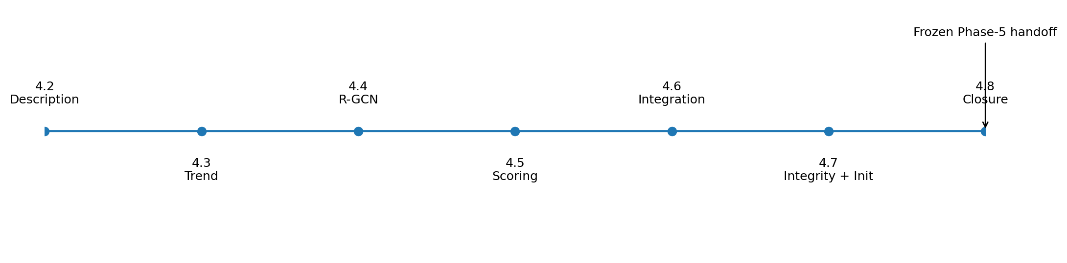
Figure 1. Phase-4 reconstruction sequence from component contracts to frozen handoff.

2. Paper-Grounded ITRS Architecture
The ITRS paper describes four model modules: description extraction, trend extraction, preference propagation, and recommendation scoring. The final score is trained from positive and randomly sampled negative investment events with binary cross-entropy. The paper reports 40-dimensional latent embeddings, description features, trend features, and structural features; a 32-dimensional Doc2Vec representation with window size 3; a two-layer GRU with hidden dimension 40; a two-layer R-GCN with five bases; four hidden MLP layers for final scoring; Kaiming initialization; Adam with learning rate 0.001; and batch size 512. [1]
The paper does not disclose every implementation detail needed for exact code reproduction. In particular, it does not report description-branch hidden widths, final-scoring hidden widths, the exact R-GCN activation symbol used in Equation 9, the exact Kaiming variant, the neural random seed, the training negative ratio, training negative eligibility rules, epoch count, early-stopping rule, or weight decay. Phase 4 therefore separates paper-specified facts from reproduction choices and leaves training/evaluation policy unresolved where appropriate.

Module | Paper-grounded core | Phase-4 outcome
Description | Doc2Vec + one-hot labels; final feature dimension 40 | Two shared ReLU branches: 32→20 and 802→20; concatenate to 40
Trend | Bilinear attention over historical targets + GRU; hidden 40, 2 layers | 80-D query/items, explicit empty periods, 60-period T60 sequence, 40-D output
Preference propagation | R-GCN, 2 layers, 5 bases; structural feature 40 | 12 frozen typed channels; incoming relation mean + root transform; ReLU
Scoring | NCF-style MLP, 4 hidden layers, BCE | 280→128→64→32→16→1; raw logits + BCEWithLogitsLoss

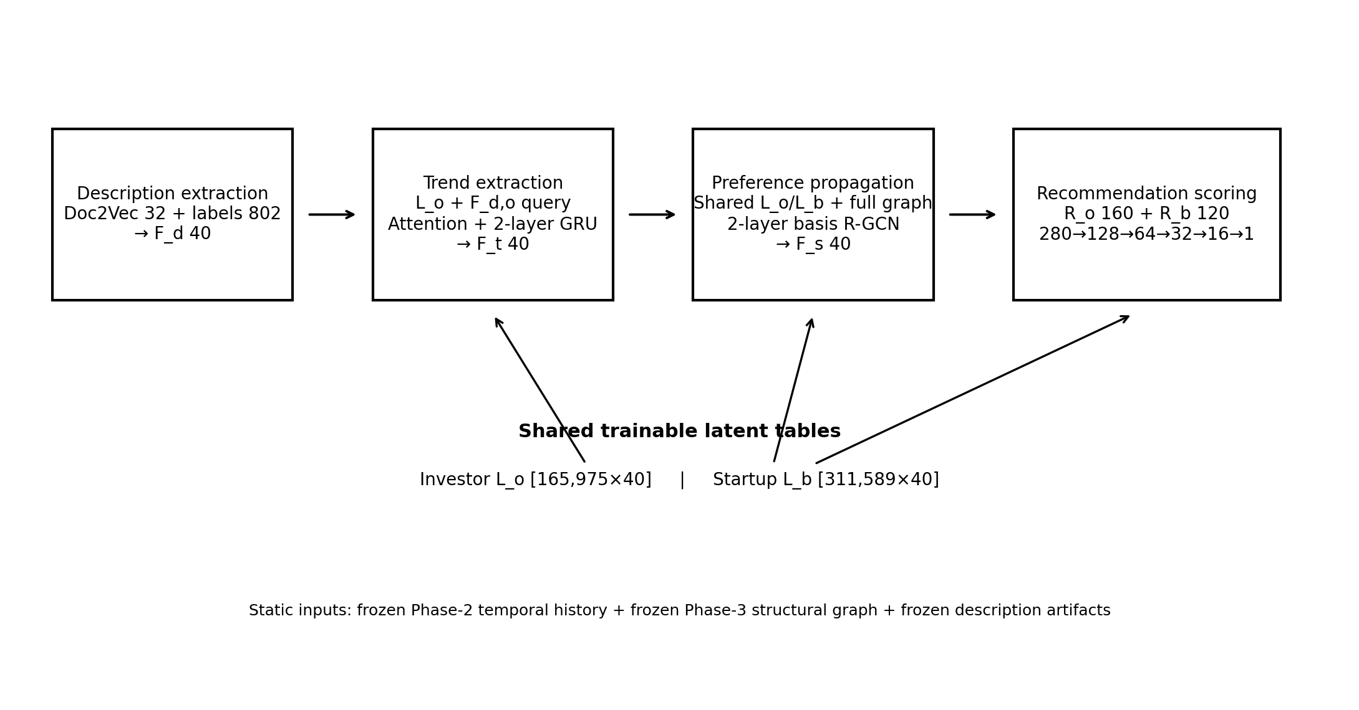
Figure 2. Frozen Phase-4 ITRS architecture and shared latent ownership.

3. Frozen Inputs and Reconstruction Method
Phase 4 treated earlier decisions as immutable. The temporal history remained the Phase-2 interaction sequence; the structural graph remained the Phase-3 graph; and the role-namespaced identity scheme remained unchanged. Model reconstruction used audit-first subphases: measure the available artifacts, freeze a contract, execute a forward audit, then verify integration and autograd before moving to the next module.
Input family | Authoritative Phase-4 source | Frozen role
Temporal interactions | data/experimental/phase_2/model_ready/interactions_itrs_temporal_split.parquet | T0-T59 history and T60 validation/test identities
Graph nodes | data/experimental/phase_3/model_ready/node_index.parquet | Global role-node order
Graph relations | relation_index.csv + edge_index.npy + edge_type.npy | Full 12-channel structural message-passing graph
Text features | doc2vec_vectors_all.npy | Static 32-D document vectors
Category features | description_label_multihot.npz | Static sparse 802-D multi-hot labels
Trend runtime | trend_period_ptr.npy + trend_startup_node_indices.npy + trend_period_startup_counts.npy | Historical Investor-period membership CSR

Global static row alignment was later rechecked across the Phase-3 node index, the Doc2Vec manifest, and the category-label manifest. The three coordinate systems were exactly aligned over rows 0-477,563, and node_id, node_type, and raw_entity_id matched row-by-row.

4. Description Extraction Reconstruction
Phase 4.2 constructed the model-ready description inputs from audited Crunchbase text and categories and then reconstructed the neural description module. Text is role-specific: Investor text is derived from the Investor registry and Startup text from the Company registry, using description when available and short_description as fallback. Missing text is not fabricated. Category labels use a shared vocabulary of 802 observed categories; missing categories produce an all-zero vector.
Description artifact / decision | Frozen result
Global static inputs | 477,564 rows; Doc2Vec shape (477,564,32), float32
Doc2Vec sparsity / training | 2,670 zero rows; window3; epochs5 (reproduction choice)
Category matrix | shape (477,564,802), sparse CSR; 1,230,068 nonzeros
Category zero rows | 111,919
Text branch | Linear(32,20,bias=True) -> ReLU
Label branch | Linear(802,20,bias=True) -> ReLU
Final F_d | 40 dimensions
Description trainable parameters | 16,720

The 20/20 split of the final 40-dimensional description feature is not reported by ITRS and is therefore a PAPER_UNSPECIFIED_REPRODUCTION_CHOICE. The two branches are shared across Investor and Startup roles; there are no role-specific description MLP copies, dropout layers, batch normalization, residual connections, or persisted learned F_d features.

5. Trend Extraction Reconstruction
Phase 4.3 reconstructed the investor trend feature as a temporal sequence of period-level attended Startup representations. For target period T_h, only periods T0 through T(h-1) are consumed. Therefore T60 uses T0-T59 and never includes the current T60 investment as history. Same Investor-Startup memberships repeated within one period collapse to one attention item. Empty periods are represented by an explicit zero80 vector.
Trend quantity | Frozen value
Historical events T0-T59 | 1,173,422
Collapsed historical memberships | 1,145,364
Active Investor-periods | 554,171
Empty Investor-periods | 9,404,329
Historically active Investors | 161,065
Investors with zero history | 4,910
T60 Investors with no prior history | 3,060 / 11,884 = 25.7489%
Investor query | [L_o(40) || F_d,o(40)] = 80
Startup item | [L_b(40) || F_d,b(40)] = 80
Attention matrix | W: 80×80
GRU | input 80, hidden 40, 2 layers
Trend output | Linear(40,40,bias=False) -> Sigmoid
Trend parameters | 32,480

The trend runtime was encoded as a compact CSR-style representation rather than dense Investor × period storage. The pointer array has length 9,958,501, the Startup membership array contains 1,145,364 entries, and the period-count array contains 9,958,500 entries. The runtime footprint was approximately 122.70 MiB. Learned trend features are recomputed from current parameters; they are not persisted across optimizer updates.
A notation ambiguity exists between the trend-section definition and the recommendation-scoring equation in the paper. Phase 4 resolves this operationally: the trend input supplied to a target T_h already represents history through T(h-1), and the scorer applies no additional one-period shift. This was recorded as a paper-indexing notation reconciliation rather than a change to Phase-3/Phase-2 semantics.

6. Preference Propagation / R-GCN Reconstruction
Phase 4.4 reconstructed the preference-propagation module directly against the frozen Phase-3 graph. The initial structural node representation is the concatenation of the same Investor and Startup latent tables used elsewhere in the model. No third structural embedding table is allowed.
R-GCN component | Frozen specification
Input node matrix | [477,564, 40] = cat(L_o.weight, L_b.weight)
Graph | 158,818 directed edges; 12 typed relations
Neural depth / bases | 2 layers; 5 bases per layer
Hidden/output dimension | 40
Relation aggregation | Mean over incoming neighbors within each typed relation
Self information | Separate learned root transform; no graph self-loop relation
Activation / extras | ReLU after each layer; no layer bias, dropout, normalization, or residual
Parameters | 9,660 per layer; 19,320 total

The ITRS paper writes a generic sigma activation in the R-GCN equation but does not define it explicitly. ReLU was frozen as a PAPER_UNSPECIFIED_REPRODUCTION_CHOICE consistent with the R-GCN formulation and the rest of the reconstructed network. Isolated structural nodes are retained and receive root-only transformations; no structural-coverage filtering is introduced.
Forward implementation audits verified basis reconstruction, message direction, relation-specific mean normalization, isolate behavior, and full-graph outputs. Integration/autograd auditing confirmed finite non-zero gradients through both R-GCN layers, relation coefficients, bases, root transforms, and the shared latent input.

7. Recommendation Scoring Reconstruction
Phase 4.5 reconstructed the NCF-style scoring module using the feature ordering disclosed by ITRS. The Investor and Startup representations are concatenated in a fixed order and passed through a four-hidden-layer ReLU MLP. The paper specifies four hidden layers but not their widths; Phase 4 freezes a progressively shrinking NCF-guided architecture without claiming that the exact widths are reported by ITRS.
Scoring object | Frozen representation
Investor R_o | [F_t || L_o || F_d,o || F_s,o] = 160
Startup R_b | [L_b || F_d,b || F_s,b] = 120
Pair order / dimension | F_t, L_o, F_d,o, F_s,o, L_b, F_d,b, F_s,b = 280
Hidden architecture | 128 -> 64 -> 32 -> 16
Output / probability | Linear(16,1,bias=True) raw logit; sigmoid(logit)
Loss / extras | BCEWithLogitsLoss; dropout0; no normalization/residual
Scoring parameters | 46,849

Returning raw logits and using BCEWithLogitsLoss is mathematically equivalent to the paper's logistic-output BCE while providing a numerically stable implementation. Forward audits verified feature order, all hidden shapes, sigmoid/logit correspondence, BCE equivalence, ranking equivalence, deterministic duplicate-input behavior, and non-zero finite gradients to every feature block and all scoring parameters.

8. Full Model Topology and Shared Latent Identity
Phase 4.6.1 assembled the authoritative full-model topology. The integrated model owns exactly two embedding tables. The same parameter objects conceptually provide L_o and L_b to trend extraction, preference propagation, and recommendation scoring. This closes the possibility that individually correct modules could silently maintain separate copies of the latent representation.
Parameter family | Parameters
Investor latent embeddings | 6,639,000
Startup latent embeddings | 12,463,560
Description encoder | 16,720
Trend module | 32,480
R-GCN | 19,320
Scoring MLP | 46,849
FULL ITRS | 19,217,929

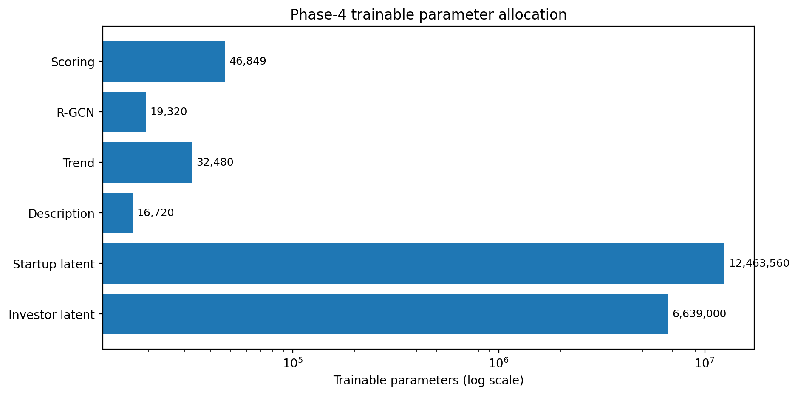
Figure 3. Parameter allocation. Shared latent embeddings dominate the trainable parameter budget.
The model topology was first instantiated on PyTorch's meta device so parameter ownership and counts could be checked without allocating the full initialized state. Static Doc2Vec and label artifacts were then aligned exactly to the global role-node order. The final topology contains 32 trainable tensors and 19,217,929 trainable scalar parameters.

9. End-to-End Forward, BCE, and Autograd Integration
Phase 4.6.2 executed the complete reconstructed architecture numerically using one real frozen T60 validation positive. The audit deliberately selected a case with prior Investor history, at least one multi-item historical period, structural incoming degree on both endpoints, non-zero Doc2Vec vectors, and Startup labels so that all major branches were exercised. These selection criteria were diagnostic only and did not alter model or evaluation eligibility.
End-to-end checkpoint | Result
Real static Doc2Vec and categories | PASS
Real T0-T59 Investor history | PASS
Full Phase-3 graph | PASS
F_d description forward | PASS
F_t attention + GRU forward | PASS
F_s full-graph R-GCN forward | PASS
Investor representation shape | (1, 160) PASS
Startup representation shape | (1, 120) PASS
Pair representation shape | (1, 280) PASS
Raw logit + sigmoid probability | PASS
BCEWithLogitsLoss vs manual stable BCE | Equivalent
Description gradients | finite, non-zero
Trend attention / GRU gradients | finite, non-zero
R-GCN layer 1 / 2 gradients | finite, non-zero
Scoring MLP gradients | finite, non-zero
Investor / candidate / historical Startup latent gradients | finite, non-zero

This is the strongest integration result of Phase 4: one BCE objective was shown to connect differentiably through the entire reconstructed ITRS computation graph. No optimizer was created and no optimizer.step() was called. The positive audit example therefore verifies integration without constituting training.

10. Global Initialization and Seed Contract
The ITRS paper states that all parameters were initialized by Kaiming initialization but does not disclose the exact variant or neural seed. Phase 4.7 therefore froze a transparent reproduction-specific initialization policy and verified it byte-for-byte.
Initialization decision | Frozen value | Classification
Family | Kaiming | PAPER_SPECIFIED
Exact variant | kaiming_normal_; a=0; fan_in; relu | PAPER_UNSPECIFIED_REPRODUCTION_CHOICE
Biases | zero | PAPER_UNSPECIFIED_REPRODUCTION_CHOICE
Global neural seed | 42 | PAPER_UNSPECIFIED_REPRODUCTION_CHOICE
Canonical environment | CPU dedicated torch.Generator; PyTorch 2.7.0 | REPRODUCTION_ENVIRONMENT_LOCK

All 32 trainable tensors are covered explicitly: 21 matrix-like tensors use Kaiming initialization and 11 one-dimensional bias tensors are initialized to zero. Each R-GCN basis matrix is initialized independently rather than applying fan computation to the entire three-dimensional basis stack.
Canonical seed-42 initial-state SHA256:
49e822ea7fad35c458f47e134c94c05eac099b68c5c468e2c71559c8c88998ab
Two independent seed-42 initializations produced the same complete state hash and zero per-parameter hash mismatches. A seed-43 control produced a different state. Runtime deterministic-algorithm policy was intentionally not frozen here because initialization reproducibility and training-kernel determinism are separate concerns.

11. Final Integrity, Closure, and Authoritative Artifacts
Phase 4.7 re-audited every major contract after the module reconstructions and again after the initialization freeze. The final cross-contract audit found no parameter namespace drift, no static-feature hash mismatch, no trend CSR mismatch, no graph relation-count change, no gradient regression, and no accidental freezing of the decisions deliberately deferred to training/evaluation.
Closure check group | Final result
Frozen Phase-4 contract statuses | PASS
Full parameter total | PASS: 19,217,929
Exact parameter namespace | PASS: 32 tensors
Static artifact hashes | PASS
Static row identity alignment | PASS
Trend CSR pointer/count integrity | PASS
Frozen structural graph / relation counts | PASS
Phase-4.6 forward shapes | PASS
All parameter gradients finite and non-zero | PASS
Initialization coverage | PASS: 21 Kaiming + 11 zero bias
Seed reproducibility | PASS
Historical contract provenance | PASS
Model-reconstruction blockers | 0
Training boundary | PASS: no training/evaluation

The Phase-4 closure script registered 34 final model decisions, created the authoritative Phase-5 handoff contract, wrote the reproduction log, built the final artifact registry, and rechecked the closure manifest. The terminal closure confirmed that every required Phase-2, Phase-3, and Phase-4 input existed and every major Phase-4 contract remained frozen or complete.

Authoritative closure output | Path / group
Core closure contracts | phase_4_closure_manifest.json; phase_4_to_phase_5_handoff_contract.json
Decision documentation | phase_4_final_model_decision_register.csv; phase_4_deferred_training_evaluation_decisions.csv; phase_4_known_limitations_and_adaptations.csv
Registry / summary / status | phase_4_authoritative_artifact_registry.csv; phase_4_parameter_summary.csv; phase_4_final_contract_status_audit.csv
Reproduction log | Phase_4_Reproduction_Log_Entry.md
Closure hashes | phase_4_closure_artifact_hashes.csv

12. Final Model Specification
Component | Final frozen specification
Role latent tables | L_o [165,975,40]; L_b [311,589,40]; shared by trend, R-GCN, scoring
Description | Doc2Vec32 + labels802 -> two 20-D ReLU branches -> F_d40
Trend | query80/item80; bilinear attention; T60 uses 60 prior periods; GRU(80,40,2) -> F_t40
Structure | 477,564 nodes; 158,818 edges; 12 typed channels; 2 R-GCN layers; 5 bases -> F_s40
Scoring | R_o160 + R_b120 -> pair280 -> 128 -> 64 -> 32 -> 16 -> 1
Loss | raw logit + BCEWithLogitsLoss; sigmoid for reporting probability
Initialization | Kaiming normal, a=0, fan_in, ReLU; zero biases; seed42; CPU generator; PyTorch2.7.0

Final trainable parameter total: 19,217,929 across 32 tensors.

13. Known Limitations and Reproduction Choices
Limitation / ambiguity | Phase-4 handling
Original ITRS relation vocabulary / Crunchbase adaptation | The full 103-relation Tianyancha vocabulary is unavailable. Phase 4 consumes the frozen 12-channel Crunchbase graph; ACQUIRED/ACQUIRED_BY remains an explicit Crunchbase adaptation.
Current-snapshot side information | Description text/categories and SHARED_FOUNDER are not historically versioned; they are disclosed as current-snapshot information rather than silently treated as historical observations.
Structural sparsity and T60 coverage | 402,807 of 477,564 role nodes are isolates, and 72.1682% of T60 pairs have neither endpoint structurally connected. Isolates and all T60 cases remain in the primary universe.
Description branch widths unavailable | The 20/20 split producing F_d40 is a paper-unspecified reproduction choice.
Scoring hidden widths unavailable | The 128/64/32/16 widths are NCF-guided reproduction choices; only the four-hidden-layer count is paper specified.
R-GCN activation unspecified | ReLU after each R-GCN layer is a reproduction choice.
Exact Kaiming variant / seed unspecified | Kaiming normal fan_in ReLU with zero biases and seed42 is a documented reproduction choice.
Training policy deliberately unresolved | Negative sampling, epochs, early stopping, weight decay, and evaluation candidate generation are owned by Phase 5.

14. Phase-5 Handoff Constraints
Phase 5 begins from a frozen model reconstruction. It may define optimization and evaluation policy but must not silently reinterpret the Phase-4 architecture or upstream data semantics.
- Treat the Phase-2 temporal segmentation and train/validation/test identities as immutable.
- Treat the Phase-3 role-node identity, structural graph, typed relation vocabulary, and graph-variant masks as immutable.
- Use the frozen Doc2Vec vectors, 802-dimensional category matrix, and trend CSR as authoritative static/runtime inputs.
- Keep exactly two shared latent tables L_o and L_b; do not introduce branch-specific copies.
- Preserve the description, trend, R-GCN, and scoring architecture and exact feature order.
- Initialize the model from the frozen Kaiming/seed contract before training.
- Recompute learned F_d, F_t, and F_s from current trainable parameters; do not persist stale learned feature caches across optimizer updates.
- Resolve negative sampling before the first optimizer step.
- Resolve training epoch count, early stopping, weight decay, and runtime determinism explicitly in Phase 5.
- Use the frozen T60 validation/test population unchanged; structural coverage may be used only as a diagnostic slice.
The seven decisions explicitly handed to Phase 5 are:
- early stopping
- evaluation candidate-generation runtime contract
- training epoch count
- training historical negative exclusion
- training negative candidate eligibility
- training negative:positive ratio
- weight decay
Phase-4 closure status: COMPLETE / FROZEN. No model-reconstruction blockers remain.

Appendix A. Final Parameter Budget and Namespace
Parameter family | Shape / structure | Parameters
investor_embedding.weight | [165,975,40] | 6,639,000
startup_embedding.weight | [311,589,40] | 12,463,560
Description text projection | Linear 32→20 + bias | 660
Description label projection | Linear 802→20 + bias | 16,060
Trend attention | 80×80 | 6,400
Trend GRU | 2-layer GRU, input80 hidden40 | 24,480
Trend output projection | 40×40, no bias | 1,600
R-GCN layer 1 | 5 bases + 12×5 coeff + root | 9,660
R-GCN layer 2 | 5 bases + 12×5 coeff + root | 9,660
Scoring hidden 1 | 280→128 + bias | 35,968
Scoring hidden 2 | 128→64 + bias | 8,256
Scoring hidden 3 | 64→32 + bias | 2,080
Scoring hidden 4 | 32→16 + bias | 528
Scoring output | 16→1 + bias | 17
FULL ITRS |  | 19,217,929

The frozen integrated namespace contains 32 trainable tensors because GRU and R-GCN parameter families decompose into multiple named tensors. Phase 4.7 verified that the initialization specification covers every one exactly once.

Appendix B. Phase-4 Subphase and Artifact Inventory
Subphase | Objective | Closure result
4.1 | Model contract | Reconstruct four ITRS modules against frozen Phase-2/3 inputs; classify paper-unspecified decisions.
4.2 | Description extraction | Freeze text/category inputs, Doc2Vec artifacts, label matrix, and 40-D neural description encoder.
4.3 | Trend extraction | Freeze historical membership semantics, attention, GRU, and CSR runtime.
4.4 | Preference propagation | Freeze R-GCN input direction, 12 typed channels, two-layer/five-basis neural contract, full-graph forward/autograd.
4.5 | Recommendation scoring | Freeze feature order, 280-D input, NCF-guided hidden widths, raw-logit BCE interface, forward/autograd.
4.6 | Complete integration | Freeze full topology, static input alignment, shared latent ownership, real validation forward/BCE/backward.
4.7 | Integrity + initialization | Cross-contract audit; Kaiming/seed freeze; canonical state fingerprint; post-init integrity.
4.8 | Closure / handoff | Write final closure manifest, handoff contract, decision register, limitations, artifact registry, hashes, reproduction log.

Confirmed high-value scripts from the final integration/closure sequence:
- scripts/phase_4_5_1a_scoring_input_contract_audit.py
- scripts/phase_4_5_2_scoring_forward_bce_autograd_audit.py
- scripts/phase_4_6_1b_freeze_full_model_topology_contract.py
- scripts/phase_4_6_2_end_to_end_itrs_forward_bce_audit.py
- scripts/phase_4_7_1a_complete_model_integrity_audit.py
- scripts/phase_4_7_1b_freeze_neural_initialization_seed_contract.py
- scripts/phase_4_7_2_final_post_initialization_integrity_audit.py
- scripts/phase_4_8_close_model_reconstruction.py
Earlier Phase-4 scripts and audit artifacts remain authoritative according to the final closure registry; this appendix lists only script names explicitly confirmed in the recorded Phase-4 integration/closure workflow rather than inventing filenames for earlier subphases.

References
[1] Chen et al. (2021). A Trend-aware Investment Target Recommendation System with Heterogeneous Graph. International Joint Conference on Neural Networks (IJCNN).

