Random Taco Cookbook

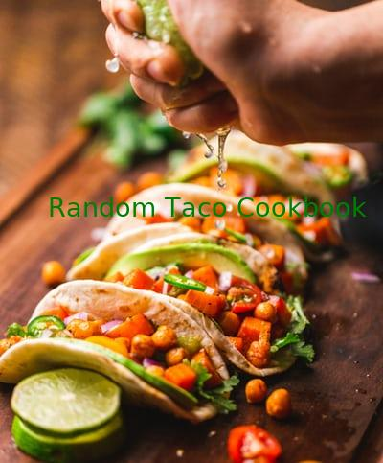

# Credits

Photo author: Chad Montano

Code: Misael Arreola

API URL: https://taco-1150.herokuapp.com/random/?full_taco=true

{base}