Single layer lstm 1000, 10 epoch

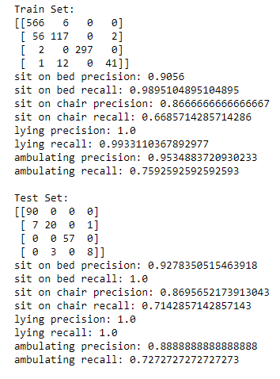

Double layer lstm 500,500, 10 epoch

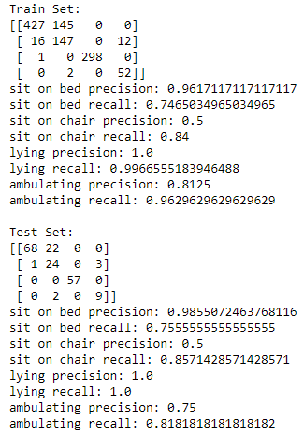

Double layer lstm 500,500, 20 epoch

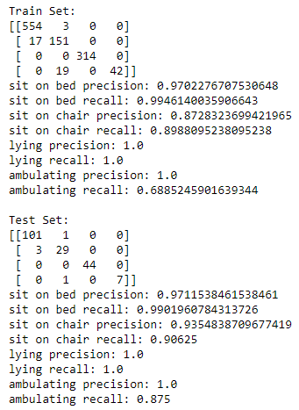

Triple layer lstm 500,500,500 20 epoch

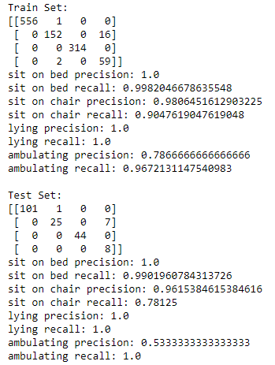

Triple layer lstm 500,500,500, 40 epoch

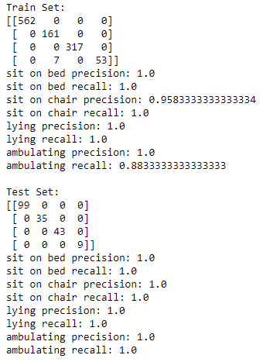

Alex Results

lstm_model_process_1slookahead.h5

0.2steps|10s window |1s Lookahead |60%|21 Epochs with es|[1,2,3,4,5,8,9]|Linear

Train Set:

[[12232 51 70 138]

[ 6 10372 1 21]

[ 42 3 13642 8]

[ 49 80 28 2194]]

sit on bed precision: 0.9921323708329953

sit on bed recall: 0.9792650708510128

sit on chair precision: 0.9872453835903293

sit on chair recall: 0.9973076923076923

lying precision: 0.9927952841860127

lying recall: 0.9961299744432275

ambulating precision: 0.9292672596357475

ambulating recall: 0.9332199064227988

Test Set:

[[3597 11 17 42]

[ 0 2931 0 5]

[ 11 0 3853 8]

[ 9 12 5 624]]

sit on bed precision: 0.9944705557091512

sit on bed recall: 0.9809108262885192

sit on chair precision: 0.9922139471902505

sit on chair recall: 0.9982970027247956

lying precision: 0.9943225806451613

lying recall: 0.9950929752066116

ambulating precision: 0.9189985272459499

ambulating recall: 0.96

lstm_model_process_1slookahead.h5

0.2steps |3s Lookahead |60%|21 Epochs with es|[1,2,3,4,5,8,9]|Linear

0.2steps |5s Lookahead |60%|21 Epochs with es|[1,2,3,4,5,8,9]|Linear

|  |  |
| --- | --- |
| Test Params | Done |
| 0.2steps|10s window |1s Lookahead |60%|21 Epochs with es|[1,2,3,4,5,8,9]|Linear | Yes |
| 0.2steps|10s window |2s Lookahead |60%|21 Epochs with es|[1,2,3,4,5,8,9]|Linear | Pend |
| 0.2steps|10s window |3s Lookahead |60%|21 Epochs with es|[1,2,3,4,5,8,9]|Linear | Pend |
| 0.2steps|10s window |Bs Lookahead |60%|21 Epochs with es|[1,2,3,4,5,8,9]|Linear | No |
| 0.2steps|5s window |Bs Lookahead |60%|21 Epochs with es|[1,2,3,4,5,8,9]|Linear | No |
| 0.2steps|15s window |Bs Lookahead |60%|21 Epochs with es|[1,2,3,4,5,8,9]|Linear | No |
| 0.2steps|Bs window |Bs Lookahead |60%|21 Epochs with es|[1,2,3,4,5,8,9]|Linear |  |
| 0.1steps|Bs window |Bs Lookahead |60%|21 Epochs with es|[1,2,3,4,5,8,9]|Linear |  |
| 0.5steps|Bs window |Bs Lookahead |60%|21 Epochs with es|[1,2,3,4,5,8,9]|Linear |  |
| Bsteps|Bs window |Bs Lookahead |60%|21 Epochs with es|[1,2,3,4,5,8,9]|Linear |  |
| Bsteps|Bs window |Bs Lookahead |60%|21 Epochs with es|[1,2,3,4,5,8,9]|Linear |  |
| Bsteps|Bs window |Bs Lookahead |60%|21 Epochs with es|[1,2,3,4,5,8,9]|Linear |  |
| Bsteps|Bs window |Bs Lookahead |%|21 Epochs with es|[4,5,8,9]|Linear |  |
|  |  |
|  |  |
|  |  |
|  |  |
|  |  |