1. 建立包含5个学生信息的单链表并输出，每个学生信息包括：学号，姓名，高数成绩，大物成绩，C语言成绩。

#include <stdio.h>

#include <stdlib.h>

typedef struct _data

{

char num[20];//学号

char name[20];//姓名

double mathScore;//数学分数

double physicsScore;//物理分数

double CScore;//C分数

}Data;

typedef struct _stu

{

Data data;//数据区

struct _stu* next;//地址区

}Student;

Student* g_head = NULL;

void AddHead()

{

Student* p = (Student*)malloc(sizeof(Student));

printf("请输入当前学生学号：");

scanf("%s",p->data.num);

printf("请输入当前学生姓名：");

scanf("%s",p->data.name);

printf("请输入当前学生数学分数：");

scanf("%lf",&p->data.mathScore);

printf("请输入当前学生物理分数：");

scanf("%lf",&p->data.physicsScore);

printf("请输入当前学生C语言分数：");

scanf("%lf",&p->data.CScore);

p->next = g_head;

g_head = p;

}

void AddTail()

{

Student* p = (Student*)malloc(sizeof(Student));

printf("请输入当前学生学号：");

scanf("%s",p->data.num);

printf("请输入当前学生姓名：");

scanf("%s",p->data.name);

printf("请输入当前学生数学分数：");

scanf("%lf",&p->data.mathScore);

printf("请输入当前学生物理分数：");

scanf("%lf",&p->data.physicsScore);

printf("请输入当前学生C语言分数：");

scanf("%lf",&p->data.CScore);

if(g_head == NULL)

{

g_head = p;

p->next = NULL;

}

else

{

Student* t = g_head;

while(t->next != NULL)

{

t = t->next;

}

t->next = p;

p->next = NULL;

}

}

void Print()

{

Student* p = g_head;

printf("%10s%10s%15s%15s%15s\n","学号","姓名","数学分数","物理分数","C语言分数");

while(p != NULL)

{

printf("%10s%10s%15.2lf%15.2lf%15.2lf\n",p->data.num,p->data.name,p->data.mathScore,p->data.physicsScore,p->data.CScore);

p = p->next;

}

}

int Menu()

{

int choose;

printf("1、从头部添加\n");

printf("2、从尾部添加\n");

printf("3、打印当前学生信息\n");

printf("0、退出\n");

scanf("%d",&choose);

switch(choose)

{

case 1:

AddHead();

break;

case 2:

AddTail();

break;

case 3:

Print();

break;

default:

break;

}

return choose;

}

int main()

{

while(Menu())

{

}

}

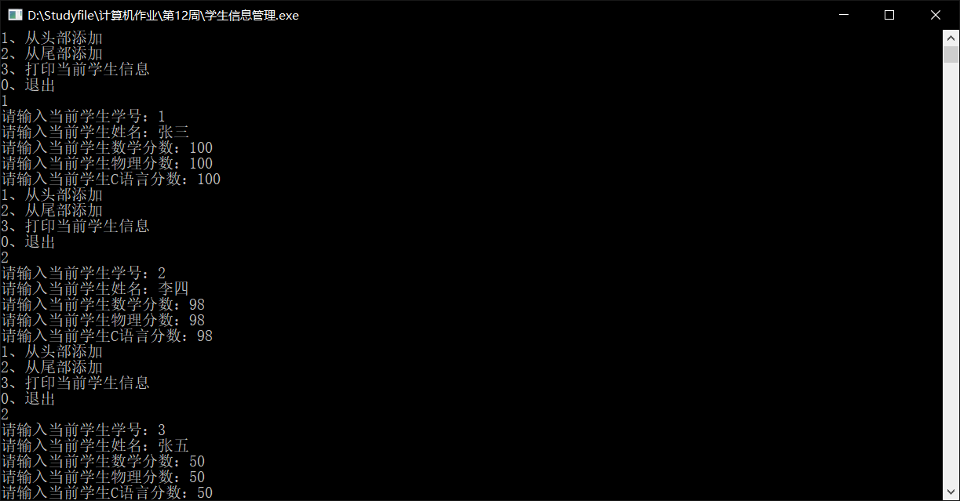

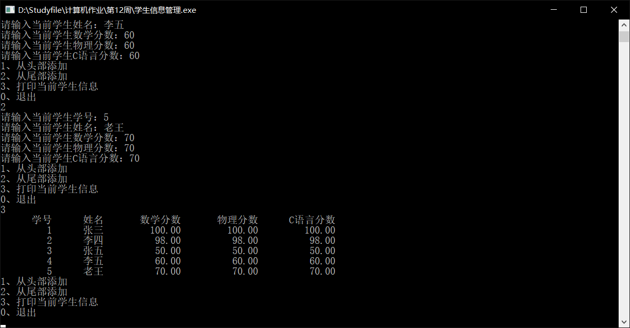

二、使用文件实现100个整数的排序。

#include <stdio.h>

int main()

{

FILE* fp1 = NULL;

FILE* fp2 = NULL;

int count = 0;

int nums[100];

if((fp1 = fopen("D:\\Studyfile\\计算机作业\\第12周\\1.txt","r")) == NULL)

{

printf("文件打开失败！");

return 1;

}

for(int i = 0; i < 100; i++)

{

fscanf(fp1,"%d",&nums[i]);

}

fclose(fp1);

for(int i = 0; i < 100; i++)

{

printf("%d\t",nums[i]);

}

printf("\n");

for(int i = 0 ; i < 99; i++)

{

for(int j = 0;j < 99 - i; j++)

{

if(nums[j] > nums[j + 1])

{

int t = nums[j];

nums[j] = nums[j + 1];

nums[j + 1] = t;

}

}

}

if((fp2 = fopen("D:\\Studyfile\\计算机作业\\第12周\\2.txt","w")) == NULL)

{

printf("文件2打开失败！");

return 2;

}

for(int i = 0; i < 100; i++)

{

fprintf(fp2,"%d\t",nums[i]);

count++;

if(count % 10 == 0)

{

fprintf(fp2,"%c",'\n');

}

}

fclose(fp2);

}

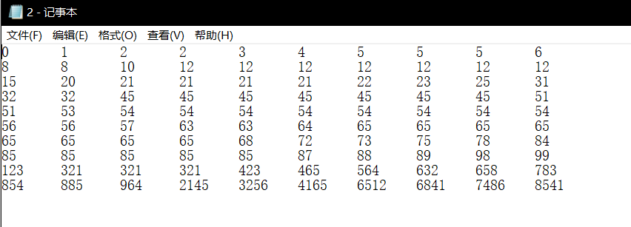

#include <stdio.h>

int main()

{

FILE* fp1 = NULL;

FILE* fp2 = NULL;

int count = 0;

int nums[100];

if((fp1 = fopen("D:\\Studyfile\\计算机作业\\第12周\\1.txt","r")) == NULL)

{

printf("文件打开失败！");

return 1;

}

for(int i = 0; i < 100; i++)

{

fscanf(fp1,"%d",&nums[i]);

}

fclose(fp1);

for(int i = 0; i < 100; i++)

{

printf("%d\t",nums[i]);

}

printf("\n");

for(int i = 0 ; i < 99; i++)

{

int min = i;

for(int j = i;j < 100; j++)

{

if(nums[j] < nums[min])

{

min = j;

}

}

if(min != i)

{

int t = nums[i];

nums[i] = nums[min];

nums[min] = t;

}

}

if((fp2 = fopen("D:\\Studyfile\\计算机作业\\第12周\\2.txt","w")) == NULL)

{

printf("文件2打开失败！");

return 2;

}

for(int i = 0; i < 100; i++)

{

fprintf(fp2,"%d\t",nums[i]);

count++;

if(count % 10 == 0)

{

fprintf(fp2,"%c",'\n');

}

}

fclose(fp2);

}

