

**Advanced Client-side Web Development**

**5COSC026W**

**Portfolio**

Name: C.M.M.S. Silva

UOW ID: W2053190

IIT ID: 20230183

Tutorial Group: CS 14

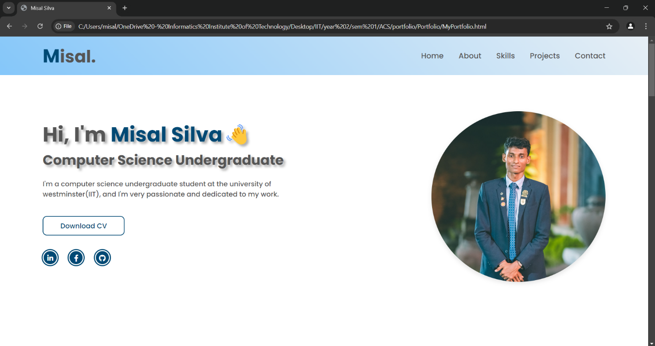Portfolio Screenshots

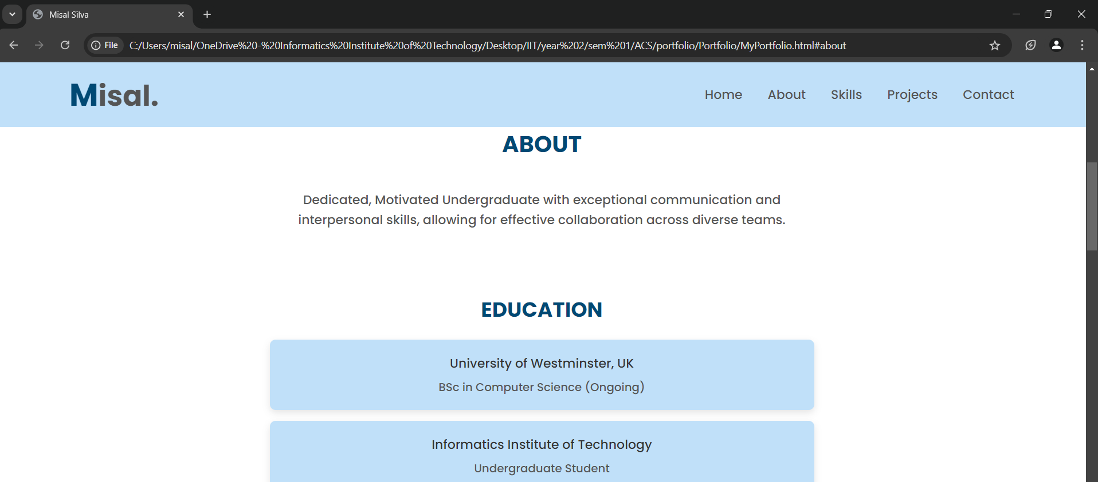

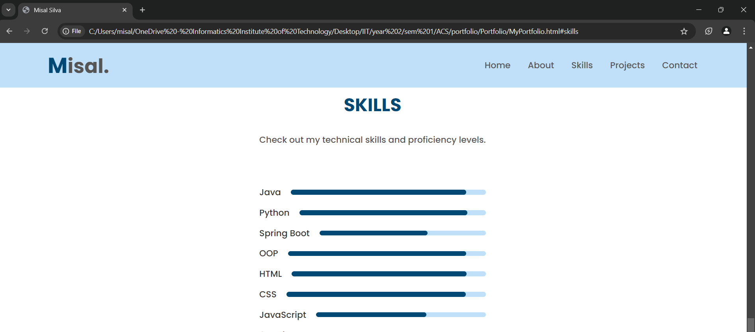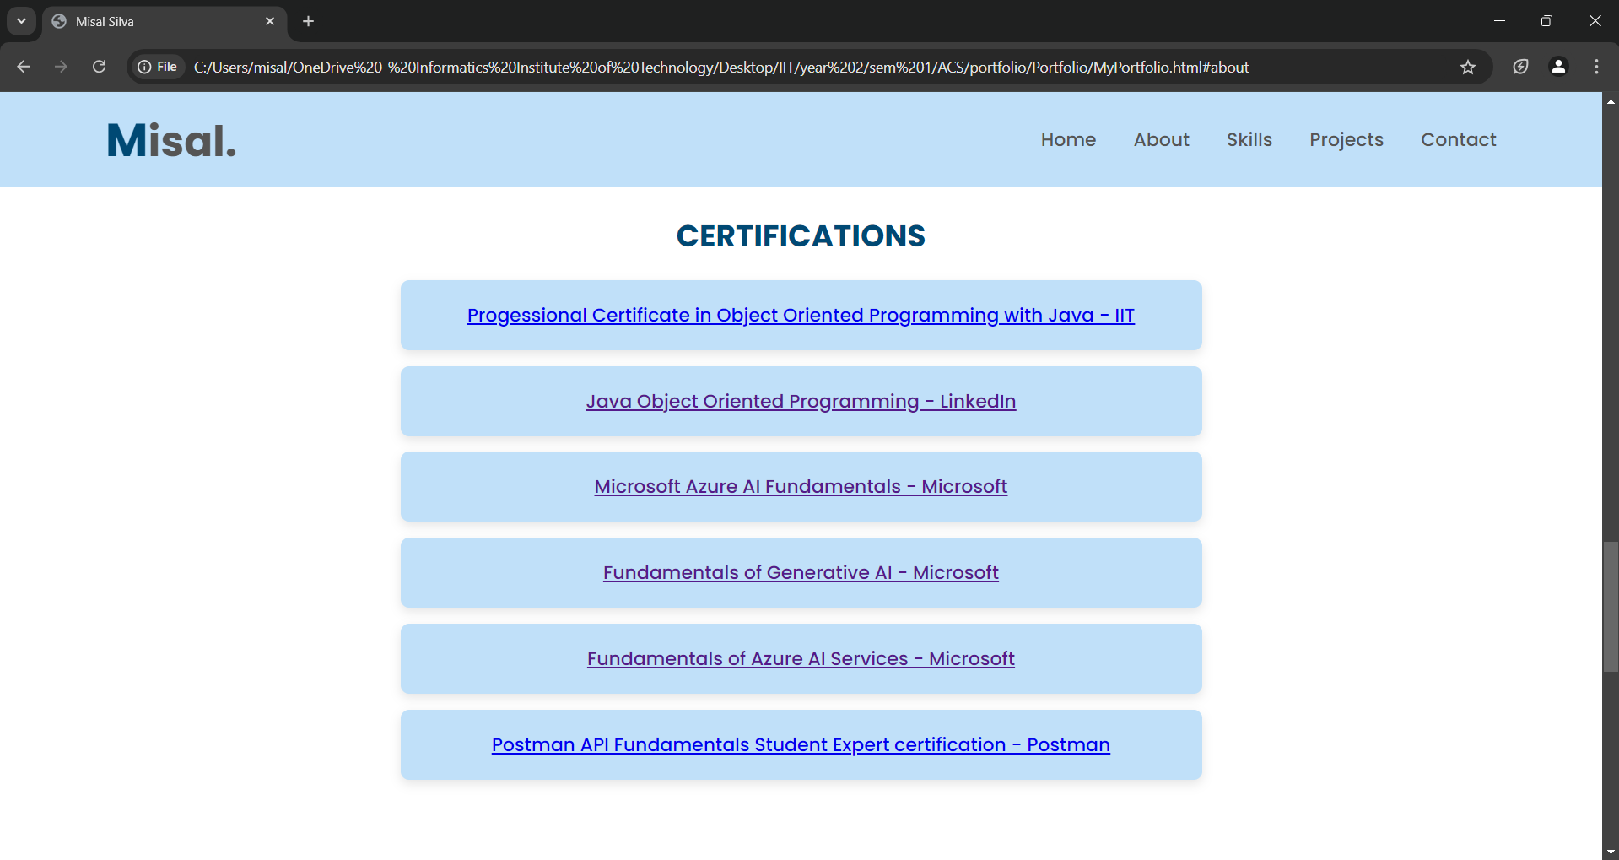

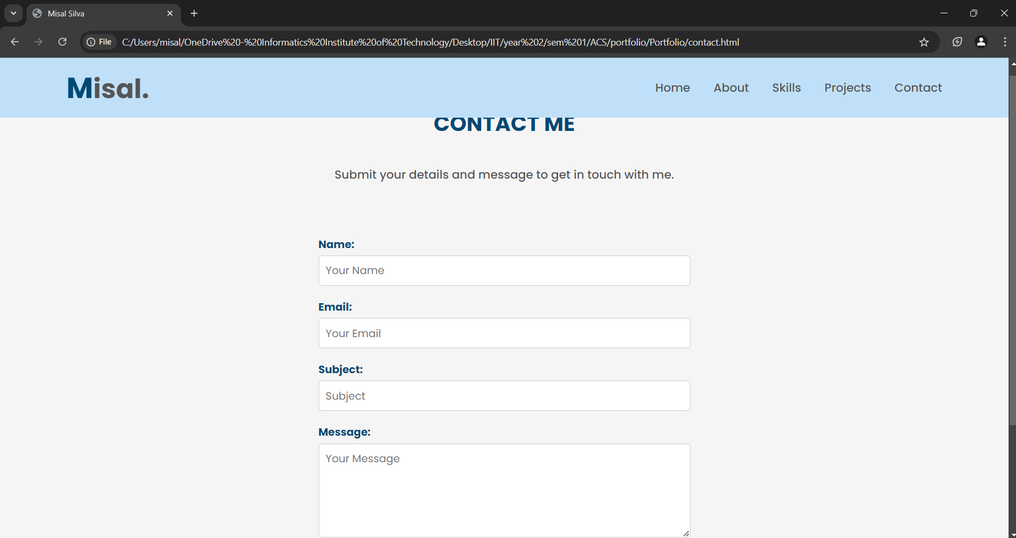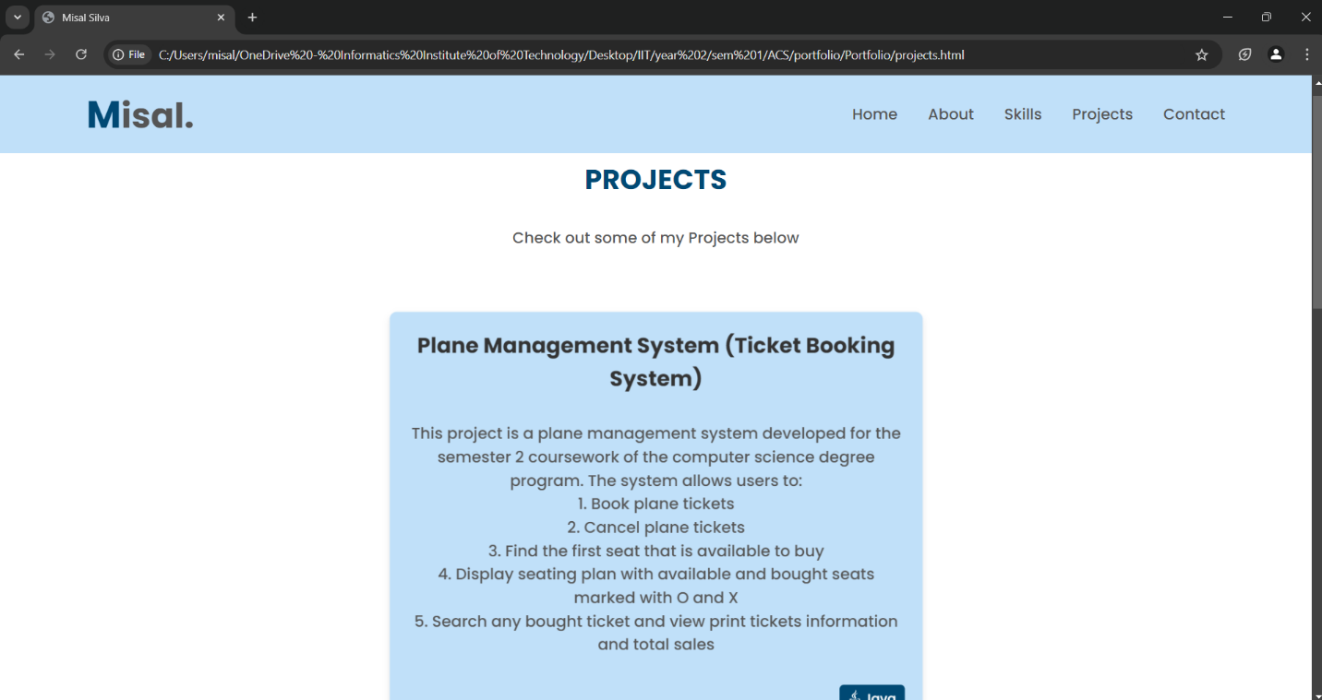

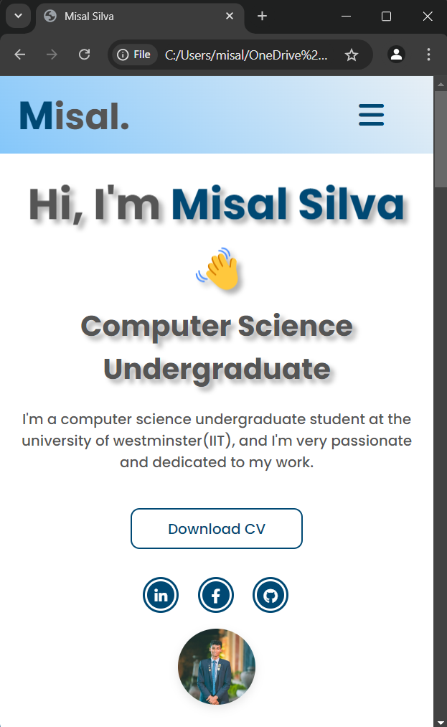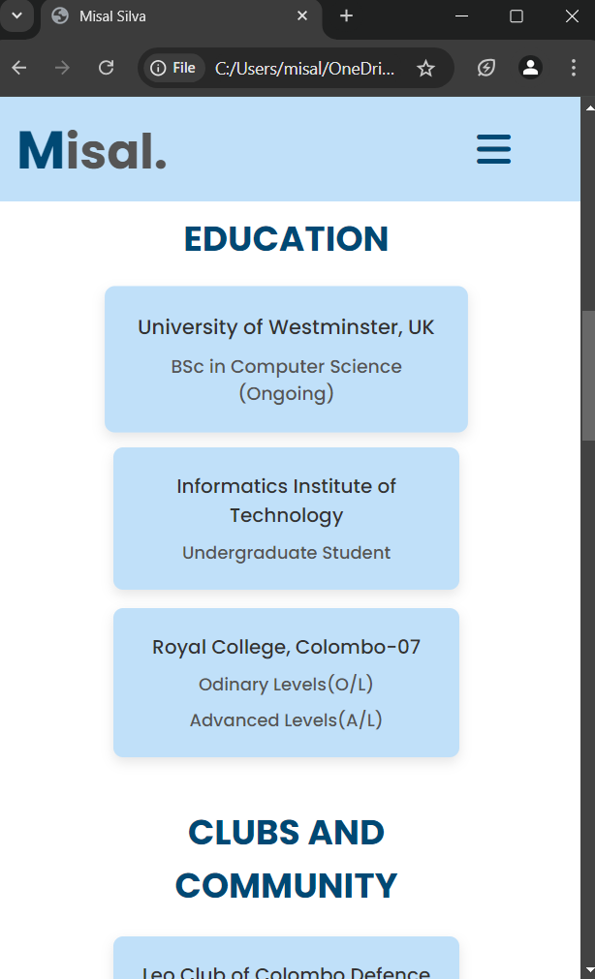

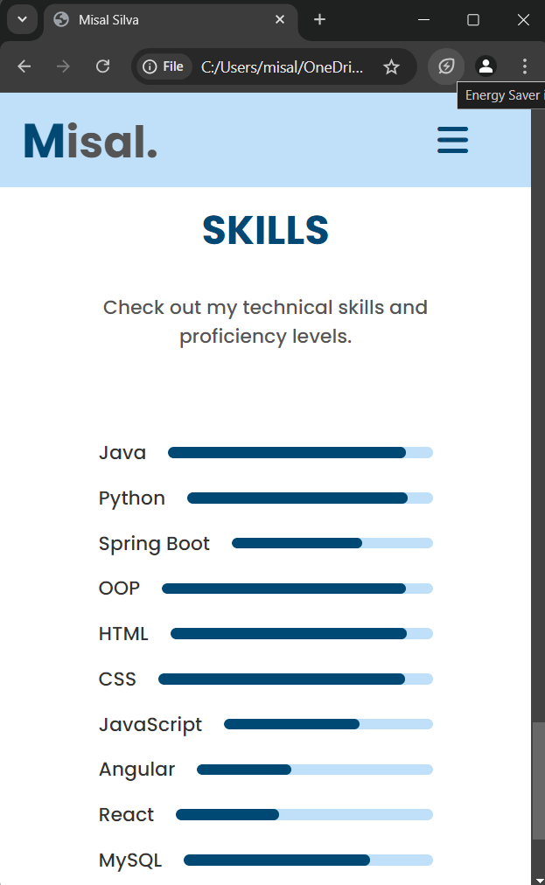

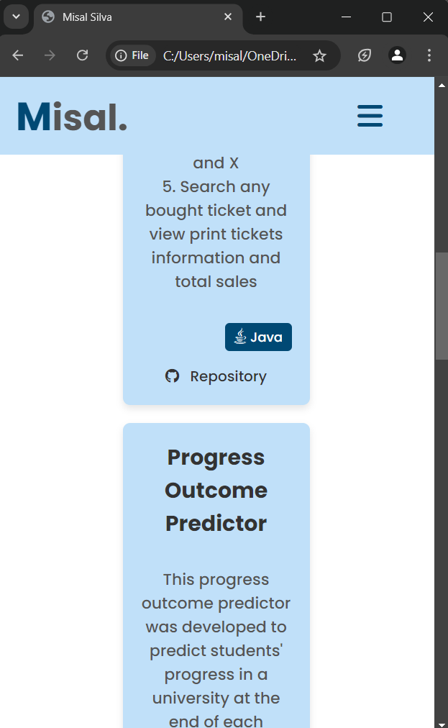

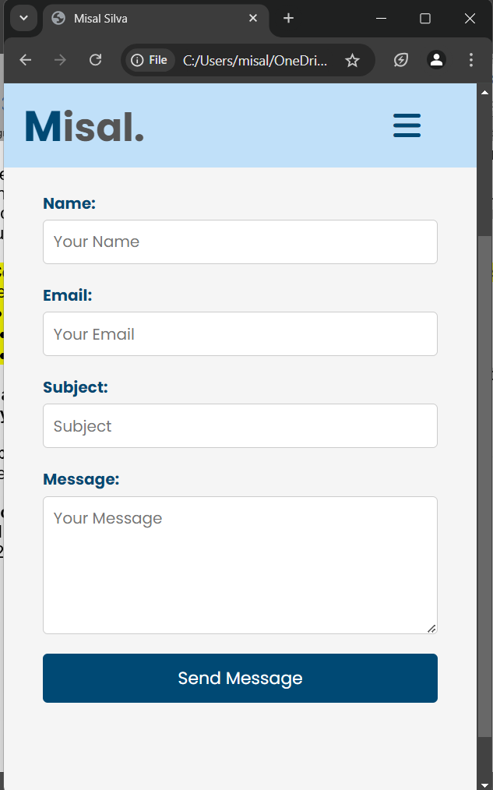

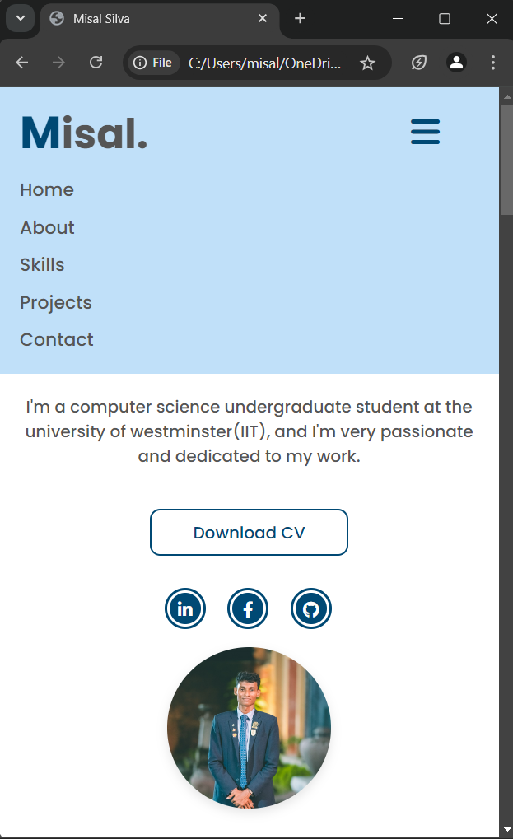

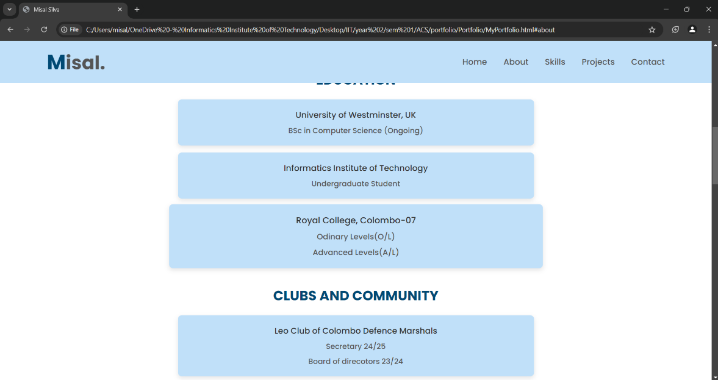

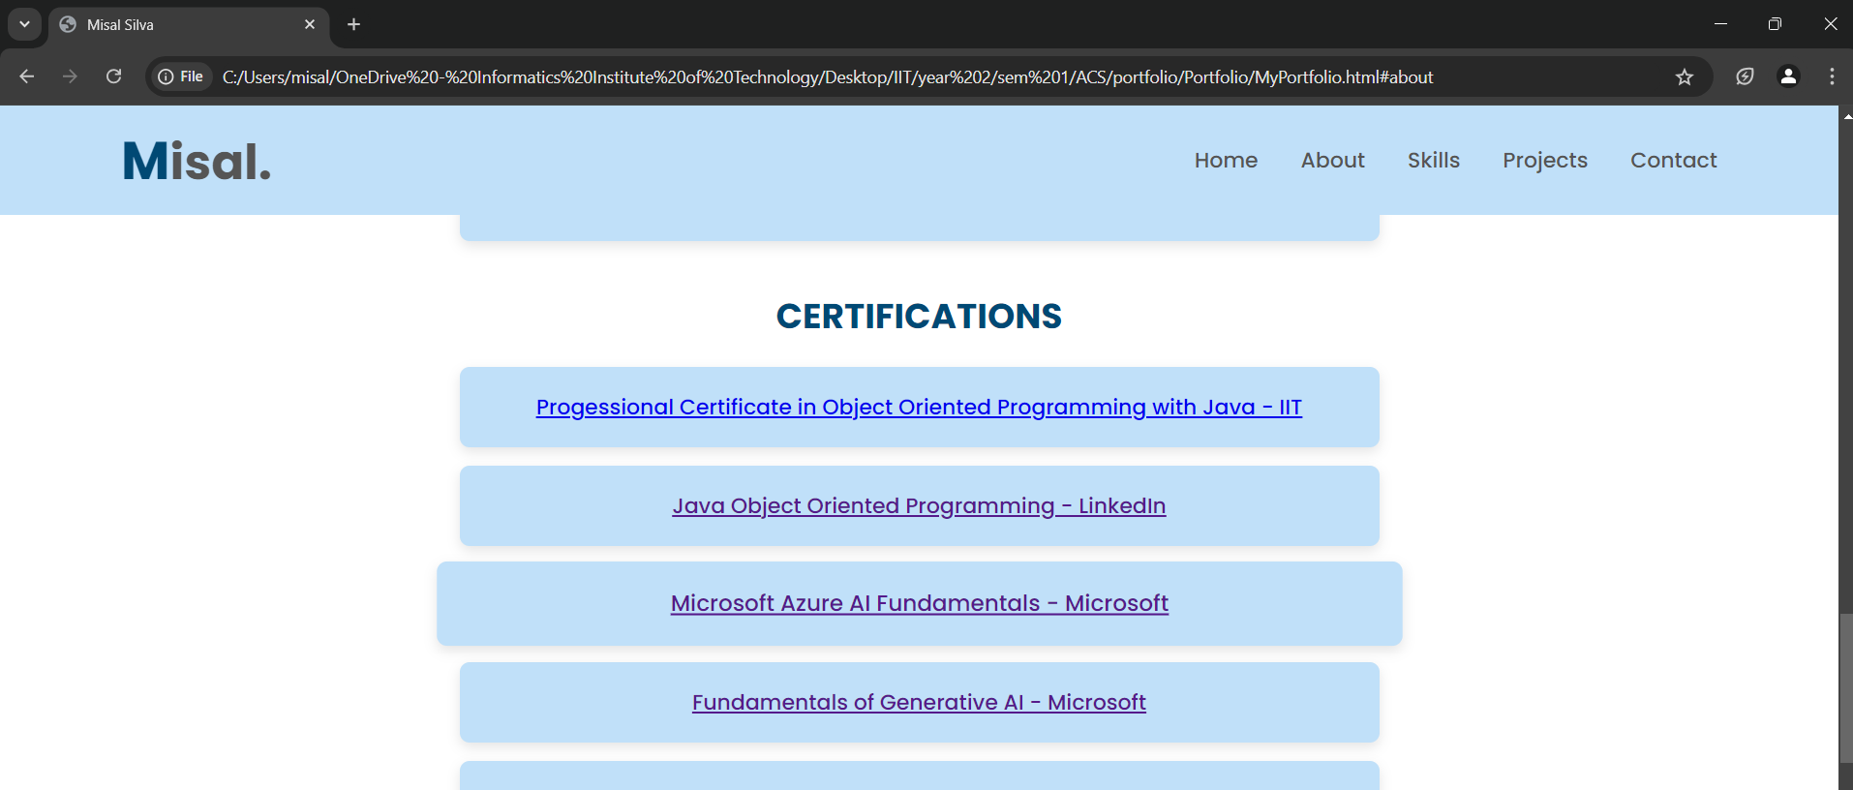

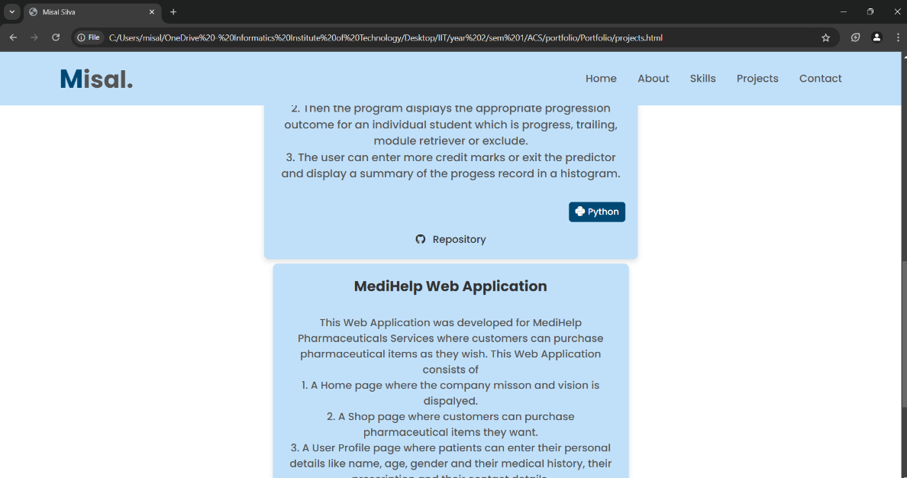

Validation Screenshot

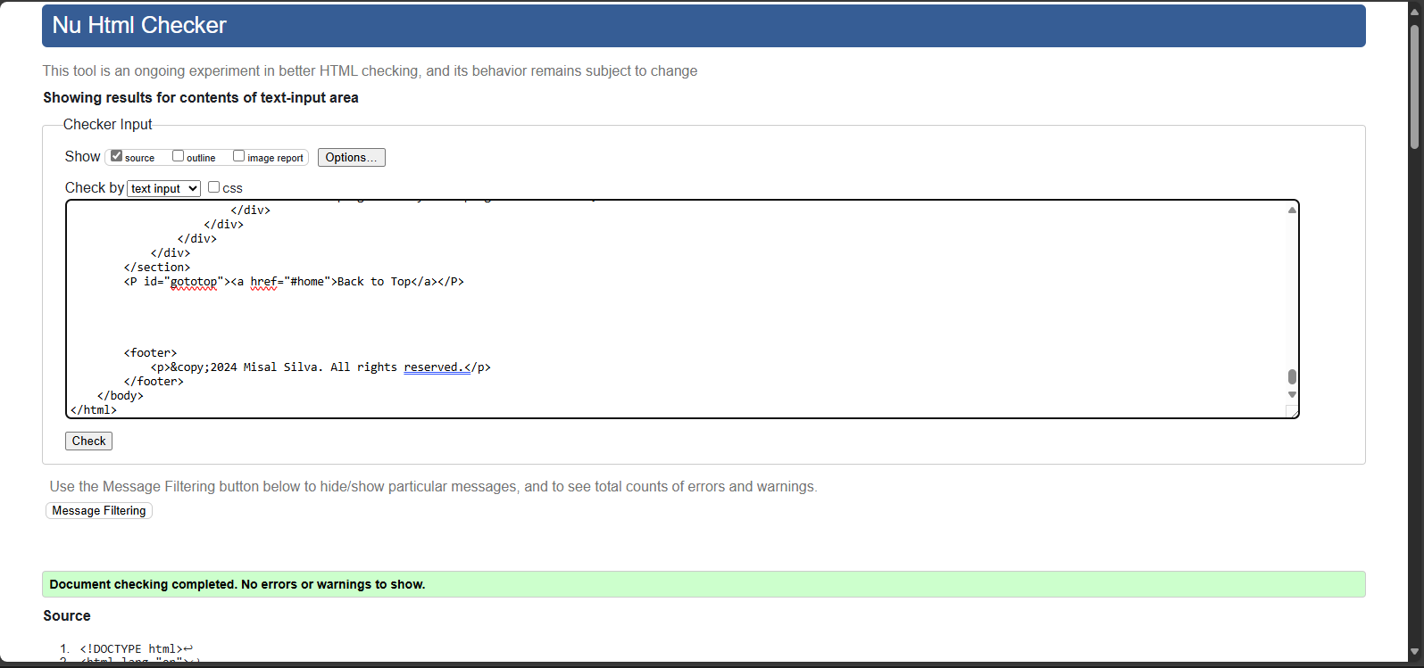

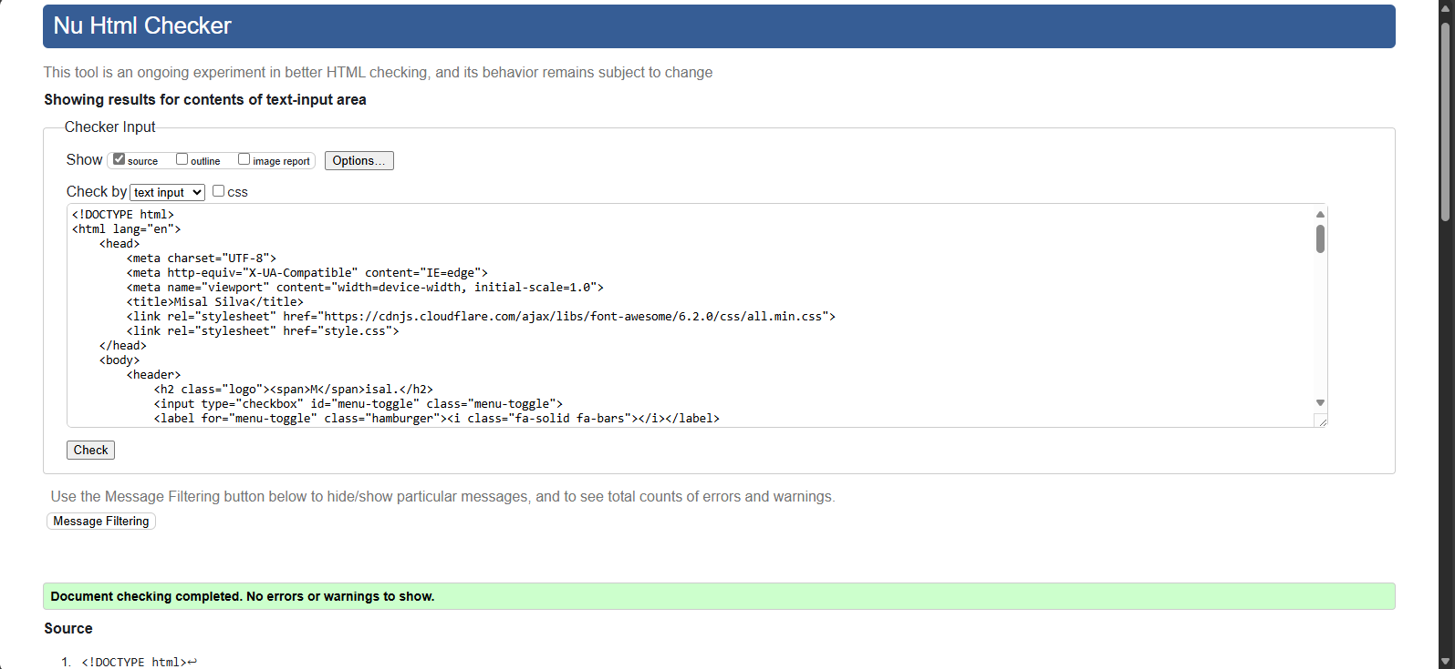

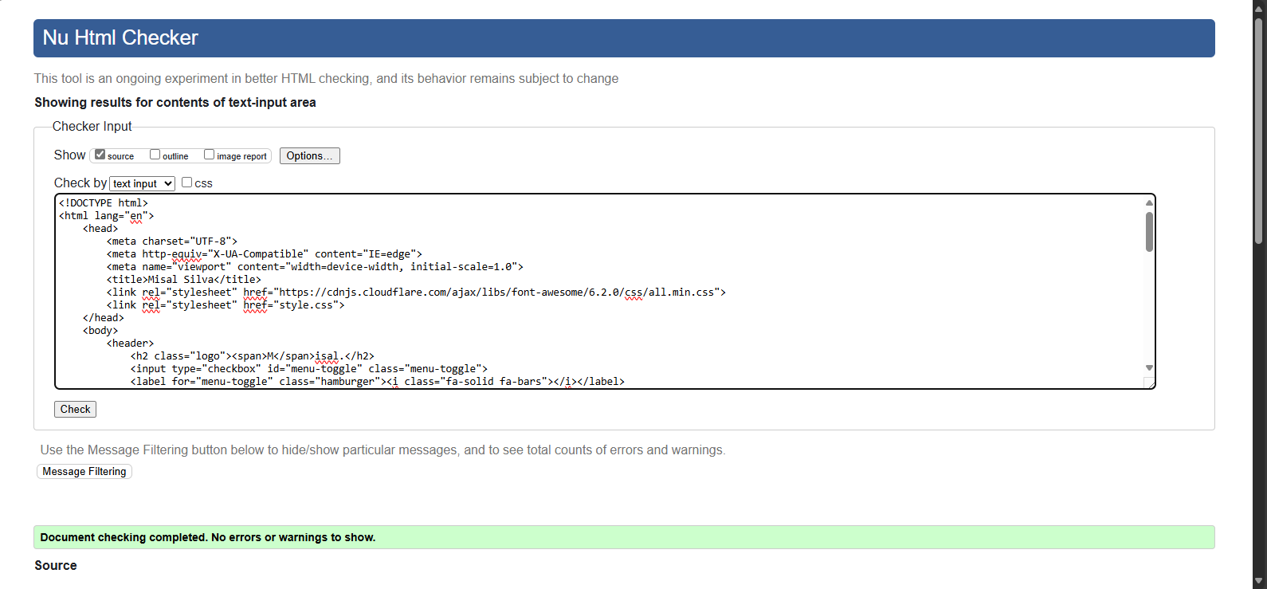

MyPortfolio HTML

<!DOCTYPE html>

<html lang="en">

    <head>

        <meta charset="UTF-8">

        <meta http-equiv="X-UA-Compatible" content="IE=edge">

        <meta name="viewport" content="width=device-width, initial-scale=1.0">

        <title>Misal Silva</title>

        <link rel="stylesheet" href="https://cdnjs.cloudflare.com/ajax/libs/font-awesome/6.2.0/css/all.min.css">

        <link rel="stylesheet" href="style.css">

    </head>

    <body>

        <!--Navigation Bar of the Portfolio with the logo and nav bar-->

        <header>

            <h2 class="logo"><span>M</span>isal.</h2>

            <input type="checkbox" id="menu-toggle" class="menu-toggle">

            <label for="menu-toggle" class="hamburger"><i class="fa-solid fa-bars"></i></label>

            <nav class="navigation">

                <a href="#home">Home</a>

                <a href="#about">About</a>

                <a href="#skills">Skills</a>

                <a href="projects.html">Projects</a>

                <a href="contact.html">Contact</a>

            </nav>

        </header>

        <!--Home Section of the Portfolio where a brief introduction is displayed along with CV, Social Media links and an Image-->

        <section id="home">

            <div class="content">

                <h2>Hi, I'm <span>Misal Silva</span></h2>

                <h4>Computer Science Undergraduate</h4>

                <p>I'm a computer science undergraduate student at the university of westminster(IIT),

                    and I'm very passionate and dedicated to my work.</p>

                <div class="cv-button">

                    <a href="C.M.M.S.Silva.pdf" target="_blank">Download CV</a>

                </div>

                <div class="social-icons">

                    <a href="https://www.linkedin.com/in/misal-silva-903154267/" target="_blank"><i class="fa-brands fa-linkedin-in"></i></a>

                    <a href="#"><i class="fa-brands fa-facebook-f"></i></a>

                    <a href="https://github.com/MisalSilva" target="_blank"><i class="fa-brands fa-github"></i></a>

                </div>

            </div>

            <div class="image-container">

                <img src="portfolio.jpg" alt="Misal Silva">

            </div>

        </section>

        <!--About section of the portfolio where education, community services, sports, certifications and current endeavors are displayed-->

        <section id="about">

            <div class="content">

                <h4>ABOUT</h4>

                <p>Dedicated, Motivated Undergraduate with exceptional communication and interpersonal skills, allowing for effective collaboration across diverse teams. </p>

                <div class="about-section">

                    <!-- Education heading of about section -->

                    <h5>EDUCATION</h5>

                    <div class="tile">University of Westminster, UK<br><span>BSc in Computer Science (Ongoing)</span></div>

                    <div class="tile">Informatics Institute of Technology<br><span>Undergraduate Student</span></div>

                    <div class="tile">Royal College, Colombo-07<br><span>Odinary Levels(O/L)</span> <span>Advanced Levels(A/L)</span></div>

                </div>

                <div class="about-section">

                    <!-- CLUBS AND COMMUNITY heading of about section -->

                    <h5>CLUBS AND COMMUNITY</h5>

                    <div class="tile">Leo Club of Colombo Defence Marshals<br><span>Secretary 24/25</span> <span>Board of direcotors 23/24</span> </div>

                    <div class="tile">Royal College Red Cross Society<br><span>Involved in first-aid training and community service</span></div>

                    <div class="tile">Royal College Library Readers Association<br><span>Gaining Knowleagde through reading books</span></div>

                </div>

                <div class="about-section">

                    <!-- Sports heading of about section -->

                    <h5>SPORTS</h5>

                    <div class="tile">Karate<br><span>National Player</span> <span>Black Belt 1st Dan</span></div>

                </div>

                <div class="about-section">

                    <!-- Certifications heading of about section -->

                    <h5>CERTIFICATIONS</h5>

                    <div class="tile"><a href="#">Progessional Certificate in Object Oriented Programming with Java - IIT</a></div>

                    <div class="tile"><a href="https://www.linkedin.com/learning/certificates/c9e2a06e0efc95d33056f380bc26740a70d1abcdda6b31648b9bbec5560cc458?lipi=urn%3Ali%3Apage%3Ad_flagship3_profile_view_base_certifications_details%3BELe26UGaRPm7fA%2BwdteV3g%3D%3D" target="_blank">Java Object Oriented Programming - LinkedIn</a></div>

                    <div class="tile"><a href="https://learn.microsoft.com/api/achievements/share/en-us/MisalSilva-0796/F2J4QC8X?sharingId=C0E01739CFC20B8D" target="_blank">Microsoft Azure AI Fundamentals - Microsoft</a></div>

                    <div class="tile"><a href="https://learn.microsoft.com/api/achievements/share/en-us/MisalSilva-0796/CNM7YDG9?sharingId=C0E01739CFC20B8D" target="_blank">Fundamentals of Generative AI - Microsoft</a></div>

                    <div class="tile"><a href="https://learn.microsoft.com/api/achievements/share/en-us/MisalSilva-0796/2KC54R7V?sharingId=C0E01739CFC20B8D" target="_blank">Fundamentals of Azure AI Services - Microsoft</a></div>

                    <div class="tile"><a href="#">Postman API Fundamentals Student Expert certification - Postman</a></div>

                </div>

                <div class="about-section">

                    <!-- current endeavors heading of about section -->

                    <h5>CURRENT ENDEAVORS</h5>

                    <div class="tile">Pursuing BSc(hons) in Computer Science degree</div>

                    <div class="tile">Working on Software Development Project</div>

                    <div class="tile">Looking to work and Collaborate with any driven individual</div>

                </div>

            </div>

        </section>

        <!--Skills sections where skills and proficiency levels are displayed using animations-->

        <section id="skills">

            <div class="content">

                <h4>SKILLS</h4>

                <p>Check out my technical skills and proficiency levels.</p>

                <div class="skills-container">

                    <div class="skill">

                        <span>Java</span>

                        <div class="progress-bar">

                            <div class="progress" style="--progress-width: 90%;"></div>

                        </div>

                    </div>

                    <div class="skill">

                        <span>Python</span>

                        <div class="progress-bar">

                            <div class="progress" style="--progress-width: 90%;"></div>

                        </div>

                    </div>

                    <div class="skill">

                        <span>Spring Boot</span>

                        <div class="progress-bar">

                            <div class="progress" style="--progress-width: 65%;"></div>

                        </div>

                    </div>

                    <div class="skill">

                        <span>OOP</span>

                        <div class="progress-bar">

                            <div class="progress" style="--progress-width: 90%;"></div>

                        </div>

                    </div>

                    <div class="skill">

                        <span>HTML</span>

                        <div class="progress-bar">

                            <div class="progress" style="--progress-width: 90%;"></div>

                        </div>

                    </div>

                    <div class="skill">

                        <span>CSS</span>

                        <div class="progress-bar">

                            <div class="progress" style="--progress-width: 90%;"></div>

                        </div>

                    </div>

                    <div class="skill">

                        <span>JavaScript</span>

                        <div class="progress-bar">

                            <div class="progress" style="--progress-width: 65%;"></div>

                        </div>

                    </div>

                    <div class="skill">

                        <span>Angular</span>

                        <div class="progress-bar">

                            <div class="progress" style="--progress-width: 40%;"></div>

                        </div>

                    </div>

                    <div class="skill">

                        <span>React</span>

                        <div class="progress-bar">

                            <div class="progress" style="--progress-width: 40%;"></div>

                        </div>

                    </div>

                    <div class="skill">

                        <span>MySQL</span>

                        <div class="progress-bar">

                            <div class="progress" style="--progress-width: 75%;"></div>

                        </div>

                    </div>

                    <div class="skill">

                        <span>Postman</span>

                        <div class="progress-bar">

                            <div class="progress" style="--progress-width: 70%;"></div>

                        </div>

                    </div>

                </div>

            </div>

        </section>

        <!--A link to go back to top of the page-->

        <P id="gototop"><a href="#home">Back to Top</a></P>

        <!--Footer of the Portfolio page-->

        <footer>

            <p>&copy;2024 Misal Silva. All rights reserved.</p>

        </footer>

    </body>

</html>

Projects HTML

<!DOCTYPE html>

<html lang="en">

    <head>

        <meta charset="UTF-8">

        <meta http-equiv="X-UA-Compatible" content="IE=edge">

        <meta name="viewport" content="width=device-width, initial-scale=1.0">

        <title>Misal Silva</title>

        <link rel="stylesheet" href="https://cdnjs.cloudflare.com/ajax/libs/font-awesome/6.2.0/css/all.min.css">

        <link rel="stylesheet" href="style.css">

    </head>

    <body>

        <!--Navigation Bar of the Portfolio with the logo and nav bar-->

        <header>

            <h2 class="logo"><span>M</span>isal.</h2>

            <input type="checkbox" id="menu-toggle" class="menu-toggle">

            <label for="menu-toggle" class="hamburger"><i class="fa-solid fa-bars"></i></label>

            <nav class="navigation">

                <a href="MyPortfolio.html">Home</a>

                <a href="MyPortfolio.html#about">About</a>

                <a href="MyPortfolio.html#skills">Skills</a>

                <a href="projects.html">Projects</a>

                <a href="contact.html">Contact</a>

            </nav>

        </header>

        <!--Projects Section of the Portfolio where projects and it's features and github links are displayed-->

        <section id="projects">

            <div class="content">

                <h4>PROJECTS</h4>

                <p>Check out some of my Projects below</p>

                <div class="project-grid">

                    <div class="project-card">

                        <!-- Description of the projects and Features -->

                        <h5>Plane Management System (Ticket Booking System)</h5>

                        <p>This project is a plane management system developed for the semester 2 coursework of the computer science degree program. The system allows users to:

                            <br> 1. Book plane tickets

                            <br> 2. Cancel plane tickets

                            <br> 3. Find the first seat that is available to buy

                            <br> 4. Display seating plan with available and bought seats marked with O and X

                            <br> 5. Search any bought ticket and view print tickets information and total sales

                        </p>

                        <!-- github link for the repository -->

                        <a href="https://github.com/MisalSilva/w2053190_PlaneManagement" target="_blank" class="github-link">

                            <i class="fab fa-github"></i> Repository

                        </a>

                        <!-- Languages used for the project -->

                        <div class="language-label">

                            <i class="fab fa-java"></i> Java

                        </div>

                    </div>

                    <div class="project-card">

                        <!-- Description of the projects and Features -->

                        <h5>Progress Outcome Predictor</h5>

                        <p>This progress outcome predictor was developed to predict students' progress in a university at the end of each academic year. Finally, the progress outcome was recorded in a histogram.

                        <br>1. The program prompts for the number of credits at pass, defer and fail.

                        <br>2. Then the program displays the appropriate progression outcome for an individual student which is progress, trailing, module retriever or exclude.

                        <br>3. The user can enter more credit marks or exit the predictor and display a summary of the progess record in a histogram.

                        </p>

                        <!-- github link for the repository -->

                        <a href="https://github.com/MisalSilva/Progress-Outcome-Predictor" target="_blank" class="github-link">

                            <i class="fab fa-github"></i> Repository

                        </a>

                        <!-- Languages used for the project -->

                        <div class="language-label">

                            <i class="fab fa-python"></i> Python

                        </div>

                    </div>

                    <div class="project-card">

                        <!-- Description of the projects and Features -->

                        <h5>MediHelp Web Application</h5>

                        <p>This Web Application was developed for MediHelp Pharmaceuticals Services where customers can purchase pharmaceutical items as they wish.

                            This Web Application consists of

                            <br> 1. A Home page where the company misson and vision is dispalyed.

                            <br> 2. A Shop page where customers can purchase pharmaceutical items they want.

                            <br> 3. A User Profile page where patients can enter their personal details like name, age, gender and their medical history, their prescription and their contact details.

                            <br> 4. A Feedback page where customers can give out their personal feedback and submit it.

                            <br> 5. A Team page where the team members are displayed.

                        </p>

                        <!-- github link for the repository -->

                        <a href="https://github.com/MisalSilva/MediHelp-Web-Application" target="_blank" class="github-link">

                            <i class="fab fa-github"></i>  Repository

                        </a>

                        <!-- Languages used for the project -->

                        <div class="language-label">

                            <i class="fab fa-html5"></i> HTML

                            <i class="fab fa-css3"></i> CSS

                            <i class="fab fa-js"></i> Javascript

                        </div>

                    </div>

                </div>

            </div>

        </section>

        <!--Footer of the Portfolio page-->

        <footer>

            <p>&copy;2024 Misal Silva. All rights reserved.</p>

        </footer>

    </body>

</html>

Contact HTML

<!DOCTYPE html>

<html lang="en">

    <head>

        <meta charset="UTF-8">

        <meta http-equiv="X-UA-Compatible" content="IE=edge">

        <meta name="viewport" content="width=device-width, initial-scale=1.0">

        <title>Misal Silva</title>

        <link rel="stylesheet" href="https://cdnjs.cloudflare.com/ajax/libs/font-awesome/6.2.0/css/all.min.css">

        <link rel="stylesheet" href="style.css">

    </head>

    <body>

        <!--Navigation Bar of the Portfolio with the logo and nav bar-->

        <header>

            <h2 class="logo"><span>M</span>isal.</h2>

            <input type="checkbox" id="menu-toggle" class="menu-toggle">

            <label for="menu-toggle" class="hamburger"><i class="fa-solid fa-bars"></i></label>

            <nav class="navigation">

                <a href="MyPortfolio.html">Home</a>

                <a href="MyPortfolio.html#about">About</a>

                <a href="MyPortfolio.html#skills">Skills</a>

                <a href="projects.html">Projects</a>

                <a href="contact.html">Contact</a>

            </nav>

        </header>

        <!--Contact Section of the Portfolio where user can enter their details and send a message-->

        <section id="contact">

            <div class="content">

                <h4>CONTACT ME</h4>

                <p>Submit your details and message to get in touch with me.</p>

                <!-- Form that need to  be submitted -->

                <form id="contact-form" action="mailto:your-email@example.com" method="post" enctype="text/plain">

                    <div class="form-group">

                        <label for="name">Name:</label>

                        <input type="text" id="name" name="name" required placeholder="Your Name">

                    </div>

                    <div class="form-group">

                        <label for="email">Email:</label>

                        <input type="email" id="email" name="email" required placeholder="Your Email">

                    </div>

                    <div class="form-group">

                        <label for="subject">Subject:</label>

                        <input type="text" id="subject" name="subject" required placeholder="Subject">

                    </div>

                    <div class="form-group">

                        <label for="message">Message:</label>

                        <textarea id="message" name="message" rows="5" required placeholder="Your Message"></textarea>

                    </div>

                    <!-- button to submit the message -->

                    <button type="submit" class="send-button">Send Message</button>

                </form>

            </div>

        </section>

        <!--Footer of the Portfolio page-->

        <footer>

            <p>&copy;2024 Misal Silva. All rights reserved.</p>

        </footer>

    </body>

</html>

Style CSS

/* import necessary fonts */

@import url('https://fonts.googleapis.com/css2?family=Poppins:wght@300;400;500;600;700;800;900&display=swap');

* {

    margin: 0;

    padding: 0;

    box-sizing: border-box;

    font-family: 'Poppins', sans-serif;

}

/* Ensuring a smooth scrolling when scrolling throughout the page */

html {

    scroll-behavior: smooth;

}

/* Header Styles*/

header {

    position: fixed;

    top: 0;

    left: 0;

    width: 100%;

    padding: 12px 100px;

    display: flex;

    justify-content: space-between;

    align-items: center;

    z-index: 100;

    background: linear-gradient(45deg, #85c7fa, #e7eff5); /* Gradient Stylings*/

}

/* logo styles */

.logo {

    font-size: 2.5em;

    color: #555;

    cursor: default;

}

/* logo span styles */

.logo span {

    color: #004974;

    font-size: 1.1em;

}

/* nav bar styles */

.navigation {

    display: flex;

    gap: 35px;

}

.navigation a {

    font-size: 1.1em;

    color: #555;

    text-decoration: none; /* Text Effects */

    font-weight: 500;

    transition: .3s; /* Smooth transitions */

}

/* Smooth transitions */

.navigation a:hover { /* User Action Pseudo Class - based on user action */

    color: #004974;

    transform: translateX(-5px); /* transform stylings */

}

/* Hamburger Menu Styles */

.menu-toggle {

    display: none;

}

.hamburger {

    display: none;

    font-size: 2em;

    cursor: pointer;

    color: #004974;

}

/* media quaries for making the header and nav bar responsive */

@media (max-width: 768px) {

    header {

        padding: 10px 20px;

        flex-direction: column;

        align-items: flex-start;

    }

    .hamburger {

        display: flex;

        position: absolute;

        padding-left: 380px;

        padding-top: 17px;

    }

    .content h2{

        padding-top: 80px;

    }

    .social-icons{

        padding-top: 25px;

        padding-left: 20px;

    }

    .navigation {

        display: none;

        flex-direction: column;

        gap: 10px;

        width: 100%;

        background-color: #c0e0f9;

        padding: 10px 0;

    }

    .menu-toggle:checked + .hamburger + .navigation {

        display: flex;

    }

}

/* home section styles */

#home {

    position: relative;

    width: 100%;

    height: 100vh;

    display: flex;

    justify-content: space-between;

    align-items: center;

    padding: 30px 100px;

    background-size: cover;

    background-position: center;

}

/* styles for content class of home section */

.content {

    max-width: 50%;

    color: #555;

    font-weight: 450;

}

.content > h2 { /* Child Combinator */

    font-size: 3em;

    transition: .3s; /* Smooth transitions */

    text-shadow: 5px 5px 5px rgba(0, 0, 0, 0.3); /* Text Shadows */

}

/* High specificity */

.content h2 span {

    color: #004974;

}

.content h2::after { /* Pseudo Elements with Generated Content */

    content: "👋" ;

    color: #004974;

}

.content h2:hover { /* User Action Pseudo Class - based on user action */

    transform: translateY(-5px);

}

.content > h4 { /* Child Combinator */

    font-size: 2em;

    text-shadow: 5px 5px 5px rgba(0, 0, 0, 0.3); /* Text Shadows */

}

.content > p { /* Child Combinator */

    padding: 20px 0 50px 0;

}

/* cv button styles */

.cv-button a {

    color: #004974;

    text-decoration: none; /* Text Effects */

    padding: 10px 40px;

    background: #fff;

    border-radius: 10px; /* Slightly rounded corners */

    border: 2px solid #004974; /* Border styling */

    font-weight: 500;

    transition: .3s; /* Smooth transitions */

}

/* Smooth transitions */

.cv-button a:hover { /* User Action Pseudo Class - based on user action */

    color: #fff;

    background: #004974;

    transform: translateX(-5px); /* transform stylings */

}

/* social media icons styles */

.social-icons {

    padding-top: 25px;

    position: relative;

    margin-top: 20px;

}

.social-icons a {

    display: inline-block;

    width: 35px;

    height: 35px;

    background: #004974;

    border-radius: 50%; /* Slightly rounded corners */

    margin-right: 22px;

    text-align: center;

    line-height: 35px;

    border: 3px solid #fff; /* Border styling */

    outline: 3px solid #004974;

    transition: .3s; /* Smooth transitions */

}

/* Smooth transitions */

.social-icons a:hover { /* User Action Pseudo Class - based on user action */

    transform: translateY(-5px); /* transform stylings */

}

.social-icons a i {

    color: #fff;

}

/* styles for Image container class of home section */

.image-container {

    max-width: 40%;

    height: 400px;

    overflow: hidden;

    border-radius: 50%; /* Slightly rounded corners */

    display: flex;

    justify-content: center;

    align-items: center;

    box-shadow: 0 4px 10px rgba(0, 0, 0, 0.1);

    margin-top: 20px; /* Added margin for spacing */

}

.image-container img {

    width: 100%;

    height: 100%;

    object-fit: cover;

    object-position: top;

    border-radius: 50%;

}

/* Styles to make home section responsive */

@media (max-width: 768px) {

    #home {

        flex-direction: column;

        align-items: center;

        padding: 30px 20px;

    }

    .content {

        max-width: 100%;

        text-align: center;

    }

    .image-container {

        max-width: 60%;

    }

}

/*About section styles*/

#about {

    padding: 90px;

    background-color: #fff;

    color: #333;

    text-align: center;

}

#about .content {

    max-width: 800px;

    margin: 0 auto;

    padding: 0 20px;

}

#about h4 {

    font-size: 2em;

    color: #004974;

    margin-bottom: 20px;

}

#about p {

    font-size: 1.1em;

    color: #555;

    margin-bottom: 40px;

    line-height: 1.6;

}

.about-section {

    margin-bottom: 40px;

}

.about-section > h5 { /* Child Combinator */

    font-size: 1.8em;

    color: #004974;

    margin-bottom: 20px;

}

/* styles for tile class of about section */

.tile {

    background-color: #c0e0f9;

    color: #333;

    border-radius: 8px;

    padding: 20px;

    margin-bottom: 15px;

    box-shadow: 0 4px 10px rgba(0, 0, 0, 0.1);

    transition: transform 0.3s ease; /* Smooth transitions */

    font-size: 1.1em;

}

.tile span {

    display: block;

    margin-top: 8px;

    font-size: 0.9em;

    color: #555;

}

/* Smooth transitions */

.tile:hover { /* User Action Pseudo Class - based on user action */

    transform: scale(1.05); /* transform stylings */

}

/* Styles to make about section responsive */

@media (max-width: 768px) {

    #about .content {

        padding: 0 10px;

    }

    .tile {

        font-size: 1em;

    }

}

/* Skills section styles */

#skills {

    padding: 90px ;

    text-align: center;

    display: flex;

    flex-direction: column;

    align-items: center;

    justify-content: center;

}

#skills .content{

    padding-top: 8px;

}

/* High specificity */

#skills .content h4 {

    font-size: 2.3em;

    margin-bottom: 10px;

    color: #004974;

}

/* High specificity */

#skills .content p {

    font-size: 1.1em;

    color: #555;

    margin-bottom: 30px;

    max-width: 600px;

}

/* Styling for the skills container class */

.skills-container {

    max-width: 800px;

    width: 100%;

    display: flex;

    flex-direction: column;

    gap: 15px;

}

.skill {

    display: flex;

    align-items: center;

    justify-content: space-between;

    font-size: 1.1em;

    color: #333;

}

/* Styles for the progress bar */

.progress-bar {

    background-color: #c0e0f9;

    border-radius: 5px; /* Slightly rounded corners */

    flex: 1;

    margin-left: 20px;

    height: 10px;

    overflow: hidden;

    position: relative;

}

.progress {

    background-color: #004974;

    height: 100%;

    border-radius: 5px; /* Slightly rounded corners */

    width: 0;

    transition: width 0.3s ease; /* Smooth transitions */

    animation: fillProgress 2s forwards; /* Animation keyframes for progress bar */

}

/* Animation keyframes for progress bar */

@keyframes fillProgress {

    from {

        width: 0;

    }

    to {

        width: var(--progress-width);

    }

}

/* Projects section styles */

#projects {

    display: flex;

    align-items: center;

    justify-content: center;

    padding: 60px 200px;

    text-align: center;

}

#projects .content {

    padding-top: 60px;

    max-width: 600px;

    color: #555;

    font-weight: 450;

}

/* High specificity */

#projects .content h4 {

    color: #004974 ;

    font-size: 2em;

    text-align: center;

    margin-bottom: 10px;

}

/* High specificity */

#projects .content p {

    font-size: 1.1em;

    color: #555;

    margin-bottom: 30px;

}

.project-grid {

        display: flex;

        justify-content: space-between;

        gap: 20px;

        flex-wrap: wrap;

        margin-top: 20px;

}

.project-card {

    position: relative;

    background-color: #c0e0f9;

    padding: 20px;

    border-radius: 8px; /* Slightly rounded corners */

    box-shadow: 5px 5px 5px rgba(0, 0, 0, 0.1); /* bow shadows */

    transition: transform 0.3s ease; /* Smooth transitions */

}

.project-card:hover { /* User Action Pseudo Class - based on user action */

    transform: scale(1.05); /* transform stylings */

}

.project-card > h5 { /* Child Combinator */

    font-size: 1.5em;

    color: #333;

    margin-bottom: 10px;

}

.project-card p {

    font-size: 1em;

    color: #666;

    margin-bottom: 15px;

}

/* styles for language label class of projects section */

.language-label {

    position: absolute;

    bottom: 40px;

    right: 20px;

    background-color: #004974;

    color: #fff;

    padding: 5px 10px;

    border-radius: 5px; /* Slightly rounded corners */

    font-size: 0.9em;

    display: flex;

    align-items: center;

    gap: 5px;

}

.language-label i {

    font-size: 1.2em;

}

.github-link {

    text-decoration: none;

    color: #333;

    font-size: 1em;

}

 a[href="https://github.com/MisalSilva/w2053190_PlaneManagement"] { /*  Attribute Selectors */

    color: #2cc917;

}

 a[href="https://github.com/MisalSilva/Progress-Outcome-Predictor"] { /*  Attribute Selectors */

    color: #f14747;

}

 a[href="https://github.com/MisalSilva/MediHelp-Web-Application"] { /*  Attribute Selectors */

    color: #dabb11;

}

.github-link i {

    margin-right: 8px;

}

/* Smooth transitions */

.github-link:hover { /* User Action Pseudo Class - based on user action */

    color: #004974;

}

/* styles for Contact Section */

#contact {

    padding: 90px 20px;

    background-color: #f5f5f5;

    text-align: center;

    color: #333;

}

#contact .content {

    max-width: 600px;

    margin: 0 auto;

    padding: 0 20px;

}

#contact h4 {

    font-size: 2em;

    color: #004974;

    margin-bottom: 20px;

}

#contact p {

    font-size: 1.1em;

    color: #555;

    margin-bottom: 30px;

}

/* Contact Form Styling */

#contact-form {

    display: flex;

    flex-direction: column;

    gap: 20px;

}

.form-group {

    display: flex;

    flex-direction: column;

    text-align: left;

}

.form-group label {

    font-weight: bold;

    margin-bottom: 5px;

    color: #004974;

}

.form-group input, .form-group textarea {

    padding: 10px;

    border: 1px solid #ccc; /* Border styling */

    border-radius: 5px; /* Slightly rounded corners */

    font-size: 1em;

    outline: none;

    transition: border-color 0.3s; /* Smooth transitions */

}

.form-group input:focus, .form-group textarea:focus {

    border-color: #004974;

}

.send-button {

    padding: 12px 20px;

    background-color: #004974;

    color: #fff;

    border: none; /* Border styling */

    border-radius: 5px; /* Slightly rounded corners */

    font-size: 1.1em;

    cursor: pointer;

    transition: background-color 0.3s; /* Smooth transitions */

}

/* Smooth transitions */

.send-button:hover { /* User Action Pseudo Class - based on user action */

    color: #004974;

    background-color: #c0e0f9;

}

/* styles for go to top link */

#gototop{

    text-align: center;

    color: #004974;

    font-size: 1.1em;

}

/*styles for footer*/

footer {

    text-align: center;

    padding: 20px;

    background: #f1f1f1;

    color: #555;

}

footer p {

    margin: 0;

}

Diary

GitHub Repository – <https://github.com/MisalSilva/Personal-Portfolio-Advanced-Client-Side-Development-CW1>

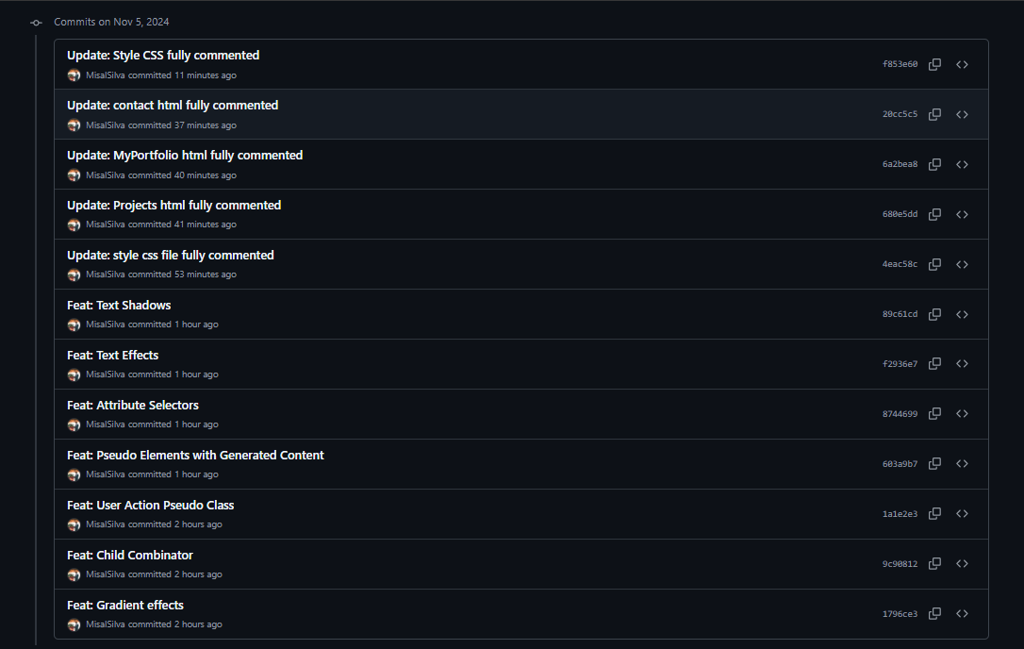5th November 2024

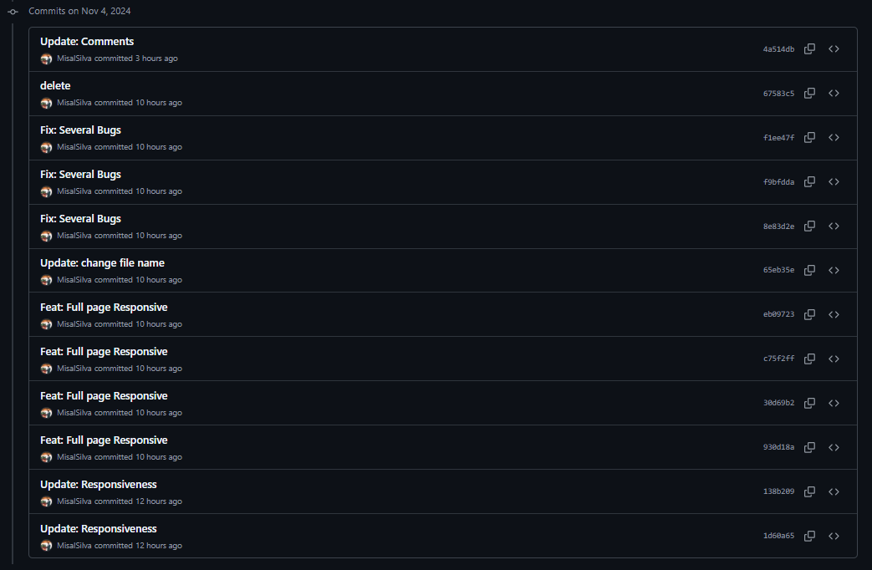4th November 2024

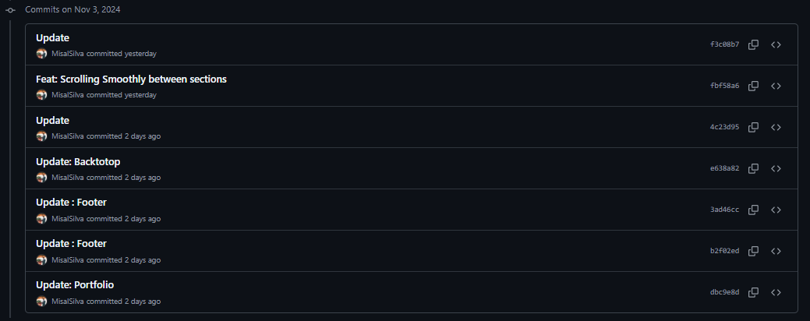3rd November 2024

2nd November 2024

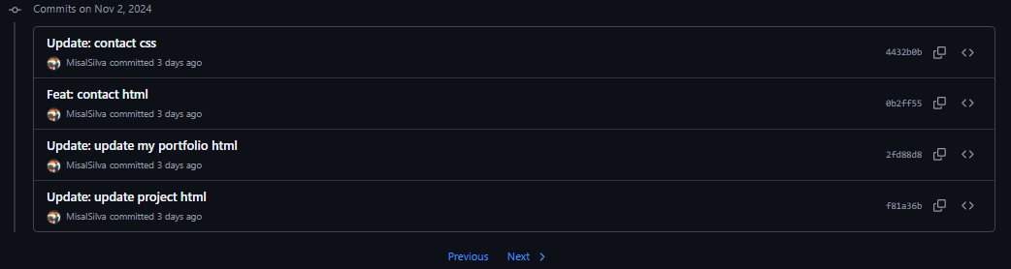

1st November 2024

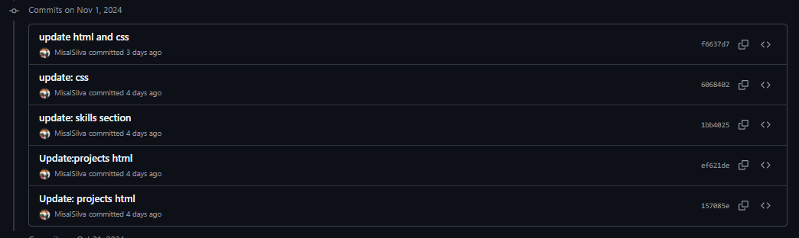

31st October 2024

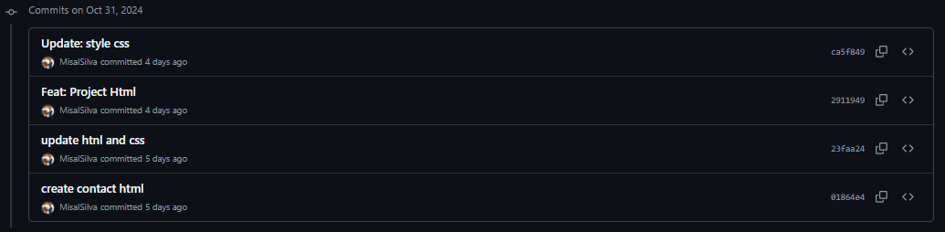

24, 21, 20, 19 October 2024

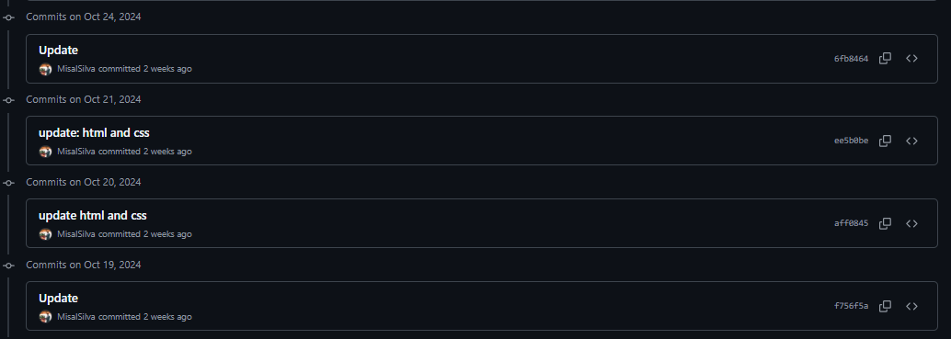

18th October 2024

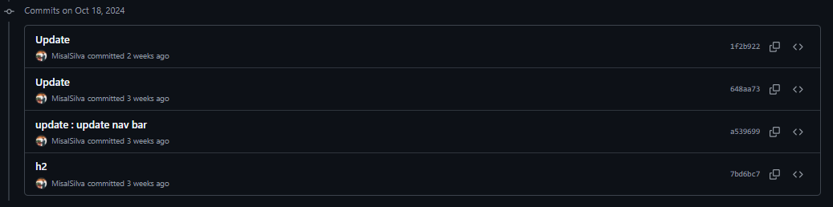

14th and 5th October 2024

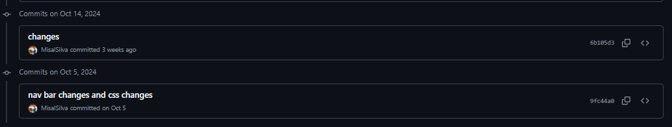

4th October 2024

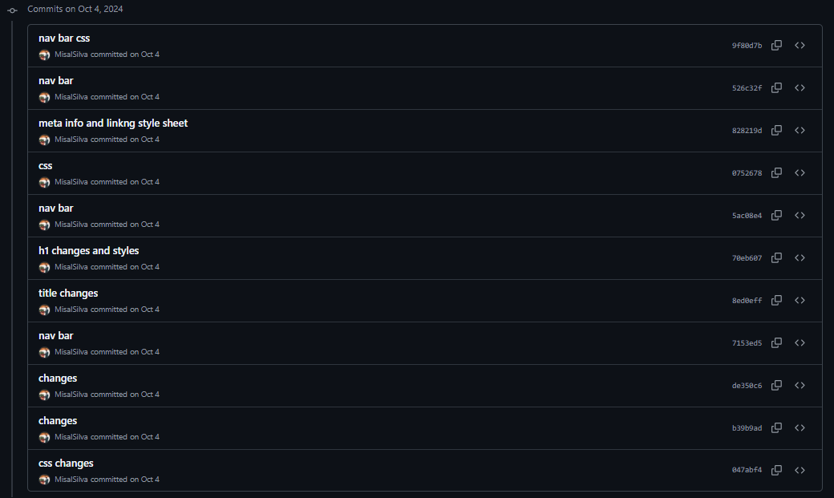

3rd October 2024

