Library Management System
Database Management Systems – Fall 2026
Part A: Entities, Relationships, and Business Rules
Justin Hoang, Anthony Rios, Huynh Nguyen, Zarrah Shahjahan
Contact Person: Justin Hoang (Jxh6543)
Email: justin.hoang321@gmail.com

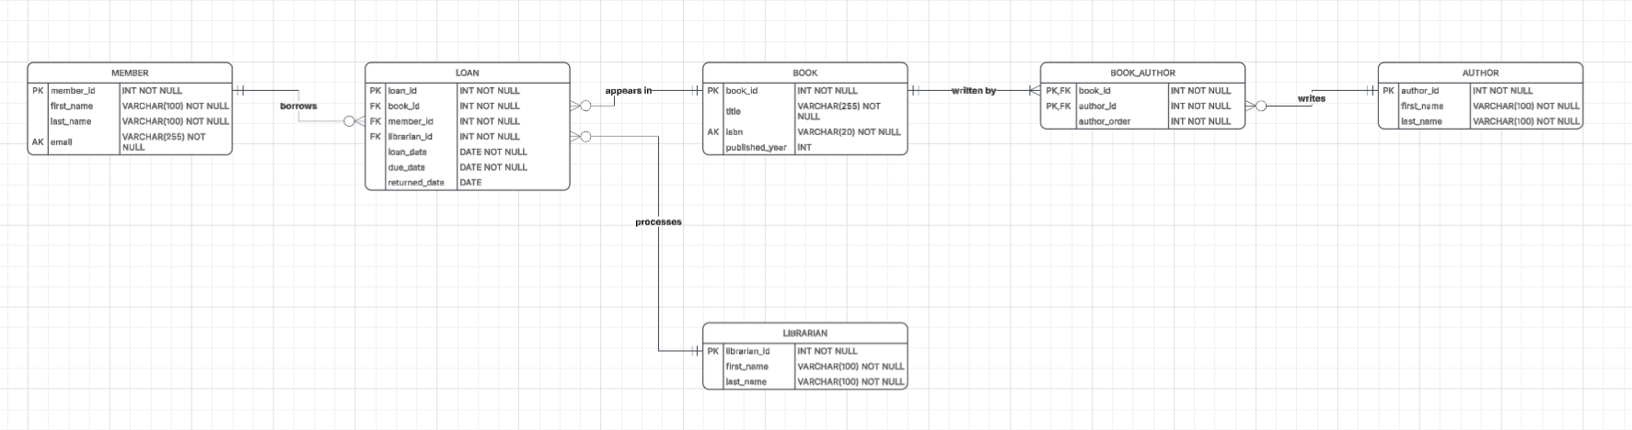
Part 2A:

Part 2B:
- BOOK:
- BOOK (BOOK_ID, title, isbn, published_year)

- AUTHOR:
- AUTHOR (AUTHOR_ID, first_name, last_name)

- MEMBER:
- MEMBER (MEMBER_ID, first_name, last_name, email)

- LIBRARIAN:
- LIBRARIAN (LIBRARIAN_ID, first_name, last_name)

- BOOK_AUTHOR:
- BOOK_AUTHOR (BOOK_ID, AUTHOR_ID, author_order)
- LOAN:
- LOAN (LOAN_ID, book_id, member_id, librarian_id, loan_date, due_date, returned_date)

Third Normal Form (3NF)
The relational schema for the library management system is designed in 3NF. Every relation contains a primary key, and every non-key attribute is fully dependent on the key, with no partial dependencies and no transitive dependencies. The many-to-many relationship between BOOK and AUTHOR is resolved with the relation BOOK_AUTHOR, where it uses a composite primary key created from the combination of the primary keys book_id and author_id. The foreign keys in the LOAN relation are derived from the primary keys of the respective relations, with no redundant information.

Part 2C:
Overview:
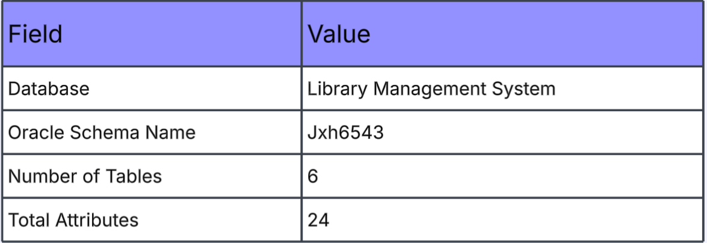
Book:
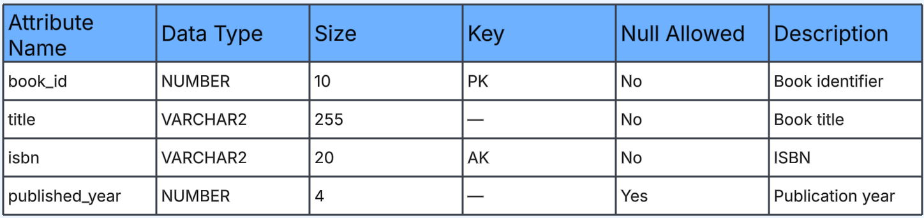
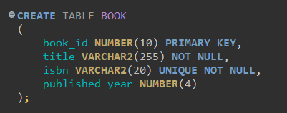
Author: 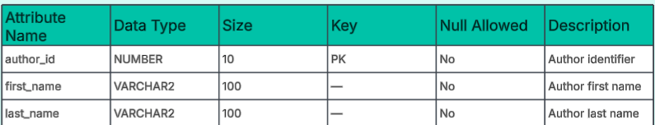
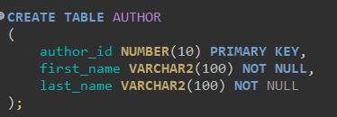
Member:
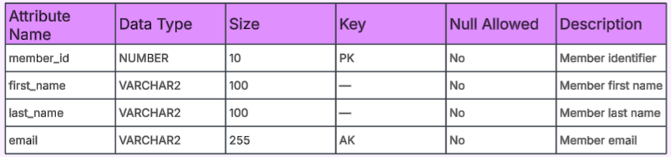
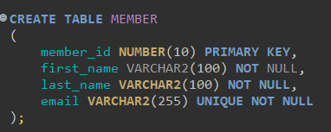

Librarian:
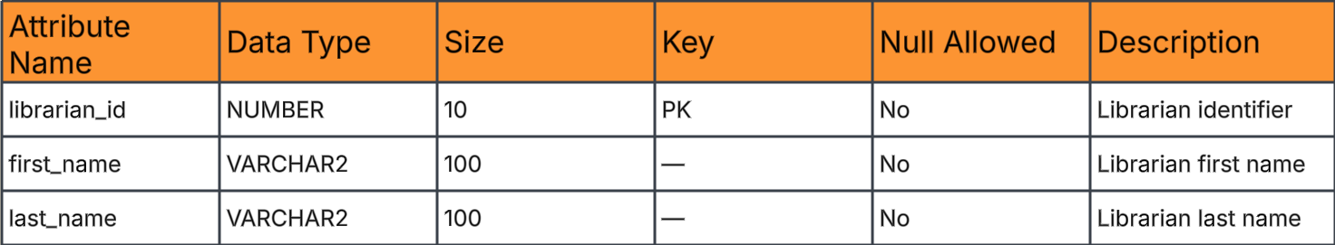
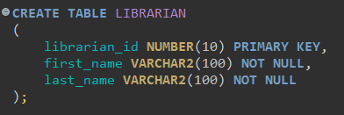
Book_Author:
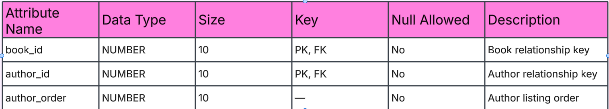
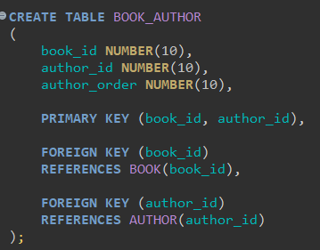

Loan:
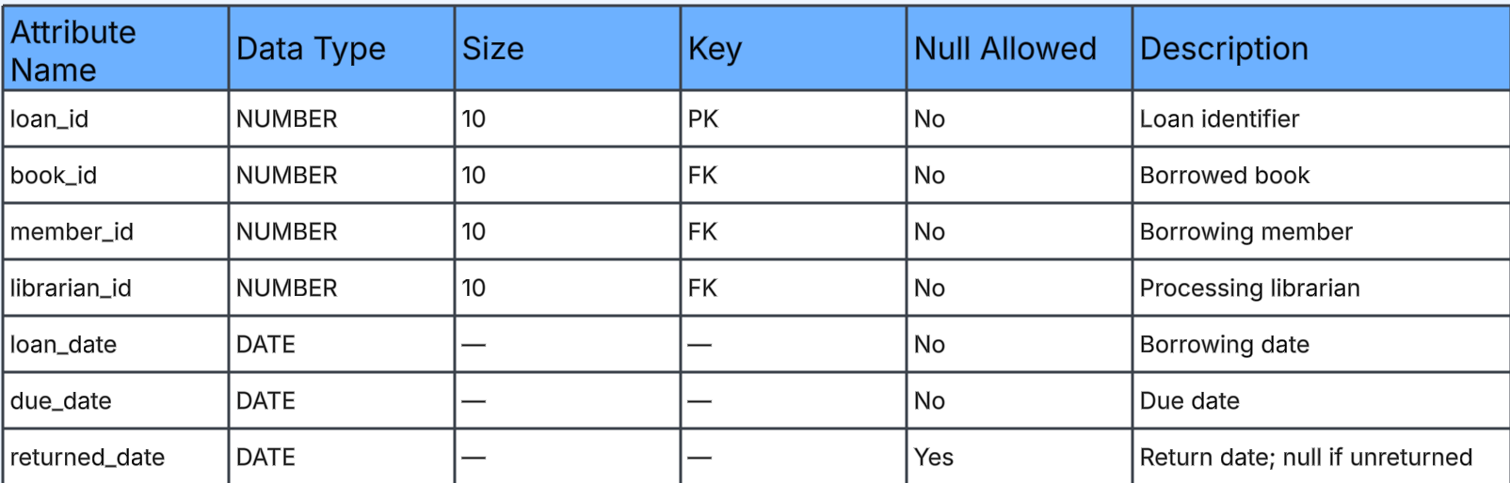
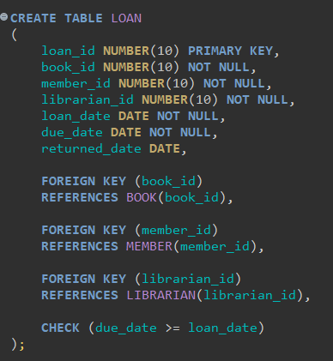

Part 2D:
Book:

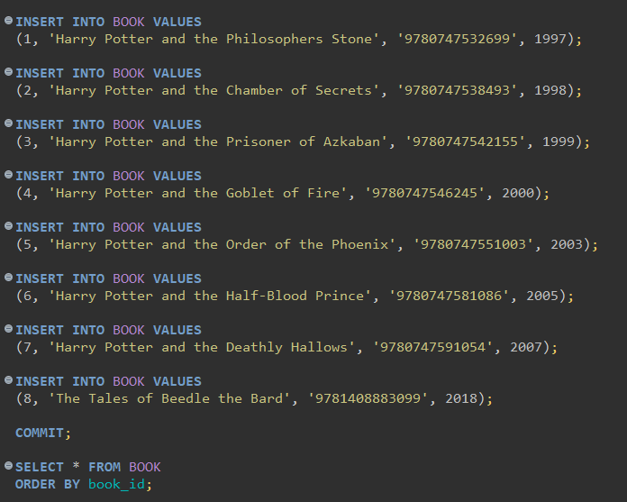

Author:
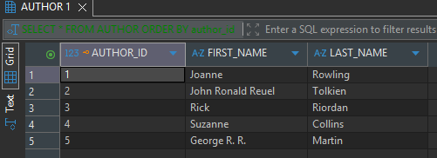
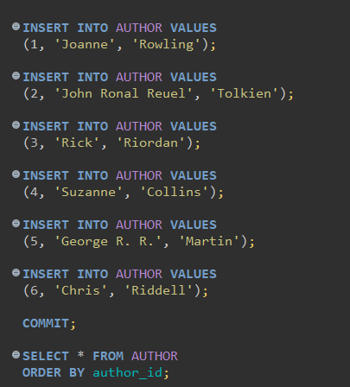

Member:
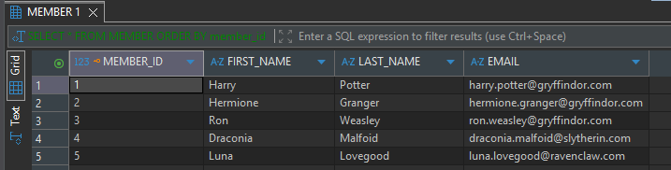
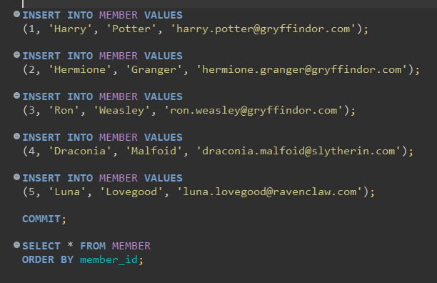

Librarian:
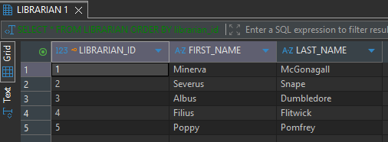
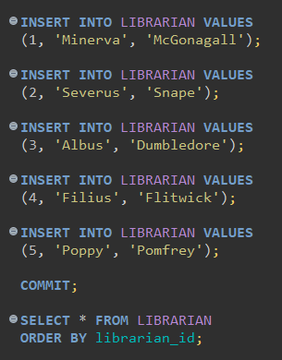

Book_Author: (They’re all Harry Potter Books, so all the same Author)
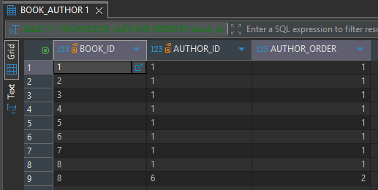
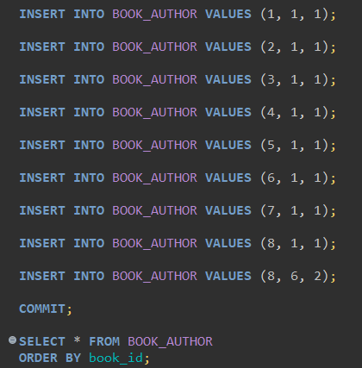
Loan:
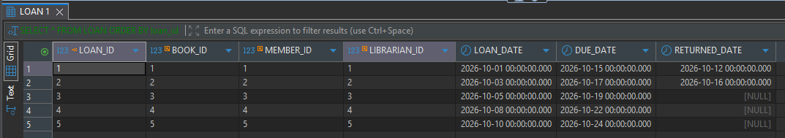 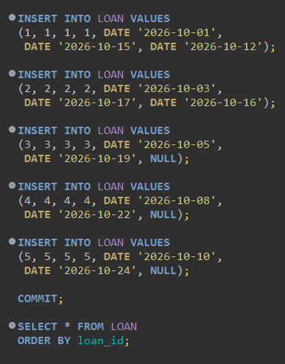

ACCESS GRANTING TO patras2:
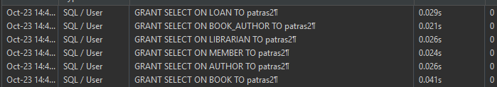
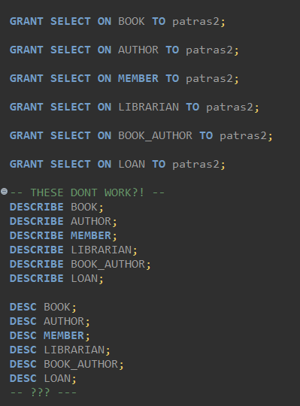

DESCRIBE:
