NAME: Misbah Alam
CMS-ID: 023-24-0134
SEC: E

Warmup_activity:
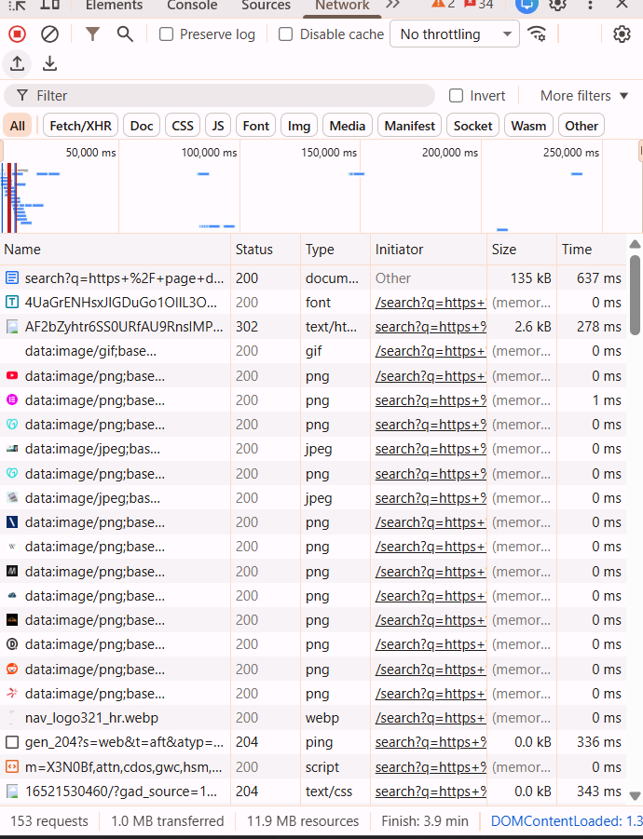

Class_Activity A:
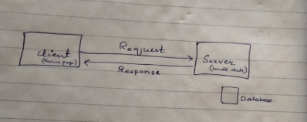
Class_Activity B:
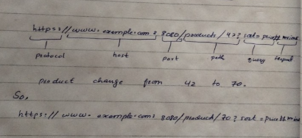
Class_Activity C:
2xx
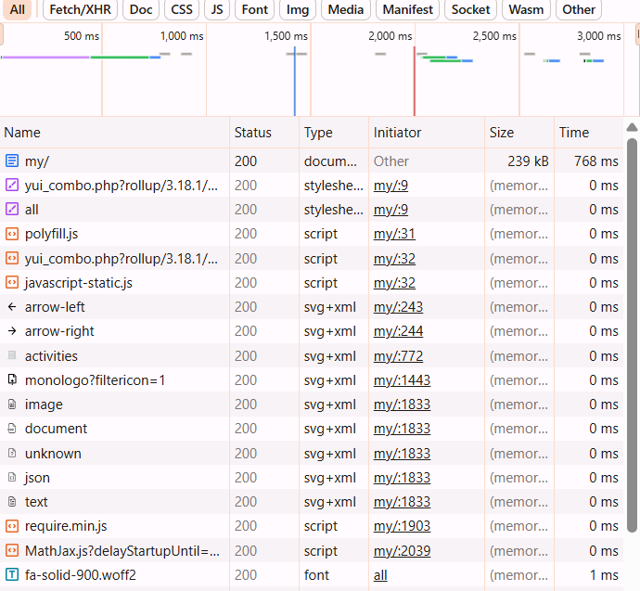
200 = success.

3xx:
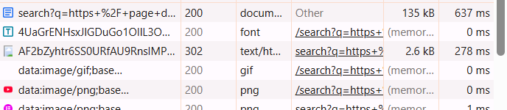
302: temporary moved to a different url.

4xx:
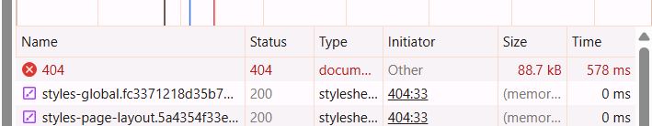
404= page not found

5xx:
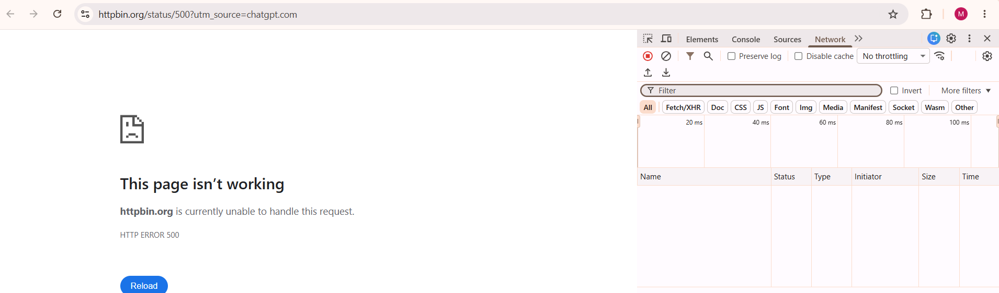
500 = server error.

Class_Activity D:
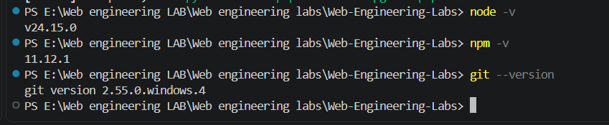





Class_Activity E:
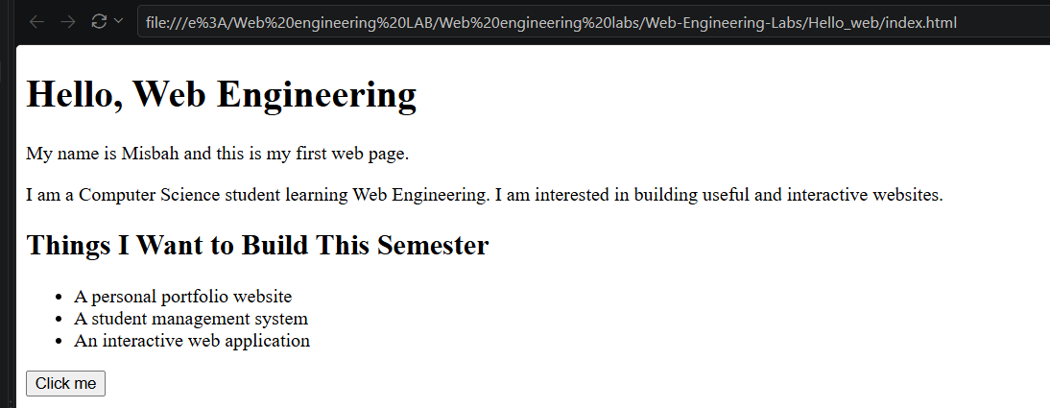
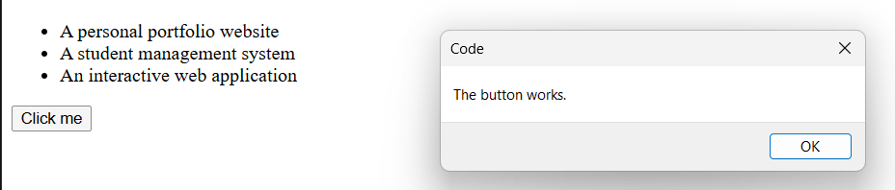
Class_Activity F:
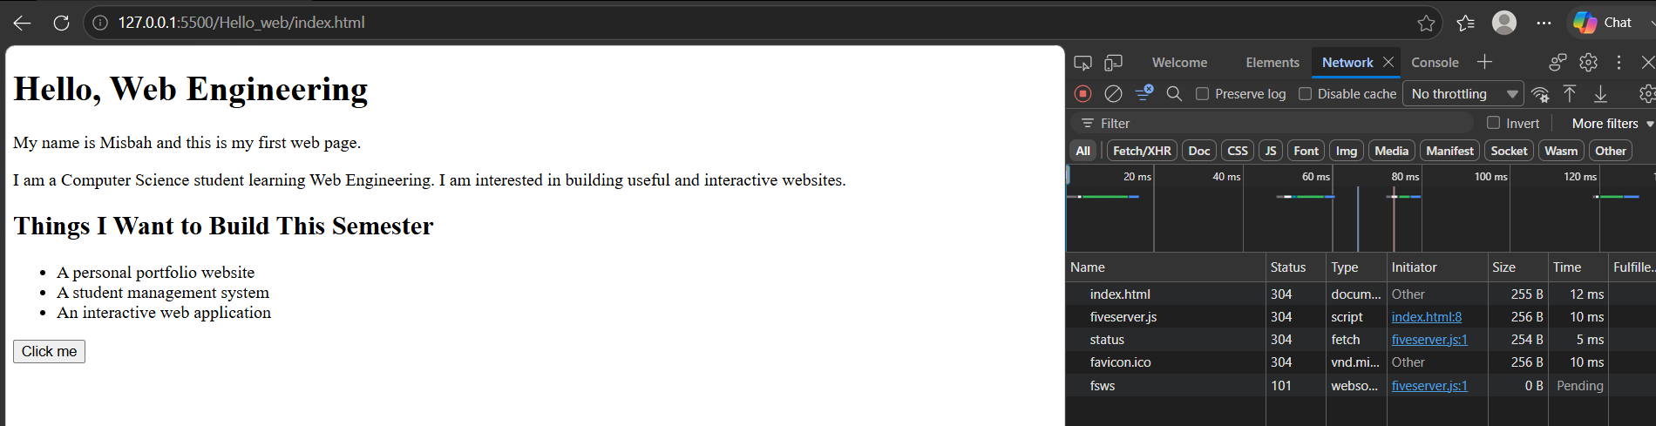
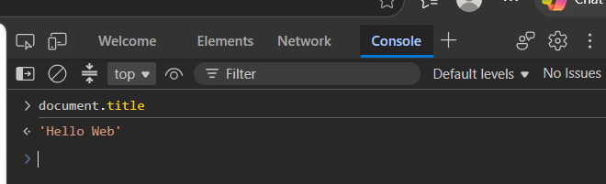
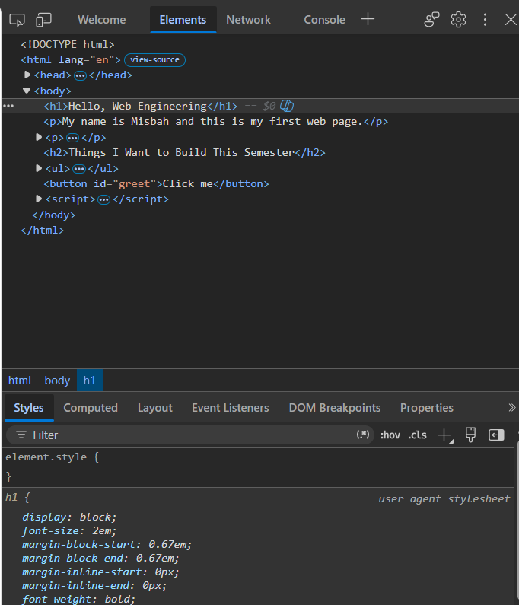

HomeWork:
Task_1:
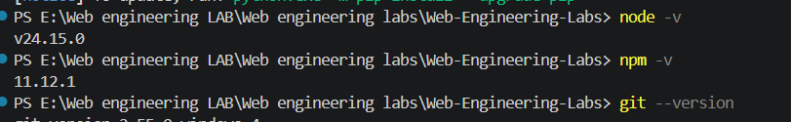
Task_2:
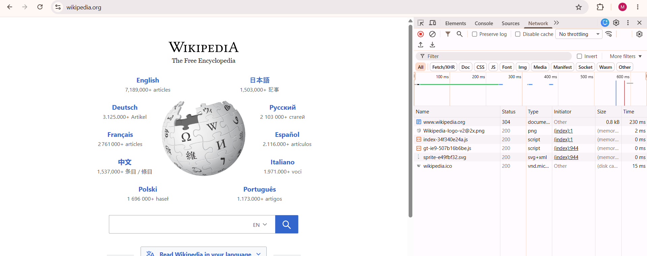

No of requests: 06

Non 200: 304

