WHAT IS LARAVEL?

- FRAMEWORK FOR CREATING PHP WEBSITES

- WORKS WELL WITH MySQL DATABASES

- PACKED WITH USEFUL FEATURES (BLADE, AUTH, ELOQUENT)

MVC PATTERN

- MODEL (represets kind of date we store in database for example user)

- VIEW (represets a html tamplate that we user o display our data)

- CONTROLLER (controller is the middle man that get the data from db and provide it to the template)

COMPOSER - is a dependency manager that help installing external php libraries inside the project

ARTISAN - is a command line interface tha has many functionality but one of them is to speedup a development server

LARAVEL BASICS

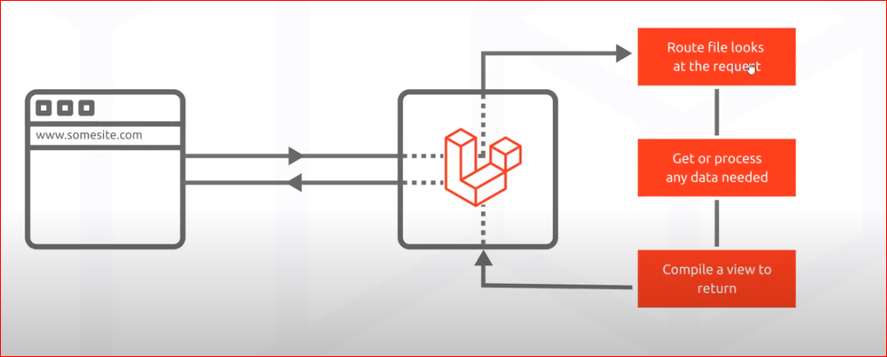

Add an existing project to bistbusket repository

1. *git init*
2. *git add --all*
3. *git commit -m "Initial Commit"*
4. *git remote add origin https://username@your.bitbucket.domain:7999/yourproject/repo.git*
5. *git push -u origin master*

**CONTROLLERS**

CONTROLLERS HANDLE ALL THE LOGIC THAT IS BEING APPLYED TO A SPECIFIC GROUP OF

*php artisan make:controller {nameController}*

**MIGRATIONS**

MIGRATIONS ALLOWS TO PROGRAMMATICALLY FROM OUR CODE DEFINE A STRUCTURE OF A TABLE IN DATABASE

*php artisan make:migration create_pizzas_table*

(after updating the migration with all the columns you want run the command *php artisan migrate* to automatically create the table in the db

**ROLLING BACK MIGRATIONS**

Php artisan – press enter shows up all the commands and if you scroll down to migration section there is a list with all possible command you can apply to migrations with a description on the side

*php artisan migrate:rollback*

**ELOQUENT MODELS**

What is a model?

A model in programming is usually a class that represents certain type of data for example the pizzas table is going to save a specific type of data that contins (type, base name and pice) and for that we create a model in order to interact to that type of date in database

In order to get set update data in database for example in pizza table we are going to use pizza model in order to interact with this table as shown in the picture above

