Supply Chain Decision Brief
Careem Quik — UAE dark-store network
2025-01-01 to 2026-06-30 · 546 days · AED
ILLUSTRATIVE — SYNTHETIC DATA
This brief demonstrates an analytical method. The underlying data is generated, not observed. No Careem data of any kind has been used and no figure in this document describes a real business.

Prepared for the Supply Chain Director
Data-quality gate: WARN

The decision
The network converts AED 7.45m of gross margin a year and gives back AED 983k of it through availability failures, write-off and supplier shortfalls. This brief identifies where that goes and what recovers it.
Six actions are recommended. Together they are worth AED 727k a year net of the cost of doing them, against AED 103k of one-off investment. A seventh — the intuitive fix for the network's worst-performing store — is analysed and not recommended, because it costs more than it saves.
What is being asked: approval to proceed with R1 and R5a immediately — both are scheduling changes with no incremental headcount — and a mandate to open supplier negotiations behind R2 and R3.
Actions recommended | Net annual value | One-off investment | Identified leakage
6 | AED 727k | AED 103k | AED 983k

Executive summary
Findings are ordered by materiality weighted by confidence. Root causes are reported rather than the symptoms they produce, so the same money is not counted twice.
- Availability swings 16pp across the week — Thursday 96.4% down to Monday 80.2% — because orders are reviewed Monday and Wednesday but demand peaks Friday and Saturday. AED 478k/yr · 97% confidence · root cause
- 266 store-SKU lines have a case pack holding more days of stock than the product's own shelf life — 65% of network write-off, AED 204k a year that no store can prevent by ordering better. AED 204k/yr · 87% confidence · root cause
- Network fill rate is 90.5% against a 97% target — closing the gap is worth AED 0.71m a year. AED 708k/yr · 97% confidence · symptom of SUP-01, SUP-02, CAD-01
- Gulf Fresh Produce is the network's least reliable supplier — OTIF 76% against a 95% target, costing about AED 191k a year. AED 191k/yr · 98% confidence · root cause
- The slowest 82 of 215 SKUs earn 5.0% of revenue but occupy 26% of shelf slots and account for 35% of write-off. AED 154k/yr · 93% confidence · root cause
- Al Nahda delivers in 30 min against a network median of 20 and cancels 8.5% of orders — the constraint is fleet capacity, not stock. AED 98k/yr · 94% confidence · root cause

Where the margin goes
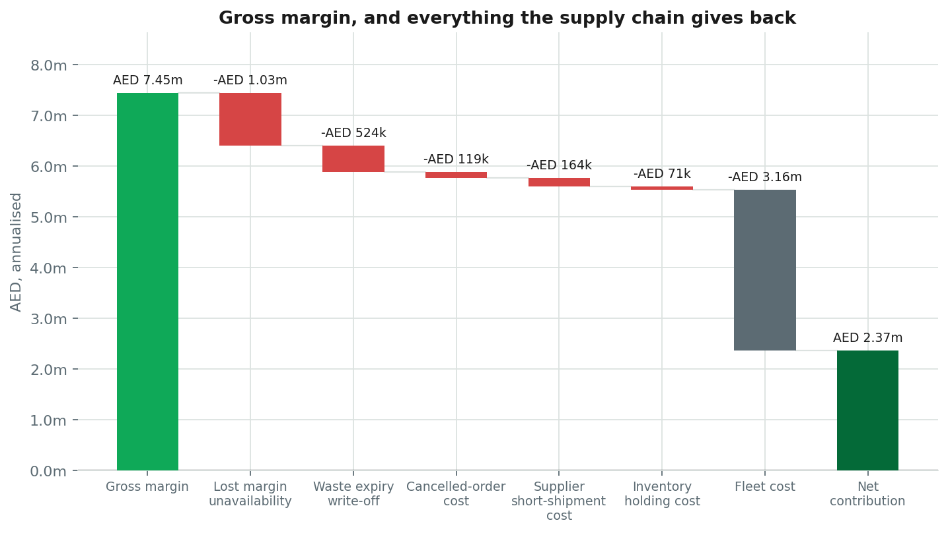
Annualised. Fleet cost is shown as a cost of doing business rather than a leak — it is the price of the service, not a failure of it.
Item | Annualised | Type
Gross margin | AED 7.45m | positive
Lost margin — unavailability | -AED 1.03m | leak
Waste — expiry write-off | -AED 524k | leak
Cancelled-order cost | -AED 119k | leak
Supplier short-shipment cost | -AED 164k | leak
Inventory holding cost | -AED 71k | leak
Fleet cost | -AED 3.16m | cost
Net contribution | AED 2.37m | net

What is actually going wrong

Availability swings 16pp across the week — Thursday 96.4% down to Monday 80.2% — because orders are reviewed Monday and Wednesday but demand peaks Friday and Saturday
Worth AED 478k a year (range AED 354k to AED 598k), at 97% confidence.
Evidence
- Best day: Thursday 96.4%
- Worst day: Monday 80.2%
- Replenishment reviewed on: Monday, Wednesday
- Demand peaks on: Friday, Saturday
- Weekend demand vs review-day demand: 1.33 x (vs order quantities are sized on review-day demand)
- Spread: 16.2% (vs materiality threshold 4pp)
How the number was derived. For every weekday below the weekly mean fill rate, the share of lost margin that would have been recovered at the best day's fill rate (96.4%), summed, penalised and annualised.
Method. Day-of-week fill rate profile against the replenishment review calendar and the demand profile; two-proportion z-test on best vs worst day
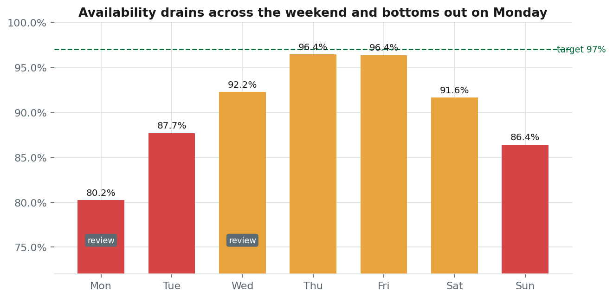

266 store-SKU lines have a case pack holding more days of stock than the product's own shelf life — 65% of network write-off, AED 204k a year that no store can prevent by ordering better
Worth AED 204k a year (range AED 119k to AED 289k), at 87% confidence.
Evidence
- Store-SKU lines affected: 266 (vs of 1,350 stocked lines, all selling at or above 0.5 units/day)
- Share of network write-off: 65.0%
- Categories affected: Fresh Produce, Bakery, Ready Meals, Dairy & Eggs (vs all short shelf life)
- Median days of cover per case: 9.4 days (vs median shelf life 5 days)
- Largest contributing supplier: Modern Bakehouse (vs AED 201,785 of write-off across 22 lines)
- Write-off value on affected lines: 509,386.16 AED
How the number was derived. AED 509,386 of write-off over the period sits on lines where one case pack exceeds the full shelf life at observed velocity. 60% of that is treated as addressable by re-specifying pack size; the balance is demand volatility a smaller pack would not have caught. Annualised.
Method. Case pack divided by observed daily velocity, compared against shelf life, at store-SKU grain; write-off attributed to lines where a single minimum lot cannot be sold within its own shelf life AND the line still turns at least 0.5 units/day. The velocity floor keeps this separate from the assortment finding, so the same write-off is not claimed twice
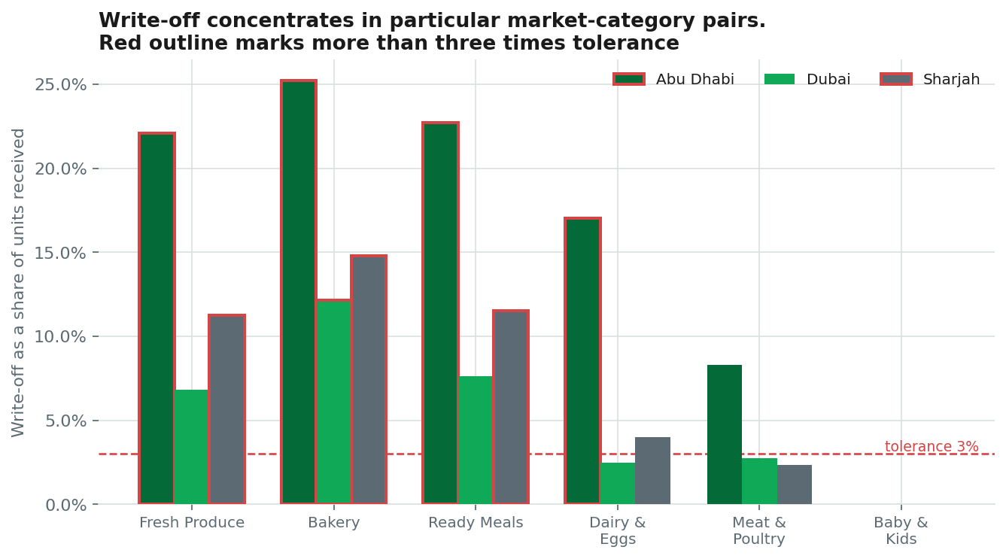

Gulf Fresh Produce is the network's least reliable supplier — OTIF 76% against a 95% target, costing about AED 191k a year
Worth AED 191k a year (range AED 70k to AED 249k), at 98% confidence.
Evidence
- OTIF: 76.2% (vs target 95%)
- On-time rate: 83.6%
- In-full rate: 86.7%
- Lead time: 2.39 days (vs promised 2)
- Lead-time variability (CV): 41.3% (vs peer median 0.09)
- Units short-shipped: 9,050 units
How the number was derived. Short-shipment cost AED 104,842 over the period (annualised AED 70,087), plus AED 121,217 of annualised lost margin in Fresh Produce attributable to this supplier's categories running 15.2% below the fill rate of categories it does not supply.
Method. OTIF and lead-time CV against target; binary-segmentation changepoint on the monthly lead-time series
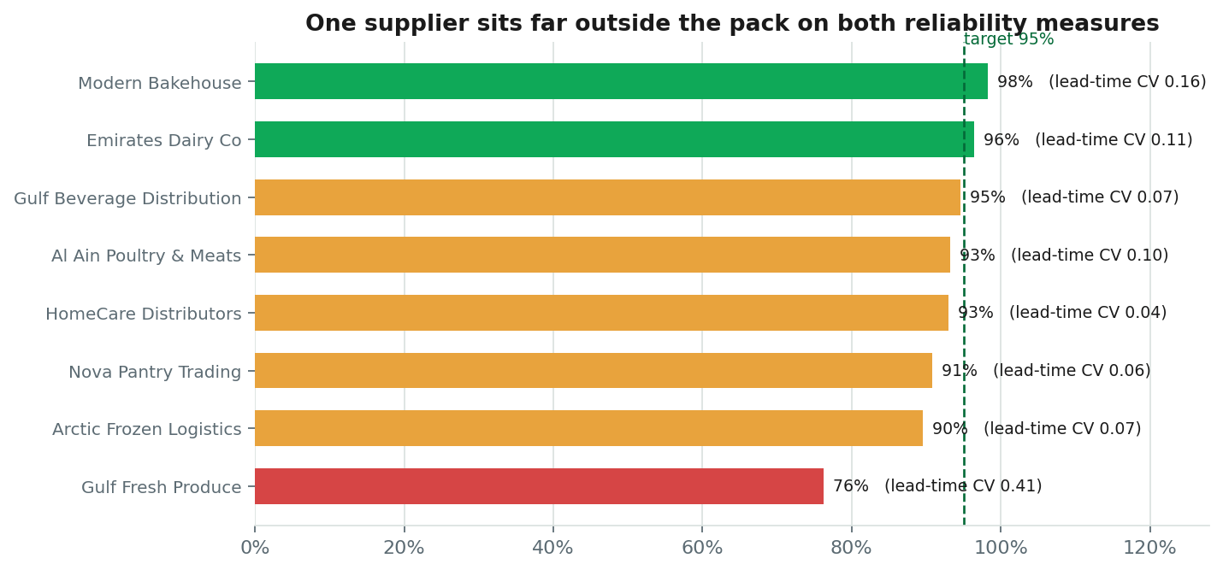

Recommended actions
# | Action | Owner | Net/yr | Payback
R1 | Re-time replenishment review and forecast forward, not backward | Demand Planning Lead | AED 311k | 1.0 mo
R2 | Re-specify case packs on short-shelf-life lines | Procurement Lead | AED 111k | immediate
R4 | Rationalise the slow-moving tail and reallocate the slots | Category Manager | AED 107k | 2.5 mo
R3 | Put Gulf Fresh Produce on a formal performance plan and dual-source | Procurement Lead | AED 83k | immediate
R5a | Re-time captain shifts at Al Nahda to the demand peak | Fleet Operations Manager | AED 73k | 2.5 mo
R6 | Build a Ramadan operating playbook | Supply Chain Director | AED 42k | 11.5 mo
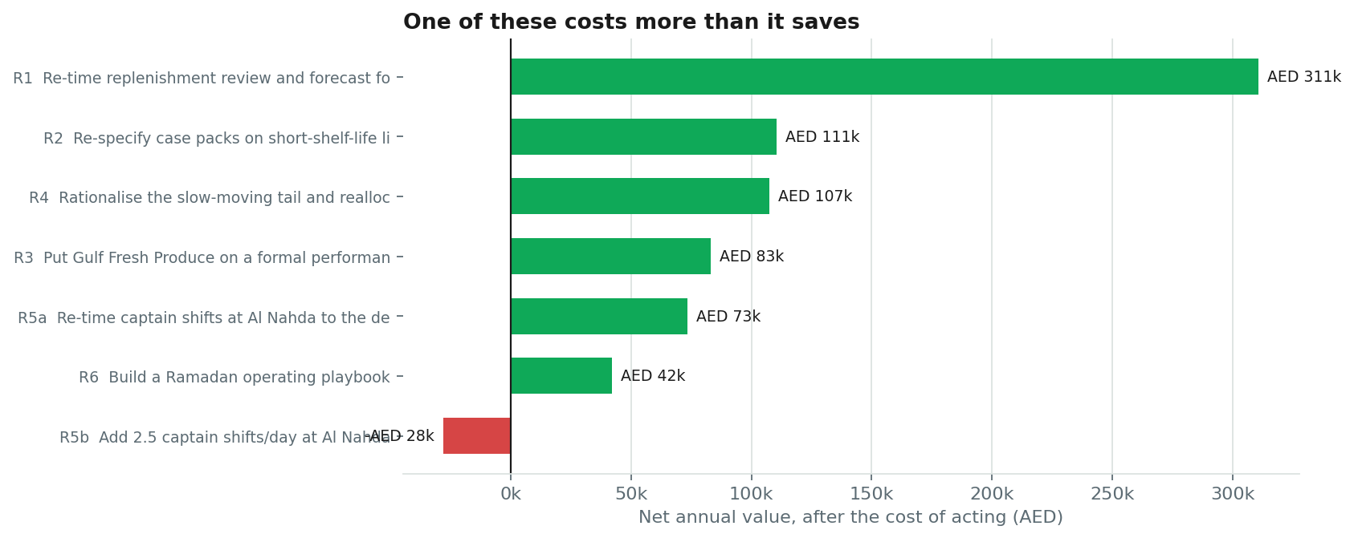

R1 · Re-time replenishment review and forecast forward, not backward
Demand Planning Lead · immediate · medium effort · addresses CAD-01, SVC-01
Two changes to the same process. First, move the replenishment review off Monday, Wednesday so that at least one review lands within 48 hours of the Friday and Saturday peak. Second — and this is the larger of the two — size order quantities against forecast demand over the full cover period rather than against the demand rate observed on the review day itself. Review days are currently the quietest days of the week, so every order is sized to a demand level the following weekend will exceed by 133%.
Benefit, after capture rate | AED 311k
Cost of acting | AED 25k
Net annual | AED 311k
Why. This is the largest single recoverable item and the cheapest to act on, because it is a scheduling decision rather than a capital or contractual one.
Risk. Ordering to a forward forecast raises average stock, so waste will rise on short-shelf-life lines unless the safety-stock factor is reduced at the same time. Sequence this after, or alongside, the pack-size work.
Success metric. Weekly fill-rate spread (best day minus worst day) below 5pp within two months; Monday fill rate above 92%. Reviewed weekly.
Assumptions
- Capture rate 65% — a re-timed review recovers most but not all of the weekly swing; some of it is supplier lead-time noise that no calendar fixes.
- One-off cost AED 25,000 for system configuration, supplier renegotiation of order windows, and planner training.

R2 · Re-specify case packs on short-shelf-life lines
Procurement Lead · near term · high effort · addresses LOT-01, WST-01, WST-02, WST-03, WST-04
Renegotiate minimum order quantity on the store-SKU lines where a single case cannot be sold within the product's shelf life. Target a pack size giving no more than 50% of shelf life in cover at current velocity. Open with Modern Bakehouse, which accounts for the largest share of the affected write-off. Where a supplier will not break the pack, the alternative is cross-docking a single delivery across two or three stores rather than forcing full cases into each.
Benefit, after capture rate | AED 123k
Cost of acting | AED 12k
Net annual | AED 111k
Why. The write-off on these lines is not an execution failure. No amount of store discipline recovers it, because the stock is guaranteed to expire from the moment it is ordered. It is a single procurement decision with a single owner.
Risk. Suppliers will price smaller lots higher, and may resist on handling grounds. If the achieved premium exceeds 1.5% the case weakens quickly — this should be re-tested against actual quoted terms before committing.
Success metric. Waste rate on affected lines below 4% within one quarter; no fill-rate deterioration on the same lines. Reviewed monthly.
Assumptions
- Capture rate 60% — a right-sized pack removes the guaranteed expiry but not waste caused by demand volatility.
- Unit-cost premium of 1.5% on AED 803,936 of annual purchase value on affected lines. THIS IS THE WEAKEST ASSUMPTION IN THE ANALYSIS — it is a placeholder until suppliers quote.

R4 · Rationalise the slow-moving tail and reallocate the slots
Category Manager · near term · medium effort · addresses AST-01
Delist the slowest-moving lines across 348 store-SKU slots, protecting any line that is a known basket-builder or a category-completeness requirement. Reallocate freed slots to the top revenue decile, where availability is currently the binding constraint. Run it market by market rather than network-wide so the demand-migration assumption can be tested on the first market before the rest follow.
Benefit, after capture rate | AED 107k
Cost of acting | AED 23k
Net annual | AED 107k
Why. The tail consumes slot capacity and write-off out of all proportion to what it earns, and those slots are the same constraint limiting availability on the lines that do sell.
Risk. Range perception. Customers do not experience a delist as an efficiency gain, and quick-commerce baskets are sensitive to one-missing-item abandonment. The 50% demand-migration assumption behind the benefit is unverified and is the number most likely to be wrong.
Success metric. Slot productivity (revenue per slot) up 10% within two quarters with no fall in basket size or order frequency. Reviewed monthly.
Assumptions
- Capture rate 70% of the modelled slot and waste saving.
- Half the demand on delisted lines migrates to remaining range. Unverified — a basket-affinity analysis should precede execution.
- Range reset costs AED 65/slot.

R3 · Put Gulf Fresh Produce on a formal performance plan and dual-source
Procurement Lead · near term · medium effort · addresses SUP-01
Three steps. (1) Raise a supplier performance plan with a contractual OTIF floor and weekly reporting; the degradation is recent and datable — performance changed in 2026-02: lead time moved from 2.05 to 3.23 days and its standard deviation from 0.28 to 1.48. (2) Dual-source roughly 40% of volume on the highest-velocity lines this supplier covers, to cap exposure while the plan runs. (3) Until on-time performance recovers, raise the safety-stock factor on affected lines to absorb the observed lead-time variability of 2-day promise against 2.39-day actual.
Benefit, after capture rate | AED 105k
Cost of acting | AED 22k
Net annual | AED 83k
Why. This is a datable change in a single supplier's behaviour, not a gradual drift, which makes it both diagnosable and negotiable.
Risk. Dual-sourcing fresh produce splits volume and may weaken terms with both suppliers. Temporary safety-stock uplift raises waste on a short-shelf-life category — this is a deliberate trade of waste for availability and should be time-boxed.
Success metric. OTIF above 90% within one quarter; lead-time CV below 0.35. Reviewed weekly.
Assumptions
- Capture rate 55% — supplier remediation is slow and partial; a plan rarely restores full performance inside a year.
- Dual-source premium 3.0% on 40% of AED 1,854,658 annual spend with this supplier.

R5a · Re-time captain shifts at Al Nahda to the demand peak
Fleet Operations Manager · immediate · low effort · addresses FLT-01
35% of this store's orders fall in four hours (18:00, 19:00, 20:00, 21:00), and delivery time in those hours averages 35 min against 30 min outside them. Rebuild the shift pattern so captain hours track that curve, before adding any headcount. This is a rostering change, not a hiring decision.
Benefit, after capture rate | AED 73k
Cost of acting | AED 15k
Net annual | AED 73k
Why. Do this first because it is cheap and reversible, and because it tests whether the constraint is genuinely total capacity or merely its distribution across the day.
Risk. Captain availability may not be elastic to the required hours, and late-evening shifts may need a pay differential that is not costed here.
Success metric. Delivery p50 at Al Nahda below 25 min and cancellation rate below 4.0% within six weeks. Reviewed weekly.
Assumptions
- Capture rate 75% — re-timing addresses the peak-hour constraint but not total daily capacity.
- Rescheduling cost AED 15,000, no incremental headcount.

R6 · Build a Ramadan operating playbook
Supply Chain Director · structural · medium effort · addresses SEA-01
Codify the peak as a planned event rather than an annual surprise. Volume rises 51% and the daypart mix inverts — 40% of orders fall after 20:00 against 25% normally. The playbook needs three things: a demand uplift applied at category level in the forecast, a replenishment window moved to late night so shelves are full when demand arrives, and captain shifts weighted to the post-Iftar window. Lock it four weeks before the window opens.
Benefit, after capture rate | AED 42k
Cost of acting | AED 40k
Net annual | AED 42k
Why. This is the only finding in the set that is fully predictable in advance, which makes it the cheapest kind of problem to solve.
Risk. The window moves roughly eleven days earlier each year, so a playbook tied to calendar dates rather than the lunar date will drift. Two observed cycles is a thin basis for a category-level uplift factor.
Success metric. Fill rate inside the peak window within 2pp of the annual average, versus the current shortfall. Reviewed annual, with a post-event review.
Assumptions
- Capture rate 50% — planning improves availability but a 51% surge will not be fully absorbed in the first year.
- Playbook development cost AED 40,000.
- Based on two observed cycles. Treat the uplift factor as provisional and re-fit after the next one.

Considered and not recommended

R5b · Add 2.5 captain shifts/day at Al Nahda
Benefit AED 83k/yr against a cost of AED 111k/yr — net -AED 28k/yr.
Presented for completeness and because it is the intuitive answer. On these numbers it does not pay: the cost of the capacity exceeds the value of the cancellations it would prevent. Worth revisiting only if the rostering change fails, or if the lost lifetime value of repeatedly failed customers is judged materially higher than the single-order margin used here.

What we would measure
Each action carries a leading indicator that moves before the financial result does. If the indicator has not moved by the review point, the action is not working and should be stopped rather than extended.
# | Leading indicator | Cadence
R1 | Weekly fill-rate spread (best day minus worst day) below 5pp within two months; Monday fill rate above 92% | weekly
R2 | Waste rate on affected lines below 4% within one quarter; no fill-rate deterioration on the same lines | monthly
R4 | Slot productivity (revenue per slot) up 10% within two quarters with no fall in basket size or order frequency | monthly
R3 | OTIF above 90% within one quarter; lead-time CV below 0.35 | weekly
R5a | Delivery p50 at Al Nahda below 25 min and cancellation rate below 4.0% within six weeks | weekly
R6 | Fill rate inside the peak window within 2pp of the annual average, versus the current shortfall | annual, with a post-event review

Appendix

Method
Data was loaded from nine related tables and profiled. A quality gate ran eight families of check — key uniqueness, referential integrity, null rates, impossible values, ledger balance, three cross-table reconciliations and date coverage — before any analysis was permitted. KPIs were computed once, at every grain, so that no two sections of this document can disagree. Eight detectors then interrogated those KPIs, each returning findings with their own evidence, statistical method and confidence.
Confidence combines three components as a geometric mean: statistical strength, sample adequacy, and the quality score of the source tables. The geometric mean is deliberate — one weak component drags the result down and no strong component can rescue it.

Data quality
Gate result: WARN. 8 issue(s) found and 5 repair(s) applied before analysis. Repairs are deterministic and disclosed; no data was invented.
- orders: removed 1,916 exact duplicate rows
- orders: collapsed 19 rows sharing a primary key ['order_id'] (kept first)
- order_items: removed 708 exact duplicate rows
- inventory_daily.closing_units: clamped 2,211 negative values to zero (flagged in closing_units_was_negative)
- orders.actual_minutes: capped 39 physically impossible values at 120 min (percentile winsorising deliberately avoided — it would suppress genuine slow-service signal)
Checks that ran clean
- referential_integrity · all — 12 foreign-key relationships validated, no orphans
- reconciliation · order_items ↔ orders — line values reconcile to basket value across 483,722 orders
- reconciliation · order_items ↔ inventory_daily — units sold agree between order lines and the stock ledger across 4,360 store-days (0.000% gap)
- reconciliation · courier_daily ↔ orders — daily order counts agree across 4,360 store-days

Assumptions
Every figure converting an operational failure into money rests on one of these. They are declared so they can be challenged.
- Stockout penalty: lost margin × 1.35. The uplift represents basket abandonment and reduced repeat rate. Not derived from this data. Sensitivity 1.0–1.7.
- Cancelled order cost: AED 11.5 of picking labour and rider time. Sensitivity 8–16.
- Inventory holding: 22% annually.
- Capture rates run 50% to 85% — never 100%, because some part of every leak is structural.
- Materiality floor: AED 60k/yr. Findings below this are recorded but not surfaced.

Limitations — what this analysis cannot support
Stating the boundary matters as much as stating the result.
- The supplier premium behind R2 is a placeholder, not a quote. If smaller case packs cost more than 1.5% extra per unit, that recommendation weakens quickly and should be re-tested before committing.
- The 50% demand-migration assumption behind the assortment recommendation is unverified. A basket-affinity analysis should precede any delisting, because a tail SKU that anchors a basket is not a tail SKU.
- Seasonal conclusions rest on two observed cycles. That is enough to establish the pattern exists and not enough to fit a reliable category-level uplift factor.
- Customer lifetime value is absent from this dataset, so cancellations are valued at single-order margin. This almost certainly understates the cost of repeated service failure at one store, and it is the assumption most likely to change the fleet conclusion if corrected.
- No competitor, price or promotional data is present. Demand is treated as exogenous, which it is not.
- The analysis is observational. None of the causal claims have been tested experimentally, and the recommended actions should be piloted before network-wide rollout.

