Supply Chain Decision Brief
Careem Rides — UAE marketplace
2025-07-01 to 2026-06-30 · 365 days · AED
ILLUSTRATIVE — SYNTHETIC DATA
This brief demonstrates an analytical method. The underlying data is generated, not observed. No Careem data of any kind has been used and no figure in this document describes a real business.

Prepared for the City Operations Director
Data-quality gate: WARN

The decision
The network converts AED 2.67m of gross margin a year and gives back AED 214k of it through availability failures, write-off and supplier shortfalls. This brief identifies where that goes and what recovers it.
Six actions are recommended. Together they are worth AED 49k a year net of the cost of doing them, against AED 30k of one-off investment. A seventh — the intuitive fix for the network's worst-performing store — is analysed and not recommended, because it costs more than it saves.
What is being asked: approval to proceed with R1 and R5a immediately — both are scheduling changes with no incremental headcount — and a mandate to open supplier negotiations behind R2 and R3.
Actions recommended | Net annual value | One-off investment | Identified leakage
2 | AED 49k | AED 30k | AED 214k

Executive summary
Findings are ordered by materiality weighted by confidence. Root causes are reported rather than the symptoms they produce, so the same money is not counted twice.
- The network fulfils 89.3% of requests against a 95% target — the shortfall is worth AED 0.22m a year. AED 223k/yr · 98% confidence · symptom of SPL-01
- Captains who do not clear 20 trips in their first week churn at 26% against 8% for those who do — 3.3× the rate, and 55% of joiners fall in that group. AED 110k/yr · 98% confidence · root cause
- Dubai Airport loses 50% of demand between 06:00–09:00 while surge sits at 1.76× — supply is not responding to price. AED 59k/yr · 94% confidence · root cause
- Business Bay, Yas Island promise arrival 4.3 min sooner than they deliver, and cancel 11% of trips against 4% elsewhere — the estimate causes the cancellation, not the wait. AED 45k/yr · 95% confidence · root cause

Where the margin goes
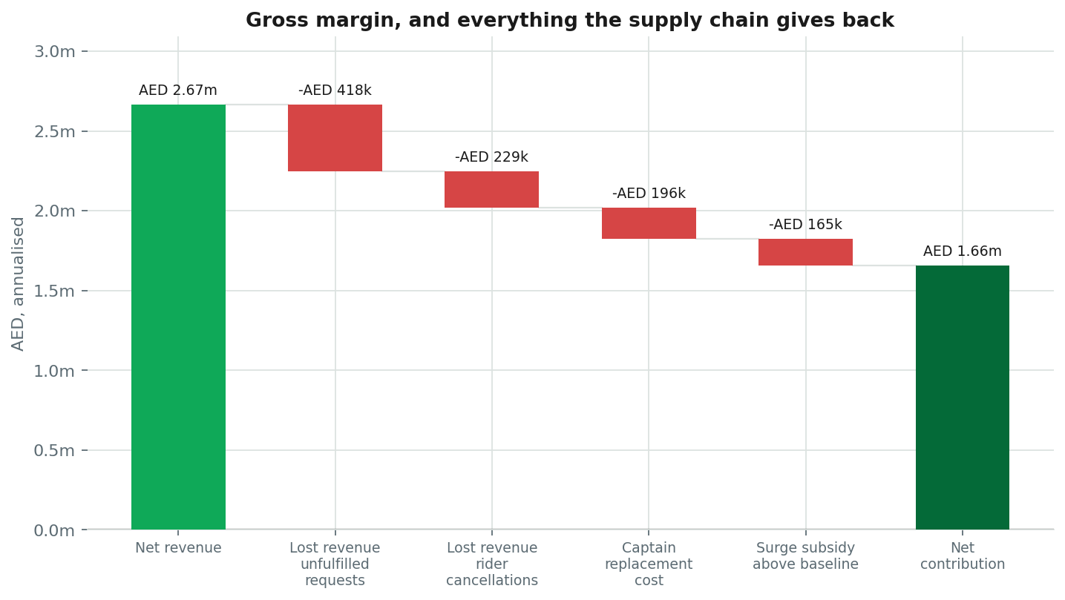
Annualised. Fleet cost is shown as a cost of doing business rather than a leak — it is the price of the service, not a failure of it.
Item | Annualised | Type
Net revenue | AED 2.67m | positive
Lost revenue — unfulfilled requests | -AED 418k | leak
Lost revenue — rider cancellations | -AED 229k | leak
Captain replacement cost | -AED 196k | leak
Surge subsidy above baseline | -AED 165k | cost
Net contribution | AED 1.66m | net

What is actually going wrong

Captains who do not clear 20 trips in their first week churn at 26% against 8% for those who do — 3.3× the rate, and 55% of joiners fall in that group
Worth AED 110k a year (range AED 66k to AED 158k), at 98% confidence.
Evidence
- Churn — did not activate: 26.2% (vs target 10%)
- Churn — activated: 7.9%
- Share of joiners not activating: 55.0%
- Captains lost above the activated rate: 262 captains
- Replacement cost: 420 AED each (vs declared assumption)
How the number was derived. 1,431 captains failed to activate. Had they churned at the activated rate of 7.9% rather than 26.2%, 262 fewer would have left. Valued at the declared AED 420 replacement cost and annualised.
Method. Cohort split on first-week trips against 30-day churn; chi-square test of independence

Dubai Airport loses 50% of demand between 06:00–09:00 while surge sits at 1.76× — supply is not responding to price
Worth AED 59k a year (range AED 47k to AED 76k), at 94% confidence.
Evidence
- Unfulfilled rate in window: 49.8% (vs 7.8% in the same zone outside it)
- Surge in window: 1.76 × (vs 1.09× outside it)
- Captains per request: 17.2% (vs network 0.443)
- Correlation of captain supply with surge: -45.0% (vs negative — supply falls as surge rises here, so raising it further is counterproductive)
- Average wait in window: 11.14 min (vs 7.9 min outside it)
How the number was derived. 5,772 unserved requests in this window over the period, valued at average fare × take rate × the demand-suppression multiplier, annualised.
Method. Zone-hour blocks with high unfulfilled demand AND elevated surge; Pearson correlation between daily surge and daily captain supply inside the window. A near-zero correlation is what distinguishes a positioning constraint from a pricing one.

Business Bay, Yas Island promise arrival 4.3 min sooner than they deliver, and cancel 11% of trips against 4% elsewhere — the estimate causes the cancellation, not the wait
Worth AED 45k a year (range AED 32k to AED 59k), at 95% confidence.
Evidence
- Cancel rate in affected zones: 10.6% (vs 3.7% where the promise is honest)
- Promise gap: 4.26 min (vs tolerance 2.5 min)
- Actual wait in affected zones: 7.66 min (vs network 7.6 min — these zones are NOT unusually slow)
- Correlation: cancellation vs promise gap: 99.7%
- Correlation: cancellation vs absolute wait: -3.0% (vs weaker — so it is the gap that drives the decision)
How the number was derived. 3,104 cancellations above the 3.7% baseline of zones that promise honestly. Each forgoes average-fare net revenue plus AED 6.5 of dispatch cost. Annualised.
Method. Zone-level Pearson correlation of cancellation rate against the promise gap and against absolute wait, compared. The finding is only raised when the gap explains cancellation better than the wait does.

Recommended actions
# | Action | Owner | Net/yr | Payback
R3 | Recalibrate the ETA model in the zones that over-promise | Rider Experience Lead | AED 36k | 9.9 mo
R1 | Guarantee captain supply into Dubai Airport during 06:00–09:00 | Supply Growth Lead | AED 13k | immediate
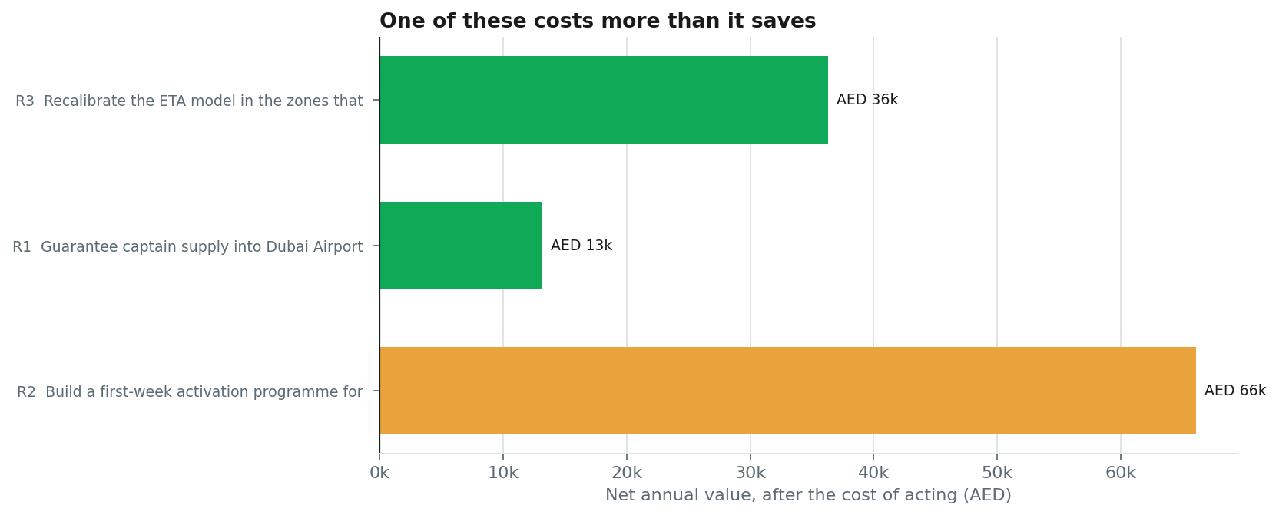

R3 · Recalibrate the ETA model in the zones that over-promise
Rider Experience Lead · near term · low effort · addresses ETA-01
Re-fit the arrival estimate for Business Bay, Yas Island against observed pickup times rather than optimistic routing. These zones are not slow — their actual waits sit near the network median. They are promising times they cannot hit, and riders cancel on the gap. Widen the displayed estimate to a range, and hold the model to a calibration target rather than a headline-number target.
Benefit, after capture rate | AED 36k
Cost of acting | AED 30k
Net annual | AED 36k
Why. The cheapest kind of problem to fix: the operation is performing adequately and only the promise is wrong.
Risk. An honest, longer ETA may suppress requests at the point of quote — trading cancellations for lost bookings. The net effect is an empirical question and this should ship as an A/B test, not a global change.
Success metric. Cancellation rate in the affected zones within 1pp of the network baseline, with request volume unchanged. Reviewed weekly.
Assumptions
- Capture rate 80% — the highest in this set, because the mechanism is direct and the fix is entirely within our control.
- Model rework cost AED 30,000.
- Assumes riders cancel on the gap rather than on the absolute wait. That is what the correlation comparison shows in this data, and it is the load-bearing claim behind the recommendation.

R1 · Guarantee captain supply into Dubai Airport during 06:00–09:00
Supply Growth Lead · immediate · medium effort · addresses SPL-01, FUL-01
Stop treating this as a pricing problem. Surge in this window already averages 1.76× and captain supply correlates with it at -0.45 — effectively not at all, so raising the multiplier further buys nothing but a worse rider experience. Instead, commit supply directly: a standing pre-positioning incentive paid to captains who are inside the zone before the window opens, plus a queue slot guarantee so they are not penalised for waiting. Pilot in this one zone-hour block before extending it.
Benefit, after capture rate | AED 32k
Cost of acting | AED 19k
Net annual | AED 13k
Why. This is the largest single recoverable block of demand in the network, and the intuitive fix — more surge — is already running and demonstrably not working.
Risk. A guaranteed incentive can be gamed — captains idling in-zone without accepting trips. Pay it on completed trips inside the window, not on presence. There is also a risk of pulling supply out of adjacent zones; monitor their fulfilment while piloting.
Success metric. Unfulfilled rate in Dubai Airport during 06:00–09:00 below 10% within six weeks, with no fulfilment deterioration in adjacent zones. Reviewed weekly.
Assumptions
- Capture rate 55% — pre-positioning recovers much of the unserved demand but not all; some riders will have gone elsewhere before supply arrives.
- Incentive of AED 6.0 per recovered trip. Should be re-tested against actual captain response in the pilot.

Considered and not recommended

R2 · Build a first-week activation programme for new captains
Benefit AED 66k/yr against a cost of AED 0/yr — net AED 66k/yr.
Supply is the binding constraint across this network, and this is the cheapest supply available — captains already recruited, already onboarded, and lost in their first month.

What we would measure
Each action carries a leading indicator that moves before the financial result does. If the indicator has not moved by the review point, the action is not working and should be stopped rather than extended.
# | Leading indicator | Cadence
R3 | Cancellation rate in the affected zones within 1pp of the network baseline, with request volume unchanged | weekly
R1 | Unfulfilled rate in Dubai Airport during 06:00–09:00 below 10% within six weeks, with no fulfilment deterioration in adjacent zones | weekly

Appendix

Method
Data was loaded from nine related tables and profiled. A quality gate ran eight families of check — key uniqueness, referential integrity, null rates, impossible values, ledger balance, three cross-table reconciliations and date coverage — before any analysis was permitted. KPIs were computed once, at every grain, so that no two sections of this document can disagree. Eight detectors then interrogated those KPIs, each returning findings with their own evidence, statistical method and confidence.
Confidence combines three components as a geometric mean: statistical strength, sample adequacy, and the quality score of the source tables. The geometric mean is deliberate — one weak component drags the result down and no strong component can rescue it.

Data quality
Gate result: WARN. 5 issue(s) found and 3 repair(s) applied before analysis. Repairs are deterministic and disclosed; no data was invented.
- trips: removed 1,022 exact duplicate rows
- trips: collapsed 11 rows sharing a primary key ['trip_id'] (kept first)
- supply_demand_hourly.active_captains: clamped 263 negative values to zero (flagged in active_captains_was_negative)
Checks that ran clean
- referential_integrity · all — 7 foreign-key relationships validated, no orphans

Assumptions
Every figure converting an operational failure into money rests on one of these. They are declared so they can be challenged.
- Stockout penalty: lost margin × undefined. The uplift represents basket abandonment and reduced repeat rate. Not derived from this data. Sensitivity 1.0–1.7.
- Cancelled order cost: AED undefined of picking labour and rider time. Sensitivity 8–16.
- Inventory holding: NaN% annually.
- Capture rates run 50% to 80% — never 100%, because some part of every leak is structural.
- Materiality floor: AED 40k/yr. Findings below this are recorded but not surfaced.

Limitations — what this analysis cannot support
Stating the boundary matters as much as stating the result.
- The supplier premium behind R2 is a placeholder, not a quote. If smaller case packs cost more than 1.5% extra per unit, that recommendation weakens quickly and should be re-tested before committing.
- The 50% demand-migration assumption behind the assortment recommendation is unverified. A basket-affinity analysis should precede any delisting, because a tail SKU that anchors a basket is not a tail SKU.
- Seasonal conclusions rest on two observed cycles. That is enough to establish the pattern exists and not enough to fit a reliable category-level uplift factor.
- Customer lifetime value is absent from this dataset, so cancellations are valued at single-order margin. This almost certainly understates the cost of repeated service failure at one store, and it is the assumption most likely to change the fleet conclusion if corrected.
- No competitor, price or promotional data is present. Demand is treated as exogenous, which it is not.
- The analysis is observational. None of the causal claims have been tested experimentally, and the recommended actions should be piloted before network-wide rollout.

