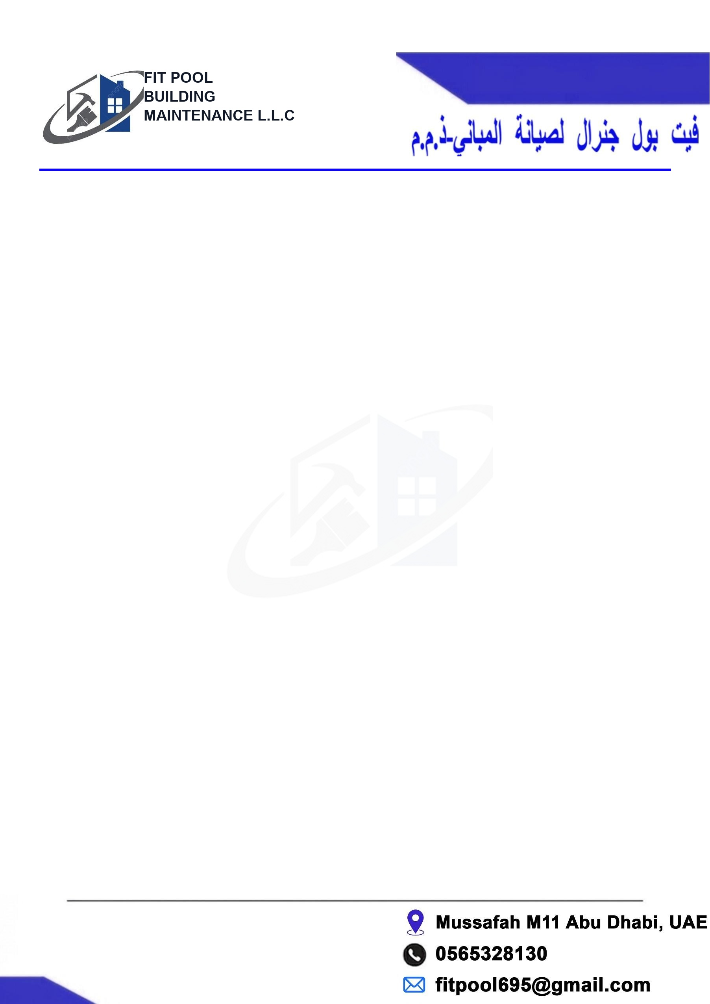

To
The Manager Abu Dhabi, UAE.
Date: 31/05/2026 Swimming Pool Cleaning Contract
Ref: FP/SPC-2026/0402

The Manager Golf Garden
Villa A 45
SWIMMING POOL CLEANING CONTRACT

No | Description | Qty | Total (AED)
01 | Swimming Pool Cleaning Service (2 Types)
02 | Pool Cleaning (Type 1) - Once a week  Monthly Payment (1 Month): 350.00 AED  1 Year Payment (12 Months): 4,200.00 AED | 1 Year | 4200.00
03 | Pool Cleaning (Type 2) - Twice a week  Monthly Payment (1 Month): 550.00 AED  1 Year Payment (12 Months): 6,600.00 AED | 1 Year | 6600.00
Total Amount: |  |  | 10800.00
Amount in words AED:

Notes or Special comments

Inclusion :
1. Checking of PH & Chlorine level and adjust as required supply of required chemicals.
2. Check level of water in the pool, fill as required (water to be provided by client).
3. Vacuum of the pool using vacuum head and telescopic handle and brush the walls as required.
4. Check filtration system for pressure reading. Backwash the filters as required.
5. Clean all debris from the pre-filter baskets as required.
6. Check and ensure that all timers, underwater pool lights, all electrical controls & equipment's are in proper operation then report irregularities to client.

Exclusion :
1. Repairs/ rectification works such as pool leakage, re-grouting of tiles, replacement of underwater lights, filters and Pumps Repairs/rectification and spare parts will be charged on separate cost and subject to clients approval before proceeding with the required works.
2. Snag and all materials
3. All other works not related to pool cleaning and checking of equipment

Notes
1. A separate quotation for items under exclusions (if required) will be provided to client for approval
2. Services provided Monday, Thursday, Friday, excluding public holidays.
3. Client is required to give access to the pool
4. Our company is not liable for any direct or consequential costs or liabilities arising due to failure or malfunction of any part of the pool or pool equipment.

Payment Advance 100%

Sincerely,  Ijaz Hussian  Fit Pool General Building Maintenance LLC  Abu Dhabi, Dubai  Signed for and on behalf of Customer  Name and Signature:  Date: | Account details  Ijaz Hussain  Meshruq Bank  IBAN: AE 660330000019200061112  Contact No: +971564378296

