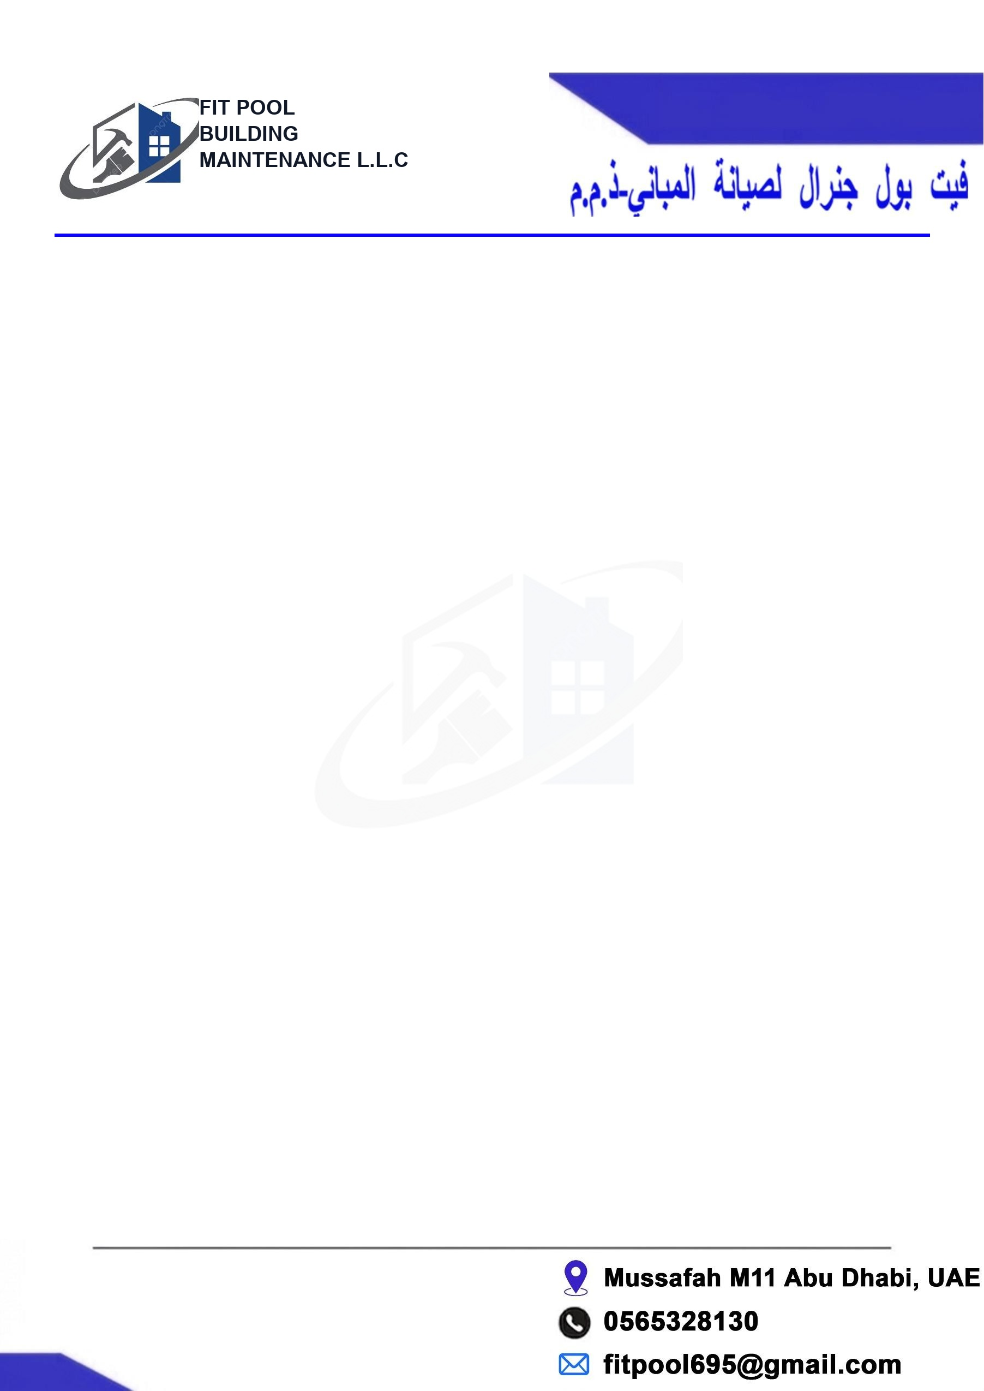

To
The Manager Abu Dhabi, UAE.
Date: 30/07/2026 Work Completion Report
Ref: FP/WCR-2026/0402

The Manager Loft-1
Apt 605
WORK COMPLETION REPORT
  Work Completed Photo 1 |   Work Completed Photo 2

No | Description | Qty | Total (AED)
01 | Swimming Pool under water light . | 1 No's | 450.00
Total Amount: |  |  | 450.00
Amount in words AED:

