UrbanCart
AI-Powered Customer Engagement & Automation Platform
Solution Proposal & System Architecture — Task 1
Client | UrbanCart (E-Commerce, Pakistan)
Prepared for | Sarah Malik — Operations Manager
Prepared by | Solutions & Automation Engineering Team
Business Developer | Ibrahim Wasiq Qurashi
Meeting date | 1 September 2026
Document date | 1 September 2026
Document type | Discovery-based solution proposal (Task 1 of 2)

Table of Contents

1. Executive Summary
UrbanCart is an e-commerce retailer selling electronics, accessories, home and lifestyle products across Pakistan, reached through its website, Instagram and WhatsApp. Its core problem is not a lack of demand — it is that a manual support team cannot keep up with the volume of repetitive questions, cannot respond outside business hours, and has no single place where customer, lead, order and support information lives. Leads leak between spreadsheets, sales follow-up is inconsistent, and product/policy answers depend on whichever document a staff member happens to remember.
This proposal designs an AI-driven customer engagement layer that sits in front of UrbanCart's existing operations rather than replacing them. Customers can ask questions and get accurate, policy-grounded answers by chat or by phone, 24 hours a day. Interested buyers are automatically captured as structured leads with full context, so the sales team stops re-asking questions customers already answered. Order-status questions are resolved instantly against real order data. Anything that requires judgment — a damaged item, a disputed refund, an angry customer — is deliberately handed to a person, with the right team alerted immediately and quietly, without flooding Slack with routine chatter.
The system is built from ten purpose-fit components, each solving one part of the problem: Vapi for the voice channel, n8n as the orchestration brain connecting everything, Airtable as the day-to-day workspace for sales/ops/support, PostgreSQL (hosted on Supabase) as the system of record for customers/orders/conversations, Supabase's pgvector extension for retrieval-augmented generation (RAG) over UrbanCart's own policy and product documents, Google Drive as the intake point for those documents, Notion for internal knowledge and playbooks, Slack for filtered internal alerts, and Zapier for one clearly-scoped business workflow (automated lead follow-up). None of these are used because they appear on a checklist — each one is mapped to a specific requirement raised in the discovery meeting, and that mapping is made explicit in Section 8.
The design deliberately does not try to automate everything on day one. It follows UrbanCart's own stated preference: ship the highest-value functionality first — grounded Q&A, lead capture and order lookups — and expand escalation handling, voice, and the Zapier workflow in later phases, inside a 6–8 week window.

2. Business Problem Analysis
The discovery conversation surfaces seven distinct, interlocking problems. Treating them separately (rather than as one generic “we need a chatbot” request) is what makes the automation boundary in Section 4 possible.
# | Problem (from the meeting) | Business impact | Root cause
1 | High volume of repetitive questions (availability, price, delivery, returns) answered manually | Support team time consumed by low-value work; slower responses to everyone | No self-serve, always-on answer layer grounded in real data
2 | No coverage outside business hours | Leads and questions that arrive at night are lost or delayed until next day | Human-only support model
3 | Customer/lead/order/complaint data scattered across spreadsheets, the e-commerce system, and a separate complaints sheet | No single view of a customer; duplicate effort; nothing reconciles automatically | No shared system of record
4 | Leads collected inconsistently across channels, hard to track | Sales follow-up delays and drop-offs; no visibility into pipeline | No structured lead intake or pipeline tool
5 | Order-status lookups are fully manual | Support agent time spent searching; slow answers to a simple, high-frequency question | No AI/automation access to order data
6 | Policies and product information change frequently; risk of AI giving stale or invented answers | Wrong answers erode trust and create liability (e.g., incorrect return windows) | No mechanism to keep AI answers grounded in current documents
7 | Complaints, damaged items and disputed refunds need human judgment, and the team must know immediately when this happens | Risk of the AI mishandling sensitive cases, or the team missing a serious issue | No defined escalation and priority-notification path

A secondary, cross-cutting theme is that UrbanCart is not a technical organisation: they explicitly asked the vendor to choose the architecture, and prioritised reliability, security, easy maintenance, reasonable cost and the ability to expand later over any specific technology. That constraint shapes every choice in this document toward well-supported, low-code-friendly platforms that UrbanCart's own staff can operate without engineering help for day-to-day use (uploading a document, editing a lead, adding a Slack channel rule).

3. Solution Objectives
Restating the client's own definition of success (from the closing of the discovery meeting) as measurable objectives:
- 24/7 availability: Customers can reach UrbanCart by chat or phone at any time and get an immediate response.
- Grounded answers: The AI answers common questions using UrbanCart's actual, current product and policy information — never invented content.
- Lead capture: Potential buyers are identified in conversation and handed to sales as structured, de-duplicated leads with context.
- Order self-service: Simple order-status questions are answered without a human touching the request.
- Reliable escalation: The team is alerted immediately, and only, when human judgment is genuinely required.
- Management visibility: Leadership can see what is happening across customers, leads, orders and issues in one place.
- Incremental delivery: A working core in 6–8 weeks, built so it can be extended rather than rebuilt.

4. What Is Automated vs. What Stays Human
This boundary is the single most important design decision in the proposal, because the client explicitly said the AI “should not try to solve everything” and should escalate rather than guess. The rule applied throughout the system is: the AI may answer, look up, and collect information; only a human may resolve a dispute, make an exception, or apologise for a failure.
Fully automated | Automated with human follow-up | Always human
- Product availability / price / delivery-area questions  - Delivery-time, return-window and warranty questions (RAG-grounded)  - Order-status lookups by order ID  - Lead data collection (name, phone, product, budget, location, readiness)  - Logging every conversation and creating/updating records  - Routine internal record-keeping (Airtable, Postgres) | - High-value or purchase-ready leads — captured automatically, then a person calls to close  - Ambiguous order lookups (order not found / multiple matches) — AI asks a clarifying question, escalates if still unresolved  - New knowledge documents — ingested automatically, but a staff member is notified so obviously wrong content can be corrected | - Damaged / defective product complaints  - Refund or compensation decisions  - Angry or escalated customers (sentiment-detected)  - Any question the AI cannot answer from grounded content  - Legal, warranty-dispute or exception requests

5. Users & Customer Journeys

5.1 User Personas
Persona | Channel(s) | What they need from the system
Prospective customer | WhatsApp, website chat, phone | Fast, accurate answers; a simple way to express purchase interest
Existing customer with an order | WhatsApp, website chat, phone | Order status without waiting on hold or for a reply
Customer with a complaint | WhatsApp, website chat, phone | To be heard and handed to a real person quickly, without repeating themselves
Sales team | Slack, Airtable | Qualified leads with full context, in one place, in real time
Support / operations team | Slack, Airtable, Notion | Complaints and order issues triaged by priority, with conversation history
Management | Airtable, Notion | A clear, current view of customers, leads, issues and system health

5.2 Customer Journey Maps

Journey A — Product / policy question (chat)
1. Customer messages UrbanCart on WhatsApp or the website widget: “Can I return headphones after 10 days?”
2. The system recognises the customer (or creates a new profile) and classifies the message as a policy question.
3. The RAG pipeline retrieves the relevant passage from the current return policy document and the AI answers using only that content.
4. If no confident match exists, the AI says it needs to check with the team rather than guessing, and flags the gap for follow-up.

Journey B — Purchase interest (voice)
1. Customer calls the UrbanCart number; the Vapi voice agent answers and asks how it can help.
2. Customer describes interest in a product (e.g. iPhone 15) and asks about price and availability.
3. The agent answers from grounded product data, then asks a short set of qualifying questions (budget, location, readiness to buy).
4. A lead record is created with full context and, if it qualifies as high-value, the sales team is notified in Slack with the customer's prior history attached.

Journey C — Existing order status
1. Customer provides an order ID (e.g. UC-10452) by chat or voice.
2. The system validates the format, looks it up in the orders table, and returns status, expected delivery, and last update.
3. If the order cannot be found or the ID is ambiguous, the AI asks for clarification once, then escalates rather than guessing.

Journey D — Complaint requiring a human
1. Customer reports a damaged item, requests a complex refund, or becomes frustrated.
2. The system detects this is outside the automation boundary (Section 4) and stops attempting to resolve it itself.
3. A high-priority support ticket is created with the full conversation attached, and the support channel in Slack is notified immediately.
4. The customer is told a team member will follow up, with an honest expectation of timing — not a false promise of resolution.

6. Channel Strategy — Chat & Voice
UrbanCart asked for both channels, because customers already split between messaging (WhatsApp, website, Instagram) and phone calls. Rather than building two separate “brains,” both channels are designed as thin front ends over one shared conversational core (Section 11.3): the same intent classification, the same RAG knowledge base, the same customer records, and the same escalation rules apply everywhere. This keeps behaviour consistent — a policy answer is the same whether asked by voice or by chat — and means a channel can be added later (e.g. Instagram DMs) without redesigning the logic underneath.
Channel | Entry point | Best suited to
Website chat / WhatsApp | Chat webhook → n8n | Asynchronous, text-heavy questions; sharing links/images; leaving a conversation and returning to it
Phone (Vapi voice agent) | Inbound call → Vapi → n8n via function calls | Customers who prefer speaking; urgent questions; a more natural “receptionist” experience

7. System Architecture
The architecture has five layers: a channel layer where customers and staff enter the system; an orchestration layer (n8n) that is the only component every request passes through; an AI/RAG layer that reasons over the request and retrieves grounded knowledge; a data layer split between a strict relational system of record and a flexible operational workspace; and a notification/automation layer that keeps humans informed and closes the loop with sales.
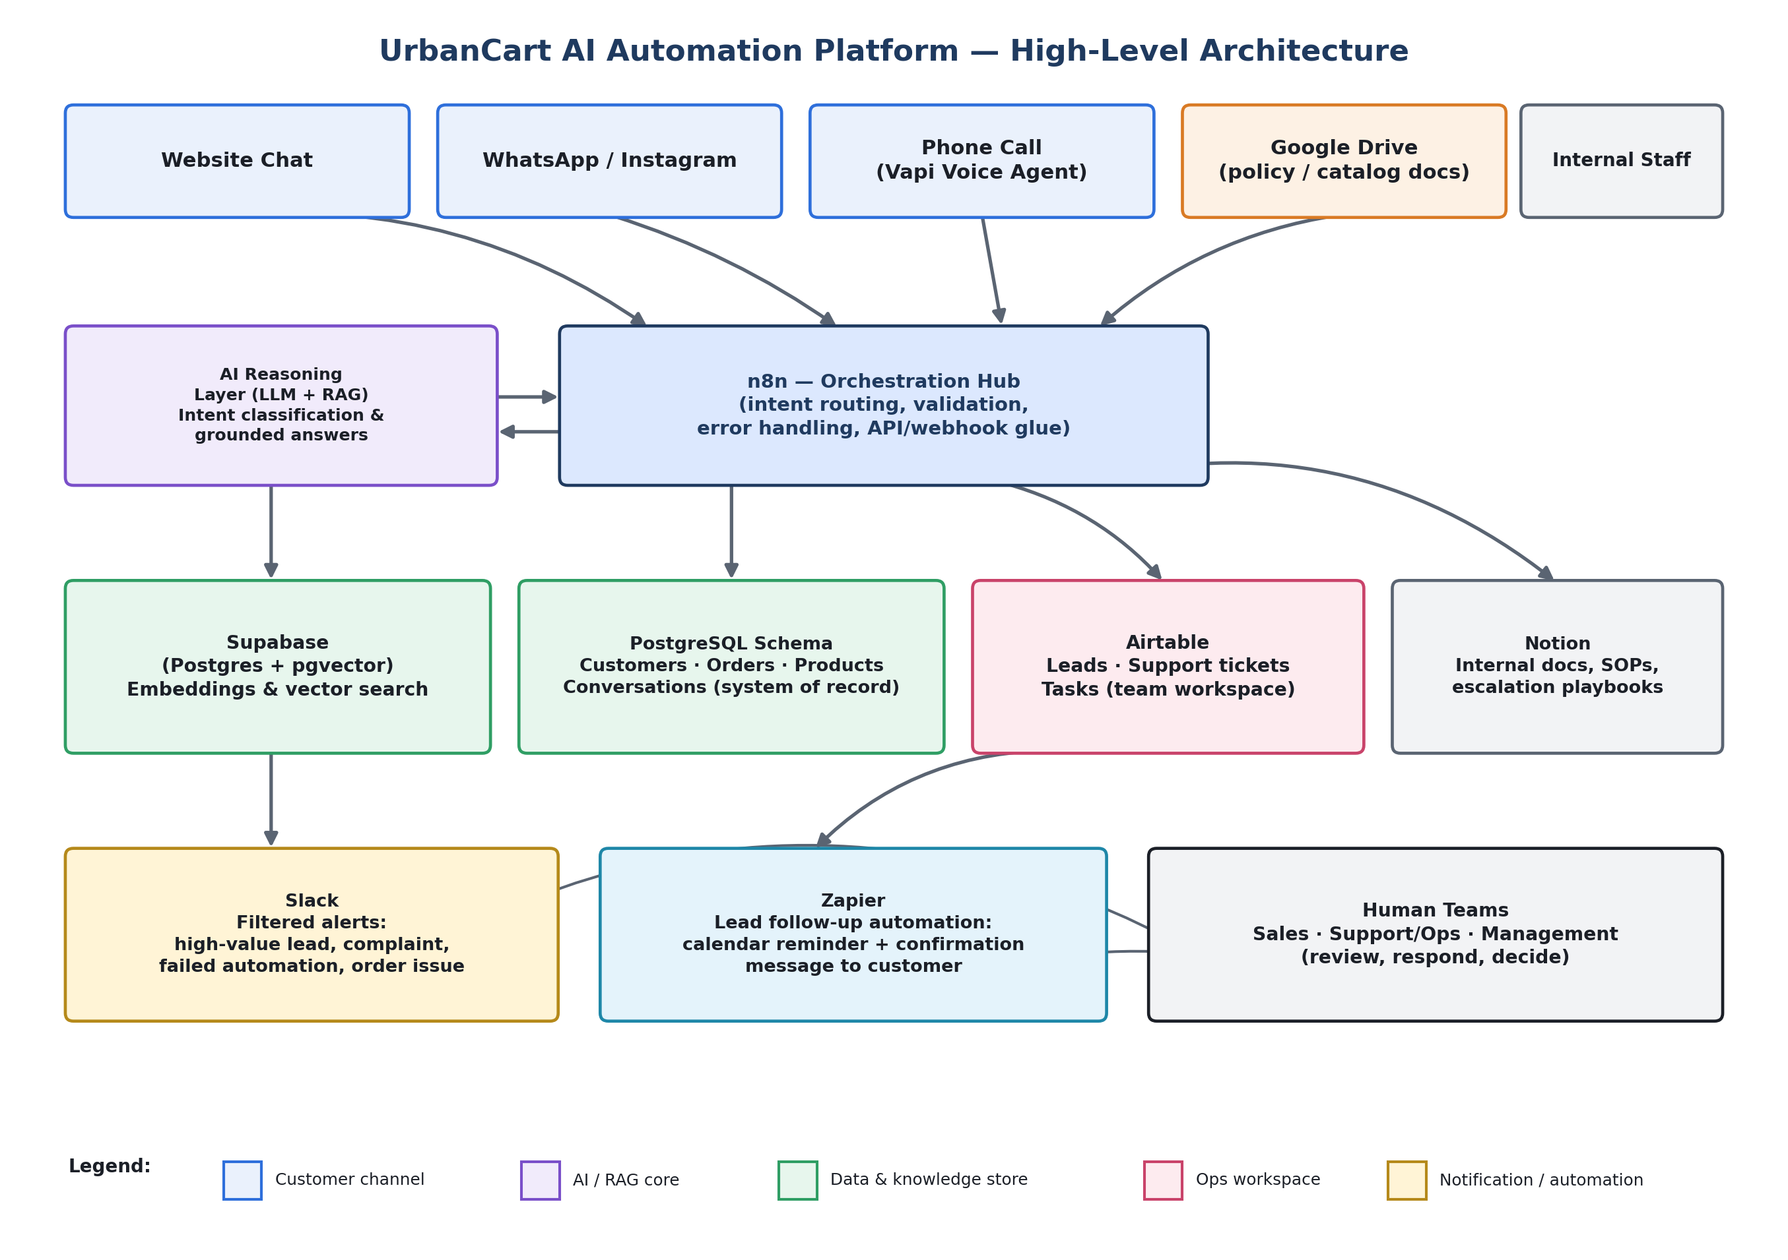
Figure 1. High-level system architecture across all required platforms.

7.1 Why n8n is the orchestration hub
n8n is the one component that talks to every other system, so it was chosen for that role rather than Zapier: it supports custom logic (branching on intent, retries, error-catch workflows), direct database queries against PostgreSQL, and self-hosting for cost and data-residency control — all needed for a system that must classify intent, decide when to escalate, and never silently fail. Zapier is intentionally kept out of this critical path (see Section 7.2) and used instead for one well-defined, business-editable workflow.

7.2 Why Zapier still has a defined role
The brief requires “at least one meaningful business workflow using Zapier,” and there is a genuine fit rather than a forced one: once a lead is marked “ready to purchase” in Airtable, Zapier watches for that update and (a) creates a follow-up reminder on the assigned salesperson's calendar and (b) sends the customer a short confirmation message. This is a simple, linear, non-AI business rule — exactly what Zapier is best at — and keeping it in Zapier means UrbanCart's own operations staff can view or adjust it later without touching the n8n workflows that run the AI. Full detail in Section 12.

7.3 Component responsibilities
Layer | Component | Responsibility
Channel | Website / WhatsApp chat | Text conversation entry point
Channel | Vapi | Voice conversation entry point; speech-to-text, text-to-speech, function calling
Channel | Google Drive | Intake point for policy/product/support documents
Orchestration | n8n | Intent routing, validation, retries/error handling, all API and webhook integration
AI / Knowledge | LLM + RAG pipeline | Intent classification and grounded answer generation
AI / Knowledge | Supabase (pgvector) | Document embeddings and vector similarity search
Data (system of record) | PostgreSQL (on Supabase) | Customers, products, orders, conversation logs — machine-queried, high-integrity data
Data (operational) | Airtable | Leads pipeline, support tickets, tasks — the day-to-day human workspace
Data (documentation) | Notion | SOPs, escalation playbooks, internal knowledge for staff
Notification | Slack | Filtered alerts to the right team, only for events that matter
Automation | Zapier | Post-lead follow-up: calendar reminder + customer confirmation

8. Technology Stack — Role & Justification
Each required technology is mapped below to the specific requirement it satisfies, and to the reason it — rather than an alternative — fits that role.
Technology | Role in this architecture | Why it fits
Vapi | Voice AI receptionist for the phone channel: understands intent, answers grounded questions, collects lead details, escalates complaints | Purpose-built for real-time voice with low-latency speech-to-text/text-to-speech and native function-calling into n8n, which a generic IVR cannot do
n8n | Central orchestration: every webhook, intent route, database call, retry and error path passes through it | Handles complex conditional logic and custom code that Zapier struggles with, connects directly to PostgreSQL/Supabase, and can be self-hosted for cost control and data residency — important for an SME watching cost
Zapier | One scoped business workflow: lead-ready-to-purchase → calendar reminder + customer confirmation | Its simple trigger-action model is easier for non-technical ops staff to view/adjust later than an n8n workflow, and it is not asked to carry AI logic or sensitive data flows
Google Drive | Intake and storage for product catalog, return/shipping/warranty policies, support guidelines and training docs | UrbanCart already works in PDFs, Word and spreadsheets; Drive lets staff update a document exactly as they do today, with no new tool to learn, while n8n watches the folder for changes
Airtable | Operational workspace: Leads pipeline, Support tickets, Tasks — what sales, ops and support actually work from day to day | Directly answers the client's own request for something “simple” that each team can see and use, with spreadsheet-like familiarity plus views, statuses and no-code automation staff can adjust themselves
Notion | Internal documentation: SOPs, escalation playbooks, system overview, project notes | Matches the client's existing tool (“we also use Notion for internal documentation”) — kept separate from the machine-facing RAG store because staff need a readable wiki, not a vector index
Slack | Filtered internal notifications: high-value lead, serious complaint, failed automation, important order issue | Already UrbanCart's internal tool; the requirement was explicitly to reduce noise, which is an n8n conditional-logic problem solved by routing only qualifying events here
PostgreSQL | Relational schema for customers, products, orders and conversation logs — the authoritative, machine-queried system of record | Enforces referential integrity (an order must belong to a real customer, a conversation must reference a real record) that a spreadsheet or no-code table cannot guarantee, and is fast enough for real-time lookups during a live chat or call
Supabase | The managed backend hosting that PostgreSQL database, providing the pgvector extension for embeddings/vector search, instant REST access for n8n, and row-level security | One managed platform gives UrbanCart both a production-grade relational database and vector search without operating two separate systems — directly serving the client's stated priorities of reliability, security and low maintenance
RAG (Retrieval-Augmented Generation) | Grounds every product/policy answer in UrbanCart's actual current documents instead of the model's general knowledge | This is the direct technical answer to the client's explicit concern: “we don't want the AI making up information” — detailed in full in Section 10

Note on scope discipline
Every row above is tied to a requirement raised in the meeting minutes, not included because it appeared on a suggested list. Where two technologies could plausibly do the same job (e.g. PostgreSQL vs. Airtable for orders), Section 9.3 explains why the split was made rather than picking one arbitrarily.

9. Data Architecture & Data Model

9.1 End-to-end data flow
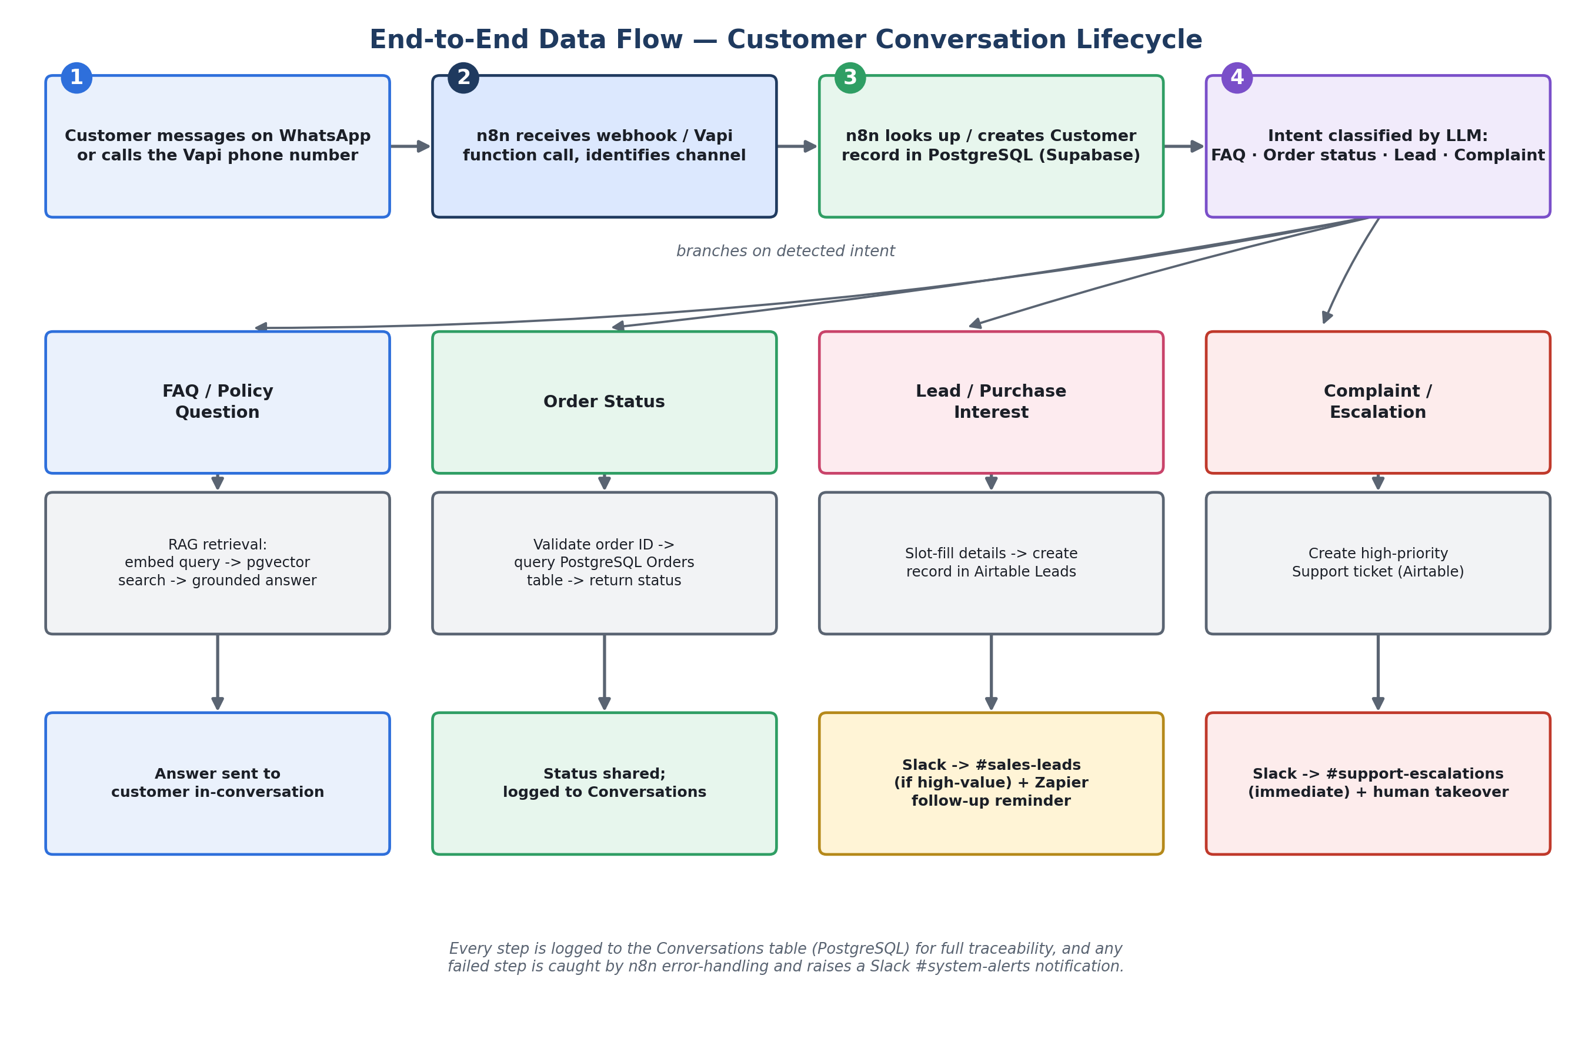
Figure 2. How a single customer conversation moves through the system, branching by intent.

9.2 System of record vs. operational workspace
A deliberate split avoids two systems silently disagreeing about the same fact. PostgreSQL (via Supabase) is the system of record for anything the AI must query at machine speed and trust completely: customer identity, product catalog, orders, and the full conversation log. Airtable is the operational workspace where humans work day to day — leads moving through a pipeline, support tickets being triaged, tasks being assigned — written to by n8n at the moment those things happen, but not re-queried by the AI as a source of truth. This means the AI never gives a customer an answer that depends on whether someone remembered to update a spreadsheet-like tool; that tool is instead the team's window into what already happened.

9.3 Core entities

Customer
Field | Notes
customer_id | Primary key
name, phone, email | Phone is the primary match key across WhatsApp and Vapi
location | City-level, used for delivery questions
source_channel | website / whatsapp / instagram / phone
created_at, last_contacted_at | Drives “see previous customer information” requirement

Lead
Field | Notes
lead_id, customer_id | Links back to Customer
product_of_interest | Free text + matched product_id where possible
budget_estimate | Approximate, as the client requested
location | Copied at capture time
readiness | ready_to_buy / just_asking
status | New → Contacted → Qualified → Won / Lost (Airtable pipeline)
assigned_to, notified_at | Which salesperson, and whether Slack/Zapier already fired

Product
Field | Notes
product_id, name, category | electronics / accessories / home / lifestyle
price, availability | Kept current for grounded price/availability answers
spec_summary | Short structured fields, separate from the long-form catalog used for RAG

Order
Field | Notes
order_id | e.g. UC-10452, matches UrbanCart's existing format
customer_id, product_id(s) | Links
status | placed / shipped / out_for_delivery / delivered / return_requested
last_update, expected_delivery | What the AI reads back to the customer

Conversation
Field | Notes
conversation_id, customer_id, channel | chat or voice
transcript / message log | Full history, used for context and human handoff
detected_intent | faq / order_status / lead / complaint
resolution | auto_resolved / escalated

Support ticket
Field | Notes
ticket_id, customer_id, conversation_id | Links back to the triggering conversation
category | damaged_item / refund / complaint / order_issue
priority | high / normal — drives Slack notification
status, assigned_to | Open → In progress → Resolved (Airtable board)

Document (knowledge base)
Field | Notes
document_id, source_file, doc_type | catalog / return_policy / shipping / warranty / support_guidelines
version, uploaded_at | Supports replacing stale chunks on update
chunk_id, embedding, chunk_text, metadata | One row per chunk in the vector store — see Section 10

Task
Field | Notes
task_id, related_ticket_id / lead_id | What the task is about
assigned_to, due_date, status | Operations team board in Airtable

10. RAG Knowledge Pipeline
This section is the direct answer to the client's clearest requirement: “we don't want the AI making up information… it should use our actual information,” and updates should happen “without developers changing the system every time.” Retrieval-Augmented Generation (RAG) means the AI never answers a policy or product question from memory — it first retrieves the relevant passage from UrbanCart's own current documents, and answers only from what it retrieved.

10.1 Ingestion
1. A staff member uploads or replaces a file in a designated Google Drive folder (product catalog, return policy, shipping policy, warranty information, support guidelines, or training material — PDF, Word or spreadsheet).
2. n8n polls/watches that folder and picks up new or modified files automatically — no developer involvement.
3. Each file is tagged with its document type and version, and the previous version's chunks are marked superseded rather than immediately deleted, so retrieval never mixes old and new policy text.

10.2 Text extraction & chunking
n8n extracts plain text from each format (PDF and Word text extraction; spreadsheets converted row-by-row into readable statements, e.g. “Return window for Electronics: 7 days”). Text is split into overlapping chunks of roughly 300–500 words — small enough for precise retrieval, with enough overlap that a fact split across a page boundary is not lost. Each chunk keeps metadata: source document, document type, section heading, and version.

10.3 Embeddings & vector storage
Each chunk is converted into a vector embedding and stored in Supabase using the pgvector extension, alongside its metadata. This keeps the knowledge index in the same managed Postgres environment as the rest of the structured data, rather than operating a separate vector database — simpler to secure and maintain, which matters given UrbanCart's stated preference for easy maintenance.

10.4 Retrieval & grounded response
1. A customer question is embedded the same way as the documents.
2. A similarity search returns the top-matching chunks, optionally filtered by document type (e.g. prioritising the return policy for a returns question).
3. The retrieved passages are given to the AI as its only source of truth for that answer, with an instruction not to add information beyond them.
4. The AI's answer references what the policy actually says (e.g. citing the specific return window) rather than a generic response.

10.5 Keeping knowledge current
Because ingestion is triggered automatically by a file change in Drive, a policy update becomes searchable within minutes of being uploaded, with no code change and no developer ticket — directly satisfying “the AI's knowledge should eventually update automatically.” A lightweight internal notification (Notion log entry, and optionally a low-priority Slack note) confirms ingestion succeeded, so staff have confirmation without being interrupted.

10.6 When there is no good answer
If the similarity search returns nothing above a confidence threshold, the AI does not guess. It tells the customer it needs to confirm with the team, and the question is logged as a knowledge gap — visible to staff as a signal that a document may be missing or unclear, turning failures into a concrete to-do rather than a silent bad answer. This is the same rule the client stated directly: “if the information isn't available, the AI should tell the customer it needs human assistance rather than guessing.”

11. Voice & Chat Interaction Design

11.1 Vapi voice agent
Vapi answers inbound calls, transcribes speech in real time, and uses the same intent-classification and RAG logic as chat by calling out to n8n through function calls (e.g. lookup_order, search_knowledge_base, create_lead, escalate_to_human). This keeps Vapi itself a thin conversational layer — all business logic and data access live in n8n, so behaviour stays consistent with chat and there is only one place to maintain the rules.
- Greets the caller and asks how it can help, in plain conversational language.
- Answers FAQs (availability, price, delivery area, delivery time, returns, warranty) using grounded retrieval, exactly as chat does.
- If purchase interest is expressed, asks the qualifying questions (product, budget, location, readiness) conversationally and passes them to the lead-capture flow.
- If the caller reports a complaint or the conversation turns negative, the agent stops attempting to resolve it, tells the caller a team member will follow up, and triggers the escalation flow (Section 14) before ending the call.

11.2 Chat agent (WhatsApp / website)
Chat messages arrive at n8n by webhook. The same intent classification, RAG retrieval, lead capture and escalation logic apply; chat additionally supports asynchronous conversations (a customer can return hours later and the system still has the context) and rich content such as product links or images where useful.

11.3 The shared conversational core
Both channels call the same n8n workflow rather than duplicating logic per channel. A single request object (channel, customer identifier, message/transcript, timestamp) enters one pipeline: identify customer → classify intent → branch to the matching handler → log the outcome. This is what lets UrbanCart add a channel later (Instagram DMs, for example) as a new entry point into the same brain, instead of a new project.

12. Lead Capture & Sales Handoff
Whenever a conversation signals purchase interest, the AI collects the client's stated minimum fields — name, phone number, product of interest, approximate budget, location, and whether the person is ready to buy or just browsing — conversationally, without turning the exchange into a form. Partial information is accepted; missing required fields (name and phone, at minimum) trigger one follow-up question before the lead is saved as incomplete rather than discarded.
1. n8n validates the captured fields (phone format, budget as a number/range) and checks for an existing customer by phone to avoid duplicate leads.
2. A new Lead record is created in Airtable with status “New,” linked to the customer's full prior history.
3. If the lead is high-value (budget above a configurable threshold) or marked “ready to buy,” n8n posts to the #sales-leads Slack channel in the client's own requested format — e.g. “New customer interested in iPhone 15, budget Rs. 200,000, located in Lahore” — with a link to the full record so the rep sees history instead of starting from zero.
4. The Zapier workflow watches for leads marked “ready to buy” in Airtable and automatically creates a calendar follow-up reminder for the assigned salesperson and sends the customer a short confirmation message, so no lead is forgotten between systems.

13. Existing Order Retrieval
Order questions are handled deterministically rather than through RAG, because order data is structured and must be exact — unlike policy text, there is no ambiguity to retrieve around.
1. The customer provides an order ID (e.g. “My order UC-10452 hasn't arrived yet”) by chat or voice.
2. n8n validates the format and queries the PostgreSQL orders table directly.
3. If found, the AI reads back status, last update, and expected delivery in plain language.
4. If not found, or the customer cannot recall the exact ID, the AI asks once for clarification (e.g. phone number to search by); if still unresolved, it escalates rather than guessing at an order.

14. Human Escalation
Escalation triggers on three conditions, matching the client's own examples: a reported damaged/defective product, a complex or disputed refund request, or detected frustration/anger in the conversation (via sentiment/keyword signals, e.g. repeated complaints, explicit dissatisfaction, escalation language). The moment any of these fires, the AI stops attempting to resolve the issue itself.
1. n8n creates a high-priority Support ticket in Airtable, with the full conversation transcript attached for context.
2. Slack is notified immediately in #support-escalations — this is one of the four event types the client explicitly wants to see (Section 15).
3. The customer receives an honest, calm message confirming a team member will follow up, without a false promise that the issue is already solved.
4. The support agent picks up the ticket in Airtable with full history already visible, so the customer never has to re-explain what happened.

15. Internal Notifications
The client was explicit that Slack should not become noisy: “normal customer questions don't need to notify the entire team.” Notification rules are therefore enforced as conditional logic inside n8n — not by relying on staff to mute channels — so only genuinely actionable events reach Slack.
Event | Channel | Trigger condition
High-value lead | #sales-leads | Budget above threshold, or explicitly “ready to buy”
Serious customer complaint | #support-escalations | Damaged item, disputed refund, or detected anger/frustration
Failed automation | #system-alerts | Any n8n workflow error-catch (API timeout, invalid data, integration failure)
Important order issue | #support-escalations | Delivery significantly delayed, repeated status inquiries, or order/customer mismatch

Routine FAQ answers, normal order-status lookups, and low-budget or exploratory leads are logged to Airtable and PostgreSQL as usual, but deliberately do not post to Slack.

16. Internal Knowledge & Team Visibility
The client asked for something simple, where each internal audience sees only what is relevant to them:
Audience | Tool / view | What they see
Management | Airtable — Customer Overview view | Key customer/lead metrics and high-level activity, rolled up from the underlying data
Operations team | Airtable — Tasks & Tickets view | Open tasks and issues, by priority and status
Sales team | Airtable — Leads pipeline view | New/Contacted/Qualified/Won leads, each linked to full customer history
Support team | Airtable — Support Tickets view | Complaints and order issues, with linked order and conversation data
All staff | Notion | SOPs, escalation playbooks, how the AI system works, and a running log of knowledge-base updates

Airtable is used for per-team, per-record working views because that is what the client asked for and is used to; Notion is kept for reference material that is read rather than acted on record-by-record — avoiding two tools trying to do the same job.

17. Error Handling & Missing Information
Situation | System behaviour
Customer question has no confident grounded answer | AI declines to guess, tells the customer it needs to confirm with the team, and logs the gap as a knowledge-base signal (Section 10.6)
Required lead field missing (e.g. no phone number given) | AI asks one clarifying follow-up; if still missing, the lead is saved as incomplete rather than lost, flagged for sales to complete manually
Order ID not found / ambiguous | AI asks once for an alternative identifier (phone number); if still unresolved, escalates to support rather than guessing at a match
Downstream API/database call fails (Airtable, Postgres, Slack, etc.) | n8n's error-handling path retries with backoff; if it still fails, the customer gets a graceful fallback message instead of silence, and #system-alerts is notified (“failed automation”) so the team can intervene
Document upload fails to parse (corrupted file, unsupported format) | Ingestion workflow logs the failure and notifies staff via Notion/Slack rather than silently skipping the document
Duplicate or conflicting customer/lead records | Matching by phone number at creation time prevents most duplicates; any conflict is surfaced to the sales/ops team rather than auto-merged silently

18. Non-Functional Requirements
These map directly to the priorities UrbanCart named at the end of the discovery meeting: reliability, security, easy maintenance, reasonable cost, ability to scale, and accurate AI responses.
Priority | How the design addresses it
Reliability | n8n error-catch workflows with retries on every external call; nothing fails silently — failures surface in #system-alerts
Security | Credentials/API keys held in n8n's credential store, not in workflow code; Supabase row-level security restricts data access by role; Slack messages avoid exposing full customer PII beyond what's operationally needed
Easy maintenance | Non-technical staff manage day-to-day operation entirely through Google Drive uploads, Airtable records, Notion pages and Slack — no developer needed to update policy content or view leads
Reasonable cost | All ten platforms have usable free or low-cost tiers suited to an initial rollout; n8n can be self-hosted to avoid per-workflow execution fees as volume grows
Ability to scale | PostgreSQL and pgvector both scale well beyond an SME's transaction and document volume; n8n workflows are modular and can move to queue mode under higher load without a redesign
Accurate AI responses | RAG grounding (Section 10) plus an explicit “don't know → escalate” rule (Section 17) directly targets the client's stated concern about invented answers

19. Implementation Roadmap (6–8 Weeks)
Matching the client's own preference to start with the most important functionality and expand later, rather than automate everything at once.
Phase | Weeks | Scope
Phase 1 — Foundation | 1–2 | Data model in PostgreSQL/Supabase; Google Drive ingestion → chunking → embeddings → pgvector; Airtable base (Leads, Tickets, Tasks) and Notion workspace set up
Phase 2 — Core chat experience | 3–4 | Website/WhatsApp chat wired to n8n; intent classification; grounded RAG answers; order-status lookups; conversation logging
Phase 3 — Voice, leads & alerts | 5–6 | Vapi voice agent live with function-calling into n8n; structured lead capture on both channels; filtered Slack notifications; Zapier lead follow-up workflow
Phase 4 — Escalation, hardening & demo | 7–8 | Complaint/escalation detection and handoff; error-handling and retry coverage; management views in Airtable; end-to-end demo with realistic scenarios

20. Conclusion & Next Steps
This proposal turns seven concrete problems raised in the discovery meeting into a system where every required technology plays one clear, justified role: Vapi and chat give customers a 24/7 front door; n8n and the RAG pipeline over Supabase ensure every answer is grounded in UrbanCart's real, current documents; PostgreSQL and Airtable together give the business a single, trustworthy view of customers, leads, orders and issues instead of scattered spreadsheets; Slack and Zapier keep the human team informed and acting quickly, without noise; and Notion keeps the team's own knowledge in one place.
Task 2 of this engagement implements this design as a working system — connecting the ten platforms, building the RAG pipeline, and demonstrating realistic UrbanCart scenarios end to end, starting with the Phase 1–2 scope above.

