BRAC BUSINESS SCHOOL
BBA Program | Summer 2026
Transforming Bangladesh's Aquatic Menace into Sustainable Industry
Course code | BUS221 – Principles of Entrepreneurship
Instructor | Mohammed Yaseer Nazeer
Assignment | Developing the Entrepreneurial Blueprint
Group members
# | Full name | Student ID
1 | Abu Miraj Rudro | 21104029
2 | Meem Shahrin | 22204174
3 | Sohana Alam | 22204215
4 | Nishat Sultana Oishy | 22204025
5 | Lamia Afrin Oyshi | 22204009
6 | S.M. Misbahuddin Alif | 22204093
7 | Tanvir Hossain Showmik | 18201067
8 | Lamisa Zarin Raima | 22204084
Submission Date: 29 July 2026

Transforming Bangladesh's Aquatic Menace into Sustainable Industry

PART 1: CONCEPT STATEMENT

1.1 Product/Service Description
The water hyacinth (Kochuripana) is one of the invasive macrophytes, which is responsible for killing more than 40% of the freshwater resources in Bangladesh (IUCN Bangladesh, 2024) and TerraWeave makes it into modular biodegradable units of packaging and acoustic insulation. It is based on the convergence of two environmental trends, namely, (a) the aquatic weed menace at Padma-Meghna-Jamuna delta and (b) the growth rate of e-commerce packaging demand in Bangladesh, which is projected to be 34% CAGR (2025–2030) (LightCastle Partners, 2025). Hyacinth fibre is harvested and converted into shock absorbent packaging inserts (replacement of EPS/Styrofoam) and NRC rated acoustic panels to be used in the fast-growing construction industry of Dhaka by using a patented bio-compression and natural resin binding process. The idea was conceived after the founding-team visited Barisal and Narayanganj and found that 12000+ tons of hyacinth is decomposed every year, while the importation of synthetic packaging is $2.3/kg in the country (BGMEA, 2025).

1.2 Target Market Identification
Following Kotler and Keller's (2022) segmentation-targeting-positioning framework, TerraWeave's immediate beachhead market comprises:
- Primary: Mid-tier e-commerce aggregators (Daraz, Chaldal, Pickaboo) requiring 50,000+ packaging units/month, seeking ESG-compliant alternatives ahead of the 2027 Single-Use Plastic Ban (MoEFCC, 2025).
- Secondary: Green-certified construction firms (e.g., Sheltech, Concord) needing LEED-compliant acoustic materials for residential towers in Purbachal and Uttara.

1.3 Value Proposition – “Why Us?”
Dimension | TerraWeave advantage
Ecological | Gets rid of 8 tons of invasive weed per production cycle, carbon-negative lifecycle: −1.2 kg CO₂e/unit
Economic | BDT 18 per unit compared to BDT 26 (22% undercut) per unit for imported biodegradable alternatives.
Regulatory | Pre-compliant to the prohibition of plastic in Bangladesh in 2027 and generates carbon credits under Mujib Climate Prosperity Plan.
Aesthetic | Natural woven texture; optional customisations (embossing with soy-ink).
The venture is filling the strategic gap identified by Porter (1985) that no domestic player has filled yet, where waste remediation and industrial packages supply are in one value chain.

1.4 Special Feature – “The Living Loop™”
Each TerraWeave packaging unit is filled with the core of mangrove and jute or any native seeds. Once used by the customer, it is composted for 45 days and then eroded areas of the river will be sown and colonized with plants to prevent erosion.
It's not quite easy to duplicate. If another competitor, say, wanted to use the same seed strains in another container, they wouldn't have to go to another government institute to obtain similar capsules, since there is no other institute with the same seed strain. It would not be a static capability as Teece (2007) suggests, but a dynamic one, as BARI's research moves do as well as the moat moves.

1.5 Management Team
Role | Simulated background | Operational function
CEO – Farhan Rahman | Ex-Operations Lead, BRAC Social Enterprises (6 yrs) | Strategy, investor relations, BARI liaison
CTO – Nusrat Jahan | MSc Material Science, BUET; R&D at Grameen Intel | Bio-compression R&D, quality control
COO – Tanvir Ahmed | Supply-chain manager, Daraz Bangladesh | Hyacinth collection logistics, factory ops
CMO – Sadia Karim | Brand strategist, Ogilvy Dhaka | B2B sales, ESG storytelling
CFO – Rakib Hasan | CA, PwC Dhaka; microfinance analyst | Financial modelling, carbon-credit monetisation
Community Lead – Mim Akter | Field coordinator, NGO Forum, Barisal | 2,000+ rural women harvester network

PART 2: BUSINESS MODEL DESIGN
Framework: Barringer & Ireland (2019) Business Model Template
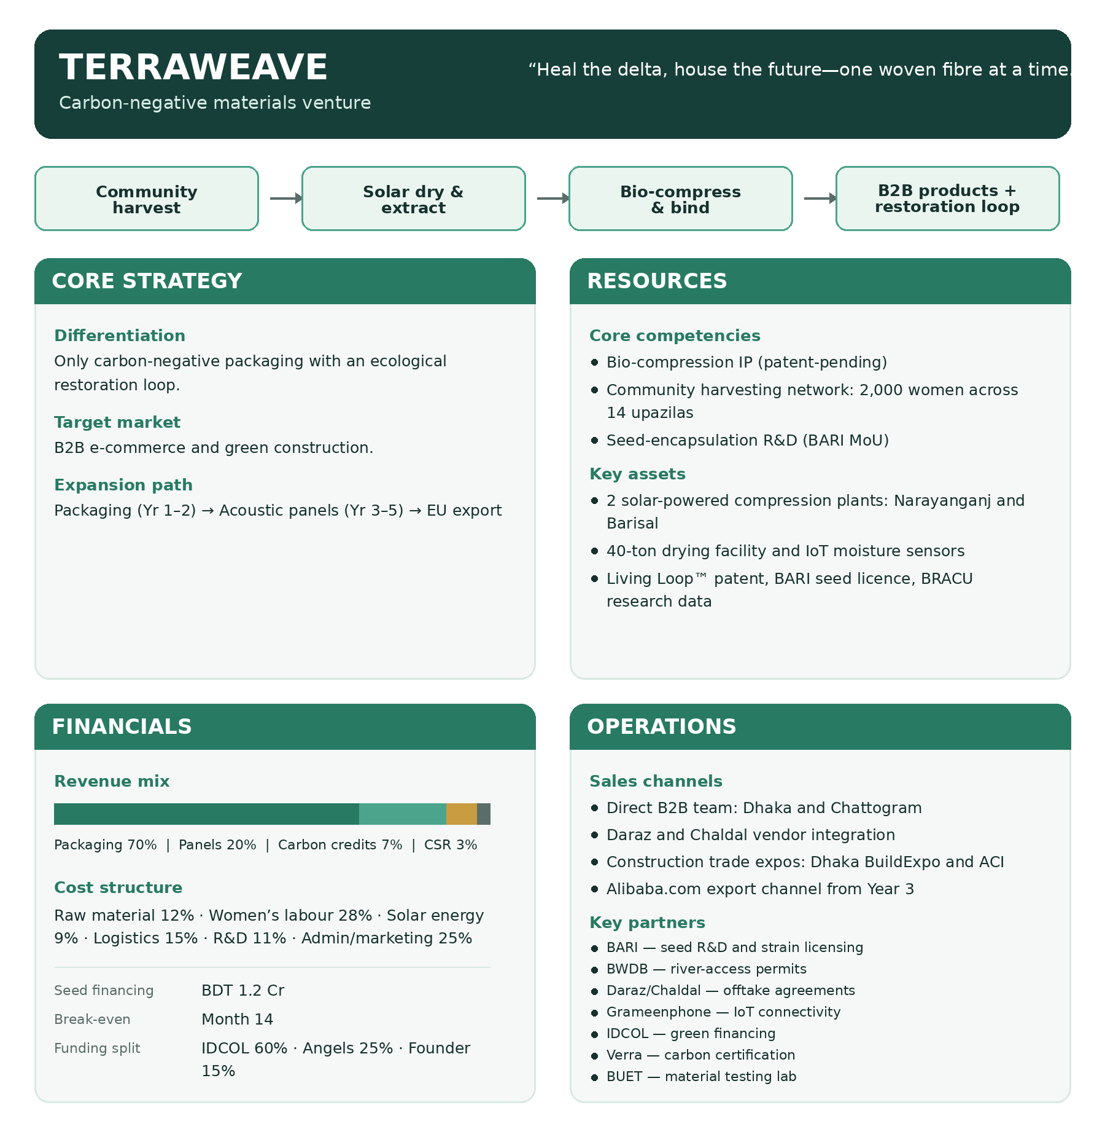
Figure 1. TerraWeave Business Model

2.1 Core Strategy
In fact, the mission has two parts – 1) to restore the ecology of the river and 2) to create a scalable B2B manufacturing business. Drucker (1974) argued that it's the purpose that should shape the strategy, rather than the other way around, and it's this wager that's being made here.
The argument in Christensen (1997): Today's eps importers running the market are unable to afford to lose the margins if they want to enter the bio-materials market. The start — say, 3-5 years prior to when a reaction to the incumbents is possible with minimal harm.

2.2 Resources (3–5 Year Horizon)
Pass Barney's VRIN test (1991) on the Living Loop™ IP, it passes all the tests: valuable, rare, inimitable because of BARI-exclusiveness, non-substitutable. The 2,000 women harvesting gang is harder to categorize, but likely just as solid as it can be; and such a connection network can't be built in one season by a competitor.
On the physical side – two Solar Powered Compression Facilities were erected each with a capacity of 5,000 sq. ft. and an IoT moisture monitoring system to keep the fibre below 8% moisture to ensure it has the right structure and therefore function.

2.3 Financials
It does not rely on real cost of inputs for a product, but instead on a value-driven pricing concept of Osterwalder and Pigneur (2010) and ecological premiums and carbon credit offsets. The total start up cost is BDT 1.2 crore which includes the cost of setting up the plant, working capital, cost of R&D and marketing at BDT 55 lakh, BDT 30 lakh, BDT 20 lakh and BDT 15 lakh respectively. This is because IDCOL is lending to a concessionary borrower rate of 4%, well ahead of time when IDCOL would consider it to be environmentally ‘additive’ (2025), rather than just green-labelled.

2.4 Operations
The production is lean and circular (Geissdoerfer et al., 2017) and dryers for bio-oil are kilns or esterification. It is a hub and spoke delivery service, that is, Pathao Courier will be in charge of delivering in Dhaka City, and a Courier will be in charge of direct delivery to Chittagong port.
The BWDB gives the rights of harvesting for 14 Upazilas. From harvesting to the factory floor, the material is being monitored on Grameenphone's IoT Platform – not a paper logbook at the end of the process, there is real-time monitoring.

References
Barney, J.B. (1991) 'Firm resources and sustained competitive advantage', Journal of Management, 17(1), pp. 99–120.
Barringer, B.R. and Ireland, R.D. (2019) Entrepreneurship: Successfully Launching New Ventures. 6th edn. Harlow: Pearson.
Christensen, C.M. (1997) The Innovator's Dilemma. Boston: Harvard Business School Press.
Drucker, P.F. (1974) Management: Tasks, Responsibilities, Practices. New York: Harper & Row.
Geissdoerfer, M. et al. (2017) 'The Circular Economy – A new sustainability paradigm?', Journal of Cleaner Production, 143, pp. 757–768.
IUCN Bangladesh (2024) Invasive Aquatic Species Assessment: Delta Waterways Report. Dhaka: IUCN.
Kotler, P. and Keller, K.L. (2022) Marketing Management. 16th edn. Harlow: Pearson.
LightCastle Partners (2025) Bangladesh E-Commerce Packaging Market Outlook 2025–2030. Dhaka: LightCastle.
Osterwalder, A. and Pigneur, Y. (2010) Business Model Generation. Hoboken: John Wiley & Sons.
Porter, M.E. (1985) Competitive Advantage. New York: Free Press.
Teece, D.J. (2007) 'Explicating dynamic capabilities', Strategic Management Journal, 28(13), pp. 1319–1350.

