**Airmon-ng (Monitor Mode)**

* Airmon-ng – enable monitor mode on wireless interfaces, go back to managed ( station ) mode, entering without parameters shows the interface status.
* Usage: airmon-ng <start|stop> <interface> [channel] or airmon-ng <check|check kill>
  + <start|stop> indicates if you wish to start or stop the interface. (Mandatory)
  + <interface> specifies the interface. (Mandatory)
  + [channel] optionally set the card to a specific channel.
  + <check|check kill> “check” shows any alternate process interference.
* Code:
  + Airmon-ng ( Show current status of wireless interfaces )
  + Airmon-ng check ( See what may interfere with packet capture )
  + Airmon-ng check kill ( Kill anything that would interfere )
  + Airmon-ng start wlan0 ( Start monitor mode )
  + Airmon-ng stop wlan0 ( Start monitor mode )
  + Service NetworkManager start ( Restart the network service )
  + iwconfig
  + Airmon-ng stop ath0
* Madwifi-ng Driver Monitor Mode
  + Iwconfig ( Show current status of wireless interfaces )
  + Multiband Atheros Driver for Wireless Fidelity.
* Turn on Monitor Mode
  + Airmon-ng start wlan0
* Start to Finish:
  + Airmon-ng check ( check for interference )
  + Airmon-ng check kill ( kill task interference )
  + Airmon-ng start wlan0 (start monitor mode )
  + Airmon-ng stop wlan0 ( stop monitor mode )
  + Service NetworkManger start ( restart networking )
* Access Point: shows MAC address of the NIC (Network Interface Card).

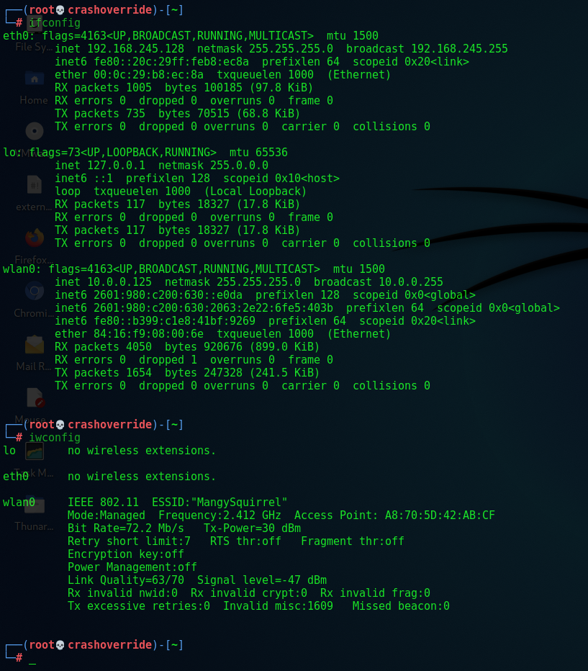

* Determine Current Channel:
  + “iwlist wlan0 channel”
* Debuggin Issues:
  + –verbose flag ( airmon-ng –verbose )
    - Info about the System & Wireless Card
      * Detailed Linux distribution info & kernel version
      * System is a virtual machine ( detailed info & supporting features )
      * Detailed driver information (kernel, vendor driver, staging or unknown source), wireless stack, current operating system & firmware version
  + –debug Issues ( airmon-ng –debug )
    - Same &:
      * Shell name & version
      * Debug info regarding wireless adapter & loaded driver
* If RFs are blocked:
  + “Rfkill unblock all”