WEEK 3 TASK
Unsupervised Learning and Clustering Analysis
Project: Iris Dataset Clustering Using K-Means
Prepared as a beginner/fresher-level machine learning project

1. Introduction
Unsupervised learning is a type of machine learning where the data does not have a target label that the model has to predict. Instead, the model tries to find patterns or groups in the data. Clustering is one of the common techniques used for this purpose.
For this task, I selected the Iris dataset and used the K-Means clustering algorithm. My main aim was to understand how similar data points can be grouped together and how the clusters can be visualized and interpreted.

2. Objective
- Understand the basic idea of unsupervised learning and clustering.
- Use a publicly available dataset for a practical clustering problem.
- Preprocess and scale the numerical features.
- Apply K-Means clustering using Scikit-learn.
- Use the Elbow Method and Silhouette Score to study the number of clusters.
- Visualize and interpret the clusters.

3. Dataset Description
The Iris dataset is a well-known public dataset available through Scikit-learn. It contains 150 observations of iris flowers and four numerical measurements: sepal length, sepal width, petal length, and petal width. The original dataset also contains species labels, but I did not use those labels while training the clustering model because the purpose was to perform unsupervised learning.
Feature | Meaning | Type
sepal length (cm) | Sepal length | Numerical
sepal width (cm) | Sepal width | Numerical
petal length (cm) | Petal length | Numerical
petal width (cm) | Petal width | Numerical

4. Tools and Technologies
I used Python for the analysis. The main libraries were Pandas for data handling, NumPy for numerical work, Matplotlib for graphs, and Scikit-learn for preprocessing, K-Means, PCA, and evaluation.

5. Data Exploration
The dataset contains 150 rows and 4 numerical features used for clustering. I first checked the structure of the dataset and basic statistics. There were no missing values in the four features used.
Sample Python code:
from sklearn.datasets import load_iris
import pandas as pd
iris = load_iris(as_frame=True)
df = iris.frame
print(df.head())
print(df.shape)
print(df.isnull().sum())

6. Data Preprocessing
The four measurements are numerical, so no categorical encoding was required. I selected the four measurement columns and used StandardScaler to put them on a similar scale. Scaling is useful for K-Means because the algorithm uses distances between points.
from sklearn.preprocessing import StandardScaler
X = df[feature_cols]
scaler = StandardScaler()
X_scaled = scaler.fit_transform(X)

7. K-Means Clustering
K-Means is a clustering algorithm that divides the observations into a selected number of groups. It starts with cluster centroids, assigns each observation to the nearest centroid, updates the centroids, and repeats the process until the clusters become stable.
I used random_state=42 so that the result can be reproduced, and n_init=10 so that the algorithm tries multiple centroid initializations.
from sklearn.cluster import KMeans
kmeans = KMeans(n_clusters=3, random_state=42, n_init=10)
labels = kmeans.fit_predict(X_scaled)

8. Choosing the Number of Clusters
I tested values of k from 2 to 7. The Elbow Method uses WCSS (also called inertia) and looks for a point where increasing the number of clusters gives smaller improvements. I also checked the Silhouette Score, which gives an idea of how well-separated the clusters are.
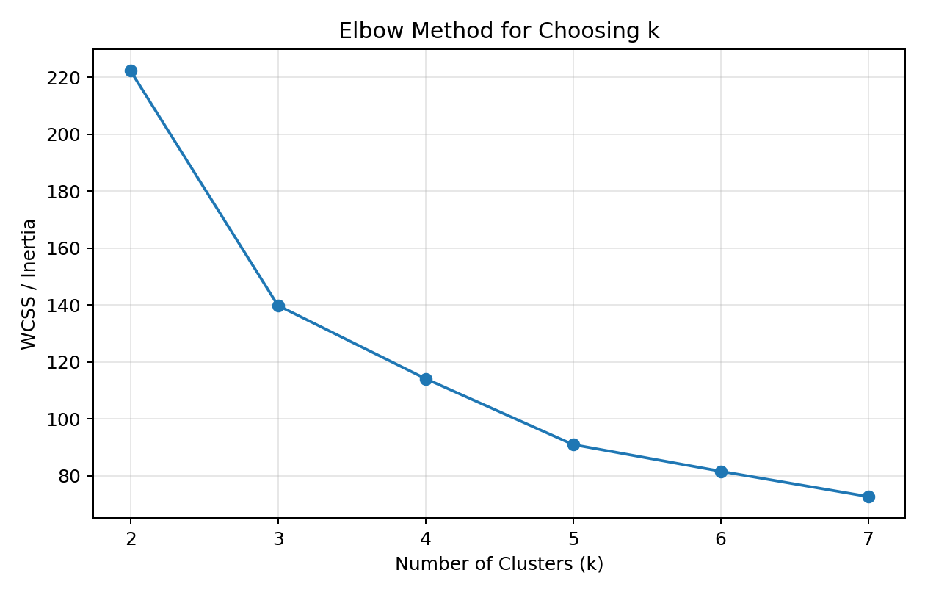
Figure 1: Elbow Method
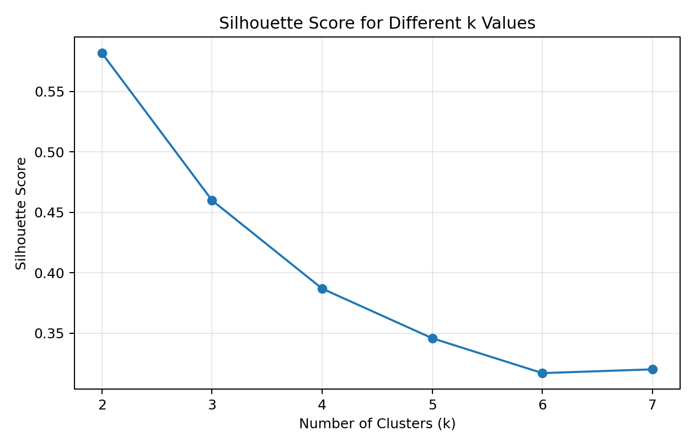
Figure 2: Silhouette Scores
k | WCSS | Silhouette Score
2 | 222.36 | 0.582
3 | 139.82 | 0.460
4 | 114.09 | 0.387
5 | 90.93 | 0.346
6 | 81.54 | 0.317
7 | 72.63 | 0.320
From the plots and the nature of the Iris data, I selected k=3. The choice also gives three reasonably interpretable groups. I treated the evaluation measures as guidance rather than assuming that one metric alone decides the answer.

9. Applying K-Means
After selecting three clusters, I fitted the final K-Means model and added the resulting cluster number to the dataset. The model grouped the 150 observations into three clusters.
The resulting cluster sizes were: Cluster 1: 53 observations, Cluster 2: 50 observations, Cluster 3: 47 observations.

10. Cluster Visualization
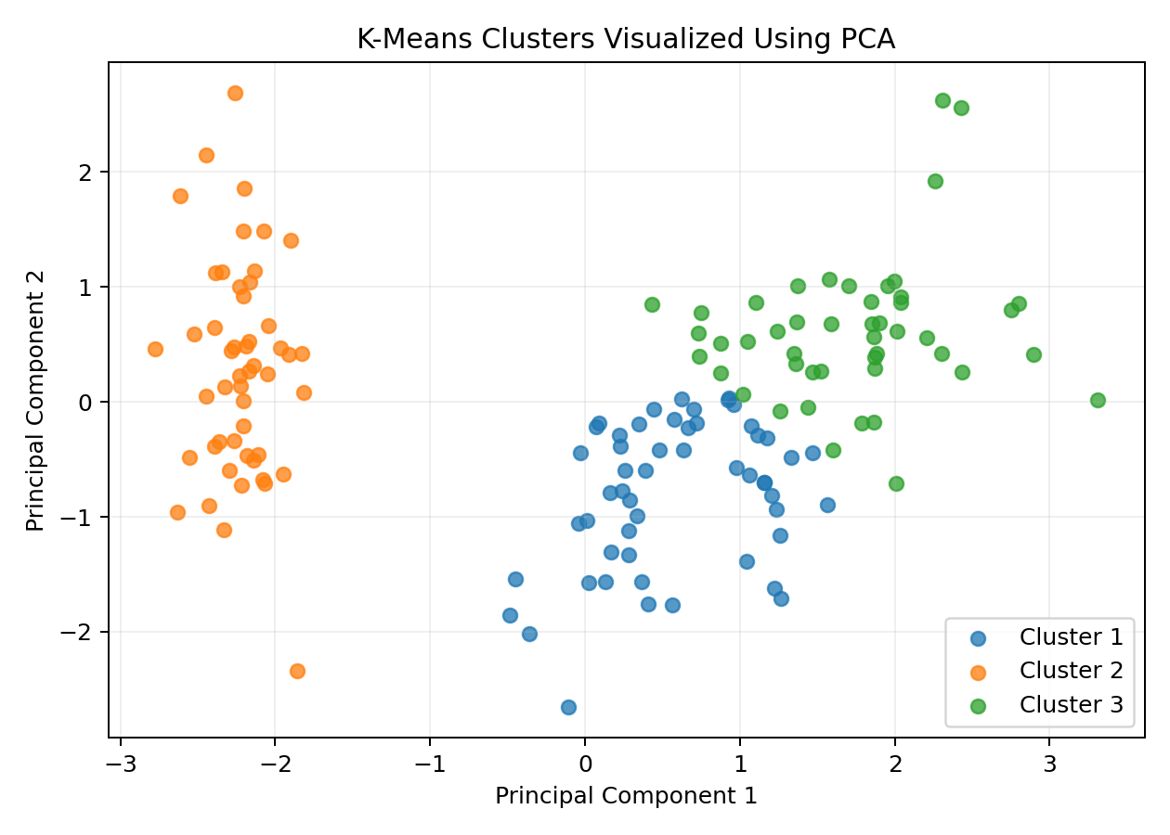
Figure 3: Cluster visualization after reducing the four scaled features to two PCA components
PCA was used only for visualization. The K-Means model itself was trained using all four standardized measurements.

11. Cluster Analysis
Cluster | Size | sepal length | sepal width | petal length | petal width
1 | 53 | 5.80 | 2.67 | 4.37 | 1.41
2 | 50 | 5.01 | 3.43 | 1.46 | 0.25
3 | 47 | 6.78 | 3.10 | 5.51 | 1.97
The table shows the average feature values for each cluster. I used these averages to understand how the groups differ. The clusters mainly differ because of the combination of sepal and petal measurements. In general, clusters with larger petal measurements represent flowers that are different from the group with smaller petals.
It is important to remember that the cluster numbers themselves do not have a natural meaning. For example, Cluster 1 is not automatically 'better' than Cluster 2. The numbers are simply labels assigned by the algorithm.

12. Business or Research Implications
Although Iris is mainly an educational dataset, the same clustering idea can be used in real applications. For example, a business can group customers according to buying behavior, a researcher can group samples according to measurements, or a company can group products according to similar characteristics.
The main benefit is that clustering can reveal groups without requiring a predefined target label. After finding the groups, a domain expert can study what makes each group different and decide how the information should be used.

13. Challenges Faced
- Understanding why clustering is used when there is no target variable.
- Understanding why feature scaling is important for distance-based algorithms.
- Choosing a suitable number of clusters instead of selecting k randomly.
- Understanding that cluster labels are only identifiers and do not represent classes by themselves.
- Interpreting the clusters using average feature values instead of only looking at a graph.

14. What I Learned
Through this task, I learned the basic working of unsupervised learning and K-Means clustering. I also learned how preprocessing can affect a machine learning algorithm, how to use the Elbow Method and Silhouette Score, and how to make a clustering result easier to understand using visualization. This was useful for understanding the practical side of machine learning instead of only studying the theory.

15. Conclusion
In this project, I applied K-Means clustering to the public Iris dataset. I first explored the data, selected the numerical measurements, standardized the features, and tested different values of k. Based on the Elbow Method and the practical interpretability of the groups, I selected three clusters.
The final clustering showed that the observations could be separated into groups with different measurement patterns. The project helped me understand how unsupervised learning can be used to discover structure in data when there is no target variable. It also gave me practical experience with Python, Scikit-learn, preprocessing, evaluation, and visualization.

16. Complete Python Code
import pandas as pd
import matplotlib.pyplot as plt
from sklearn.datasets import load_iris
from sklearn.preprocessing import StandardScaler
from sklearn.cluster import KMeans
from sklearn.metrics import silhouette_score
from sklearn.decomposition import PCA
# Load dataset
iris = load_iris(as_frame=True)
df = iris.frame
features = iris.feature_names
X = df[features]
# Scale the data
scaler = StandardScaler()
X_scaled = scaler.fit_transform(X)
# Test different numbers of clusters
inertias = []
silhouette_scores = []
for k in range(2, 8):
model = KMeans(n_clusters=k, random_state=42, n_init=10)
labels = model.fit_predict(X_scaled)
inertias.append(model.inertia_)
silhouette_scores.append(
silhouette_score(X_scaled, labels)
)
# Final K-Means model
kmeans = KMeans(
n_clusters=3,
random_state=42,
n_init=10
)
df["Cluster"] = kmeans.fit_predict(X_scaled) + 1
# Cluster summary
print(df.groupby("Cluster")[features].mean())
# PCA visualization
pca = PCA(n_components=2)
X_pca = pca.fit_transform(X_scaled)
plt.scatter(X_pca[:, 0], X_pca[:, 1], c=df["Cluster"])
plt.xlabel("Principal Component 1")
plt.ylabel("Principal Component 2")
plt.title("K-Means Clusters")
plt.show()

17. References
1. Scikit-learn, Iris plants dataset documentation.
2. Scikit-learn, KMeans clustering documentation.
3. Scikit-learn, StandardScaler documentation.
4. Scikit-learn, silhouette_score documentation.

