WEEK 4 TASK
Supervised Learning Model Implementation
Project: Iris Flower Classification Using Logistic Regression
Beginner / Fresher-Level Machine Learning Project

1. Introduction
Supervised learning is a type of machine learning where a model learns from data that already has known output labels. The model uses the relationship between input features and the known output to make predictions for new data.
For this project, I selected a classification problem using the Iris dataset. The goal is to predict the species of an Iris flower based on its sepal and petal measurements. I used Logistic Regression as the main machine learning model.

2. Problem Statement
The problem is to classify an Iris flower into one of three species: setosa, versicolor, or virginica. The prediction is based on four numerical features: sepal length, sepal width, petal length, and petal width.

3. Objectives
- Understand the basic workflow of supervised machine learning.
- Use a publicly available dataset for a classification problem.
- Explore and preprocess the dataset.
- Split the data into training and testing sets.
- Build a Logistic Regression classification model.
- Validate the model using 5-fold cross-validation.
- Evaluate the model using accuracy, precision, recall, F1-score, and a confusion matrix.
- Understand the strengths and limitations of the selected model.

4. Dataset Description
The Iris dataset is a commonly used public dataset available through Scikit-learn. It contains 150 observations and four numerical input features. There are three flower species, with 50 observations for each species.
Feature | Description | Type
Sepal length (cm) | Length of the sepal | Numerical
Sepal width (cm) | Width of the sepal | Numerical
Petal length (cm) | Length of the petal | Numerical
Petal width (cm) | Width of the petal | Numerical
The target variable contains three classes: setosa, versicolor, and virginica.

5. Tools and Technologies
Python was used for the complete analysis. Pandas was used for data handling, NumPy for numerical operations, Matplotlib for visualization, and Scikit-learn for preprocessing, model training, cross-validation, and evaluation.

6. Data Exploration
I first loaded the dataset and checked its shape, columns, basic statistics, and missing values. The dataset contains 150 rows and 4 input features. There were no missing values in the features used for the model.
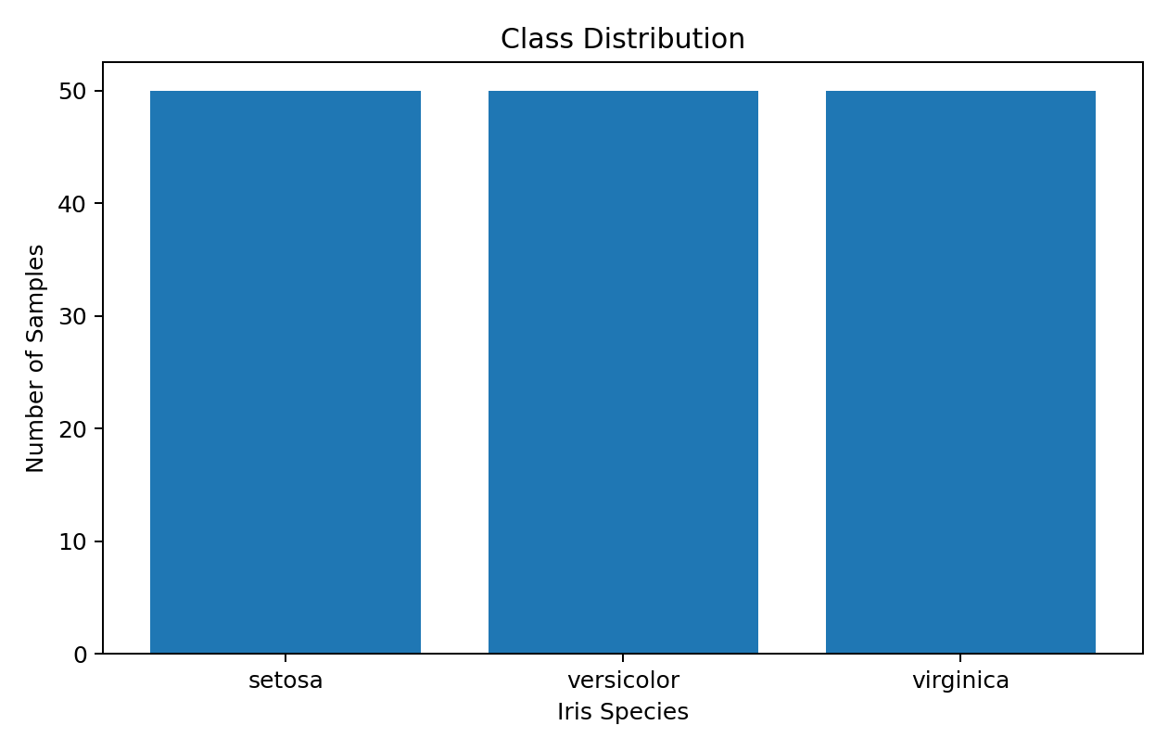
Figure 1: Distribution of the three Iris classes

7. Data Preprocessing
The features are numerical, so categorical encoding was not required. I divided the data into 80% training data and 20% testing data. I also used StandardScaler to standardize the input features. Scaling was included before Logistic Regression because the features have different ranges.

8. Feature Engineering
For this beginner-level project, I did not create complicated new features. I used the four original flower measurements because they already contain useful information for classification. Standardization was the main preprocessing step.

9. Model Selection
I selected Logistic Regression because it is a simple and commonly used classification algorithm. It is relatively easy to understand and provides a good starting point for a beginner. The model can classify observations into multiple classes and works well with numerical features.

10. Model Training
from sklearn.pipeline import Pipeline
from sklearn.preprocessing import StandardScaler
from sklearn.linear_model import LogisticRegression
model = Pipeline([
("scaler", StandardScaler()),
("logistic_regression", LogisticRegression(
max_iter=200,
random_state=42
))
])
model.fit(X_train, y_train)
y_pred = model.predict(X_test)
I used a Pipeline so that scaling is performed correctly before the model makes predictions. The model was trained only on the training data.

11. Cross-Validation
To check whether the model performs consistently, I used 5-fold cross-validation. The data was divided into five parts. The model was trained and tested multiple times using different parts of the data.
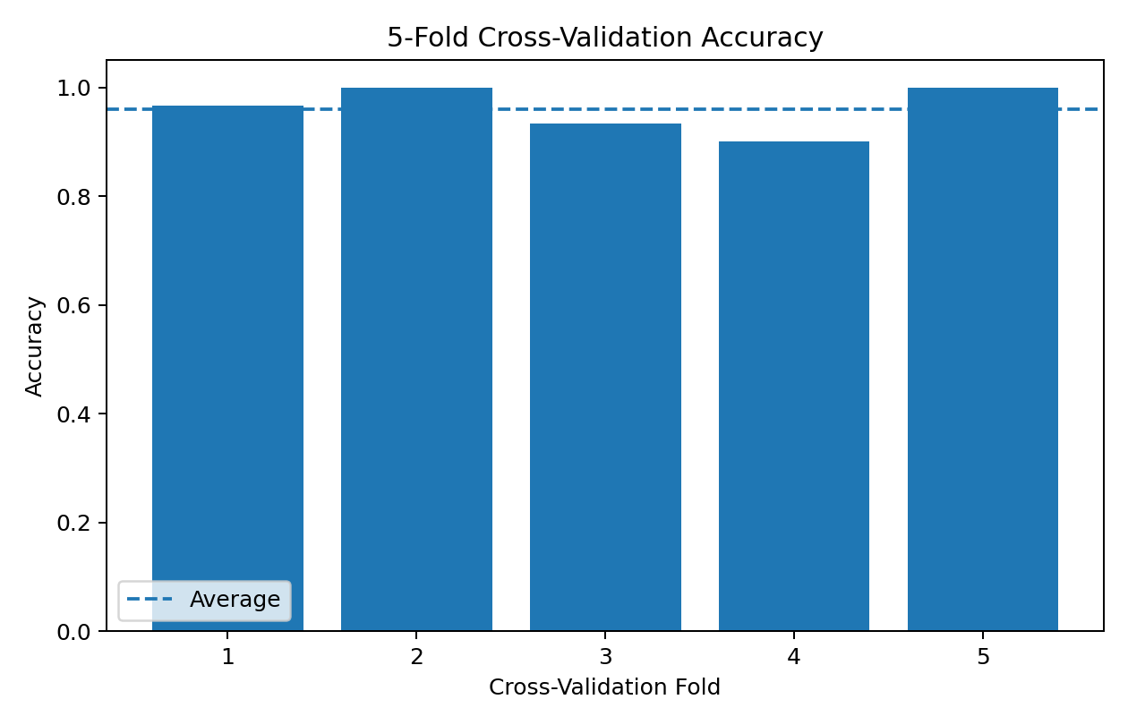
Figure 2: 5-fold cross-validation accuracy
The five cross-validation accuracy scores were: 0.967, 1.000, 0.933, 0.900, 1.000. The average cross-validation accuracy was 0.960.

12. Model Evaluation
After training, I evaluated the model on the test set. I used accuracy, precision, recall, and F1-score. These metrics help give a better understanding of the model performance instead of relying on only one measurement.
Metric | Score
Accuracy | 0.933
Precision (weighted) | 0.933
Recall (weighted) | 0.933
F1-score (weighted) | 0.933
Classification Report:
precision recall f1-score support
setosa 1.00 1.00 1.00 10
versicolor 0.90 0.90 0.90 10
virginica 0.90 0.90 0.90 10
accuracy 0.93 30
macro avg 0.93 0.93 0.93 30
weighted avg 0.93 0.93 0.93 30

13. Confusion Matrix
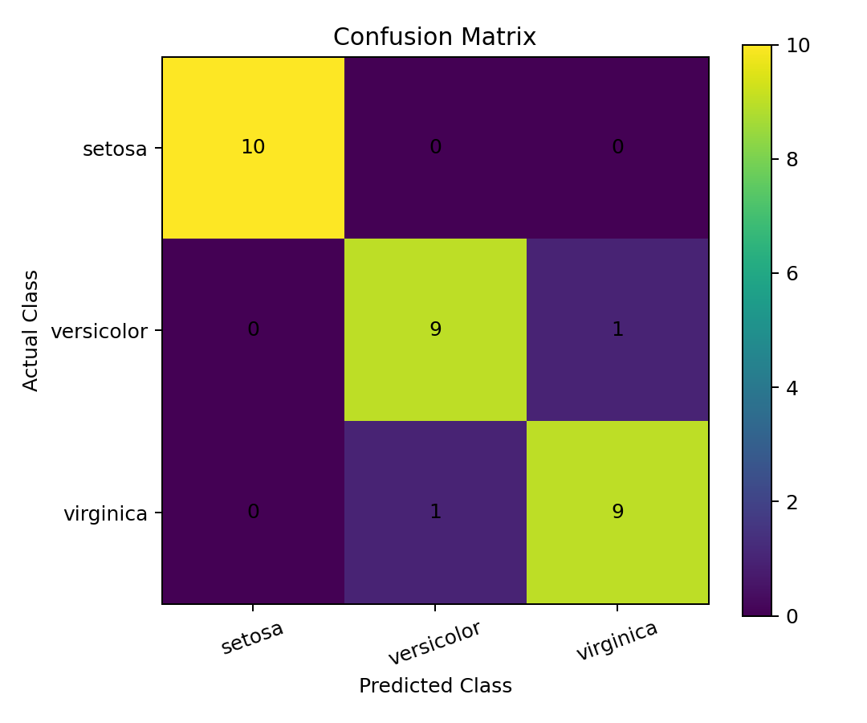
Figure 3: Confusion matrix for the test set
The confusion matrix shows the actual classes compared with the predicted classes. The diagonal values represent correctly classified observations, while values outside the diagonal represent incorrect predictions.

14. Results and Analysis
The Logistic Regression model achieved a test accuracy of 0.933 (93.3%). The cross-validation average accuracy was 0.960 (96.0%).
The results show that the model was able to classify the Iris flowers with high accuracy on this dataset. The confusion matrix can also be used to see which classes were confused with each other. Because the Iris dataset is relatively small and well structured, this result should not be treated as proof that the same performance would happen on every real-world dataset.

15. Strengths of the Model
- Logistic Regression is simple and relatively easy to understand.
- The model is fast to train on a small dataset.
- Feature scaling can be included easily using a Pipeline.
- Accuracy, precision, recall, and F1-score provide several ways to evaluate the model.
- Cross-validation helps check whether the result is reasonably consistent.

16. Limitations
- The Iris dataset is small compared with many real-world datasets.
- The features are already clean and well structured, so the project does not cover difficult data-cleaning situations.
- Logistic Regression may not perform well on every classification problem, especially when class boundaries are very complex.
- The test result can vary if a different train-test split is used.
- Good performance on this dataset does not automatically mean the model will perform equally well on new real-world data.

17. Possible Improvements
As a next step, I could compare Logistic Regression with other classification algorithms such as Decision Tree, K-Nearest Neighbors, Random Forest, or Support Vector Machine. I could also perform hyperparameter tuning and compare the cross-validation results of different models. With a larger real-world dataset, more detailed feature engineering and data cleaning would also be useful.

18. What I Learned
This project helped me understand the basic workflow of supervised machine learning. I learned how to load a dataset, separate features and target values, split data into training and testing sets, scale features, train a classification model, and evaluate its performance. I also learned why cross-validation is useful and how a confusion matrix can help explain classification results.

19. Conclusion
In this project, I built a supervised machine learning classification model using the Iris dataset. I selected Logistic Regression because it is a simple model that is suitable for learning the basic classification workflow. I performed data preprocessing, feature scaling, train-test splitting, model training, 5-fold cross-validation, and model evaluation.
The final model achieved a test accuracy of 93.3% and an average 5-fold cross-validation accuracy of 96.0%. The results show that the model worked well on this dataset. More importantly, the project gave me practical experience with Python, Scikit-learn, supervised learning, evaluation metrics, and model validation.

20. Complete Python Code
# Week 4 Task - Supervised Learning
# Iris Flower Classification using Logistic Regression
import pandas as pd
import matplotlib.pyplot as plt
from sklearn.datasets import load_iris
from sklearn.model_selection import train_test_split, cross_val_score
from sklearn.preprocessing import StandardScaler
from sklearn.linear_model import LogisticRegression
from sklearn.pipeline import Pipeline
from sklearn.metrics import (
accuracy_score,
precision_score,
recall_score,
f1_score,
confusion_matrix,
classification_report
)
# Load dataset
iris = load_iris()
data = pd.DataFrame(
iris.data,
columns=iris.feature_names
)
data["target"] = iris.target
print("First five rows:")
print(data.head())
print("\nDataset shape:")
print(data.shape)
print("\nMissing values:")
print(data.isnull().sum())
# Select features and target
X = data[iris.feature_names]
y = data["target"]
# Split the dataset
X_train, X_test, y_train, y_test = train_test_split(
X,
y,
test_size=0.20,
random_state=42,
stratify=y
)
# Create model pipeline
model = Pipeline([
("scaler", StandardScaler()),
("logistic_regression", LogisticRegression(
max_iter=200,
random_state=42
))
])
# Train model
model.fit(X_train, y_train)
# Make predictions
y_pred = model.predict(X_test)
# Evaluation
accuracy = accuracy_score(y_test, y_pred)
precision = precision_score(
y_test, y_pred, average="weighted"
)
recall = recall_score(
y_test, y_pred, average="weighted"
)
f1 = f1_score(
y_test, y_pred, average="weighted"
)
print("\nModel Results")
print("Accuracy:", round(accuracy, 3))
print("Precision:", round(precision, 3))
print("Recall:", round(recall, 3))
print("F1 Score:", round(f1, 3))
# Cross-validation
cv_scores = cross_val_score(
model,
X,
y,
cv=5,
scoring="accuracy"
)
print("\nCross Validation Scores:")
print(cv_scores)
print(
"Average CV Accuracy:",
round(cv_scores.mean(), 3)
)
# Confusion matrix
cm = confusion_matrix(y_test, y_pred)
print("\nConfusion Matrix:")
print(cm)
# Classification report
print("\nClassification Report:")
print(
classification_report(
y_test,
y_pred,
target_names=iris.target_names
)
)
# Save predictions
results = X_test.copy()
results["Actual"] = [
iris.target_names[i]
for i in y_test
]
results["Predicted"] = [
iris.target_names[i]
for i in y_pred
]
results.to_csv(
"iris_classification_predictions.csv",
index=False
)
print("\nPredictions saved successfully.")
# Display confusion matrix
plt.figure(figsize=(6, 5))
plt.imshow(cm)
plt.title("Confusion Matrix")
plt.xlabel("Predicted Class")
plt.ylabel("Actual Class")
plt.xticks(
range(3),
iris.target_names,
rotation=20
)
plt.yticks(
range(3),
iris.target_names
)
for i in range(cm.shape[0]):
for j in range(cm.shape[1]):
plt.text(
j,
i,
cm[i, j],
ha="center",
va="center"
)
plt.colorbar()
plt.tight_layout()
plt.show()

21. References
1. Scikit-learn documentation – Iris dataset.
2. Scikit-learn documentation – LogisticRegression.
3. Scikit-learn documentation – StandardScaler.
4. Scikit-learn documentation – train_test_split and cross_val_score.
5. Scikit-learn documentation – Classification metrics.

