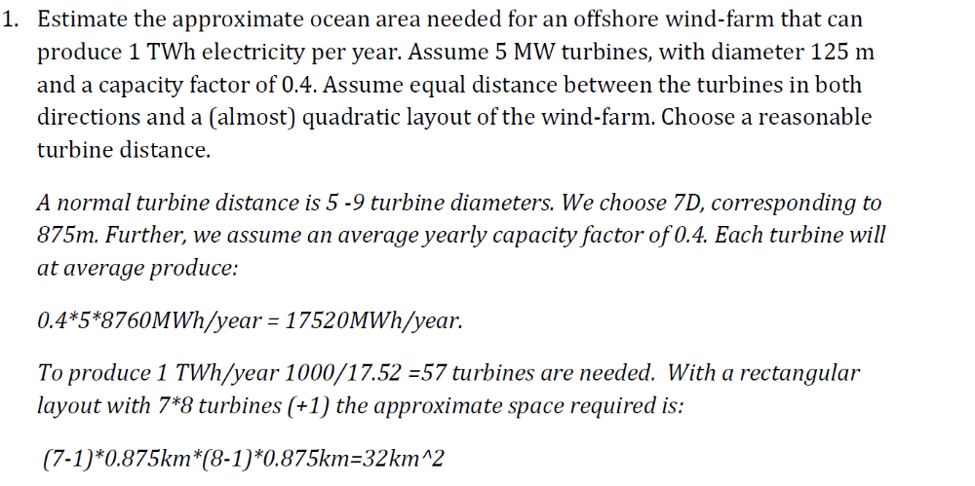
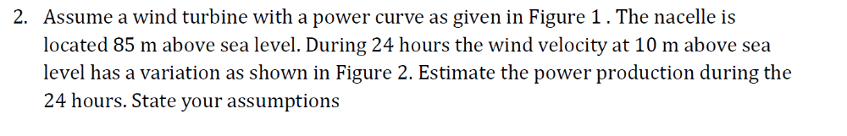
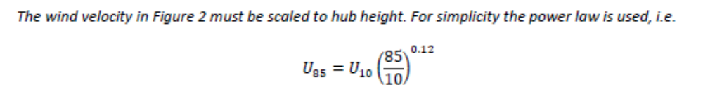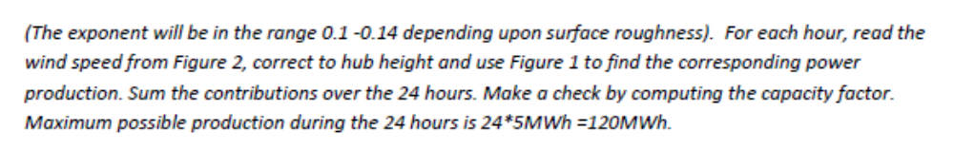
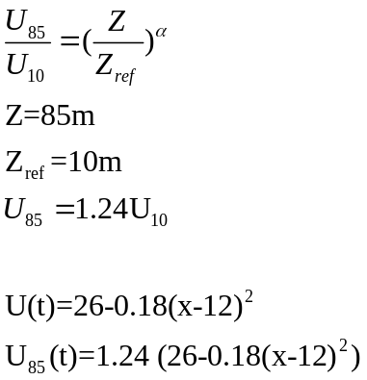

26-a(x-12)² =U(t)
a=26/144=0.18

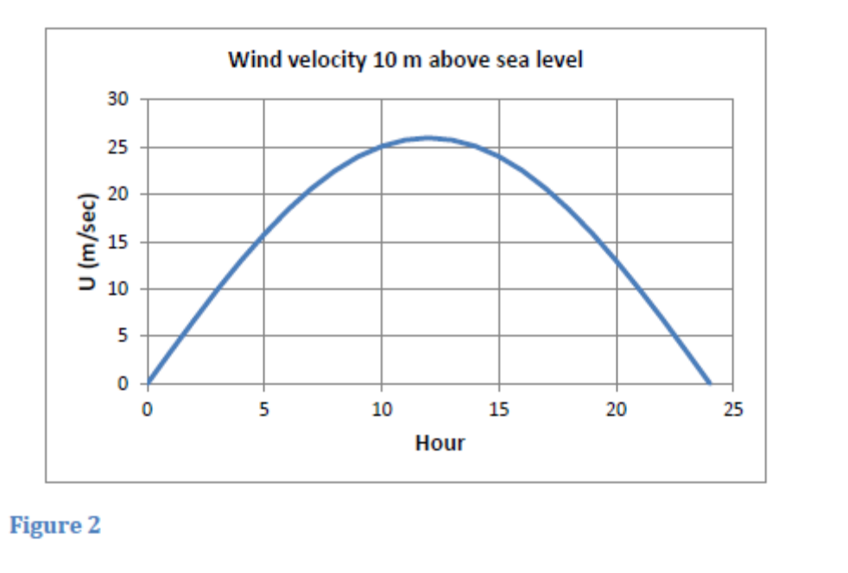
U₈₅(t)=1,24(26-0.18(x-12)²)
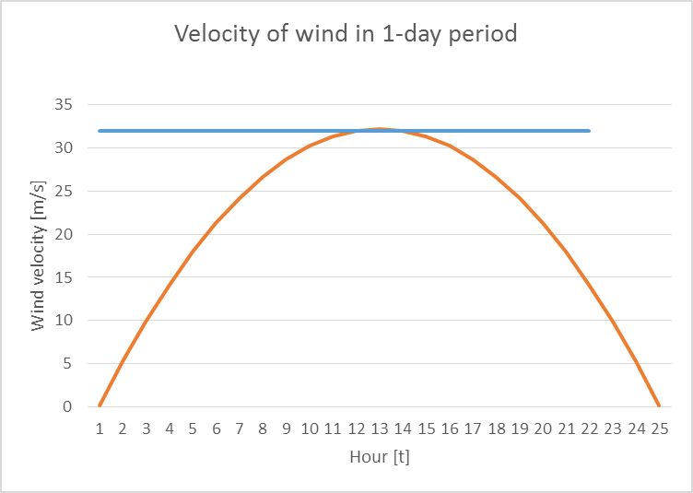

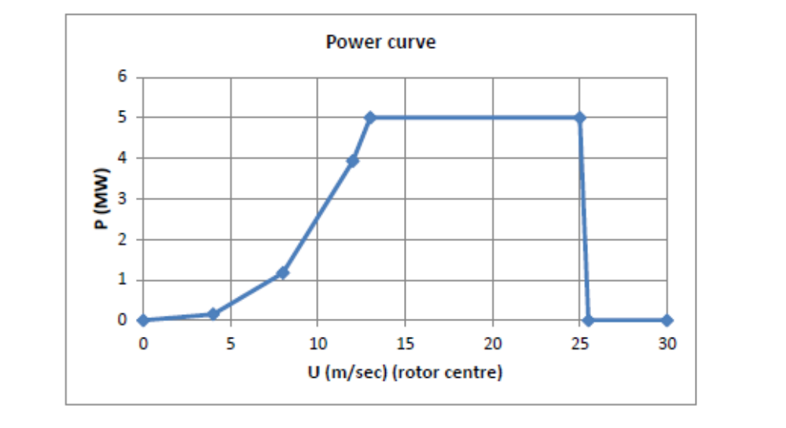

U wind velocity [m/s] | Range of Time [h]  (according to graph) | Power [MW] | Total time [h] | Total Energy [MWh]
U>26 | 8-17.2 | 0 | 0 | 0
13<U<26 | 2.7-6.8  17.2-21.3 | 5 | 8.2 | 41
8<U<13 | 1.5 – 2.7  21.3-22.54 | 3 | 2.48 | 7.2
0<U<8 | 0-1.5  22.54-24 | 0.5 | 3 | 1.5

Total Energy is 49.7 MWh

- Problem: In the file wavedat_new.dat you will find a table containing the following columns of data
Month Day Hour Minute Hmo (m) Tp (sec) Wave dir.(deg) U_10 (m/sec) Wind dir (Deg)
Here
Month is the month of the year (value 1 -12),
Day is day of the month (value 1- 31)
Hour is the hour of the day (value 0 -23),
Minute is always zero,
Hm0 is significant wave height,
Tp is wave spectrum peak period.
Wave dir is the direction of the waves (waves coming from North corresponds to zero degrees, while coming from East corresponds to 90 degrees),
U_10 is average wind velocity 10 meters above sea level (1 hour average) and
Wind dir is the average wind direction, defined similarly as the wave direction.

The table contains data for one full year. Based upon the given data you shall estimate the monthly and yearly production of a wind turbine at the given location. Assume the power curve as given in Figure 1. Take into account a nacelle height giving a clearance between the rotor and the mean sea level of 20 meters. State how you extrapolate of the wind data to the actual height of the nacelle.
We assume a rotor diameter of 125m, With a tip clearance to sea of 20m, the hub height becomes 125/2+20 = 82.5m.
Read the wind velocity at each hour of the year and correct to hub height, see problem 2. Make a simple curve fitting to the power curve in Figure 1. For each hour compute the corresponding power production. Make summation over each month of the year and the full year. Check if a reasonable capacity factor is obtained. The analysis is most easily performed by writing a Matlab script or in Excel or similar tools. Below an example of a Matlab script is used. (Note that a slightly different power curve is used in the below example.
Typical results:
Statistics of the wind velocities in the data file:
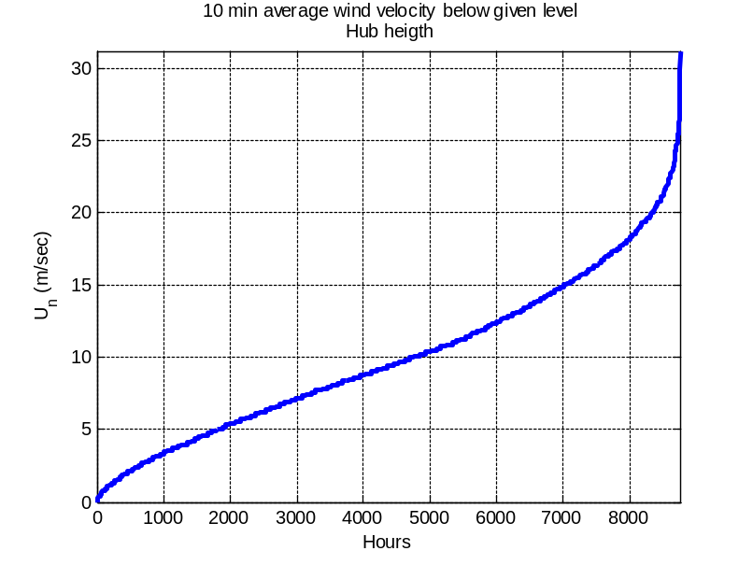
Corresponding statistics of power production:
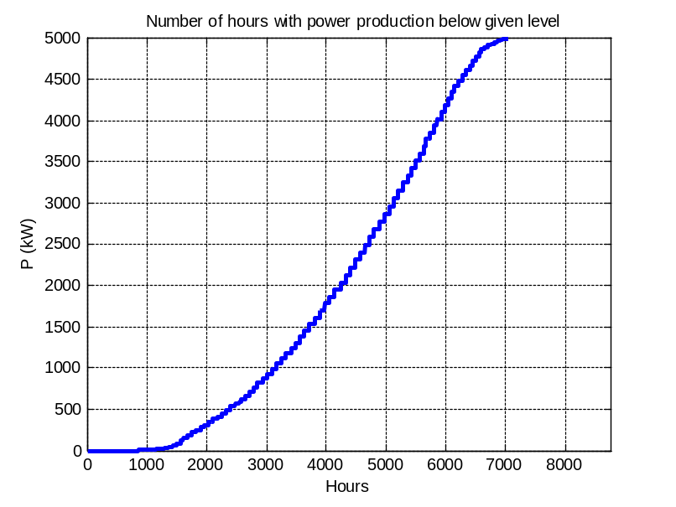
Maximum and minimum wind speed in each month:
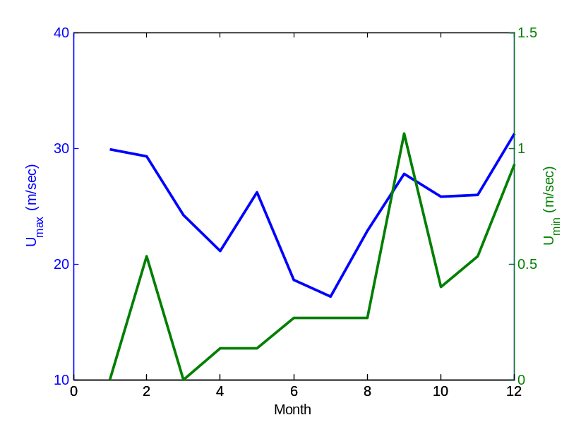
Capacity factor and mean wind velocity for each month:
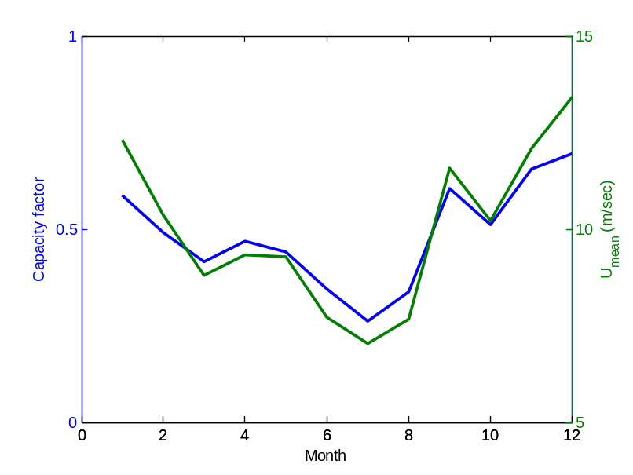
Numerical results:
yearly_production_wind
Starting date and time:
Year - month - day - hour
date_1 =
1 1 1 0
End date and time:
Year - month - day - hour
date_2 =
1 12 31 23
Number of lines skipped (U<0): 232
Capacity factor per month: Cap_mon =
0.5877 0.4912 0.4151 0.4680 0.4407 0.3459 0.2617 0.3366 0.6059 0.5116 0.6563 0.6967
Capacity factor for full year: Cap_tot = 0.4860
Average of monthly capacity factors: Mean_cap_month = 0.4848
Mean_wind_tot = 10.0043 m/sec
Average of monthly mean wind velocities: Mean_wind_mon = 9.9829 m/sec

Matlab script:
% Computes yearly production of wind power from a wind turbine.
% Turbine power curve is located in teh file power_curves.dat.
% Wave and wind data are loaded from either wavedat_new.dat.
% FGN 11.09.06
% Last revision 06.11.14

clear all;
%close all;
%clc;
format compact

% INPUT
H = 85; % Heigth of turbine axis (m)
alfa = 0.133; % Heigth exp. U= U_10*(z/10)^alfa
Start_line= 1; % First data line to use in analyses (remove heading of input file)
End_line = -1; % Last data line to use in analyses (<0: All data)

%Read power curve
load power_curve.dat; % Contains power curve for wind turbine
% This file contains data for a
% 2.5MW turbine, scale it to 5 MW

% Wind Data
winddat = load('wavedat_new.dat');

% End input
%***********************************************
%
Inp_wi = power_curve(:,1);
Inp_po = power_curve(:,2)*2; % Factor 2 to scale from 2.5 to 5 MW

scale = (H/10)^alfa; % Correction of wind velocities from 10m to H

%**********************************************************************

if End_line<0
End_line = size(winddat,1);
end
Nline0= End_line-Start_line+1;

% Assign data
month = winddat(Start_line:End_line,1);
day = winddat(Start_line:End_line,2);
clock = winddat(Start_line:End_line,3);
minute = winddat(Start_line:End_line,4);
U = winddat(Start_line:End_line,8);
Udir= winddat(Start_line:End_line,9);

% Remove invalid numbers
% Keeps samples where the wind velocity is non-negative.
U_pos_ind = find(U >= 0);
month = month(U_pos_ind);
day = day(U_pos_ind);
clock = clock(U_pos_ind);
Un = U(U_pos_ind)*scale; % Velocity in nacelle height

End_line = length(Un);
Nline= End_line-Start_line+1;
DNline = Nline0-Nline;
year= 1*ones(size(month)); % assigns all months to year 1
fclose all;

% write data interval used
tekst = [' Starting date and time:'];
disp (tekst)
tekst = [' Year - month - day - hour'];
disp (tekst)
date_1 = [year(1) month(1) day(1) clock(1)]
tekst = [' End date and time:'];
disp (tekst)
tekst = [' Year - month - day - hour'];
disp (tekst)
date_2 = [year(Nline) month(Nline) day(Nline) clock(Nline)]
tekst = ['Number of lines skipped (U<0): ', num2str(DNline)];
disp(tekst)

Start_year = year(1);
End_year = year(Nline);

% Computes production for all measured wind velocities, uses cubic interpolation:
Power = interp1(Inp_wi,Inp_po,Un,'cubic',0); % Values outside the given interval are set to zero

%Computes distribution of Power production
hour=linspace(1,8760,size(Un,1));
figure
plot(hour,sort(Un),'Linewidth',3)
grid on
axis([0 8760 0 inf]);
xlabel('Hours')
ylabel('U_n (m/sec)')
title({'10 min average wind velocity below given level';'Hub heigth'})

figure
plot(hour,sort(Power),'Linewidth',3)
grid on
axis([0 8760 0 inf]);
xlabel('Hours')
ylabel('P (kW)')
title(['Number of hours with power production below given level'])

% Production per month.
mo=1;
while mo<= 12
KK = find(month==mo);
pow = Power(KK); % power for given month,ignores NaN
uw = Un(KK); % Wind velocity for given month, ignores NaN
N_smon(mo) = size(pow,1);
Pow_mon(mo)= mean(pow);
Un_mon(mo) = mean(uw);
Un_max_mon(mo) = max(uw);
Un_min_mon(mo) = min(uw);
Un_std_mon(mo) = std(uw);
mo=mo+1;
end

%Capacity factors
%Cap_year = Pow_year./max(Inp_po)
Cap_mon = Pow_mon./max(Inp_po)
Cap_tot = mean(Power)./max(Inp_po)
Mean_cap_month = mean(Cap_mon) % Differences in these mean values reflect different length of months and the effect of missing data
Mean_wind_tot = mean(Un)
Mean_wind_mon = mean(Un_mon)

% plot results

MONTH = linspace(1,12,12);
figure
[haxes,hline1,hline2] =plotyy(MONTH,Cap_mon,MONTH,Un_mon,'plot','plot','Linewidth',2);
set(hline1,'linewidth',2)
set(hline2,'linewidth',2)
xlabel('Month');
axes(haxes(1));
ylabel('Capacity factor');
axes(haxes(2));
ylabel('U_{mean} (m/sec)');

figure
[haxes,hline1,hline2] =plotyy(MONTH,Un_max_mon,MONTH,Un_min_mon,'plot','plot');
set(hline1,'linewidth',2)
set(hline2,'linewidth',2)
xlabel('Month');
axes(haxes(1));
ylabel('U_{max} (m/sec)');
axes(haxes(2));
ylabel('U_{min} (m/sec)');

