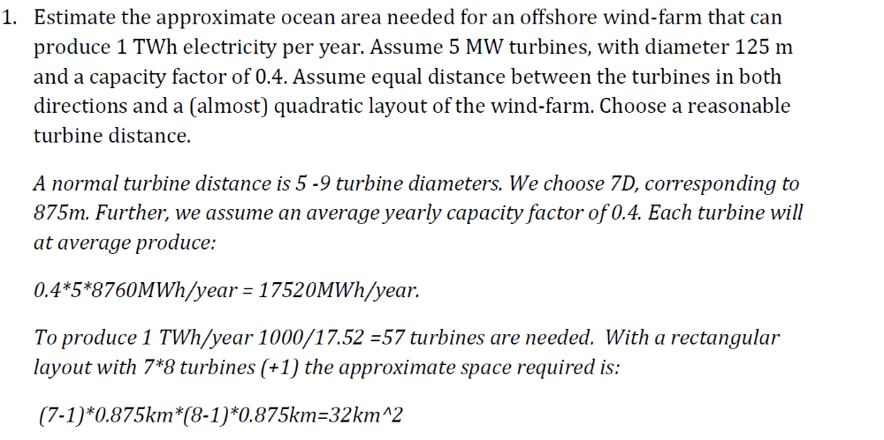
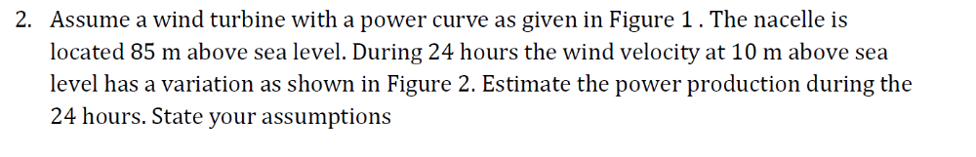
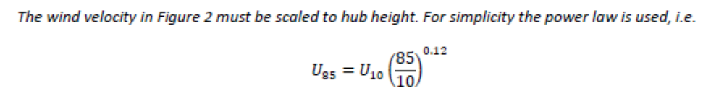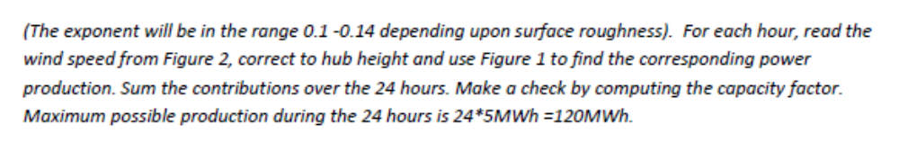
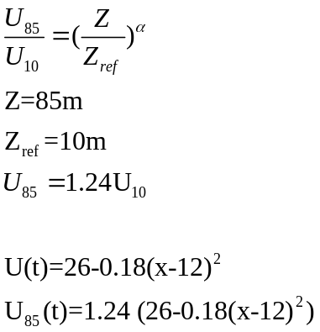

26-a(x-12)² =U(t)
a=26/144=0.18

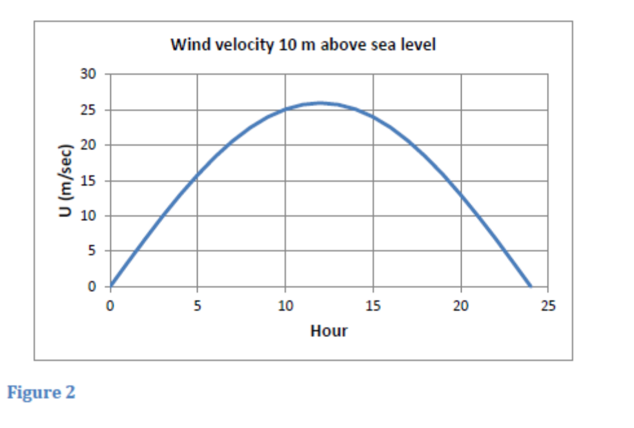
U₈₅(t)=1,24(26-0.18(x-12)²)
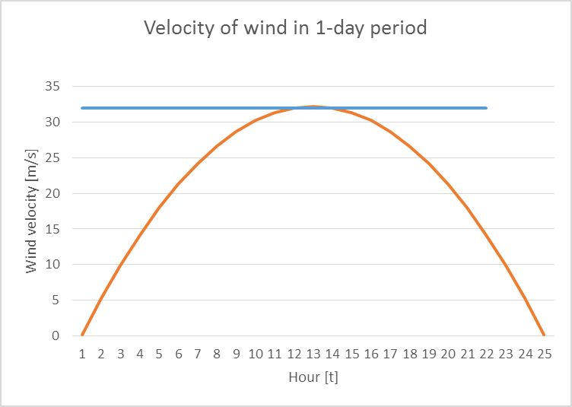

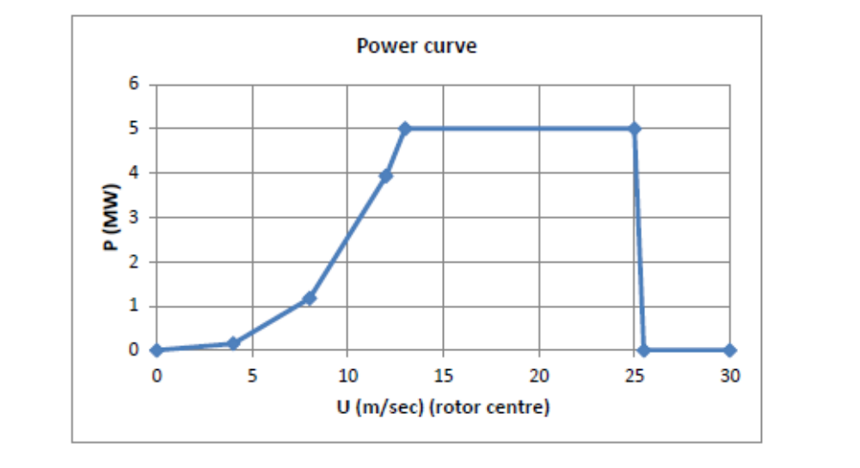

U wind velocity [m/s] | Range of Time [h]  (according to graph) | Power [MW] | Total time [h] | Total Energy [MWh]
U>26 | 8-17.2 | 0 | 0 | 0
13<U<26 | 2.7-6.8  17.2-21.3 | 5 | 8.2 | 41
8<U<13 | 1.5 – 2.7  21.3-22.54 | 3 | 2.48 | 7.2
0<U<8 | 0-1.5  22.54-24 | 0.5 | 3 | 1.5

Total Energy is 49.7 MWh

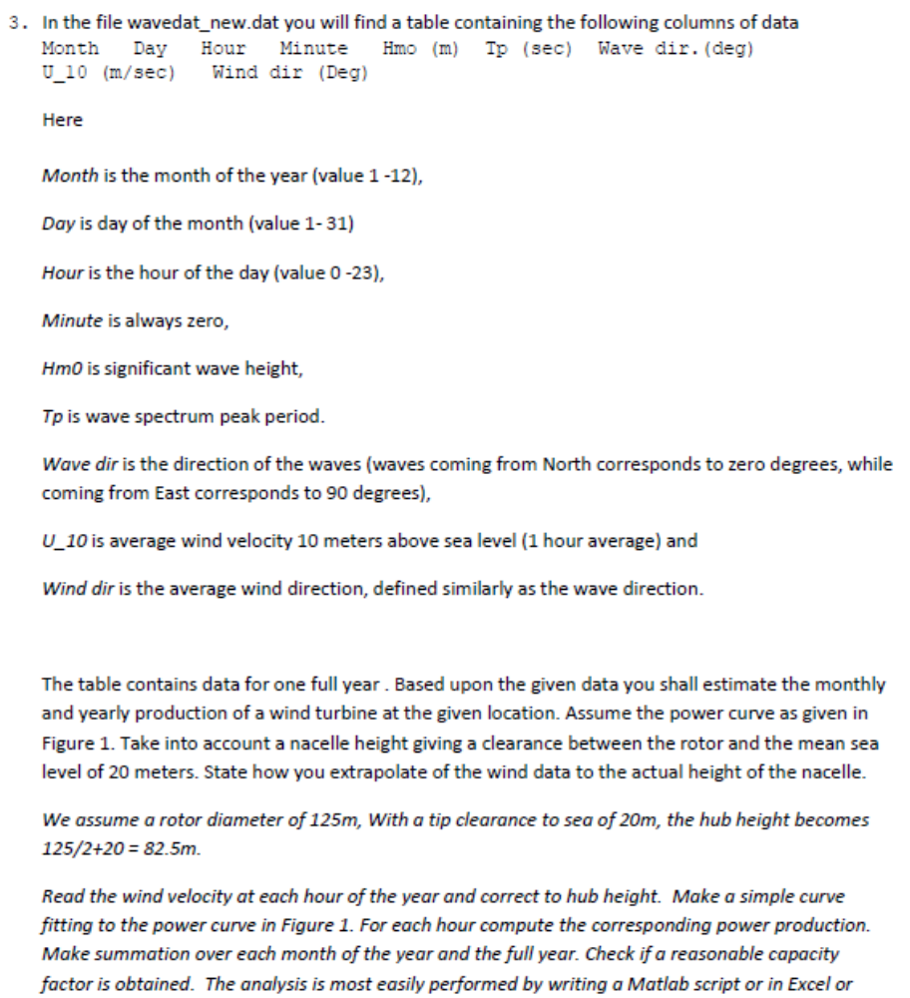

Matlab script:
clear all
load wavedat_new.dat;
data=wavedat_new;
if data<0
%file wavedat_new contains damaged data -9.99e-02!!
end
%%U_10 is average wind velocity 10 meters above sea level (1 hour average)
data(:,8)=(82.5/10)^0.12.*(data(:,8));
a=(data(:,8));
%%Velocity cannot be negative
a=a(a>0);
%%
%%Compute power for all data
ll=length(a);
for j=1:1:ll;
c = a(j);
if ((c>0.00) &&(c<=8.00))
p(j)=0.5;

elseif ((c>8.00) &&(c<=13.00))
p(j) = 3;

elseif ((c>13.00) &&(c<=26))
p(j) = 5;

elseif c(c>26)
p(j)=0;
else
p(j)=0;
end
end

figure(1)
plot(a,p,'r*');ylabel('Power [MW]');xlabel('Velocity [m/s]')
%%
m=(data(:,1));
n=length(p');
mm=max(m);
%z=0;
%%Power sumation over the months
for j=1:1:mm
for s=1:1:n
if (m(s) == j)
m01(:,j)=sum(p(s));
%z=m01(:,j);
end
end
end
%%
%%Year production in MW and Capacity of Powerhouse
year=sum(m01);%%months
Capacity = 5*12;
reasonable=year<Capacity;
year1=sum(p);%%hours
Cap1=5*365*24;
reas1=year1<Cap1;
%%
f=m01*12/Capacity;
%%

figure(2)

plot(1:12,m01');ylabel('Power [MW]');xlabel('Month');ylim([0 6]);xlim([0 13]);

%%Mean velocity over the month
j=1; s=1;
m=(data(:,1));
n=length(a);
mm=max(m);
z=1;
for j=1:1:mm
for s=1:1:n
if (m(s) == j)
m02(:,j)=(sum(a(s))/z);
z=z+1;
end
z=1;
end
end
figure(4)
plot(1:12,m02');ylabel('Mean Velocity [m/s]');xlabel('Month');xlim([0 13]);
ylim([0 20]);
%%
figure(5)
plot(1:12,f);ylabel('Capacity factor');xlabel('Month');xlim([0 13]);
ylim([0 1.1]);

