Antimicrobial resistance prediction
1. Task and study sample
This study predicts a laboratory susceptibility result at the time a culture is ordered. The final dataset has 182,487 rows from 15,952 patients and 28,498 cultures. LightGBM, weighted was selected using validation data. Its test drug-macro AUROC was 0.707.
One row is one patient, culture event, organism and candidate antibiotic. Susceptible is 1. Resistant is 0. Only observed results are used. Untested drugs have no label. Current organism identity defines the row but is excluded from predictors because it is usually unknown when the culture is ordered.
The public ARMD files come from two affiliated hospitals and use an adult cohort [1]. The release is Dryad version 403223, dated 22 October 2025 [2]. The 14 supplied files match the publisher's checksums. A fixed hash selected about 25.0% of patients before data cleaning. This is a scaled sample, not the full source cohort.
The nine candidates are ampicillin, amoxicillin/clavulanate, cefazolin, cefepime, ceftriaxone, ciprofloxacin, gentamicin, piperacillin/tazobactam, trimethoprim/sulfamethoxazole. This panel was set before model fitting. The instructor list was not supplied. It is a provisional ARMD panel, not a verified STEWARD-AW panel.
Set | Rows | Patients | Cultures | Resistant
All | 182,487 | 15,952 | 28,498 | 18.5%
Train | 109,021 | 9,602 | 17,023 | 18.7%
Validation | 36,291 | 3,147 | 5,659 | 17.8%
Test | 37,175 | 3,203 | 5,816 | 18.4%

There are 31,708 organism-events. Each has a mean of 5.76 tested candidates, a median of 7.0, and a range of 1 to 9. The final key has 0 duplicates.
Shifted order dates run from 2007-10-09 to 2024-01-24. ARMD shifts dates separately for each patient. This range is not the true calendar span. Cross-patient calendar order cannot be recovered [1a].

Data preparation
2. Labels, joins and missing values
The pipeline scanned 2,241,050 cohort rows and selected 560,188 by patient. After key, date, candidate and culture checks, 188,489 target rows entered label review.
Matching S results or matching R results were collapsed. Label review rejected 5,031 keys: 4,484 with an unsupported or missing result, and 547 with conflicting S and R results. It collapsed 0 extra agreeing rows. Untested, intermediate and unknown results were not used as labels.
The pipeline removed 0 events with conflicting dates or culture descriptions. Repeated support values had to agree; conflicts became missing. Each support table had one row per intended join key. Joins had to preserve cohort row counts. Missing age was retained under ARMD's adult inclusion rule; explicit under-18 bands were excluded.
The model uses 15 predictors: candidate, culture type, age band, anonymous gender code, four ward flags and 7 numeric summaries. The extra summaries cover laboratory tests, vital signs and prior antibiotic or resistance records. The dictionary gives each field's source, timing rule and missing-value rule.
The source defines laboratory summaries over the prior 14 days and vital signs over the prior 48 hours [1a]. Separate result-release times are absent, so availability at order cannot be checked for each measurement. Values retain source units. Prior history uses only the positive, strictly earlier day differences defined in the feature contract. No linked history means unknown, not no history.
Predictor with most missing values | Missing | Share
Days since prior resistance to candidate | 161,779 | 88.7%
Antibiotic classes recorded in prior 90 days | 118,912 | 65.2%
White blood cell count, prior 14 days | 104,942 | 57.5%
Creatinine, prior 14 days | 103,830 | 56.9%
Temperature, prior 48 hours | 64,179 | 35.2%
Heart rate, prior 48 hours | 52,779 | 28.9%
Days since prior antibiotic exposure | 52,354 | 28.7%

Missing categories receive their own code. Numeric gaps use medians learned from model-fitting patients, with separate flags for missing values. Scaling also uses only those patients. Fields with no fitting values are handled by the saved preprocessing contract. The analytical file keeps the original gaps. Missing values never become a measured zero.
Only ARMD was supplied. The harmonization matrix records the ARMD mapping and marks other dataset mappings as unavailable. These features are a proposed shared set, not a tested intersection of several datasets.

Model fitting and evaluation
3. Keep training and testing separate
A separate patient hash assigned about 60% to training, 20% to validation and 20% to testing (seed 42). All rows from a patient stay together. The audit found 0 patients shared across these sets. Patient codes, event codes, shifted dates, current organism and current susceptibility details are excluded from predictors.
Within training, 7,681 patients fit the models and 1,921 different patients fit sigmoid probability calibration [3]. Categories, medians, scaling and class weights use only the model-fitting subset. Validation and test data were not rebalanced.
Logistic regression and LightGBM [4] were each fitted with and without balanced class weights. Two baselines predict the training susceptible share, either overall or for each drug. Model settings were fixed in advance. Weighted fitting gives each class the same total training weight; it does not add synthetic rows.
Validation selected the learned model with the highest mean resistant average precision across drugs, using lower Brier score to break ties. Each model's threshold maximized validation balanced accuracy. These choices were frozen before test scoring. Calibration used only the held-out training subset, not validation or test labels.
Overall, 18.5% of labels are resistant; resistant is the smaller class. The table shows each drug's class balance. R means resistant and S means susceptible.
Candidate | Rows | Resistant | Minority
amoxicillin/clavulanate | 13,044 | 14.5% | R
ampicillin | 23,111 | 49.3% | R
cefazolin | 20,514 | 20.5% | R
cefepime | 9,095 | 6.9% | R
ceftriaxone | 17,763 | 11.0% | R
ciprofloxacin | 26,630 | 19.2% | R
gentamicin | 25,871 | 8.8% | R
piperacillin/tazobactam | 20,821 | 2.6% | R
trimethoprim/sulfamethoxazole | 25,638 | 22.2% | R

AUROC measures score ranking: 0.5 is chance and 1 is perfect. Drug-macro AUROC averages it across drugs with both classes. Macro AUPRC averages susceptible and resistant average precision within each drug, then across drugs. AUPRC here means average precision, not trapezoidal area. Balanced accuracy averages the two class recalls. Resistant precision measures how often a resistance alert is correct; resistant recall measures how much resistance is found. Lower Brier score means less probability error.

Test results
4. Ranking, resistance detection and calibration
Test model | Macro  AUROC | Macro  AUPRC | Balanced  accuracy | R  precision | R  recall | Brier
Overall baseline | 0.500 | 0.500 | 0.500 | 0.000 | 0.000 | 0.150
Drug baseline | 0.500 | 0.500 | 0.654 | 0.272 | 0.776 | 0.133
Logistic | 0.698 | 0.617 | 0.720 | 0.342 | 0.776 | 0.122
Logistic, weighted | 0.698 | 0.617 | 0.720 | 0.350 | 0.757 | 0.123
LightGBM | 0.706 | 0.637 | 0.730 | 0.381 | 0.723 | 0.118
LightGBM, weighted * | 0.707 | 0.636 | 0.730 | 0.377 | 0.732 | 0.118

The drug baseline can help overall decisions because drugs have different resistance rates. It cannot rank patients within a drug, so its drug-macro AUROC is 0.5.
* Selected using validation data. All 9 test drugs have both classes. At its validation-set threshold of 0.812, LightGBM, weighted found 73.2% of resistant results; 37.7% of its resistance alerts were correct. Its mean resistant AUPRC across drugs was 0.381.
The selected model's drug-macro AUROC was 0.707 (95% interval 0.682 to 0.722). Its Brier score was 0.118 (95% interval 0.114 to 0.123). The intervals resample patients 200 times, keeping all rows for each sampled patient together. They measure uncertainty in this test sample with fitted models held fixed.
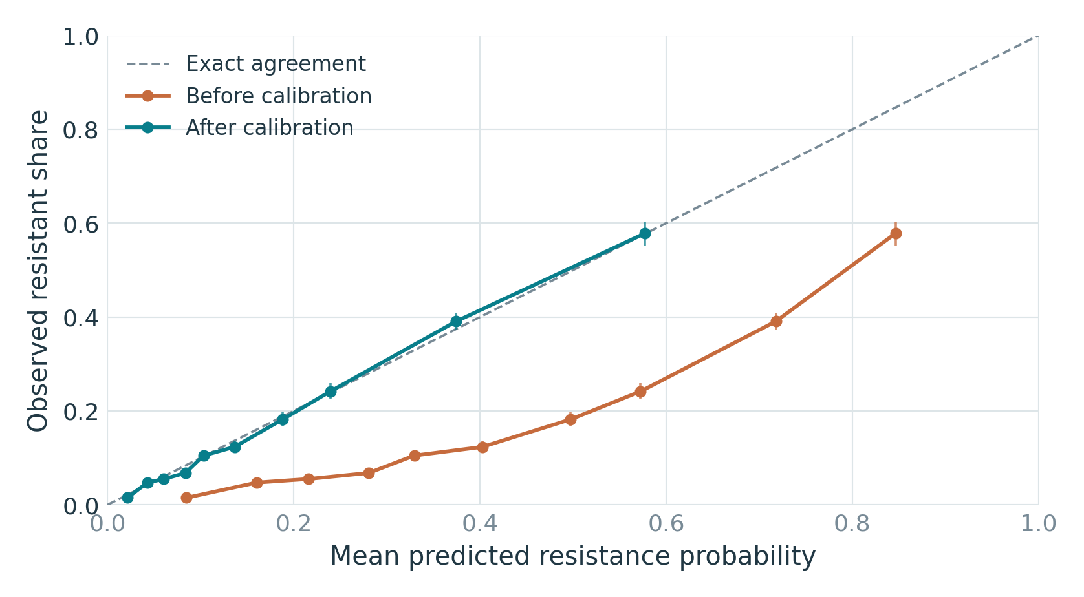
Figure 1. Selected model before and after training-only calibration. Points compare predicted resistance with the observed resistant share. Bin edges were set on validation. Lines show 95% intervals from 500 patient bootstrap samples. This follow-up check did not change test predictions.
For the selected model, test Brier score was 0.1791 before calibration and 0.1182 after calibration. Brier score reflects both ranking and calibration, so this comparison alone does not prove better calibration [3].

What the results mean
5. Differences and limits
Selected model by test drug | Rows | R share | AUROC | R AUPRC
amoxicillin/clavulanate | 2,615 | 14.3% | 0.675 | 0.295
ampicillin | 4,637 | 49.1% | 0.640 | 0.662
cefazolin | 4,118 | 20.2% | 0.722 | 0.453
cefepime | 1,907 | 7.7% | 0.851 | 0.479
ceftriaxone | 3,541 | 11.4% | 0.750 | 0.376
ciprofloxacin | 5,493 | 18.7% | 0.745 | 0.474
gentamicin | 5,327 | 9.3% | 0.712 | 0.322
piperacillin/tazobactam | 4,298 | 2.5% | 0.653 | 0.048
trimethoprim/sulfamethoxazole | 5,239 | 22.2% | 0.612 | 0.323

Compared with unweighted logistic regression, the selected model's drug-macro AUROC difference was 0.009 (paired 95% interval 0.001 to 0.014). The same patient samples were used for both models. This estimates their difference in this test set, not in a new hospital.
Further checks are in advanced_analysis.pdf. At the original cutoff, all 4,637 ampicillin rows were flagged, including 2,361 false alerts. All 108 resistant piperacillin/tazobactam rows were missed. An overall recall score hides these drug differences.
On validation, adding prior history to the basic fields raised mean resistant AP from 0.250 to 0.375. Using all features scored 0.373. The paired interval showed no clear added gain from these lab and vital summaries. These follow-up comparisons used fixed model settings. They did not select a new model or change the original test results.
Independent dataset or hospital validation was not possible. The supplied ARMD files do not identify the two hospitals separately. Ward and culture groups cannot replace an outside-site test. Patient separation also does not test future years, since calendar dates are shifted.
Labels cover tested drugs with clear results. Testing choices may depend on the patient, organism and laboratory rules. Results may differ for untested drugs. Excluding intermediate or conflicting labels also changes the sample.
The current organism is unknown at culture order. Different organisms in one culture can have the same inputs but different outcomes. Exact feature release times and some units are also unavailable. These results do not measure treatment benefit.
The next checks are to confirm the instructor's drug list, obtain a hospital field or second dataset, and verify feature release times and units. The code can rerun the study when these inputs are available.

References and file guide
Outside the five-page report body
[1] Nateghi Haredasht, F., et al. Antibiotic Resistance Microbiology Dataset (ARMD): A Resource for Antimicrobial Resistance from EHRs. Scientific Data (2025).
https://www.nature.com/articles/s41597-025-05649-7
[1a] ARMD author manuscript. Source windows and date shifts.
https://arxiv.org/pdf/2503.07664
[2] Antibiotic Resistance Microbiology Dataset. Dryad. Version 403223 (22 October 2025).
https://datadryad.org/dataset/doi:10.5061/dryad.jq2bvq8kp
[3] scikit-learn. Probability calibration documentation.
https://scikit-learn.org/stable/modules/calibration.html
[4] LightGBM. Model parameter documentation.
https://lightgbm.readthedocs.io/en/stable/Parameters.html
[5] National Archives. Top 10 Principles for Plain Language.
https://www.archives.gov/open/plain-writing/10-principles.html
[6] University of Southern California Libraries. Generative AI and Writing.
https://libguides.usc.edu/writingguide/AIwriting
Sources checked on 12 October 2026. The writing follows the plain-language advice in [5]. The review of AI writing problems in [6] informed checks for invented facts, false citations and unsupported claims. Every reported number is loaded from the pipeline outputs. The report uses short sentences and no em dashes.
This analysis and report were prepared with AI assistance. The data are public, de-identified ARMD records. Software checks and saved output tables support review; they do not replace review of the study design.
File or folder | Purpose
report.pdf / report.docx | Page-controlled report and editable copy
docs/feature_harmonization_matrix.xlsx | Field mapping, dictionary, source decisions, target list
results/construction_audit.json | Row exclusions, label decisions, joins and leakage checks
results/cohort_summary.csv; missingness.csv | Cohort counts, candidate depth, dates and missing values
results/models/ | Full metrics, subgroups, intervals, predictions and fitted models
advanced_analysis.pdf / .html | Exploratory appendix and figure gallery
results/advanced/ | Extra results, workbook and editable figures
docs/methods.html; README.txt | Detailed method and commands to repeat the run

