ABSTRACT
This assignment presents the logical design of a Flood Alert and Community Reporting System intended to support the collection and organization of flood-related reports from residents and community coordinators in Freetown, Sierra Leone. The project addresses the challenge of receiving community information in different forms and organizing it consistently for review. The proposed design accepts a reporter role, location, water-level category and road condition. It validates the entries, applies illustrative decision rules, displays a caution message and organizes the report for coordinator review. The assignment demonstrates computational thinking, algorithm design, pseudocode, a flowchart, variables, data types, Boolean logic, decision structures, repetition structures, functions and modular design. It also discusses Sustainable Development Goals, Open Source Software, Digital Public Goods and potential community impact. This is a logical design rather than a completed software application. The example alert rules are not official flood-warning criteria and would require appropriate expert review, testing, privacy safeguards and validation before real-world use.
Keywords: flood reporting, Freetown, algorithm, pseudocode, flowchart, computational thinking, community preparedness.

TABLE OF CONTENTS
Abstract | 1
1.0 Introduction and Background | 3
2.0 Problem Analysis and Community Relevance | 4
3.0 Proposed Solution and Scope | 5
4.0 Computational Thinking Process | 6
5.0 Algorithm Design | 7
6.0 Pseudocode | 8
7.0 Flowchart | 9
8.0 Logical Design: Inputs, Processing and Outputs | 10
9.0 Variables, Constants and Data Types | 11
10.0 Decision Structures and Boolean Logic | 12
11.0 Repetition Structures | 13
12.0 Functions and Modular Design | 14
13.0 Expected Outputs and Test Cases | 15
14.0 Sustainable Development Goals | 16
15.0 Open Source Software | 17
16.0 Digital Public Goods | 18
17.0 Sierra Leone Community Impact | 19
18.0 Limitations and Future Improvements | 20
19.0 Conclusion | 21
References  GitHub Repository Link | 22  23
Appendix A: GitHub and README Evidence | 24

1.0 INTRODUCTION AND BACKGROUND

1.1 Background
Communities in Sierra Leone may face challenges associated with flooding, including disruption to movement, homes, businesses and access to services. When residents observe flooding or blocked roads, useful information may be communicated through different channels. If reports are incomplete, inconsistent or difficult to organize, it can be harder for community coordinators to review them efficiently.
Information technology can help structure how reports are submitted and categorized. Before a computer program is developed, its logic should be planned through problem analysis, algorithms, pseudocode and flowcharts. This assignment therefore focuses on designing how a proposed system should behave rather than writing executable source code.

1.2 Aim
The aim is to design a logical system for collecting, checking, classifying and organizing community flood reports in Freetown so that residents and community coordinators can review the information in a consistent format.

1.3 Objectives
- Identify the community problem and the people affected.
- Define the information needed for a flood report.
- Design a step-by-step algorithm and pseudocode.
- Represent the process using a clearly labelled, coloured flowchart.
- Demonstrate input, processing, output, decisions, Boolean logic, repetition, functions and modules.
- Show expected system behaviour through sample scenarios and test cases.
- Explain possible links to SDGs, Open Source Software and Digital Public Goods.

2.0 PROBLEM ANALYSIS AND COMMUNITY RELEVANCE

2.1 Problem Description
The problem addressed is the difficulty of collecting and organizing flood-related information from community members in a consistent way. Residents may observe rising water, difficult road access or blocked roads. Community coordinators need a structured way to receive these reports and review the details.

2.2 Who Is Affected?
- Residents who need to report flood-related conditions in their communities.
- Community coordinators who receive and review reports.
- Other community members who may benefit from better organized local information.

2.3 Why the Problem Exists
Reports may be shared verbally or through different communication channels, and details may be missing or described inconsistently. Without a shared structure, it can be difficult to compare reports or identify which entries need follow-up. This assignment does not claim that all communities in Freetown experience these issues in the same way; it uses them as the problem scenario for the proposed design.

2.4 Background and Rationale
A structured reporting process can ask every reporter for the same basic fields and check that entries use accepted categories. A logical design can then apply consistent rules to display an illustrative message and organize the report for review. This does not verify the report, predict flooding or replace official warnings; it is a proposed information-organizing aid.

2.5 Community Impact
Potential beneficiaries include residents and community coordinators. If implemented and responsibly managed, the system could improve the consistency of submitted information, make reports easier to review and support community awareness. Its long-term sustainability would depend on local ownership, training, reliable maintenance, appropriate data protection, access to devices and connectivity, and collaboration with relevant authorities.

3.0 PROPOSED SOLUTION AND SCOPE

3.1 Proposed Solution
The proposed Flood Alert and Community Reporting System accepts reports from residents and community coordinators. Each report contains the reporter's role, location, water level and road condition. The system validates the information, classifies a valid report using defined demonstration rules, displays an illustrative message and organizes the report for coordinator review.

3.2 Scope
The logical design includes collecting report details, validating required fields, using decision structures to select a message, displaying the result, organizing the report for review and allowing users to submit multiple reports.

3.3 Exclusions
- It does not predict future floods or use artificial intelligence.
- It does not connect to physical sensors or live weather services.
- It does not independently verify whether a report is accurate.
- It does not automatically contact emergency services or dispatch rescue teams.
- It is not a production application and does not yet implement a database or user interface.

3.4 Inputs and Outputs
Inputs are reporter role, location, water level and road condition. Processing consists of validation and classification. Outputs include an error and correction request for invalid entries, or an illustrative caution message and a notice that the report is organized for coordinator review when entries are valid.

3.5 Assumptions
The design assumes that users can select from the accepted categories and that a coordinator will review submitted reports. Example classification rules are for demonstrating programming logic only and must not be used as official emergency thresholds.

4.0 COMPUTATIONAL THINKING PROCESS

4.1 Decomposition
Decomposition means dividing a large problem into smaller tasks. The system is divided into collecting information, validating entries, classifying the report, displaying a message, organizing the report and asking whether another report should be submitted.

4.2 Pattern Recognition
Pattern recognition means identifying similarities in repeated problems. Each report uses the same basic fields, and similar combinations of water level and road condition can be processed using the same decision rules.

4.3 Abstraction
Abstraction means focusing on the information needed to solve the problem while leaving out unnecessary details. The design focuses on reporter role, location, water level and road condition rather than collecting unrelated personal information.

4.4 Algorithm Design
Algorithm design means arranging instructions in a logical order. The system receives a report, checks it, applies the classification rules, displays the result, organizes the report for review and repeats the process if the user wants to submit another report.

4.5 How Computational Thinking Helps
These techniques make the problem easier to understand and provide a clear basis for the algorithm, pseudocode and flowchart. They also help identify where input errors can occur and where decisions or repeated actions are required.

5.0 ALGORITHM DESIGN
The following step-by-step algorithm describes the intended behaviour of the proposed system.
- Start the system.
- Display the welcome message.
- Set the variable another_report to YES.
- While another_report is YES, ask for the reporter role, location, water level and road condition.
- Check that all required fields are complete and that the values match the accepted categories.
- If the report is invalid, display an error message and request corrections.
- If the report is valid, classify it using the illustrative decision rules.
- Display the selected message and indicate that the report is organized for coordinator review.
- Ask whether the user wants to submit another report.
- If the answer is neither YES nor NO, request a valid answer.
- Repeat the process when the answer is YES.
- If the answer is NO, display a thank-you message.
- End the system.

6.0 PSEUDOCODE
Pseudocode expresses the algorithm in a structured, language-independent form. It is intended to show the logic clearly and is not executable source code.
FUNCTION ValidateReport
IF location IS EMPTY THEN
RETURN FALSE
ELSE IF reporterRole NOT IN ("RESIDENT", "COORDINATOR") THEN
RETURN FALSE
ELSE IF waterLevel NOT IN ("LOW", "MODERATE", "HIGH") THEN
RETURN FALSE
ELSE IF roadCondition NOT IN ("PASSABLE", "DIFFICULT", "BLOCKED") THEN
RETURN FALSE
ELSE
RETURN TRUE
END IF
END FUNCTION

FUNCTION ClassifyReport
IF roadCondition = "BLOCKED" THEN
RETURN "Blocked road reported - caution and review required"
ELSE IF waterLevel = "HIGH" THEN
RETURN "High water reported - caution and review required"
ELSE IF waterLevel = "MODERATE" OR roadCondition = "DIFFICULT" THEN
RETURN "Caution - conditions require attention"
ELSE
RETURN "Lower-concern report - continue monitoring"
END IF
END FUNCTION

FUNCTION DisplayAlert(alertMessage)
DISPLAY alertMessage
END FUNCTION

BEGIN
DISPLAY "Welcome to the Flood Alert and Community Reporting System"
SET anotherReport = "YES"

WHILE anotherReport = "YES"
DISPLAY "Enter reporter role (RESIDENT or COORDINATOR)"
INPUT reporterRole
DISPLAY "Enter location"
INPUT location
DISPLAY "Enter water level (LOW, MODERATE or HIGH)"
INPUT waterLevel
DISPLAY "Enter road condition (PASSABLE, DIFFICULT or BLOCKED)"
INPUT roadCondition

IF ValidateReport() = FALSE THEN
DISPLAY "Invalid or incomplete information."
DISPLAY "Please enter the report details again."
ELSE
SET alertMessage = ClassifyReport()
CALL DisplayAlert(alertMessage)
DISPLAY "Report organized for community coordinator review."
END IF
DISPLAY "Submit another report? (YES or NO)"
INPUT anotherReport
WHILE anotherReport NOT IN ("YES", "NO")
DISPLAY "Invalid choice. Please enter YES or NO."
INPUT anotherReport
END WHILE
END WHILE
DISPLAY "Thank you for using the system."
END

7.0 FLOWCHART
Figure 1 presents the logical flow of the Flood Alert and Community Reporting System. The flowchart uses coloured symbols to distinguish start/end points, input and process steps, decision points, and message outputs.

8.0 LOGICAL DESIGN: INPUT, PROCESSING AND OUTPUT
Input | Processing | Output
Reporter role, location, water level, road condition | Check completeness and allowed categories | Error message and correction request if invalid
Valid report details | Apply classification decision rules | Illustrative caution message
Selected message and valid report | Display message and organize report for review | Message shown and report flagged for coordinator review
YES or NO response | Check response and repeat or terminate | Another report is collected or the system ends

8.1 Input
Input is the information supplied to the system. The design asks for reporter role, location, water level and road condition.

8.2 Processing
Processing checks the input and applies decision rules to select an illustrative message. Valid values are required before classification.

8.3 Output
Output is the information displayed by the system, including error messages, caution messages and the confirmation that a report is organized for coordinator review

9.0 VARIABLES, CONSTANTS AND DATA TYPES
Variable | Data type | Purpose
reporterRole | String | Stores RESIDENT or COORDINATOR.
location | String | Stores the reported community/location.
waterLevel | String | Stores LOW, MODERATE or HIGH.
roadCondition | String | Stores PASSABLE, DIFFICULT or BLOCKED.
alertMessage | String | Stores the selected illustrative message.
anotherReport | String | Stores YES or NO.
reportIsValid | Boolean | Represents whether a report passes validation checks.
reportCount | Integer (optional) | Could count reports in a future expanded design.

9.1 Variables
A variable is a named storage location for a value that may change while a program runs. For example, location stores the location entered for the current report.

9.2 Data Types
A data type defines the kind of value a variable can store. String is used for text, Boolean represents TRUE or FALSE, and Integer stores whole numbers. The main report categories are represented as strings in this pseudocode.

9.3 Constants
A constant is a value intended to remain unchanged during program execution. The accepted category labels RESIDENT, COORDINATOR, LOW, MODERATE, HIGH, PASSABLE, DIFFICULT, BLOCKED, YES and NO can be treated as fixed values in an implementation.

10.0 DECISION STRUCTURES AND BOOLEAN LOGIC
A decision structure allows a program to choose between different actions depending on whether a condition is true or false. The system uses IF, ELSE IF and ELSE statements to validate inputs and select an illustrative message.

10.1 Example Decision Logic
IF roadCondition = "BLOCKED" THEN
RETURN "Blocked road reported - caution and review required"
ELSE IF waterLevel = "HIGH" THEN
RETURN "High water reported - caution and review required"
ELSE IF waterLevel = "MODERATE" OR roadCondition = "DIFFICULT" THEN
RETURN "Caution - conditions require attention"
ELSE
RETURN "Lower-concern report - continue monitoring"
END IF

10.2 Boolean Operators
- AND is true only when both connected conditions are true.
- OR is true when at least one connected condition is true.
- NOT reverses a condition's truth value.
The system also uses Boolean results from ValidateReport(), returning TRUE for valid entries and FALSE for invalid entries. The blocked-road check is placed first so a blocked road is not treated as lower concern solely because the water category is LOW. These decision rules are examples for the assignment only, not official safety thresholds.

11.0 REPETITION STRUCTURES
A repetition structure, also called a loop, repeats instructions while a condition is satisfied. The system uses a WHILE loop to let a user submit multiple reports and a second WHILE loop to ensure the continuation response is valid.

11.1 Main Loop
SET anotherReport = "YES"
WHILE anotherReport = "YES"
Collect and validate report details
Classify valid report
Display message and organize report
INPUT anotherReport
END WHILE
DISPLAY "Thank you for using the system"

11.2 Input Validation Loop
WHILE anotherReport NOT IN ("YES", "NO")
DISPLAY "Invalid choice. Please enter YES or NO."
INPUT anotherReport
END WHILE
The main loop continues when the user enters YES and ends when the user enters NO. The validation loop prevents other responses from being accepted as a valid continuation choice. A real implementation should also ensure that invalid report details are re-entered before the report-processing sequence continues.

12.0 FUNCTIONS AND MODULAR DESIGN

12.1 Functions
A function is a named block of instructions that performs a particular task. Functions divide the program into manageable parts, reduce repeated instructions and make the logic easier to test and maintain.
- Collect Report: Collects the reporter role, location, water level and road condition.
- Validate Report: Checks whether required fields are complete and use accepted categories.
- Classify Report: Applies the illustrative decision rules and returns a message.
- Display Alert(alert message): Displays the message passed to it.

12.2 Modular Design
A module is an organized part of a program that groups related functions or instructions. The proposed design can be organized into the following modules:
- Report Module: Collects report details.
- Validation Module: Checks the report information.
- Alert Module: Classifies valid reports and displays messages.
- Report Records Module: Organizes submitted reports for coordinator review.

12.3 How Functions Work Together
The main program coordinates the order of operations. It collects a report, calls ValidateRepor, calls ClassifyReport when validation succeeds, passes the returned message to DisplayAlert, and then organizes the report for review. This separation gives each function a clear responsibility. The function names describe the proposed design and do not imply that working code has been created.

13.0 EXPECTED OUTPUTS AND TEST CASES
The following test cases describe expected behaviour for sample inputs. They are planned tests, not observed results from a completed application.
Test | Sample input | Expected output | Purpose
1 | RESIDENT; Community A; LOW; PASSABLE | Lower-concern report - continue monitoring | Valid low-concern example
2 | COORDINATOR; Community B; HIGH; PASSABLE | High water reported - caution and review required | High water branch
3 | RESIDENT; Community C; LOW; BLOCKED | Blocked road reported - caution and review required | Blocked-road branch
4 | RESIDENT; Community D; MODERATE; PASSABLE | Caution - conditions require attention | Moderate water branch
5 | COORDINATOR; Community E; LOW; DIFFICULT | Caution - conditions require attention | Difficult road branch
6 | RESIDENT; empty location; HIGH; BLOCKED | Invalid/incomplete information; request correction | Missing field
7 | RESIDENT; Community F; EXTREME; PASSABLE | Invalid/incomplete information; request correction | Invalid water category
8 | VISITOR; Community G; LOW; PASSABLE | Invalid/incomplete information; request correction | Invalid reporter role
9 | Submit another report = YES | System begins another report cycle | Loop continues
10 | Submit another report = NO | Thank-you message; system ends | Loop terminates

13.1 Sample Output
Welcome to the Flood Alert and Community Reporting System
High water reported caution and review required
Report organized for community coordinator review.
Submit another report? (YES or NO)
NO
Thank you for using the system.
The sample output demonstrates the expected sequence of messages. It is illustrative and does not represent a live flood alert.

14.0 SUSTAINABLE DEVELOPMENT GOALS
The proposed system can support the aims of several United Nations Sustainable Development Goals (SDGs), particularly through community information organization and preparedness.
SDG | Relevance to the proposed project
SDG 3: Good Health and Well-being | Organized reports may help people become aware of potentially hazardous conditions.
SDG 9: Industry, Innovation and Infrastructure | Demonstrates how information technology and logical design can support community reporting.
SDG 11: Sustainable Cities and Communities | Focuses on community reporting and preparedness for flooding.
SDG 13: Climate Action | Connects to flood-related information and community resilience.

The project relates to these goals but does not by itself achieve them. Its contribution would depend on responsible implementation, community use, reliable information and collaboration with relevant authorities.

15.0 OPEN SOURCE SOFTWARE

15.1 Why Open Source Could Be Suitable
Open Source Software is distributed under licences that allow access to source code and, subject to licence terms, use, modification and redistribution. An open approach could make a future implementation easier for educators, developers or community groups to inspect and adapt.

15.2 Benefits for Sierra Leone
- Potentially lower software licensing costs, depending on the tools selected.
- Local developers and students could study, improve and adapt the system.
- Shared code and documentation could support learning and collaboration.
- The system could be adapted for different communities if local requirements are considered.

15.3 Potential Community Contributions
Community members, students and developers could contribute documentation, usability feedback, translations, testing and code improvements. Contributions should be reviewed, documented and managed responsibly, particularly where safety-related messages and personal information are involved.

15.4 Possible Tools
Python could be used for a future implementation; Visual Studio Code could be used as a code editor; Git could track changes; and GitHub could host the repository. These are suggested tools, not evidence that the application or repository has already been created.

16.0 DIGITAL PUBLIC GOODS

16.1 How the System Could Become a DPG
Digital Public Goods are digital resources that support sustainable development and meet relevant requirements related to openness, privacy, security and public benefit. If the proposed system were developed further, its source code and suitable documentation could potentially be shared under an appropriate open licence.

16.2 Accessibility, Openness and Public Benefit
A future implementation could be designed for simple use on available devices, clear language and low-bandwidth settings. Open documentation could help other communities understand and adapt the design. Public benefit would depend on whether the system meets real community needs and is maintained over time.

16.3 Safeguards
The project is not automatically a certified Digital Public Good. A real implementation would need suitable licensing, security testing, privacy protection, responsible data retention and controls over access to reports. Personal or sensitive location information should not be published openly without appropriate safeguards.

17.0 SIERRA LEONE COMMUNITY IMPACT

17.1 Problem Being Addressed
The project addresses the need for a structured way to submit and organize flood-related observations from residents and community coordinators in Freetown.

17.2 Expected Local Impact
If implemented responsibly, the system could make reports more consistent, help coordinators review submitted information and support community awareness. It would not guarantee faster rescue, prevent flooding or replace official emergency communications.

17.3 Beneficiaries
- Residents who want to report observed conditions.
- Community coordinators who need to review incoming reports.
- Local organizations that may benefit from better-organized community information.
- Students and developers learning to design technology solutions for local challenges.

17.4 Long-Term Sustainability
Sustainability would require local ownership, accessible training, maintenance, privacy safeguards, reliable access to devices and connectivity, and collaboration with relevant community and disaster-management stakeholders. Any public-facing alert process would need verified rules and clear responsibility for reviewing reports.

18.0 LIMITATIONS AND FUTURE IMPROVEMENTS

18.1 Limitations
- The design depends on the accuracy and completeness of user-submitted reports.
- It does not independently verify reports or predict future floods.
- It does not use live weather data, sensors or automatic emergency-service notifications.
- The example classification rules have not been validated as official safety criteria.
- The project is a logical design, not a completed application with a database or user interface.

18.2 Future Improvements
- Build a user-friendly application and secure report storage.
- Add timestamps and unique report reference numbers.
- Provide a dashboard for authorized community coordinators.
- Add role-based access controls, privacy safeguards and data-retention rules.
- Validate safety-related rules with qualified local disaster-management authorities.
- Consider integration with reliable official weather or emergency information sources.
- Test usability, accessibility and performance with intended users.

19.0 CONCLUSION
This assignment has presented the logical design of a Flood Alert and Community Reporting System for collecting and organizing flood-related reports from residents and community coordinators in Freetown, Sierra Leone. It identifies a community problem and proposes a structured reporting process that collects required information, validates entries, applies illustrative decision rules, displays a message and organizes reports for coordinator review.
The design demonstrates computational thinking, algorithm design, pseudocode, a coloured flowchart, input and output, variables, constants, data types, Boolean logic, decision structures, repetition structures, functions and modular design. Sample scenarios and test cases describe the system's expected behaviour. The assignment also considers SDGs, Open Source Software, Digital Public Goods and potential community impact.
The proposed system remains a logical design and should not be treated as an operational flood-warning service. Future implementation would require testing, secure data handling, community consultation and validation of any safety-related rules by appropriate authorities.

REFERENCES
- United Nations. The 17 Goals. https://sdgs.un.org/goals
- Open Source Initiative. The Open Source Definition. https://opensource.org/osd
- GitHub Docs. About repositories. https://docs.github.com/en/repositories/creating-and-managing-repositories/about-repositories
- Git Documentation. Git documentation. https://git-scm.com/doc

GitHub Repository Link
The source files and project documentation for the Flood Alert and Community Reporting System are available in the GitHub repository below:

https://github.com/Misha-tech000/PROG101_Assignment1_Medisha-A.R.-Fornah_905006117.git

Appendix A: Project Evidence

Figure 1: GitHub repository showing the assignment files:
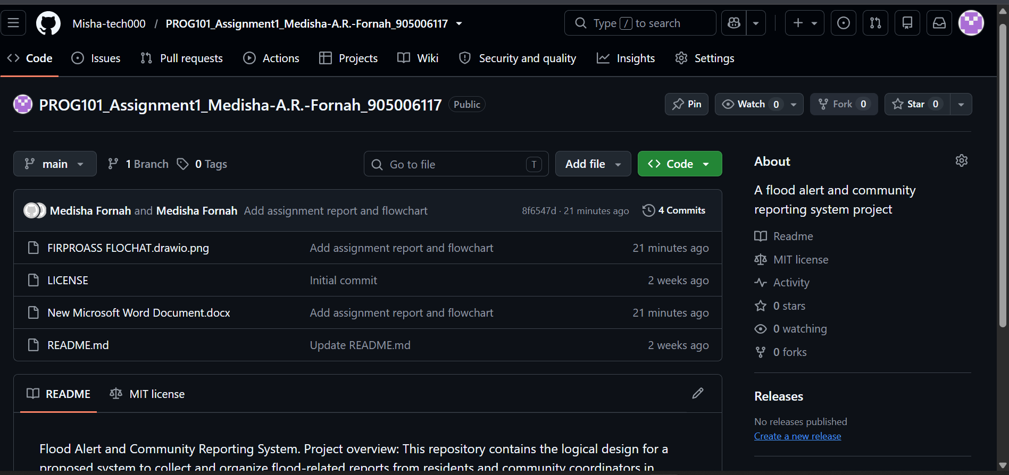

Figure 2: Coloured flowchart for the proposed system
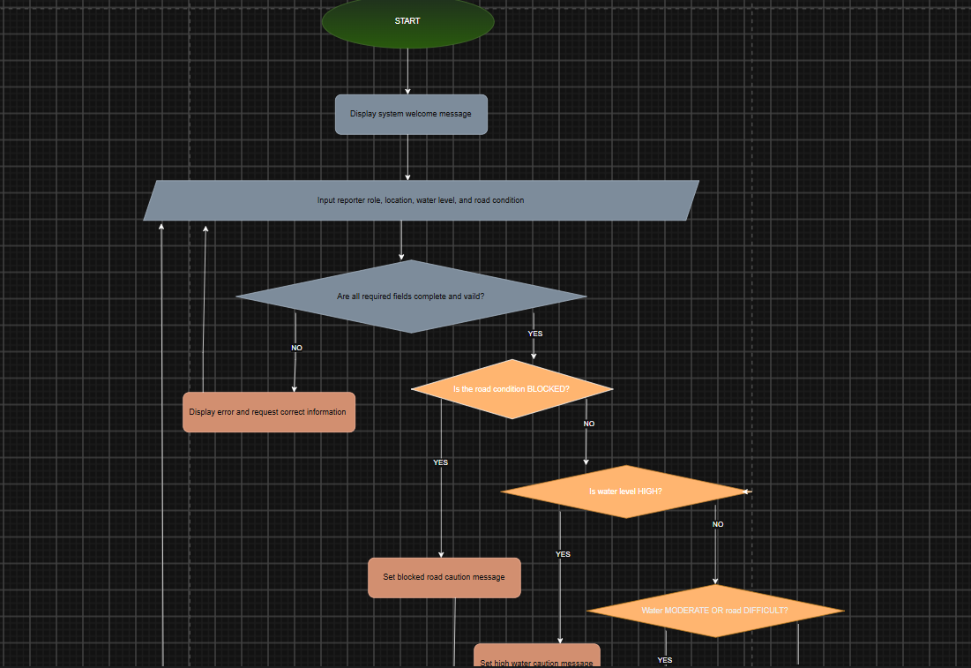

Figure 2: GitHub commit history showing the development progress:
