EXPERIMENT X • SYSTEM PROVISIONING AND MONITORING (CO5)
FinOps & Cloud Cost Observability
Student Name: Misha | SAP ID: 500119679 | Course: System Provisioning & Monitoring

Abstract
Modern cloud infrastructure makes provisioning instant, but tracking expenses across dynamic services remains a persistent challenge. Without real-time visibility, idle resources and silent budget overruns quickly inflate infrastructure spending. This report presents a practical FinOps cost-observability pipeline built using standard Python and structured billing datasets. The workflow ingests CSV billing logs, aggregates cost metrics by service tier, evaluates variance against allocated budgets, flags resource-level overspends, and automatically generates an interactive HTML dashboard. Designed as a lightweight local proof-of-concept, the system requires no third-party cloud SDK dependencies or paid accounts. The report details the system architecture, compares automated cost observability against conventional manual spreadsheet reviews, outlines critical operational limitations, and defines a phased roadmap for organizational FinOps adoption.
1. Introduction & Problem Statement
The elasticity of modern cloud providers allows engineering teams to deploy compute, storage, and database instances on demand. However, this decentralized agility often leads to financial opacity. Infrastructure costs are fragmented across hundreds of micro-services, fluctuating usage patterns hide inefficiency, and abandoned or under-utilized resources continuously incur charges.
Traditional manual invoice reviews—often conducted weeks after billing cycles close—are reactive and ineffective at preventing overspend. They fail to map line-item charges directly to service owners or operational priorities. FinOps bridges this gap by embedding financial accountability directly into the software lifecycle, treating cost as a primary operational metric alongside uptime and latency.
Project Aim: This project develops a lightweight, automated cost monitoring proof-of-concept for Experiment X (Operations track). By processing structured billing records, the system turns raw spending data into actionable visual insights, budget variance alerts, and targeted recommendations for idle resource review.
2. Background & Literature Survey
The FinOps Foundation defines FinOps as an operational framework and cultural discipline that maximizes the business value of cloud investments through cross-functional collaboration between engineering, finance, and product teams [1]. The framework relies on three core phases: Inform (visibility and allocation), Optimize (waste reduction and rate optimization), and Operate (continuous governance) [2].
Leading cloud vendors provide native monitoring tools such as AWS Cost Explorer [3] and AWS Budgets [4], Google Cloud Billing reports [5], and Microsoft Cost Management [6]. Furthermore, the Cloud Native Computing Foundation (CNCF) emphasizes integrating cost observability into Kubernetes and cloud-native deployments [7]. While commercial vendor tools provide deep cloud-native integration, this project models their core aggregation and alerting principles in a clear, transparent local workflow.
3. System Architecture & Working Principle
The monitoring pipeline follows a four-stage architecture:
1. Data Ingestion: Standardized CSV file storing resource attributes including timestamp, service category, resource ID, actual cost, budget target, average utilization percentage, and idle status flags.
2. Aggregation Engine: A pure Python processor that parses raw records, aggregates costs per service tier, and computes total spend versus total budget variance.
3. Rule Engine & Alerting: Automated logic checks that evaluate resource-level budget limits and extract resources marked as idle for human review.
4. Visualization Layer: Dual reporting via a structured terminal summary, a CSV export, and an intuitive single-page HTML dashboard for visual inspection.
Billing CSV Data ➔ Python Parsing & Aggregation ➔ Rule Engine Checks ➔ HTML Dashboard & CSV Output

4. Demonstration Setup & Execution
The implementation requires Python 3.9+ with zero external package dependencies. Execution is initiated via the command line:
Command: python demo/finops_dashboard.py
The script ingests data/sample_billing.csv, executes spending calculations, evaluates thresholds, and generates two outputs: demo/finops_summary.csv and demo/finops_dashboard.html.
4.1 Dashboard Visual Inspection
Below is the real-time visual output of the generated HTML dashboard (demo/finops_dashboard.html), displaying executive summary metrics, service spend distribution, and active budget alerts:
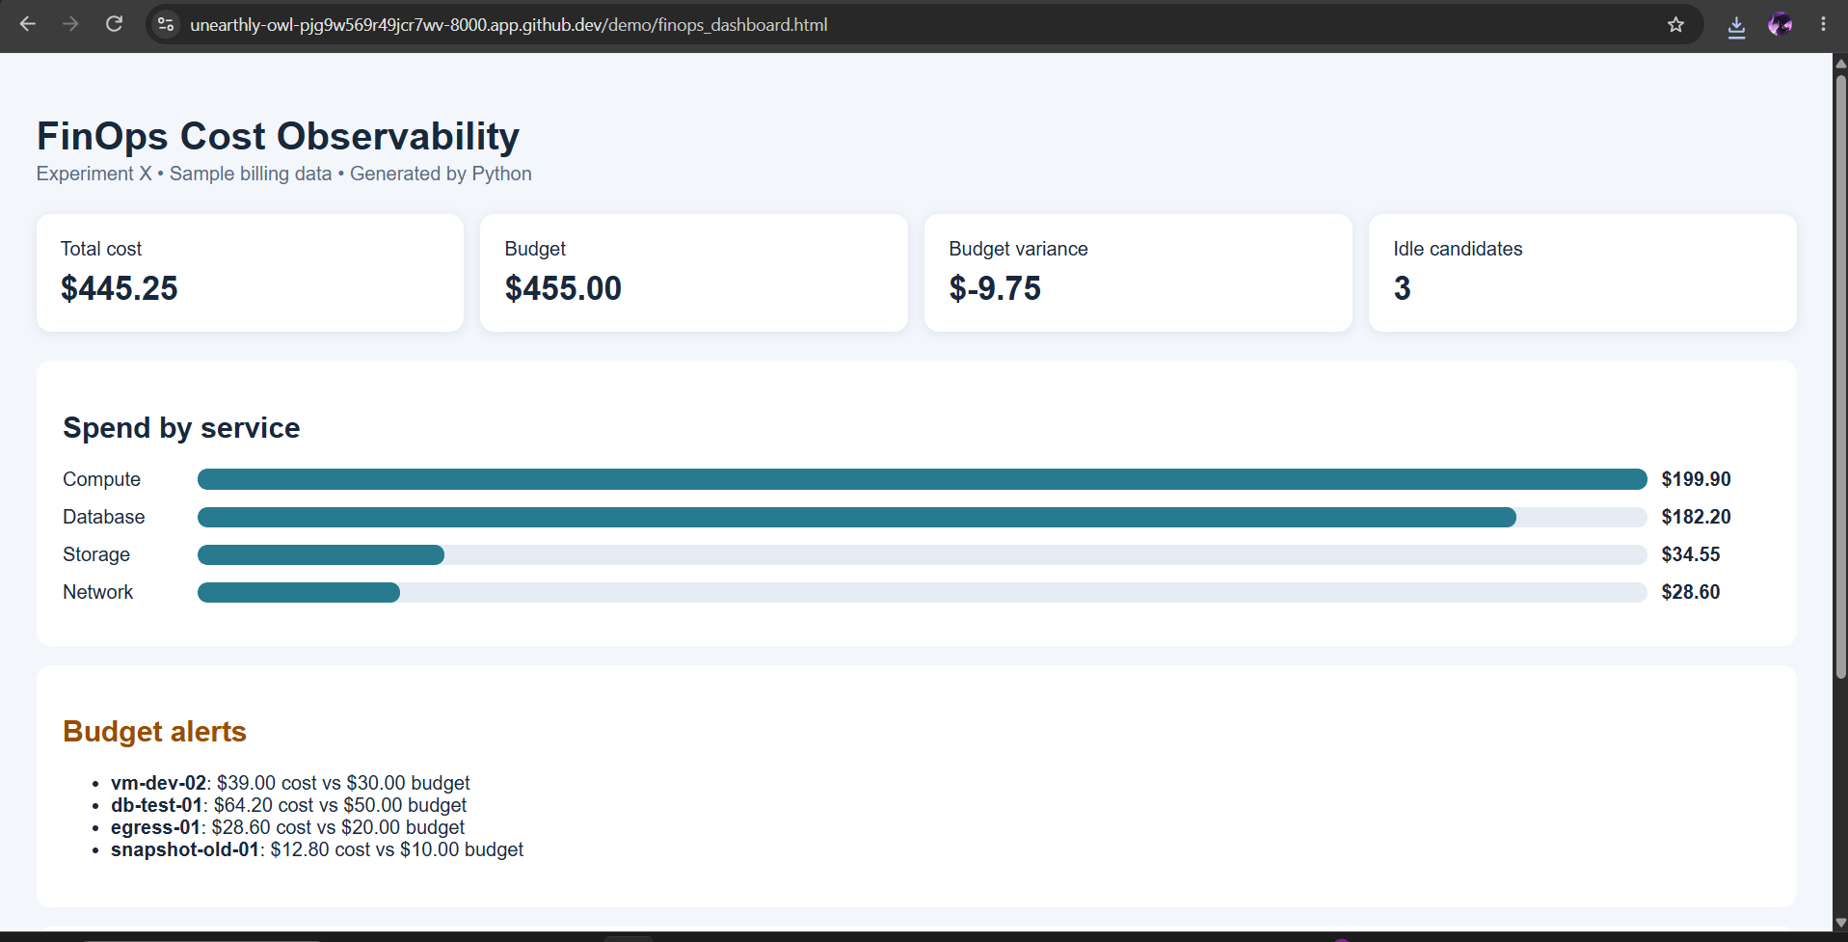
Figure 1: Generated FinOps Cost Observability Dashboard showing total spend ($445.25), overall variance (-$9.75), spend breakdown by service, and active budget alerts [cite: 3].
5. Observations & Results
The monitoring prototype processed 8 sample resource records from the billing dataset. Key calculated figures include:
• Total Spend: $445.25 across all 8 resources [cite: 3].
• Total Budget: $455.00 allocated [cite: 3].
• Budget Variance: -$9.75 (-2.1%), indicating that overall spending remained within the aggregate allocation limit [cite: 3].
• Spend by Service: Compute ($199.90), Database ($182.20), Storage ($34.55), and Network ($28.60) [cite: 3].
• Idle Resources: 3 resources explicitly tagged as candidates for review [cite: 3].
Despite a favorable overall budget variance (-$9.75), resource-level analysis revealed four specific budget overruns requiring attention: vm-dev-02 ($39.00 vs $30.00 budget), db-test-01 ($64.20 vs $50.00 budget), egress-01 ($28.60 vs $20.00 budget), and snapshot-old-01 ($12.80 vs $10.00 budget) [cite: 3]. This highlights a crucial insight: aggregate spending metrics often mask granular waste and localized overruns.
6. Comparative Analysis
A comparison between traditional manual spending reviews and automated FinOps cost observability highlights key operational improvements:
Dimension | Conventional / Manual Approach | FinOps Cost Observability
Cost Visibility | Periodic, manual monthly invoice reviews [cite: 3]. | Automated, daily aggregation by service & resource [cite: 3].
Alert Triggers | Discovered weeks late during finance audits [cite: 3]. | Immediate rule-based alerts on budget variance [cite: 3].
Waste Identification | Manual, ad-hoc spreadsheet inspections [cite: 3]. | Automated flagging of idle resource candidates [cite: 3].
Monitoring Target | Infrastructure uptime & server performance [cite: 3]. | Financial spend, budget variance & unit economics [cite: 3].
Operational Maturity | Reactive firefighting after invoice shock [cite: 3]. | Proactive accountability & continuous governance [cite: 3].

7. Limitations & Technical Trade-offs
While effective as a proof-of-concept, the current implementation has several practical limitations:
1. Synthetic Billing Data: The program relies on static CSV billing records rather than live cloud API billing feeds.
2. Simplified Pricing Rules: Simplified budget logic omits cloud savings plans, reserved instances, taxes, credits, and multi-currency conversions.
3. Context-Blind Waste Rules: An idle flag is an indicator for human review, not a definitive prompt to terminate a resource. Low utilization may belong to critical standby or disaster recovery nodes.
4. Tagging Dependencies: Accurate allocation depends heavily on standardized resource tagging across engineering teams.
8. Organizational Adoption Roadmap
Organizations transitioning to automated cloud cost governance should adopt a phased approach:
Phase 1 (Inform): Deploy read-only spend visibility dashboards and establish clear service-level budget targets.
Phase 2 (Optimize): Enforce strict resource tagging policies, route budget alert notifications to service owners, and perform bi-weekly idle resource reviews.
Phase 3 (Operate): Automate low-risk optimization actions (e.g., auto-stopping non-production development environments outside business hours) after rigorous validation.
9. Conclusion
This project successfully demonstrates how Python-driven cost observability turns raw cloud billing data into actionable financial metrics and visual dashboards. By flagging resource-level budget overruns and highlighting idle candidates, the system establishes essential financial visibility without complex infrastructure requirements. Future enhancements will integrate live cloud billing APIs, predictive cost forecasting, and automated tagging validation.
References
[1] FinOps Foundation, “What is FinOps?” https://www.finops.org/introduction/what-is-finops/ (accessed 26 Oct. 2026).
[2] FinOps Foundation, “FinOps Framework.” https://www.finops.org/framework/ (accessed 26 Oct. 2026).
[3] Amazon Web Services, “Analyzing your costs with AWS Cost Explorer.” https://docs.aws.amazon.com/cost-management/latest/userguide/ce-what-is.html (accessed 26 Oct. 2026).
[4] Amazon Web Services, “Managing your costs with AWS Budgets.” https://docs.aws.amazon.com/cost-management/latest/userguide/budgets-managing-costs.html (accessed 26 Oct. 2026).
[5] Google Cloud, “Cloud Billing reports and cost management.” https://cloud.google.com/billing/docs/how-to/reports (accessed 26 Oct. 2026).
[6] Microsoft Learn, “What is Microsoft Cost Management?” https://learn.microsoft.com/en-us/azure/cost-management-billing/costs/overview-cost-management (accessed 26 Oct. 2026).
[7] Cloud Native Computing Foundation, “FinOps resources.” https://www.cncf.io/ (accessed 26 Oct. 2026).

