**1. METHODOLOGY**

*1.1 DATASET.*

The recent statistical review by BP [2] had been used as the dataset. The dataset contains information on total electricity consumption by countries and regions, electricity generation by sources, and installed capacities and production by renewable sources, covering years since 1995 until 2020. Five areas with wind electricity production above 50 TWh per year by 2021 and ten countries were analyzed – World total, Europe, North America, South&Central America, Asia&Pacific regions and Canada, USA, Argentina, Brasil, United Kingdom, Germany, France, Sweden, China and Australia .

*1.2 PRELIMINARY ASSUMPTIONS.*

Three standard models were used to provide the research: The Bass model [6], the Logistic Growth model[11], and the Gompertz model. All models were implied within three modes: the original equation, with variable upper limit and variable upper limit considering the variable costs. Models are initially described by three parameters, two of which determine the function shape, and the last one defines the boundary of process growth. Those parameters are adjusted with the least-squares criteria to minimize the difference between the model and actual data. Thus, the limit of process growth could be evaluated.

Following assumptions were applied to introduce variability into the models:

* Wind energy will take the fixed limited share of the electricity generation.

To introduce this assumption into the models, the following statement accepted:

|  |  |
| --- | --- |
| $$\lim_{t→∞}{{\left(E^{W}\left(t\right)\right)=k*E(t)}^{}}$$ | (1) |

*Ew* – wind generation; *t* – time; *k* – the final share of wind energy in total electricity generation; *E* – whole generation for variable upper boundary mode.

* The share depends on wind energy costs.

To introduce this assumption into the models, the following statement accepted:

|  |  |
| --- | --- |
| $$\lim_{t→∞}({{E^{W}(t))=k(t)*E(t)}^{}}$$ $$k\left(t\right)=\frac{R}{R+c(t)}$$ | (2)  (3) |

*Ew* – wind generation; *t* – time; *k* – the share of wind energy in total electricity generation depending on wind energy costs; *E* – whole generation for varying upper boundary mode; *R* – constant, *c* – WE costs

(see Appendix A).

*1.3 MODELS DESCRIPTION.*

***The Logistic Growth model:***

***Description***

In his work “Diffusion of Innovation” [10], Rogers investigated the adoption rates of various innovations. He found that most of the graphs of innovation adoption by members of society resemble a standard bell curve divided into five parts (Pictures 2,3).

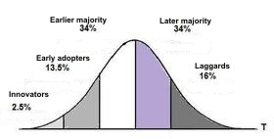

**Picture 2. Time distribution of the innovation adopters [10].**



**Picture 3. Total number of adopted innovations [10].**

Total innovation volume represents the typical “S-curve,” which could be described with numerous equations. One of the most known is the “Logistic Growth.”

Basic equation:

|  |  |
| --- | --- |
| Y $\left(t\right)=X_{min}+ M*\frac{1}{1+e^{-l(t-α)}}$ | (9) |

Where Y(t) – wind generation at period t; Xmin – Wind generation at the first point; M – Upper limit of generation growth since the first known number; l and $α$– coefficients, determining the curve shape.

Variable upper limit:

|  |  |
| --- | --- |
| Y $\left(t\right)=X_{min}+(M(t-1)- X_{min})*k*\frac{1}{1+e^{-l*(t-α)}}$ | (10) |

Where *Y(t)* – wind generation at period t; *Xmin* – Wind generation at first point; M(t-1) = the total electricity generation in the previous year; *k* – the achievable wind energy generation share; *l* and $α$– coefficients, determining the curve shape.

Variable upper limit considering variable costs:

|  |  |
| --- | --- |
| Y $\left(t\right)=X_{min}+(M(t-1)- X_{min})*\frac{R}{R+c(t)}*\frac{1}{1+e^{-k(t-α)}}$ | (11) |

Where Y(t) – wind generation at period t; Xmin – Wind generation at first point; M(t-1) = the total electricity generation in the previous year, R – the price curve coefficient, ct-1 – costs per 1 KWh during the last year, k, $α$– coefficients, determining the curve shape.

***The Bass model.***

***Description.***

The essence of the Bass model [6] is that two categories explain the growth in the number of consumers of an innovative product:

• Those who try a new product themselves in the first place - innovators;

• Those who learn about a new product from the first category - imitators.

At the initial stage of the product life cycle, the innovators prevail. As the number of adopters grows, the effect of imitators increases. The model illustrates well the principles of reinforcing feedback (the number of consumers of a product increases the flow of new consumers due to interpersonal communication). Unlike Rogers, Bass identified not five but only two categories of people (see Picture 4,5).

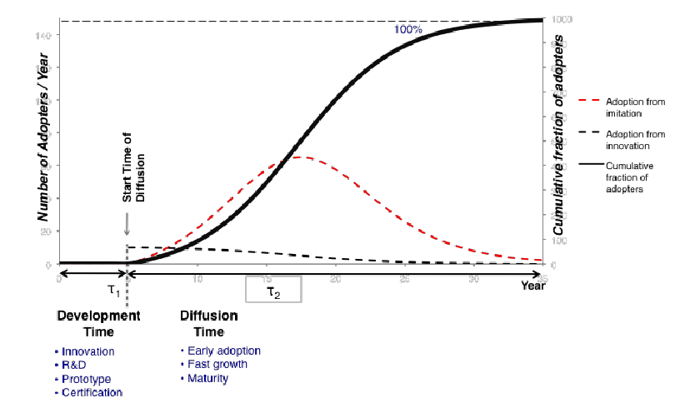

**Picture 5. Total number of adopted innovations** [15]**.**

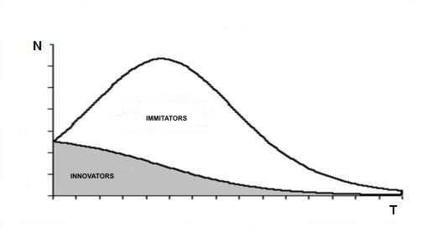

**Picture 4. Time distribution of the innovation adopters** [15]**.**

The Bass Model describes sales at the period, which are the derivative from the distribution. Following original equation [6] had been used.

Basic equation:

|  |  |
| --- | --- |
| $$S\left(t\right)=p*m+\left(q-p\right)*Y\left(t-1\right)- \frac{q}{m}Y^{2}(t-1)$$ | (6) |

Where S(t) – sales at period t; $Y\left(t-1\right)=\sum_{x=1}^{x=t-1}{S(x)}$– cumulative sales through the period [0 ... t - 1]; p – coefficient of innovation, q – coefficient of imitation, m – the total number of all purchasings.

Variable upper limit:

|  |  |
| --- | --- |
| $$S\left(t\right)=p*M(t-1)*k+\left(q-p\right)*Y\left(t-1\right)- \frac{q}{(M(t-1)*k)}Y^{2}(t-1)$$ | (7) |

Where S(t) – sales at period t; $Y\left(t-1\right)=\sum_{x=1}^{x=t-1}{S(x)}$– cumulative sales through the period [0 ... t - 1]; p – coefficient of innovation, q – coefficient of imitation, Mi = the total electricity generation in the previous year, k – the share limit of wind energy in the total electricity production.

Variable upper limit considering variable costs:

|  |  |
| --- | --- |
| $$S\left(t\right)=p*M(t-1)*\frac{R}{R+c\left(t-1\right)})+\left(q-p\right)*Y\left(t-1\right)- \frac{q}{M(t-1)*\frac{R}{R+c\left(t-1\right)}}*Y^{2}(t-1)$$ | (8) |

Where S(t) – sales at period t; $Y\left(t-1\right)=\sum_{x=1}^{x=t-1}{S(x)}$– cumulative sales through the period [0 ... t - 1]; p – coefficient of innovation, q – coefficient of imitation, M(t-1) = the total electricity generation in the previous year, R – the price curve coefficient, ct-1 – costs per 1 KWh in the previous year.

***The Gompertz model:***

This is a type of mathematical model for time series where growth is slower at the beginning than at the end of the period (see picture 6,7). It resembles a logistic curve but is not symmetrical. The deceleration does not occur as fast as its acceleration. The Gompertz model [12] [13], successfully applied to different growth processes evaluation [14][15]. In some cases, Gompertz distribution shows better results than logistic growth models.

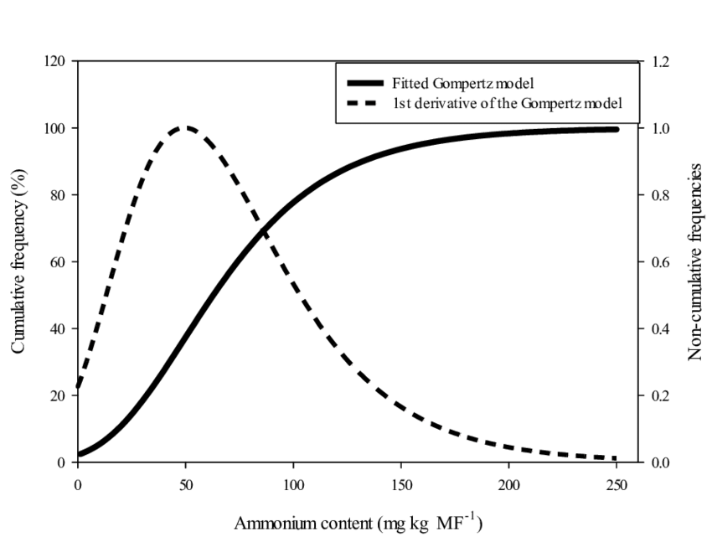

**Picture 6. Gompertz model and the first derivative example .**

Basic equation:

|  |  |
| --- | --- |
| Y $\left(t\right)=X_{min}+ (M- X_{min})*e^{-e^{(l-αt)}}$ | (12) |

Where Y(t) – wind generation at period t; Xmin – Wind generation at the first point; M – Upper limit of generation growth; l and $α$– coefficients, determining the curve shape.

Variable upper limit:

|  |  |
| --- | --- |
| Y $\left(t\right)=X_{min}+(M(t)- X_{min})*k*e^{-e^{(l-αt)}}$ | (13) |

Where *Y(t)* – wind generation at period t; *Xmin* – Wind generation at first point; *M(t)* – the total electricity production in period *t*; *k* – the achievable wind energy generation share; *l* and $α$– coefficients, determining the curve shape.

Variable upper limit considering variable costs:

|  |  |
| --- | --- |
| Y $\left(t\right)=X_{min}+(M(t-1)- X_{min})*\frac{R}{R+c(t)}*e^{-e^{(l-αt)}}$ | (14) |

Where Y(t) – wind generation at period t; Xmin – Wind generation at first point; M(t-1) = the total electricity generation in the previous year; R – the price curve coefficient; ct-1 – costs per 1 KWh in the previous year; *l* and $α$– coefficients, determining the curve shape.

1.4 THE RESEARCH STEPS.

The research consists of two steps. In both steps, the equation parameters were evaluated with the OLS criteria using the Gradient Descent optimization method assuming total electricity generation trends and decreasing wind energy LCOE costs. The first step serves to provide the consistency check on the models using data from the 1997-2020 period. Then the regression analysis comparing model and actual values had been provided. The second step is prognosis for the 2016-2020 period consistency check.