

PROJECT REPORT

OPERATING SYSTEM (CS-329)

“THE BARBERSHOP PROBLEM”

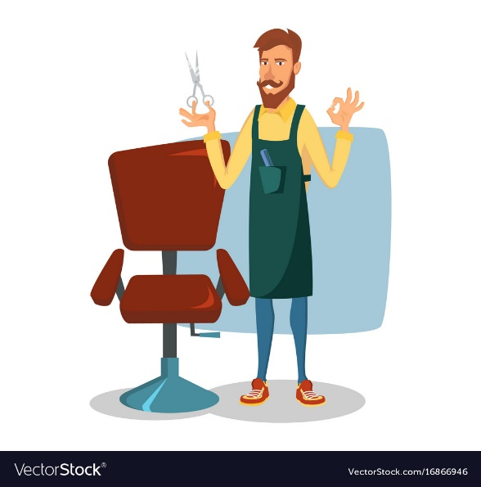

GROUP MEMBERS:

MISHA AKRAM BAIG (CS-18118) IQRA IRFAN (CS-18123)

**ABSTRACT**

In this project we have implemented a Barber Shop classical synchronization problem using semaphores and threads. Barber keep working when there are customers, resting when there are none, and doing so in an orderly manner. The barber has one barber chair and a waiting room with a number of chairs in it. When the barber finishes cutting a customer's hair, he dismisses the customer and then goes to the waiting room to see if there are other customers waiting. If there are, he brings one of them back to the chair and cuts his hair. If there are no other customers waiting, he returns to his chair and sleeps in it.

Each customer, when he arrives, looks to see what the barber is doing. If the barber is sleeping, then the customer wakes him up and sits in the chair. If the barber is cutting hair, then the customer goes to the waiting room. If there is a free chair in the waiting room, the customer sits in it and waits his turn. If there is no free chair, then the customer leaves.

**SOURCE CODE:**

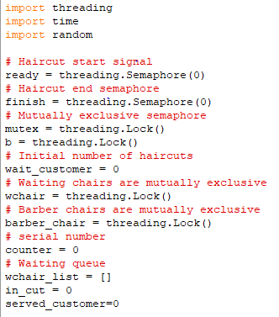

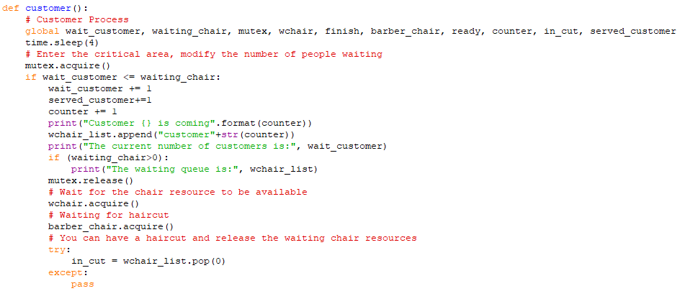

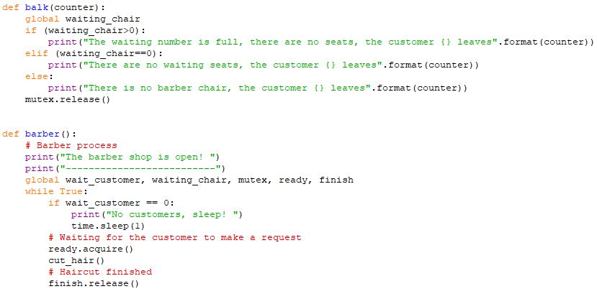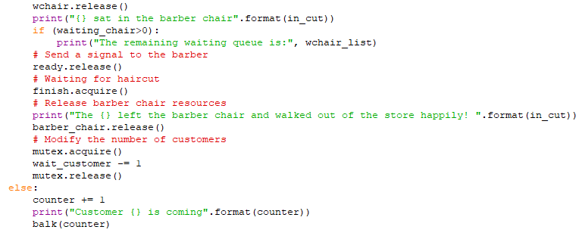

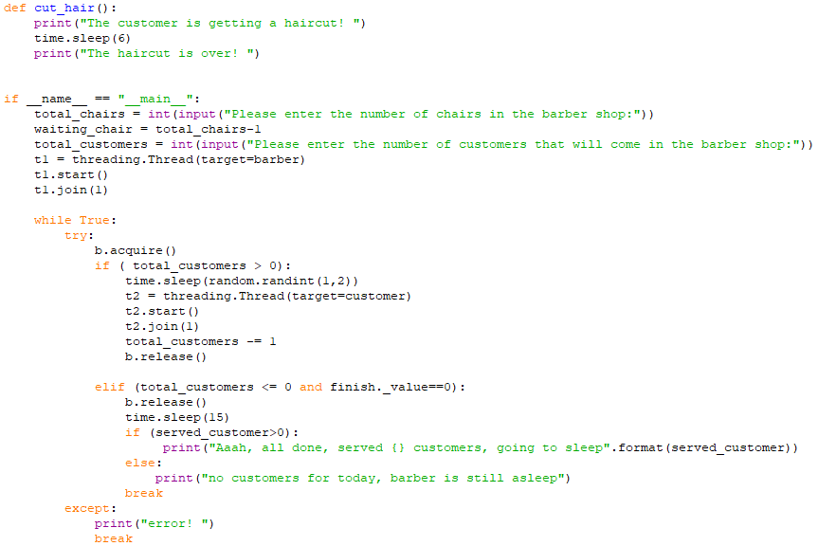

**TEST CASES:**

Test Case 1:

|  |
| --- |
| Total number of chairs : 2 |
| Number of waiting chairs : 1 |
| Total customers entering in the shop : 2 |
| Description: Customer 1 came in the barber shop & occupy the waiting chair, he calls the barber & having the hair cut meanwhile customer 2 came as the waiting chair is empty he occupied it & waits for his turn. As none of the customer is waiting so barber going to sleep. |
| Status : Pass |

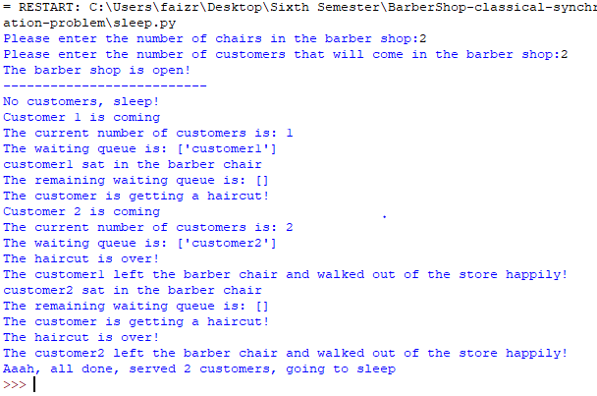

Test Case 2:

|  |
| --- |
| Total number of chairs : 2 |
| Number of waiting chairs : 1 |
| Total customers entering in the shop : 3 |
| Description: Customer 1 came in the barber shop & occupy the waiting chair, he calls the barber & having the hair cut meanwhile customer 2 came as the waiting chair is empty he occupied it waits for his turn. Now customer 3 came, as the waiting chair is already occupied he left the shop without having the haircut. Now none of the customer is waiting so barber going to sleep. |
| Status : Pass |

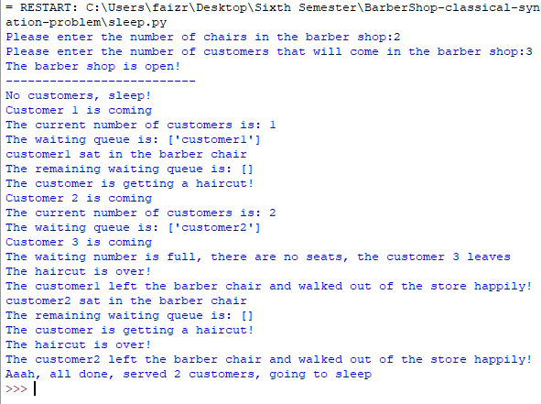

Test Case 3:

|  |
| --- |
| Total number of chairs : 4 |
| Number of waiting chairs : 3 |
| Total customers entering in the shop : 0 |
| Description: Barber opens the shop, as no customer enters the shop so he still asleep. |
| Status : Pass |

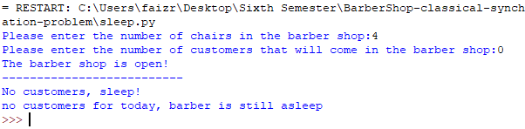

Test Case 4:

|  |
| --- |
| Total number of chairs : 0 |
| Number of waiting chairs : -1 |
| Total customers entering in the shop : 4 |
| Description: As there are no chairs for the customers to sit so all of the customers came & left the shop without having the haircut. |
| Status : Pass |

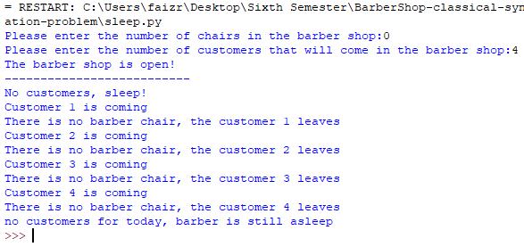

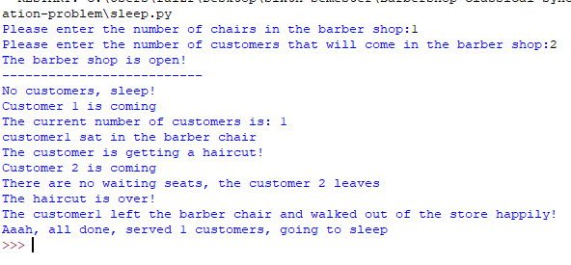Test Case 5:

|  |
| --- |
| Total number of chairs : 1 |
| Number of waiting chairs : 0 |
| Total customers entering in the shop : 2 |
| Description: Customer 1 came to the shop & having the haircut meanwhile customer 2 came but there are no waiting seats so he left the shop without having the haircut. |
| Status : Pass |