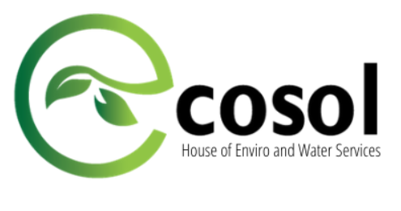



**Name:** Misha Akram

**Roll no:** cs-18118

**Course:** Entrepreneurship for Computer Engineers

**Submitted to:** Dr Khurram

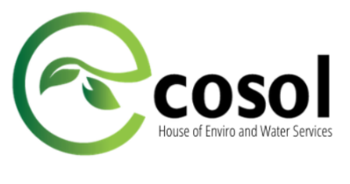

**About**

**Ecosol Pvt. Ltd**

Ecosol is a House of Water and Environmental Services. With a team of seasoned environmentalists, hydrologists, and engineers, we are committed to revolutionize environmental landscape byoffering high standard services.

Maliha Abbass Zaidi is a civil Engineering graduate from NED University back in 2014 Jan, after that she went through few competitive exams and from there she started thinking of having her own initiative. Then she started off with National Dialog for Climate Change, from that idea she thought of started her own company by the name Ecosol (Ecological solutions. Her initiative has pioneered the idea of dialogue by bringing scientists and policy makers to the front. She feels honoured to revolutionize the discourse on climate change through research, training, journalism, activism and education to prepare young scientists and policymakers to fight against the diverse effects of climate change.

Ecosol is basically a house for water and environmental services, where they provide engineering services, soft skill when it comes to imparting knowledge about climate change by arranging and conducting seminars, fellowships, trainings on engineering software and policy making, further more in the near future they are planning to offer courses to school and colleges on the subject of environment and climate change and further be moving on to having their certifications in Pakistan for buildings specially.



MISSION

*Ecosol Pvt. Ltd. aims to improve the environment by providing its clients with sustainable solutions whereas, identifying global environmental problems**caused by climate change and other anthropogenic factors and presents eco-friendly solution for a**green future.*

VISION

*Our vision is to promote**research and development and bring innovation in the field of engineering, environment and provide economical solutions of high**quality standard whereas, enlighten masses about deterioration of**environment and create content to change public opinion in favour of eco-friendly development.*

**Company Structure**

Incubated at **National Incubation Centre Karachi (NIC),** in the year 2015. Their office is situated in **NIC NED University of Engineering and Technology**. Their headquarters are located at Karachi and Sindh**.** It took around more than a year to earn a profit.Revenue is generated through partnership and sponsorship. So far the company’s success is good, over the period of time they have concluded some significant partnerships with Nespak, NIC, Essa Lab, BUITEMS. So with respect to partnership the company is quite successful as they believe that without partnership no business can succeed. It took around more than a year to earn a profit. At the current there are no permanent employees all are hired on project basis.

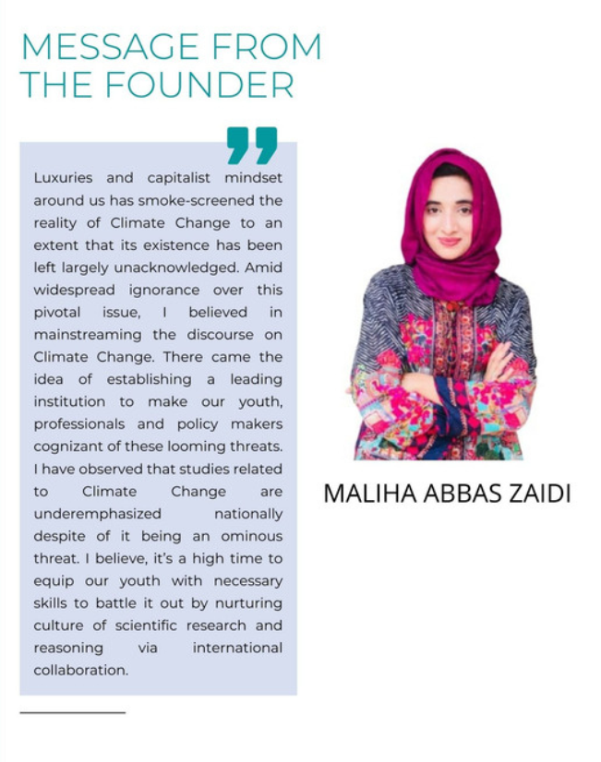



**What they Offer**

* **Building Science & Sustainability.**
* **Environmental Impact Assessment Report.**
* **Indoor Environmental Quality. Assessment of Climatic variability.**
* **Hydrological and Hydraulic Design.**
* **Training seminars & courses in all aspects of these fields.**
* **Certification & Fellowships.**
* **Research and Development.**

**Services**

**Water Division** Department comprises of well-experienced and expert team of engineers and hydrologist. Water Division department primarily deals with:

* Watershed Management
* Hydrological and Hydraulics
* Design Channel Design
* Storm Water Drainage
* System connection and disposal analysis
* Study of Water Treatment Plants

**Enviro Division** of Ecosol (Pvt.) Ltd. provides the following services according to the client requirements.

* Environmental Impact Assessment Report
* Pre-Feasibility and Feasibility Study Reports
* Project Management
* Environmental Review
* Environmental Management
* Program Report
* Environmental Planning
* Environmental Review
* ·Public Consultation & Facilitation

**Research Division**

* Ecosol Research division is taking steps to promote Low Impact Development (LID) and cope up with the adverse impact of Climate Change through Research and Development. NDCC (National Dialogue on Climate Change) is one of the Research think tank under this division.



* NDCC offers you to have dialogue and think critically to initiate research on climate change. NDCC also envisage the environmental journalism and activism to create awareness about the issue of Climate Change. NDCC also offers summer internship, research opportunities, trainings and workshops.

**Conferences**

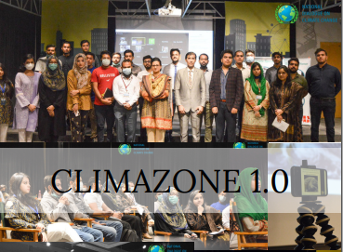Ecosol and NDCC in partnership with NESPAK organized a first ever training workshop to address diverse climate change-related threats to the construction industry by engaging experts and scientists from Academia and Industry. The workshop was led by high regard speakers who are experts in their fields. The principle focused audience of the workshop were Ph.D. Scholars, Graduate

Students, Industrialists, and young professionals working in the field of Climate Change and the Construction Industry. **ClimaZone 1.0** was a great workshop that provided a platform to locals and students to have their say about the current climate change situation and also get the knowledge and insight of it from the top-notch professionals in the industry. An eye-opening workshop on our current worsening climate change situation and its impacts on different industries such as the construction industry, water resources, etc.

The outcome was AWARENESS. Locals and students got a chance to have the knowledge they couldn't get anywhere else from. It opened many minds to the current climate change situation for sure. People got to know the impacts of the climate change situation and its impacts on different industries and also got a chance to have their say on it. It was overall a successful workshop that imparted great knowledge and awareness from industry professionals.



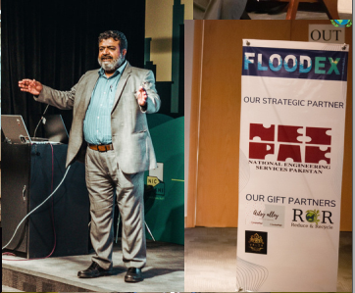**Floodex** was a two-day workshop held at the National Incubation Centre (NIC), Karachi. The purpose of this workshop was to discuss what can be done regarding the flooding issues that prevail in the country. This workshop included some of the brightest minds of the country who put forward ideas on how to work against urban flooding.

The outcome of this workshop can be understood by the fact that it gave people a platform to discuss the flooding issue in the country. It raised awareness among the general public. And because of the help of the educated people of Karachi, we now know about the importance of resolving this issue. In the workshop, several issues were given importance and emphasis was made in Solid waste management, Emergency Plan and Action, Effective Flood warning system and implementation of Flood Risk Management Techniques.

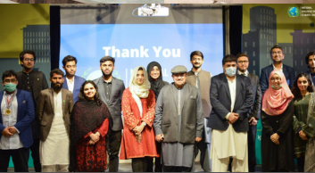It gave a platform to the brilliant minds of the city and the country to come together and share their views regarding the urban flooding issue that is prevailing in Karachi. This workshop also encouraged these bright minds to share their views on how these issues can be resolved



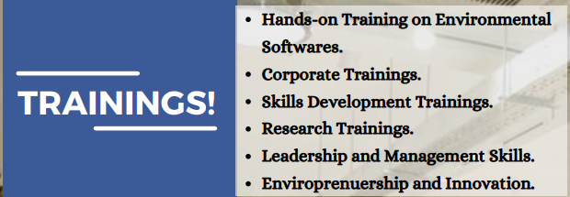

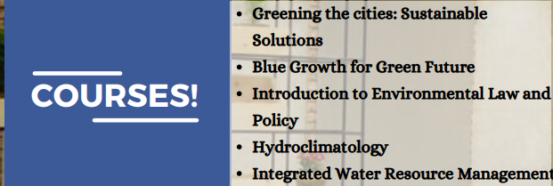

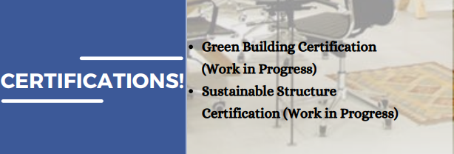

**ACHIEVEMENTS**

So far the company has achieved in doing the following mentioned below.

* Successfully created a forum of more than 5000 climate enthusiasts.
* Trained around 1000 plus students in environmental and Climatic studies.
* Organized multiple national level training programs: in partnership with USPCAS, PCRWR and PDMA and NESPAK.
* Successfully launched two cohorts and have trained them in climate change related studies.
* Ventured into partnership with Sindh University and BUITEMS for Climate Leadership
* Initiated multiple dialogues, quizzes, recycling and waste management competitions.
* Formalised fellowship program for the youth of Balochistan to train students and faculty in Environment and Sustainable studies.
* Launched multiple software training workshops to observe and  
  mitigate Climatic Changes