DLT Bronze–Silver–Gold Pipeline for NYC Taxi Data
This pipeline implements the required Bronze → Silver → Gold architecture using Delta Live Tables and the sample NYC taxi dataset provided by Databricks.
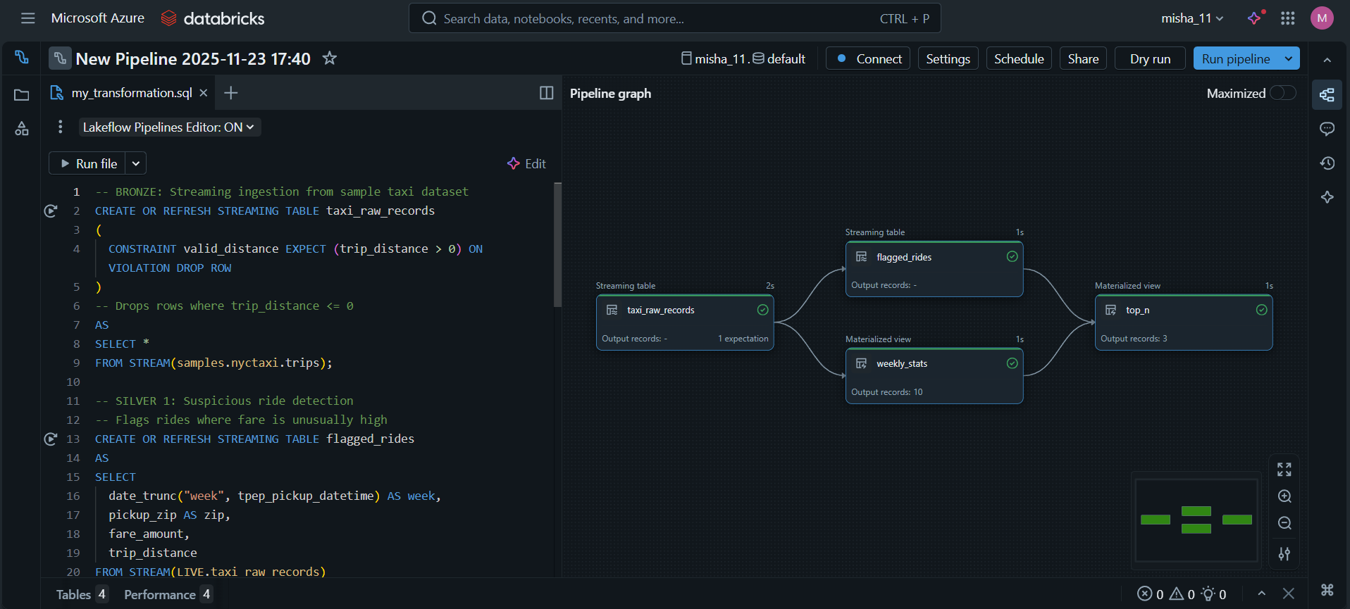
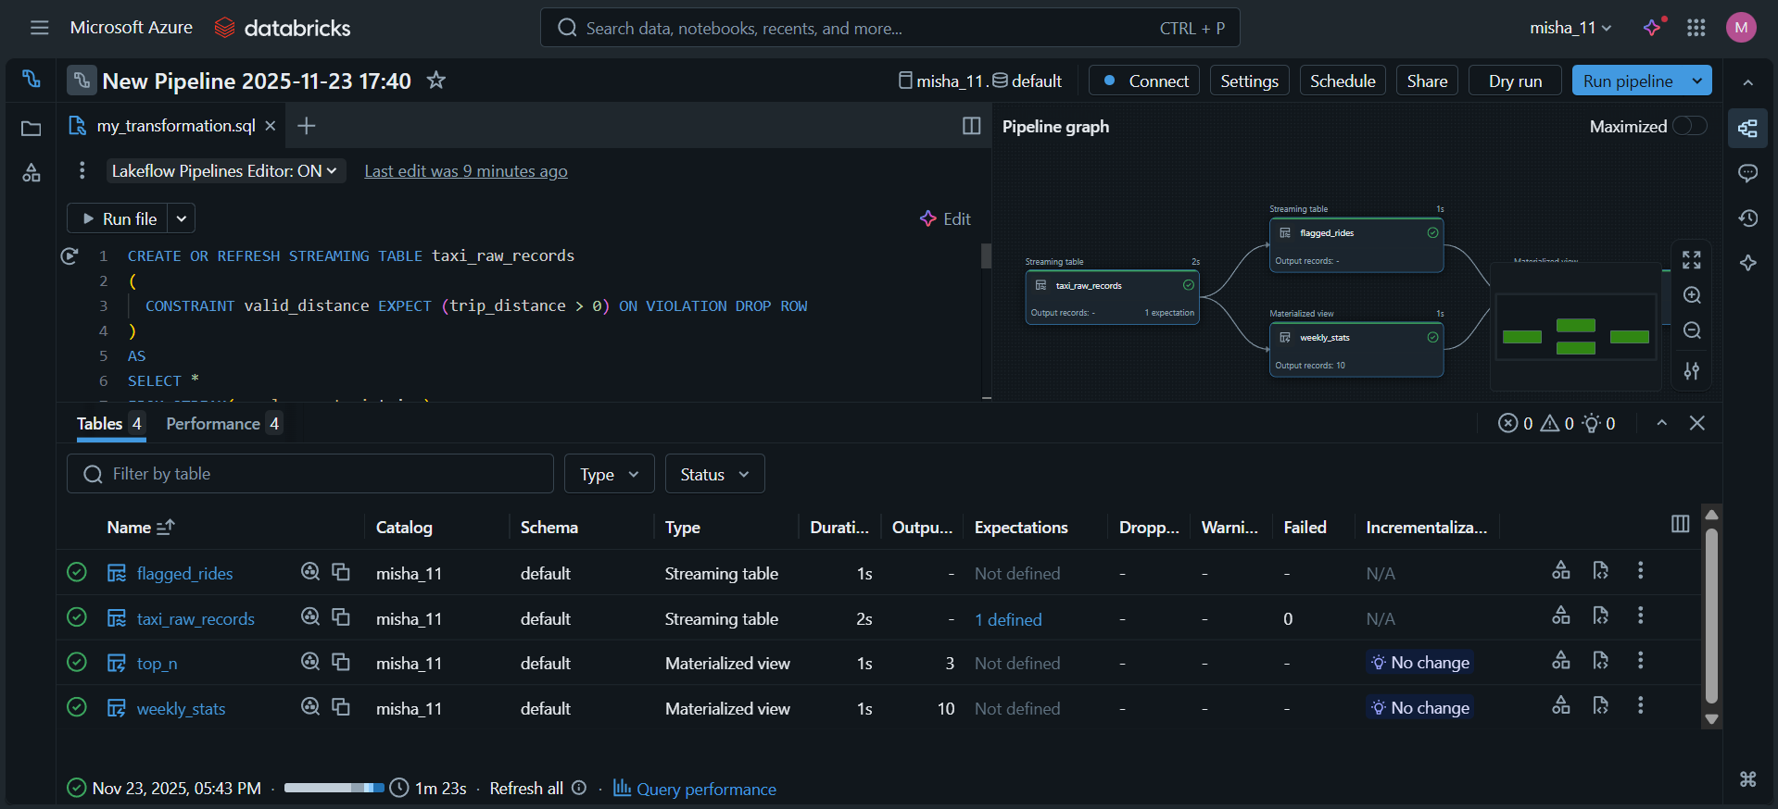
1. Ingest raw events into a streaming Bronze table.
2. Apply a DLT expectation to drop records with non-positive trip_distance.
- In the Bronze layer, I ingested raw taxi trip data as a streaming table from samples.nyctaxi.trips.
- A data quality rule was added to drop any records where trip_distance is not positive. This ensures that obviously incorrect or incomplete trips do not move forward in the pipeline.
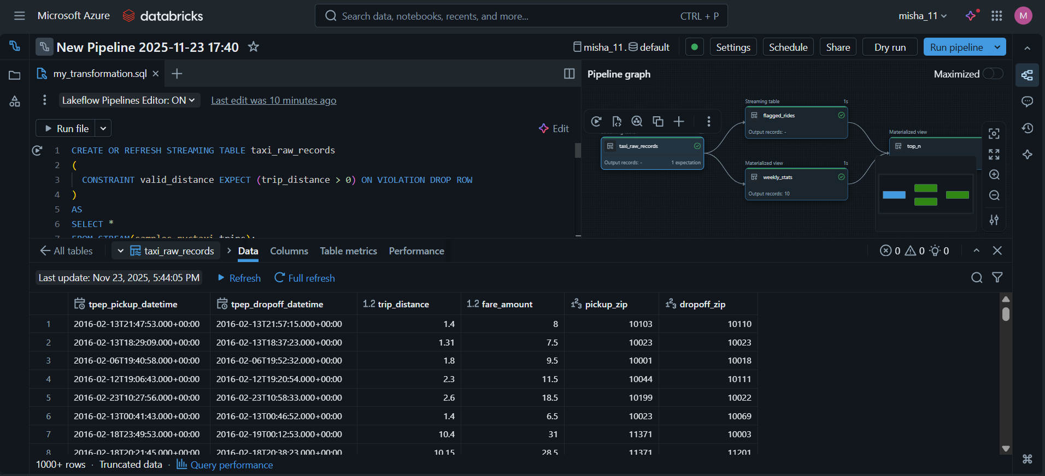

3. Build a Silver table that flags suspicious rides (e.g., fare &gt;&gt; distance) and another Silver table with weekly aggregates.
- The Silver layer contains two tables.
The first Silver table identifies suspicious or unusual rides based on simple business rules.
- A ride is flagged as suspicious if the pickup and dropoff zip codes are the same but the fare is unusually high, or if the trip distance is very short but the fare is still above a threshold.
- The second Silver table calculates weekly statistics, including average fare and average trip distance. These weekly aggregates provide a useful summary of ride trends over time.

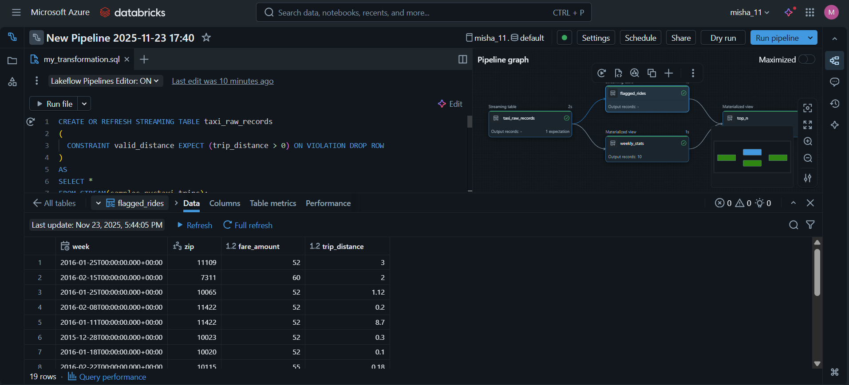
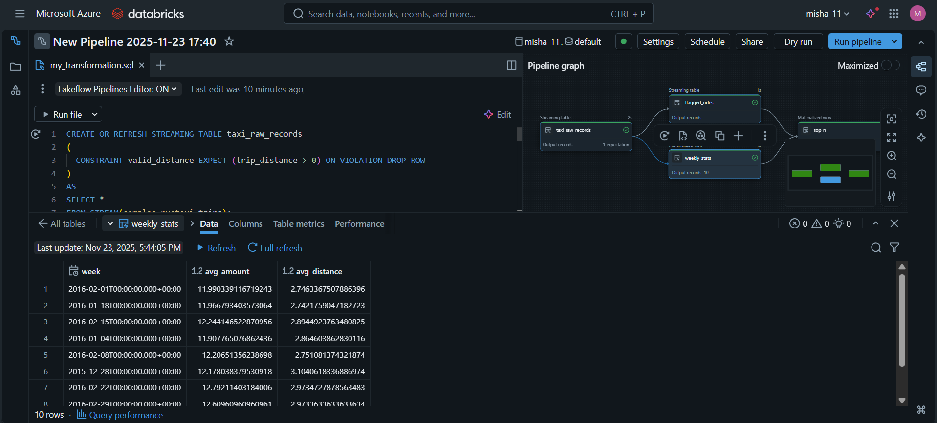

4. Produce a Gold materialized view showing top-3 highest fare rides with passenger info and expected schema.
- The Gold layer combines the weekly statistics with the suspicious rides to produce a final table that lists the top three highest-fare suspicious trips.
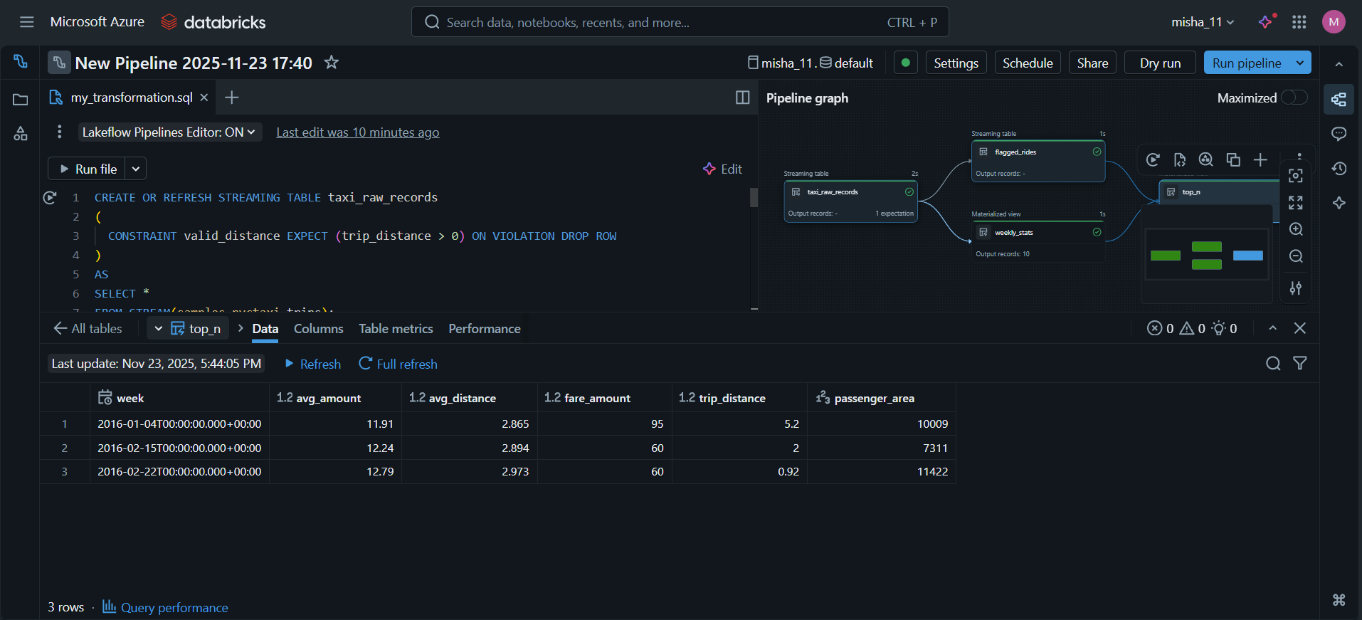

5. Provide a short notebook showing sample queries and validation that the pipeline produces correct results and lineage is visible
- A separate validation notebook was also created to run simple SQL queries on the Bronze, Silver, and Gold tables, confirming that the pipeline produced the correct outputs.

