Architecture & Design
1. Architecture Overview
This project implements a modern Lakehouse architecture on Azure to support scalable, reliable, and analytics-ready data processing for a retail enterprise. The architecture follows the Medallion pattern (Bronze → Silver → Gold) to progressively refine raw data into high-quality analytical datasets.
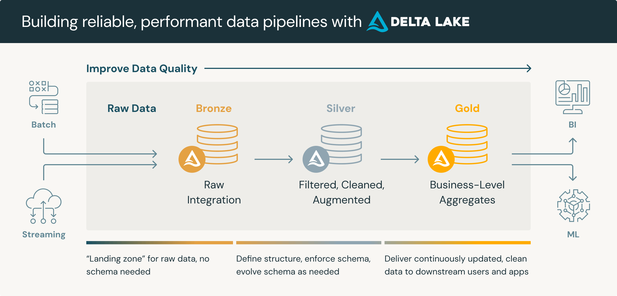

2. High-Level Architecture Flow
The end-to-end data flow is as follows:
- Raw sales and master data files are ingested into Azure Data Lake Storage (ADLS).
- Data is loaded into the Bronze layer in raw format using Apache Spark.
- The Silver layer performs data cleansing, validation, deduplication, and calibration.
- The Gold layer contains business-ready aggregated datasets.
- Power BI connects directly to Gold Delta tables for reporting and visualization.

Source CSV Files
↓
Azure Data Lake Storage
↓
Bronze Layer (Raw Delta Tables)
↓
Silver Layer (Cleaned & Validated Delta Tables)
↓
Gold Layer (Aggregated Analytics Tables)
↓
Power BI Dashboards

3. Technology Stack & Roles
Azure Databricks
Azure Databricks is used as the primary data engineering platform to:
- Execute distributed data processing jobs
- Orchestrate the Bronze → Silver → Gold pipeline
- Manage notebooks and workflows
Apache Spark
Apache Spark is the core processing engine responsible for:
- Large-scale data ingestion
- Data transformations and aggregations
- Incremental and batch processing using PySpark and Spark SQL
Delta Lake
Delta Lake provides reliability and performance by enabling:
- ACID transactions on data lake storage
- Incremental UPSERTs using MERGE
- Schema evolution
- Time travel and rollback capabilities
Power BI
Power BI is used for analytics and reporting:
- Connects directly to Gold Delta tables
- Supports interactive dashboards and scheduled refresh
- Enables business users to analyze trends and KPIs

4. Medallion Architecture Design
The project follows the Medallion Architecture pattern:
Layer |  |  |  |  |  | Description | Data State
Bronze |  |  |  |  |  | Raw data ingestion | Uncleaned, unvalidated
Silver |  |  |  |  |  | Cleansed and validated data | Trusted, structured
Gold |  |  |  |  |  | Aggregated business metrics | Analytics-ready
Bronze Layer
- Stores raw data in Delta format
- Preserves original schema
- Adds ingestion metadata
- Supports file-based incremental ingestion
Silver Layer
- Cleans and validates data
- Removes duplicates
- Applies business rules and calibration
- Separates invalid records into a quarantine table
Gold Layer
- Stores aggregated, analytics-ready data
- Optimized for reporting
- Registered as managed tables in Unity Catalog

5. Data Lake Storage Structure
The Azure Data Lake is organized into clear layer-based directories:
/Volumes/main/default/retail_datalake/
│
├── bronze/
│ ├── sales_transactions/
│ ├── products/
│ └── stores/
│
├── silver/
│ ├── sales_transactions/
│ ├── products/
│ ├── stores/
│ └── sales_quarantine/
│
└── gold/
├── daily_sales_summary/
├── monthly_revenue_region/
└── product_performance/

6. Partitioning Strategy
Partitioning is applied to optimize performance and scalability.
Bronze Layer
- Partitioned by ingestion_date
- Enables efficient incremental ingestion and storage management
Silver Layer
- Partitioned by transaction_date
- Optimizes filtering and downstream transformations
Gold Layer
- Partitioned by year and month
- Optimized for time-based analytics and Power BI queries

7. Data Flow Summary
- Source → Bronze: Raw ingestion with metadata
- Bronze → Silver: Cleansing, validation, deduplication, quarantine handling
- Silver → Gold: Business aggregations and KPI creation
- Gold → Power BI: Analytics and visualization

8. Architecture Benefits
- Scalable and cloud-native
- Fault-tolerant and ACID compliant
- Supports incremental processing
- Optimized for enterprise BI reporting
- Clear data lineage and governance

