Final Document

Storage Organization (Bronze, Silver, Gold)
The project follows a structured data lake layout using Databricks Volumes for physical storage and Unity Catalog tables for governance and lineage.
Storage Layout
- Bronze: Raw ingested data
- Silver: Cleaned and validated data
- Gold: Aggregated analytics data
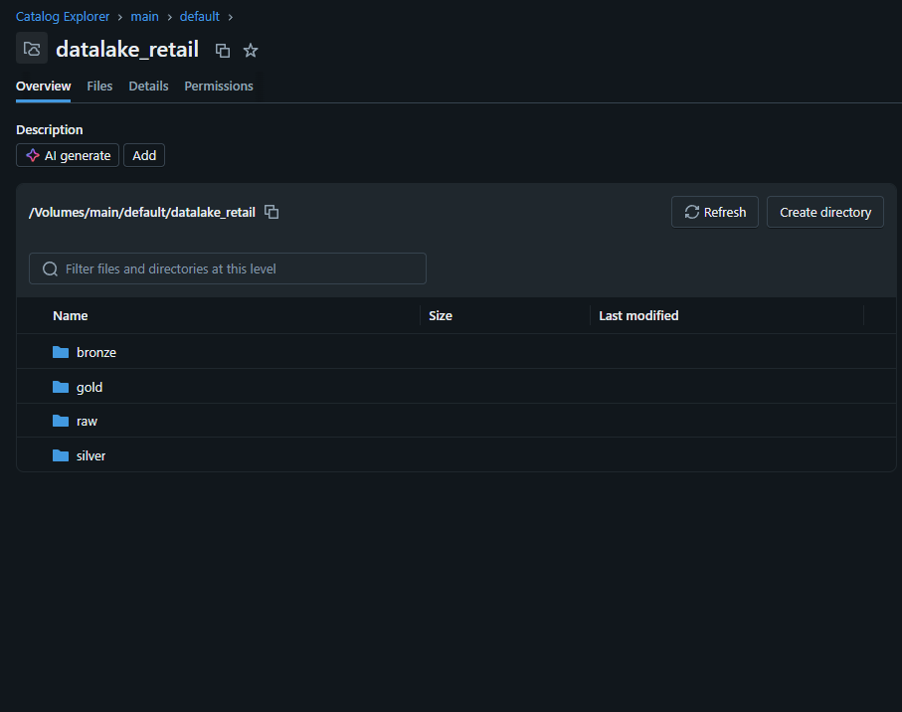
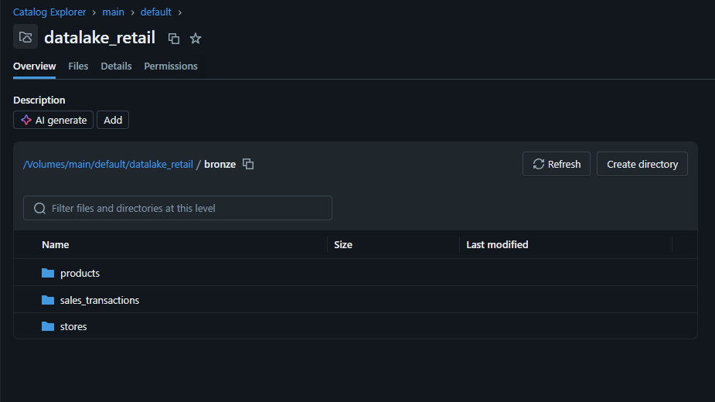
`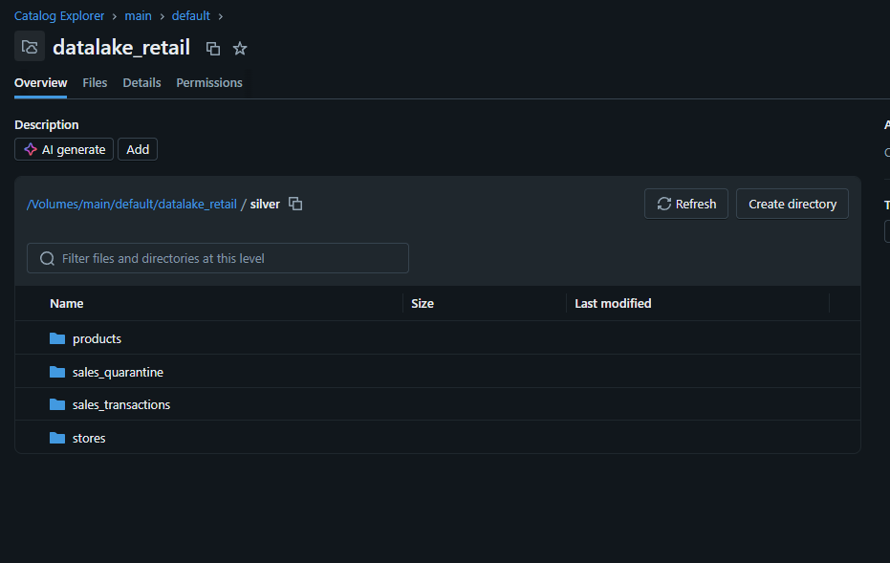
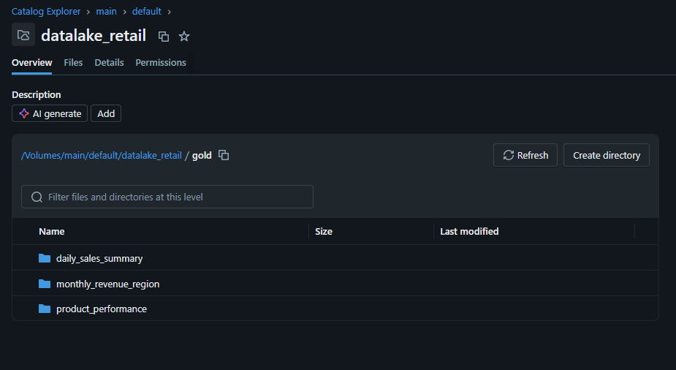

Gold Tables in Unity Catalog
Gold datasets are registered as managed Unity Catalog tables in main.default, enabling governed access and BI integration.
Gold Tables Created
- daily_sales_summary
- monthly_revenue_region
- product_performance
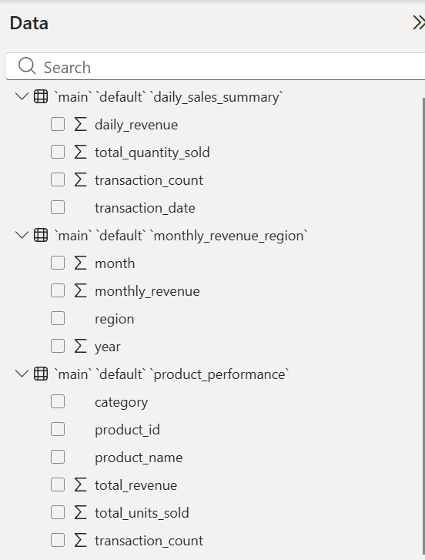
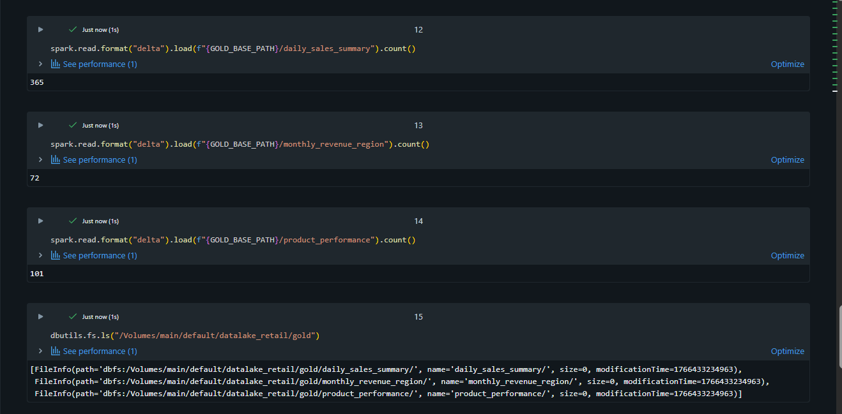

Gold Pipelines & Data Lineage
Gold tables are created using SQL-based table-to-table transformations from Silver tables.
Because all upstream and downstream datasets are registered in Unity Catalog, end-to-end lineage is automatically captured.
Lineage Validation
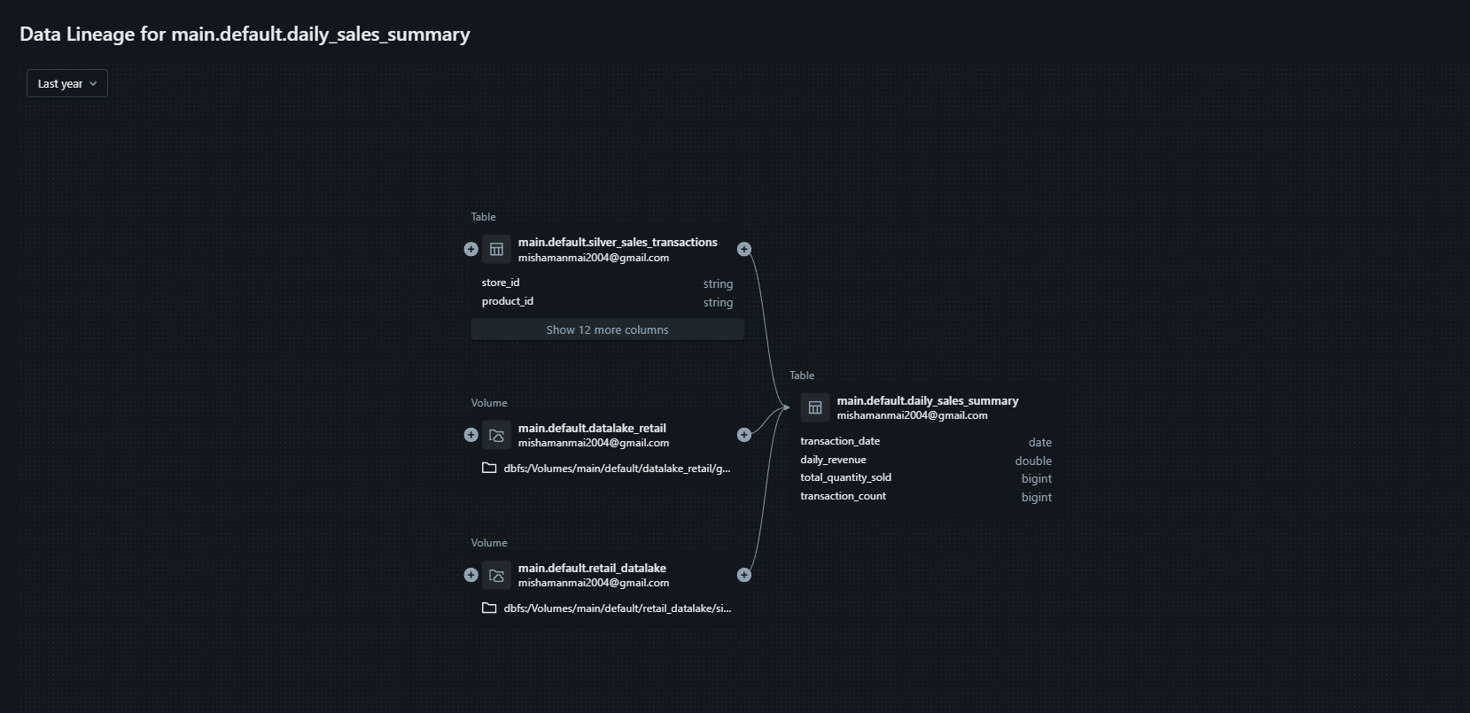
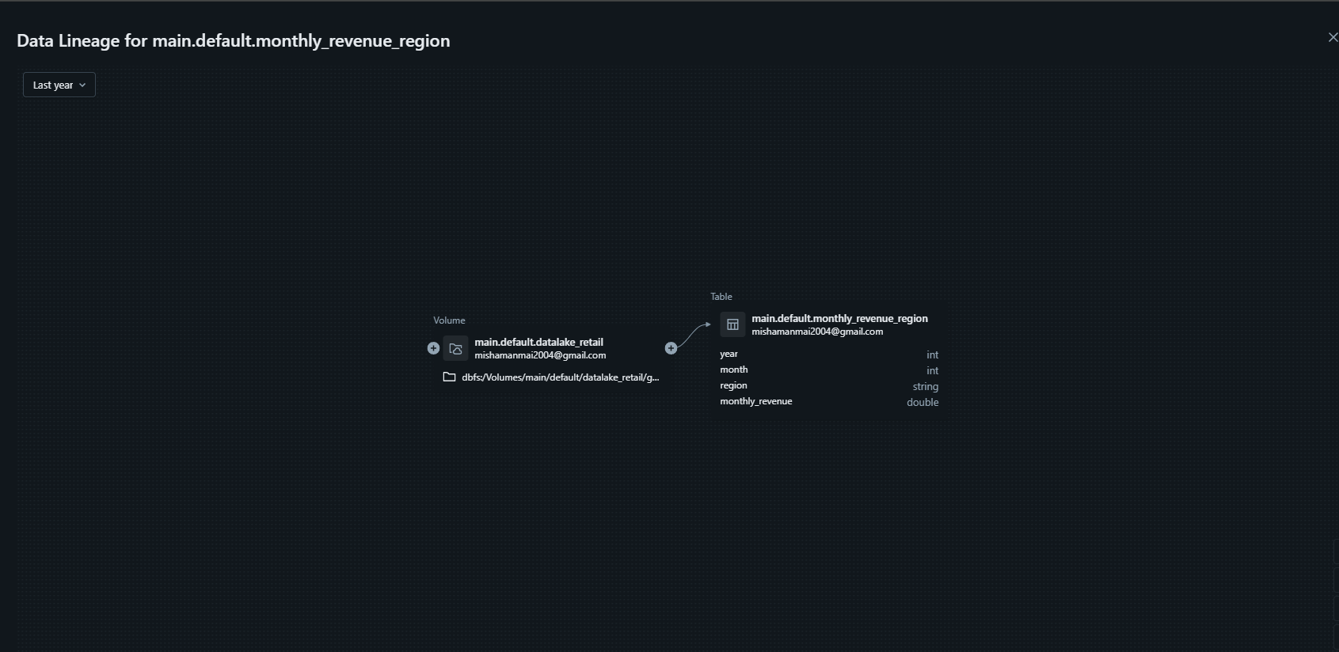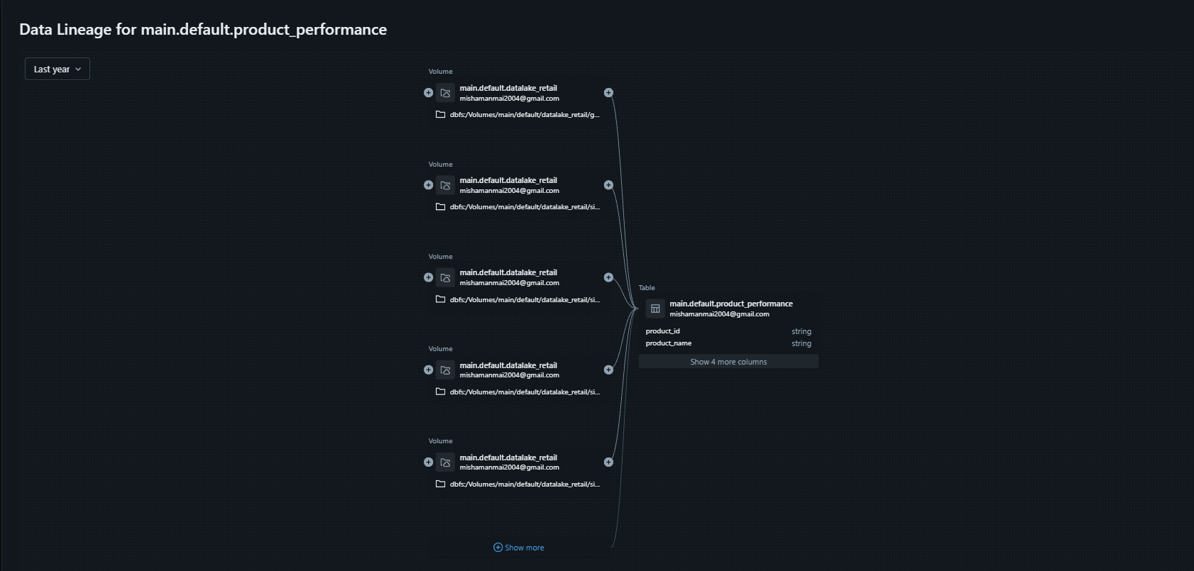

Power BI Dashboards
Gold tables are consumed in Power BI via Databricks SQL Warehouse to build business dashboards.
Dashboards Developed
- Executive Sales Dashboard
- Regional Performance Dashboard
- Product Performance Dashboard
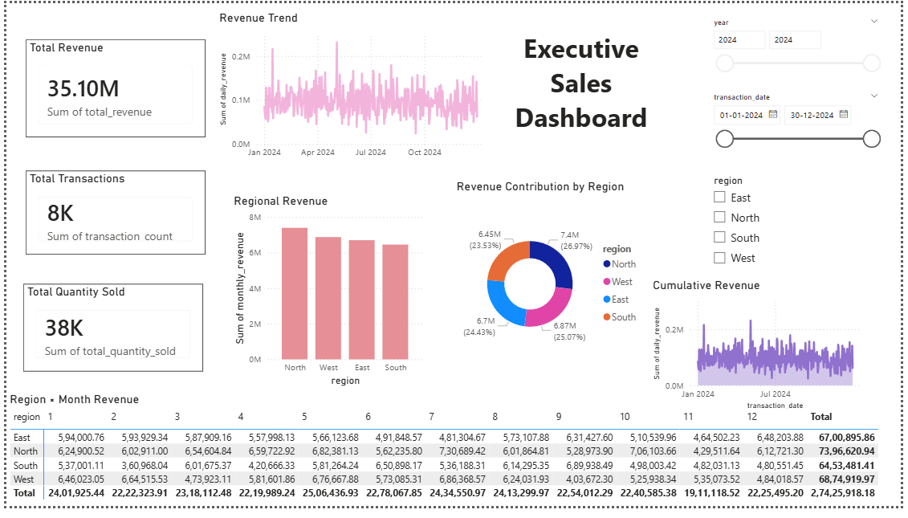
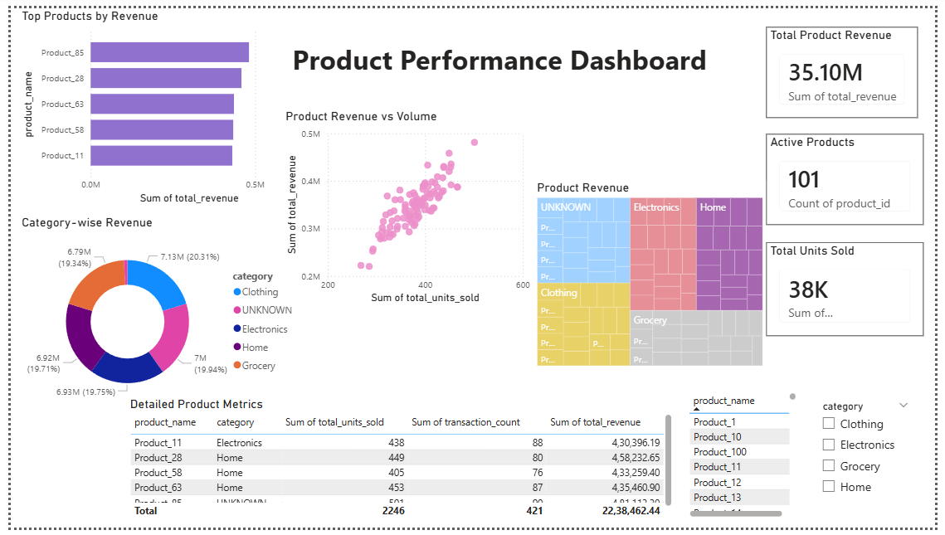
Pipeline Logging & Monitoring
Pipeline execution is logged to a dedicated Delta table to ensure observability and auditability.
Logged Information
- Pipeline start time
- Pipeline end time
- Record counts
- Execution status
- Error messages (if any)
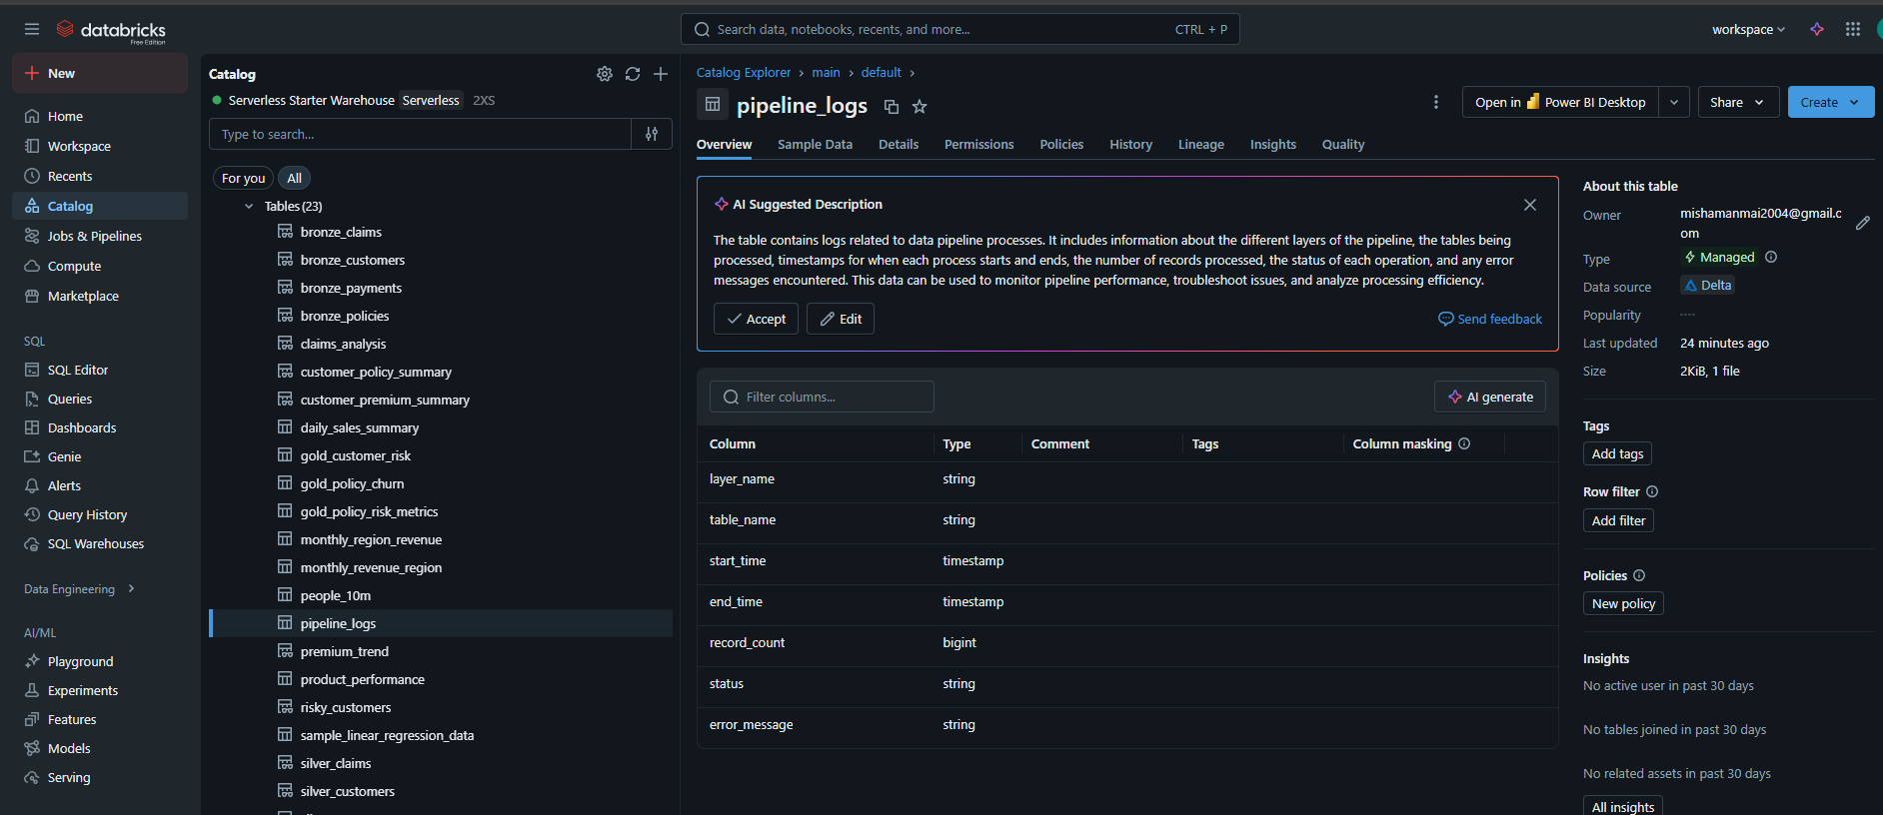
7. Validation Summary
The following validations were successfully completed:
- Bronze ingestion preserves raw schema
- Silver layer enforces data quality and calibration
- Gold tables correctly aggregate business metrics
- Unity Catalog lineage verified for all Gold tables
- Power BI dashboards refresh successfully
- Pipeline logs confirm successful execution

