

**Capstone Project Phase A**

**- Classroom Challenges Simulator**

**Reemy Halabi**

**Michael Trifonov**

**Supervisor:**

**Dr. Nataly Levi**

**project Code:**

**25-2-D-14**

**Link to** [**Github**](https://github.com/MishaTrifonov/Classroom-Challenges-Simulator)

**Table of Contents**

**Abstract ……………………………………………………………………………….……. 3**

**1. Introduction ..….…...…………………………………………………………….…….. 4**

**2. Background and Related work ………………………………………………..…….. 5**

**2.1 Evaluation of Alternatives …………………………...…………….…….…. 5**

**2.2. Unity Engine …….………...……………………………………….………… 6**

**2.3 Student Behavior …….…………...……………………………...………….. 7**

**3. Expected Achievements …………………………………………….……………….. 9**

**4. Engineering Process ………………………………………..………………………. 11  
 4.1 Functional Requirements ………………………………………………… 12  
 4.2 Non Functional Requirements …………………………….…………. 13 4.3 Product …………………………………………………………………….. 14 4.3.1 System Components …………………………………………….. 14**

**4.3.2 System Architecture…...…………………………………………..19**

**4.3.2 Emotional State Parameters …………………………….…...… 21  
 4.3.3 Pseudo Code ……………………………………………………… 22  
 4.3.4 Use Case Diagram ………………………………………..……… 23 4.3.5 Activity Diagram - Teacher …………………………….………. 24 4.3.6 Activity Diagram - Instructor ………….……..………………….25 ------------------4.3.7 Activity Diagram - Instructor ………….……..……………..….. 26**

**//////////////////// /4.3.8 Package Diagram ………….……..…………………………..….. 27**

**5. Interview ……………………..………………………………………...……………… 28**

**6. References ……………………………..………..………………………...………….. 32**

**Abstract.** The focus of this academic final project is to develop a system that is designed to support teachers in managing classroom dynamics by integrating real-time simulation, decision-making scenarios, and emotional-behavioural tracking within an interactive Unity-based environment.

This tool aims to address the complex challenges teachers face daily ranging from behavioural incidents and disengagement to time constraints and communication gaps with students.

By simulating authentic classroom situations, the system allows educators to practice responses, assess outcomes, and reflect on pedagogical strategies in a risk-free virtual space.

The project leverages gamification to enhance engagement and retention, while also providing analytics to inform professional growth. Ultimately, the system aspires to contribute to teacher preparedness, reduce stress, and improve student outcomes through more confident and responsive classroom management.

# **Introduction**

In recent years, particularly in the post-COVID era, teachers from grades 1–12 have increasingly called for strengthening the educational staff in schools. Teachers report growing workloads, feelings of professional isolation, and an urgent need to recruit additional support staff, reduce class sizes, and integrate permanent support teams within schools — such as school nurses, special education teachers, teaching assistants, lab technicians, emotional support aides, librarians, and IT specialists [1].

Simultaneously, teachers are facing new social phenomena that intensify educational challenges, such as increasing dependency on screens, loss of personal identity among students, and a heightened need for digital-social affirmation [2]. This reality highlights the importance of understanding students' challenging behaviours, recognizing that every behaviour is a form of communication reflecting an underlying need.

Without sufficient knowledge of cognitive theories, sensory sensitivities, and hidden anxieties, educators risk providing ineffective — or even harmful — support that could trigger negative emotional reactions and hinder learning [3;4]. Therefore, it is essential to design learning environments with emotional impacts in mind, while leveraging teachers' deep familiarity with their students to create tailored interventions [5].

Studies have shown that homeroom teachers, unlike subject-specific teachers, often contribute to higher student achievement due to their close emotional bonds with students [6]. Nevertheless, many of these teachers report inadequate preparation for the demands of their role; 88% reported receiving either insufficient training or none at all, and only a third received professional support for dealing with issues such as violence [7].

Given the evolving needs of educational staff and the role of schools as public institutions striving to deliver quality, equitable education, there is a clear need for innovative solutions. Schools must not only impart knowledge but also prepare students for societal life, promote cultural values, and support the realization of each student's full potential [8;9].

Another aspect of the problem is that despite recent reforms aimed at improving teacher salaries in Israel, many teachers still face economic instability. According to the OECD [10], teacher salaries, although increasing, often do not fully reflect the demands and stress of the profession. This economic pressure has contributed to teacher shortages and high attrition rates, creating challenges for maintaining a stable and experienced educational workforce.

This context brings to light the complex dilemmas faced by educators trying to support struggling students without reinforcing harmful labelling and social stratification [11].

To address this challenge, we are developing an innovative application designed to prepare new teachers for real-world classroom situations. The app simulates an interactive classroom environment where teachers must deliver lessons on pedagogical topics while simultaneously managing various real-time challenges — such as behavioral disruptions, emotional or learning needs, emotional overload, and unexpected student reactions[2][4].

The model provides a safe, scenario-based environment for practice and skill development, bridging the gap between theoretical academic training and the complex realities of classroom management. The app offers personalized feedback[6], practical improvement suggestions, and actionable tools to help teachers build confidence, develop classroom management skills, and respond thoughtfully and effectively to diverse situations[5].

In the next chapters we will talk about solutions that are available today that help the educators deal with such scenarios of the classroom environment and how they are being prepared and also our solution and contribution for the efficiency and training of today's teacher[15].

# **Background and Related Work**

**2.1 Evaluation of Alternatives**

A few of the existing solutions that available for the inexperienced educators:

**Internship / Teaching Practicum Lessons:** Most teacher training institutions offer field experience with a mentor teacher. While beneficial, these internships are often limited in duration and may not expose trainees to the full spectrum of classroom challenges, particularly those involving behavioral crises or emotional regulation[17][14].

**Theoretical Courses in Classroom Management:** Concepts such as authority, discipline, and student engagement are taught in academic settings. However, these courses typically lack the element of live, scenario-based practice, making it difficult for educators to internalize strategies through experience[2][3][19].

**Virtual Simulations (e.g., Mursion, SimSchool):** These applications offer simulated classroom environments with virtual students who respond in varying ways. While they provide valuable experiential learning in a controlled space, such systems are often cost-prohibitive or technically complex, limiting accessibility and ease of use[18][15].

**Educational Literature and Strategy Guides:** A range of books and resources provide theoretical strategies for classroom management. However, they lack interactive, real-time feedback, making it difficult for educators to transfer knowledge into practice effectively[8][9].

Although each of these tools offers value, none fully addresses the need for an **affordable, accessible, and immersive training experience** that equips new teachers to manage the emotional, behavioral, and technological complexities of modern classrooms.

Leonard A. Annetta’s research (2008) provides a critical theoretical foundation for our approach. He advocates for the use of **serious educational games** to engage learners through narrative, interaction, and feedback mechanisms. Such games offer “stealth learning” opportunities—where users absorb knowledge and skills while immersed in story-driven, decision-making tasks. These environments foster intrinsic motivation, cognitive reflection, and scenario-based experimentation—precisely the kind of pedagogy that novice teachers need as they develop classroom readiness [15].

Importantly, the gap between theory and practice is not solely rooted in pedagogy, but also in policy. For instance, in **China**, teacher training has undergone significant reform over several decades, structured into three phases: the period of exploration (1949–1976), recovery and development (1977–2009), and the current stage of consolidation and innovation (2010–present) [12;13]. Similarly, **France** has emphasized diversified teacher training, combining pedagogical theory with practical experience to create a well-rounded model [14].

These international examples illustrate how educational policy influences teacher preparedness and how innovative solutions can contribute. Drawing lessons from these systems while considering our own national context, we propose a new solution to address the persistent theory-practice divide.

Our project seeks to bridge this gap through the development of an **accessible, gamified simulation platform**. Built in Unity, the system will offer novice teachers practical training in classroom management, emotional regulation, and adaptive decision-making—all within **dynamic educational scenarios** that mirror real-life complexity and emotional nuance.

### **2.2 Unity Engine**

The proposed simulation system is developed using **Unity**, a leading cross-platform game engine created by Unity Technologies. Unity is widely adopted in both the gaming and educational technology industries due to its robust feature set, intuitive interface, and support for real-time interactive environments. These attributes make it especially well-suited for designing immersive simulations such as the classroom management platform in this project.

Unity's core advantages include:

* **Game Development Framework**: Unity provides a comprehensive suite of development tools, including a visual scene editor, animation systems, asset pipeline, and integration with third-party development assets. These tools allow developers to rapidly prototype and refine interactive content in both 2D and 3D environments.
* **Cross-Platform Compatibility**: One of Unity’s most significant strengths is its ability to deploy a single codebase across numerous platforms. The system being developed in this project will benefit from Unity's compatibility with Windows, macOS, iOS, Android, and virtual reality (VR) devices, ensuring broad accessibility for teacher training programs.
* **Scripting in C#**: Unity supports C# as its primary scripting language. This allows for a clean and maintainable codebase to implement core simulation mechanics, such as behavior trees, AI logic, and real-time feedback systems.
* **Physics Simulation**: Unity includes an integrated physics engine that supports realistic modeling of object interactions, rigid body dynamics, and collision detection. In the context of the classroom simulation, these features are leveraged to create responsive environments where avatar behaviors and user interactions reflect realistic dynamics.

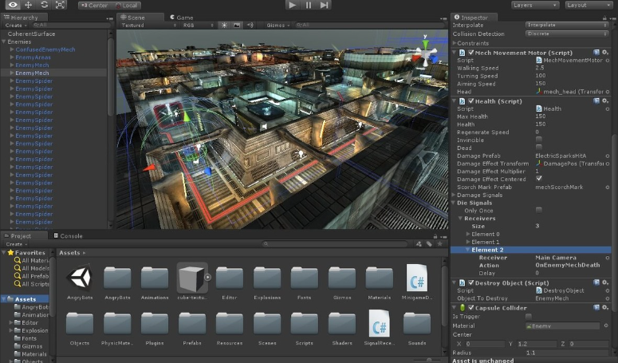  
The development interface when building with Unity3D engine.

Unity’s flexibility, scalability, and active developer ecosystem make it a practical and future-proof choice for implementing this educational simulation. It also supports modular integration with AI frameworks (e.g., Unity ML-Agents) and database systems, aligning with the technical needs of this project.

**2.3 Student behavior**

The single most common request for assistance from teachers is related to behavior and classroom management [16]. Student behavior is especially important in this project, especially understanding it at a fundamental level to simulate it at the highest level possible in our logic so that the inexperienced educators will receive the best representation of the classroom environment. In this subchapter we will discuss frequent student behavior and how to deal with it or what tools are best to prevent or react to it.

**2.3.1 Disruptive or aggressive student behavior**

Classrooms with frequent disruptive behaviors have less academic engaged time, and the students in disruptive classrooms tend to have lower grades and do poorer on standardized tests [17]. Furthermore, attempts to control disruptive behaviors cost considerable teacher time at the expense of academic instruction. Effective classroom management focuses on preventive rather than reactive procedures and establishes a positive classroom environment in which the teacher focuses on students who behave appropriately [18]. Rules and routines are powerful preventative components to classroom organization and management plans because they establish the behavioral context of the classroom by specifying what is expected, what will be reinforced, and what will be retaught if inappropriate behavior occurs [19]. This prevents problem behavior by giving students specific, appropriate behaviors to engage in. Monitoring student behavior allows the teacher to acknowledge students who are engaging in appropriate behavior and prevent misbehavior from escalating [20].

**2.3.2 Engaging students**

Students who have the opportunity to participate in collaborative discussion and engage in argumentation show an increase in knowledge and in their ability to use reasoning [21;22]. Engaging in argumentation also encourages students to think scientifically and exchange reasoning with peers [23]. and to perform better on tasks that require the use of reasoning [24]. For example, [25] showed that students who engaged in argumentation with the intention of reaching consensus were more likely to construct knowledge but also to increase the quality of their arguments. However, variation in the ways that students choose to interact can also have negative implications both within their current groups and on future individual performance [26]. Many studies have shown that student interactions are modulated by circumstance and context. For example, in the process-oriented guided-inquiry learning (POGIL) instructional approach, assigning students to take on specific roles during discussion can positively affect a group’s productivity [27]. When implemented effectively, this approach can promote individual participation and cultivate functional groups and improve performance and retention [28].

**2.3.3 Talkative students**

Talkative students occupy a dual space in classroom life: their verbal energy can ignite rich peer-to-peer reasoning, yet, if unmanaged, it can erode instructional time and silence quieter voices. Research on disruption shows that frequent interruptions reduce academic engaged time and tax teacher attention, elevating the risk that vigorous talk morphs into broader off-task behavior [17–20]. At the same moment, studies of collaborative argumentation and guided-inquiry approaches demonstrate that structured discussion roles—such as facilitator, summarizer, or questioner—transform that same verbal enthusiasm into higher-quality reasoning and deeper knowledge construction [21–25, 27, 28].

Beyond sheer frequency of speech, talkative students often display extroversion, strong social-affiliation needs, and a desire for immediate feedback; when these dispositions are recognized and positively channeled, they can serve as catalysts for classroom motivation [6, 22]. Effective management therefore blends clear participation norms (“one mic,” hand-raising, or digital queues) with constructive outlets for expression: rotating roles, employing talking tokens, and using proximity or subtle non-verbal cues to curb side-conversations before they escalate [18, 19]. Strategically giving these students leadership tasks—such as time-keeper during POGIL activities or peer-questioner in a debate—harnesses their verbal energy while modelling equitable discourse practices for the rest of the class [27, 28]. When teachers acknowledge moments of restraint (“Thanks for waiting—now share your point”) and set specific speaking goals in brief conferences, they reinforce desirable behavior while sustaining the motivational spark that fuels lively discussion [18, 22]. Such preventive, role-based routines not only balance classroom airtime; they also bolster teacher morale by reducing disruptive incidents and fostering an emotionally supportive climate in which every student’s voice—quiet or exuberant—can be heard [1, 3].

**2.3.4 Distracted students**

Distracted students—those whose gaze drifts to side-conversations, daydreaming, or digital devices—represent a subtler but equally corrosive challenge to classroom efficiency. Like overt disruptions, sustained inattention steadily shrinks academic engagement time and burdens teachers with constant re-directing, ultimately depressing overall achievement [17–19]. Yet evidence from collaborative learning research shows that active, role-based participation can pull wandering minds back into the task: when students are assigned concrete responsibilities (e.g., evidence-checker in an argumentation task or data-recorder in a POGIL activity) they re-anchor their attention and improve reasoning quality [21–25, 27, 28]. Preventive management therefore rests on two pillars. First, establish predictable routines and visual prompts—clear task timers, progress trackers, and strategic teacher walk-abouts—to signal when and where attention should focus, reducing the cognitive load of guessing “what’s next” [18, 19]. Second, weave frequent, structured check-ins—think “turn-and-summarize” micro-tasks or digital polling—so that every student is called on to *produce* rather than passively receive information; these micro-engagements not only cut inattention but also heighten class-level positive emotions, a predictor of stronger academic performance and teacher morale alike [1, 3, 6, 22]. By combining routine clarity with interactive accountability, educators convert potential drift into purposeful engagement and preserve the instructional flow for all learners.

1. **Expected Achievements**

**3.1 Objectives** The primary objective of this project is to create a simulation-based learning platform that enables novice teachers to bridge the gap between academic theory and practical classroom experience. The simulation, built using Unity, aims to recreate the real-time complexity of classroom management through interactive, scenario-driven gameplay. By placing users in dynamic situations involving student behavior, emotional responses, and pedagogical challenges, the platform allows future educators to experiment with intervention strategies in a safe, controlled environment. This hands-on exposure fosters better preparedness, confidence, and adaptive decision-making before stepping into an actual classroom.

**3.2 Outcomes** The intended outcomes of the project include the successful development and deployment of a fully functional application that provides immersive training experiences for education students. Users will engage with realistic simulations that mirror everyday classroom events, enabling them to develop practical skills such as de-escalation, positive reinforcement, and situational judgment. The platform will track user decisions and behavioral impacts, allowing both users and instructors to assess performance and monitor progress over time. These outcomes are designed to enhance individual skill development and provide institutions with insight into the learning trajectories and competency gaps of their teacher candidates.

**3.3 Unique Features** The system will feature a range of unique components that distinguish it from existing tools. A behavior simulation engine using Finite State Machines (FSMs) and probabilistic models such as Markov Chains will enable avatars to react in varied and realistic ways based on user input. The Teacher Response System will offer multiple intervention options with branching consequences, and the platform will include gamified elements—such as experience points, performance-based badges, and session summaries—to promote user motivation and engagement. A scenario manager will allow for the customization and randomization of classroom conditions, and instructors will have access to a feedback dashboard with replay functionality and performance analytics.

**3.4 Improving Teacher Training** The simulation is designed not only as a training tool for individuals but also as a means of improving broader teacher education methodologies. By offering structured opportunities for repeated practice, reflection, and analysis, the system supplements traditional lectures and teaching practices, which often lack consistency, exposure to edge cases, or timely feedback. The integration of session logging and decision tracking helps users identify patterns in their behavior and allows instructors to tailor support accordingly. As a result, the simulation supports a pedagogically sound, evidence-based approach to professional development in teacher preparation programs.

**3.5 Criteria for Success** Criteria for success include both technical and educational benchmarks. On the technical side, the application must maintain high performance across devices and platforms, providing smooth interactions and stable behavior simulations. On the educational side, success will be determined by positive user feedback, noticeable improvements in classroom decision-making, and adoption by teacher education institutions. Pedagogically, the simulation leverages Leonard Annetta’s concept of stealth learning [15], where users acquire core teaching competencies through immersive, story-driven interaction without explicit instruction. The platform’s long-term value will be reflected in its adaptability to various educational settings and its measurable impact on preparing teachers for the emotional, behavioral, and practical demands of today’s classrooms.

**4. Engineering process**

To develop a simulation that is not only technically functional but also educationally impactful, we began the engineering process by focusing on the real-world challenges that teachers face in the classroom. Our goal was to build a system that authentically reflects the emotional, behavioral, and pedagogical complexity of modern teaching. To guide development, we structured our early design thinking around a series of critical questions, including:

* What does the teacher encounter in the classroom on a daily basis?
* What situations are the most difficult or stressful for teachers to manage?
* What are the most extreme or emotionally charged scenarios teachers deal with?
* How can the simulation remain engaging and immersive for users over time?
* How can we design a visual interface that is both intuitive and aesthetically appealing?
* How can we simulate authentic student behavior that reacts meaningfully to teacher decisions?
* What kind of feedback is most helpful for teacher growth and self-reflection?
* How do we balance realism with playability to avoid overwhelming users?
* How can we differentiate scenarios to reflect different classroom types, subjects, and age groups?
* What game mechanics would motivate users to keep learning through multiple sessions?
* How do we ensure the system is inclusive and accessible for users with varying levels of experience or ability?
* How can we capture and analyze user actions to support long-term professional development?

To confront these questions and expand our knowledge, we used various resources ranging from scientific papers and peer-reviewed articles to educational blogs, case studies, and real classroom videos. These sources helped us understand not only the technical and pedagogical aspects of classroom management but also the emotional and behavioral realities teachers face in their day-to-day practice. After thoroughly reviewing the available literature and media, our team convened for collaborative discussions to share insights and highlight recurring themes.

### **4.1 Functional Requirements**

* The system allows the user to load, save, and switch between classroom scenarios defined in external JSON configuration files.
* It supports instantiating and managing at least 20 unique student avatars per scenario.
* Each avatar has configurable behavioral attributes such as attention level, engagement, and disruption likelihood.
* The user can select intervention actions in real time, including verbal prompts, seating rearrangement, positive reinforcement, and one-on-one dialogues.
* The system monitors teacher actions and avatar responses, generating real-time feedback through an in-game UI panel.
* All teacher actions and student responses are logged into a local SQLite database, enabling session replay and analytics.
* The simulation calculates and displays points, badges, and level progression based on the effectiveness of interventions.
* At the end of each session, a summary is presented to reflect performance and provide suggestions for improvement.

### **4.2 Non-Functional Requirements**

* The application maintains a minimum performance of 60 FPS on reference hardware (e.g., Intel i5 + GTX 1050 or equivalent mobile device).
* The system architecture is modular, allowing the integration of new scenarios, behaviors, and feedback rules without recompiling the source code.
* The application is deployable across Windows, macOS, Android, and iOS using Unity’s cross-platform capabilities.
* All interface components adhere to WCAG 2.1 AA accessibility standards, ensuring inclusive usability in font size, contrast ratio, and navigation support.
* Local session logs are encrypted, and atomic write operations are implemented to maintain data integrity.
* The simulation engine is built using Unity 2024 LTS with C# as the primary scripting language.
* Student behavior is powered by Unity ML-Agents Toolkit, enabling data-driven, adaptive simulations.
* Feedback modules are implemented via ScriptableObjects and displayed within the Unity scene using contextual prompts.
* The gamification layer utilizes Unity UI Toolkit to manage and display points, badges, level progression, and session statistics.

**4.3 Product**

### **4.3.1 System Components**

#### **1. Student Behavior Simulation Engine**

At the core of the application is the **Student Behavior Simulation Engine**, which generates realistic student behaviors in a virtual classroom. Each avatar operates based on an individualized behavior model with parameters such as attentiveness, engagement level, temperament, and likelihood of disruption. These variables evolve dynamically in response to teacher actions, classroom conditions, time progression, 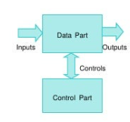and situational triggers.

The system employs **Finite State Machines (FSMs)** to define discrete behavioral states—such as *listening*, *talking*, *distracted*, *arguing*, and *engaged*—and the transitions between them.

The transitions and content generated will be based on **Unity ML-Agents** models. When appropriate, student avatars generate spontaneous verbal interactions — such as questions or off-topic comments. These models are integrated via API and conditioned by student profiles and classroom context to:

* Generate concise questions
* Simulate misunderstandings or confusion
* Create natural interruptions or social chatter

This adds a layer of unpredictability and realism to the training environment, forcing the trainee to respond as they would in a real classroom and allow us (the programmers) to imitate the learning of the students.

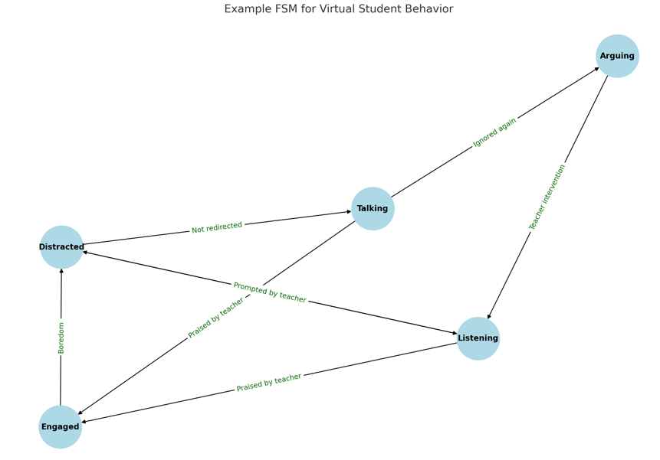

In addition, **Markov Chains** or **Bayesian Networks** may be implemented to probabilistically model state transitions, allowing more nuanced and unpredictable behavior. For example, if a talking student is consistently ignored, the model can increase the probability of escalating to argumentative behavior. This structure aims to mirror real classroom interactions with sufficient unpredictability to challenge and train the user.

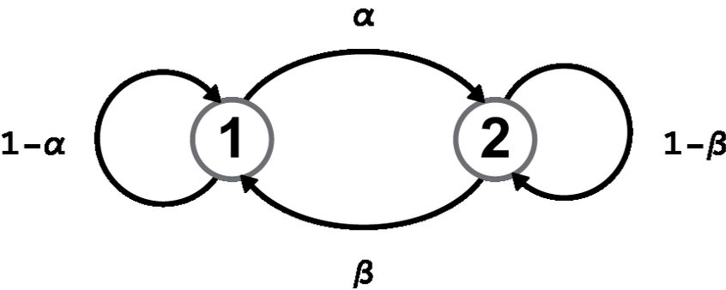

#### **2. Teacher Response System**

The ***Teacher Response System*** equips users with a dynamic set of pedagogical intervention options, including issuing a verbal warning, praising individual students, inviting a student to the board, altering instructional style, changing student seating arrangements, or asking a student to leave the classroom. Each of these actions initiates a cascade of both **immediate and long-term behavioral consequences**, affecting not only the targeted student but also **nearby peers within a defined influence radius**.

A **rule-based engine** or **decision tree** governs student responses, taking into account emotional state vectors, individual sensitivity traits, and contextual conditions. For example, a student with a background marked as *highly sensitive* may respond to a public reprimand with emotional withdrawal, while a more extroverted peer might escalate to confrontation. To simulate realistic social dynamics, the system uses **spatial proximity** to determine which students are affected indirectly by teacher actions. This design reflects how real classrooms operate, where students often react to their peers’ interactions with the teacher.

The teacher is equipped with a context-sensitive action menu, offering the following intervention types:

* **Yell** (raises authority but may raise anger/sadness nearby),
* **Praise a student** (increases happiness, encourages helping behavior),
* **Call student to the board** (can decrease boredom or raise anxiety),
* **Change seating position** (may reduce friction or isolate disruption),
* **Ask student to leave the class** (resets emotional state but may escalate peer tension).

Some examples of the mechanism of the actions:

**public class EmotionVector** { // Student emotion vector

public float Happiness = 5;

public float Sadness = 1;

public float Frustration = 1;

public float Boredom = 1;

public float Anger = 1;

**public void Decay()** { // Students emotion vector through time

Happiness = Mathf.Max(1, Happiness - 0.01f);

Boredom += 0.02f;

// ...

}

**public void ApplyTeacherAction**(TeacherAction action) {

switch(action.type) {

case Yell:

Anger += 2;

Sadness += 1;

break;

case Praise:

Happiness += 2;

break;

// etc.

}

}

}

Furthermore, the system incorporates a **feedback mechanism** that accounts for critical pedagogical nuances such as tone of delivery, timing, and consistency. These elements modulate the effectiveness of each action over time, shaping classroom climate and influencing overall student engagement, morale, and discipline.

For instance, **yelling at a disruptive student** may reduce their immediate noise level but simultaneously raise fear, sadness, or frustration in nearby students—especially those with vulnerable emotional profiles. Conversely, **praising a quiet or overlooked student** may improve not only their confidence but also positively affect neighboring students who share similar insecurities, encouraging more participation.

By enabling **multi-directional emotional propagation** through the classroom, the system demands that users weigh the **social-emotional ripple effects** of every action. This elevates the complexity of decision-making and fosters pedagogical empathy.

This dynamic system aligns with **Annetta’s emphasis on feedback loops** as a core design principle of educational games, promoting user reflection, adaptive learning, and emotional intelligence development through iterative interaction and real-time feedback [15].

#### **3. Scenario Management System**

This subsystem manages both pre-built and user-defined classroom scenarios. Each scenario consists of:

* **Initial classroom configuration** (e.g., number of students, individual behavior profiles)
* **Environmental factors** (e.g., time of day, subject matter, classroom layout)
* **Specific goals or constraints** (e.g., maintaining group cohesion during a project, managing a student with special needs)

Scenarios are governed by **scripted events** and **trigger-based logic**, enabling diverse branching outcomes based on the user’s decisions. This approach supports the development of adaptive expertise in managing real-world classroom diversity.

#### **4. Performance Tracking and Analytics**

To monitor user progress and support self-reflection, the system includes a Performance Tracking and Analytics module. This subsystem records:

Decision history and resulting student behaviors

Classroom-level metrics such as engagement, disruptions, and de-escalation success

Response time and pattern tracking across sessions

A **scoring algorithm** evaluates decisions against pedagogical best practices. Additionally, **data visualization tools** (e.g., attention heatmaps, behavioral trend graphs) offer insights for both users and instructors. These analytics serve to identify growth areas and reinforce effective strategies.

#### **5. Instructor Dashboard and Feedback Tool**

To support institutional use, the system includes a robust **Instructor Dashboard**. This interface allows teacher educators to:

Assign or customize specific classroom scenarios

Monitor student progress through decision logs and behavior outcomes

Provide **rubric-based feedback** aligned with teacher training standards

Replay user sessions for in-depth review and commentary

The ability to embed feedback and observe user evolution over time helps establish a cycle of reflection and improvement, echoing Annetta’s findings that **stealth learning** and narrative immersion enhance learner engagement and cognitive development [15].

### **4.3.2 System Architecture**

The architecture of the Classroom Challenges Simulator is strategically structured to maximize modularity, flexibility, and realism, addressing the pedagogical needs of teacher training programs through a comprehensive interactive simulation.

**Presentation Layer**

The user interface (UI) is built using the Unity UI Toolkit, providing trainees with intuitive interactions, clear scenario visualizations, and real-time, context-sensitive feedback. Visual elements such as emotional indicators, student behavior states, and intervention outcomes are dynamically rendered, enabling educators to intuitively navigate scenarios and interpret classroom dynamics effectively.

**Application Layer**

This layer encompasses the simulation's core logic, divided into distinct but integrated subsystems:

**Student Behavior Simulation Engine**

At the heart of the simulation lies the Student Behavior Simulation Engine. Employing Finite State Machines (FSMs), each student avatar transitions among discrete behavioral states—listening, talking, distracted, arguing, and engaged—in response to environmental conditions, elapsed time, and teacher interventions. Probabilistic modeling techniques, specifically Markov Chains and Bayesian Networks, introduce nuanced unpredictability, closely mirroring authentic student behaviors. The integration of Unity ML-Agents facilitates spontaneous interactions, including verbal questions, misunderstandings, and peer chatter, further enhancing realism.

**Teacher Response System**

This subsystem provides educators with contextually adaptive intervention options, such as verbal warnings, praise, seating adjustments, and targeted dialogues. A rule-based decision tree engine modulates immediate and cascading student emotional responses, factoring individual sensitivity profiles and classroom contexts. Emotional ripple effects propagate realistically through spatial proximity mechanisms, compelling educators to consider broader social-emotional impacts of each intervention, in alignment with Annetta’s educational feedback loop principles.

**Scenario Management System**

Scenario Management System supports both pre-defined and user-customized classroom setups. Scenario parameters encompass initial classroom conditions, student profiles, environmental settings, and specific pedagogical goals. Script-driven events and trigger-based logic yield complex, branching narrative outcomes contingent upon user decisions, fostering adaptive expertise in diverse teaching scenarios.

### **Data Layer (MongoDB)**

The system utilizes MongoDB, a flexible NoSQL document database, to store and manage simulation data. Its schema-less structure supports evolving classroom configurations, complex emotional state tracking, and varied session logs.

MongoDB stores documents representing:

* Student emotional vectors (happiness, anger, frustration, boredom, sadness)
* Teacher actions and their contextual metadata
* Scenario definitions (JSON-based)
* Session histories and analytics outputs

The Performance Tracking and Analytics module queries MongoDB to produce metrics such as engagement levels, disruption frequency, and intervention effectiveness. Aggregation pipelines enable the generation of visual insights like heatmaps and behavior trend charts, supporting data-driven reflection and pedagogical development.

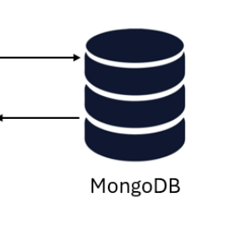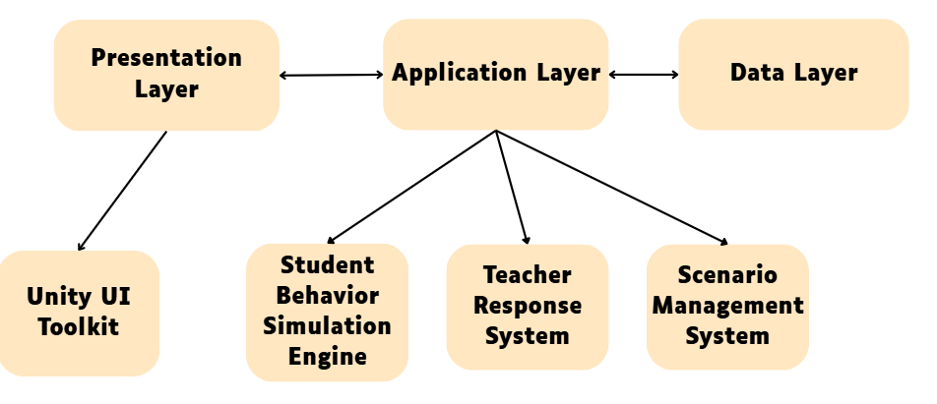

### **4.3.3 Emotional State Parameters**

Each StudentAgent maintains a lightweight "emotion vector" whose five scalar components continuously shape the agent’s decision policy. Values range from 1 (minimal) to 10 (maximal) and are updated every simulation tick.

|  |  |  |  |
| --- | --- | --- | --- |
| **Parameter** | **Increase Triggers** | **Decrease / Decay** | **Behavioural Influence** |
| **Happiness** | - Teacher acknowledges contribution  - Peer praise | - Time since last positive event  - Negative feedback | High values bias actions toward Listening or Engaged Participation and raise the probability of Helping Peers. |
| **Sadness** | - Teacher ignores raised hand  - Wrong answer / public correction | - Subsequent successful contribution  - Private teacher encouragement | Elevated sadness lowers talk frequency and can push state to Withdrawn (silent, avoids eye‑contact). |
| **Frustration** | - Multiple ignored attempts to speak  - Surrounding noise prevents being heard | - Successful turn‑taking  - Clear teacher guidance | Drives transitions from Listening → Side‑Talk → Disruptive. Also feeds into Angry when compounded. |
| **Boredom** | - Long stretch without interactive activity  - Topic mis‑matches student profile | - New task/role assignment  - Physical movement break | Rising boredom raises the chance of Off‑Task behaviours (doodling, phone). At ≥ 8 triggers yawning animation and peer‑distraction attempts. |
| **Angry** | - Teacher cuts off mid‑sentence  - Repeated invalidation by peers/teacher | - Teacher apology or restorative conversation  - Peer empathy event | High anger (> 7) unlocks Confront action (argues aloud). Also doubles the reward penalty for subsequent negative feedback. |

### **4.3.4 Simulation Loop Pseudocode**

This structure ensures synchronization between lesson delivery, student response, and behavioral outcome tracking—providing a complete learning loop for both simulation and pedagogical feedback.

**Class_Simulator:**

**classroom = Create_Classroom()**

**teacher = Create_Teacher()**

**students = Create_Students(number_of_students)**

**lesson = Initiate_Lesson(type_of_lesson, students)**

**lesson.start()**

**logs = []**

**while not lesson.finished():**

**teaching = teacher.teach()**

**student_behavior = students.trigger_behavior(teaching)**

**reaction = teacher.address_students_behavior(student_behavior)**

**logs.append((student_behavior, reaction))**

**Create_Analytics(logs)**

**classroom.close()**

### **4.3.5 Use case diagram:**

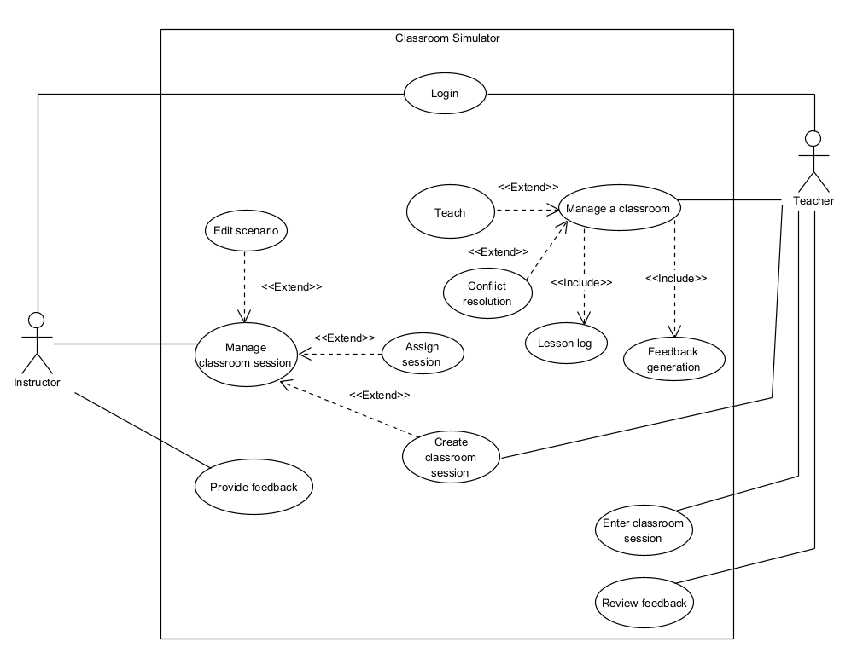

### **4.3.6 Activity diagram - teacher :**

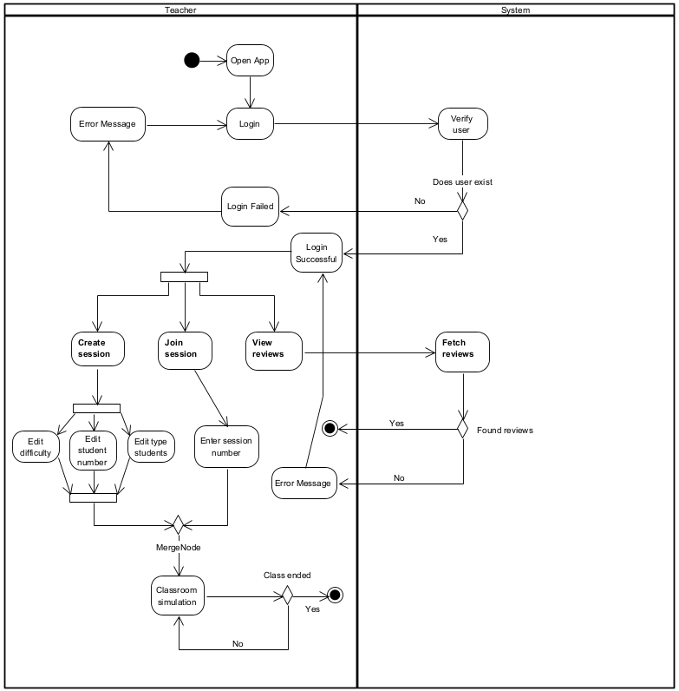

### **4.3.7 Activity diagram - Instructor:**

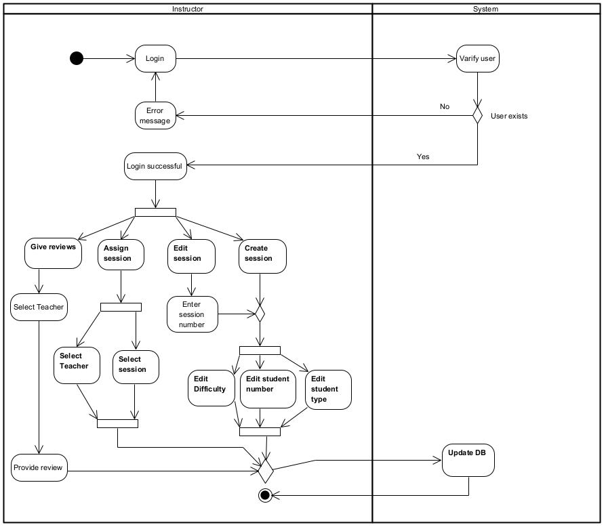

### **4.3.8** **Package Diagram**

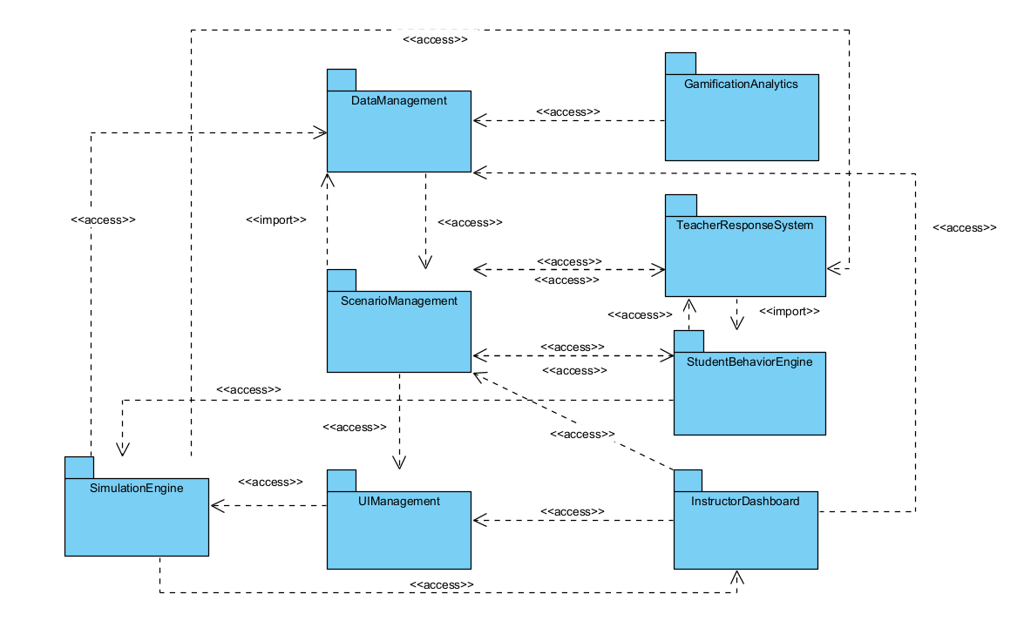

### **5. An interview with a teacher - Keren:**

The interview reveals that daily classroom management poses significant challenges, particularly in dealing with disruptive students, adapting to changing teaching plans, and engaging with families. Teachers often rely on personalized strategies, behavior charts, empathy, and parental involvement, though they feel underprepared due to limited and insufficient training during their studies. While simulation weeks are offered, real-life classroom dynamics remain difficult to manage without hands-on experience. Teachers emphasize the importance of emotional intelligence, recognizing student distress through behaviors like frustration or silence. When facing stress, they use calming techniques like music, breaks, and games. Understanding each student's background is considered essential. There is strong interest in simulation tools to prepare for a wide range of realistic classroom scenarios, including both positive and negative student behaviors. Teachers value visual, concise feedback and prefer gamified elements like levels and rewards to enhance engagement. Overall, the need for adaptable, emotionally aware, and practically equipped educators is clear, along with the desire for modern, accessible digital tools in teacher training.

The interview is conducted between a high-school teacher, Keren, and 2 students, Rimi and Michael.

**Interviewer** – מהם האתגרים המרכזיים שאתה חווה בניהול היומיומי של הכיתה?  
 **Karen the teacher** –  
 ניהול כיתה: איך לנהל, איך ליצור אווירה נכונה, איך להסתגל לתוכנית משתנה, איך להתמודד עם קשיים.  
 ילדים מפריעים שלא מקשיבים.  
 הורים ומשפחות.

**Interviewer** – איך אתה מתמודד עם תלמידים מפריעים או לא משתפים פעולה?  
 **Karen the teacher** –  
 יש תלמידים שלא מעוניינים ללמוד, "שוברים את הכללים" ומפריעים לתהליך כולו. אנו מערבים את המנהל, המחנך, ובמקרים קיצוניים — את ההורים.  
 יש מקרים שבהם תלמידים מקללים או מסרבים להקשיב. פתרונות:

* טבלאות התנהגות
* שיחות אמפתיות
* תגמולים לתלמידים (כלים מותאמים אישית לכל תלמיד)
* תוכניות אישיות, הרבה עידוד
* אם לתלמיד יש בית יציב – לערב את ההורים
* כיתות מחוננים: לשבץ בתוכניות מצוינות כדי להראות פרספקטיבה אחרת
* להפוך את השיעור למעניין, להשתמש בשיטות לימוד חדשות
* הלימודים עצמם אינם תמיד העיקר; עבור חלק מהתלמידים, בית הספר הוא מקום בטוח
* המורה צריך להיות גמיש – לדעת לשחרר תלמיד כאשר באמת אין עוד מה לעשות

**Interviewer** – עד כמה אתה מרגיש שקיבלת הכשרה מספקת להתמודדות עם התנהגות בעייתית?  
 **Karen the teacher** – מאוד מעט. אולי קורס אחד במהלך הלימודים, ללא מיקוד או במה לתרגול.

**Interviewer** – האם ההכשרה שלך כללה סימולציות של מצבים מהחיים האמיתיים?  
 **Karen the teacher** – פעמיים בשנה מתקיים שבוע מלא שבו סטודנטים מלמדים שיעורים (וכותבים תוכניות שיעור).  
 שבוע אחד בכל סמסטר. פעמים אחרות הם צופים במורה בכיתה.  
 ההתנהגויות והמצבים חוזרים על עצמם בכל שלב – יסודי, חטיבה ותיכון.

**Interviewer** – אילו מיומנויות היית רוצה לפתח עוד לפני כניסה לכיתה?  
 **Karen the teacher** –

* התמודדות עם דילמות
* תרגול במצבים אמיתיים
* דיבור בפני קהל
* מנהיגות
* גמישות
* חמלה
* אסרטיביות
* רוך
* הגעה לכל תלמיד
* האצלת סמכויות
* ללמד עצמאות
* לדעת מתי לשחרר

**Interviewer** – האם נתקלת במצב שבו ההכשרה התאורטית לא הספיקה?  
 **Karen the teacher** – כן, מורים שמסיימים את התואר לא יודעים לאן הם נכנסים. הניסיון שמקבלים במהלך התואר לא מספק.

**Interviewer** – איך אתה מזהה מצבים רגשיים אצל תלמידים שמובילים להפרעות?  
 **Karen the teacher** –  
 מכירים את הילד ולומדים לזהות:

* אם הוא נכשל (תסכול) – תגובות ספונטניות
* חוסר הבנה – עלול להוביל לכעס ("למה אחרים מבינים ואני לא?")
* שקט וחוסר השתתפות הם גם סימנים לאי הבנה

**Interviewer** – מה אתה עושה כשאתה מרגיש לחץ או תסכול במהלך שיעור?  
 **Karen Pedagogical Supervisor** –

* לומדים להירגע, להבין, להראות אמפתיה, לערב אחרים
* נותנים לתלמידים משימות
* לפעמים חשוב להתעלם

**Interviewer** – איך אתה מחזיר את השקט לכיתה כשהיא נהיית רועשת?  
 **Karen Pedagogical Supervisor**–

* "פעמון שקט" – דוגמה לרעש שמושך את תשומת הלב
* משחקי סיטואציה
* הפסקה של 5 דקות
* מוזיקת רקע (ג'אז רגוע, בלוז...)
* משחקי כיתה (כמו Kahoot)

**Interviewer** – עד כמה חשוב להבין את הרקע האישי של תלמידים לניהול כיתה?  
 **Karen Pedagogical Supervisor** – חשוב מאוד. בכל בית ספר יש ישיבות על תלמידים.  
 המחנך צריך להכיר כל תלמיד אישית – זה מה שמאפשר להבין באמת את ההתנהגות ואת מה שהם מרגישים.

**Interviewer** – האם היית משתמש באפליקציה שמדמה ניהול כיתה ככלי תרגול?  
 **Karen Pedagogical Supervisor**– כן, חיפשתי אחת בעבר ולא מצאתי. מצאתי דברים דומים אך לא כמו זה.

**Interviewer** – מה היית מצפה מהסימולציה כדי שתהיה שימושית עבורך?  
 **Karen Pedagogical Supervisor** –

* כל התרחישים האפשריים – כולל אלימות, קללות, מקרים קיצוניים
* קשיים פרטניים וכיתתיים
* כלים להתמודדות, ניהול מצבים, שיתוף אתגרים

**Interviewer** – עד כמה אתה פתוח לשימוש בכלים דיגיטליים בהכשרת מורים?  
 **Karen Pedagogical Supervisor**– תמיד פתוח.  
 מורים ותיקים נוטים להימנע מכלים דיגיטליים, אך מורים צעירים יותר דווקא מעוניינים.  
 הרתיעה נובעת לרוב מפחד או חוסר ידע.

**Interviewer** – איך אתה בדרך כלל לומד מטעויות בניהול כיתה?  
 **Karen Pedagogical Supervisor** – לומד דרך רפלקציה עצמית, התייעצות עם קולגות או יועצים.

**Interviewer** – האם משוב ממנחים/קולגות עוזר לך להשתפר? כיצד?  
**Karen Pedagogical Supervisor** – כן, במיוחד מקולגות – עוזרים לפתור מצבים, בונים פתרונות יחד, נותנים תחושת תמיכה, מראים שאתה לא לבד, ומציעים פתרונות שלא חשבת עליהם.

**Interviewer** – האם היו מצבים שבהם התגובה שלך רק החריפה את ההתנהגות של תלמיד?  
 **Karen Pedagogical Supervisor** – כן — כשכועסים או מתוסכלים מתלמידים מסוימים, הם נהנים מזה וזה מחמיר את המצב.

**Interviewer** – אילו תרחישים היית רוצה לראות במשחק כדי שישקף את המציאות שלך?  
 **Karen Pedagogical Supervisor** –

* התמודדות עם אתגרים
* פדגוגיה מותאמת אישית
* עבודה עצמאית (התקדמות לאורך זמן)
* עבודת צוות – איך מעודדים עבודת צוות בכיתה
* שמירה על קשב
* גמישות ופתרון בעיות
* סוגי תגובות
* סדרי עדיפויות

**Interviewer** – אילו סוגי תגובות של תלמידים היית רוצה לראות במשחק כדי שישקף את המציאות?  
 **Karen Pedagogical Supervisor** –

**שליליות:**

* קללות
* אלימות
* חיקוי
* לגלוג
* בריונות
* חטטנות
* התנהגות מתריסה
* ריח גוף לא נעים
* חוסר כבוד

**חיוביות:**

* מחמאות למורה
* הערכה לשיעור
* בקשה ללמידה נוספת
* אווירה חיובית
* מילים טובות על המשפחה

**Interviewer** – איזה סוג משוב היה עוזר לך הכי הרבה בסימולציה – מספרי? מילולי? חזותי?  
 **Karen Pedagogical Supervisor** – חזותי — מוחשי יותר, קצר ולעניין. גם מספרי, אך לא מסובך מדי.

**Interviewer** – איזה סוג של "אלמנט משחקי" (פרסים, נקודות, שלבים) היה גורם לך להרגיש יותר מעורב?  
 **Karen Pedagogical Supervisor** – משוב ותגמול בכל פעם — אולי שלבים כמו XP. שיהיה הכי פשוט שאפשר — גופן גדול, נגישות מעל הכל.

**References**

[1] - Kurtz, H. (2025). Teachers say these factors could boost their morale. Education Week, 44(19), 26-29.

[2] - McDonnell, A. A., & McCreadie, M. ([2019](https://doi.org/10.4135/9781526470409.n36)). Behavioral issues and supports. In The SAGEhandbook of autism and education (pp. 449).

[3] - Hargreaves, A. (1998). The emotional practice of teaching. Teaching and Teacher Education,14(8), 835–854.

[4] - Bower, G. H. (1992). How might emotions affect learning. The Handbook of Emotion andMemory: Research and Theory, 3, 31.

[5] - Stichter, J. P., Laffey, J., Galyen, K., & Herzog, M. (2014). iSocial: delivering the SocialCompetence Intervention for Adolescents (SCI-A) in a 3D virtual learning environment for youth with high functioning autism. Journal of Autism and Developmental Disorders,44(2), 417–430.

[6] - Kashy‐Rosenbaum, G., Kaplan, O. & Israel‐Cohen, Y. (2018). Predicting academic achievement by class‐level emotions and perceived homeroom teachers' emotional support. Psychology in the Schools, 55(7), 770-782.

[7] - Zeira, A., Astor, R. A. & Benbenishty, R. (2004). School violence in Israel: Perceptions of homeroom teachers. School Psychology International, 25(2), 149-166.

[8] - Y. Harpaz. How to Design an Educational Environment in Six Steps: A Guide.

[9] - Lam, Tz. (1972). The Contradictory Rationales in Teaching. Tel Aviv: Poalim Library.

[10] - OECD. (2024). Education at a Glance 2024: Israel Country Note. OECD. Retrieved from <https://gpseducation.oecd.org/CountryProfile?primaryCountry=ISR>

[11] - Toval, 2007.

[12] - Qu, T., & Gong, X. (2019). Review and prospect of teacher training policy for primary and secondary schools in the 70 years of new China [in Chinese]. Journal of Hebei Normal University (Educational Science Edition), 5(3), 49–55.

[13] - Li, Yang, Wang, Policies, Strategies, and the Evolutionary Logic of LargeScale Teacher Training in China.

[14] - Ries, F. (2016). A study of teacher training in the United States and in Europe. The European Journal of Social and Behavioural Sciences, 27(8), 29–34.

[15] - Video games in education: Why they should be used and how they are being used.” - 2008 Leonard A. Annetta

[16] - Rose, L. C., & Gallup, A. M. (2005). The 37th Annual Phi Delta Kappa/Gallup Poll of the Public’s Attitudes toward the Public Schools. Phi Delta Kappan, 87, 41-57. <http://dx.doi.org/10.1177/003172170508700110>.

[17] - Shinn, M. R., Ramsey, E., Walker, H. M., Stieber, S., & O'Neill, R. E. (1987). Antisocial behavior in school settings: Initial differences in an at risk and normal population. *The Journal of Special Education, 21*(2), 69–84. [https://doi.org/10.1177/002246698702100207](https://psycnet.apa.org/doi/10.1177/002246698702100207).

[18] - Effective Behavior Support: A Systems Approach to Proactive Schoolwide Management, Timothy J. Lewis and George Sugai.

[19] - Colvin, G., Kameenui, E. J., & Sugai, G. (1993). Reconceptualizing behavior management and school-wide discipline in general education. *Education and Treatment of Children, 16*(4), 361–381.

[20] - "Judgable" people: Personality, behavior, and competing explanations, Colvin, C. Randall.

[21] - Johnson, D. W., Johnson, R. T., & Taylor, B. (1993). Impact of cooperative and individualistic learning on high-ability students’ achievement, self-esteem, and social acceptance. Journal of Social Psychology, *133*(6), 839–844.

[22] - Johnson, D. W., & Johnson, R. T. (1999). Making cooperative learning work. Theory into Practice, *38*(2), 26–35. [https://doi.org/10.1080/ 00405849909543834](https://doi.org/10.1080/00405849909543834). [Google Scholar](http://scholar.google.com/scholar_lookup?hl=en&volume=38&publication_year=1999&pages=26-35&journal=Theory+into+Practice&issue=2&author=D.+W.+Johnson&author=R.+T.+Johnson&title=Making+cooperative+learning+work).

[23] - Asterhan, C. S. C., & Schwartz, B. B. (2009). Argumentation and explanation in conceptual change: Indications from protocol analyses of peer-to-peer dialog. Cognitive Science, 33(3), 374–400. [https://doi.org/ 10.1111/j.1551-6709.2009.01017](https://doi.org/10.1111/j.1551-6709.2009.01017) [Medline](https://www.lifescied.org/servlet/linkout?suffix=B2&dbid=8&doi=10.1187%2Fcbe.20-03-0054&key=21585475), [Google Scholar](http://scholar.google.com/scholar_lookup?hl=en&volume=33&publication_year=2009&pages=374-400&journal=Cognitive+Science&issue=3&author=C.+S.+C.+Asterhan&author=B.+B.+Schwartz&title=Argumentation+and+explanation+in+conceptual+change%3A+Indications+from+protocol+analyses+of+peer-to-peer+dialog).

[24] - Boa, L., Cai, T., Koenig, K., Fang, K., Han, J., Wang, J., … & Wu, N. (2009). Learning and scientific reasoning. Science, 323(5914), 587–597. <http://doi.org/10.1126/science.1167740> [Google Scholar](http://scholar.google.com/scholar_lookup?hl=en&volume=323&publication_year=2009&pages=587-597&journal=Science&issue=5914&author=L.+Boa&author=T.+Cai&author=K.+Koenig&author=K.+Fang&author=J.+Han&author=J.+Wang&author=N.+Wu&title=Learning+and+scientific+reasoning)

[25] - Felton, M., Garcia-Mila, M., Villarroel, C., & Gilabert, S. (2015). Arguing collaboratively: Argumentative discourse types and their potential for knowledge building. British Journal of Education Psychology, 85(3), 372–386.

[26] - Marion, S. B., & Thorley, C. (2016). A meta-analytic review of collaborative inhibition and post collaborative memory: Testing the predictions of the retrieval strategy disruption hypothesis. Psychological Bulletin, 142(11), 1141–1164.

[27] - Moog, R. S., & Spencer, J. N. (2008). Process oriented guided inquiry learning (POGIL) (p. 994). Washington, DC: ACS Symposium Series; American Chemical Society.

[28] - Simonson, S. R. (2019). POGIL: An introduction to process oriented guided inquiry learning for those who wish to empower learners. Sterling VA: Stylus Publishing.

• Israel Innovation Authority. (n.d.). *Enhancing Educational Technologies*. Retrieved from https://innovationisrael.org.il/en/article/enhancing-educational-technologies/

• JNS. (2024). *Israel Unveils Groundbreaking AI Education Plan for 2025*. Retrieved from https://www.jns.org/israel-unveils-groundbreaking-ai-education-plan-for-202

Unkelos-Shpigel, N., Berencwaig, B., & Kas, S. (2023). Revise That Again: Are You Motivated?