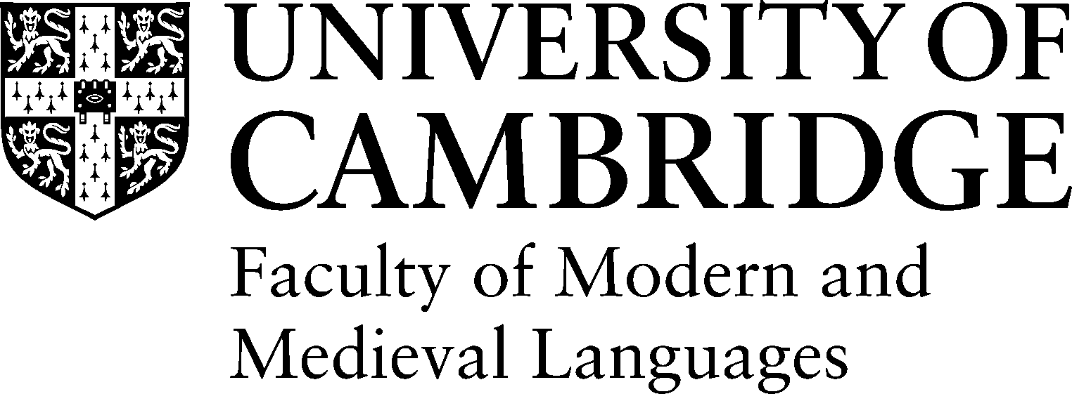

**CONSENT FORM**

Project title: Comparative Earnings and Strategic Behaviour

Research team: Misha Tseitlin and Dr John Williams

If you have any questions, please contact Misha Tseitlin, mjt208@cam.ac.uk

* I confirm that I have read and understand the information sheet dated __/11/2019 for the above-mentioned study and have had the opportunity to ask questions.
* I understand that my participation is voluntary and that I am free to withdraw at any time, without giving any reason, and without my rights being affected.
* I understand that any data that are collected will be used and stored anonymously, in accordance with the Data Protection Act. Results are normally presented in terms of groups of individuals. If any individual data were presented, the data would be completely anonymous, without any means of identifying the individuals involved.
* I understand that these data may be used in analyses, publications, and conference presentations by researchers at the University of Cambridge and their collaborators at other research institutions. I give permission for these individuals to have access to these data.
* I understand that personal information (such as language background, age, gender, and other information such as hometown and education information) will be collected as part of this research. Full data will only be accessible to the research team. However, anonymised data may be used in analyses, publications and conference presentations. For full details on how we use your personal information, see *https://www.information-compliance.admin.cam.ac.uk/data-protection/research-participant-data*
* I have been given a copy of this form to keep.

I _____________________________________ agree to participate in the above mentioned study run by Misha Tseitlin, an undergraduate student at the Faculty of MML at the University of Cambridge.

Date Signature of participant

Misha Tseitlin /11/2019

Name of researcher Date Signature of researcher