Mishaal Khaled Almubarak

Project 1

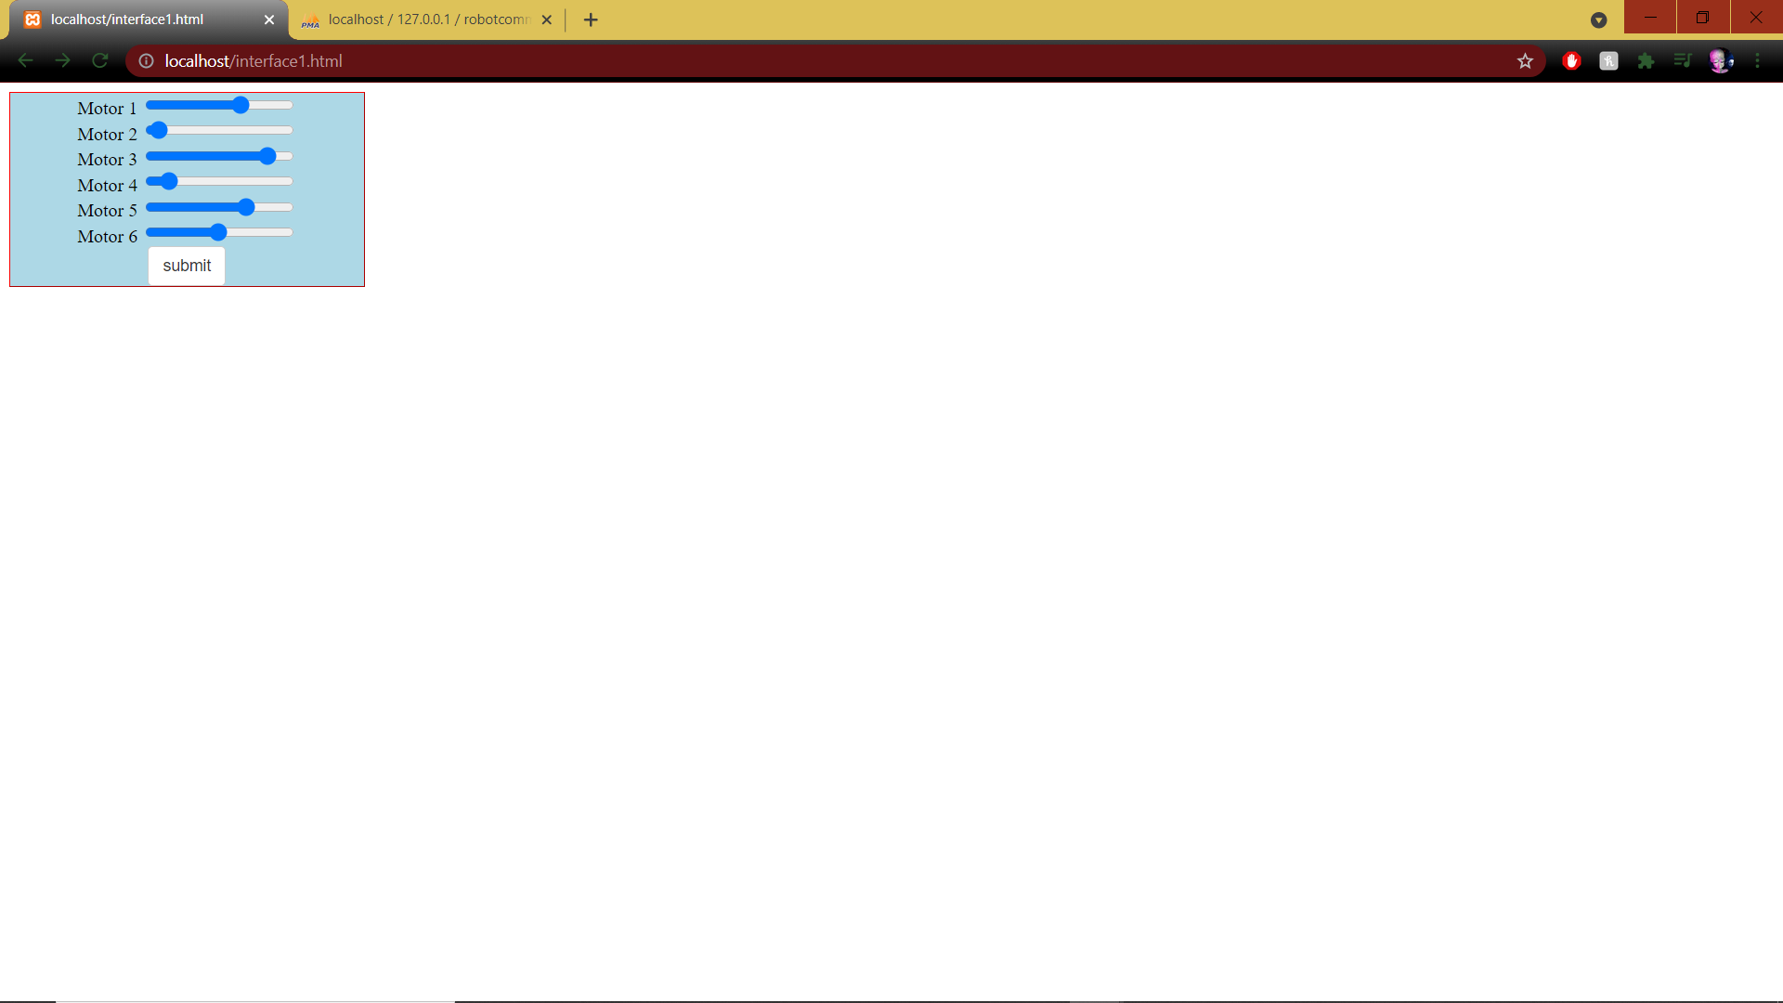Interface

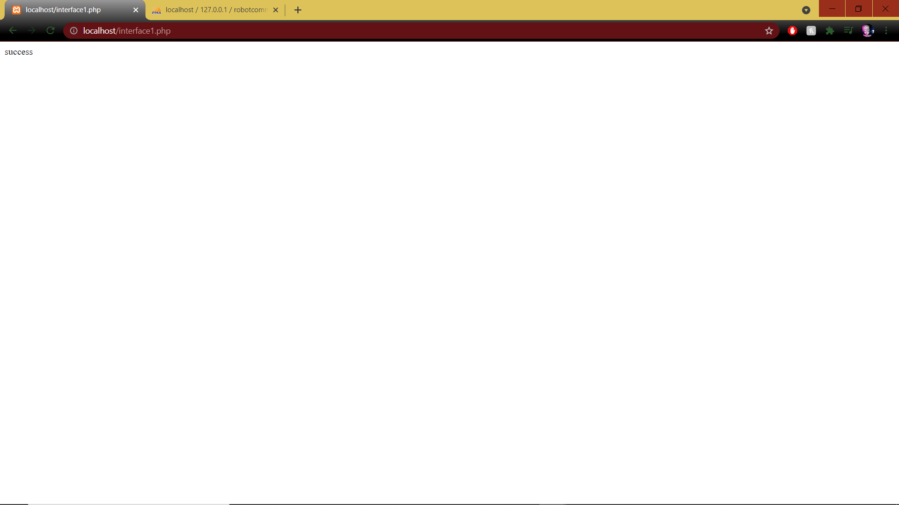After clicking button (success)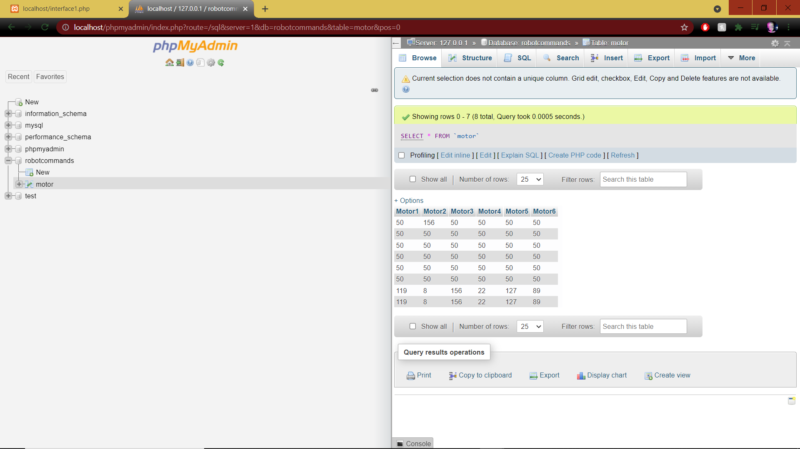

Database shown with range input in newly updated table