Mishaal Almubarak STT

In this window, after using the command (python transcribe.py -t 5) and speaking into the mic (hello world this is me), this output is shown.

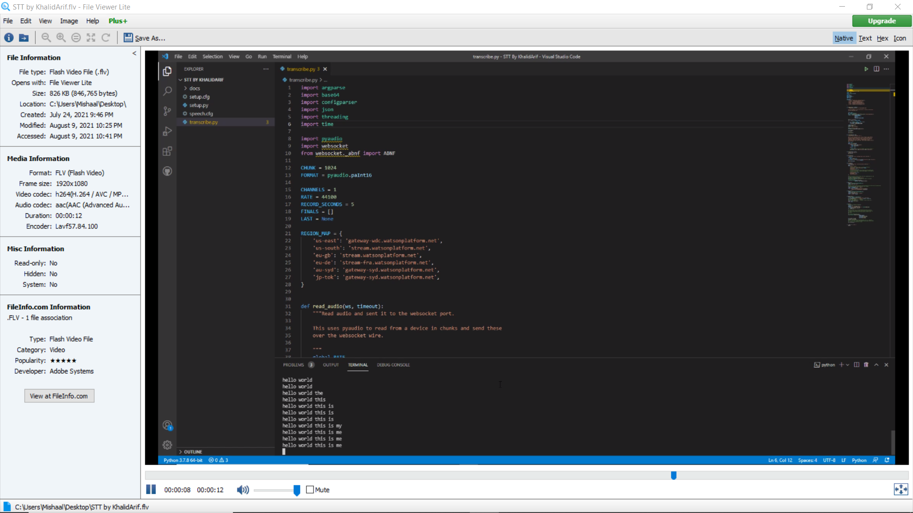

TTS

Use the files to create any sound from the text.