Task 2

Mishaal Khaled Almubarak

Control Panel

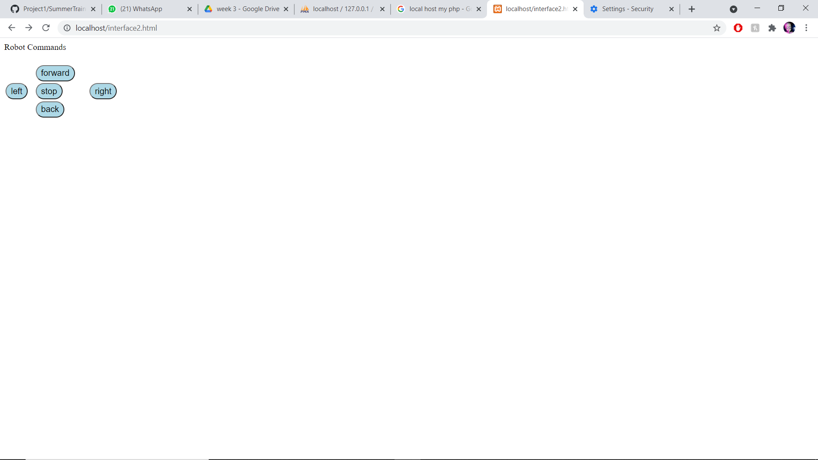

Database when clicking forward > left > stop adds the following –

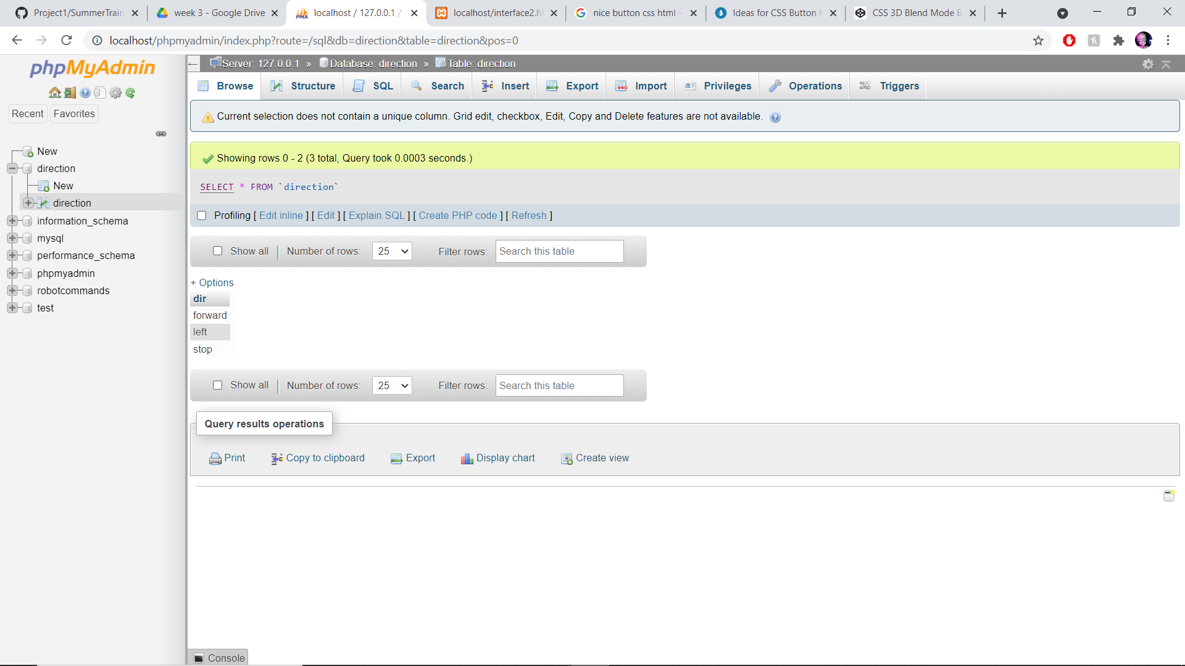

Then forward> stop> left> back> back

