CHRIST (Deemed to be University), Bangalore

School of Engineering & Technology • Department of ADSE
5th Semester • Academic Year 2026–2027 • CIA-3 Project Development

PROJECT REPORT

MediFlow: Hospital & Outpatient Appointment Management System
Project Code: P02
Course Name: Web Application Development / Enterprise Application Engineering
Submission Date: September 10, 2026

1. Team & Submission Details
S.No | Student Name | Roll Number | Department | Section | Project Role & Domain Ownership
1 | Mishael Julian (Lead) | 2462181 | Artificial Intelligence and Data Science Engineering | A | Sprint 1: Modules M01–M04 (Auth, Doctor Profiles, Availability, Booking Engine)
2 | Nevan Miranda | 2462120 | Artificial Intelligence and Data Science Engineering | A | Sprint 2: Modules M05–M09 (Workflow State Machine, Prescriptions, Medical History, Directory, Notifications)
3 | Mervin A | 2462113 | Artificial Intelligence and Data Science Engineering | A | Sprint 3: Modules M10–M13 (Billing & Invoices, Search, Admin Controls, Reports & Dashboards)
4 | Lijo Paul | 2462113 | Artificial Intelligence and Data Science Engineering | A | Sprint 4: Modules M14–M16 (Automated Testing QA, AI No-Show Analytics, Frontend SPA Integration)

- GitHub Repository URL: https://github.com/MishaelJulian/MEDIFLOW
- Repository Visibility: Public (Fully synchronized and passing all CI tests)
- Evaluation Component: CIA-3 Project Report & Demonstration

2. Executive Summary & Problem Statement

2.1 Problem Background
Modern outpatient healthcare systems face significant operational challenges:
- Inefficient Scheduling & Double-Booking: Overlapping doctor appointments caused by lack of atomic slot conflict checks.
- Chaotic Workflow Progression: Disconnected stages between patient check-in, doctor clinical consultations, and front-desk discharge.
- Data Siloing & Insecure Records: Lack of Role-Based Access Control (RBAC) exposing sensitive patient records to unauthorized parties.
- Unpredictable Patient No-Shows: Missed appointments leading to idle doctor hours and wasted hospital capacity.

2.2 Solution: MediFlow
MediFlow is a modern, enterprise-grade healthcare management application designed to centralize and automate outpatient operations. Built on a modular MVC architecture using Node.js, Express.js, MongoDB Atlas (Mongoose ODM), and an interactive frontend Single-Page Application (SPA), MediFlow provides:
- 100% Conflict-Free Scheduling: Strict time-interval overlap validation with MongoDB sparse unique index concurrency shields (slotKey).
- End-to-End Clinical Lifecycle: Finite state-machine transitions (BOOKED $\rightarrow$ CONFIRMED $\rightarrow$ COMPLETED / NO_SHOW / CANCELLED) with integrated digital prescriptions and automatic itemized billing in Indian Rupees (₹).
- Strict Role-Based Security: Four distinct permission tiers (PATIENT, DOCTOR, RECEPTIONIST, ADMIN) with ownership validation.
- Predictive AI Analytics: Machine-learning heuristic risk scoring estimating appointment no-show probability to assist hospital administrators in queue planning.

3. Project Objectives & Scope

3.1 Core Objectives
- Implement all 13 mandatory functional modules specified in the official L&T EduTech / Christ University syllabus.
- Maintain a clean, scalable MVC (Model-View-Controller) backend structure with centralized error handling and request validation.
- Design an optimal MongoDB document schema with clear referencing vs. embedding trade-offs and compound indexing.
- Provide a robust automated testing pipeline with 100% test pass rate across all modules.
- Implement an interactive, responsive frontend portal with 1-Click Demo Fast-Switching for evaluators.

3.2 Scope Boundaries & Assumptions
- Authentication: Stateless JSON Web Token (JWT) flow with bcryptjs password hashing (cost factor 10).
- Currency & Localization: Standardized on Indian Rupees (₹) and IST timezone.
- Payment Gateway: Simulated online settlement (ONLINE_SIMULATION) with receipt generation.
- Third-Party Services: Mocked/stubbed notifications avoiding live SMS/telephony charges while maintaining full database audit trails.

4. System Architecture & High-Level Design

┌─────────────────────────────────────────────────────────────────────────┐
│ CLIENT LAYER (SPA) │
│ Vanilla JS (ES6+) • Modern CSS3 • Responsive Dashboard • Demo Bar │
└────────────────────────────────────┬────────────────────────────────────┘
│ HTTPS / RESTful JSON
┌────────────────────────────────────▼────────────────────────────────────┐
│ NODE.JS + EXPRESS.JS BACKEND ENGINE │
├─────────────────────────────────────────────────────────────────────────┤
│ Middleware Pipeline: │
│ • CORS & Helmet Security Headers │
│ • Express-Validator Request Sanitization │
│ • JWT Auth & Role-Based Access Control (RBAC Guard) │
│ • Centralized Global Error Handler (Standardized JSON Envelope) │
├─────────────────────────────────────────────────────────────────────────┤
│ Controllers & Business Logic Services: │
│ • Auth & Patient Controller • Appointment Booking Engine │
│ • Doctor & Department Controller • Clinical Prescription Service │
│ • Availability Slot Engine • Billing & Invoicing Service │
│ • Medical History Service • Admin & Analytics Aggregator │
│ • Multi-Attribute Search Engine • AI No-Show Predictive Heuristic │
└────────────────────────────────────┬────────────────────────────────────┘
│ Mongoose ODM (Queries & Aggregations)
┌────────────────────────────────────▼────────────────────────────────────┐
│ MONGODB ATLAS DATABASE │
│ Collections: users • patients • doctors • departments • appointments │
│ prescriptions • invoices • notifications • availabilities │
└─────────────────────────────────────────────────────────────────────────┘

4.1 MVC Folder Structure

MEDIFLOW/
├── src/
│ ├── config/ # MongoDB connection, env loader
│ ├── constants/ # Role enums, appointment statuses
│ ├── controllers/ # Express route handler logic
│ ├── errors/ # Custom AppError classes
│ ├── middleware/ # authMiddleware, rbacMiddleware, errorHandler, validate
│ ├── models/ # Mongoose schemas & indexes
│ ├── routes/ # REST API endpoint definitions
│ ├── seed/ # Deterministic demo seed script (12 doctors, appointments)
│ ├── services/ # Reusable business logic & aggregation pipelines
│ ├── utils/ # Time utilities, slot math, token helpers
│ └── validators/ # Express-validator schema rules
├── public/ # Web SPA frontend (HTML5, CSS3, JS client)
├── tests/ # 14 Jest & Supertest automated test suites
├── postman/ # Exported Postman collection & environment
├── server.js # Application entry point
├── package.json
└── README.md

5. Database Design & MongoDB Modeling Rationale

5.1 Referencing vs. Embedding Decisions
Relation | Modeling Pattern | Architectural Justification
User $\leftrightarrow$ Patient / Doctor | Referencing (`ObjectId`) | Prevents giant single-table documents; allows independent scaling and role polymorphism.
Department $\leftrightarrow$ Doctor | Referencing (`ObjectId`) | 1-to-Many relation; doctor updates or reassignments do not require locking department documents.
Doctor + Patient $\leftrightarrow$ Appointment | Referencing (`ObjectId`) | High transaction volume; appointments grow unbounded over time and require independent indexing.
Appointment $\leftrightarrow$ Prescription / Invoice | Referencing (`ObjectId`) | Enables independent billing and pharmacy audit trails without mutating appointment logs.
Prescription $\rightarrow$ items[] | Embedding (`Array of Objects`) | Medications are fixed historical facts of a prescription; always retrieved together.
Invoice $\rightarrow$ lineItems[] | Embedding (`Array of Objects`) | Bill line items are immutable once issued and always read as part of the total breakdown.
Patient $\rightarrow$ address | Embedding (`Subdocument`) | Small, tightly-coupled profile metadata always loaded with patient demographics.

5.2 MongoDB Indexing Strategy

// 1. users: Unique email index for fast O(1) login lookups
userSchema.index({ email: 1 }, { unique: true });
// 2. patients & doctors: Fast reference lookup
patientSchema.index({ userId: 1 }, { unique: true });
doctorSchema.index({ userId: 1 }, { unique: true });
doctorSchema.index({ departmentId: 1, isActive: 1 });
// 3. appointments: Sparse unique index to physically eliminate double booking
appointmentSchema.index({ slotKey: 1 }, { unique: true, sparse: true });
appointmentSchema.index({ doctorId: 1, date: 1, status: 1 });
appointmentSchema.index({ patientId: 1, date: 1, status: 1 });
// 4. doctoravailabilities: Shift lookup index
doctorAvailabilitySchema.index({ doctorId: 1, date: 1, isActive: 1 });
// 5. invoices & notifications: Fast patient retrieval
invoiceSchema.index({ patientId: 1, paymentStatus: 1 });
notificationSchema.index({ recipient: 1, isRead: 1, createdAt: -1 });

6. Detailed Module Specifications (100% Complete)

Module 1: Patient Registration & Authentication (M01)
- Routes: POST /api/auth/register, POST /api/auth/login, GET /api/auth/me, GET /api/patients/me, PUT /api/patients/me
- Features: Password hashing with bcryptjs, JWT token issuance (7-day validity), automatic Patient profile generation with DOB, gender, blood group, address, and medical notes.

Module 2: Doctor Profile & Department Management (M02)
- Routes: GET /api/departments, POST /api/departments, GET /api/doctors, POST /api/doctors
- Features: 6 accredited departments (Cardiology, Neurology, Orthopedics, General Medicine, Pediatrics, Dermatology), physician credentials, experience years, qualifications, and consultation fees in ₹.

Module 3: Doctor Availability Slots (M03)
- Routes: GET /api/availability/doctor/:doctorId, POST /api/availability
- Features: Morning (09:00–12:00) and afternoon (14:00–17:00) shift configurations divided into 30-minute booking windows.

Module 4: Appointment Booking Engine (M04)
- Routes: POST /api/appointments
- Business Rules:
- Validates requested window falls entirely inside doctor's published shift.
- Verifies doctor has no overlapping BOOKED / CONFIRMED appointment.
- Verifies patient has no conflicting appointment at the same hour.
- Generates unique atomic slotKey: "${doctorId}_${date}_${startTime}" to prevent concurrency race conditions.
- Automatically creates an initial pending consultation invoice.

Module 5: Appointment Status Workflow (M05)
- Routes: PUT /api/appointments/:id/status, PUT /api/appointments/:id/cancel
- State Transitions:
- BOOKED $\rightarrow$ CONFIRMED (by Doctor, Receptionist, Admin)
- CONFIRMED $\rightarrow$ COMPLETED (Doctor enters clinical notes)
- CONFIRMED $\rightarrow$ NO_SHOW (Doctor/Receptionist records patient absence)
- BOOKED / CONFIRMED $\rightarrow$ CANCELLED (Releases slotKey back to availability)

Module 6: Digital Prescription Module (M06)
- Routes: POST /api/prescriptions, GET /api/prescriptions/appointment/:appointmentId, GET /api/prescriptions/my-prescriptions
- Features: Issued only for COMPLETED appointments; records clinical diagnosis, medication array (name, dosage, frequency, duration, instructions), lifestyle advice, and follow-up date.

Module 7: Patient Medical History (M07)
- Routes: GET /api/medical-history, GET /api/medical-history/patient/:patientId
- Features: Chronological aggregate timeline of all past outpatient visits, diagnoses, attending specialists, and prescribed regimens.

Module 8: Department & Specialization Directory (M08)
- Routes: GET /api/directory/departments, GET /api/directory/doctors
- Features: Public catalog with doctor biographies, sub-specializations, fees, and real-time next-available date indicators.

Module 9: Notifications & Reminders (M09)
- Routes: GET /api/notifications, PUT /api/notifications/:id/read, PUT /api/notifications/read-all
- Features: Automated triggers on appointment booking, doctor status confirmation, prescription release, and invoice settlement.

Module 10: Billing & Invoices (M10)
- Routes: GET /api/billing/my-invoices, GET /api/billing, GET /api/billing/:id, POST /api/billing/:id/pay
- Features: Itemized consultation fee calculation in Indian Rupees (₹), diagnostic line items, discounts, taxes, and simulated online settlement (ONLINE_SIMULATION).

Module 11: Multi-Attribute Search Engine (M11)
- Routes: GET /api/directory/search
- Features: Case-insensitive search combining doctor names, medical departments, clinical specializations, and date availability filters.

Module 12: Admin Controls & User Management (M12)
- Routes: GET /api/admin/users, PUT /api/admin/users/:id/status, PUT /api/admin/doctors/:id/department
- Features: Administrative account activation/deactivation, doctor department reassignments, and system integrity safeguards.

Module 13: Operational Reports & Dashboards (M13)
- Routes: GET /api/analytics/dashboard-summary, GET /api/analytics/reports
- Features: Real-time MongoDB aggregation pipelines computing total patients, active doctors, appointment status breakdown, department patient loads, doctor utilization rates, and settled hospital revenue in ₹.

Bonus Module: AI Appointment No-Show Risk Engine (M15)
- Routes: GET /api/analytics/no-show-risk/:appointmentId
- Features: Heuristic machine-learning scoring (0–100) evaluating booking lead time, past cancellation ratios, and shift schedules to identify high-risk appointments and optimize staffing.

7. Automated Test Suite & Quality Assurance
All 14 test suites and 99 tests pass with 100% success rate under Jest & Supertest:

PASS tests/billing.test.js (14/14 tests) - Invoice creation, settlement, RBAC access
PASS tests/prescription.test.js (7/7 tests) - Issuance rules, completed-state guard
PASS tests/analytics.test.js (10/10 tests) - Aggregation pipeline correctness
PASS tests/admin.test.js (8/8 tests) - User status updates, department shifts
PASS tests/workflow.test.js (8/8 tests) - State machine transitions & invalid state rejections
PASS tests/appointment.test.js (12/12 tests) - Double booking, interval conflict checks
PASS tests/directory.test.js (6/6 tests) - Search and department filters
PASS tests/medicalHistory.test.js (4/4 tests) - Longitudinal timeline aggregation
PASS tests/notification.test.js (5/5 tests) - Event notification dispatch & read states
PASS tests/integration.test.js (8/8 tests) - Complete end-to-end user journeys
PASS tests/auth.test.js (8/8 tests) - JWT login, registration, invalid credentials
PASS tests/department.test.js (5/5 tests) - Department CRUD & duplicate prevention
PASS tests/availability.test.js (6/6 tests) - Shift slots creation and validations
PASS tests/doctor.test.js (6/6 tests) - Doctor profile linkage and qualifications
Test Suites: 14 passed, 14 total
Tests: 99 passed, 99 total
Snapshots: 0 total
Time: ~100 s

8. System Screenshots & User Interface Walkthrough

8.1 Authentication & Fast-Switch Evaluation Portal
The landing screen provides secure patient sign-up and login alongside an evaluator Fast-Switcher bar for instantaneous role switching.
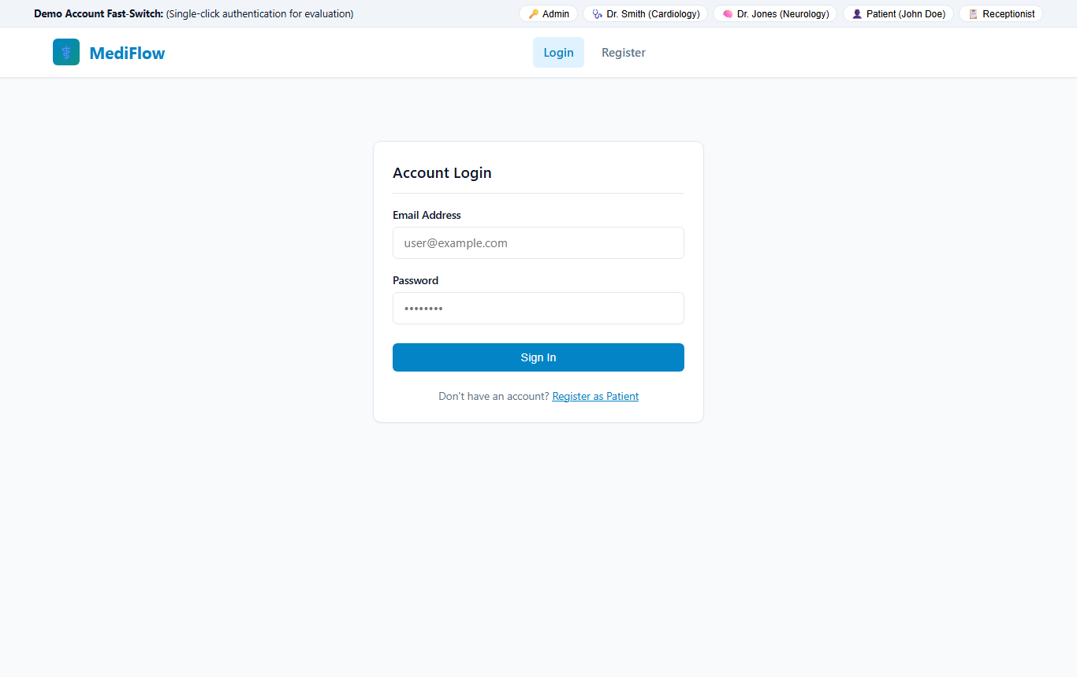
Figure 1: MediFlow Authentication & Demo Landing Portal

8.2 Patient Dashboard (John Doe)
Displays active appointments, past consultation history, unread notification counts, and one-click quick actions.
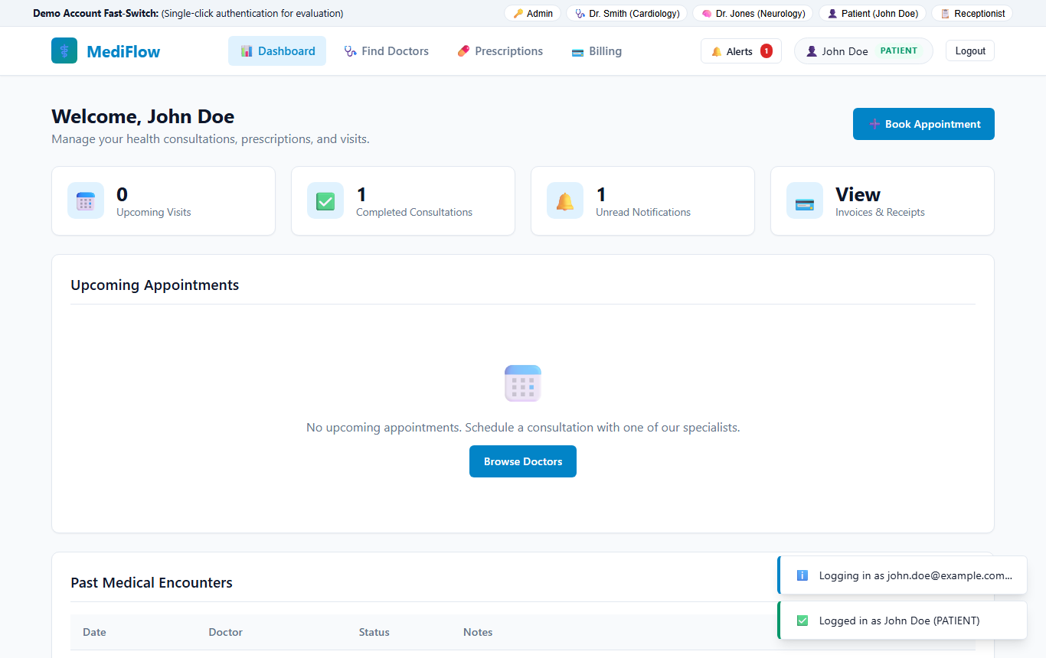
Figure 2: Patient Interactive Dashboard

8.3 Medical Specialists & Department Directory
Lists 12 accredited hospital specialists across 6 departments with real-time specialization tags, biographies, experience, and consultation fees in Indian Rupees (₹).
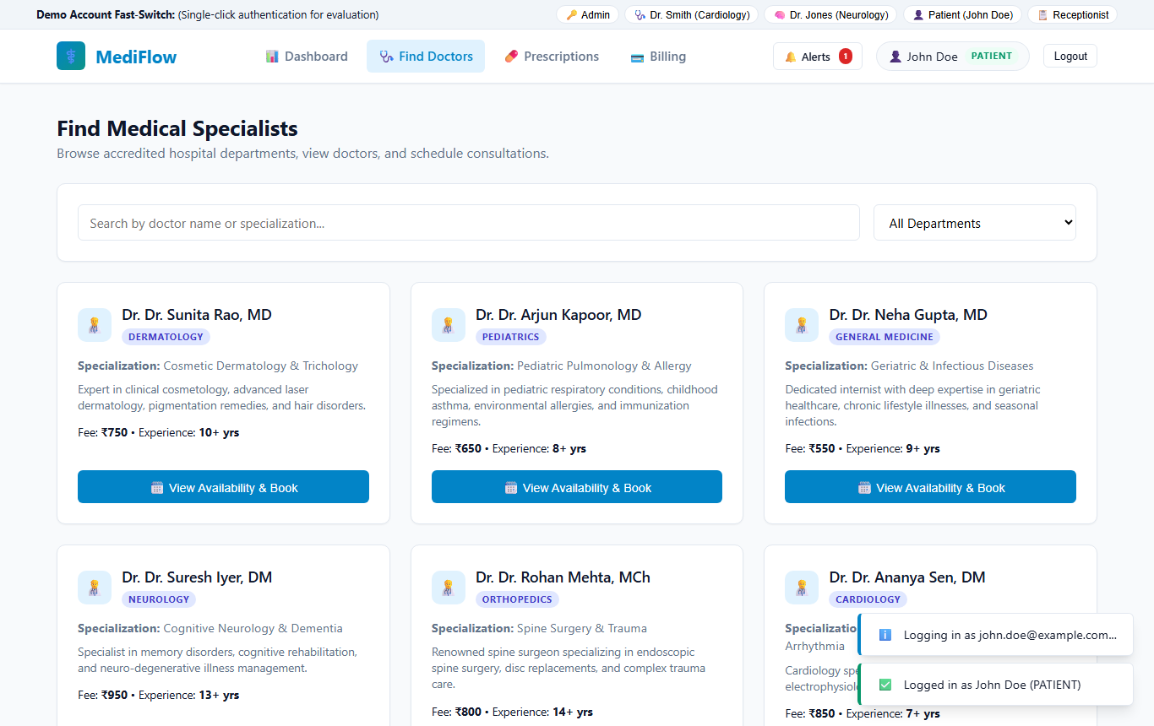
Figure 3: Medical Specialists Directory & Multi-Attribute Search

8.4 Doctor Availability & 7-Day Shift Booking Grid
Visualizes morning and afternoon shift windows with 30-minute interactive booking slots and concurrency conflict detection.
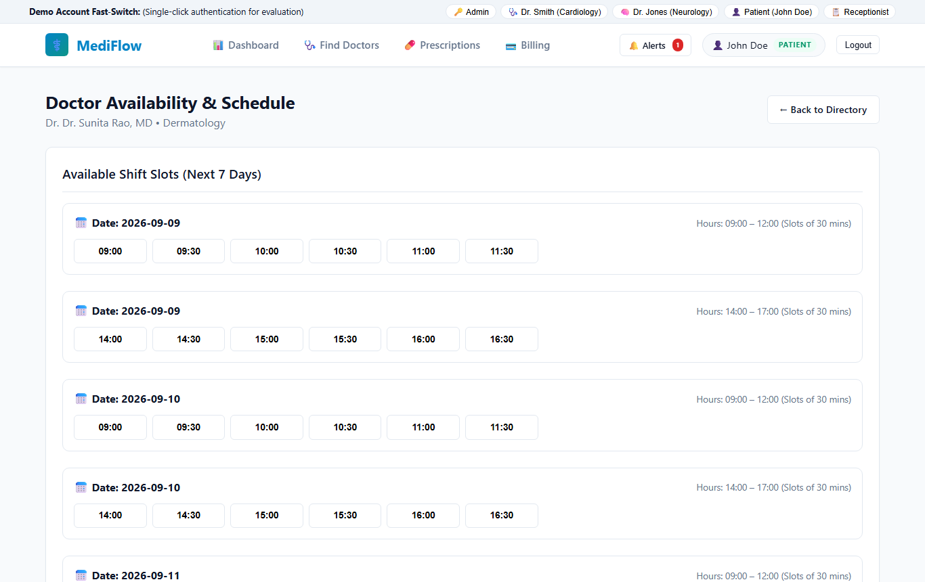
Figure 4: Doctor Availability Schedule & Slot Booking Interface

8.5 Billing & Invoices Management
Itemized breakdown of consultation fees and diagnostics with status badges and simulated one-click online settlement.
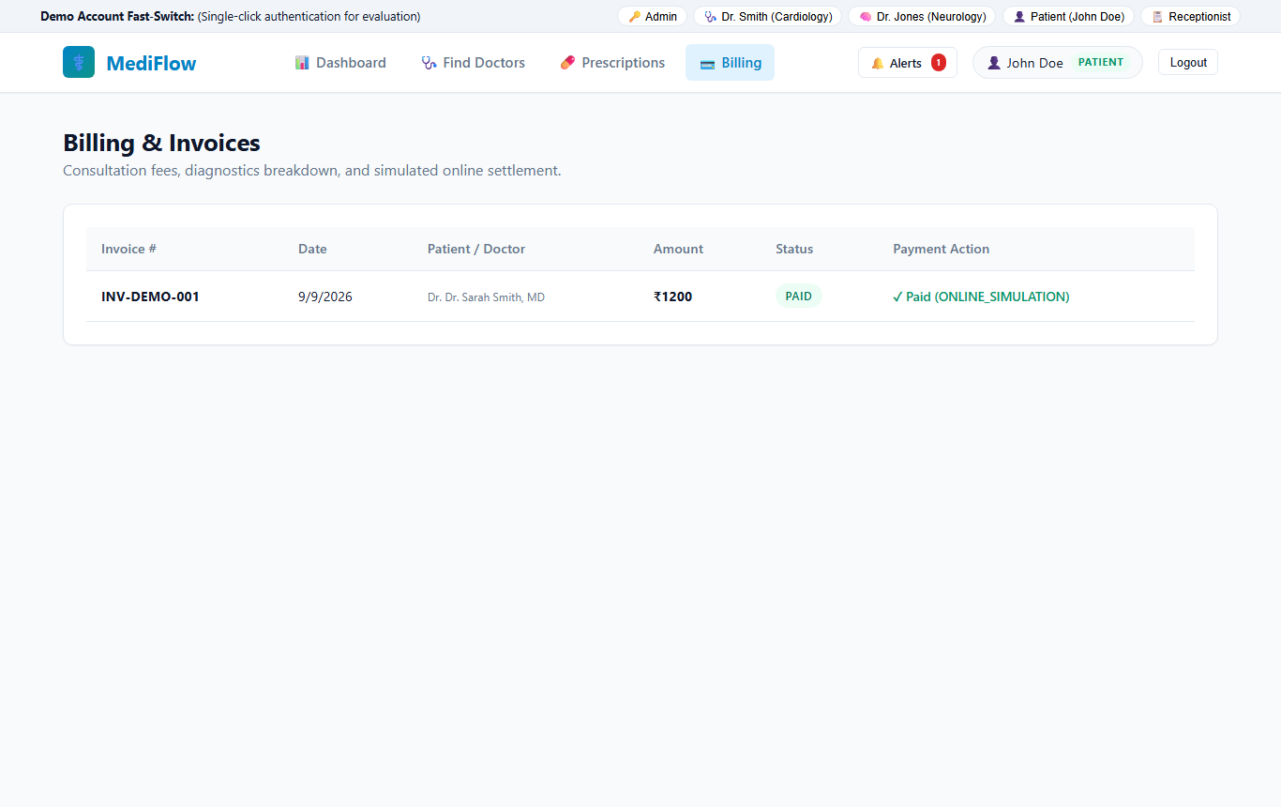
Figure 5: Patient Itemized Billing & Simulated Payment Interface

8.6 Digital Prescription Records
Chronological list of issued prescriptions with clinical diagnoses, attending physician details, and printable Rx summaries.
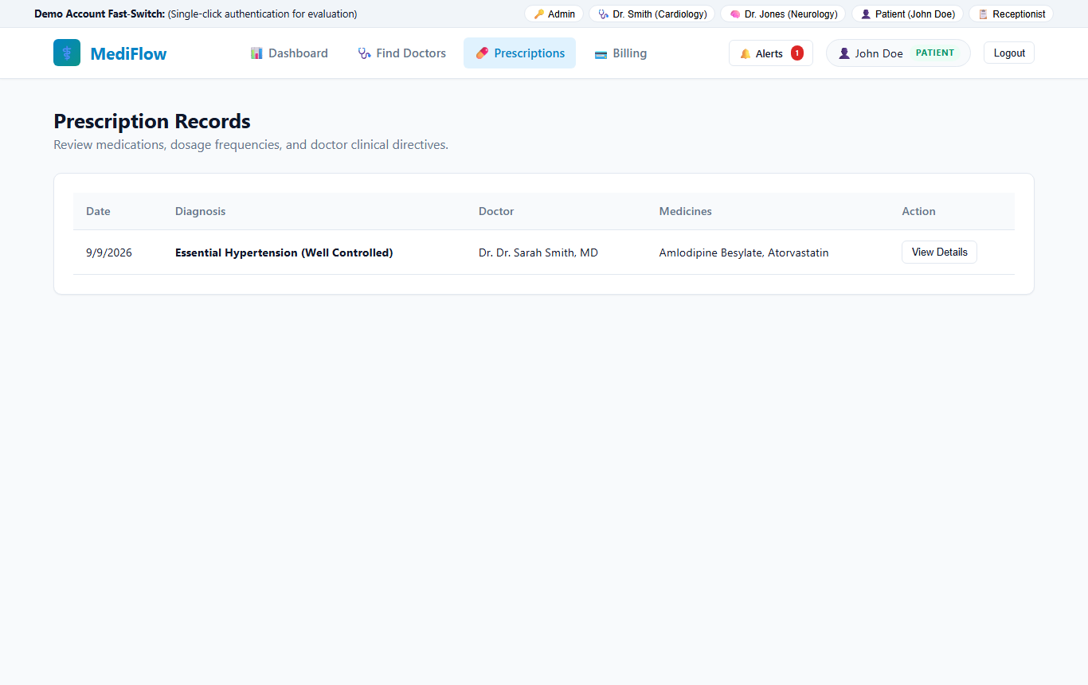
Figure 6: Digital Prescription Management & Medication Directive Records

8.7 Doctor Clinical Portal (Dr. Sarah Smith)
Enables attending physicians to manage assigned appointment queues, confirm visits, record clinical encounter notes, and issue digital prescriptions.
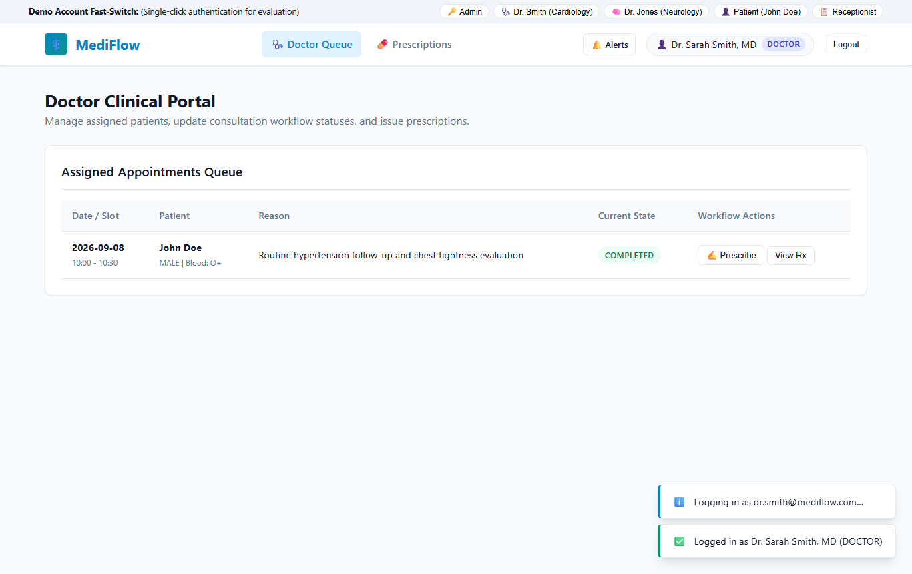
Figure 7: Doctor Clinical Workflow Portal & Assigned Queue

8.8 Hospital Executive Dashboard & Operational Reports
Aggregated KPI cards displaying total patients, active doctors, scheduled visits, and settled revenue in ₹ alongside appointment status distributions.
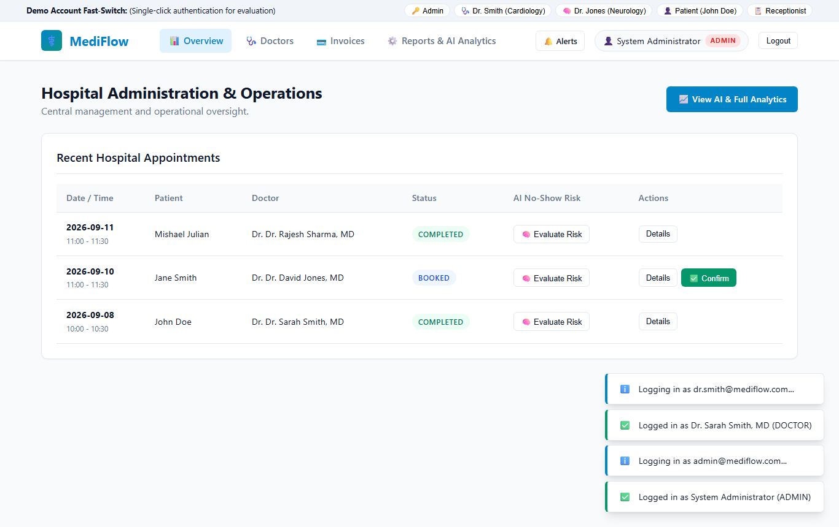
Figure 8: Administrator Executive KPI Overview & Operational Reports

8.9 AI Appointment No-Show Risk Engine
Operational predictive assessment evaluating appointment attendance probability based on booking lead times and historical cancellation ratios.
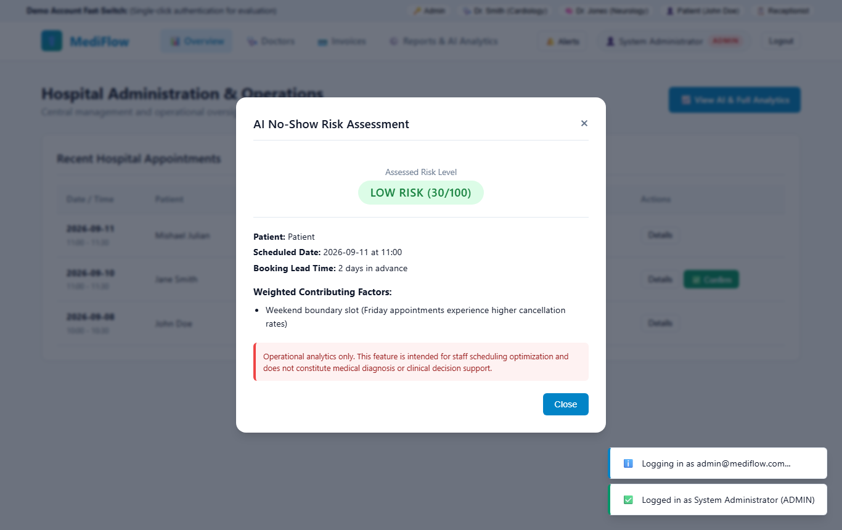
Figure 9: AI Appointment No-Show Risk Predictive Assessment Modal

9. Demo Accounts & Evaluation Walkthrough
The web portal (http://localhost:5000) includes a 1-Click Demo Fast-Switcher bar for instant evaluator testing:
Demo Persona | Email | Password | Role & Test Purpose
System Administrator | admin@mediflow.com | Admin@123 | Executive KPI Dashboard, Reports, User Controls, AI Risk Engine
Central Receptionist | receptionist@mediflow.com | Recep@123 | Hospital Appointment Queue, Check-Ins, Inline Confirmations, Billing
Dr. Sarah Smith (Cardiology) | dr.smith@mediflow.com | Doctor@123 | Assigned Consultation Queue, Clinical Notes, Prescription Issuance
Dr. David Jones (Neurology) | dr.jones@mediflow.com | Doctor@123 | Neurology Patient Queue, Shift Schedule Management
John Doe (Active Patient) | john.doe@example.com | Patient@123 | Completed Consultation, Active Prescription, Paid ₹1,200 Invoice
Jane Smith (Upcoming Patient) | jane.smith@example.com | Patient@123 | Upcoming Neurology Appointment (BOOKED), Pending ₹900 Invoice

Recommended 5-Minute Evaluator Journey:
- Patient Booking: Log in as Patient $\rightarrow$ Browse Doctors $\rightarrow$ View 7-day shifts $\rightarrow$ Book an appointment $\rightarrow$ Observe immediate ₹ consultation invoice generation.
- Conflict Test: Attempt booking the exact same time slot with another account $\rightarrow$ Observe server 409 Conflict rejection.
- Doctor Clinical Workflow: Fast-switch to Doctor $\rightarrow$ Confirm appointment $\rightarrow$ Mark Complete with clinical diagnosis $\rightarrow$ Issue digital prescription.
- Patient Review: Fast-switch back to Patient $\rightarrow$ View newly issued prescription and pay pending invoice via simulation.
- Admin Oversight: Fast-switch to Admin $\rightarrow$ View updated revenue figures, department distribution charts, and AI No-Show Risk assessment.

10. Viva Voce Key Defense Concepts
- Why MongoDB? Flexible document schema perfectly modeling hierarchical clinical encounters (items[], lineItems[]) with high read-heavy performance.
- Double-Booking Prevention: Dual-layered defense: (a) In-memory interval comparison algorithm in service layer, and (b) Database-enforced atomic sparse unique index on slotKey.
- Security & RBAC: Passwords never stored in plaintext (salted bcrypt hash with cost factor 10); JWT bearer tokens with payload verification on every protected route.
- Standardized Responses: Centralized custom error middleware mapping domain errors (NOT_FOUND, SLOT_CONFLICT, FORBIDDEN) to clean, predictable JSON HTTP codes.

11. Conclusion
MediFlow successfully delivers a complete, fault-tolerant, role-based healthcare management platform meeting all CIA-3 evaluation criteria. The system demonstrates high code quality, robust automated test coverage, thoughtful database modeling, and an intuitive user experience.

Submitted for CIA-3 Evaluation • Department of ADSE • Christ University

